Numeracy Analysis Of Grade 5 Elementary School Students In Solving Polya-Based Math Story Problem

Nur Handayani¹, Dyah Tri Wahyuningtyas², Nyamik Rahayu Sesanti³
Elementary School Teacher Education Study Program
^{1,2,3} PGRI Kanjuruhan University
Malang, Indonesian
handayaninur275@gmail.com; dyahtriwahyu@unikama.ac.id; nyamik.malang@gmail.com

Abstract:
The background of this research is based on the AKM in one of the elementary schools, the numeracy skills possessed by students are still relatively low. In fact, numeracy is one of the important abilities possessed by students. In solving math problems, numeracy literacy skills are needed. One of the forms of questions in the numeracy test is in the form of story problems. In solving story problems, there are stages of problem solving used, namely the stages of problem solving proposed by Polya. However, students' numeracy skills in solving story problems with Polya's stages are different. Thus, this study aims to describe the numeracy skills of 5th grade elementary school students in solving Polya-based math story problems. This research uses descriptive qualtative research methods. Data collection techniques were carried out by observation, tests and interviews. Based on the results of the study, students with high numeracy ability can carry out 3 numeracy indicators and 4 stages of Polya well, students with medium numeracy ability can carry out 3 numeracy indicators and 4 stages of Polya with constraints, while students with low numeracy ability can carry out 2 numeracy indicators and 3 stages of Polya with constraints.
Keywords: Numeracy skills; Student grade 5; Solving problem; Math story; Polya's stages.

Introduction
Numeracy is one of the skills that students must have at the primary and secondary education levels [1]. However, the numeracy skills of students in Indonesia are low. This can be seen from the results of the Program for International Student Assessment (PISA) test organized by the Organization for Economic Co-Operation and Development (OECD). Based on the results of the PISA 2022 test, students' numeracy skills are still classified at a low level. The average PISA score on numeracy skills is 366 which has a distance of 106 from the average world score. Numeracy skills include low-level skills below level two [2]. Numeracy skills are the ability to interpret quantitative information found around us. This ability is characterized by easily understanding numbers and being able to use mathematical skills practically to meet the demands of life [3]. This ability can also be expressed in the appreciation and understanding of mathematical information, such as graphs, charts, and tables [4]. Numeracy skills are also defined as the ability to understand and use mathematics in various contexts to solve problems, as well as being able to explain to others how to use mathematics [5].
Numeracy skills are important to have to be applied in everyday life. This ability can train thinking to solve problems and make judgments [6]. Having good numeracy skills can improve their chances in the world of work and build a secure mathematical foundation that can be built through lifelong learning [7]. Numeracy is a skill that permeates all aspects of our lives, from weekly shopping, to loans, to finding a job [8]. With numeracy skills can help us become more financially literate, can help to understand money and manage it wisely, then be able to interpret numerical information appropriately for example to check whether our money is enough or not and use the information to draw conclusions, assess risks and be able to make decisions about money matters that are very important for survival [9].
Numeracy skills can be measured through tests, one of which is in the form of description questions or story problems. In math story problems, the problems presented are problems related to everyday life [10]. In solving math story problems, there are stages that must be done, namely by reading the problem carefully then separating and expressing what is known in the problem, what is asked / asked in the problem, what work operations are needed, then making a mathematical model of the problem, after that solving the model according to mathematical rules so as to get the answer to the model and finally returning the answer to the original answer [11]. In short, students can solve story problems by taking the known and questionable elements of the problem and converting them into mathematical sentences [12]. However, not all students are able to solve story problems or students tend to experience difficulties [13]. The difficulties experienced by students in solving story problems are difficulties in understanding concepts, understanding problem problems and compiling solution steps [14]. In addition, students often experience difficulties in the process of working to the final result [15]. In fact, solving math story problems requires problem solving skills such as the ability to understand problems, design mathematical models, solve models and interpret the solutions obtained [16].
According to The National Council of Teachers of Mathematics (NCTM) problem solving is important for developing mathematical knowledge [17]. Based on this statement, problem solving should be the main focus of mathematics in schools [18]. Thus, problem solving is an integral part of mathematics and is the goal of learning mathematics [19]. One of the stages of problem solving that can be given to students in learning mathematics is the stages of problem solving proposed by Polya. Polya was one of the most influential mathematician of the 20th century. Polya is famous for his four steps in solving problems [20]. Problem solving is an attempt to find a solution to a goal that is not so easy to achieve immediately [21]. There are 4 steps in problem solving according to Polya. The steps in solving the problem are understanding the problem, planning the solution, implementing the solution and checking back [22]. The reason for using the stages of problem solving proposed by Polya is because Polya's stages have structured stages to solve complex problems so that they can help students in solving problems [23].
Based on the explanation above, numeracy skills and problem solving skills are important for students. However, numeracy skills are still relatively low. Based on the results of interviews with 5th grade homeroom teachers at one of the elementary schools in Malang Regency explained that only a few students mastered numeracy skills, meaning that not all students have good numeracy skills. Then, the 5th grade teacher also explained that not all students can solve math story problems well, meaning that students' ability to solve math story problems is also different for each student. Based on research conducted by [24] and [25] also revealed that students' numeracy skills also vary. Then based on research conducted by [26] and [27] also revealed that students' abilities in solving math story problems using the stages of problem solving proposed by Polya also vary from student to student. Based on this, this research focuses on describing the numeracy skills of grade 5 elementary school students in solving Polya-based math story problems.

methods
This research uses descriptive qualitative research with the aim of describing the numeracy skills of 5th grade elementary school students in solving Polya-based math story problems. This research was conducted on all 5th grade students at one of the elementary schools in Malang Regency, totaling 9 students in the odd semester of the 2024/2025 school year. Then from these 9 students, one student each with high, medium and low abilities was selected to be interviewed. Data collection techniques in this study were carried out by observation, tests, interviews and documentation. Observations were made by observing all 5th grade students during the test process. The goal is to find out whether the test results are the result of students' own answers or not. Then the test was given to all 5th grade students totaling 9 people. The test questions contain numerical questions about the scope of numbers, more precisely the operation material of fractional numbers with the number of questions, namely 5 questions in the form of story problems. Next is the interview which aims to reconfirm the written test work of the research subject. The interview subjects were three students from each category of high, medium and low numeracy ability. Then documentation in the form of photos of test results that have been done by students. In this study, data analysis was carried out by data reduction, data presentation and data verification [28].

results & discussion
The following are the results of the numeracy test of grade 5 students with test questions in the form of story problems and their grouping.
TABLE 1. Student Test Results
Name | Score | Category | Code
AAL | 82 | High numeracy ability | HNAS
DDP | 75 | Medium numeracy ability | MNAS
EOP | 96 | High numeracy ability | HNAS
EK | 77 | Medium numeracy ability | MNAS
JBA | 81 | High numeracy ability | HNAS
NMRP | 59 | Low numeracy ability | LNAS
RF | 56 | Low numeracy ability | LNAS
SFS | 71 | Medium numeracy ability | MNAS
TAN | 78 | Medium numeracy ability | MNAS

Based on the table of student test results, it can be seen that students with high numeracy skills amounted to 3 people, then students with moderate numeracy skills amounted to 4 people and students with low numeracy skills amounted to 2 people. Furthermore, students with high, medium and low numeracy abilities were selected one student from each of the three ability categories to be interviewed. The following is a description of student test results and student interview results based on numeracy indicators and Polya stages. In indicator 1 of numeracy ability and Polya's stage 1, what is measured is that students can write down what is known and what is asked correctly. then in indicator 2 of numeracy ability and Polya's stages 2 and 3, what is measured is that students can write the solution plan correctly and carry out the solution plan correctly. Then in indicator 3 of numeracy ability and Polya's stage 4, what is measured is that students can conclude the calculation results correctly.
Stage 1, namely formulating the problem
HNAS, MNAS and LNAS can mention what is known and what is asked from the five problems presented correctly. The following is one of the pictures of HNAS test results on one of the question numbers, namely number 1 with the question "Budi went fishing to the river on a motorcycle. He has traveled through the main road km and still has to travel km by passing a small road to get to the River. How many kilometers is the total distance Budi traveled from home to the river?"
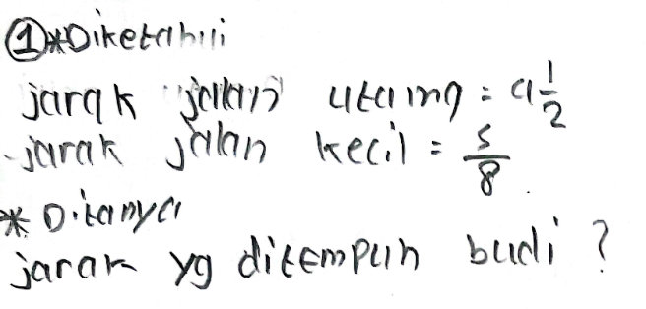
Fig. 1. Test Result HNAS
Then, during the interview, HNAS, MNAS and LNAS can mention what is known and what is asked from the problem correctly. The following are the results of the interview with HNAS on one of the question numbers, namely number 1.
ASK: “What do you understand from question number 1, what is known and what is asked?”
HS: “What is known is the distance from the main road , the distance from the small road .”
ASK: “Then what is being asked?”
HS: “The distance traveled by Budi is.”
So, HNAS, MNAS and LNAS can carry out indicator 1 of numeracy ability and can carry out stage 1 of Polya well. HNAS, MNAS and LNAS were able to mention what was known and what was asked from the problem presented correctly.
Stage 2, namely planning the solution
HNAS and MNAS can determine the solution planning of the five problems presented correctly. The following is a picture of HNAS's answer on one of the problem numbers, namely number 1.
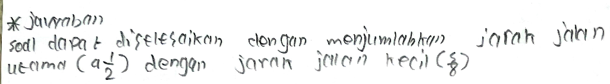
Fig. 2. Test Result HNAS
Meanwhile, LNAS can generally determine the solution plan of the five problems presented. However, LNAS did not write the solution plan in detail. The reason LNAS did not write the plan in detail was due to forgetfulness. The following is a picture of LNAS's answer on one of the problem numbers, namely number 1.
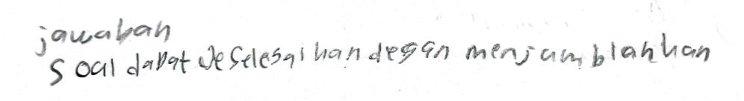
Fig. 3. Test Result LNAS
So, HNAS and MNAS can write the solution plan of the problem presented correctly. During the interview, HNAS and MNAS could also convey the solution plan of the problem correctly. Meanwhile, LNAS has not written the solution plan of the problem completely. LNAS only wrote the calculation operation in general, not writing which part used the calculation operation. The reason is because LNAS forgot not to write it completely.
Stage 3 implementing the solution
HNAS can implement the solution correctly and in accordance with the stages of planning the solution in numbers 1,2,3, and 5. In number 4, HNAS can also implement the solution, but there is an error in the final result. The error is because HNAS is not careful in calculating the final result so that the answer is not correct. This was known during the interview. The following is a picture of HNAS's answer on one of the problem numbers, namely number 4 with the question "Dad has just received a salary and bought liters of cow's milk for supplies at home. As much as a liter of milk is given to grandma for daily consumption. Then the remaining milk is poured into small glasses of each liter. How many glasses are needed to hold the remaining milk?"
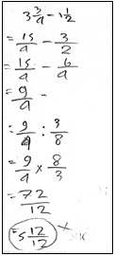
Fig. 4. Test Result HNAS
Then MNAS can implement the solution correctly in number 1 and number 2. Whereas in number 3, 4 and 5 MNAS can also implement the solution but there are calculation errors, namely in the process of converting mixed fractions into ordinary fractions MNAS is less careful in calculating so that the results become incorrect. This was known during the interview. The following is a picture of the results of MNAS answers on one of the problem numbers, namely number 5 with the question "Mr. Ismet has a side business producing syrup. He has a supply of kg sugar at home and buys additional kg of sugar for production purposes. Each bottle of syrup requires kg of sugar. How many bottles of syrup can Mr. Ismet produce with the amount of sugar available?"
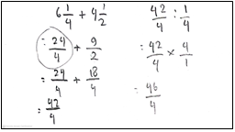
Fig. 5. Test Result MNAS
Furthermore, LNAS has implemented the solution to problem numbers 1 to 5 but the implementation is incomplete and there are still errors in the process of equalizing the denominator and in the fraction division operation. LNAS did not really understand how to equalize the denominator and the fraction division operation. This was known during the interview. The following is a picture of LNAS's answer on one of the problem numbers, namely number 4.
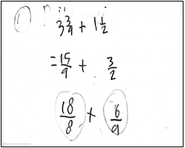
Fig. 6. Test Result LNAS
So, HNAS can carry out indicator 2 of numeracy ability and can carry out Polya's stage 3 well, then MNAS can carry out indicator 2 of numeracy ability and Polya's stage 3 with the obstacle that MNAS is less careful in the process of calculating the results of converting mixed fractions to ordinary fractions so that the next step becomes incorrect calculation results, while LNAS has carried out indicator 2 of numeracy ability and Polya's stage 3 with several obstacles, namely LNAS has not been able to equalize the denominator and has not been able to calculate the division of fractions.
Stage 4 checking back
HNAS can write the conclusion of the answer correctly on numbers 1,2,3, and 5. Whereas in number 4, HNAS also wrote the answer but it was still not correct because at the stage of implementing the solution, the final result of the answer was not correct. The following is a picture of HNAS's answer on one of the problem numbers, namely number 4.
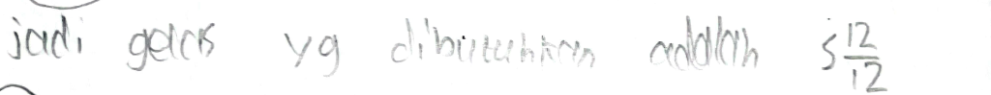
Fig. 7. Test Result HNAS
Then MNAS can write the conclusion of the answer correctly in numbers 1 and 2. Whereas in numbers 3, 4 and 5 MNAS has written the answer but it is not correct because in carrying out the solution there are obstacles so that the final result of the answer is not correct. The following is a picture of MNAS's answer on one of the question numbers, namely number 5.
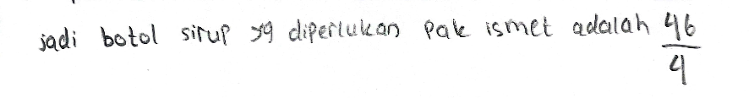
Fig. 8. Test Result MNAS
Furthermore, LNAS did not write the conclusion because LNAS did not have the final answer so LNAS did not write the conclusion. Then during the interview, LNAS also did not convey the conclusion of his answer because the solution had not been completed. The following are the results of the interview with LNAS.
ASK: “The conclusion isn't there yet?”
LS: “Yes, sis.”
So, HNAS can carry out indicator 3 of numeracy and stage 4 of Polya well, then MNAS can carry out indicator 3 of numeracy and stage 4 of Polya, although the answer is not correct, while LNAS has not carried out indicator 3 of numeracy and stage 4 of Polya because LNAS has not completed the implementation of the solution so that the final result is not yet available and LNAS cannot conclude the answer to the problem presented.
Based on the exposure of test data and interview results based on the Polya stages above, the following is a graph that illustrates the numeracy skills of students based on the Polya stages.
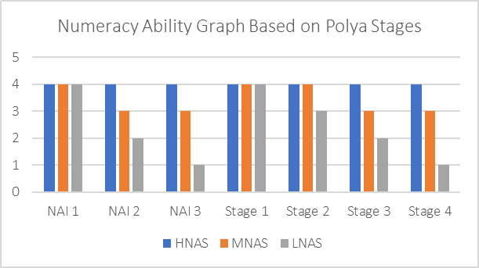
Graph 1. Numeracy Skills Based on Polya Stages
Based on the graph above, HNAS can carry out 3 numeracy indicators and stages 1, 2, 3, and 4 very well, then MNAS can carry out indicator 1 numeracy very well and stages 1 and 2 very well, while for indicators 2 and 3 numeracy as well as for stages 3 and 4 MNAS can carry out these stages well but still experience obstacles, then LNAS can carry out indicator 1 numeracy and stage 1 very well, for stage 2 LNAS can carry out well with few obstacles, then for indicator 2 numeracy and stage 3 LNAS can carry out the stages quite well because there are still many obstacles and for indicator 3 and stage 4 LNAS is lacking in carrying out these stages. Below is a further discussion related to students' numeracy skills based on Polya's stages.
Students with high numeracy skills can answer questions correctly and can carry out the three numeracy indicators and the four stages of Polya well. This is in line with the results of research conducted by [29], namely the higher the ability category owned by students, the tendency for students to answer questions correctly is also higher.
Students with moderate numeracy skills still experience problems in numeracy indicator 2 and Polya stage 3, namely when calculating mixed fractions to ordinary fractions the results are not correct so that the calculation process until the final result becomes incorrect. This is in line with the opinion [12] which states that student errors can occur when using incorrect numbers. Then students with moderate numeracy skills also experience problems in Polya's indicator 3 and stage 4 because at the stage of implementing the solution the final result is not correct. This is supported by the opinion [30] [31] that in solving problems, after carrying out the calculation process, students must re-examine the results that have been obtained to determine the accuracy of the answers obtained.
Furthermore, students with low numeracy ability at stage 2 of planning the solution, this student has not written the answer in detail. Then for indicator 2 and stage 3 of Polya, this student still has difficulty in calculating, especially in the process of equalizing the denominator so that some problems have not been calculated until the final result. This is in line with the opinion [32] that students have difficulty in the calculation process so that students' answers are not correct. Then, students with low numeracy skills have not carried out numeracy indicator 3 and stage 4 of Polya because the numeracy indicator 2 and stage 3 of Polya have not been completed because these students have not been able to equalize the denominator and have not been able to calculate the division operation of fractions. This is in line with research conducted by [33] which suggests the reason the subject has not solved the problems is because the subject has not been able to answer the problem and give the right conclusion.

conclusion
Based on the results of research and discussion, it is concluded that the numeracy skills of grade 5 students in solving Polya-based math story problems in one of the elementary schools in Malang Regency, namely students with high numeracy skills can carry out 3 indicators of numeracy skills and 4 stages of Polya. Then students with moderate numeracy skills can also carry out 3 indicators of numeracy skills and 4 stages of Polya with constraints on indicator 2 and stage 3 and experience obstacles in indicator 3 and stage 4. While students with low numeracy skills can carry out 2 indicators of numeracy skills and 3 stages of Polya with constraints on indicator 2 and stage 2 and constrained in indicator 3 and stage 3.
Furthermore, based on the results of the research and conclusions, the suggestions proposed by the researcher are for homeroom teachers to more often provide numeracy problem exercises in the form of story problems in order to improve numeracy skills in solving Polya-based math story problems. Then for students, to be more careful in the calculation process and practice more working on numeracy problems based on story problems so that their abilities increase. As for future researchers, it is recommended that before carrying out the test, students are given practice problems first so that students are more careful and understand more about working on numeracy problems in the form of story problems

References
[1] Sulistyowati, F., Istiqomah, I., Kusumaningrum, B., Kuncoro, K. S., Pramudianti, T., & Usman, A, “Mathematical Literacy Skills of Students with Kinesthetic Learning Style,” FRAKTAL J. Mat. Dan Pendidik. Mat., vol. 2, no. 2, pp. 53–62, 2021, doi: https://doi.org/10.35508/fractal.v2i1.3590.
[2] Rosmilawati, E. K. Y. & I E, “Numeracy Literacy in Elementary Schools Based on PISA 2023 Indicators; Systematic Literature Review,” J. Instr. Dev. Res., vol. 4, no. 3, pp. 172–191, 2024, doi: https://doi.org/10.53621/jider.v4i3.326.
[3] Sani, R. A, AKM Oriented Learning: Minimum Competency Assessment. Bumi Aksara, 2021.
[4] Ekowati, D., & Suwandayani, B, Numeracy Literacy for Elementary School. 2018.
[5] Han, W., Susanto, D., Dewayani, S., Pandora, P., & Hanifah, N, Numeracy Literacy Support Materials. 2017.
[6] Situmorang, N. I. F., Anggraini, N., & Alpajri, M, “The Importance of Numeration and Number System for Elementary School Students,” J. Social Education and Humanities., vol. 4, no. 2, pp. 2899–2911, 2025.
[7] Gal. I, Grotlüschen. A, Tout. D, & Kaiser, “Numeracy, Adult Education, and Vulnerable Adults: a Critical View of a Neglected Field,” Zdm, vol. 52, pp. 377–394, 2020.
[8] Kus. M, “Numeracy,” Brock Educ. J., vol. 27, no. 2, 2018.
[9] Yunarti, T., & Amanda, A, “The Importance of Numeracy Skills for Students. National,” Seminar on Mathematics, Science and Technology Learning., vol. 2, no. 1, pp. 44–48, 2022.
[10] Vitaloka, W. P., Habibi, M., Putri, R., & Putra, A, “Analysis of Problem Solving Ability in Solving Mathematics Story Problems on Social Arithmetic Based on Newman Procedure,” Delta-Pi J. Math, vol. 9, no. 2, 2020.
[11] Aminah, A., & Kurniawati, K. R. A K. R. A, “Analysis of Students' Difficulties in Solving Mathematics Story Problems on Fraction Topics Based on Gender,” TAM (Jurnal Teor. Dan Apl. Mat., vol. 2, no. 2, pp. 118–122, 2018, doi: https://doi.org/10.31764/jtam.v2i2.713.
[12] Nugroho, R. A., & Sutarni, S, “Analysis of Students' Difficulties in Solving Story Problems on Fraction Matter Judging from Polya's Problem Solving,” 2017.
[13] Dila, O. R., & Zanthy, L. S, “Identification of Student Difficulties in Solving Social Arithmetic Problems,” Teorema Teor. Dan Ris. Mat., vol. 5, no. 1, pp. 17–26, 2020, doi: http://dx.doi.org/10.25157/teorema.v5i1.3036.
[14] Khofifah, L., Supriadi, N., & Syazali, M, “Flipped Classroom and Discovery Learning Models on Concept Understanding and Mathematical Problem Solving,” PRISMA, vol. 10, no. 1, pp. 17–29, 2021, doi: https://doi.org/10.35194/jp.v10i1.1098.
[15] Kusumaningrum, B., Irfan, M., & Wijayanto, Z, “Errors Analysis of Students in Solving Volume of The Solid of Revolution Problem in Term of Critical Thinking Aspects.,” Kalamatika J. Pendidik. Mat., vol. 5, no. 2, pp. 119–132, 2020, doi: https://doi.org/10.22236/KALAMATIKA.vol5no2.2020pp119-132.
[16] Harini, E., Islamia, A. N., Kusumaningrum, B., & Kuncoro, K. S, “Effectiveness of E-Worksheets on Problem-Solving Skills: A Study of Students’ Self-Directed Learning in the Topic of Ratios,” Int. J. Math. Math. Educ., pp. 150–162, 2023, doi: https://doi.org/10.56855/ijmme.v1i02.333.
[17] Ariawan, R., & Nufus, H, “The Relationship between Mathematical Problem Solving Ability and Students' Mathematical Communication Ability,” J. THEOREMS (The Orig. Res. Math., vol. 1, no. 2, 2017.
[18] Fendrik. M, Development of Mathematical Connection Skills and Habits of Mind in Students. Media Sahabat Cendekia, 2019.
[19] Kusumaningrum, B., Fauziah, E., & Harini, E, “The Effectiveness of E-Worksheet on Problem Solving Ability Based on Students' Learning Interest in Comparison Materials. Union: Scientific Journal of Mathematics Education,” Union J. Ilm. Pendidik. Mat., vol. 10, no. 2, pp. 193–204, 2022, doi: https://doi.org/10.30738/union.v10i2.12484.
[20] Ariani, Y., & Kenedi, A. K, “Polya Model in Improving Mathematics Learning Outcomes in Learning Volume Story Problems in Elementary Schools,” J. Inspirasi Pendidik., vol. 8, no. 2, pp. 25–36, 2018, doi: https://doi.org/https://doi.org/10.21067/jip.v8i2.2520.
[21] Herianto, H., Saedi, S., & Mokat, S, “Polya's Problem Solving Theory in Mathematics Learning,” Sigma (Suara Intelekt. Gaya Mat., vol. 3, no. 1, 2011.
[22] Yuwono, T., Supanggih, M., & Ferdiani, R. D, “Analysis of Mathematical Problem Solving Ability in Solving Story Problems Based on the Polya Procedure,” J. Tadris Mat., vol. 1, no. 2, pp. 137–144, 2018, [Online]. Available: http://ejournal.iain-tulungagung.ac.id/index.php/jtm.
[23] Dewi, S. K., Suarjana, I. M., & Sumantri, M, “Application of the Polya Model to Improve Learning Outcomes in Solving Mathematics Story Problems of Grade V Students,” Mimb. PGSD Undiksha, vol. 2, no. 1, 2014.
[24] Rahmah, N. R, “Analysis of Literacy and Numeracy Skills of Grade IV Elementary School Students in Mathematics Problem Solving,” UIN Raden Intan Lampung, 2023.
[25] Baharuddin, M. R., Sukmawati, S., & Christy, C, “Description of Students' Numeracy Ability in Solving Fraction Operations,” J. Pendidik. Mat., vol. 6, no. 2, pp. 90–101, 2021, doi: https://doi.org/10.30605/pedagogy.v6i2.1607.
[26] Fatmasari, O. A, “Analysis of Students' Problem Solving Ability in Solving Mathematics Story Problems Based on Polya's Theory at SDN Surat Kediri,” Universitas Nusantara PGRI Kediri, 2024.
[27] Siswadi. A, “Analysis of Mathematical Ability on Story Problems in Measuring the Numeration Level of Fifth Grade Students of SD Negeri Ngemplak Kidul 03 Pati,” Universitas PGRI Semarang, 2022.
[28] Winarni. E.W, Theory and Practice of Quantitative, Qualitative Research, PTK, R & D. Bumi Aksara, 2021.
[29] Rifai, R., & Wutsqa, D. U, “Mathematical Literacy Ability of State Junior High School Students in Bantul Regency,” J. Pendidik. Mat. dan Sains, vol. 5, no. 2, pp. 152–162, 2017, doi: http://dx.doi.org/10.21831/jpms.v5i2.15747.
[30] Putri, A. A., & Sasomo, B, “Analysis of Student Errors in Solving Mathematics Problems in View of Cognitive Style,” Indones. J. Educ. Learn. Math., vol. 2, no. 02, pp. 64–68, 2022.
[31] Kuncoro, K. S., & Juandi, D, “The Effect of Module-Assisted Direct Instruction on Problem-Solving Ability Based on Mathematical Resilience,” J. Medives J. Math. Educ. IKIP Veteran Semarang, vol. 7, no. 1, pp. 8–15, 2023, doi: https://doi.org/10.31331/medivesveteran.v7i1.2137.
[32] Kuncoro, K. S., & Junaedi, I, “Analysis of Problem Solving on Project Based Learning with Resource Based Learning Approach Computer-Aided Program,” J. Phys. Conf. Ser., vol. 983, no. 1, 2018, doi: 10.1088/1742-6596/983/1/012150.
[33] Ratri, A. K., & Setyaningsih, N, “Analysis of Mathematical Literacy on the Ability to Solve High Order Thinking Skills Oriented Problems,” in Prosiding Konferensi Nasional Penelitian Matematika dan Pembelajarannya, 2020, pp. 162–175.

