Development of Ethnomathematics-Based E-LKPD on Cube and Block Spaces for Elementary School Students
Development of ethnomathematics-based E-LKPD on Cube and Beam Spaces for Elementary School Students

Elfiyohana Harapan
PGRI Kanjuruhan University Malang
Elementary School Teacher Education
line 3 Malang, East Java
yohanaanna041@gmail.com

I Ketut Suastika
PGRI Kanjuruhan University Malang, Indonesia
suastika@unikama.ac.id

Dyah Tri Wahyuningtyas
PGRI Kanjuruhan University Malang, Indonesia
dyahtriwahyu@unikama.ac.id

Abstract—The low understanding of mathematical concepts of cube and block building materials is caused by the lack of utilization of interactive media and related examples of culture-based learning problems such as traditional cake food. Therefore, this study aims to determine the feasibility, practicality, and effectiveness of ethnomathematics-based E-LKPD on cube and block building materials for elementary school students. The type of research used is development research (Research and Development) which refers to the ADDIE development model (Analysis, Design, Development, Implementation, Evaluation). The research instruments include expert validation (material, language, LKPD), teachers, and effectiveness test using N-Gain. The novelty of this research is to develop ethnomathematics-based E-LKPDs that focus on the introduction of traditional cakes, namely jadah cakes resembling cube spaces and getuk cakes resembling beam spaces. Data were obtained through questionnaires, observations, interviews, documentation, and tests, then analyzed qualitatively and quantitatively. The validation results showed that the developed E-LKPD obtained an average score of 80% material experts (feasible), 97% media experts (very valid), and 89% language experts (very valid). The teacher's questionnaire showed a practicality of 100%, while the effectiveness test reached 75% which was classified as quite effective. Thus, the ethnomathematics-based E-LKPD is declared feasible, practical, and effective enough to be used in learning mathematics cube and beam material in elementary schools.
Keywords— E-LKPD, Ethnomathematics, Building Spaces

Introduction
Learner Worksheets (LKPD) are printed teaching materials designed to guide students through certain tasks, containing instructions, steps, and how to complete tasks on certain materials (Iriani et al., 2023). LKPD is one of the learning resources that can be developed by educators as facilitators in learning activities (jowita, v., 2017). Learner Worksheets (LKPD) are very important learning media to help students understand concepts and develop skills (Zuriatin et al., 2022). LKPD as a well-designed teacher evaluation tool and can facilitate teachers in implementing learning and support students in an active learning process and can encourage students to think critically, increase students' participation ability in the learning process and can understand teaching material (Rewatus et al., 2020). The LKPD contains material, instructions, and steps as well as practice questions that must be done by students (Amali et al., 2019;). With this LKPD, it can encourage students to be actively involved in the learning process and be able to practice the concepts that have been learned.
Based on the results of direct observations and interviews with fifth grade homeroom teachers at public elementary schools in Malang district, the LKPD provided by the teacher is still print-based, colorless and still focuses on teaching materials from the government and has never designed its own LKPD, this causes the LKPD to be less attractive and still not effective in encouraging active student participation. The LKPD provided by the teacher contains tedious exercise questions and has not been fully connected with examples of mathematical problems related to culture in everyday life in mathematics learning, especially in the material of building space, this causes students to find it difficult to understand concepts in real situations, lack of interest in learning and students think that learning mathematics is a difficult and boring lesson. So that this has an impact on the low learning outcomes of students. Based on the explanation above, to attract students' interest and attention in learning, appropriate learning resources are needed that are more interesting and interactive, one of which is the Electronic Learner Worksheet (E-LKPD) (Nusroh et al., 2024).
Technological developments have opened up new opportunities in the world of education, especially in designing teaching materials, LKPD which used to be only in printed form, can now be converted into digital LKPD. With the use of LKPD technology, it can be designed as interesting as possible so that it can produce LKPD that is easily accessible to students by utilizing technology so as to produce Electronic Learner Worksheets (E-LKPD) (Siregar et al., 2023). Digital-based E-LKPD functions as an effective learning media to improve the learning process of mathematics, and offers a new approach for students in understanding subject matter (Nabilla et al., 2022). The use of E-LKPD serves as an effective media, because it can provide a new approach for students in understanding the material taught by the teacher with a complex where this E-LKPD has interactive features. With the help of this E-LKPD, it can provide opportunities for students to hone technological skills such as online information capabilities, use digital devices, and be able to interact with digital technology in the learning process.
Mathematics learning, the application of ethnomathematics is often ignored in the learning process which results in less effective learning (Sarwoedi et al., 2018). According to (Lubis et al., 2024) due to the absence of the application of ethnomathematics in the mathematics learning process students lose the opportunity to learn their own culture through mathematics learning. According to (Dari & Jatmiko, 2024), with this problem, it is important to apply ethnomathematics in mathematics learning as a reference for understanding mathematical concepts and is directly related to students' daily environment, besides that through the application of ethnomathematics, students are aware of the importance of preserving local wisdom culture and students also know more about what is included in their culture. According to (Nurniyati et al., 2024) the importance of the ethnomathematics approach by inserting cultural elements in learning can increase student motivation and involvement and strengthen critical thinking skills. According to (Juliyansah & Hakim, 2024) a good understanding of the cubes and beams is very important, because it is the basis for learning more complex geometry material at the next level of education.
Based on the results of research conducted by (Y.A. Talo et al., 2022) developing LKPD based on ethnomathematics of grave stones and traditional houses of Sumba for grade IV students in elementary schools, these researchers used cultural elements of grave stones and traditional houses of the Sumba community and the material developed from these researchers, namely square, rectangular, and triangular flat shapes. The research was carried out limited to only knowing the level of quality of ethnomathematics-based LKPD on the material of the perimeter and surface area of flat shapes so that it did not know the results of the effectiveness of the LKPD products developed. According to (Anggreyani et al., 2024) developing ethnomathematics-based mathematics LKPD on Jambi batik motifs for grade III in elementary schools is still in printed form. According to (Rahmadhani et al., 2024) developed LKPD based on kawung batik ethnomathematics on the material of the elements of a circle. These researchers use cultural elements from kawung batik with the material of the elements of a circle which is applied to grade VI students in elementary school. In line with the previous researchers above, this researcher also has similarities, namely both focus on developing ethnomathematics-based LKPD. However, in this development research, a novelty will be carried out from previous researchers, namely developing ethnomathematics-based E-LKPD with cube and beam building material. The E-LKPD that the researchers developed can also be accessed using smartphones, computers so that it is expected to increase students' interest in learning mathematics. While in the cultural context, researchers will focus on traditional jadah cake food typical of Rembang, Central Java, where the specific shape of the cake resembles a cube and getuk cake from Magelang, Central Java, where the specific shape of the cake resembles a block.

Methodhe
The research method used is the Research and Development method of the ADDIE model (Analysis, Design, Development, Implementation, and Evaluation) developed by Dicky and Cray. According to (Mulyatiningsih, 2016) the development of teaching materials is carried out through 5 stages visually but researchers only take three, namely analysis, design and development. At the analysis stage, it is carried out to determine the CP and ATP on the material of cube and beam spaces in grade V SD in Malang district, analyze student characteristics to understand variations in learning styles and levels of interaction in learning, and analyze the needs for teaching materials for LKPDs based on ethnomathematics of traditional Jadah cakes in the form of cubes and Getuk cakes in the form of blocks that are already available. The ethnomathematics-based E-LKPD is designed in three main sections: introduction (cover, instructions, CP mapping, TP, ATP, and activities), core (material, important information, and student activities), and closing (evaluation and assessment). Equipped with videos and color images to increase learning motivation. At the development stage, validation was carried out by material experts, LKPD, language, and supervisors, along with revisions according to the input. Implementation was carried out through trials in elementary schools in Malang Regency to assess initial interaction and effectiveness. The evaluation stage was carried out through tests and analysis of teacher-student responses to assess the effectiveness and practicality of the product. The research subjects totaled 18 students. This E-LKPD integrates Indonesian culture in cube and block materials, encouraging interactive learning and independent concept discovery. The product is available in soft file form and can be accessed through a web link, supporting the flexibility of digital use.
The data collection instruments in this study include questionnaires, observations, and documentation to develop ethnomathematics-based E-LKPDs on cube and beam material. Questionnaires in the form of closed questionnaires were used to assess the feasibility, practicality, and effectiveness of the product. Feasibility is assessed by material, language, and teaching material experts based on the suitability of content, curriculum, presentation, and language. Practicality was assessed by teachers based on aspects of language, presentation, material content, and learning components. Effectiveness was measured through students' pre-test and post-test results to see the improvement of learning outcomes. The assessment used a Likert scale of 1-4. Data were analyzed quantitatively and descriptively qualitatively. Quantitative data came from the questionnaire results, while qualitative data came from expert advice and teacher input. The pre-test and post-test results were also used to measure the effectiveness of E-LKPD in improving students' concept understanding.

Results and discussion
RESULTS
The product produced from this research is an E-LKPD based on ethnomathematics of typical jadah cake from Rembang, Central Java and typical getuk cake from Magelang, Central Java on the material of cube and beam spaces. The process of developing this E-LKPD by applying the ADDIE development model which has five stages but researchers only take five stages, namely Analysis, Design, Development, Implementation, Evaluation:
- The analysis stage is carried out to carry out curriculum analysis based on the results of interviews with the V grade homeroom teacher that the curriculum used is with the guidance of the independent curriculum, in addition, the results of analyzing student characteristics found that students have a variety of different learning styles, so that interactive learning media is needed that can increase participation and understanding of mathematical concepts more effectively. At the needs analysis stage, the observation results show that the available teaching materials are still printed and less interactive, so it is necessary to develop ethnomathematics-based E-LKPDs that can be accessed digitally to help students understand the concepts of area and volume of cube and beam spaces more contextually.
- Design stage, Product design results.
- ETHNOMATHEMATICS-BASED E-LKPD PRODUCT DESIGN
NO | Development Results | Ethnomathematics
1. | In this section, we will look at what the LKPD activities are. | 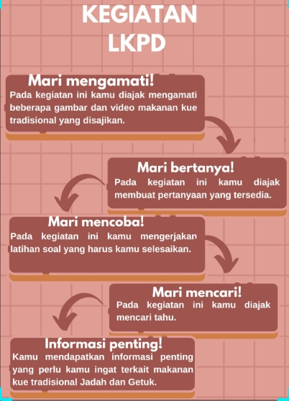
2 | Let's Ask. In this activity, students are invited to observe the pictures that have been provided. Let's ask questions students will be invited to make questions. | 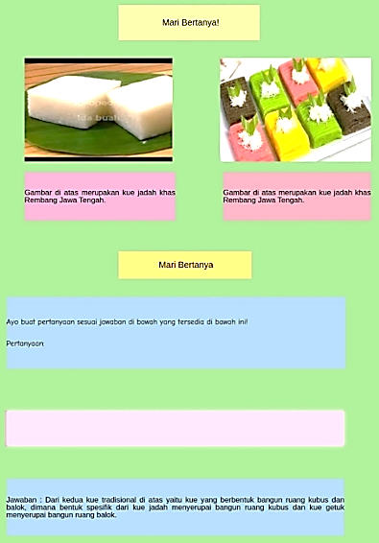
3 | Important information. Students will get important information about kue jadah and kue getuk. | 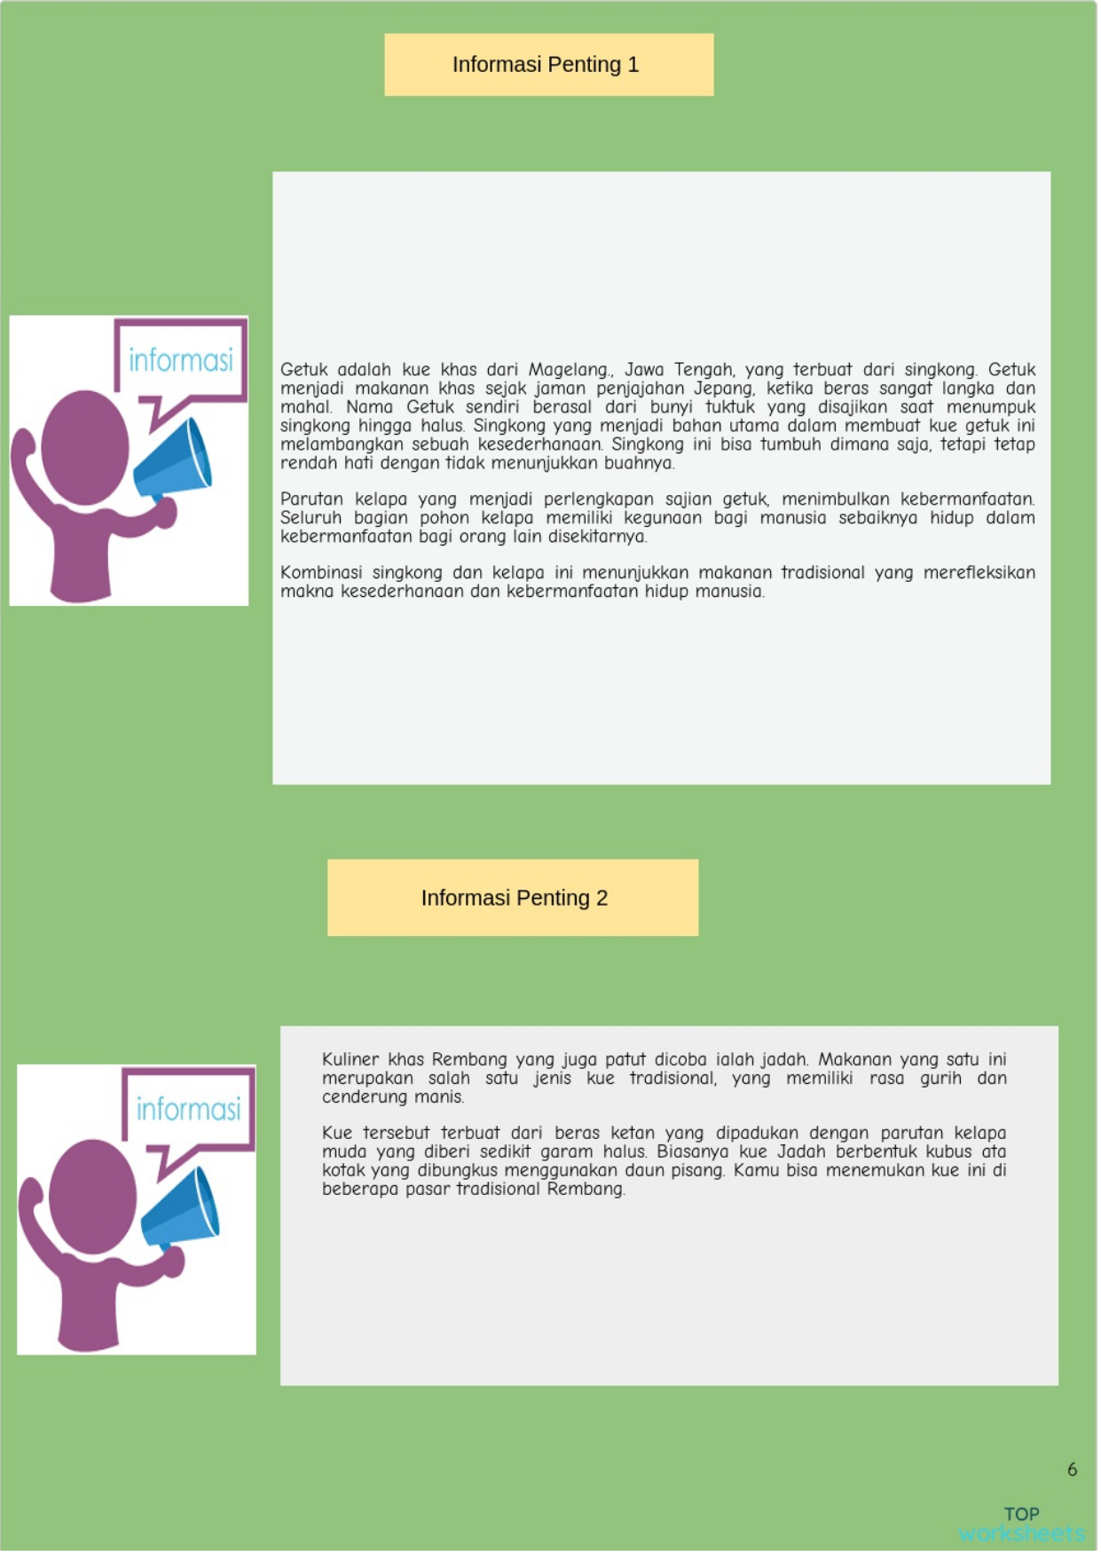
4 | On this page, students pay attention to the images that are already available from the two cakes, there is a description of each cake resembling the cubes and blocks. | 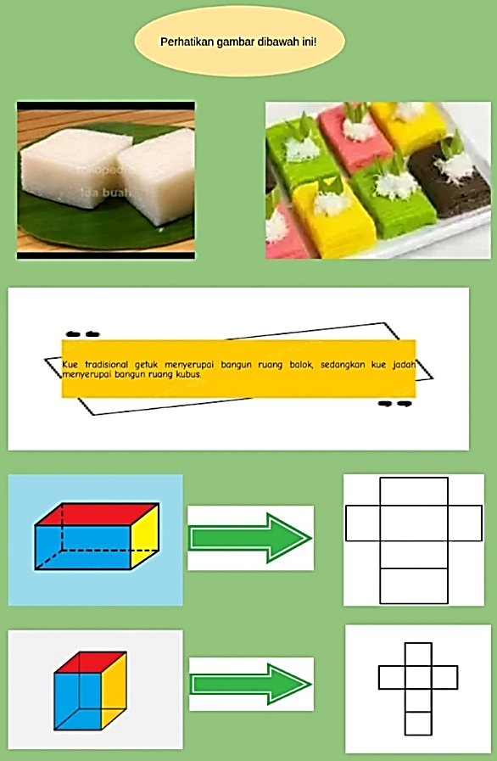
5 | Let's Observe In this section, students will find out and work out what are the characteristics of cube and block shapes. | 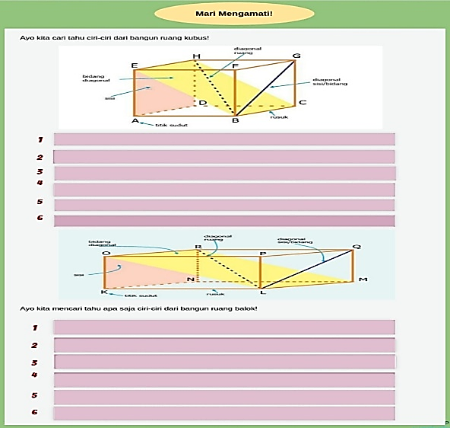
6 | In the section students will learn how to find the formula for the surface area and volume of cubes and provided video examples of problems and the process of making typical Palembang srikayaka cakes, as well as working on surface area and volume problems of cubes that are already available. | 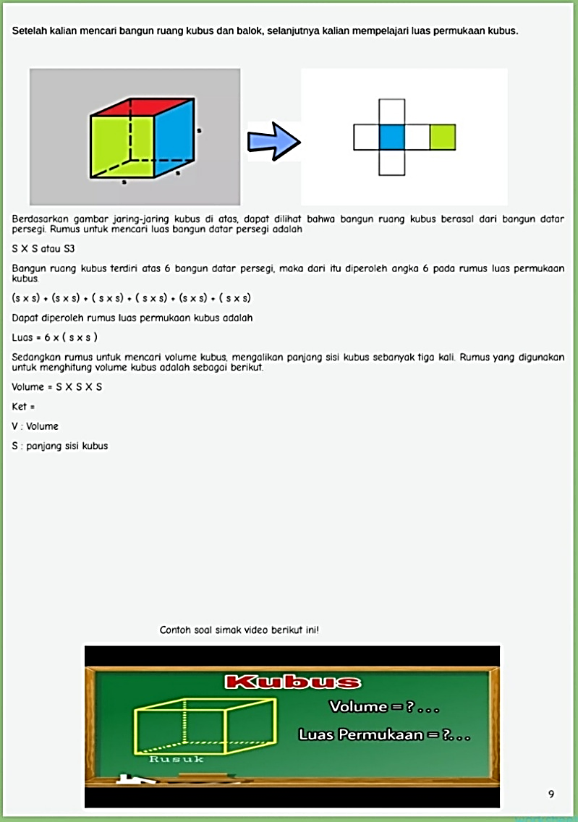  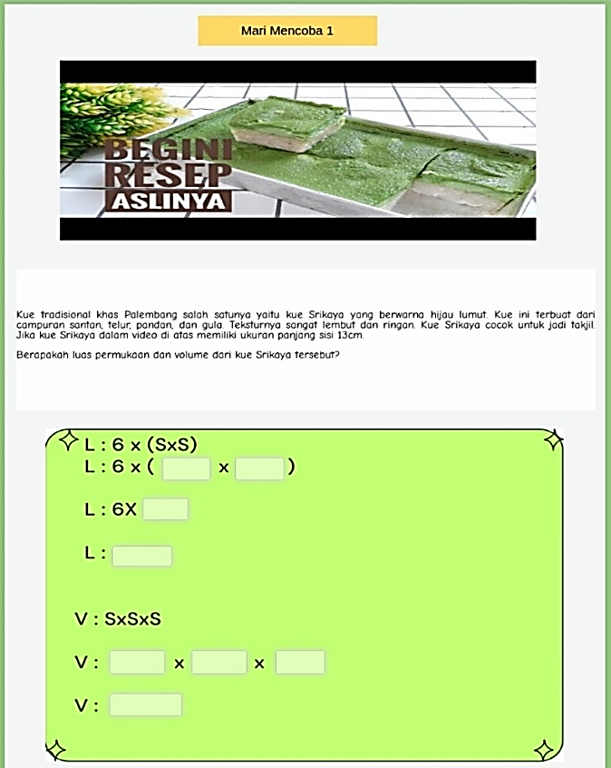
7 | In this section, students will learn how to determine the surface area and volume formulas for cuboids systematically. | 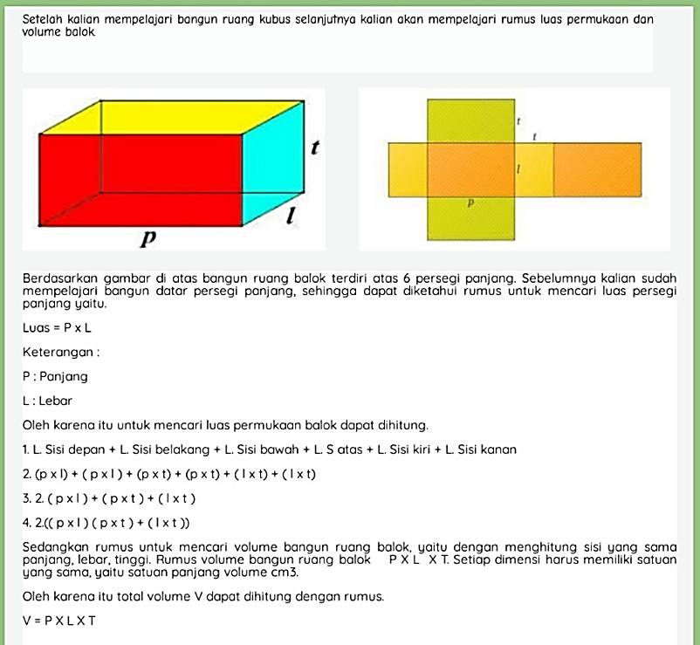
8 | In this section, a video example of a problem and a video of the process of making a typical Bugis peca sponge cake and providing questions to work on the next slide is provided. | 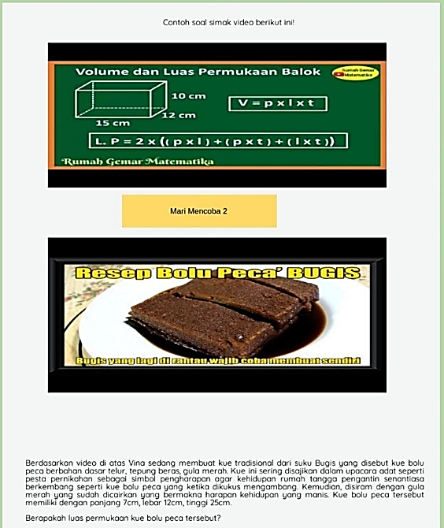  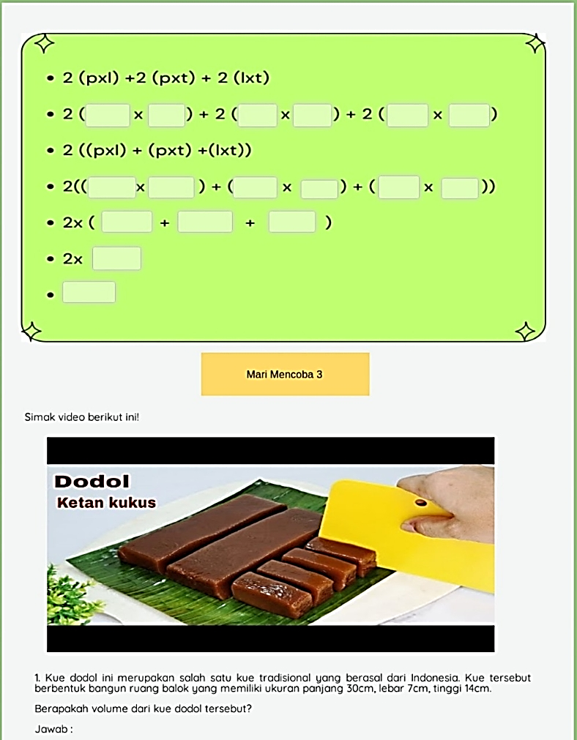
9 | In this section, students will work on the volume problem of the beam building. | 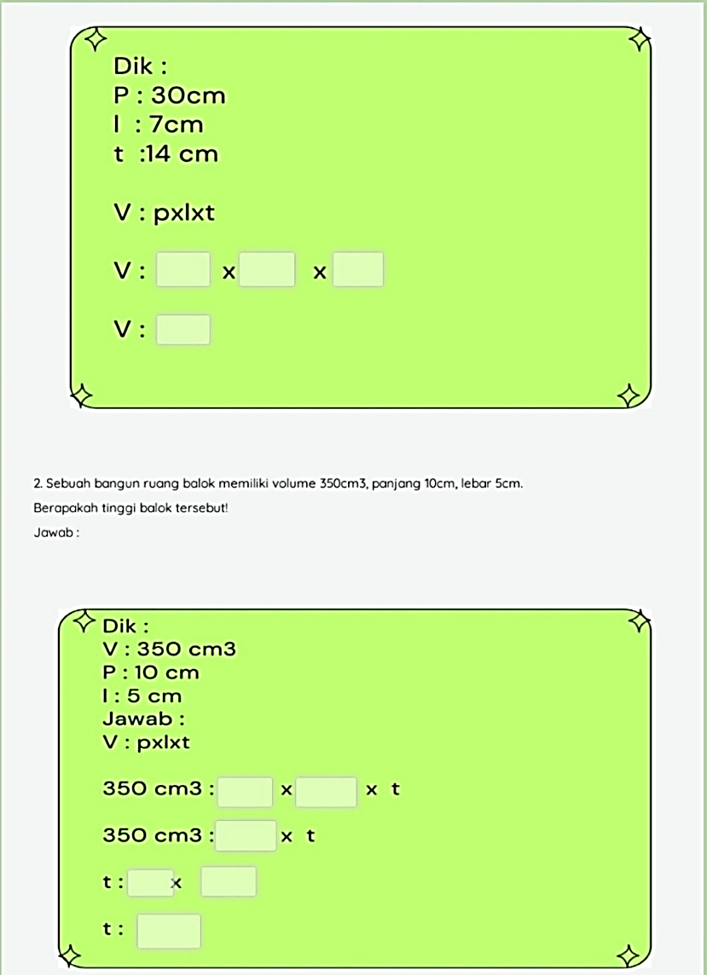
10 | In this section students will work on the evaluation stage | 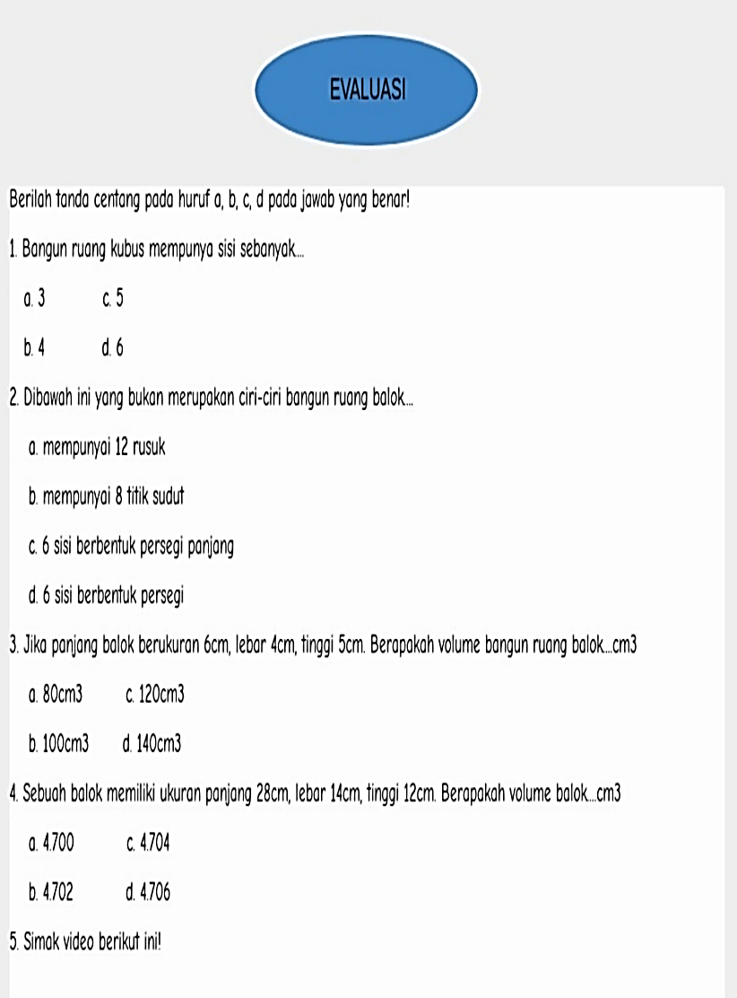  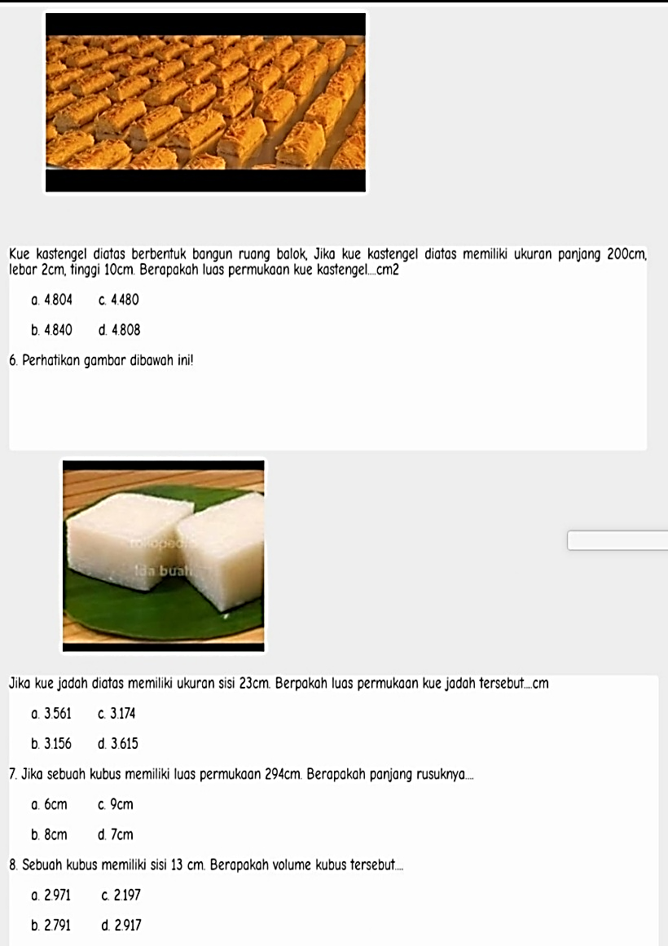  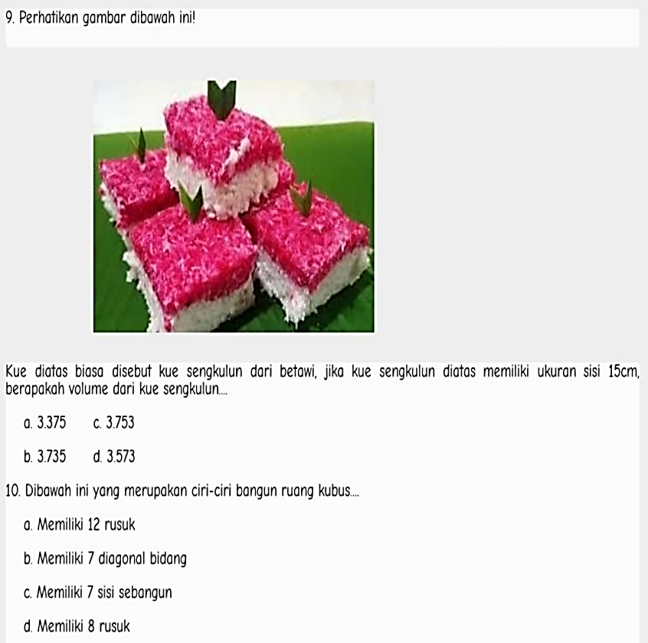
- Sample of a Table footnote. (Table footnote)

- Development stage, the results of suggestions from supervisors regarding ethnomathematics-based E-LKPD products, the application used must be able to include videos, images and student answers must be recorded in the application. Enter from the material expert, the presentation of the material must be systematic and the LKPD instructions must be complete. Input from LKPD teaching material experts provides a unique logo, adjusts the color of the writing with the backgraound, while input from language experts, namely using good and correct EYD language. Based on the results of the supervisor and three expert validators, the ethnomathematics-based E-LKPD on the building material of cubes and blocks is suitable for use according to the criticisms and suggestions that have been given. The results of the validation on the validation sheet instrument, so that data is obtained in the form of a percentage of determining the level of validity of the material, E-LKPD, and language on the E-LKPD.
The validation results can be seen in the following table:
Assessment Aspect | Average Score | Category
Material Expert | 80% | Worth
Expert on LKPD | 97% | Very Feasible
Linguist | 89% | Very Feasible

Based on the table above, the results obtained from the material expert are 80% which indicates that the criteria are feasible to use, the LKPD expert gets a score of 97% with a very feasible category to use, and from the language expert the results are 89% with very feasible criteria to use.
4. In the implementation stage, researchers tested ethnomathematics-based E-LKPD products on cube and beam building materials in class V of one of the elementary schools in Malang City involving 18 students. The trial began with giving a pretest, followed by the delivery of learning materials and the distribution of E-LKPD links. Students were then asked to work on the E-LKPD independently. This activity aims to measure students' understanding of the material provided.
5. At the Evaluation stage, the results of student work on ethnomathematics-based E-LKPDs produce the following scores:
Picture of student activity

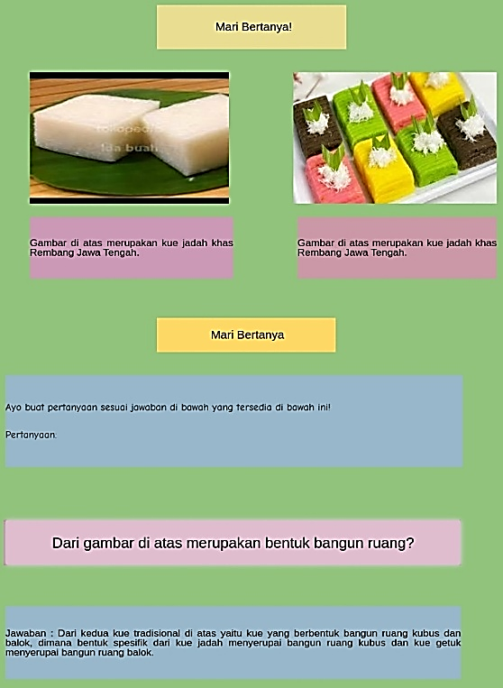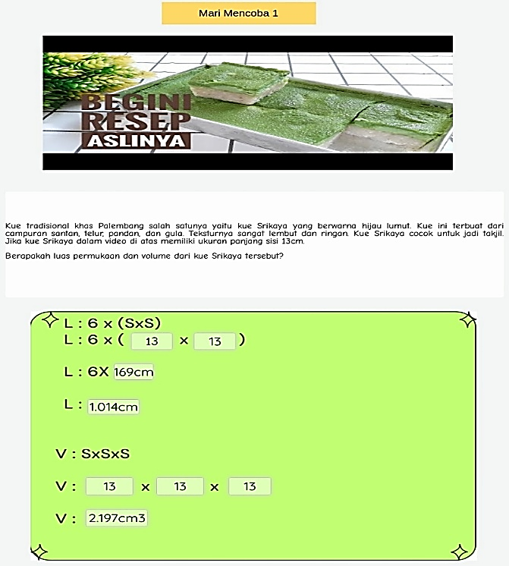
- Table 1. Comparison of Pre-Test and Post-Test Scores
NO | INITIAL | RESEARCH RESULTS |  | X2-X1 | X MAX -X1 | N-GAIN
NO | INITIAL | X1 | X2 | X2-X1 | X MAX -X1 | N-GAIN
1 | AA | 44 | 90 | 30 | 50 | 60%
2 | MST | 40 | 80 | 40 | 60 | 67%
3 | RAN | 55 | 80 | 40 | 50 | 80%
4 | RAA | 44 | 90 | 40 | 60 | 67%
5 | AEPD | 44 | 80 | 40 | 60 | 67%
6 | JRR | 55 | 80 | 30 | 50 | 60%
7 | BAS | 55 | 80 | 30 | 50 | 60%
8 | NIA | 33 | 80 | 50 | 70 | 71%
9 | FDP | 44 | 100 | 40 | 60 | 67%
10 | GAM | 55 | 80 | 50 | 50 | 100%
11 | ACH | 55 | 80 | 30 | 50 | 60%
12 | FAP | 66 | 100 | 40 | 40 | 100%
13 | SO | 66 | 100 | 50 | 60 | 83%
14 | CFDNJ | 44 | 80 | 30 | 40 | 75%
15 | KF | 55 | 90 | 40 | 50 | 80%
16 | YTA | 66 | 100 | 40 | 40 | 100%
17 | ASN | 55 | 100 | 50 | 50 | 100%
18 | AMA | 30 | 80 | 20 | 40 | 50%
 | Average | 50,33333 | 87,22222 | 38,3 | 51,666667 | 75%

Based on the pretest results of 50.3 and posttest of 87.2, an average increase of 75% was obtained. This shows that ethnomathematics-based E-LKPD is feasible to use as a learning media to help students understand the concept of cube and beam building material.
DISCUSSION
Based on the five stages above, students work by understanding the prompts or rare activities in the LKPD in the first part students are asked to pay attention to the images of the two types of traditional cakes in the form of cube and block spaces, then students are asked to make short questions related to the answers that have been provided. After that, in the third part, students are asked to watch a video of a recipe for making a traditional Palembang crescent cake, in the video about what the ingredients are in making crescent cakes and then make a problem to find the surface area and volume of the cube. According to (Fajriyah, 2018) Ethnomathematics owned by each region has a relationship with mathematical concepts that can be integrated in elementary school level learning. Related to this concept, the author highlights ethnomathematics that focuses on various types of traditional cakes. In this context, traditional cakes are not only seen as cultural heritage, but also as objects of mathematical study that reflect various concepts. Through this approach, math learning can be linked to real life, so that students more easily understand abstract concepts by linking them to objects or activities that are close to their culture. Thus, the use of traditional cakes as media in ethnomathematics can be an innovative strategy to increase students' understanding and appreciation of mathematics and local culture. Ethnomathematics is applied in the E-LKPD on learning mathematics of cubes and beams to introduce mathematical concepts through local culture relevant to learning involving patterns from traditional cake food Jadah typical of Rembang and Getuk typical of Magelang. According to (Dewi & Agustika, 2022) E-LKPD based on ethnomathematics is very helpful for students and motivated and can improve students' learning style in understanding the material provided because it is continuous with real concepts in everyday life. In line with the opinion according to (Lely Marlina et al., 2023) learning mathematics through the ethnomathematics approach combines culture with mathematics so that learning becomes more interesting and is able to increase students' cultural values and can improve student learning outcomes. This helps students to better understand math in a more contextual and meaningful way. Ethnomathematics in learning cube and block spaces provides an opportunity for students to see that math is not only taught abstractly, but also in the context of their real lives. According to (Silvia, 2019) ethnomathematics-based LKPD can take advantage of the culture that is around us, so that the existence of cultural links in mathematics learning can increase the effectiveness of student learning and learning becomes fun because it takes place with real concepts. By incorporating local cultural elements such as traditional cake food into E-LKPDs, students can feel a direct connection between mathematics and their world, which in turn can increase their interest and understanding of mathematics.
The use of E-LKPD in ethnomathematics learning also serves to improve students' technological skills, because they will get used to using digital devices to solve problems and access learning materials. This is in accordance with the development of an increasingly digital age. According to (Firtsanianta & Khofifah, 2022) E-LKPD is very important to be applied in schools according to the rapid development of the era, the school learning process must be able to collaborate by utilizing current technology so that students are not left behind in skills using technology and can link mathematics learning with ethnomathematics by utilizing local culture. this is also expressed according to (Helmina et al., 2022) Current learning must be able to collaborate with the use of technology, 2022) Current learning must be able to collaborate with technology in developing teaching materials as a provision for the nation's children so that they can face an increasingly advanced world, with the E-LKPD it can help students understand the use of technology and can link mathematics learning by linking ethnomathematics with local culture around the student environment. In the ethnomathematics-based E-LKPD, the problem of building cubes and blocks refers to the patterns of various traditional cake foods. E-LKPDs that integrate ethnomathematics can increase students' creativity and critical thinking skills. Students not only work on math problems technically, but also learn to appreciate their cultural wealth and understand it through the lens of mathematics. This is in line with the opinion of (Liesandra & Nurafni, 2022) the development of E-LKPD in learning mathematics flat geometry material based on ethnomathematics, the results of this study E-LKPD media in the form of ethnomathematics-based geometry material is able to provide students with freedom of thought because students learn mathematics through experiences from the surrounding environment (culture) so that students are able to apply mathematical theory more easily, with this, of course, understanding of student geometry material is not only limited to concepts and over time the independence of learning mathematics students will increase. Another study (Susanto & Yenni, 2022) showed that this LKPD can improve students' understanding of mathematical concepts through the context of local culture, especially pyramid houses. In addition, research conducted by (Wiwi et al., 2023) shows that this LKPD can improve students' critical thinking skills through the integration of local culture in mathematics learning.
Based on the results of the study, it shows that the ethnomathematics-based E-LKPD on cube and beam building materials for elementary school students meets the eligibility criteria. In the feasibility test which has gone through the validation stage by material experts, LKPD teaching materials, language. The results obtained from material experts reached 80% with decent criteria, LKPD teaching material experts reached 97% with very valid criteria, language validation reached 89% with very valid criteria. This indicates that the ethnomathematics-based E-LKPD has met the eligibility standards to be applied in learning mathematics in elementary schools.
The results of the practicality test of the ethnomathematics-based E-LKPD on the material of building cubes and blocks show an average coefficient of 100% with very practical criteria, based on teacher responses through a questionnaire. This proves that E-LKPD is feasible and effective to use in learning. This finding is in line with research (Disnawati & Nahak, 2019), (Setiani et al., 2023), as well as (Luthfi & Rakhmawati, 2022) and (Oktavia, 2024) which show that ethnomathematics-based LKPDs are valid, practical, and easy to apply in improving understanding of mathematical concepts.
The effectiveness test at SD Negeri Malang showed an average N-Gain of 75% with a fairly effective category. These results are consistent with research (Dewi & Agustika, 2022) and Luthfi & Rakhmawati (2022) which concluded that ethnomathematics-based E-LKPDs can improve student learning outcomes and understanding of mathematical concepts through cultural integration in learning.
CONCLUSION AND ACKNOWLEDGMENT
Ethnomathematics-based E-LKPDs received excellent ratings from material, LKPD, and language expert validations, with the category feasible for learning mathematics. The practicality of the product received a very practical category based on teacher questionnaires, while the effectiveness was measured through pretest and posttest with moderately effective results using the N-Gain formula. Thus, this E-LKPD is declared very feasible, practical, and effective enough to be used in elementary schools. This product can improve students' learning outcomes and motivation in learning about cube and block building materials. In addition, the E-LKPD is developed using the Topworksheet platform which makes learning more interactive through its features.
I would like to express my deepest appreciation and gratitude to Dr. I Ketut Suastika, M.Si. and Dr. Dyah Wahyuningtyas, S.Si., M.Pd. for their direction, guidance, and support during the process of preparing this journal. My gratitude also goes to the fifth grade homeroom teacher and students at the research location who have participated and contributed to the implementation of this research. In addition, I would also like to thank the validation experts who have been willing to take the time to provide evaluation and input on the products developed in this study.

References

  - Amali, K., Kurniawati, Y., & Zulhiddah, Z. (2019). Development of Science Technology Community-Based Learner Worksheets in Science Subjects in Elementary Schools. Journal of Natural Science and Integration, 2(2), 70. https://doi.org/10.24014/jnsi.v2i2.8151
  - Anggreyani, R., Sastrawati, E., & Budiono, H. (2024). DEVELOPMENT OF ETHNOMATHEMATICS-BASED MATH LKPD ON JAMBI BATIK MOTIFS FOR GRADE III SD. JP2M (Journal of Mathematics Education and Learning), 10(1), 239-249.
  - Dari, S. W., & Jatmiko, J. (2024). Analysis of the Role of Ethnomathematics in Mathematics Learning. Proceedings of the National Seminar ..., 269-278. https://proceeding.unpkediri.ac.id/index.php/seinkesjar/article/view/4522%0Ahttps://proceeding.unpkediri.ac.id/index.php/seinkesjar/article/download/4522/3153
  - Dewi, N. P. D. M., & Agustika, G. N. S. (2022). Interactive E-LKPD based on Balinese Jejahitan Ethnomathematics on Flat Building Material for Grade IV SD. 10(1), 94-104.
  - Disnawati, H., & Nahak, S. (2019). Development of Student Worksheet Based on Ethnomathematics of Timor Weaving on Number Pattern Material. Journal of Elements, 5(1), 64-79. https://doi.org/10.29408/jel.v5i1.1022
  - Fajriyah, E. (2018). The role of ethnomathematics related to mathematical concepts in supporting literacy. PRISMA, Proceedings of the National Seminar on Mathematics, 1, 114-119. https://journal.unnes.ac.id/sju/index.php/prisma/article/view/19589
  - Firtsanianta, H., & Khofifah, I. (2022). Effectiveness of E-LKPD assisted by Liveworksheets to Improve Learners' Learning Outcomes. Conference of Elementary Studies, 140-147.
  - Helmina, H., Fajriah, N., & Suryaningsih, Y. (2022). Development of Ethnomathematics-Based E-Lkpd with Purun Weaving Context on Number Pattern Material for Grade Viii Students. Jurmadikta, 2(2), 38-49. https://doi.org/10.20527/jurmadikta.v2i2.1236
  - Iriani, R., Leny, L., Misbah, M., Rinaya, M. J., Nana, N., Sopranti, N., Muhaimin, M., & Norhasanah, H. (2023). Preparation of Chemistry Learner Worksheets (LKPD) Using Liveworksheet to Improve Learning Quality in the Independent Curriculum. High ridge: Journal of Community Service, 5(4), 1679. https://doi.org/10.20527/btjpm.v5i4.10085
  - jowita, v., N. (2017). Development of Learner Worksheets (Lkpd) Using Problem Based Learning Model on Theme 4 Healthy is Important Sebtema 3 Healthy Environment in Class V Sd Negeri 55/I Sridadi. 1-10.
  - Juliyansah, R., & Hakim, D. L. (2024). Students' Ability in Solving Combined Space Building Problems. JP2M (Journal of Mathematics Education and Learning), 10(1), 70-84. https://doi.org/10.29100/jp2m.v10i1.5350
  - Lely Marlina, Somakim, S., & Aisyah, N. (2023). Ethnomathematics in Ki Muara Ogan Mosque Palembang and its Integration in Elementary Mathematics Learning. Indiktika: Journal of Mathematics Education Innovation, 6(1), 11-20. https://doi.org/10.31851/indiktika.v6i1.13593
  - Liesandra, S. O., & Nurafni, N. (2022). Development of E-Lkpd on Learning Mathematics Flat Geometry Materials Based on Ethnomathematics. AKSIOMA: Journal of Mathematics Education Study Program, 11(3), 2498. https://doi.org/10.24127/ajpm.v11i3.5560
  - Lubis, A. P., Sirait, C. D., Mailani, E., May, L. C., Ketaren, M. A., & Maharaja, S. (2024). Effectiveness of Ethnomathematics-Based Mathematics Learning for Strengthening Cultural Values. 2(5).
  - Luthfi, H., & Rakhmawati, F. (2022). Development of Ethnomathematics-Based Learner Worksheets (LKPD) on the Material of Class IX Curved Side Spaces. Cendekia Journal: Journal of Mathematics Education, 7(1), 98-109. https://doi.org/10.31004/cendekia.v7i1.1877
  - Mulyatiningsih, E. (2015). DEVELOPMENT OF ENDANG LEARNING MODEL. Islamic Education Journal, 35,110,114,120,121.
  - Nabilla, N., Edy, S., & Khikmiyah, F. (2022). DEVELOPMENT OF INTERACTIVE MATH E-LKPD BASED ON DIGITAL LITERACY. Journal of Innovative Mathematics Learning, 5(6), 1581-1594. https://doi.org/10.22460/jpmi.v5i6.1581-1594
  - Nurniyati, T., Djafar, S., S, P., & Nurdin. (2024). Meta Analysis of Ethnomathematics Approach in Improving Mathematical Problem Solving Ability. 08 (November), 1981-1992.
  - Nusroh, H., Kusumaningsih, N., & ... (2024). The use of Interactive Learning Media to Improve the Motivation and Learning Outcomes of Science students in class VIII D SMPN 18 Semarang. Proceedings of Seminar ..., 728-734. https://proceeding.unnes.ac.id/snpptk/article/view/3200%0Ahttps://proceeding.unnes.ac.id/snpptk/article/download/3200/2665
  - Oktavia, L. et al. (2024). Development of rme-based lkpd with ethnomathematics approach on line and angle material. Journal of MathEdu (Mathematic Education Journal), 7(2), 97-106.
  - Rahmadhani, S. E., Sabara, I. M., & Marhayati, M. (2024). Development of Lkpd Based on Kawung Batik Ethnomathematics on the Elements of a Circle. AKSIOMA: Journal of Mathematics Education Study Program, 13(1), 116. https://doi.org/10.24127/ajpm.v13i1.8078
  - Rewatus, A., Leton, S. I., Fernandez, A. J., & Suciati, M. (2020). Development of Ethnomathematics-Based Learner Worksheets on Triangle and Quadrilateral Materials. Journal of Scholarship: Journal of Mathematics Education, 4(2), 645-656. https://doi.org/10.31004/cendekia.v4i2.276
  - Sarwoedi, Marinka, D. O., Febriani, P., & Wirne, I. N. (2018). Effectiveness of ethnomathematics in improving students' mathematical understanding ability. Raflesia Journal of Mathematics Education, 03(02), 171-176. https://ejournal.unib.ac.id/index.php/jpmr/article/view/7521
  - Setiani, W., Fajriah, N., & Budiarti, I. (2023). Development of Ethnomathematics-Based Learner Worksheets (Lkpd) for Mathematical Literacy Skills in Spldv Material. Jurmadikta, 3(1), 78-88. https://doi.org/10.20527/jurmadikta.v3i1.1749
  - Silvia, T. (2019). Development of ethnomathematics-based student worksheets (LKPD) on line and angle material. Hipotenusa: Journal of Mathematical Society, 1(2), 38-45. https://doi.org/10.18326/hipotenusa.v1i2.38-45
  - Siregar, N. A. R., Susanti, S., Liana, M., & Elvi, M. (2023). Interactive E-LKPD Training Using Liveworksheets for Teachers of SMP Negeri 14 Tanjungpinang. Anugerah Journal, 5(1), 83-94. https://doi.org/10.31629/anugerah.v5i1.5659
  - Susanto, E., & Yenni, R. F. (2022). Development of Lkpd Based on Ethnomathematics of Limas Houses Using the Inquiry Method. Nabla Dewantara: Journal of Mathematics Education, 7(1), 38-48.
  - Wiwi, W. N., Octaria, D., & Dwi Nopriyanti, T. (2023). Development of Ethnomathematics-Based Lkpd on Flat-Sided Space Building Materials to Improve Critical Thinking Ability. Nabla Dewantara: J.Pendidik.Matematika, 8(2), 58-73. https://doi.org/10.51517/nabla.v8i2.262
  - Y.A. Talo, I.M. Ardana, & I.W. Kertih. (2022). Development of Learner Worksheets (Lkpd) Based on Ethnomathematics of Grave Stones and Sumba Traditional Houses for Grade Iv Elementary School Students. PENDASI: Indonesian Journal of Basic Education, 6(1), 84-93. https://doi.org/10.23887/jurnal_pendas.v6i1.562
  - Zuriatin, S., Susanta, A., & Muktadir, A. (2022). Development of Learner Worksheets (LKPD) Mathematics Fraction Materials Using Problem Based Learning Model in Class IV Elementary School. Journal of Primary Education Learning and Teaching, 5(2), 268-275. https://doi.org/10.33369/dikdas.v5i2.20347

