Development of Genially-Based Learning Media to Train Student’s Problem-Solving Skills

Putri Rahmawati
Elementary School Teacher Education Study Program, Faculty of Education
University of PGRI Kanjuruhan Malang
Malang, Indonesia
putrirahmawati253@gmail.com
Arnelia Dwi Yasa
Elementary School Teacher Education Study Program, Faculty of Education
University of PGRI Kanjuruhan Malang
Malang, Indonesia
arnelia@unikama.ac.id
Farida Nur Kumala
Elementary School Teacher Education Study Program, Faculty of Education
University of PGRI Kanjuruhan Malang
Malang, Indonesia
faridankumala@unikama.ac.id

Abstract— IPAS learning at SDN Sukun 3, the teacher only uses monotonous learning media.So that students easily get bored during the learning process in class.The purpose of this research is to determine the validity, practicality, and effectiveness of Genially-based learning media in the IPAS learning of elementary school students.This development research uses the R&D method with the ADDIE model.The data analysis of this research uses qualitative and quantitative methods.Based on the assessment results from media experts, the language and content received an average score of 88.52% with the category "very valid."The results of the teacher's practicality test obtained 96.42% with the category "very practical," while the limited trial by students obtained 86.1% with the category "very practical," and the extensive trial obtained 71.8% with the category "practical."In the effectiveness test using the N-Gain score, 71.8% was obtained with the category "Effective."To determine the difference between pretest and posttest results using the Wilcoxon test, a value of 0.000<0.05 was obtained, which means there is a difference between the pretest and posttest results.Thus, it can be concluded that the use of Genially-based learning media is valid, practical, and effective for use as IPAS learning media in elementary schools.
Keywords— Learning Media, Genially App, Elementary School Students

INTRODUCTION
In the current digital era, education is highly needed and demanded to carry out engaging and innovative learning processes. One of the things that educators can do for the learning process is to use interactive learning media. The use of interactive learning media will help students better understand concepts and can enhance their skills (Zulhelmi, 2017). One of the learning media that can be utilized in the learning process is Genially. Compared to other learning media such as PowerPoint Genially offers more varied and engaging features, one of which is the availability of various templates with diverse themes (Ni’mah, 2022). Genially offers many advantages as a digital learning medium, such as various pre-existing and easy-to-use templates, a range of animations, and a lot of easily manageable content with buttons that can be customized to specific requirements (Shalimar, 2024). With the presence of learning media, it will increase students' interest in learning (Supriyono, 2018). In the current learning context, students are required to master basic knowledge, but problem-solving skills are also very important.
Problem-solving is the process of addressing an issue or difficulty to achieve the desired goal (Sri Sumartini, 2016). In line with the opinion of (Yuhani, 2018) that problem-solving is a way to address issues ranging from the simplest to the most complex. Problem-solving skills are the ability of an individual to identify, analyze, and effectively resolve problems. Indicators of problem-solving skills include the ability to identify problems, analyze them, design solutions, implement the planned actions, and evaluate the results (Makiyah, 2021). The problem-solving process is highly relevant to be applied in science learning, as it can develop critical, logical, and creative thinking skills in students (Sukmasari, 2017).
IPA (Natural Sciences) is a discipline that studies various natural phenomena and everything related to the surrounding natural environment (Purbosari, 2016). Science does not only focus on the introduction of concepts, facts, or principles in seeking knowledge or studying systematically, but rather a process based on observations and experiments conducted by humans (Barkah, 2022). In this digital era, implementing science education is expected to emphasize science, technology, and the environment (KH, Putri, 2024).
Based on the interview results obtained, at SDN Sukun 3 Kota Malang in the fourth grade, traditional or monotonous teaching methods are still used, relying solely on LKS books and still using teaching media such as photosynthesis material boards, dioramas, and others. Additionally, there is an issue in the IPAS subject on the topic of photosynthesis, where students are still unable to solve a problem regarding deforestation and its impact on the photosynthesis process. In this case, Genially-based learning media offers an interesting solution. Transforming the learning process into something more engaging and interactive is expected to enhance student motivation and encourage them to be more active in finding solutions to the problems presented. In this case, it aligns with the research findings (Shalimar, 2024a) which show that the use of Genially is effective in helping students solve problems in mathematics subjects.
In addition, another study by (Toyibatul, 2024) mentions that the use of Genially learning media can make the learning process for students more enjoyable. According to (Enstein, 2022), Genially is an educational tool that helps educators develop learning media, enabling the creation of creative and innovative teaching devices, such as presentations, educational games, and interactive learning videos. Meanwhile, according to (Fatma, 2022), Genially media presents attractive images and texts, thereby increasing students' interest in following the material and reducing boredom during the learning process. From previous research opinions, there are differences among researchers, namely in previous studies, the subjects used were mathematics and Indonesian language, but the researcher developed Genially-based learning media for IPAS learning in the 4th grade of elementary school and focused on training students' problem-solving skills.
Based on the data description, the objective of this research is to develop Genially-based learning media designed to train students' problem-solving skills on the topic of photosynthesis for fourth-grade students. With a better understanding of this, educators can more easily design engaging and effective learning activities. This is very important, considering the increasing number of challenges faced in the world of education today.

METHOD
This research employed the Research and Development (R&D) approach using the ADDIE model, which consists of five systematic stages: analysis, design, development, implementation, and evaluation (Rosmiati, 2019). In the analysis phase, performance analysis and needs analysis were conducted. The performance analysis revealed that learning media used in classrooms remain conventional and monotonous, relying primarily on bulletin boards, dioramas, and student worksheets (LKS), with limited use of creative and innovative instructional media. At the needs analysis stage, it was identified that the integration of innovative learning media by teachers is essential to enhance the effectiveness of the learning process. The design stage involves designing the structure, content, and mechanisms of the media to align with the results of the previous analysis stage. Next, this development stage implements the design into a tangible product used in the learning process. The developed learning media uses Genially, which is then validated by subject matter experts, media experts, and language experts to determine the validity of the developed media. The implementation stage involved limited trials with 5 students and extensive trials with 22 students from the 4th grade at SDN Sukun 3. Next, in the evaluation stage, we will determine whether the product has been effectively used in the learning process.
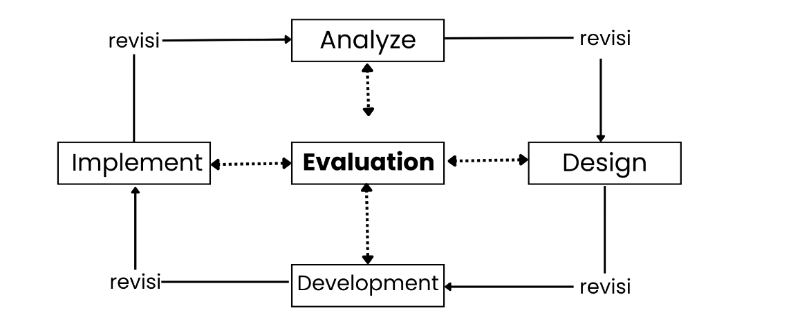

Picture 1. ADDIE Model Stages, (Hidayat, 2021)

This research focuses on the development of Genially-based learning media by employing a mixed-methods approach that integrates both qualitative and quantitative data. Qualitative data were gathered through the evaluation of the media's validity, practicality, and effectiveness using expert validation sheets (covering content, language, and media), practicality questionnaires, and pretest–posttest instruments. Quantitative data were derived from expert validation scores, as well as the results of practicality surveys completed by teachers and students. The following is an analysis of the learning media in terms of its validity, practicality, and effectiveness:
In the validity analysis, scoring is conducted based on data analysis results and validation from expert lecturers in the subject matter, media, and language. With the following percentages
Table1. Validity Presentation
No | Range of Value | Criteria
1 | 81% - 100% | Very Valid
2 | 61% - 80% | Valid
3 | 41% - 60% | Fairly Valid
4 | 21% - 40% | Less Valid
5 | 0% - 20% | Not Valid
Source: (Gulo, 2022) with modification
Analysis of the practicality of learning media through the practicality of teachers and students with data collected through teacher questionnaires with the following percentages
Table 2. Presentation Of Practicality
No | Range of Value | Criteria
1 | 80% < ≤ 100% | Very Practical
2 | 60% < ≤ 80% | Practical
3 | 40% < ≤ 60% | Quite Practical
4 | 20% < ≤ 40% | Less Practical
5 | 0% < ≤ 20% | Very Impractical
Source: (Gulo, 2022) with modification
The analysis of data effectiveness is conducted through the results of pretests and posttests carried out by students using the N-Gain Score formula with a percentage:
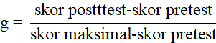
Table 3. Effectiveness Presentation
Normalized Gain (%) | Criteria
≥ 76% | Very Effective
56% ≤ N-Gain (%)≤ 75% | Effective
40% ≤ N-Gain (%)≤ 55% | Less Effective
≤ 40% | Not Effective
Source: (Prasetyo, 2024) with modification

Following the calculation of the N-Gain Score, a T-Test was initially planned to analyze the differences between pretest and posttest scores. However, prior to conducting the T-Test, prerequisite tests for normality and homogeneity were performed. The results indicated that the data did not meet the assumption of normality, although the homogeneity requirement was satisfied. As a result, the Wilcoxon Signed-Rank Test was employed as an alternative. The analysis was conducted using SPSS version 23 for Windows, with a significance level set at 0.05. The decision rule was: Ha is accepted if the p-value < 0.05, and rejected if the p-value > 0.05. The hypotheses for the test were as follows:
Ho : There is no significant difference between the pretest and posttest scores.
Ha : There is a significant difference between the pretest and posttest scores

RESEARCH RESULT
This research was conducted at SDN Sukun 3, using the Research and Development (R&D) method with the ADDIE model. ADDIE is systematically structured because it has structured and interrelated stages in the development process, making it easier to use (Syahid, 2024).
Analysis stage, it was found that the use of learning media in the 4th grade of SDN Sukun 3 is still traditional. Teachers still use traditional, monotonous learning media and rely on worksheets, causing students to quickly become bored with the learning process. In addition, there is a problem in the IPAS subject on the topic of photosynthesis, where students are still unable to solve a problem regarding deforestation and its impact on the photosynthesis process. With this, the researcher wants to develop learning media that can be used by students to make it more interesting and not feel quickly bored.
The design stage of the researcher involved developing learning media based on Genially with the help of the Canva application, which includes materials, questions or quizzes, and educational videos on photosynthesis for fourth grade.

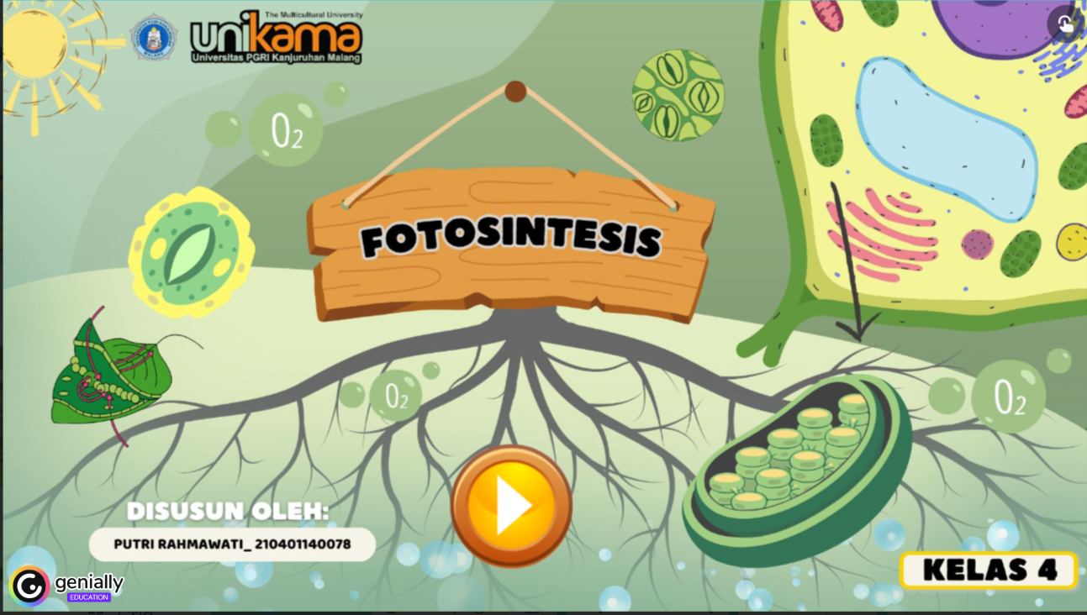
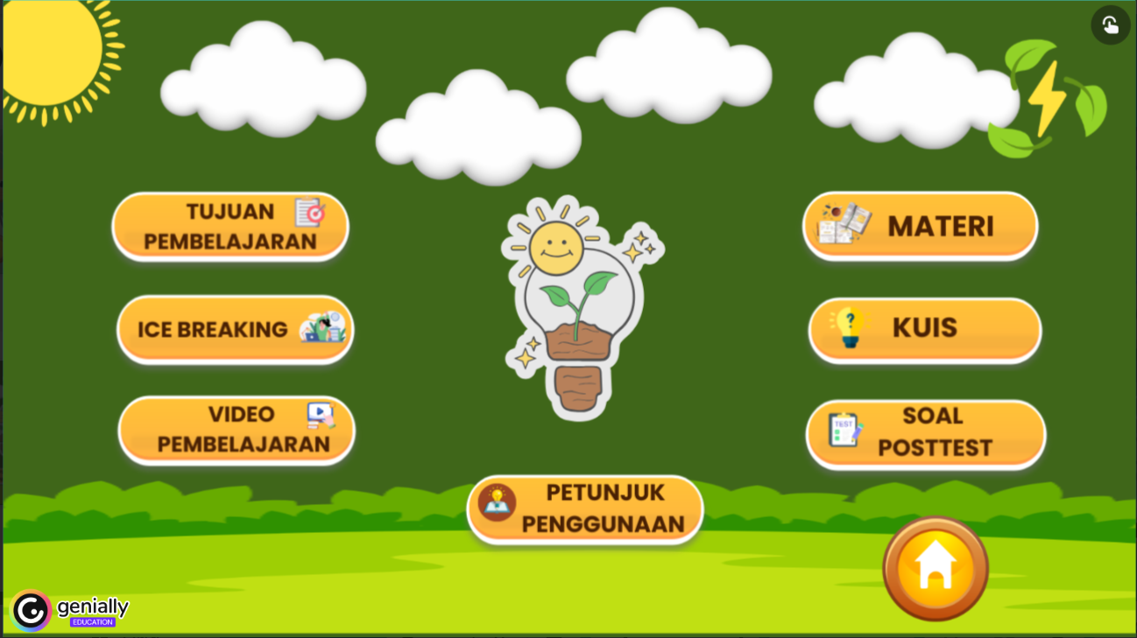
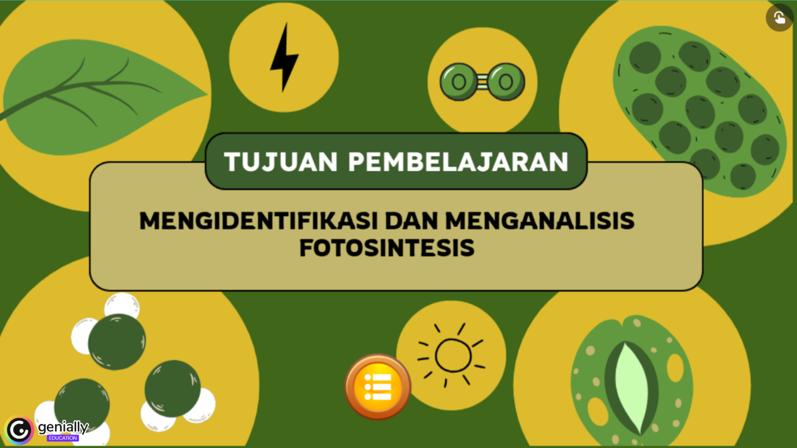
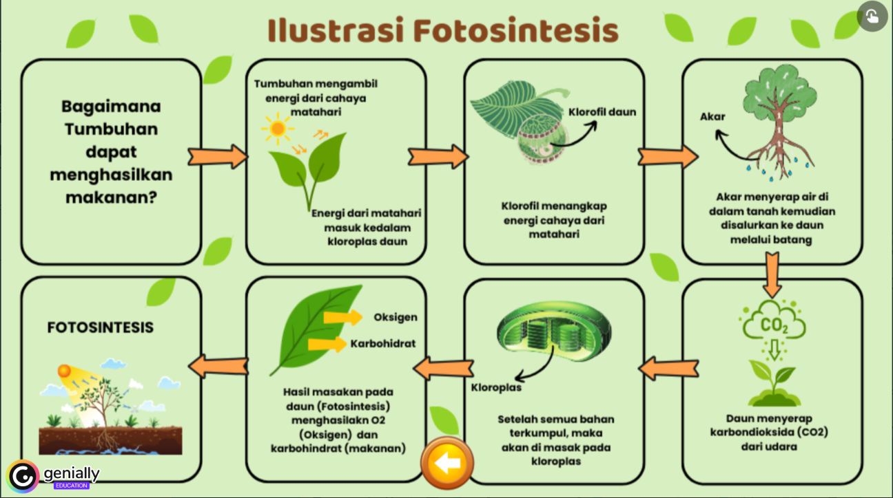
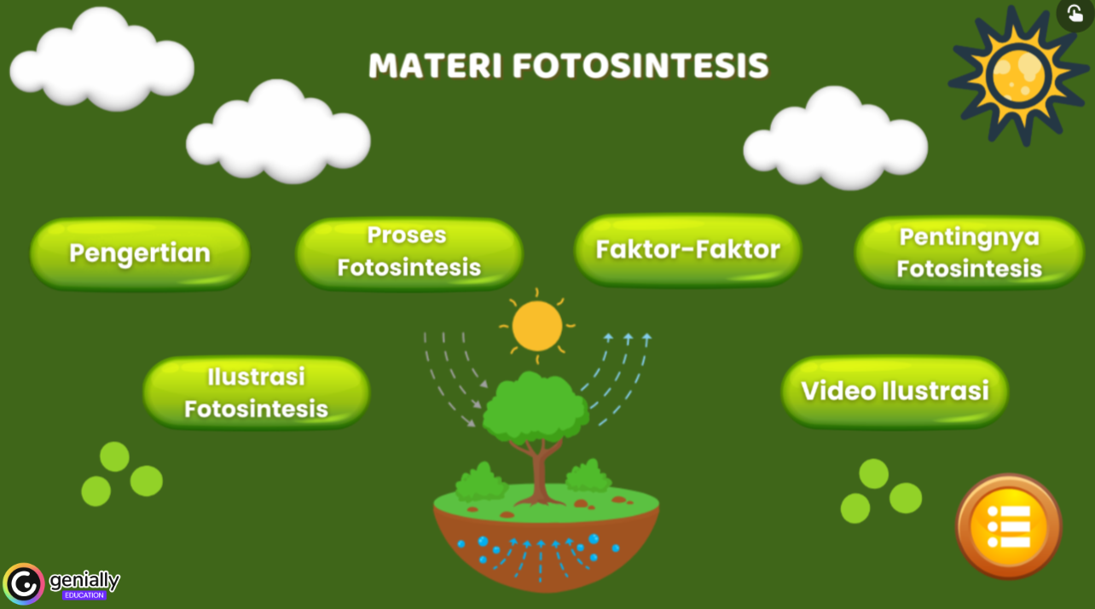

Picture 2. The design of learning media
Next, In the development phase, the learning media underwent validation by subject matter experts, media experts, and language experts. The validation results were 82.14% from subject matter experts, 96.42% from media experts, and 87.00% from language experts, all falling under the "Very Valid" category. The average validation score across all three expert evaluations was 88.52%, indicating that the media is considered highly valid for use in the learning process.
After completing the development stage, the process proceeded to the implementation stage. The implementation stage was carried out through a limited trial with 5 students and a wide trial with 22 students. The results of the media's practicality tested by students in the limited trial were 86.1%, categorized as "Very Practical," and in the extensive trial, 71.8%, categorized as "Practical." Meanwhile, the practicality of the media provided to teachers received a score of 96.42% with the category "Very Practical."
The subsequent stage is the evaluation phase, which aims to assess the effectiveness of the learning media. To determine the appropriateness of applying the T-Test, prerequisite tests for normality and homogeneity were conducted. However, the posttest data did not meet the normality requirement, so the t-test could not be used. The researcher then used the non-parametric Wilcoxon Signed Rank Test, which showed significant results (p= 0.000 < 0.05), indicating a significant difference between the pretest and posttest scores, with a significance of 0.000, meaning the value is less than 0.05. Therefore, learning media developed using Genially is effective in enhancing students' problem-solving abilities.

DISCUSSION
This research develops Genially-based learning media using the Research and Development (R&D) method to produce and test the effectiveness of the product so that it can be beneficial for the community (Ambarwati, 2023), with the ADDIE model, namely analysis, design, development, implementation, and evaluation. In the initial stage, observations were conducted at SDN Sukun 3 in the fourth grade. It was found that the teacher still uses traditional teaching media and relies on worksheets, making the learning process monotonous and causing students to quickly feel bored. Moreover, there is an issue in the IPAS subject on the topic of photosynthesis, where students are still unable to solve a problem regarding deforestation and its impact on the photosynthesis process. Problem-solving skills themselves are the students' abilities to identify, analyze, and find solutions to a problem effectively, which are used to help students think independently. With the occurrence of that event, the researcher developed a learning media that can be used by students through smartphones, namely Genially-based learning media. The use of this media helps achieve learning objectives optimally (Wahid, 2018).
The researchers used Genially because the development of Genially-based learning media can train students' problem-solving skills through its features, which include exercises tailored to problem-solving skill indicators, as well as quizzes or games, and learning materials that contain the definition of photosynthesis, influencing factors, illustrative videos of photosynthesis, the importance of photosynthesis, and the process of photosynthesis. The indicators of problem-solving skills are defining the problem, examining the problem, planning a solution, executing the plan that has been made, and evaluating (Makiyah, 2021). According to (Nur Aprilia, 2024), Genially is used to support the learning process because it has interesting features. So that the learning process is not boring with materials that only use text and images. This media is different from PowerPoint because Genially provides various more interesting features, such as themed templates (Ni’mah, 2022).
The development of this media involves the Canva application in assisting the creation of learning materials and icons present in the learning media display. (Made, 2025) argues that Genially has great potential to enhance efficiency and appeal in learning because the capabilities of the Genially platform provide an interactive and engaging learning experience. The initial appearance of this learning media contains the identity of the media as an introductory description regarding the learning media on the topic of "photosynthesis." In the material section, it contains the definition of photosynthesis, the factors that influence it, a video illustration of photosynthesis, the importance of photosynthesis, and the process of photosynthesis. After development, validation tests will be conducted by several experts, namely material expert Mrs. H. D, media expert Mr. A.G, and language expert Mr. D. A. This procedure is carried out to evaluate the validity of the developed learning media.
The outcomes of the validation conducted by subject matter experts obtained 82.14% with the category "Very Valid," media experts 96.42% with the category "Very Valid," and language experts 87.00% with the category "Very Valid," so the average obtained from the validity results of the learning media by material, media, and language experts was 88.52% with the category "Very Valid." aligned after the revisions made by the experts in content, media, and language. Before being tested on students, improvements are necessary.
After the media improvements, it will be implemented and tested on a limited basis with 5 students, who will then be given a questionnaire. The first stage conducted was a pretest for all fourth-grade students at SDN Sukun 3, which aims to measure students' problem-solving abilities before the implementation of Genially. The next step taken is for the students to use smartphones or cell phones to access the provided link. Then students can access Genially with various features that have been prepared, such as materials, learning videos, quizzes, and questions. One of the unique features of Genially is that it creates a more engaging and interactive learning atmosphere with a fresh ambiance in the learning process (Rinjani, 2024). The next step after students can view the material on photosynthesis is for them to take a quiz or game using Gimkit. Next, students will work on questions or a post-test to measure their problem-solving skills. Prcentage from the limited trial is 86.1% with the category "Very Practical," and the results of the overall trial obtained a percentage of 71.8% with the category "Practical." In addition, the practicality questionnaire was given to teachers and received a percentage of 96.42% with the category "Very Practical." Previous studies have also indicated that Genially-based learning media is well-suited for use in the instructional process. (Yolanda, 2023).
Next, at the evaluation stage, to determine and measure the effectiveness of using Genially-based learning media. Genially offers various interesting and interactive features. This research is relevant to previous studies that Genially is capable of increasing student interest in engaging with the material and can reduce boredom (Fadhil, 2025). In line with the opinion of (Shalimar, 2024b) that Genially is very good and can be used effectively in learning. In the study, there is significance in developing learning media using Genially based on problem-solving. The development of this media involves the use of pretests and posttests to measure the effectiveness of the media after treatment, using the N-Gain Score formula. The analysis results show that the average pretest score was 43.7%, while the posttest score increased to 84.1%. The N-Gain calculation resulted in a score of 0.7, which falls into the "medium" category, with an effectiveness percentage of 71.2% categorized as "Effective." After conducting the media effectiveness test, a test was subsequently carried out to determine the significant difference between the pretest and posttest scores. Because the data did not meet the normality assumption, the non-parametric Wilcoxon Signed Ranks test was used as an alternative to the parametric test.
The results of the Wilcoxon Signed Ranks Test show Negative Ranks (0 students), indicating that no students experienced a decrease in posttest scores compared to pretest scores. Positive Ranks (27 students) means that all students (27 students) experienced an increase in posttest scores compared to pretest scores, with an average rank increase of 14.00 and a total rank of 378.00. Ties (0 students) indicate that no students had posttest scores that were the same as their pretest scores. In the Test Statistics table, a Z Value of -4.563 was obtained, indicating a significant difference between the pretest and posttest. The Asymp. Sig. (2-tailed) value = 0.000, which is less than 0.05. The conclusion from the Wilcoxon test, because the significance value ha < 0.05, there is a difference between the pretest and posttest scores. Thus, the use of Genially to train students' problem-solving skills has a positive impact on students. This is relevant to previous research that the Genially media in the 4th-grade elementary school IPAS subject is strategically used in problem-based learning (Al Anbiya, 2024). Genially can train problem-solving skills because the Genially media includes several features such as exercises tailored to problem-solving indicators, quizzes or games, materials, and learning videos that can be accessed by teachers and students. This is relevant to the research by (Shalimar, 2024b) that Genially is very good and can be used effectively in learning, and showing the positive impact generated from the use of Genially-based learning media.

CONCLUSION & RECOMENDATION
Research on the development of Genially-based learning media on photosynthesis material for fourth-grade students shows that this media is very effective in the learning process. Validation by subject matter, media, and language experts each received scores of 82.14%, 96.42%, and 87.00%, respectively, with an overall average of 88.52%. Student response to the use of media reached 71.8%, while teachers rated it at 96.42%, indicating a high level of practicality. The effectiveness of the media is also evident from the N-Gain Score of 0.7 (medium category) with an effectiveness of 71.2%. The Wilcoxon test produced a significance value of 0.000 (< 0.05), indicating a significant difference between the pretest and posttest scores. Thus, Genially has proven effective in improving the learning outcomes of elementary school students. For the recommendations from this research for the school authorities, particularly at SDN Sukun 3 Malang, it is recommended to conduct training for teachers in the use of interactive learning media, so that teachers can optimize the use of technological devices and provide adequate facilities such as digital devices and stable internet access. For future researchers, it is recommended to test the effectiveness of Genially-based learning media in other subjects or to combine it with other innovative learning strategies to enhance the learning process more broadly

Acknowledgment
The author expresses the deepest gratitude to all parties who have provided support, both directly and indirectly, in the process of writing this article. Special thanks are extended to Mrs. Dr. Arnelia Dwi Yasa, M.Pd, and Mrs. Farida Nur Kumala, M.Pd., M.Si, as supervising lecturers for their invaluable guidance and direction. Special thanks also to SDN Sukun 3 Kota Malang for providing the opportunity to conduct research at the institution. And to my parents who have given support and affection. I hope this article can provide benefits and make a positive contribution to the field of education.

References
- Al Anbiya, H. (2024). Prosiding Konferensi Ilmiah Dasar Penerapan Model Pembelajaran Problem Based Learning (Pbl) Berbantuan Media Genially Pada Pembelajaran Ipas Kelas Iv Sdn 01 Jiwan. Http://Prosiding.Unipma.Ac.Id/Index.Php/Kid
- Ambarwati, H. A., Kumala, F. N., & Chrisyarani, D. D. (2023). Pengembangan Media Pembelajaran Daring Berbasis “Mock-Up Ku” Pada Materi Ekosistem Kelas V Sekolah Dasar. Kognisi : Jurnal Penelitian Pendidikan Sekolah Dasar, 3(2), 37–43. Https://Doi.Org/10.56393/Kognisi.V2i2.950
- Barkah, L., Puspita Rini, C., & Amaliyah, A. (2022). Analisis Pemahaman Konsep Ipa Siswa Kelas Iv Sdn Kalideres 09 Pagi. Berajah Journal, 2(2), 287–292. Https://Doi.Org/10.47353/Bj.V2i2.91
- Enstein, J., Citra, U., Vera, B., Bulu, R., Roswita, B., & Nahak, L. (2022). Pengembangan Media Pembelajaran Game Edukasi Bilangan Pangkat Dan Akar Menggunakan Genially. Jurnal Jendela Pendidikan, 02.
- Fadhil, A. A. Al, & Novio, R. (2025). Penerapan Media Pembelajaran Berbasis Genially Untuk Meningkatkan Hasil Belajar Geografi Bagi Siswa Kelas Xi Di Sma Swasta Cendana Mandau. Indo-Mathedu Intellectuals Journal, 6(1), 1002–1011. Https://Doi.Org/10.54373/Imeij.V6i1.2616
- Fatma, N., & Ichsan. (2022). Penerapan Media Pembelajaran Genially Untuk Meningkatkan Hasil Belajar Ipa Di Sd Muhammadiyah. Genderang Asa: Journal Of Primary Education, 3(2), 50–59. Https://Doi.Org/10.47766/Ga.V3i2.955
- Gulo, S., & Harefa, A. O. (2022). Pengembangan Media Pembelajaran Interaktif Berbasis Powerpoint. Educativo: Jurnal Pendidikan, 1(1), 291–299. Https://Doi.Org/10.56248/Educativo.V1i1.40
- Hidayat Smp Negeri, F., Jl Cihanjuang No, P., Rahayu, C., Parongpong, K., Bandung Barat, K., Nizar Sman, M., Jl Ir Juanda Jl Dago Pojok, B. H., Coblong, K., Bandung, K., & Barat, J. (2021). Model Addie (Analysis, Design, Development, Implementation And Evaluation) Dalam Pembelajaran Pendidikan Agama Islam Addie (Analysis, Design, Development, Implementation And Evaluation) Model In Islamic Education Learning.
- Kh, P. R. W., & Satianingsih, R (2024) Pentingnya Media Pembelajaran Untuk Meningkatkan Minat Belajar Siswa Sd.
- Made, N., Widiya Paramita, N., Lasmawan, W., & Kertih, W. (2025). Pengembangan Media Pembelajaran Interaktif Berbasis Web Dengan Genially Materi Karakteristik Geografi Indonesia Kelas V Sekolah Dasar. Http://Jiip.Stkipyapisdompu.Ac.Id
- Makiyah, Y. S., Mahmudah, I. R., Sulistyaningsih, D., & Susanti, E. (2021). Hubungan Keterampilan Komunikasi Abad 21 Dan Keterampilan Pemecahan Masalah Mahasiswa Pendidikan Fisika. Journal Of Teaching And Learning Physics, 6(1), 1–10. Https://Doi.Org/10.15575/Jotalp.V6i1.9412
- Ni’mah, N. K., & Hermiati, D. T. (2022). Upaya Meningkatkan Minat Belajar Siswa Melalui Media Genially Dalam Pembelajaran Daring Bahasa Indonesia Pada Siswa Kelas X Sma Negeri 5 Malang. Journal Metamorfosa, 10(1), 1–10. Https://Ejournal.Bbg.Ac.Id/Metamorfosa
- Nur Aprilia, I., Siti Sundari, F., & Wijaya, A. (2024). Kalam Cendekia: Jurnal Ilmiah Kependidikan Pengembangan Media Pembelajaran Interaktif Berbasis Genially Pada Mata Pelajaran Ipas Kelas V Di Sekolah Dasar Negeri Tajur 1 Bogor.
- P., Rachma, P., Kh, W., & Satianingsih, R. (2024). Pengaruh Model Pembelajaran Problem Based Learning Berbantu Aplikasi Genially Terhadap Kemampuan Berpikir Kritis. In Jurnal Pengembangan Pendidikan (Vol. 8, Issue 6).
- Prasetyo, D. A., & Nugraheni, N. (2024). Pengembangan Media Pembelajaran Matematika Berbasis Video Animasi Pada Pokok Bahasan Luas Dan Keliling Bangun Datar Berbantuan Software Synfig Di Sdn Denanyar 3. Jagomipa: Jurnal Pendidikan Matematika Dan Ipa, 4(1), 127–135. Https://Doi.Org/10.53299/Jagomipa.V4i1.461
- Purbosari, P. M. (2016). Pembelajaran Berbasis Proyek Membuat Ensiklopedia Ilmu Pengetahuan Alam (Ipa) Untuk Meningkatkan Academic Skill Pada Mahasiswa.
- Rosmiati, M., & Sitasi, C. (2019). Animasi Interaktif Sebagai Media Pembelajaran Bahasa Inggris Menggunakan Metode Addie. 21(2), 261–268. Https://Doi.Org/10.31294/P.V20i2
- Shalimar, A. K., & Rukmana, D. (2024a). Pengembangan Media Pembelajaran Berbasis Problem Solving Menggunakan Aplikasi Genially Pada Materi Bangun Datar Kelas V. Jurnal Pemikiran Dan Pengembangan Sekolah Dasar, 12(2), 272–290. Https://Doi.Org/10.22219/Jp2sd.V12i2.34632
- Shalimar, A. K., & Rukmana, D. (2024b). Pengembangan Media Pembelajaran Berbasis Problem Solving Menggunakan Aplikasi Genially Pada Materi Bangun Datar Kelas V. Jurnal Pemikiran Dan Pengembangan Sekolah Dasar, 12(2), 272–290. Https://Doi.Org/10.22219/Jp2sd.V12i2.34632
- Siti Rinjani. (2024). Implementasi Media Genially Dalam Pembelajaran Bahasa Indonesia Bagi Mahasiswa Pbsi Uin Jakarta. Diajar: Jurnal Pendidikan Dan Pembelajaran, 3(1), 57–64. Https://Doi.Org/10.54259/Diajar.V3i1.2345
- Sri Sumartini, T. (2016). Peningkatan Kemampuan Pemecahan Masalah Matematis Siswa Melalui Pembelajaran Berbasis Masalah (Vol. 5, Issue 2). Http://E-Mosharafa.Org/
- Sukmasari, V. P., & Rosana, D. (2017). Pengembangan Penilaian Proyek Pembelajaran Ipa Berbasis Discovery Learning Untuk Mengukur Keterampilan Pemecahan Masalah. Jurnal Inovasi Pendidikan Ipa, 3(1), 101. Https://Doi.Org/10.21831/Jipi.V3i1.10468
- Supriyono, S (2018). Pentingnya Media Pembelajaran Untuk Meningkatkan Minat Belajar Siswa Sd.
- Syahid, I. M., Annisa Istiqomah, N., & Azwary, K. (2024). Model Addie Dan Assure Dalam Pengembangan Media Pembelajaran. Journal Of International Multidisciplinary Research. Https://Journal.Banjaresepacific.Com/Index.Php/Jimr
- Toyibatul, S., 1, H., Hidayat, R., & Mirawati, M. (2024). Pengembangan Media Pembelajaran Interaktif Menggunakan Platform Genially Pada Pembelajaran Ipa Materi Siklus Air. Innovative: Journal Of Social Science Research, 4, 14440–14451.
- Wahid, A., Keguruan, S. T., Pendidikan, I., & Pinrang, D. (2018). Volume V Nomor 2 Maret 2018 Istiqra’ Pentingnya Media Pembelajaran Dalam Meningkatkanprestasi Belajar (The Importance Of Learning Media In Inproving Student Learning Achievements).
- Yolanda, A., Sri Indriani, R., & Fkip Universitas Pakuan, P. (2023). Pengembangan Media Pembelajaran Interaktif Menggunakan Genially Pada Materi Norma Dalam Adat Istiadat Daerahku.
- Yuhani, A., Sylviana Zanthy, L., Hendriana, H., Siliwangi Bandung, I., Terusan Jenderal Sudirman, J., & Barat, J. (2018). Pengaruh Pembelajaran Berbasis Masalah Terhadap Kemampuan Pemecahan Masalah Matematis Siswa Smp. Jurnal Pembelajaran Matematika Inovatif, 1(3). Https://Doi.Org/10.22460/Jpmi.V1i3.445-452
- Zulhelmi, Adlim, & Mahidin. (2017). Pengaruh Media Pembelajaran Interaktif Terhadap Peningkatkan Keterampilan Berpikir Kritis Siswa. In Jurnal Pendidikan Sains Indonesia (Vol. 05, Issue 01). Http://Jurnal.Unsyiah.Ac.Id/Jpsi

