Analysis of the Implementation of Angklung Music as an Effort to Preserve Traditional Music at YBPK Wonorejo Elementary School
Subtitle as needed (paper subtitle)

Kukuh Prayoga Wasono
Department of Primary School Teacher Education,
Universitas PGRI Kanjuruhan Malang,
Indonesia
kukuh.gkjw@gmail.com
Cicilia Ika Rahayu Nita
Department of Primary School Teacher Education,
Universitas PGRI Kanjuruhan Malang,
Indonesia

Abstract— Traditional music at SD YBPK Wonorejo is still being preserved through various activities, one of which is by making angklung an extracurricular activity of interest to students. Angklung is one of Indonesia's traditional musical instruments that has high cultural value and needs to be preserved. This study aims to analyze the application of angklung music as an effort to preserve traditional music at SD YBPK Wonorejo. The research method used in this study is descriptive qualitative, with data collection techniques through observation, interviews, and documentation. This research refers to the data analysis model according to Miles & Huberman, which consists of several stages, namely: Data collection, data reduction, data display, and conclusions. To ensure the validity of the data, this study used technical triangulation and source triangulation. The results showed that the application of angklung music at YBPK Wonorejo Elementary School was carried out through extracurricular activities. After angklung music was implemented, there were positive changes in students, where they became more responsible in maintaining and playing musical instruments, as well as more disciplined in participating in training and working together in groups. Supporting factors in the implementation of this program include support from the school, students' enthusiasm, and the availability of angklung instruments. There are obstacles in implementation such as limited musical instruments, lack of teaching staff which causes time inefficiency. The implementation of angklung music at YBPK Wonorejo Elementary School has gone well and has made a positive contribution to efforts to preserve traditional music. One concrete form of this effort is making angklung an extracurricular activity, students are also given the opportunity to appear at various events, such as church performances, school celebrations, and take part in various competitions. This program not only increases student responsibility and discipline, but also fosters a sense of love and pride in Indonesia's traditional musical heritage.
Keywords— Angklung, traditional music, preservation of traditional music

Introduction
Learning is an effort made deliberately by educators to convey knowledge, organize and create environmental systems with various methods so that students can carry out learning activities effectively and efficiently and with optimal results (Festiawan, 2020:11). According to (Ubabuddin, 2019:18) learning is a process of interaction between students and educators and learning resources in a learning environment. Burton defines learning as a change in individual behavior through interactions between individuals and between individuals and their environment that allow them to interact with their environment. The meaning of learning in Barton's opinion is different from the previous three opinions. According to Barton, the key word is interaction. This interaction has meaning as a process. Someone who is consciously involved in an activity to achieve a certain change goal is said to be a learner (Learning, 2024:466-476). Learning with learning is closely related where in the learning process there is a learning experienced by each individual.
Learning in elementary schools is very diverse, one of which is art learning. Art is one of the subjects studied at the elementary school level which is known as the subject of Arts and Crafts. In the independent curriculum, Arts and Crafts learning is taught separately from the subjects (Aida., 2024: 521-536). Art is a broad creative expression and includes various branches that complement each other. In art learning, there are several components, namely music, dance, fine arts, theater and drama. One of the most important branches of art is music. Music is a form of expression that uses sound and rhythm to convey emotions, ideas and messages.
Music art is a learning that can creatively express, develop skills and creativity of students in the field of music art (Irawana, 2019:212-225). Music is a comprehensive need for humans. Music is also part of the art that gives color to every human life, music has become one of the favorite things among generations of children, adults, even the elderly, because with music someone can feel happy, excited and comfortable. Music art covers various genres and styles, from classical, traditional to contemporary pop music. Music also has various functions, from entertainment, education, to cultural preservation. Music is often used in ceremonies and rituals, or to convey the cultural identity of a society. Various types of music that develop in society and the areas around us, one of which is traditional music.
Traditional music is one of the musical arts that is passed down from generation to generation in a particular group. Traditional music is composed or created based on the style, tradition, or language that suits a region. According to (Murcahyanto, 2022:207-216), traditional music is music that has developed from generation to generation in a region and still survives today, which is rooted in the traditions of a particular community. One of the traditional musical instruments that is famous as a cultural heritage and is still found in society is the angklung.
Angklung is a musical instrument made of bamboo. It is said that angklung has existed in Sundanese land since the time of the Sundanese kingdom. Angklung is one example of traditional Indonesian musical art that is able to keep up with the times and is even recognized in various countries as a classy musical instrument with high artistic value. In 2010, UNESCO designated angklung as a Masterpiece of the Oral and Intangible Heritage of Humanity belonging to the Indonesian Nation (Kusumawardani, 2020:116-120). The implementation of angklung music in elementary schools is a strategic step in efforts to preserve traditional music in elementary schools. Children of elementary school age have the ability to absorb knowledge well, so learning angklung in schools can be an effective way to instill a love for the instrument traditional music. Several studies have shown that angklung lessons not only help preserve culture and love for traditional music but also increase responsibility, cooperation, and discipline among students (Julia, 2019:75-87).

Angklung can train students to be able to work together, be disciplined and creative. Playing angklung music is a means for students to foster responsibility and discipline. The form of responsibility in angklung music is cooperation. Cooperation in angklung is needed because each player holds one or more angklungs with different tones. Cooperation is very much needed in order to create harmony and melody that is comfortable to listen to. This was also expressed by (Haifa, 2023) that learning music arts is an activity in elementary schools that can foster cooperation in students. Angklung music art is not only a medium for developing responsibility, but angklung also requires discipline such as arriving on time when learning angklung, being responsible, and obeying the rules while playing angklung.
Previous researchers (Herdianti, 2021:51-61) revealed that by learning angklung, a sense of love for the homeland can be created in students, training discipline, togetherness and tolerance between friends. Learning angklung is not only the realm of knowledge that students get but also the affective and psychomotor domains. Learning angklung can train students to have responsibility, discipline, respect for each other, and love for the nation's culture. This was also expressed by (Fatmawati, 2021) that through learning the art of angklung music, students can develop character values, for example, discipline and responsibility.
Angklung music learning at SD YBPK Wonorejo has been going very well and has had a positive impact on preserving traditional music among students. However, there are still some obstacles faced in its implementation. The limited number of angklung musical instruments is one of the main challenges, because not all students can play the instrument at the same time. In addition, the lack of teachers who have expertise in teaching angklung makes learning time sometimes less efficient. On the other hand, some students start to feel bored because they feel they have mastered the basic techniques of playing angklung and want to try other extracurricular activities. Therefore, further efforts are needed, such as adding musical instruments, training for teachers, and innovation in learning methods so that this program can continue to run optimally and remain interesting for students. Based on the results of the observation, the researcher is interested in conducting a study entitled "Analysis of the Implementation of Angklung Music as an Effort to Preserve Traditional Music at SD YBPK Wonorejo." This study aims to analyze how the process of implementing angklung music in schools, supporting factors and obstacles faced, and its impact on students in increasing appreciation for traditional music. Through this research, it is hoped that solutions can be found to optimize angklung music learning so that it can continue to develop as part of efforts to preserve traditional music in elementary schools.

Methodology
The research uses a qualitative descriptive research design. Descriptive research is a study that provides an in-depth description of something or a phenomenon with data in the form of information or data in the form of words. Qualitative research methods are Qualitative research is research that aims to understand human or social phenomena by creating a comprehensive and complex picture that can be expressed in words, reporting detailed views from informants, and carried out in a natural setting (Fadli, 2021:35). This research was conducted at SD YBPK Wonorejo which is located in Wonorejo Village, Bantur District, Malang Regency. This study uses data collection techniques including interviews, observation, and documentation.
Observation
The observations made by the researcher were to observe the environmental conditions of YBPK Wonorejo Elementary School, in addition to observing the angklung music learning process activities, observing angklung music learning activities and seeing the availability of angklung at the school.
Interview
Interviews used by researchers to find out more information related to the implementation of angklung music in elementary schools as an effort to preserve traditional music at SD YBPK Wonorejo. This interview will be conducted with the principal, music teachers, and students in grades 4, 5 and 6.
The process in this study uses an analysis model according to Miles & Huberman, namely through several stages of Data Collection, Data Reduction, Data Display, and Conclusions.

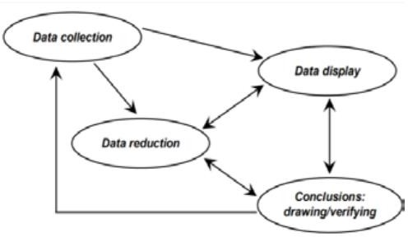
Figure 1 Data analysis techniques according to Miles & Huberman (Fadli, 2021)

Data Collection
Researchers collect data directly from the field without any limitations on the focus of the research, making it possible to obtain broader and deeper information. Data collection is carried out through various methods, such as observation, where researchers directly observe the process of learning angklung music; interviews, which aim to obtain information from teachers, students, and schools regarding the implementation of angklung music; and documentation, which is used for supporting evidence, such as photos, videos, and notes related to angklung learning. Through this combination of methods, the data obtained becomes more accurate in supporting the research.

Data Reduction
Qualitative data analysis techniques are carried out to simplify data, and sort out data that has been collected from the field. Data reduction is carried out by summarizing, selecting the main points and focusing on the important things ( Nuralan, 2022:16).Researchers conducted data reduction such as participation in angklung music activities, angklung music learning hours, student enthusiasm in learning angklung music, and love for traditional music after learning angklung.

Display Data
After the data is reduced, the next step is to display the data or present the data. In qualitative research, data presentation can be in the form of descriptions, charts, tables, graphs and the like. With the aim of making it easier to understand what is happening clearly in the research (Nuralan, 2022:16).

Conclusions
Conclusions or drawing conclusions and verification is a summary of the main findings obtained from descriptive data analysis. This conclusion not only answers the research question, but also provides something new about the phenomenon being studied. (Fadli, 2021)
This study uses triangulation which is used to check the validity of the data, namely; data source triangulation and technique triangulation (Sugiyono, 2019):
1. Data Source Triangulation
At this stage, it is done to test the credibility of the data by checking the dataobtained from various sources, namely; Principal, Teachers, Students. The aim is to test the validity of the data on the implementation of angklung music in elementary schools. Then the data is analyzed by the researcher to produce a conclusion.

2. Triangulation Technique
Triangulation Technique is done by comparing information in different ways. In qualitative research, researchers use interview and observation methods. To find out the complete truth of information about certain information, researchers can use interview, observation, or observation methods to verify its truth. This triangulation step is carried out when the authenticity of the information provided by the subject is questionable.

Results
Implementation of Angklung Music in Elementary Schools
This research was conducted by collecting data directly at schools. with the aim of obtaining real and actual research findings. SD YBPK Wonorejo became the location of the research with the basis of a school that has implemented angklung music learning for students. In this study, information was obtained directly through observation, interviews, and documentation to the school, which includes the application of angklung music in elementary schools. Based on the results of observations and interviews on January 23-25, 2025, it was found that the school has 3 sets of angklung musical instruments, including 2 large sets and 1 small set. Each set of angklung consists of 7 notes do, re, mi, fa, so, la, si, do and each child holds their own note section. The application of angklung music is carried out through extracurricular activities. Initially, angklung music in schools was only carried out for performances at certain events, but after several years many wanted to learn and participate in performing at events at school and in the village. Thus, the school made angklung music an extracurricular activity at school. This activity involves students from high grades, namely grades 4, 5, and 6, with the guidance of music teachers. Students are taught basic techniques for playing the angklung, starting from recognizing notes to playing songs harmoniously in groups.
The implementation of this program has supporting factors including support from the school, student enthusiasm, and the availability of angklung musical instruments. During angklung music learning, students seemed happy and enthusiastic in participating in the activities. They actively participated, starting from recognizing the notes to playing songs together. The joy was seen when they worked together to produce beautiful harmonies and notes. The application of angklung music at SD YBPK Wonorejo, after being observed, it was found that students not only obtained cultural values but also showed a sense of responsibility such as good cooperation in playing angklung music, following exercises or activities well and being able to maintain and care for angklung musical instruments. The next character is discipline. Such as being on time during practice, playing angklung according to the beat and rhythm and responsibility with the part of the angklung he is holding.
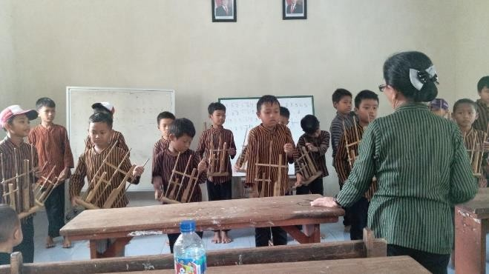
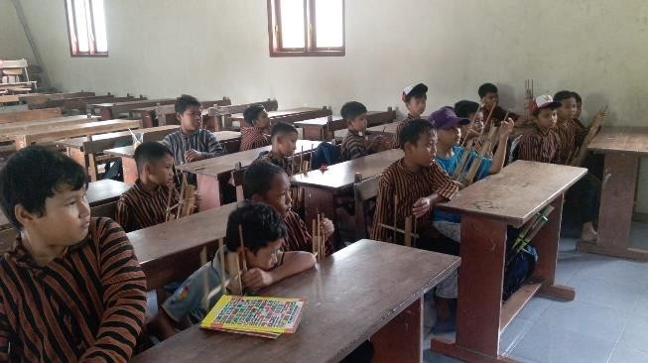
Figure 1.The process of learning angklung music

Angklung music learning at SD YBPK Wonorejo is carried out every Thursday after class learning activities end. This activity is part of the school's extracurricular program which aims to introduce and preserve traditional music culture in Indonesia to students. Each angklung music practice session has a maximum duration of 2 hours. This time is considered sufficient to provide an opportunity for students to practice and understand the basic techniques in playing the angklung. This learning process takes place in a pleasant atmosphere and full of enthusiasm, because the unique shape and sound of the angklung are able to attract students'interest.
In practice, students need about a month to be able to play angklung music well. During this period, teachers guide students in learning basic techniques such as how to hold, shake, and understand the tones produced by this musical instrument. After mastering the basics, students begin to be taught to accompany several simple songs such a Gundhul-Gundhul Pacul, Ibu Kita Kartinii, and other easy songs. The difference in the ability to play angklung between students in grades 4, 5, and 6 is quite visible. Students in grades 5 and 6 are generally more disciplined, quick to understand instructions, and more compact in playing songs. On the other hand, students in grade 4 sometimes still experience confusion when following the rhythm of the song and need more time to understand the instructions given. This is natural considering their level of cognitive development and experience which is still lower than their seniors. Along with regular practice and guidance from teachers, students are gradually able to play the angklung more confidently and harmoniously. It is hoped that through this angklung music learning activity, students will not only gain musical skills, but also foster a love for traditional Indonesian music.
Barriers to Implementing Angklung Music in Elementary Schools
For teachers, teaching elementary school students to play the angklung is a challenge in itself, because their job is to introduce students to notes, and not all students can understand them easily.

Barriers for Teachers
Limited teaching time and the tight schedule of teaching other subjects make it difficult for teachers to allocate enough time to guide students in playing the angklung. Teaching techniques and how to play the angklung also takes a long time. This is because the love and interest in angklung and traditional music are still less popular with students. Then there are several other obstacles, one of which is the learning process which is less effective due to limited teaching staff, so that the guidance given to students is not optimal. In addition, the limited number of angklungs is also an obstacle, because not all students can practice simultaneously. In addition, some students sometimes feel bored during practice, especially if they have mastered the material, this makes them want to switch to other extracurricular activities. Therefore, teachers need more interesting and innovative strategies so that angklung learning remains effective, fun, and can increase student interest.

Barriers for Students
There are also several obstacles in learning angklung music for students, such as the limited number of angklungs that require students to take turns during practice, making learning time less effective. Some students also have difficulty recognizing notes and following rhythms harmoniously in group games, so they only play when their friends play too. Students sometimes get bored easily after understanding the basics of angklung and are sometimes less motivated to practice regularly because they already know the basic techniques. The next obstacle in coordinating playing angklung music is because playing angklung requires cooperation and togetherness, but some students have difficulty adjusting to the rhythm of group play due to lack of concentration and lack of understanding of each other's notes.

Preserving Traditional Music in Elementary Schools
The availability of adequate traditional musical instruments in schools, such as angklung, is an important factor in supporting learning. Through a sufficient number of angklung, students can more actively participate in practice and understand playing techniques better. Support from the principal and the school in preserving traditional music is very real, one of which is by making angklung a part of extracurricular activities, then other support in the form of time where the principal always accompanies during practice and during angklung music performances. With the angklung extracurricular, students have the opportunity to learn and play this musical instrument well, so that they can participate in preserving the nation's cultural heritage.
Efforts to preserve traditional music in schools are carried out through extracurricular learning, where students are given the opportunity to learn and practice playing traditional musical instruments. In addition, schools also provide motivation and appreciation so that students are more enthusiastic in developing musical skills. Students are encouraged to participate in various events, such as art performances, celebrations of big days, and cultural festivals. To support these activities, schools provide and maintain traditional musical instruments so that students can learn and practice well.
The school plans to further strengthen the preservation of traditional music by adding art teachers who can assist in extracurricular angklung learning. In addition, the school will also collaborate angklung music with other types of music, both traditional and modern, to make it more interesting for students. Not only that, the school also plans to increase the number of angklungs so that students in lower grades have the opportunity to try and learn to play this traditional Indonesian musical instrument. These steps are expected to make angklung music increasingly developed and preserved among the younger generation.

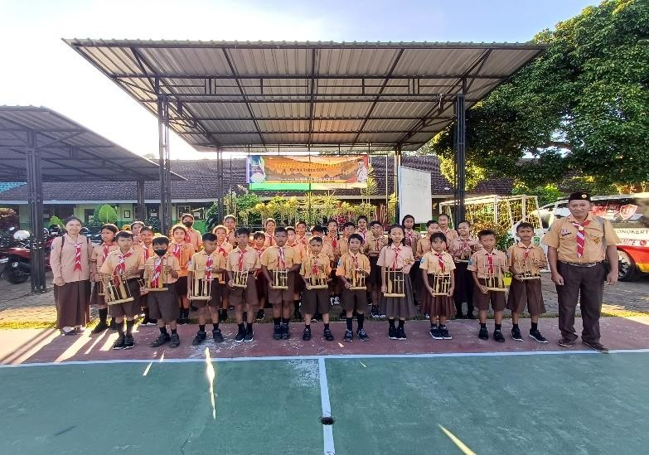
Figure 2. Children's appearance at the Teachers' Day celebration
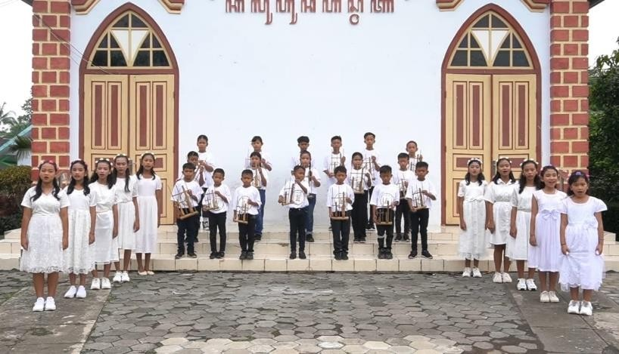
Figure 3. Children's appearance at a church event

Discussion

The implementation of angklung music at SD YBPK Wonorejo not only plays a role in preserving traditional culture, but also trains children to work together in groups. Through angklung playing, students learn to listen to each other, adjust the rhythm, and contribute to the harmony of music together. In addition, this learning also forms the character of students to be more responsible, disciplined in following directions, and increasingly creative in exploring music and performing arts.Learning the art of angklung music is a medium to develop creativity and foster cooperation for students. Angklung also requires discipline such as arriving on time when learning angklung, responsibility, and obeying the rules while playing angklung. Students can also improve discipline in playing angklung music such as being able to play the angklung according to the teacher's instructions, returning and caring for the angklung properly, being on time during practice and when there are activities. This is in line with what was expressed by (Fatmawati, 2021).
Learning angklung music at YBPK Elementary School is becoming increasingly well-known to the public. Through diligent and enthusiastic practice, the students managed to master this traditional musical instrument. As a result, they now often appear in various events, such as church celebrations, Teachers' Day, and senior graduation ceremonies. This achievement not only makes the school proud, but also helps preserve Indonesian culture among the younger generation. Various obstacles are also faced in implementing angklung music in schools such as Limited teaching time and the tight schedule of other subjects are challenges for teachers in allocating enough time to guide students in playing angklung. In addition, the limited number of teachers makes the learning process less effective, so that the guidance given to students is not optimal. Another obstacle is the limited number of angklung, so that not all students can practice together. Moreover, teaching the techniques and how to play the angklung also takes a long time, especially because students' interest in angklung and traditional music is still relatively low, this was also expressed by (Sriwijaya, 2020)
Efforts to preserve traditional music in schools are carried out through extracurricular learning, where students are given the opportunity to learn and practice playing traditional musical instruments. Seeing the enthusiasm of students and the support from the school, there is great hope that this angklung program will be an effort to preserve traditional music in elementary schools. This program will continue to grow and have a positive impact on preserving culture. In addition, the success of this program can also be a model for other schools in implementing similar methods to introduce and preserve traditional music. In addition, the school also provides motivation and appreciation so that students are more enthusiastic about developing musical skills. Students are encouraged to participate in various events, such as art performances, celebrations of big days, and cultural festivals. To support these activities, the school holds and maintains traditional musical instruments so that students can learn and practice well. Through these extracurricular activities, students not only learn about traditional musical instruments, but also deepen their understanding of diverse cultural values. This is in line with the goal of education to appreciate and care for regional cultural wealth as part of national identity, this is in line with (Jefrianus klau, 2023).

CONCLUSION AND SUGGESTIONS
The implementation of angklung music at SD YBPK Wonorejo has been running well and has made a positive contribution to efforts to preserve traditional music. Angklung learning is carried out through extracurricular activities, with support from the school and high student enthusiasm. This program not only improves students' musical skills, but also fosters a sense of love and pride in the heritage of traditional music in Indonesia. However, there are several obstacles in its implementation, such as the limited number of angklungs, which is also an obstacle, because not all students can practice together. In addition, some students sometimes feel bored during practice, especially if they have mastered the material, this makes them want to switch to other extracurricular activities. Nevertheless, efforts to preserve angklung music at this school are still running well and have a positive impact in introducing traditional music to the younger generation. Through angklung music learning, researchers provide suggestions to teachers to always guide and motivate students in playing angklung music, then angklung learning can be made more interesting by using various new methods. For further researchers, the implementation of angklung music in elementary schools can be an interesting research object. Researchers can collect data on its influence on the preservation of traditional music in elementary schools.

Acknowledgment
The author would like to express his deepest gratitude to all parties who have provided support and contributions in the implementation and writing of this article. Special thanks are given to the Principal of SD YBPK Wonorejo and the supervising teachers who have provided the opportunity and facilities for angklung music learning activities at school. The author also appreciates the enthusiasm of the students who have actively participated in the research process, so that the activities went well and provided satisfactory results. The author would also like to thank colleagues who helped in collecting data and compiling this article. The author would also like to express his sincere gratitude to the supervising lecturer who provided direction, input, and motivation during the process of compiling this article. His guidance played a very important role in the smoothness and completion of this article. Hopefully this article can provide benefits to readers and be an inspiration in preserving traditional Indonesian music culture in the school environment.

References

- Aida, SM, Gutama, A., Ika, C., & Nita, R. (2024). Analysis of the Implementation of Arts Learning Appearance in the Independent Curriculum in Grade II of Elementary School.Cendikia Journal of Education and Teaching,2(8), 521–536.
- Dinda, I. (2024).USE OF TRADITIONAL MUSICAL INSTRUMENT ANGKLUNG IN LEAENING. June.
- Fadli, MR (2021).Understanding qualitative research method design.21(1), 33–54. https://doi.org/10.21831/hum.v21i1.
- Fatmawati, E. (2021). School Policy in Character Education with Arts Activities Angklung Music at Al-Khairaat Integrated Islamic Elementary School.Spectrum of Education Policy Analysis,9 (1), 92–102. https://doi.org/10.21831/sakp.v9i1.17039
- Angklung Music at Al-Khairaat Integrated Islamic Elementary School.Spectrum of Education Policy Analysis,9(1), 92–102.
- Festiawan, R. (2020). Learning and learning approaches.General Soedirman University, 1–17.
- Haifa, HNS, Khaleda Nurmeta, I., & Hamdani Maula, L. (2023). Analysis of Cooperation Character Angklung Extracurricular for Elementary School Students.Pendas: Scientific Journal of Elementary Education, 8(1), 2877–2889. https://doi.org/10.23969/jp.v8i1.8106
- Herdianti, S., Respati, R., & Ganda, N. (2021). The Role of Regional Song-Based Teaching Materials
- in Angklung Learning in Elementary Schools.PEDADIDAKTIKA: Scientific Journal of Elementary School Teacher Education,8(1),51–61. https://doi.org/10.17509/pedadidaktika.v8i1.32736
- Irawana, TJ, & Desyandri, D. (2019). Musical Art and the Relationship between Use and Education Musical Art to Form the Character of Students in Elementary Schools.Educational: Journal of Educational Sciences,1(3), 222–232. https://doi.org/10.31004/edukatif.v1i3.47
- Julia, J., Iswara, PD, & Supriyadi, T. (2019). Redesigning and implementing traditional musical instruments in integrated technology classroom.International Journal of Emerging Technologies in Learning,14(10), 75–87. https://doi.org/10.3991/ijet.v14i10.10197 Klau, J.,
- Musik, P., & Klau, J. (2023).Drum.4(1), 10–19.
- Kusumawardani, S., & Aulia, NN (2020). Analysis of Angklung Musical Instrument Playing Skills In Elementary School Students.Edukatika Reflection: Scientific Journal of Education,11(1), 116–120. https://doi.org/10.24176/re.v11i1.4975
- Murcahyanto, H. (2022). Traditional Tokol Gamelan Music Arts Training for the Young Generation. ABSYARA: Journal of Community Service,3(2), 207–216. https://doi.org/10.29408/ab.v3i2.6775
- Nadiana, N. (2023).Analysis of the Use of Hand Sign Method in Angklung Learning in Elementary School Students.12(1), 82–92.
- Nuralan, S., Ummah, KM, & Haslinda. (2022). Analysis of Learning Styles of Achieving Students in Public Elementary School 5 Tolitoli.PENDEKAR JOURNAL: Educational Development AndElementary School Learning,1(1), 5. Learning, BD (2024).Basicedu Journal.8(1), 466–476.
- Education, I., & Hayati, W. (2021).Efforts to improve students' skills in playing instruments Angklung music through direct learning methods.8(1), 142–155. Prof. Dr. Sugiyono. (2019). Quantitative, Qualitative, and R&D Research Methods. ALPHABET, cv. Sriwijaya, U. (2020).THE ART OF MANAGING DATA: APPLICATION OF TECHNIQUE TRIANGULATION, SOURCES AND TIME IN SOCIAL EDUCATION RESEARCH.5(2), 146–150. Ubabuddin. (2019).
- The Nature of Learning and Learning in Elementary Schools. IAIS Sambas,1(1), 18–27.

ATTACHMENT
Observation Grid
Table 1. Observation Grid

Indicator | Sub- Indicators
- Application of music angklung in elementary school | - Introduction to angklung music in learning so far  - Adequate availability of angklung  - Students' enthusiasm in learning angklung music  - Integration of angklung learning with cultural and character values
- Implementation barriers Angklung music in elementary school | - Allocate special time to learn to play the angklung  - Teacher skills in teaching angklung music  - Students' interest in traditional music
- Preservation of music traditional in school base | - Availability of adequate traditional musical instruments in schools  - The principal's commitment to supporting the  preservation of traditional music.  - School policies that encourage the preservation of arts and culture through traditional music programs

Interview Grid
Indicator | Sub-Indicators | Instrumennt interview | Data Source
- Implementation music angklung in elementary school (Dinda, 2024) | - introduction angklung music in learning so far | - How angklung music introduced to students so far?  - What effort school in teach music angklung at school ? | Music Teacher  Music Teacher
 | - Availability the angklung adequate at school  - Enthusiasm students in learn music angklung | 1.2.1 How availability means and infrastructure for angklung music in school  1.3.1 How feeling student moment study play music angklung  1.3.2. How participation active student in play tool angklung music  1.3.3. Are you feeling happy when learning music angklung | Music Teacher  Music Teacher  Music Teacher  Class Student
 | - Integration learning angklung with cultural values and character | - How student discipline attitude in learning angklung music  - How work same students in play angklung music  - How ability student in understand and apply technique base playing the angklung  - How student understand history and value culture angklung as inheritance nation  - What wich you understand/know about music angklung | Music Teacher  Music Teacher  Music Teacher  Music Teacher  Students
- Obstacles implementation music angklung at school base (Nadiana, 2023) | - Time allocation spectifically for learn to play angklung  - Skills teacher in teach angklung music  - Interest students in music traditional | 2.1.1. How long process learning angklung music  2.2.1. How the role of teachers in teach music angklung to student ?  2.3.1. Are students show interest which quite big moment study play angklung? | Music Teacher  Teacher and Student  Music Teacher
- Preservation traditional music in elementary school (Hayati, 2021) | - Availability musical instrument tradtional that adequate in school  - Commitment headmaster in support music preservation traditional.  - Policy the school that push art preservation culture through music program traditional | 3.1.1. What are the types of music traditional which already taught or introduced in school ?  3.2.1. How head support conservation school traditional music ?  3.3.1. What planning school against preservation music traditional in school base in the future ? | Headmaster

