Implementation of Discussion Method in Developing Critical Thinking Skills in Science Learning for Grade 5
Implementasi Metode Diskusi Dalam Mengembangkan Kemampuan Berpikir Kritis Pada Pembelajaran IPAS Kelas 5

Poppy Putri Nahrowi Premaning Ayu
Department of Elementary School Teacher Education
PGRI Kanjuruhan University
Malang, Indonesia
poppyputri.dream@gmail.com
Prihatin Sulistyowati
Department of Elementary School Teacher Education
PGRI Kanjuruhan University
Malang, Indonesia
prihatinsulistyowati@unikama.ac.id

Ninik Indawati
Department of Elementary School Teacher Education
PGRI Kanjuruhan University
Malang, Indonesia
ninikberty@unikama.ac.id

Abstract— The discussion method is learning carried out in small groups involving interaction between two or more people. The discussion method can hone students' critical thinking skills so that students are able to face global challenges including political, social, economic and cultural issues. This critical thinking ability is measured using five critical thinking indicators according to Ennis. This research aims to analyze the implementation, impact and obstacles of the discussion method in developing students' critical thinking skills in learning science and science material Chapter 6 My Wealthy Indonesia in class 5. The research method used is a descriptive qualitative method. Data collection techniques are carried out using observation, tests, interviews and documentation. Based on the research results, the teacher implements the discussion method according to the steps of the discussion method which is carried out by dividing students into small groups. This method helps students develop critical thinking skills such as analyzing, arguing, solving problems, and drawing conclusions. The test results showed that 27 students had high critical thinking abilities and 1 student had moderate abilities. The discussion method has a positive impact in developing students' critical thinking skills in science learning. This method has proven effective in improving students' critical thinking skills. The research results show that the majority of students have very high critical thinking skills.
Keywords—Discussion method, critical thinking, science learning

Introduction
The discussion method is a learning approach carried out by a certain group to achieve learning objectives (Jannah, 2019). This method involves interaction between two or more people so that there is a process of exchanging information and understanding each other's points of view (Syafruddin, 2017). The discussion method is characterized by the presentation of a problem topic in the form of a question, statement, image, or example of a real situation, then discussed together to find the solution (Hartono & Irvandi, 2021). Students are trained to argue and defend their opinions by looking at problems more deeply (Elwin, 2023). Students have the opportunity to express opinions, reject opinions, and provide criticism or suggestions (Supriyati, 2020). This process makes students' understanding stronger and allows them to feel comfortable contributing or developing new ideas. This opinion is in line with the opinion of Rahmawati & Bariah (2024) who state that the discussion method is a meeting of minds, which means a meeting of thoughts. The discussion method helps students to focus more on exploration, experimentation, discovery, and problem-solving by participating in groups (Ika, 2019). This process makes the discussion method capable of strengthening and sharpening students’ critical thinking skills in an interactive and collaborative way.
Ability is the potential to master various skills, whether naturally present or acquired through regular practice, to achieve a specific goal (Harapit, 2018). Ability includes the aspect of critical thinking skills, which play an important role in everyday life (Sodik, 2023). Critical thinking is a higher-order thinking skill that helps students enhance their ability to analyze deeply (Susilawati et al., 2020). This is in line with Facione’s opinion that critical thinking is the ability to interpret, analyze, evaluate, and draw conclusions logically and systematically based on evidence (Irawan, 2016).
The rapid development of science and technology demands that students be able to filter valid information, make appropriate decisions, and sharpen their thinking skills to face global challenges, including political, social, economic, and cultural issues (Septikasari, 2018; Saputra et al., 2024). These skills are important in the process of problem-solving and finding appropriate solutions (Sholihah & Amaliyah, 2022). In addition, they enable students to distinguish between the positive and negative sides of existing issues (Nurrohmi et al., 2017). Critical thinkers usually seek and explain the connections between current problems and other relevant issues or experiences (Saputra, 2020). Ennis (Sari et al., 2021) stated that critical thinking indicators are divided into five categories: elementary clarification, basic support, inferring, advance clarification, and strategy and tactics.
The Social Studies subject plays an important role in developing students' critical thinking skills. Social Studies is not only taught at the junior high school level but also at the elementary school level (Jumriani et al., 2021). According to Firosalia (2016), Social Studies is a field of study that examines various disciplines focusing on the interaction between humans and their surrounding environment. Social Studies integrates various fields including history, geography, and economics, along with other subjects based on existing social facts and phenomena (Nawir et al., 2024). The aim of Social Studies is to equip students with the ability to develop themselves according to their interests, talents, environment, and critical and logical thinking skills, as well as problem-solving skills for life or further education (Nurlaela, 2017). This allows students to explore social issues relevant to daily life, develop thinking abilities and behavior, and help students solve emerging problems.
One of the relevant topics for applying the discussion method to develop critical thinking skills is the material on Indonesia's natural wealth, which is covered in Chapter 6 “My Wealthy Indonesia”. The application of the discussion method in this material allows students to explore more deeply. This chapter discusses the richness of Natural Resources and biodiversity in Indonesia. Discussion activities will encourage students to share insights about natural resources and learn to appreciate their peers’ opinions (Pratiwi, 2021).
Based on the results of field observations conducted by researchers in class 5 of an elementary school in Malang City in semester 1 of the 2024-2025 Academic Year, teachers often use the discussion method in social studies learning. The discussion process is carried out by dividing students into small groups to exchange opinions and solve problems. This method is used by teachers to help students understand the material well, practice critical thinking, work together, be confident in communicating, and dare to present the results of their discussions. The teacher acts as a facilitator who not only directs the discussion, but also creates an inclusive atmosphere and encourages active participation of students to convey their ideas or ideas, and helps students analyze information. Discussions are carried out by linking the material to the real context so that the learning atmosphere becomes dynamic and enthusiastic. This shows the significant role of the discussion method in developing students' critical thinking skills.
Assyifa et al.'s (2023) research focuses on the ability to collaborate in the discussion method. Astuti et al.'s (2022) research focuses on the discussion method on the skill of expressing opinions. Sari et al.'s (2022) research focuses on the discussion method in increasing self-confidence. Simatupang's (2024) research focuses on the discussion method on student understanding. Insyirah & Oktafianty's (2022) research focuses on three indicators of critical thinking according to Ennis, namely building basic skills, making conclusions, and providing further explanations, so that researchers will follow up on other indicators according to Ennis, namely elementary clarification, basic support, inferring, advance clarification, and strategy and tactics. The purpose of this study was to analyze the implementation, impact, and obstacles to the discussion method in developing students' critical thinking skills in learning science subjects Chapter 6 Indonesiaku Kaya Raya in grade 5.

METHOD
This study uses a descriptive qualitative research type, namely a research method that focuses on data processing that is descriptive in nature and based on the philosophy of postpositivism and aims to study objects in natural conditions, the researcher acts as the main instrument in data collection (Sugiyono, 2022). The stages in this study consist of four stages, namely the pre-field stage, the processing stage, the data analysis stage, and the final report writing stage (Napitupulu et al., 2023).
In this study, the researcher will act as the main instrument as well as a data collector. This study was conducted on grade V teachers and all grade V students totaling 28 students at one of the State Elementary School in Malang City in the even semester of the 2024/2025 academic year.
The data collection techniques used by the researcher were observation, tests, interviews, and documentation. Observations were conducted by observing the 5th grade teachers in implementing the discussion method and observing the 5th grade students during the discussion activities. The next data collection technique was a test. The test was given to all 28 5th grade students. The test questions given consisted of 5 questions in the form of story questions. Each question item was adjusted to the Ennis thinking indicators and categorized into 3 categories of high, medium, and low levels of critical thinking skills of students.
The test results will be analyzed using a percentage formula to determine the extent of students' critical thinking skills in solving the questions that have been given. The percentage formula used is the percentage formula according to Purwanto & Yuliani (Budianti et al., 2022) as follows :
NP = 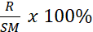
Description:
NP = Percentage Value
R = Total score obtained by students
SM = Maximum score
The percentage obtained will be interpreted in the percentage criteria according to Masrurotullaily et al (Rosmalinda et al., 2021).
Table 1. Classification of Critical Thinking Ability Levels
Mark | Classification
75 < x ≤ 100 | High
60 < x ≤ 75 | Medium
x ≤ 60 | Low
Source: Masrurotullaily et al. (Rosmalinda et al., 2021)
The next technique is interview. Interviews were conducted with grade 5 teachers with the aim of finding out how the discussion method is implemented in developing students' critical thinking skills. The last technique is documentation. This documentation is in the form of teaching modules, student test results, and photos during implementation. The instruments used by researchers are observation instruments used to study grade 5 teachers and grade 5 students, interview instruments for grade 5 teachers, and critical thinking ability tests for grade 5 students.

RESULTS AND DISCUSSION
Observations and interviews have been conducted to provide an overview of the implementation of the discussion method in developing students' critical thinking skills in the social sciences learning material Chapter 6 My Wealthy Indonesia (Indonesiaku Kaya Raya) in grade 5. To gain a deeper understanding of how the discussion method is implemented, the results of the observations and interviews have been analyzed and categorized according to the indicators. The following table presents the data obtained from the results of the observations and interviews.
Table 2. Observation and Interview Results Discussion Method Indicators
Indicator | Observation | Interview | Documentation
The teacher presents the problem or topic of discussion | The teacher explains the learning objectives and delivers the material for Chapter 6 My Rich Indonesia using PPT media, maps, pictures, videos and asks provocative questions to get students thinking. | The teacher explained that he always conveyed the learning objectives and explained the material using PPT media so that students could easily understand. The teacher also always asked questions so that students could think. | 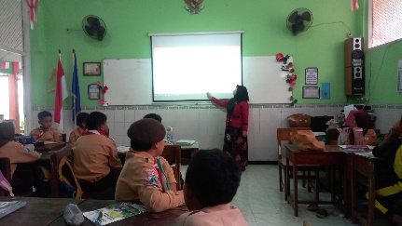  Fig 1. Observation Documentation
The teacher divides students into discussion groups | The teacher divides the groups heterogeneously. The teacher provides student worksheet and instructions related to the rules that must be agreed upon. Students divide roles or tasks in groups. | The teacher stated that the groups were divided fairly based on smart, average, and low students, as well as male and female so that the discussion would be more effective. Each group received a student worksheet containing problems that had to be solved. | 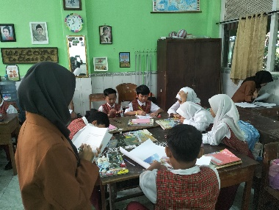  Fig 2. Observation Documentation
Students discuss in groups. The teacher observes and guides. | Students actively discuss and seek information from various sources. Students use concrete evidence to support their opinions. The teacher walks around observing the discussion and helps groups that are having difficulties. | The teacher explains, he goes around to each group to observe the discussion. The teacher guides and helps groups that are having difficulty. The teacher ensures that each student is actively involved and not just silent. | 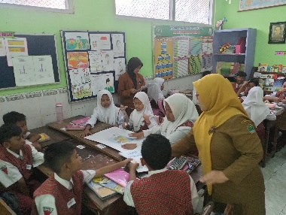  Fig 3. Observation Documentation
Presentation of discussion results and responses from other groups | Each group presents the results of the discussion in front of the class. Other groups listen and provide responses, either questions or suggestions. The teacher provides feedback and appreciation to active students. | The teacher conveys, each group is given the opportunity to present to the front. The teacher directs other groups to provide responses. The teacher also provides feedback related to what they have presented. | 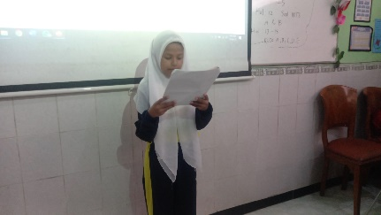  Fig 4. Observation Documentation
Writing conclusions and compiling reports | The teacher guides students to draw conclusions. Students draw conclusions together. Discussion reports are collected for evaluation by the teacher. | The teacher states that students must compile conclusions from the results of their discussions together. The results of the discussion are collected for evaluation, if there are students who do not understand, the teacher will provide additional guidance. | 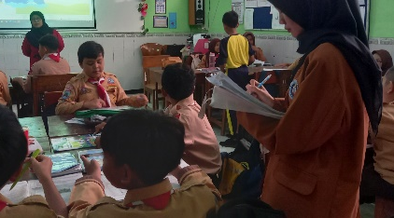  Fig 5. Observation Documentation
Source: Supriyati (2020)
Table 3. Results of Observations and Interviews on Critical Thinking Indicators
Indicator | Observation | Interview
Elementary Clariffication | The teacher gives initial questions to provoke student understanding. The teacher explains the material in simple language. Students listen to the teacher's explanation carefully, they are able to re-explain the material in their own language. | The teacher stated that he always encouraged students to express their opinions in easy-to-understand language. The questions asked by the teacher were aimed at making students think more about the material. The teacher explained with concrete examples so that it was easy to understand.
Basic Support | Students search for information from various sources such as books, maps, student worksheet according to teacher directions. Students use concrete examples in conveying their opinions. Teachers guide students in formulating opinions based on facts and data. | The teacher explains that students are taught to seek information from various sources to strengthen their opinions. Students are also asked to use concrete evidence in conveying their opinions.
Inferring | Students draw conclusions based on the results of structured discussions using their own language. The teacher guides students in drawing up systematic conclusions according to the material discussed. | The teacher said, after the discussion, students must make conclusions from the material that has been discussed systematically. The teacher provokes students by asking the question "What have you learned today?"
Advance Clarification | Students provide responses to other groups and can re-explain opinions that are not understood by other groups or students. The teacher encourages students to answer questions asked by the teacher or friends during the discussion. | The teacher stated that students are required not only to answer questions, but also to be able to explain the reasons. The teacher asked students to provide concrete examples and additional questions so that students can think critically and their understanding is deeper.
Strategy and Tactics | Students work together in groups and divide tasks fairly and follow discussion rules so that discussions can be organized. Students show politeness and respect for friends' opinions. Teachers ensure that each student has an appropriate role and is actively involved. | The teacher conveys that students must actively work together and divide group tasks fairly. The teacher observes the discussion and provides direction if there are students who are less active or have difficulty understanding the material.
Source: Ennis (Sari et al., 2021)
Based on the results from Table 2 (observation and interview on the discussion method) and Table 3 (observation and interview on critical thinking), information and data have been obtained indicating that the learning process in grade 5 uses the Merdeka Curriculum, which is designed to help students develop the competencies outlined in the Pancasila Student Profile, one of which is critical reasoning ability (Kemendikbudristek, 2022). Critical thinking is a highly essential skill in the 21st century. In line with Lukum (2019), there are three core competencies needed in the 21st century: the ability to think, act, and live in the world. The selection of an appropriate learning method will facilitate the teaching and learning process in the classroom. Teachers must be able to choose effective methods to improve student understanding, as the method plays an important role in supporting the success of the learning process (Awaelae & Rofiq, 2021). In the IPAS subject, teachers implement the discussion method in delivering material so that students can become more interactive in expressing opinions to solve problems. This statement aligns with the opinion of Munandar et al. (2024), who state that the discussion method involves an interactive process between two or more people to exchange information, express opinions, and collaborate in solving various existing problems.
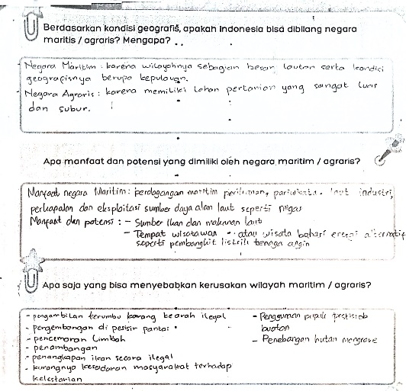
Fig 6. Group Answers on the Student Worksheet
The discussion method in this learning process is carried out systematically through steps that have been designed according to the discussion method outlined by Supriyati (2020). The first stage, the teacher presents the material using various learning media such as PowerPoint, maps, images, and videos to help students understand. The teacher also asks questions to encourage students to think more deeply about the material. Students are able to explain the material in their own words. According to Supriyadi, asking questions will increase students' interest, thinking patterns, and foster curiosity about the issues being discussed (Faizah, 2018). Students not only answer questions but also explain the reasons behind their answers and can respond to follow-up questions posed by the teacher or classmates. It is also evident from the students' worksheet answers that they have explained the geographical conditions of Indonesia. Not only that, but students also further analyze the benefits and potential of maritime countries and mention its negative impacts. This shows that students do not only provide basic information, but also develop their answers by connecting geographic aspects with economic and environmental aspects. This ability reflects the process of reasoning and allows students to think more deeply.
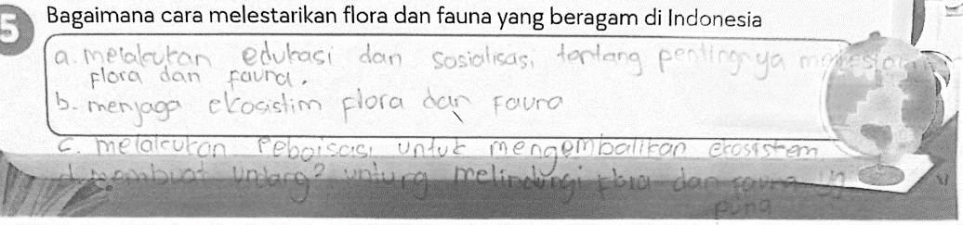
Fig 7. Group Answers on the Student Worksheet
The second stage, during the division of discussion groups, the teacher applies a heterogeneous strategy, where the teacher considers the academic abilities and gender of the students to ensure that the discussion process runs smoothly and is well-directed. The formation of these heterogeneous groups can increase the effectiveness of the learning process, giving students the opportunity to express their opinions (Zaein et al., 2025). Through the formation of these groups, students learn to divide roles and organize the steps of the discussion, which reflects their ability to plan and manage strategies in the discussion. Furthermore, this also enables students to organize systematic steps based on their understanding of the material when completing the student worksheet. As seen in the image, students have demonstrated the ability to plan effective actions based on problem analysis. This ability reflects strategic thinking, which not only focuses on theory but also on the application of solutions in real life.
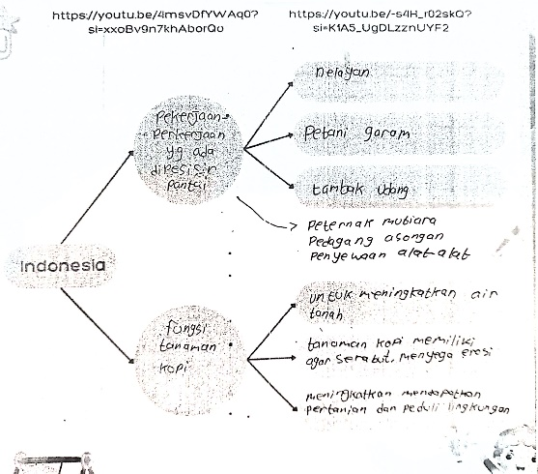
Fig 8. Group Answers on the Student Worksheet
The third stage, students gather in groups, divide roles and tasks fairly, and follow the rules of discussion. The teacher provides a student worksheet containing problems that must be discussed by the students. The process of solving these problems requires students to reason, design strategies, analyze, evaluate, make decisions based on the information received, and draw conclusions. This process encourages students to think critically. The discussion method engages students actively in the learning process, rather than simply receiving information passively (Pakaya, 2020). Discussion is not merely a conversation, but a means to solve problems based on diverse arguments (Simatupang et al., 2024). During the discussion, the teacher acts as a facilitator who observes and guides the students. Students actively seek information from various sources such as books, student worksheets, maps, videos, and use concrete evidence to express their opinions. This reflects the teacher's role as an informant in achieving educational success (Nugrahanti et al., 2022). This ability reflects basic critical thinking skills, where students not only express their opinions but also support their arguments with relevant data. The image shows that students are not just passively receiving information, but rather they search for information from the video they have watched. This process trains students to identify information by connecting knowledge with the concepts they saw in the video, which they then organize into a concept map. These skills help students process and present information in a systematic and structured way.
The fourth stage, students present the results of their discussion in front of the class. Other groups will respond, and the teacher will also provide feedback and appreciation to active students. Presenting during discussions helps students practice their confidence in public speaking as well as improve their communication and critical thinking skills. This statement is in line with the findings of Hasan et al. (2024).
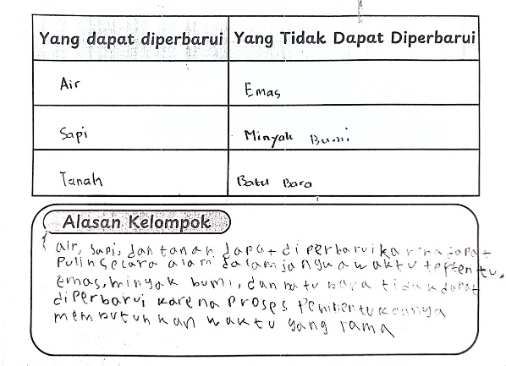
Fig 9. Group Answers on the Student Worksheet
The fifth stage, students will collectively compile conclusions from the material that has been studied logically. The teacher guides students so that the conclusions made are systematic and in accordance with the material discussed. The ability to draw conclusions that are relevant to the material shows that students have good analytical thinking skills. In the picture, students provide answers in which they not only group natural resources but also analyze the relationship between types of resources and the process of their formation. The teacher also gives students evaluation questions that must be done independently to see the extent of students' understanding of the science and science material (Samaduri, 2022).

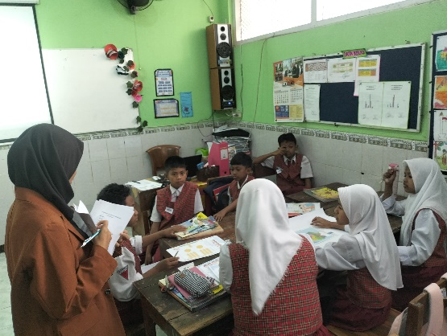
Figure 10. Discussion Activities
The discussion method has a good impact on developing students' critical thinking skills. This method provides space for students to be active in collaborating or participating, expressing opinions, having dialogues, exchanging opinions so that learning is more interesting (Munandar, 2024). Students can understand the problems given, analyze problems, solve problems or find solutions. These findings are in accordance with the opinion of Yuni et al. (2024) who stated that discussions allow students to actively participate, analyze information, express their opinions, and contribute to the development of their critical thinking skills. Students' communication skills are also getting better, they are required to be able to speak and listen with full concentration. This finding is in line with the research results of Fadhilah et al. (2023). Another impact is that students can accept and appreciate differences of opinion in the discussion, so that their attitudes of tolerance and cooperation will also be built.
In addition to having a significant impact, it is undeniable that there are also several obstacles that can affect the success of discussion activities. The obstacles that occur are differences in speed in completing group assignments. There are groups that are fast in discussing which makes them disturb other groups, so the teacher will give additional assignments. Another obstacle is that students' voices tend to be soft during presentations, and some students joke during discussions so that time is limited. As stated by Ngadha et al. (2023) that some students are still less confident in conveying ideas, and the discussion method takes longer than other methods.
The results or impacts of implementing the discussion method can be seen in students' ability to work on test questions as shown in the following learning outcomes. Based on the test results that have been carried out by students, it can be seen that students' critical thinking skills can develop well. The percentage is calculated using the percentage formula according to Purwanto & Yuliani (Budianti et al., 2022) and it is known that 27 students in grade 5 have high critical thinking skills (93.5%), there is 1 student who has moderate critical thinking skills (2.6%), and (0%) students who have low critical thinking skills. This category is determined based on the classification according to Masrurotullaily et al. (Rosmalinda et al., 2021), where a score of 75 and above is included in the high category, and a score of 60-75 is included in the moderate category. Students are able to answer each question that has been adjusted to the five student indicators including elementary clarification, basic support, inferring, advance clarification, and strategy and tactics well and correctly. The following is an analysis of the results of students' critical thinking ability tests.
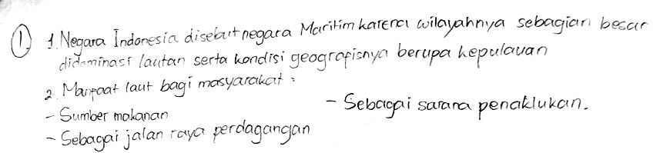
Figure 11. Results of Students' Answers to Question Number 1
Based on question number 1, students are able to explain the reasons why Indonesia is called a maritime country and mention the benefits of the sea. This explanation is in accordance with critical thinking skills to provide simple explanations to explain or reason geographical concepts. This critical thinking ability allows students to identify problems so that students are able to reason. Reasoning skills must be possessed by students, where reasoning is the process of processing information obtained either from observing activities or collecting information (Liana, 2020). The results of the analysis show that as many as 95.6% of students are able to achieve this indicator well, showing a strong understanding in connecting geographical concepts with real phenomena.
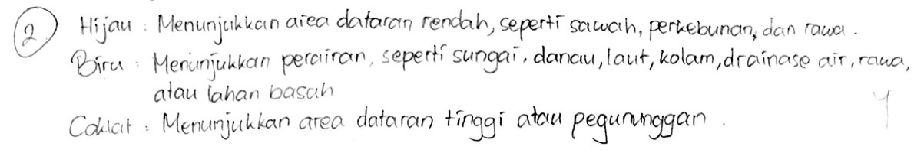
Figure 12. Results of Students' Answers to Question Number 2
Based on question number 2, students are able to understand the meaning of map colors well and provide appropriate examples. This explanation is in accordance with critical thinking skills in building basic skills to identify and connect geographic information. Students explore from various information. This ability is important to ensure that arguments are based on reliable sources. According to Christina, critical thinking is a person's ability to find information from a problem by asking themselves questions to dig up information related to the problem at hand (Asriningtyas, 2018). The percentage of achievement of this indicator reached 94.6% which indicates that almost all students have been able to use information systematically to support their understanding of the material given.
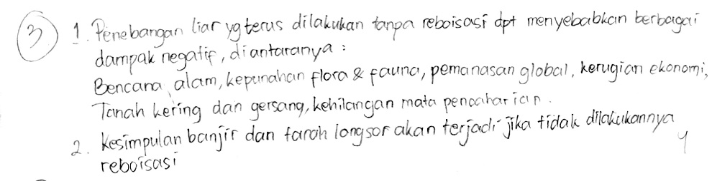
Figure 13. Results of Students' Answers to Question Number 3
Based on question number 3, students are able to draw conclusions about the negative impacts of illegal logging. This explanation is in accordance with the ability to think critically to draw conclusions in connecting cause and effect to understand environmental problems. This critical thinking indicator refers to students' ability to identify problems to find conclusions. This conclusion is drawn so that students are able to interpret what has happened and been observed (Maslakhatunni'mah, 2019). As many as 97.3% of students succeeded in meeting this indicator, which shows that almost all students have good analytical skills in identifying problems and drawing logical conclusions.
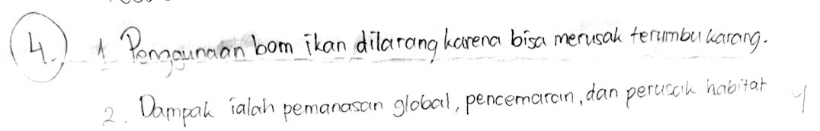
Figure 14. Results of Students' Answers to Question Number 4
Based on question number 4, students are able to explain further explanations regarding the prohibition on the use of fish bombs. This explanation is in accordance with critical thinking skills in analyzing environmental impacts in more depth. This critical thinking indicator allows students to identify the assumptions underlying ideas. Identifying assumptions in critical thinking means finding out reasons that are not directly stated in an opinion, so we have to think deeper to find out what they mean (Maolidah et al., 2017). Data analysis shows that this indicator was achieved well by 97.3% of students which reflects their level of understanding.
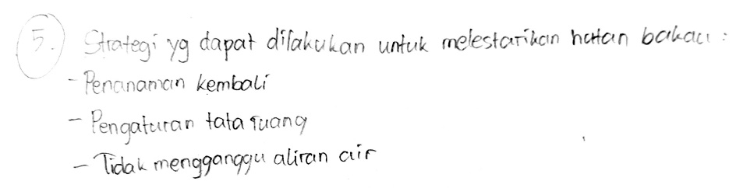
Figure 15. Results of Students' Answers to Question Number 5
Based on question number 5, students are able to organize strategies and tactics in preserving mangrove forests. This explanation is in accordance with critical thinking skills in designing strategic steps to maintain environmental sustainability. The indicators in this critical thinking refer to students' ability to plan and determine effective strategies. Students compile based on information and experiences from everyday life, this statement is in line with Anugraheni's opinion (2018). As many as 98.2% of students have met this indicator where students are able to design solutions by considering various factors.
The implementation of the discussion method in science learning in grade 5 Malang has been carried out in a directed manner and in accordance with the steps. Syaipudin & Pubian (2025) stated that this method has a positive impact on developing students' critical thinking skills, but there are several obstacles such as time constraints, lack of student confidence, and interference from several students. However, with optimal teacher guidance, this method remains effective in improving the quality of learning and students' critical thinking skills.

CONCLUSION AND SUGGESTIONS
Based on the results of the research and discussion, it can be concluded that the implementation of the discussion method in learning science subjects Chapter 6 My Wealthy Indonesia in grade 5 provides very high results in developing students' critical thinking skills. The discussion method can create an interactive learning atmosphere, where students will be encouraged to be able to participate actively, express their opinions, analyze information, and be able to draw conclusions from what they have learned logically and systematically. The discussion process encourages students to hone their critical thinking skills through five indicators of critical thinking according to Ennis. Students' critical thinking skills are very high, this is indicated by the test results which show that 27 students have high critical thinking skills and 1 student is in the moderate category. The discussion method has a positive impact, but it is undeniable that this method also has several obstacles such as differences in work speed between groups, time constraints due to some students who are less focused and joke around, and students' voices tend to be quiet during presentations.
It is recommended that teachers continue to provide exercises so that students are more confident and able to speak loudly and clearly during presentations. It is recommended for further research to study more deeply related to the implementation of the discussion method by considering other aspects or applying it to different class levels in order to expand the findings.

References

- Anugraheni, I. (2018). Meta analisis model pembelajaran problem based learning dalam meningkatkan keterampilan berpikir kritis di Sekolah Dasar [A meta-analysis of problem-based learning models in increasing critical thinking skills in elementary schools]. Polyglot: Jurnal Ilmiah, 14(1), 9-18.
- Asriningtyas, A. N., Kristin, F., & Anugraheni, I. (2018). Penerapan model pembelajaran problem based learning untuk meningkatkan kemampuan berpikir kritis dan hasil belajar matematika siswa kelas 4 SD. Jurnal Karya Pendidikan Matematika, 5(1), 23-32.
- Assyifa, S. H., Nurhasanah, N., & Tahir, M. (2023). Analisis Kemampuan Kerjasama dalam Metode Diskusi Pada Mata Pelajaran IPS Siswa Kelas IV SDN 37 Cakranegara Tahun Ajaran 2022/2023. Jurnal Ilmiah Profesi Pendidikan, 8(3), 1577–1582. https://doi.org/10.29303/jipp.v8i3.1 531
- Astuti, D. A. D., & Purnamasari, I. (2023). Analisis Metode Diskusi Kelompok Terhadap Keterampilan Mengemukakan Pendapat Peserta Didik Sekolah Dasar. Didaktik: Jurnal Ilmiah PGSD STKIP Subang, 9(2), 4640-4651.
- Awaelae, A. A., & Rofiq, A. (2021). Konsep Metode Diskusi Dalam Meningkatkan Motivasi Belajar Siswa Pada Pelajaran Fiqih Kelas X Sekolah Menengah Atas (Studi Kasus di Madrasah Nahdhatul Islamiah, Thailand Selatan) Konsep Metode Diskusi Dalam Meningkatkan Motivasi Belajar Siswa Pada Pelajaran. Chalim Journal of Teaching and Learning, 1(2), 190-197.
- Budianti, D. A., Roshayanti, F., Hayat, M. S., & Syafiq, M. A. (2022). Profil kemampuan memecahkan masalah peserta didik MA Darul Muqorrobin pada pembelajaran biologi. Jurnal Kualita Pendidikan, 3(1), 38-45.
- Elwin, F. P. N. (2023). Penerapan Metode Diskusi dalam Pembelajaran Kewarganegaraan untuk Meningkatkan Hasil Belajar Siswa. Educare : Jurnal Penelitian Pendidikan Dan Pembelajaran, 3(1), 22–29. https://doi.org/10.56393/educare.v3i1.1100
- Fadhilah, N., Subekti, E. E., Prasetyowati, D., & Nuriafuri, R. (2023). Analisis Keterampilan Berbicara Melalui Metode Diskusi Kelompok Pada Siswa Kelas 3c Sdn Sendangmulyo 02 Semarang. Didaktik: Jurnal Ilmiah PGSD STKIP Subang, 9(2), 3719-3729.
- Faizah, D., Utomo, P., & Arifin, M. (2018). Analisis pertanyaan guru dan siswa dalam proses pembelajaran bahasa indonesia di Kelas VII SMP Negeri 4 Kota Bengkulu. Jurnal Ilmiah Korpus, 2(3), 253-260.
- Firosalia, K. (2016). Efektivitas Model Pembelajaran Kooperatif Tipe STAD Ditinjau Dari Hasil Belajar IPS Siswa Kelas 4 SD. Scholaria: Jurnal Pendidikan dan Kebudayaan, 6(2), 74-79.
- Harapit, S. (2018). Peranan Problem Based Learning (Pbl) Terhadap Kemampuan Pemecahan Masalah Dan Motivasi Belajar Peserta Didik. Jurnal Pendidikan Tambusai, 2(4), 912–917.
- Hartono, H., & Irvandi, W. (2021). Pengembangan metode pembelajaran halaqah berbasis etnomatematika untuk memahamkan penyelesaian masalah transportasi kelas program linier. Pythagoras: Jurnal Pendidikan Matematika, 15(2), 216–226. https://doi.org/10.21831/pg.v15i2.36432
- Hasan, M. S. R., Rozaq, A., & Saifullah, R. (2024). Peningkatan Pemahaman Siswa Pada Pembelajaran Akidah Akhlak Melalui Model Pembelajaran Kooperatif Mind Mapping. Irsyaduna: Jurnal Studi Kemahasiswaaan, 4(2), 237-251.
- Ika Lestari & Linda Zakiah. (2019). Berfikir Kritis Dalam Konteks Pembelajaran,” (Bogor: Erzatama Karya Abadi, cet. 1, 2019), 3–9.
- Insyirah, A., & Oktrifianty. (2022). Analisis Pembelajaran Metode Diskusi dalam Mengembangkan Kemampuan Berpikir Kritis Siswa pada Pembelajaran IPA Kelas III SDN Kedaung Barat IV. Pendidikan, 4(20), 631–636. http://journal.universitaspahlawan.ac.id/index.php/jpdk/article/view/6661 %0Ahttp://journal.universitaspahlawan.ac.id/index.php/jpdk/article/downl oad/6661/5033
- Irawan Ari, G. K. (2016). Peranan Kemampuan Verbal Dan Kemampuan Numerik Terhadap Kemampuan Berpikir Kritis Matematika. 5(2), 110–119.
- Jannah, E. S. N. (2019). Penerapan Metode Pembelajaran “Active Learning-Small Group Discussion” di Perguruan Tinggi Sebagai Upaya Peningkatan Proses Pembelajaran. Fondatia, 3(2), 19-34.
- Jumriani, J., Syaharuddin, S., Hadi, N. T. F. W., Mutiani, M., & Abbas, E. W. (2021). Telaah Literatur ; Komponen Kurikulum IPS Di Sekolah Dasar pada Kurikulum 2013. Jurnal Basicedu, 5(4), 2027–2035. https://doi.org/10.31004/basicedu.v5i4.1111
- Kemendikbudristek. (2022). Buku Saku: Tanya Jawab Kurikulum Merdeka4. Kementerian Pendidikan, Kebudayaan, Riset Dan Teknologi.
- Liana, D. (2020). Berpikir Kritis Melalui Pendekatan Saintifik. Mitra PGMI, 6(1), 15-27.
- Lukum, A. (2019, December). Pendidikan 4.0 di era generasi Z: Tantangan dan solusinya. In Prosiding Seminar Nasional Kimia Dan Pendidikan Kimia (Vol. 2, No. Back Issue, pp. 1-3).
- Maolidah, I. S., Ruhimat, T., & Dewi, L. (2017). Efektivitas penerapan model pembelajaran flipped classroom pada peningkatan kemampuan berpikir kritis siswa. Educational Technologia, 1(2).
- Maslakhatunni’mah, D., Safitri, L. B., & Agnafia, D. N. (2019). Analisis kemampuan berpikir kritis pada mata pelajaran IPA siswa kelas VII SMP. In Seminar Nasional Pendidikan Sains (Vol. 2019, pp. 179-85).
- Munandar, A., Yanti, A. G., Afta, A., Mariwawo, K., Anisa, A., Diklariani, D., Prayogi, R., Wati, S. M., Rahmadani, S. F., & Khoiryah, Y. A. (2024). Desain Metode Diskusi dalam Pembelajaran Pendidikan Agama Islam di MTs Tarbiyah Islamiyah Kota Jambi. Innovative : Journal of Social Science Research, 4(4), 669–679.
- Napitupulu, A. T., Simanjuntak, G. W., Silaban, L. P., Tampubolon, S. E., Sinaga, S. M., Simanjuntak, T. L. B., ... & Naibaho, W. (2023). Penggunaan Gambar Sebagai Media Untuk Meningkatkan Kosakata Bahasa Inggris Pada Peserta Didik Kelas V SD N 091288 Sibaganding. Beru'-beru': Jurnal Pengabdian kepada Masyarakat, 2(1), 1-8.
- Nawir, M., & Suparti, D. (2024). Pembelajaran IPS Berbasis Tematik Sebagai Upaya Pembaharuan IPS di Sekolah Dasar. Aksiologi: Jurnal Pendidikan dan Ilmu Sosial, 5(1).
- Ngadha, C., Nanga, B., Ledu, M. G. G., Dhiu, M. I., & Lawe, Y. U. (2023). Penerapan Metode Diskusi Untuk Mengaktifkan Proses Berpikir Kritis Siswa Kelas 3 Sd Dalam Pembelajaran Bahasa Indonesia. Jurnal Citra Pendidikan Anak, 2(1), 36–46. https://doi.org/10.38048/jcpa.v2i1.1532
- Nugrahanti, I., Nurfadhillah, S., & Nuraeni, Y. (2022). Analisis Peranan Guru dalam Meningkatkan Motivasi Belajar Siswa Kelas II di Sekolah Dasar Negeri Sukabumi Selatan 01 Kebon Jeruk. Jurnal Pendidikan Dan Konseling (JPDK), 4(5).
- Nurlaela. (2017). Pengaruh Media Pembelajaran Dan Motivasi Belajar Terhadap Kemampuan Berpikir Kritis Siswa. Jurnal Ilmiah Pendidikan Guru Sekolah Dasar, 1(2), 180–187.
- Nurrohmi, Y., Utaya, S., & Utomo, D. H. (2017). Pengaruh model pembelajaran discovery learning terhadap kemampuan berpikir kritis mahasiswa (Doctoral dissertation, State University of Malang).
- Pakaya, F. A. (2020). Meningkatkan Hasil Belajar Melalui Metode Diskusi. Aksara: Jurnal Ilmu Pendidikan Nonformal, 5(3), 193-198.
- Pratiwi, R. A. (2021). Makalah-Penerapan Metode Ceramah Dan Diskusi Selama Pembelajaran Online.
- Rahmawati, R., & Bariah, O. (2024). Pengaruh metode diskusi terhadap hasil belajar murid kelas x pada mata pelajaran pendidikan agama islam di MAN 2 Karawang. Innovative: Journal Of Social Science Research, 4(4), 4634-4646.
- Rosmalinda, N., Syahbana, A., & Nopriyanti, T. D. (2021). Analisis kemampuan berpikir kritis siswa SMP dalam menyelesaikan soal-soal tipe PISA. Transformasi: Jurnal Pendidikan Matematika dan Matematika, 5(1), 483-496.
- Samaduri, A. (2022). Analisis Pemahaman Konsep Siswa Yang Diukur Menggunakan Tes Pilihan Ganda Beralasan Pada Mata Pelajaran Biologi. Jurnal Pendidikan Glasser, 6(1), 109-120.
- Saputra, E. E., Adelina, E., Yolanda, W., Arwanti, E., & Novikasari. (2024). Studi Literature : Peran Pendidikan IPA dalam Mengembangkan Keterampilan Berpikir Kritis Pada Anak Usia Sekolah Dasar. Catha of Journal: Creative and Innovative Research, 1(1), 34–44.
- Saputra, H. (2020). Kemampuan Berfikir Kritis Matematis. Perpustakaan IAI Agus Salim Metro Lampung, 2(April), 1–7.
- Sari, D. V. P. M., Aini, K., Syarifah, Damayanti, F., Handayani, T., & Nurokhman, A. (2021). Review: Berpikir Kritis Pada Peserta Didik. Prosiding Seminar Nasional Pendidikan Biologi, 5(1), 104–111. http://proceedings.radenfatah.ac.id/index.php/semnaspbio
- Sari, W., Anwar, F., Wirdati, W., & Engkizar, E. (2021). Metode Diskusi Guru Pendidikan Agama Islam dalam Meningkatkan Kepercayaan Diri Peserta Didik. Jurnal Pendidikan Tambusai, 5, 8904–8909. https://jptam.org/index.php/jptam/article/view/2398
- Septikasari, R., & Frasandy, R. N. (2018). Keterampilan 4C abad 21 dalam pembelajaran pendidikan dasar. Tarbiyah Al-Awlad: Jurnal Kependidikan Islam Tingkat Dasar, 8(2), 107-117.
- Sholihah, M., & Amaliyah, N. (2022). Peran guru dalam menerapkan metode diskusi kelompok untuk meningkatkan keterampilan berpikir kritis siswa kelas V sekolah dasar. Jurnal Cakrawala Pendas, 8(3), 898-905.
- Simatupang, S. A., Situmorang, E. R. V., Simbolon, I. C., & Umar, A. T. (2024). Analisis Penerapan Metode Pembelajaran Diskusi Kelompok Terhadap Pemahaman Siswa Pada Pembelajaran di SMA Negeri 21 Medan. Jurnal Nakula: Pusat Ilmu Pendidikan, Bahasa dan Ilmu Sosial, 2(4), 201-210.
- Sodik, A. J., Santoso, G., & Winata, W. (2023). Mengembangkan Kemampuan Berpikir Kritis Dan Komunikasi Efektif Untuk Kesepakatan Bersama di Kelas 4. Jurnal Pendidikan Transformatif, 2(4), 395-420.
- Sugiyono. (2015). Metode Penelitian Kuantitatif, Kualitatif, dan R&D. Bandung : ALFABETA.
- Sugiyono. (2022). Metode Penelitian Kuantitatif, Kualitatif, dan R&D. Bandung: Alfabeta.
- Supriyati, I. (2020). Penerapan metode diskusi dalam pembelajaran keterampilan berbicara pada siswa kelas viii mtsn 4 palu. Jurnal Bahasa dan Sastra, 5(1), 104-116.
- Susilawati, E., Agustinasari, A., Samsudin, A., & Siahaan, P. (2020). Analisis tingkat keterampilan berpikir kritis siswa SMA. Jurnal pendidikan fisika dan teknologi, 6(1), 11-16.
- Syafruddin, S. (2017). Implementasi Metode Diskusi Terhadap Peningkatan Hasil Belajar Siswa. CIRCUIT: Jurnal Ilmiah Pendidikan Teknik Elektro, 1(1), 63–73. https://doi.org/10.22373/crc.v1i1.1384
- Syaipudin, S. I., & Pubian, A. (2025). Pengaruh Penggunaan Metode Diskusi Terhadap Pemahaman Siswa Pada Mata Pelajaran Fiqh Di Mts Miftahul Jannah Bangkunat Pesisir Barat. Jurnal Mubtadiin, 11(01).
- Yuni, Y., Sajida, H., Saddam, S., Winata, A., Astari, W. M., & Maryati, Y. (2024). Analisis Efektivitas Pembelajaran Metode Diskusi Dalam Meningkatkan Berfikir Kritis Siswa di Kelas. Jurnal Ilmiah Telaah, 9(2), 196-201.
- Zaein, N., Wijoyo, S. H., & Hariyanti, U. (2025). Perbandingan Pembentukan Kelompok Heterogen dengan Kelompok Homogen Dalam Model Problem Based Learning Terhadap Hasil Belajar dan Motivasi Berprestasi Siswa di SMAN 3 Malang. Jurnal Pengembangan Teknologi Informasi dan Ilmu Komputer, 9(4)

