Development Song “Kita Semua Teman” to Minimize Bullying Behavior in grade VI Students in Malang

Arfi Riris Ristanti
Elementary School Education Study Program
PGRI University of Kanjuruhan Malang
Malang, Indonesia
arfiristanti908@gmail.com
Andika Gutama
Elementary School Education Study Program
PGRI University of Kanjuruhan Malang
Malang, Indonesia
andika@unikama.ac.id
Cicilia Ika Rahayu Nita
Elementary School Education Study Program
PGRI University of Kanjuruhan Malang
Malang, Indonesia
cirn@unikama.ac.id

Abstract
The high number of bullying cases in elementary schools necessitates alternative solutions to minimize bullying behavior.The purpose of this research is to understand the development process, validity, practicality, and effectiveness of the song "Kita Semua Teman" in minimizing bullying among sixth-grade students in the city of Malang.This research uses the research and development (R&D) method with the 4D model (define, design, develop, and disseminate). Data collection is carried out using validity, practicality, and effectiveness instruments with the Likert scale formula, tested by expert validators in content, language, and media.The subjects of this research are elementary school students and teachers.Data analysis in this study uses qualitative and quantitative methods.Based on the assessment of content experts with a percentage of 93.2%, language experts with a percentage of 90%, and media experts with a percentage of 94.6%, categorized as "very valid," the practicality test by teachers with a percentage of 95%, by students with a percentage of 92% categorized as "very practical," while the effectiveness test reached 92.3% categorized as "very effective."Based on the research results, it can be concluded that the development of the song " Kita Semua Teman’" is valid, practical, and effective in minimizing bullying behavior in elementary schools.

Keywords ; Bullying, Elementary School, ‘Kita Semua Teman’, Song
Abstrak
Banyaknya kasus bullying di sekolah dasar sehingga di perlukan alternatif solusi untuk meminimalisir periaku bullying. Tujuan penelitian ini untuk mengetahui proses pengembangan, kevalidan, kepraktisan, dan keefektifan pengembangan lagu “kita semua teman” untuk meminimalisir perilaku bullying pada siswa kelas VI di kota Malang. Penelitian ini menggunakan Metode pengembangan research and development (R&D) dengan model 4D (define, design, develop, dan disseminate), pengumpulan data dilakukan dengan menggunakan Instrumen kevalidan, Kepraktisan, dan Keefektifan dengan rumus skala likert yang di ujikan oleh validator ahli materi, ahli bahasa, ahli media. Subjek penelitian ini adalah siswa dan guru sekolah dasar. Analisis data pada penelitian ini menggunakan kualitatif dan kuantitatif. Berdasarkan penilaian ahli materi prosentase 93,2%, ahli bahasa prosentase 90%, dan ahli media prosentase 94,6%, dengan kategori kevalidan “sangat valid”, berdasarkan uji kepraktisan oleh guru dengan prosentase 95%, oleh peserta didik dengan prosentase 92% dengan kategori kepraktisan “sangat praktis”, sedangkan uji keefektifan mencapai 92,3% dengan kategori “sangat efektif”. Berdasarkan hasil penelitian dapat disimpulkan bahwa pengembangan lagu “kita semua teman” valid, praktis, dan efektif untuk meminimalisir perilaku bullying di sekolah dasar.
Kata Kunci : Bullying, “Kita Semua Teman”, Lagu, Sekolah Dasar.

Introduction
Elementary School is the most basic level of formal education that plays an important role in shaping students' character and personality (Dewi, 2020:40). An ideal elementary school not only provides an effective learning environment but also must be able to prevent bullying behavior through a safe and comfortable environment(Fitriani, 2022:79). Inclusive and enjoyable learning becomes a strategic effort in preventing bullying through the instillation of values such as empathy, cooperation, and mutual respect. Teachers play an important role in creating a positive and creative atmosphere (Siti Rahimah, 2023). The government also supports these efforts through the Pancasila Student Profile (P5) program, which aims to improve the quality of character education in accordance with Pancasila values (Siswati & Saputra, 2023:220).
Deviant behaviors such as bullying still frequently occur in elementary schools and have become a serious problem that must be addressed immediately(Dewi, 2020:40). Deviant behaviors such as bullying still frequently occur in elementary schools and have become a serious problem that must be addressed immediately (Permata, 2021:22). Quoted from detik.com accessed on September 17, 2024, there was an incident of bullying behavior among elementary school students in Malang, specifically at SDN 1 Jenggolo in 2022, which caused the victim to go into a coma. A similar incident also occurred in East Java in 2023, as reported by BBC.com accessed on September 17, 2024. In that bullying incident, the victim suffered blindness in one of their eyes. This incident shows that bullying behavior is very concerning and needs to be addressed immediately because bullying is not only physical attacks but also psychological attacks, so the trauma experienced by the victim greatly impacts the victim's daily life (Yuliani, 2019:3).
The results of the observation conducted at one of the elementary schools in Malang city, the researchers found several issues related to bullying behavior. In that school, bullying actions often occur, both verbal, physical, and psychological. In upper-grade students, the bullying behavior that usually occurs is verbal and psychological bullying. Like mocking, ridiculing, ignoring, and even giving disdainful looks. Physical bullying also frequently occurs, such as hitting and kicking. And based on the interview results, this bullying behavior occurs due to two factors: internal factors such as the character of the students whose mental and emotional stability is lacking, and external factors such as the family, where many students have working parents, resulting in the education that should also be provided by the parents being inadequate. And the efforts made by the school to minimize bullying behavior include conducting counseling sessions, implementing the P5 program, and putting up anti-bullying posters. However, these measures have not been fully effective because bullying behavior still persists in the school. because many students are indifferent to the anti-bullying appeals that have been disseminated by the school. Therefore, actions are still needed to address this issue.
Based on the statements above, bullying still occurs frequently in elementary schools, which contradicts the main purpose of elementary schools as environments that are safe, comfortable, and supportive of students' academic and character development. Many programs such as P5 and anti-bullying counseling have been implemented, yet in reality, cases of verbal, physical, and psychological bullying are still found. Some of the contributing factors include the lack of parental supervision, low student awareness of the impact of bullying, and the ineffectiveness of the implementation of prevention programs in schools. This indicates that firm measures and effective approaches are still needed to address bullying.
According to Setiawan (2024) character strengthening can help minimize bullying. Through character education, students are expected to develop empathy, mutual respect, and the ability to build healthy social relationships, thereby creating a school environment that is a comfortable learning space and provides protection for students (Setiawan, 2024:24). Controlling emotions is also an important step in preventing bullying behavior. One of the methods that can be used is the use of media, specifically songs, because songs can positively influence students' emotions and attitudes (Permata, 2021:22).
To address the issue of bullying in elementary schools, the researchers took the initiative to develop an anti-bullying song as an enjoyable and memorable educational medium. To instill values of empathy, tolerance, and friendship in students, thereby creating a school environment with a comfortable learning atmosphere free from bullying. A song is a work of art that can be sung, always accompanied by music, which is a medium of sound or tone that possesses beauty. Music is also considered to influence a child's personal life, evoking emotions that stem from sounds or tones that create emotions according to the writer's intent (Sujana, 2015:2). Songs as an educational medium are considered enjoyable, easy to understand, and capable of enhancing motivation and character (Widyaningrum, 2019:192). In addition, songs can also evoke emotional responses without experiencing the emotions themselves, so by developing songs about anti-bullying behavior, it is hoped that they can influence the emotions or feelings of students so that they do not engage in bullying actions (Roffiq, 2017:38). Children's pop music is the right choice because it is light and easy to understand (Mislikhah, 2021:67). In addition, music also plays a role in shaping character, expanding competencies, and developing individual skills (Gutama, 2022:85).
Similar research has been conducted by (Wathon, 2019:37) regarding the “Implementasi metode bernyanyi menggunakan media smart tv untuk meningkatkan kemampuan sosial emosional anak usia dini” has stated that the method of singing Islamic songs using Smart TV media can help individuals build social relationships and emotional intelligence. The second research was conducted by (Mulyana & Retnasary, 2024) namely “kampanye digital pada instagram @hendrabrudy melalui lagu anti bullying dalam pencegahan bullying”, showing that anti-bullying songs are effective in increasing students' social interactions.
Previous researchers conducted by Wathon (2019:37) still focused on improving emotional and social skills in early childhood. And the second previous research conducted by Mulyana & Retnasary (2024) focused on preventing bullying by developing the song “Kalau kau suka hati” with anti-bullying lyrics. Meanwhile, this research offers novelty by developing a video clip song entitled “Kita Semua Teman” with lyrics and visualization of anti-bullying behavior to improve social and emotional abilities and minimize bullying behavior in elementary schools. In addition, the song “Kita Semua Teman” is also a flexible song that can be used by all groups. So that with the development of the song “Kita Semua Teman” it is hoped that it can help minimize bullying behavior in students in elementary schools. This study also aims to develop a song “Kita Semua Teman” to minimize bullying behavior in grade VI students in Malang City which is valid, practical, and effective. This song is presented as an alternative solution to reduce bullying behavior in the elementary school environment, with the hope that it can have a positive impact on students in elementary schools

method

Method
This research was conducted at one of the elementary schools in the Malang City area, using the research and development (R&D) method with the 4D model. According to Thiagarajan (1974), this model consists of four development stages: define, design, develop, and disseminate. In the define stage, it includes an analysis of the bullying problem and ways to minimize bullying behavior, starting from the initial analysis, student analysis, concept analysis, task analysis, and goal analysis. The design stage involves preparing the product, starting from the selection of media in the form of a song titled “Kita Semua Teman the selection of the format was carried out by taking videos of students and school staff at one of the elementary schools in Malang City that depict anti-bullying behavior as the background in the video clip and edited using the CapCut application, and the initial design began with preparing the song, preparing relevant videos, and the editing process. In the development stage, it includes product development that is tested through trials. In the develop stage, it involves product development tested through validity, practicality, and effectiveness tests. The final stage is dissemination, which is the stage of spreading conducted through
Fig. 1 | socialization activities at one of the elementary schools in Malang City. The aim is for the song "Kita Semua Teman" to be utilized by teachers to shape students' character and minimize bullying behavior in schools. And the implementation of the song "Kita Semua Teman" is carried out every Friday to raise awareness about the importance of reducing bullying behavior by singing together. In addition, the song "Kita Semua Teman" is also distributed through digital platforms such as YouTube, Google Drive, Sound Cloud, and TikTok to reach more people and help minimize bullying actions.
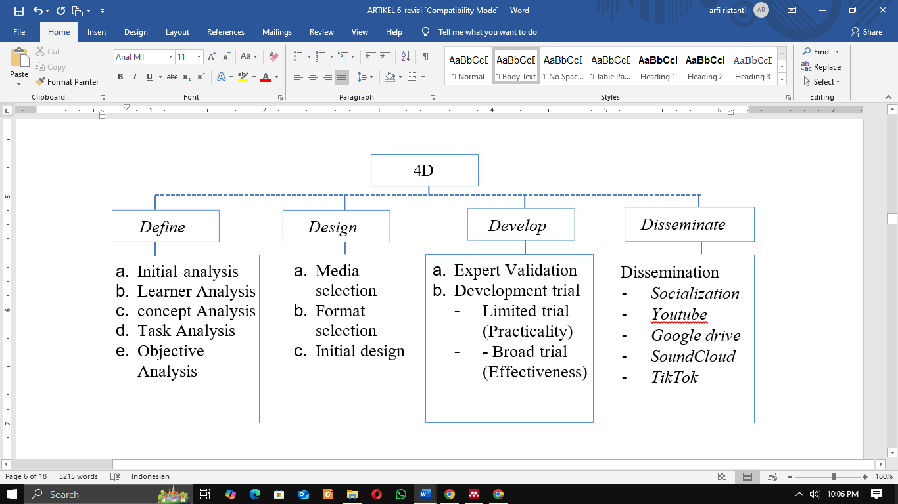
Modified from Thiagarajan in (Ramadhan & Adhisa, 2024:375)
At the development stage, the measurement of validity, practicality, and effectiveness was conducted by involving three experts, namely experts in content, language, and media, as well as two research subjects, namely teachers and sixth-grade students in Malang City. The types of data used in the development of the song " Kita Semua Teman " product include qualitative and quantitative data. Qualitative data were obtained from the results of validity, practicality, and effectiveness tests in the form of opinions and suggestions, and quantitative data were obtained from the scores of the validity, practicality, and effectiveness tests. The practicality test was conducted through a limited trial involving 6 students, and the effectiveness test was conducted through a wide trial involving 20 students. The measurement of effectiveness was conducted using an evaluative questionnaire. Data collection was carried out using instruments in the form of Likert scales and documentation. The following are the scoring criteria for the instrument results and the equations used.

Table 1 Validity and practically scoring guidlines  Modified fromsource sugiyono in (Anwar, 2023:46) | Table 2 Effectivness scoring guidelines  Modified from source (Ibrahim & Muslimah, 2021:3) | Fig. 2 Equations  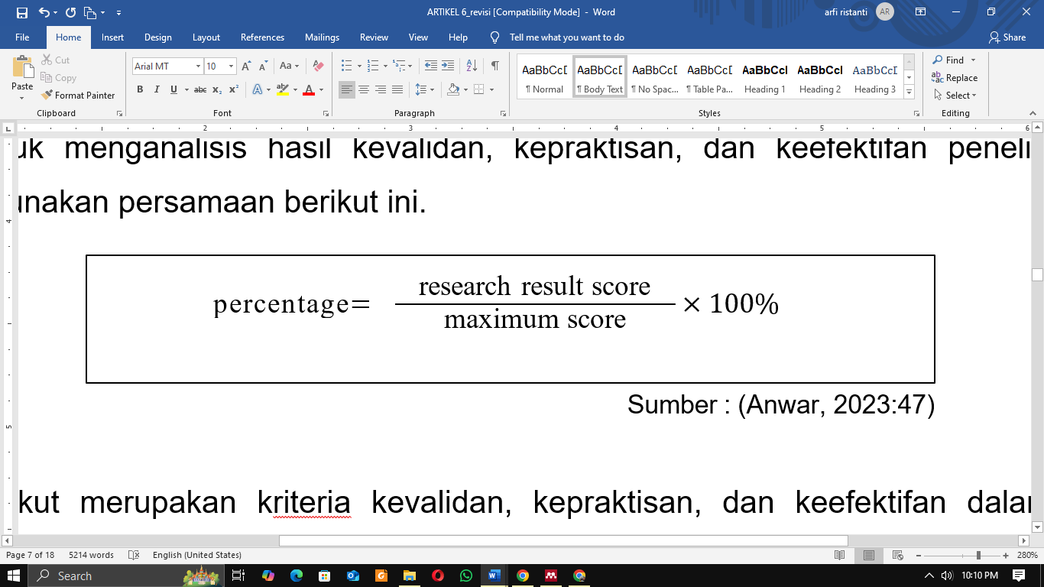  Modified from source (Anwar, 2023:47)
  Category | Score
  Very good | 4
  Pretty good | 3
  Not good | 2
  unaforable | 1
  Category |  | Score
  Correct | 1
  Wrong | 0
  Not answered | 0

The following are the criteria for validity, practicality, and effectiveness in this study:
Table 3 Validity Criteria for the Song Product “Kita Semua Teman”  Modified from source (Kurniasi & Arsisari, 2020:1217). | Table 4 Practicality Criteria for the Song Product “Kita Semua Teman”  Modified from source (Lois & Rahayu, 2022:290). | Table 5 Product Effectiveness Criteria for the Song “Kita Semua Teman”  Modified from source (Anwar, 2023:46).
  Presentase Penilaian | Klasifikasi
  85 – 100% | Very Valid
  70 – 85% | Quite Valid
  50 – 70 % | Less Valid
  <50% | Invalid
  Presentase Penilaian |  | Klasifikasi
  81 – 100% | Very Practical
  60 – 80% | Quite Practical
  41 – 60 % | Less practical
  <40% | Not practical
  Presentase Penilaian |  | Klasifikasi
  85 -100 | Very effective
  70 – 85 | Quite Effective
  50 – 70 | Less effective
  < 50 | Ineffective

Research Results
The development of the song “Kita Semua Teman” to minimize bullying behavior in 6th grade students in Malang, which is in the form of a video clip with lyrics and visualization of antibullying behavior, was carried out using the research and development (R&D) development method with the 4D model (define, design, develop, and disseminate). At the define stage, researchers found several problems regarding bullying that occurs almost every day at school. The forms of bullying found include verbal and psychological bullying (such as mocking, ridiculing, silencing, and looking sarcastically), as well as physical bullying (hitting and kicking). The causes originate from internal aspects such as students' emotional instability, and external factors such as the lack of time and attention from parents due to their busy work schedules.
At the design stage, researchers designed the development of a video clip song entitled “Kita Semua Teman” which aims to minimize bullying behavior in elementary schools. The song was designed with simple lyrics with anti-bullying messages, as well as a melody with a tone jump that is not too high. The visualization in the video clip is also adapted to positive values such as cooperation, togetherness, independence, and good behavior.
Fig. 3 Initial design
  Source: Personal Documentation | 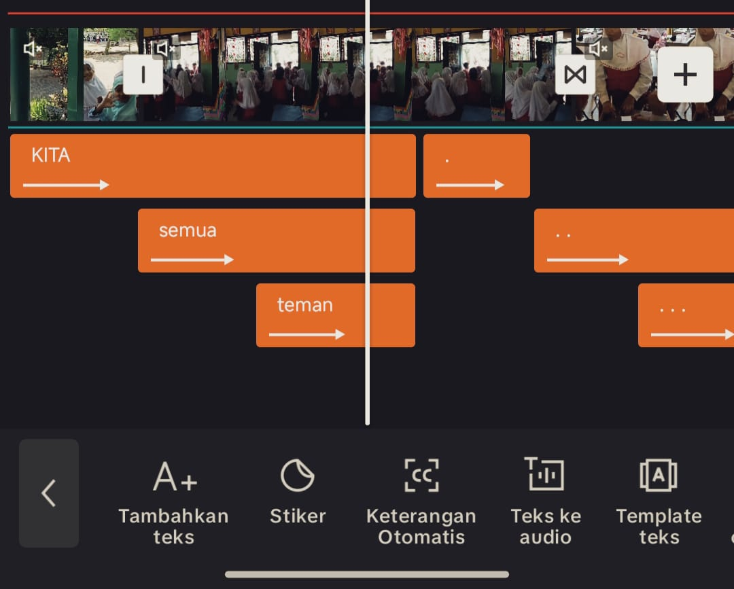  Source: Personal Documentation | 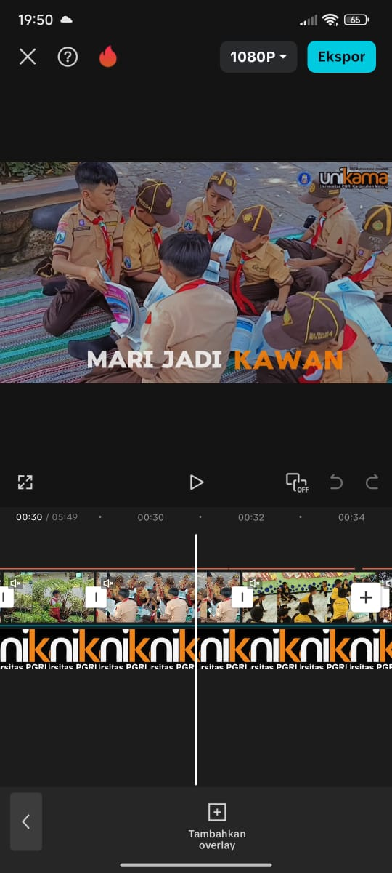  Source: Personal Documentation
In the development stage, the process is carried out to produce the song " Kita Semua Teman " media in the form of a validated, practical, and effective video clip. This will be validated by experts in content, language, and media to determine the validity of the product, followed by practicality and effectiveness tests with teachers and students. The development of the song “Kita Semua Teman” is valid based on expert assessments with aspects of content, language, and media validity reaching an average of 92.6% in the "very valid" category. At this stage, there were also many suggestions and inputs, including the addition of content, so that the development of the song “kita semua teman” can be made as well as possible.
The practicality test conducted to determine the ease and practicality of the "Kita Semua Teman" song development product based on responses from the class teacher and six students during a limited trial. The practicality of the song “Kita Semua Teman” is considered practical based on responses from teachers and sixth-grade students, with an average reaching 93.5% under the criteria of "very practical." The effectiveness test of the song "kita semua teman" video clip was conducted using an evaluative questionnaire given to students after the presentation of the material and the video clip of the song "kita semua teman." Students were asked to fill out the evaluative questionnaire with 15 statements, which was carried out in a wide trial with 20 students and obtained a percentage of 92.3% in the “Very Effective” category.
At the dissiminate stage or dissemination is carried out to introduce the song development product “kita semua teman” in the form of video clips to the wider community. At this stage the researcher disseminates the product by uploading it to easily accessible social media platforms such as YouTube, Google Drive, Sound Cloud, and Tik Tok and then disseminates it again through socialization activities at one of the elementary schools in Malang City and is applied every Friday which aims to make the media song “Kita Semua Teman” can be used by teachers to shape the character of students while minimizing bullying behavior in schools.

discussion
The development of the song “Kita Semua Teman” to minimize bullying behavior among sixth-grade students in Malang was carried out using the Research and Development (R&D) method with the 4D model. Through the validation process by three expert lecturers in the fields of content, language, and media, this product meets the criteria of being valid, practical, and effective. The practicality of the product was assessed by teachers and sixth-grade students, while its effectiveness was obtained from sixth-grade students in Malang City.
The validation results by subject matter experts indicate that the validity of this product is influenced by the alignment of the song development with the students' needs in fostering anti-bullying behavior, such as mutual affection, respect, cooperation, and the application of other social values (Wathon, 2019:37). With several suggestions and inputs provided, including the addition of material and the addition of melody to the lyrics of the song “kita semua teman”. The percentage of material validity reached 92.3% with a validity category of "very valid.". The validation results by language experts indicate that the validity of the product is influenced by the clarity of sentence structure, the accuracy of diction, the adherence to linguistic rules, the coherence of the song's meaning, as well as the elements of creativity and originality of the song "Kita Semua Teman". This validation aims to identify writing errors that can cause confusion and hinder students' understanding, in line with Immawan (2024) opinion that deviations in language or spelling can disrupt the smoothness of communication. The suggestions provided include the addition of an anti-bullying slogan, the inclusion of literacy posters, additional documentation in the video, and the reinforcement of the message at the end of the song. The validity of the language reached a percentage of 90% with the category "very valid."
The validation results by media experts show that the validity of the song "Kita Semua Teman" is influenced by the attractiveness, quality, and appeal of the media in increasing students' interest in the material. The suggestions provided include the addition of an introduction and supporting materials through applications such as Worksheet or Canva. The use of interactive media can create a more enjoyable learning atmosphere, as well as encourage increased motivation and student participation (Widyastuti, 2024). The validity of the media falls into the "very valid" category with a percentage of 94.6%. The assessment of the practicality of the song "Kita Semua Teman" in minimizing bullying behavior by teachers and sixth-grade students is influenced by the detailed and structured arrangement of the material and the song, which is capable of building communication and interaction that reflects anti-bullying behavior (Mulyana & Retnasary, 2024) The teacher suggested adding scenes or short films in the music video to enhance its appeal. The practicality test by the teacher obtained a percentage of 95%, while the students achieved 92%, both falling into the "very practical" category. This shows that the song “kita semua teman” to minimize bullying behavior among elementary school students falls into the "very practical" category. Then, in the effectiveness test, influenced by the assessment on the evaluative questionnaire given to the students, it was shown that the song ”kita semua temanhad a significant positive effect on knowledge or skills (Wahono, 2024). The broad effectiveness test with a percentage of 92.3% falls into the "very effective" category.

conclusions and suggestions
Based on the research results, it can be concluded that the development of the song “kita semua teman” using the 4D model is valid, practical, and effective in minimizing bullying behavior in elementary schools. After conducting the practicality test, the development of the song “kita semua teman” has the advantage of being appealing with a melody and lyrics that are easy for students to understand and memorize. This research was tested by 3 validators, namely material experts, language experts, and media experts. The subjects of this research are elementary school students and teachers. The data in this study were analyzed using qualitative and quantitative approaches. Based on the assessment of content experts with a percentage of 93.2%, language experts with a percentage of 90%, and media experts with a percentage of 94.6%, categorized as "very valid," the practicality test by teachers with a percentage of 95%, by students with a percentage of 92%, categorized as "very practical," while the effectiveness test reached 92.3% with the category "very effective." Based on the research results, it can be concluded that the development of the song " Kita Semua Teman" is valid, practical, and effective in minimizing bullying behavior in elementary schools. For future researchers, it is recommended to expand the scope of the study by considering additional variables that may potentially influence the results. Additionally, this research can be expanded by testing it on a larger sample or in different situations.

Acknowledgment
All praise and gratitude are offered to Allah SWT for His blessings, allowing the completion of the music video for the song 'Kita Semua Teman,' which aims to reduce bullying behavior in elementary schools. The author also expresses gratitude to Mr. Andika Gutama, S.Pd., M.Pd. and Mrs. Dr. Cicilia Ika Rahayu Nita, M.Pd. as supervising lecturers, as well as to the validators in the fields of content, language, and media for their invaluable guidance and input. Appreciation is also extended to the students, teachers, and staff at one of the elementary schools in Malang City for their support and participation. Not to forget, the author sincerely expresses gratitude to both beloved parents for their endless prayers and support. The author hopes that this work will be beneficial and is open to criticism and suggestions for improvement in the future.

References

