Analyzing the Suitability of Textbook Contents from Students’ Characteristics

Vitri Angraini Hardi
English language Education
Universitas Pahlawan Tuanku Tambusai
Riau, Indonesia
vitrihardi@gmail.com
M.Syahrul Rizal
Elementary School Teacher and Education
Universitas Pahlawan Tuanku Tambusai Bangkinang,
Riau, Indonesia
msyahrulrizal@gmail.com

Abstract— The present study is a description of suitability of English textbook (Grow with English: An English Course for Elementary School Students Book 6) on students’ characteristics. It analyzed the suitability of textbook contents and the students’ characteristics. This is a descriptive research with interview, documentation, and observation checklist as its instruments. English book for Grade 6 students was selected as the subject of the research. The findings revealed that 6 (six) of 7 (seven) indicators of students’ characteristics were suitable with textbook contents. The story time activity is not included in the textbook. However, it is known as one of the elementary students’ characteristics. In further, a good textbook considered the students’ characteristics to foster the competencies in the process of learning. Given the findings, it recommended that story time activity should be included as one of the activities in textbook.

Keywords— textbook, students’ characteristics, suitability of
textbook contents

Introduction
Textbook is central part and dominant instructional medium of an education system(1).The appears of textbook is essential for teachers due to its role such as providing course guidance and course activities(2).It helps teacher to deliver curriculum materials(1) and supports learning activities(3). Textbook is one of the elements that might involve learners depending on the materials given(4). Besides, it is the first medium use by the learners to understand the culture, and to grow learners’ characteristics. The movement to adapt learner center is probably best to view textbook as resources to achieve learning aims and objectives that have already been set in terms of learners’ need(2). In 2013 Curriculum, a core competencies and basic competencies that include character’s education should be integrated in a learning process. Therefore, teaching materials should be equipped teaching process. Curriculum 2013 should focused on the formation of competence and character of learners, in the form of guides knowledge, skills, and attitudes that demonstrated learners as a form of understanding of concepts that he learned conceptually. Therefore, the resulting teaching materials must be specially designed to develop the character of the students.
Some research reported the importance of using textbook in learning process. Learners extend familiarity with the target culture and through the contents of the book institute a positive attitude towards L2 culture offered in these books(5). Textbooks have some advantages as follows: a source of language, a learning support, motivation, stimulation, and reference(4). Textbook is the tools that help the trainee to serve the teaching process effectively. The purpose and importance of teaching-learning materials are: making learning interesting; facilitate learning; help to remember lesson material for a longer time; helping teachers to deliver their lessons successfully and easily; allows teachers to effectively disclose the concept of learning (3).
In further, research on exploration of textbook factors consideration is not conducted yet. However, in relating to the final aims of textbook is to reach learning outcome. Consideration factors such as students’ characteristics were not explored yet. The present research focuses on exploration the suitability between students’ characteristics and textbook use.

RESERACCH METHODS

Research Design
The suitability of learners’ characteristics and textbook use in learning process is a phenomenon need to be considered in educational research. An exploration on the suitability between those things is highly needed. A qualitative research was conducted to explore the phenomenon. Document analysis was used as research approach. This research aims to explore the suitability between English textbook use in Elementary education of Grade 6 students. The research strategy employed was a textbook analysis based on elementary students’ characteristics. The textbook use was obtained from elementary teacher at SD Pahlawan Bangkinang Kota, located at Jl.Akper, Desa Ridan Permai,Kec. Bangkinang.

Source of Data
The data were qualitative data. Source of Data was English Textbook used at Grade 6 elementary students published by Erlangga with entitled Grow with English: An English Course for Elementary School Students Book 6.

Research Instruments
In qualitative research, researcher is the main instrument. In further to support the research process, data triangulation was conducted. The research began with semi structure interview with elementary teacher to gain the information on the existing English book at grade 6 of SD Pahlawan Bangkinang Kota. Another instrument employed in this research is document checklist as follows:

Table 1. Document Checklist on Exploration of Students’ Characteristics and textbook used

No | Indicator | Suitability |  | Description | Code
 |  | Yes | No

Data Collection Technique
The data were collected through the use of the following two techniques, namely:
- Observation
This is a preliminary activity conducted to gain the information on the existing English book use by the teacher at grade 6 of SD Pahlawan.

- Literature Review
The researchers used literature review to relate the findings and existing theory.

Data Analysis Technique
The analysis technique used in this research was classified into 4 phases, namely:1) data reduction, 2) triangulation, 3). Data display, and 4) Conclusion (6).

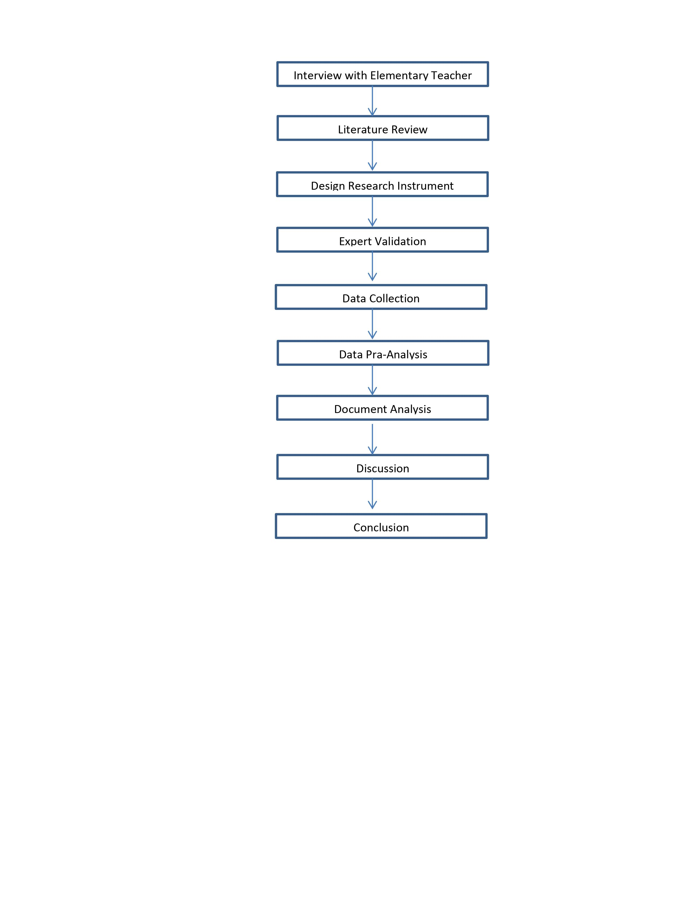
Figure 1. Steps of Research

RESULTS AND DISCUSSION

The suitability between elementary learners’ characteristics and textbook use is described in the following table:

Table. 2. Exploration of Students’ Characteristics and textbook used
NO | SUB-UNIT | INDIKATOR | S | TS | DESKRIPSI
1 | UNIT 1 | The learners prefer to do sing activities and moving activities. | √ |  | Book materials serves moving activities, but singing activity does not served
1 | UNIT 1 | The learning focus is limited | √ |  | Suitable
1 | UNIT 1 | The learner get involved in learning process | √ |  | suiatble
1 | UNIT 1 | Scientifc context of learning materials are suggested | √ |  | Daily context materials are served
1 | UNIT 1 | Telling activity is preferred |  | √ | Learning activity served on the textbook does not serve telling activity
1 | UNIT 1 | The learners are known the pairs | √ |  | The book serve dialogue practice, it helps the learners to know the pairs during dialogue practice
1 | UNIT 1 | Concrete things involvement in learning is highly suggested to ease the learning | √ |  | Picture is served in every learning unit
2 | UNIT 2 | The learners prefer to do sing activities and moving activities. | √ |  | Book materials serves moving activities, but singing activity does not served
2 | UNIT 2 | The learning focus is limited | √ |  | Suitable
2 | UNIT 2 | The learner get involved in learning process | √ |  | suiatble
2 | UNIT 2 | Scientifc context of learning materials are suggested | √ |  | Daily context materials are served
2 | UNIT 2 | Telling activity is preferred |  | √ | Learning activity served on the textbook does not serve telling activity
2 | UNIT 2 | The learners are known the pairs | √ |  | The book serve dialogue practice, it helps the learners to know the pairs during dialogue practice
2 | UNIT 2 | Concrete things involvement in learning is highly suggested to ease the learning | √ |  | Picture is served in every learning unit
3 | UNIT 3 | The learners prefer to do sing activities and moving activities. | √ |  | Book materials serves moving activities, but singing activity does not served
3 | UNIT 3 | The learning focus is limited | √ |  | Suitable
3 | UNIT 3 | The learner get involved in learning process | √ |  | suiatble
3 | UNIT 3 | Scientifc context of learning materials are suggested | √ |  | Daily context materials are served
3 | UNIT 3 | Telling activity is preferred |  | √ | Learning activity served on the textbook does not serve telling activity
3 | UNIT 3 | The learners are known the pairs | √ |  | The book serve dialogue practice, it helps the learners to know the pairs during dialogue practice
3 | UNIT 3 | Concrete things involvement in learning is highly suggested to ease the learning | √ |  | Picture is served in every learning unit
4 | UNIT 4 | The learners prefer to do sing activities and moving activities. | √ |  | Book materials serves moving activities, but singing activity does not served
4 | UNIT 4 | The learning focus is limited | √ |  | Suitable
4 | UNIT 4 | The learner get involved in learning process | √ |  | suiatble
4 | UNIT 4 | Scientifc context of learning materials are suggested | √ |  | Daily context materials are served
4 | UNIT 4 | Telling activity is preferred |  | √ | Learning activity served on the textbook does not serve telling activity
4 | UNIT 4 | The learners are known the pairs | √ |  | The book serve dialogue practice, it helps the learners to know the pairs during dialogue practice
4 | UNIT 4 | Concrete things involvement in learning is highly suggested to ease the learning | √ |  | Picture is served in every learning unit
5 | UNIT 5 | The learners prefer to do sing activities and moving activities. | √ |  | Book materials serves moving activities, but singing activity does not served
5 | UNIT 5 | The learning focus is limited | √ |  | Suitable
5 | UNIT 5 | The learner get involved in learning process | √ |  | suiatble
5 | UNIT 5 | Scientifc context of learning materials are suggested | √ |  | Daily context materials are served
5 | UNIT 5 | Telling activity is preferred |  | √ | Learning activity served on the textbook does not serve telling activity
5 | UNIT 5 | The learners are known the pairs | √ |  | The book serve dialogue practice, it helps the learners to know the pairs during dialogue practice
5 | UNIT 5 | Concrete things involvement in learning is highly suggested to ease the learning | √ |  | Picture is served in every learning unit
6 | UNIT 6 | The learners prefer to do sing activities and moving activities. | √ |  | Book materials serves moving activities, but singing activity does not served
6 | UNIT 6 | The learning focus is limited | √ |  | Suitable
6 | UNIT 6 | The learner get involved in learning process | √ |  | suiatble
6 | UNIT 6 | Scientifc context of learning materials are suggested | √ |  | Daily context materials are served
6 | UNIT 6 | Telling activity is preferred |  | √ | Learning activity served on the textbook does not serve telling activity
6 | UNIT 6 | The learners are known the pairs | √ |  | The book serve dialogue practice, it helps the learners to know the pairs during dialogue practice
6 | UNIT 6 | Concrete things involvement in learning is highly suggested to ease the learning | √ |  | Picture is served in every learning unit

Table 2 shows that in Unit 1, the fifth indicator was not find in the textbook. It deals with telling activity. Meanwhile, another 6 indicators were found in this textbook such as moving activity, students’ engagement in learning process, daily context materials used, picture complement in learning materials and so on.
Based on the interview conducted, it was found that the teacher assumed telling activity is categorized as an advance learning activity. It will be difficult for the students to implement this kinds of learning activity due to the students’ struggling in understanding basic English itself. It could be stated that teacher’s judgment play on it. The teacher assumed that the students were in low level ability of English learning.
Another idea of using this textbook is the materials given is closely related to the students’ daily context. The teacher claimed that learning materials served in the textbook is easily understood by the students. Most of learning materials were basic.

CONCLUSION

Mostly, learning materials served by the book was suitable for the students. On the contrary, another one of students’ characters was not considered by the textbook. Textbook does not serve an opportunity for the teachers to do telling learning activity. However, this kinds of learning are possible more motivated than others. In further, related to the students’ characteristics, it was suitable due to students’ English ability were basic.

ACKNOWLEDGMENT
Thank you to the Ministry of Research and Higher Education who have funded this activity included in the development research scheme in the 2020 fiscal year.

References

1. Yakob M, Hasibuan MP, Sari RP. The Development Of Textbook In Growing The Character Of Students. 2019;(January 2019).
2. Mohammadi M, Abdi H. Textbook Evaluation: A Case Study. Procedia - Soc Behav Sci. 2014;98(1994):1148–55.
3. Hadaya A, Asrowi A, Sunardi S. Perception of Junior High School Students about the Use of E-books as Learning Sources. J Educ Sci Technol. 2018;4(1):55.
4. Ahmadi A, Derakhshan A. EFL Teachers’ Perceptions towards Textbook Evaluation. Theory Pract Lang Stud. 2016;6(2):260.
5. Ahmad H. Efl Textbooks : Exploring the Suitability of Textbook Contents From Efl Teachers ’ Perspective Efl Textbooks : Exploring the Suitability of Textbook Contents From Efl Teachers ’ Perspective. 2019;(January):11–20.
6. Miles MA. Miles and Huberman (1994)- Chapter 4.pdf. In: Qualitative Data Analysis: An Expanded Sourcebook. 1994.

