Implementation of PBL Model to Improve Skills of
Problem Solving, Self-confidence, and Responsibility
Case study: Learning in Science

Wati Rohmawatiningsih
SD Negeri Dayeuhkolot 07
Bandung, Indonesia
wati.rohmawatiningsih@yahoo.co.id
Indriyani Rachman
Postgraduate Education Science
Universitas Pakuan Bogor
Bogor, Indonesia
r-indriyani@kitakyu-u.ac.jp

Yayoi Kodama
Dept. of Social Studies, Faculty of Humanies
The University of Kitakyushu
Kitakyushu, Japan
kodama@kitakyu-u.ac.jp

Muhammad Nur Hudha
Physics Education Study Program
Universitas Kanjuruhan Malang
Malang, Indonesia
muhammadnurhudha@unikama.ac.id

Abstract—This research is motivated by conditions in the field which indicate that worksheet circulating in elementary schools contains learning activities that do not encourage students' thinking abilities to solve various contextual problems and provide subjectivity experiences to develop their attitudes. Therefore, a research was carried out that aims to develop problem-based learning (PBL) model worksheet in force material to improve problem-solving skills, self-confidence, and responsibility of students. This research method uses ADDIE (Analyze, Design, Develop, Implement, Evaluate) development method. The validated worksheet was tried out limited to one class. Participants in the study were 33 fourth grade students in the elementary schools in Dayeuhkolot District, Bandung Regency Indonesia. The data was collected using test instruments, validation sheets, and observation sheets that had been tested by experts. Data analysis using N-Gain. Based on the research results, it can be concluded that the problem-based learning model worksheet the topics of force developed can improve problem solving skills, self-confidence, and responsibility of students.
Keywords— worksheet, problem-based learning model, problem-solving skills, self-confidence, responsibility.

- Introduction
During life, students will always be faced with various problems that are constantly changing and increasingly complex. Therefore, according to Karhami [1], it is very important for students to have skills that are significantly able to solve the various problems they face. This is in line with the opinion expressed by Berkowitz and Bier [2, p. 38], that a person's positive attitude affects his skills in solving the problems he faces. One effort that can be made to equip problem-solving skills and attitudes of students is through the educational process in schools. In the 2013 Curriculum, attitude competence is the top priority and gets the greatest proportion that must be developed in learning in elementary school.
Among the disciplines taught in elementary school, Natural Sciences is a discipline whose main objectives include teaching students to think at higher levels to solve real problems and develop positive attitude values. According to the National Education Standards Agency [3], this is because science learning is oriented towards the involvement of students in scientific investigation activities which include preparing hypotheses, designing experiments, evaluating, measuring, and drawing conclusions for solving various contextual problems.
The formulation of the problem in this study are, how are the characteristics of the worksheet used in elementary schools, how to design worksheet for problem-based learning models in force materials to improve problem-solving skills, self-confidence, and responsibility of students, What are the characteristics of worksheet for problem-based learning models in developed worksheet the topics of force to improve problem solving skills, self-confidence, and responsibility of students, how the feasibility of worksheet problem-based learning models on the topics of force to improve problem-solving skills, self-confidence, and responsibility of students based on expert judgment, How to implement learning using problem-based learning model worksheet in the topics of force to improve problem solving skills, self-confidence, and responsibility of students, How to improve students' problem solving skills through learning using problem-based learning model worksheet on the topics of force, How is the profile of increasing the confidence and responsibility of students through learning using problem-based learning model worksheet on the topics of force ?

RESEARCH METHODS
The research location is located in one of the elementary schools, Dayeuhkolot District, Bandung Regency. While the participants in this study were Class IV of the 2018/2019 academic year, totaling 33 students.
This study uses the ADDIE (Analysis, Design, Development, Implementation, Evaluation) development method. ADDIE is a product development concept that serves as a guiding framework for complex situations, very suitable for developing educational products and other learning resources [4, pp. 2]. In this study, the product developed was worksheet with problem-based learning models in the topics of force to improve problem-solving skills, self-confidence, and student responsibility. The ADDIE method development stages consist of analyze, design, develop, implement, and evaluate, which are presented in Fig. 1.
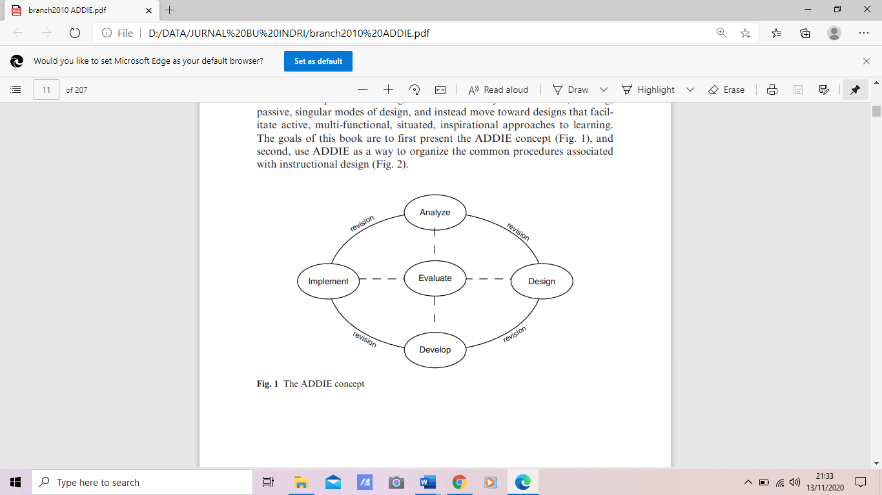
Fig. 1 The ADDIE Method Stages [4, pp.2]
Meanwhile, the research procedure in this study described in Fig. 2.
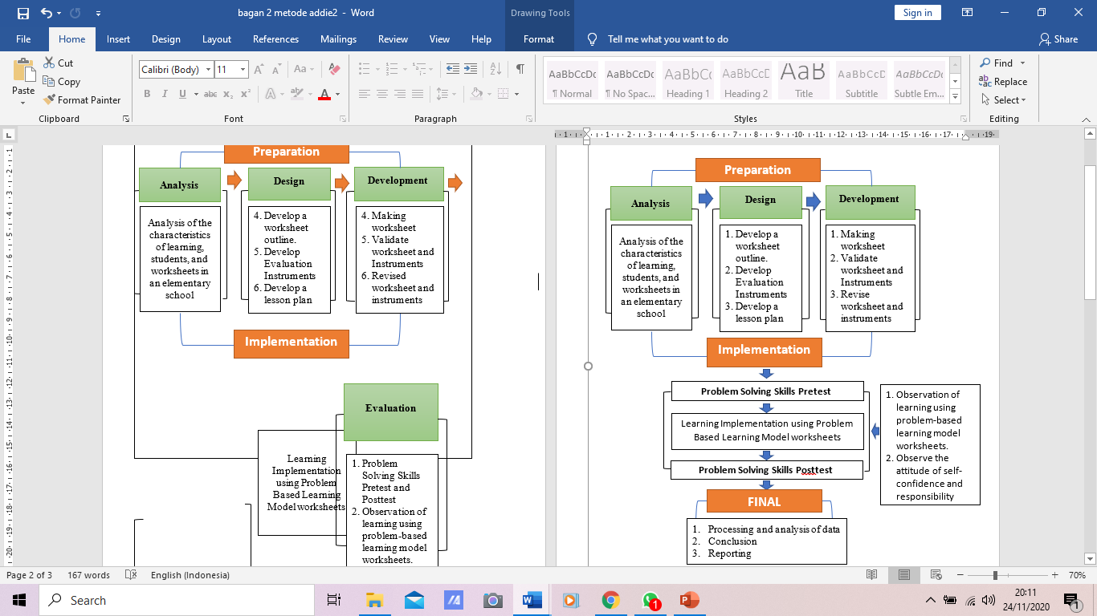
Fig. 2 Research Procedure
Fig. 2 shows that the research procedure follows the scheme of the ADDIE method. The preparation stage includes: analyze, design, and develop. The implementation stage includes: learning and evaluation. The last stage is the final stage which includes processing and analysis of data, conclusion, and reporting. The data was collected using test instruments, validation sheets, and observation sheets that had been tested by experts. Data analysis using N-Gain.

RESULT
The results of the research and discussion in this study are presented based on the results of the analysis of the research conducted.

Based on the interview
Information was obtained that the Student Book published by the Ministry of Education and Culture in 2017 is the main teaching material for grade IV students as a guide for learning activities to make it easier for students to master competencies. The Student Book is divided into nine themes, each theme consisting of three sub-themes where each sub-theme consists of six lessons. Science learning in the Student Book is integrated with other subjects which are tied together in one theme. In addition to using Student Books, students also use two types of supporting worksheets that come from certain publications. The two worksheets contain only material and evaluation questions that encourage students' knowledge retention, without containing a series of learning activities that give students experience in constructing their knowledge through scientific investigation activities to solve everyday problems.

The design of worksheet
Based on the steps for drafting worksheet from the Ministry of National Education [5], which includes: 1) curriculum analysis, namely analyzing themes, materials, core competencies, basic competencies and then translated into objectives and indicators of competency achievement; 2) compiling worksheet needs which include determining tools, materials, and procedures for learning activities; 3) set the title; 4) compiling worksheet which is designed with due observance of content suitability, didactic, construction, and technical aspects. The components in the worksheet in this study include a cover containing the title and identity of students, core competencies and basic competencies, learning objectives, learning instructions, and learning activities for the implementation of problem-based learning model steps.

To assess the feasibility of the worksheet
Three expert lecturers were validated for the worksheet, show in the table. 1.
Table. 1 Worksheet Validation Results
No. | Aspect | Percentage (%) | Category
1 | Material suitability | 82.22 | Very Good
2 | Compliance with didactic requirements | 79.45 | Good
3 | Construction | 79.63 | Good
4 | Worksheet conformity with technical requirements | 81.48 | Very Good
Average |  | 80.70 | Very Good

Based on table 1, the overall problem-based learning model worksheet reaches an average proportion of 80.70% which is in the very good category. Student worksheets have met aspects of material suitability, didactic suitability, conformance with construction requirements, and compliance with technical requirements. Thus it can be denied that the worksheets are worth using.

Implementation of problem-based learning model
The implementation of the problem-based learning model begins with the provision of a problem skill pretest to students. Furthermore, students carry out the stages of problem-based learning which include: problem orientation, formulate problems,individual and group investigations, create and present reports, analysis and evaluation of results. During the learning process, two observers made observations of learning, self-confidence and responsibility. After the learning ended, students were given posttest problem management skills. Acquisition of Pretest, Posttest, and Average N-Gain of students presented show in the table. 2.
Table. 2 Acquisition of Pretest, Posttest, and Average N-Gain
Statistical Parameters | Pretest | Posttest | N-Gain
Ideal Maximum Score | 74,00 | 74,00 | 0,71
Maximum Score | 26,00 | 71,00 | 0,71
Minimum Score | 11,00 | 35,00 | 0,71
Average | 18,94 | 57,97 | 0,71
Standard Deviation | 3,52 | 10,26 | 0,71
Based on Table. 2, it can be seen that the problem solving skills of class IV students have increased the average score. Thus it can be concluded that, learning using the problem-based learning model worksheet can improve the problem solving skills of students. Increasing indicators of problem solving skills through learning using worksheet based on problem-based learning models on the topics of force obtained from the difference in pretest and posttest scores and the ideal score of each indicator of problem solving skills can be seen in the table. 3.
Table. 3 Acquisition of Score for Pretest, Posttest, and N-Gain Indicators Problem Solving Skills
Table. 3 shows that there is an increase in each indicator of students' problem solving skills, based on the pretest and posttest after the application of problem-based models in science subjects. The increase in the high category is in the indicators of defining problems, making various choice of solutions, and making decisions. Meanwhile, the other two indicators, namely the implementation of the solution and verifying the solution are in the medium category. However, both indicators still show an increase in scores after learning. Therefore, it can be concluded that the use of problem-based learning model worksheet on the topics of force can improve every indicator of problem solving skills.
Indicator | Average |  | Ideal Max. Score | N-Gain | Category
Indicator | Pretest | Posttest | Ideal Max. Score | N-Gain | Category
Defining problems | 6,64 | 19,61 | 24,00 | 0,75 | high
Making various choice of solutions | 3,00 | 5,36 | 6,00 | 0,78 | high
Making decisions | 2,12 | 9,39 | 12,00 | 0,74 | high
Implementation of the solution | 5,91 | 17,87 | 24,00 | 0,66 | medium
verifying the solution | 1,27 | 5,72 | 8,00 | 0,66 | medium

The profile of increasing students’ 'self-confidence and responsibility
Meanwhile, the profile of increasing students 'self-confidence and responsibility through learning using the problem-based learning model worksheet on the topics of force is presented respectively in Fig. 3. and Fig. 5. It is known that the increase in students' self-confidence through learning using problem-based worksheet, can be seen in Fig. 3.
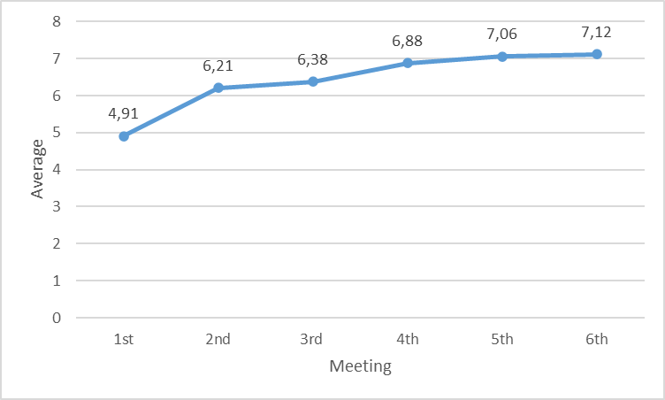
Fig. 3. The Profile of Increasing Confidence Attitude
Based on Fig. 3. it can be seen that the students' confident attitude has increased from meeting to meeting. The lowest average score for self-confidence is at the 1st meeting. Meanwhile, the highest average score of self-confidence was at the 6th meeting. The chart pattern rose sharply at the 1st meeting towards the 2nd meeting. That is, at the second meeting, the students' self-confidence has increased significantly through problem-based learning. Thus, it can be concluded that the worksheet problem-based learning model developed and used in learning the topics of force can increase students' self-confidence.
The profile of increasing students' self-confidence in each indicator, namely the courage to express opinions and dare to appear in front of the class can clearly be seen in Fig. 4.
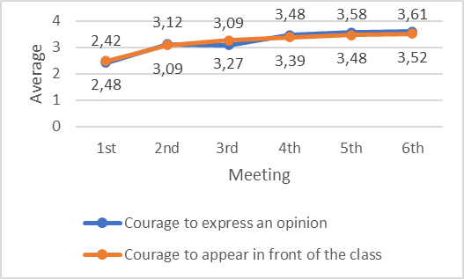
Fig. 4. The Profile of Increasing Confidence in Each Indicator
Fig. 4. shows that there is an increase in the average score of students' self-confidence both on the indicators of the courage to express opinions and dare to appear in front of the class at every meeting. The lowest average score on both indicators occurs at the 1st meeting while the highest average occurs at the 6th meeting. The average score of the first meeting on the indicator for the courage to express an opinion is 2.42 and on the indicator for the courage to appear in front of the class is 2.48. Meanwhile, the average score at the 6th meeting on the indicator for the courage to express an opinion was 3.61 and on the indicator for the courage to appear in front of the class was 3.52. A sharp increase occurred at the second meeting, while at subsequent meetings the increase occurred dynamically. Thus, it can be concluded that the worksheet developed problem-based learning model can increase self-confidence in indicators of the courage to express opinions and dare to appear in front of the class at every meeting.
During the implementation of learning using worksheet, the problem-based learning model of the topics of force was also carried out by observing the responsibility attitude of students by two observers who were teachers of the research subject schools. Observed responsibility indicators include completing assigned tasks on time, carrying out tasks that are their responsibility, and participating in groups. Thus, it can be seen that the increase in responsibility attitudes of students through learning using problem-based worksheet whose profile of improvement can show in Fig. 5.
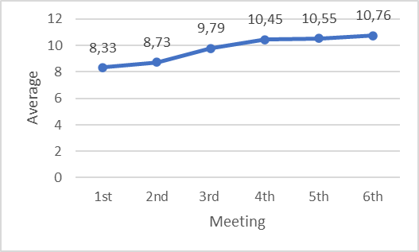
Fig. 5. Profile of Increasing Responsibility Attitudes
Based on Fig. 5. it can be seen that the responsibility attitude of fourth grade students has increased from meeting to meeting. The lowest average score of responsibility attitudes is found at the 1st meeting. Meanwhile, the highest average score of responsibility attitudes was found at the 6th meeting. The chart pattern rose sharply at the 1st meeting towards the 2nd meeting. This means that at the second meeting students almost fully have the responsibility of completing the assigned tasks on time, carrying out the tasks that are their responsibility, and participating in groups. Thus, the problem-based learning model worksheet used in learning can increase the responsibility attitude of students.
The indicators of responsible attitudes observed in this study include completing assigned tasks on time, carrying out tasks that are their responsibility, and participating in groups. The profile of increasing the attitude of responsibility on these three indicators can be seen clearly in Fig. 6.
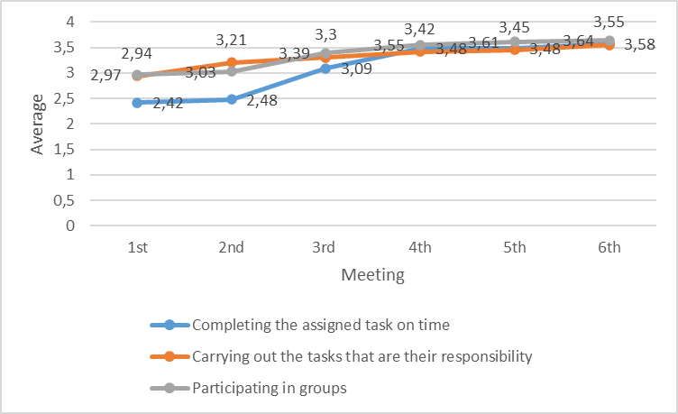
Fig. 6. Profile of Increased Responsibility for Each Indicator
Fig. 6. shows that there is an increase in the average score of the responsibility attitude of students both on the indicators of completing the assigned task on time, carrying out the tasks that are their responsibility, and participating in groups at each meeting.
- discussion
It is known that the Student Book and worksheet only contain material and evaluation questions that only emphasize the knowledge ratios of students, without containing a series of learning activities that give students experience to construct their knowledge through scientific investigation activities to solve daily problems. Curriculum analysis in worksheet design is carried out by taking into account the characteristics of the curriculum that is being used in a school. This is done so that the development carried out can be in accordance with the demands of the applicable curriculum, to what extent the themes and materials have been given to students, what material will be taught, what competencies must be developed, and the learning objectives and indicators to be achieved.
Based on the material suitability validator assessment consisting of the suitability of the material with basic competencies, the correctness of the material, and the timeliness of the presentation of the material according to the core competencies, basic competencies, indicators, and learning objectives set out in the 2013 Curriculum. which is in accordance with the needs where the breadth and depth of the material contained is in accordance with the curriculum. Regarding the correctness of the material, based on the validator's assessment, the learning materials contained in the worksheet are in accordance with the material concepts of friction and magnetic forces presented in the supporting information in the worksheet. Based on the worksheet characteristics that are presented in the research results, it can be seen that the activity steps in the worksheet are adjusted to problem-based learning steps consisting of problem orientation, formulating problems, individual and group investigations, making and presenting reports, and analyzing and evaluating the results. The implementation of the worksheet was observed by two observers from the school who were the research subjects. Based on the results of the research, it shows that all learning activities from preliminary to closing activities have been carried out in accordance with those contained in the worksheet. Activities in the problem-based learning model in science learning provide environmental conditions that encourage the imagination and curiosity of students [1]. The steps of the problem-based learning model in worksheet facilitate students to improve problem solving skills. This learning model has learning steps that are similar to the problem solving process so that it can improve problem-solving skills [6]. The model also enhances critical and creative thinking as keys to solving effective problem-solving tasks [7, 8, p. 119]. They are thus trained to be active problem solvers.
Based on the results of observations, there were several obstacles faced by students during the implementation of learning using the problem-based learning model worksheet in the form of a lack of answer columns available in the worksheet in writing information and making questions into corrective materials for the developed worksheet.
The results show the problem solving skills of students have increased through the use of worksheet problem-based learning models in science learning. This is in accordance with the results of research conducted by [17], that there is a significant difference in the problem-solving abilities of students between the implementing class and the class that does not apply the problem-based learning model. In addition, this is supported by the results of research [18] showing that the learning activities of participants, student learning outcomes, and the abilities of students after being taught by learning using worksheet increased in the high category. Increased problem solving skills of students due to the problem-based learning model worksheet encourages students to think independently in decision making for problem solving [19]. This learning model uses unstructured problems as the first step of learning to stimulate students to actively build knowledge [20, pp. 535]; [7, pp. 235].
When students apply a problem-based learning model they are trained to learn independently, set their own goals, and describe their own process for learning [9]. This is because they are in charge of their own learning process in planning, controlling, directing, application, and assessment of learning processes and outcomes [10, pp. 6]. The teacher as a facilitator tries to encourage students to accept more responsibility for their learning experience [11, 7]. This creates an attachment to learning, self-confidence as a learner, openness to challenges and acceptance of responsibility for learning [12, pp. 273]; [13, pp. 133]; [14, pp. 2]; [15]; [1, pp.64]. In other words, the situations and conditions (habituation) in the problem-based learning model allow students to get used to behaving according to values and into attitudes [16, pp. 67]. The existence of discussion, question and answer, and presentation activities can familiarize students with confidence in giving opinions and taking in front of the class. Thus, it can be concluded that the implementation of the problem-based learning model worksheet develops all the potential and competencies of students both in the aspects of knowledge, attitudes, and skills.

CONCLUSION
Based on the result and discussion it can be concluded that:1) the worksheet used in elementary schools do not have the scientific investigation activities to solve daily problems; 2) The design of the worksheet for the problem-based learning model in this study includes curriculum analysis, compiling the needs of the worksheet, set the title, and compiling worksheet; 3) the feasibility of worksheet for problem-based learning models on force materials based on expert judgment reached 80.70% with a very good category is feasible to be implemented; 4) The worksheets developed in this study have the steps of a based learning model; 5) Implementation of learning using the problem-based learning model worksheet consists pretest, implementation of steps pbl, and posttest; and 6) there is an increase in problem-solving skills, self-confidence, and student responsibility through problem-based learning through learning using worksheet problem-based learning models.
While the implementation of this research has implications for elementary school teachers, as a matter of consideration using worksheet problem-based learning models on the topics of force to improve problem-solving skills and attitudes of students. Meanwhile for other researchers, it can provide insight and conduct further research on the development of problem-based learning model worksheet on other materials and the competencies of other students.

References
- Karhami, S.K.A. dan Supriyati, Y., Development of KBM in HOTS Category at Basic Education Level, Bandung: Gapura Press, 2019.
- M. W. Berkowitz and M. C. Bier “What works in character education-Center for Character an Citizenship,” Journal of Research in Character Education, vol. 5. St. Louis, 2007, pp. 29–48.
- National Education Standards Agency, KTSP Curriculum, Jakarta: Kemendiknas, 2007.
- R.M. Branch, Instructional Design: The ADDIE Approach. London: Springer, 2009.
- Ministry of National Education, Instructional Material Development Guide, Jakarta: Directorate General of Primary and Secondary Education Management, 2008.
- H. S. Barrows. and, R. M. Tamblyn, Problem-based learning: an approach to medical education, 1st ed. New York: Springer Publishing Company, 1980.
- C.E. Hmelo-silver, “Problem-Based Learning : What and How Do Students Learn ?,” Educational Psycology Review, vol. 16, pp. 235–267, September 2004.
- W. Hung, “The 9-step problem design process for problem-based learning: Application of the 3C3R model,” Educational Research Review, vol. 4, pp. 118–141, December 2009.
- M.S. Baden, Facilitating Problem-based Learning, 1st ed. USA: Open University Press, 2003.
- S. Grabinger, J.C. Dunlap, and J.A. Duffield, “Rich environments for active learning in action: problem-based learning.,” Research in Learning Technology, vol.5, 14 Dec 2016.
- H. Barrows, H. S. “Problem-Based Learning in Medicine and Beyond : A Brief Overview, New Directions for Teaching and Learning, vol. 68 pp. 3-12, August 2006.
- B.J.S. Barron, D.L. Schwartz, N.J. Vye, A.L. Zech, J.D. Bransford, “Doing with understanding : lessons from research and project-based learning, “ The Journal of the Learning Sciences, vol 7, pp. 271–311, Jun 2011.
- M.H., Davis, M.H. and R.M. Harden, “The continuum of problem-based learning,” Medical Teacher, vol. 20, 1999, pp. 317-22.
- N. Sockalingam, J. Rotgans, and H.G. Schmidt, “Student and tutor perceptions on attributes of effective problems in problem-based learning,” High Educ, vol.62, pp. 1–16, August 2010
- K. Eun and K. Hye Young, , “Effects of Simulation-based Education Combined Team-based Learning on Self-directed Learning, Communication Skills, Nursing Performance Confidence and Team Efficacy in Nursing Students,” Journal of Korean Academy of Fundamentals of Nursing, vol 24, pp.39–50, February 2017.
- D. Budimansyah, Character Based Learning Design, Bandung: Widya Aksara Press, 2019.
- O. Akınoğlu and R.O. Tandoğan, “The effects of problem- based active learning in science education on students’ academic achievement, attitude and concept learning,” Eurasia Journal of Mathematics, Science & Technology Education, vol. 3, pp. 71–81, Juny 2007.
- Y. Hala and A.M. Taiyeb, “The Influence of Using Student Worksheets Based on a Scientific Approach to the Activities and Outcomes of Class VII Biology Science Learning at SMP Negeri 2 Students,” Jurnal Sainsmat, vol. 5, pp. 42–57, March 2016.
- J. Beckmann and P. Weber, “Cognitive presence in virtual collaborative learning: Assessing and improving critical thinking in online discussion forums,” Interactive Technology and Smart Education, vol. 13, pp. 52–70, January 2019.
- D. H. J. M. Dolmans and H.G. Schmidt, “What directs self-directed learning in a problem-based curriculum?,” In Problem-Based Learning:A Research Perspective on Learning Interactions Erlbaum D.H. Evensen and C.E. Hmelo (eds.), New York: Mahwah, 2000, pp. 251– 262.

