The Development of Intelligence Test Instrument for Children with Hearing Impairment

Ana Rafikayati, Sambira
Special Education Department
Universitas PGRI Adi Buana
Surabaya, Indonesia
ana@unipasby.ac.id, sambira@unipasby.ac.id
Mudhar
Guidance and Department Department
Universitas PGRI Adi Buana
Surabaya, Indonesia
mudhar@unipasby.ac.id

Abstract— Children with hearing impairment known to have an average IQ below average. After further analysis the results are obtained because the tests given are verbal test. Whereas for children with hearing impairment, they have difficulty in understanding verbal language. Therefore, it is necessary to develop intelligence tests adjusted to their characteristics. The aim of this study was to describe the development process of intelligence test instrument for children with hearing impairment, and describe the intelligence test instrument as product developed. This research used Research and Development research (R & D) by Borg and Gall's (1983) that consisting of 10 stages start from research and information gathering to dissemination. The research subjects in this study were 76 students of SDLB-B Karya Mulia Surabaya consisting of grade 1-6 elementary school and teachers. The primary data collection technique in this study was through observation to students and supported by interview to the teachers as secondary data. The data analysis technique used narrative data analysis techniques. The result of this research was intelligence test applications for children with hearing impairment that are visualized into sign language and animation videos.

Keywords—Intelligence Test Instrument, Children with Hearing Impairment

Introduction
Intelligence is the embodiment of a power in humans that affects a person's ability in various fields. Intelligence plays a role in storing and binding back an information, constructing concepts, capturing relationships and making conclusions, processing materials and composing a combination of materials ([1].
It was known that the IQ of children with hearing impairment was at the level of mental retardation. The same thing was found when they conducted a study again in 1924, the IQ of children with hearing impairment was below the hearing children. This research reported based on the results of the investigation of research on IQ tests of children with hearing impairment in 1930-1967 obtained data that most of the results showed similar results which was the IQ of children with hearing impairment under hearing children, especially for profound hearing loss children [2].
Although there have been many research results stating that the intelligence of children with hearing impairment is below average, it should be re-analyzed about the measuring instruments used in measuring the IQ of children with hearing impairment. There were many biased studies of psychologists, the habit of measuring the IQ of children with hearing impairment consisted of bias in the test method, sample of research subjects, and lack of experience of the tester [2].
The intelligence characteristics of children with hearing impairment generally have the same distribution of IQ scores as hearing children [3]. Even if there are difficulties that arise, are more associated with talking, reading and writing but these rights are not related to the level of intelligence. In general, intelligence of children with hearing impairment is no different from other children. So, like other children, there are those who have an above-average intelligence level, average and under-average [4].
For now, intelligence tests that are often used are still verbal intelligence tools. So that when children with hearing impairment is tested for intelligence, the results are below average. This happens not because their intelligence is low, but because the measuring instruments used cannot measure their intellectuality precisely because of language development disorders experienced by children with hearing impairment due to hearing loss. To measure intelligence of children with hearing impairment appropriately, test instrument should be made in the form of performance tests, such as form board test, picture completion, block design and other forms that are more visual. In addition, the tester should also be a person who is experienced in interacting with them, so that deviations from test results do not occur [5].
In the case of nonverbal intellectuals, children with hearing impairment and hearing children have the same ability [6]. Children with hearing impairment who master the language get better language ability scores than children with hearing impairment who do not master the language on all measures of performance and verbal IQ [7]. This can be interpreted that some considerations need to be taken in the use of intelligence testing equipment. This is very important so that the child can be given an intervention quickly and precisely. The late identification of children with hearing impairment and delayed early intervention services had an impact on the low communication skills and language [8].
Due to hearing impairment, children with hearing impairment have difficulties in communicating verbally, both expressively (speaking) and receptive (understanding the speech of others) [9]. This situation causes deaf children to experience obstacles in communicating with other people. On verbal intelligence tests, deaf children are less able to demonstrate their abilities because of the developmental language disorders. The results of intelligence tests for children with hearing impairment are low not because children cannot answer questions but because children do not understand the instructions given.
Based on the phenomena, it is known that inaccuracies often occur in measuring intelligence on children with hearing impairment. This is because the existing test equipment does not measure children’s intelligence appropriately because of the nature of verbal testing instruments while deaf children experience interference with language development and verbal communication. Therefore, it is necessary to develop intelligence tests that are adapted to the characteristics of children with hearing impairment.
The Wechsler Intelligence Scale for Children (WISC) intelligence test is one of the most frequent and commonly used tests in psychology. The WISC test is the intelligence test most often used by psychologists. Based on interviews with 30 psychologists at the Indonesian Psychology Association in East Java on January 16, 2016 regarding intelligence tests used, 13 stated that they often used WISC, 11 Binet Simon and 6 people used other test instruments.
The WISC intelligence test is an intelligence test for children aged 8-15 years. This test consists of 2 types of tests, namely verbal tests and performance tests. Verbal tests consist of information material, understanding, calculation, equation, vocabulary, range of numbers. While the performance test consists of completing images, arranging images, designing blocks, assembling objects, symbols, and mazes [1]. In implementing the WISC test for children with hearing impairment, many experts use modifications and adaptations. Some experts choose to only use performance tests and some are still using both (verbal and performance) with some modifications such as adding images. Even so, there are no specific rules that are patented so that the test model that is most suitable for children with hearing impairment is unknown.
Based on this explanation, the need for intelligence test instrument for children with hearing impairment has not been fulfilled. These researchers conducted research on the development of the WISC intelligence test for children with hearing impairment. The study developed the intelligence instrument for children with hearing impairment. With intelligence tests that are appropriate to the characteristics of children, it is expected that the IQ of children with hearing impairment can be measured precisely by measuring instruments that are appropriate to the characteristics of children so that educational services can be provided in accordance with the potential possessed and they can develop optimally.
The purpose of this study was to (1) describe the development process of intelligence test instrument for children with hearing impairment, and (2) describe the intelligence test instrument for children with hearing impairment as product developed.

Method
This research used Research and Development research (R & D) by Borg and Gall's (1983) that consisting of 10 stages start from research and information gathering to dissemination [10]. This research took place at the Karya Mulia Surabaya SDLB-B. The research subjects in this study were 76 students of SDLB-B Karya Mulia Surabaya (elementary special school) in Surabaya consisting of grade I-VI elementary school, children with hearing impairment teacher and psychologist. This location was chosen because SDLB-B Karya Mulia Surabaya is also a school that uses the Indonesian Language Sign System (SIBI) in teaching and learning process. In addition, SDLB-B Karya Mulia Surabaya is the biggest special school for children with hearing impairment in East Java so that the number of research subjects can be fulfilled. The primary data collection technique in this study was through observation to students and supported by interviews with teachers as secondary data. The data analysis technique to analyze the development process and product in this study was narrative data analysis techniques.

Result and Discuccion

Description and discussion of the process of development of intelligence test instrument for children with hearing impairment.

Research and Collection of Information
At this stage researchers conducted preliminary studies to determine the need for intelligence tests for children with hearing impairment the characteristics of intelligence tests for children with hearing impairment. To find out the urgency of the importance of developing intelligence tests for children with hearing impairment, a survey was conducted for children with hearing impairment teachers to find out the urgency of developing intelligence tests for children with hearing impairment and for knowing the characteristics of intelligence tests suitable for children with hearing impairment.
To measure the urgency of developing intelligence instrument for children with hearing impairment, researchers collected information on 48 research subjects consisting of 8 children with hearing impairment, 4 psychologists, and 16 children with hearing impairment. Based on data from interviews conducted, it was known that almost all parties agreed to adapt the development of intelligence test instrument.
While based on the results of observations of 10 students with hearing impairment it is known that most children obtain low IQ test results due to language barriers. Based on the results of these tests, it is known that in verbal tests the child gets a low score, but when the tests are non-verbal the child gets an average score there are even some who are on average. The results of this observation further strengthened the need for modification of the development of special intelligence tests instrument for children with hearing impairment.
Whereas to gather information about the characteristics of intelligence tests that are suitable for children with hearing impairment, researchers conducted a study of 4 children with hearing impairment, 2 psychologists, and 5 teachers. From the results of interviews and observations it is known that the characteristics of intelligence testing tools for children with hearing impairment include (1) instruction must be short, (2) using words that are easy to understand, (3) using paraphrase, (4) instructions must be in visual form (which can be helped by pictures and videos), (5) using sign language, and (6) using demonstrations.

Development Planning
After the information about the characteristics of intelligence tests was obtained, then the research team modified the WISC intelligence test text into an intelligence test script that was appropriate to the characteristics of children with hearing impairment. The form of modification is done, including: (1) simplifying instruction sentences, (2) eliminating the complex instructions.

Preliminary Product Development
After the script has been repaired (in accordance with the characteristics of children with hearing impairment), then taking videos. Video capture is done with the Sign Language interpreter model. The next development is to change the instructions that used to be text into Sign Language videos. Thus, children with hearing impairment who have problems in language can understand the instruction.
Video shooting is done by adapting the WISC intelligence test consisting of 11 aspects, which are : information, comprehension, arithmetic, similarities, vocabulary, digit span, picture completion, picture arrangement, block design, object assembly, and coding. All aspects mentioned in the language require that instructions in each aspect can be understood by children with hearing impairment
Video shooting has been done in the previous stage. Then at this stage researchers will begin to assemble a collection of videos into interactive multimedia. The software used is Macromedia Flash. With this application, video collection can be packaged to be more interactive by combining shapes, text and another image assistance. In addition, to facilitate the use of products, this product is also equipped with a guidebook for the use of test instrument.

Preliminary Trial
At this stage researchers conducted preliminary trials by testing the content and design validation of the experts. As for the experts in this study were 2 psychologists, 2 media experts (design), and 2 sign language interpreters. The data analysis technique used in this research is the qualitative data analysis [11]. Then the data was evaluated which are very feasible for score 4.0−5.00, feasible for score 3.0−3.99, enough feasible for score 2.0−2.99, less feasible for score 1.0−1.99, and not feasible for score 0.0−0.99. Based on the results of data analysis, the feasibility of the intelligence test application from content experts was 3,538 (feasible), design expert was 4 (very feasible) and feasibility of readability was 3,945 (feasible).
At the same time, validation is also given to children with hearing impairment. The research subjects at this stage were 6 students of SDLB-B Karya Mulia Surabaya. The 6 students are grade 1-6 students, each one student in each class. To get the results of trials on research subjects, researchers used observation techniques to students and interviews with teachers as companion during the trial test. All data is collected and analyzed as consideration in revising the main product.

Main Product Revision
After getting input from experts and based on observations to the research subject and interviews with the teacher in the preliminary trial, the researchers then revised the product. From the results of this revision, produced a draft intelligence test product for children with hearing impairment.

Main Field Testing
After the product was revised, a major trial was then conducted on 30 students of SDLB-B Karya Mulia Surabaya who had not been the subject of previous research in the preliminary trial. In this test randomly consists of students in grades 1-6.

Operational Product Revision
Based on observations to students and interviews with teachers in the main trial, the researchers then revised the product.

Operational Field Test
After the product was revised, a major trial was carried out to 40 students of SDLB-B Karya Mulia Surabaya who had not been the subject of previous research in the preliminary trials and main trials. In this test randomly consists of students in grade 1-6.

Final Product Revision
After conducting the trial, the researchers then revised the final product before being mass-produced.

Dissemination and Distribution
Furthermore, at the final stage, the researcher disseminated the results of the development of products for intelligence test instrument for children with hearing impairment to professional users through international meeting forums and in accredited national journals. In addition, the products from this development are also registered to patent rights.

Description and discussion of the intelligence test instrument for children with hearing impairment
Development of intelligence test instrument for children with hearing impairment adapted the WISC intelligence test. The adaptations made are as follows.
- Changed some instructions in the test instrument because the language used is too complex and difficult to understand for children with hearing impairment
- Eliminated some of the instructions that children with hearing impairment does not understand
- Changed verbal instructions into sign language visualized through video
- Changed the hard file media to soft file in the form of animation
- Presented test instrument in one application (software)
- This intelligence test application is equipped with a guide book on the use of applications for psychologists. This usage guide book is produced in print in the form of a book with A5. This guidebook is produced in print because printed books are more comfortable to read. Beside that A5 size was chosen to aim of practicality. With a small size, this guidebook can be carried everywhere because it does not take up space and is enough to put in a bag.
- The WISC intelligence test instrument for children with hearing impairment consists of 10 parts. In its development, the ten sections were developed and adapted according to the characteristics of deaf children. This is consistent with Mc Kay (2010) which states that a good evaluation tool is one that can be well understood by students so that they can avoid misperceptions of answers.
- Considering that the product is designed to be used by psychologist, the sign language used is accompanied by sound and subtitles. This is done to facilitate users in using this product.
- In addition, instructions and parts per aspects are explained in detail to avoid misinterpretation. A sentence is said to be effective if (1) appropriately represents the author's ideas, (2) able to generate the same ideas in the reader's mind as thought’s writer [12].
The description of intelligence test applications for children with hearing impairment can be seen in Figure 1 and 2 as follows.
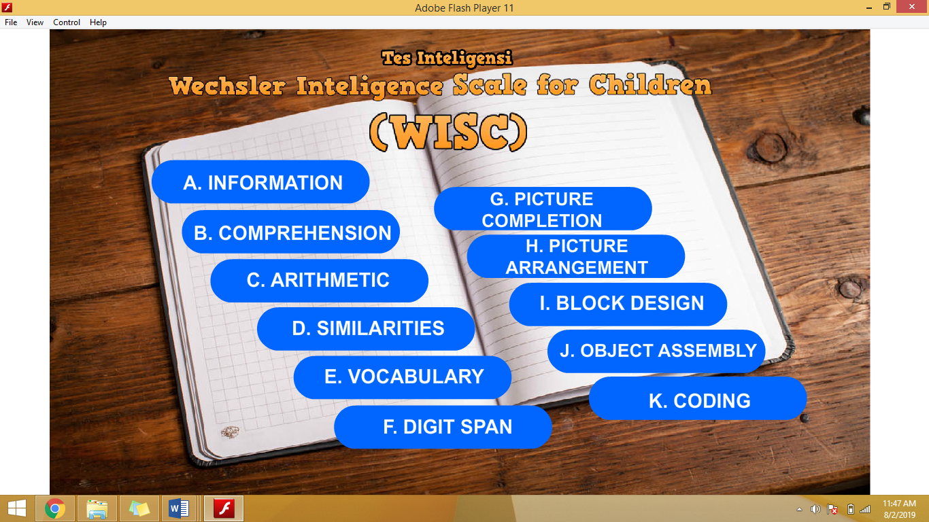
- The Display of Front Page Menu of The Application
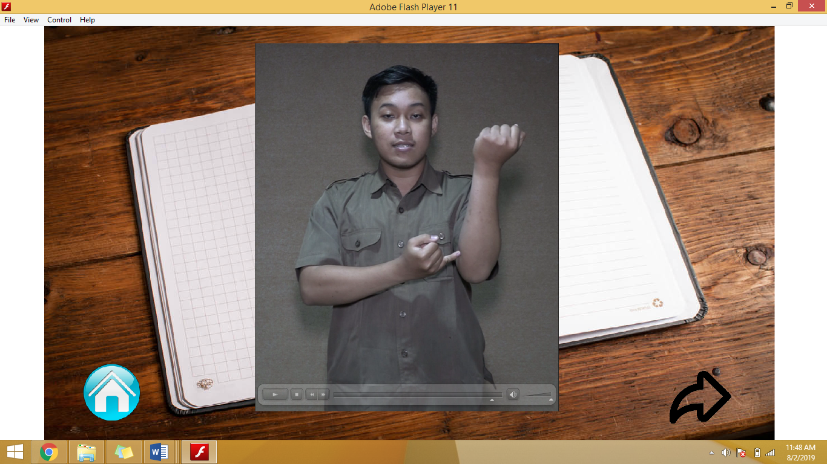
- The Display of Instructions (Questions) in Sign Language

Conclusion
- The process of development of the WISC intelligence test instrument for children with hearing impairment consists of 10 stages, namely: research and information gathering, planning, preliminary product development, preliminary trials, major product revisions, main trials, operational product improvements, operational trials, final product improvements, and dissemination.
- The product development results, intelligence test applications for children with hearing impairment that visualize into Sign Language and animation videos. This intelligence test application is equipped with a usage guide book to facilitate users in this case psychologists in conducting tests for children with hearing impairment.

References
[1] Nur’aeni, Tes Psikologi: Tes Intelegensi dan Tes Bakat. Yogyakarta: Pustaka Pelajar, 2012.
[2] M. Vernon, “Fifty years of research on the in telligence of deaf and hard-of-hearing children: A review of literature and discussion of implications,” Journal of Deaf Studies and Deaf Education. 2005, doi: 10.1093/deafed/eni024.
[3] R. M. Gargiulo, Speial Education in Contemporary Society: An Introduction to Exceptionality 4th ed. California: Sage Publication. Inc., 2012.
[4] H. T. S. Somantri, Psikologi anak luar biasa. 2007.
[5] M. Affendi, “Pengantar Psikopedagogik Anak Berkelainan,” Mycol. Res., 2006.
[6] J. P. Braden, “The structure of nonverbal intelligence in deaf and hearing subjects.,” Am. Ann. Deaf, 1985, doi: 10.1353/aad.0.0135.
[7] M. D. Remine, “The relationship between spoken language ability and intelligence test performance of deaf children and adolescents,” J. Deaf. Educ., 2009.
[8] P. Kushalnagar, K. Krull, J. Hannay, P. Mehta, S. Caudle, and J. Oghalai, “Intelligence, parental depression, and behavior adaptability in deaf children being considered for cochlear implantation,” 2007, doi: 10.1093/deafed/enm006.
[9] Wagino, “Pelaksanaan Auditory Verbal Therapy (AVT) dalam mengembangkan keterampilan berbahasa anak tunarungu,” J. Pendidik. Luar Biasa UNESA, vol. 9, no. 1, 2013.
[10] M. D. Borg, W. R., & Gall, Educational research. an introduction (5th ed.). White Plains: NY: Longman., 1989.
[11] Leksono, “Pengembangan Media Pembelajaran Berbantuan Komputer untuk SMA Pada Materi Amfibi,” J. Inov. dan Perkayasa Pendidik., vol. 1, no. April, 2010.
[12] G. Keraf, Sebuah Pengantar Kemahiran Berbahasa. Ende Flores: Nusa Indah, 1984.

