4c-Based Cooperative Learning Model Through Lesson Study Activities On Indonesian Course For Elemantary School

1st Denna Delawanti Chrisyarani
Elementary Teacher Education Program
Universitas Kanjuruhan Malang
Malang, Indonesia
dennadelawanti@unikama.ac.id
2nd Dwi Agus Setiawan
Elementary Teacher Education Program
Universitas Kanjuruhan Malang
Malang, Indonesia
setiawan@unikama.ac.id

Abstract— The implementation of Indonesian Language of Primary School course should be directed to the development of 4C (Communication, Collaboration, Critical Thinking, and Creativity). To create effective and interesting learning process, teacher must direct the learning activity by implementing Cooperative Learning (Picture and picture, Jigsaw, Demonstration, and Student Teams Achievement Division (STAD)), Think Pair Share (TPS), and Role Playing. This research employed Lesson Study activity consisting of three stages as follows: Plan, Do, and See. The activity of this research in Cycle I invited students to perform picture observation skills, the activity in Cycle II invited students to observe an article, the activity in Cycle III invited students to perform a speech, the activity in Cycle IV invited students to carry out reading skill (performing read aloud activity), and the activity in Cycle V invited students to carry reading comprehension. Based on the results of Lesson Study activity from Cyle I to Cycle V, students’ active involvement increased. At the beginning, only students with higher abilities actively involved in the learning process. As the activities went on, almost all students actively involved. The use of the cooperative learning model in each cycle by paying attention to the implementation of 4C can help students to improve their language skills (listening, speaking, reading). The implementation of Lesson Study with the 4C-based cooperative learning model allows students to be actively involved in learning and moreover, the lecturers are able to improve the quality of learning.
Keywords— Indonesian Language , Lesson study, 4C

Introduction
The quality of education is generally associated with increased achievement, renewal of the learning process, and skills achieved. A 4C skill (Communication, Collaboration, Critical Thinking and Problem Solving, and Creativity and Innovation) is a skill that is identified as a 21st century skill and it is essentially prominent to achieve the objectives of the 2013 curriculum [1]–[4]. Through 4C skill, students actively establish a certain understanding, skills, and attitude. Students no longer absorb and verbally memorize the knowledge conveyed and delivered by the lecturer (transfer of knowledge) yet, they process the information obtained and form new ideas.
The course of Indonesian Language for Primary School allows students to acquire language skills. There are four language skills that must be acquired by students, specifically listening, speaking, reading and writing [5]. These four skills require to be acquired and understood by students as pre-service primary school teachers, therefore, there will be no misconceptions or miscomprehension when delivering the lesson content later when they serve as an in-service teacher. Indonesian Language learning for primary school is already based on student-centered approach. However, in its implementation, there are still some students who are less active during the learning process. In addition to being based on student-centered approach, Indonesian Language subject for primary school requires to lead to the development of 4C skill (communication, collaboration, critical thinking, and creativity) [6], [7].
Communication skills are one of the 4C skill components and it is exceptionally important to be used in an individual’s daily life [8]. Communication skills, in specific, constitute as the delivery of thoughts, either verbally or in writing, using clear sentences, conveying orders clearly. Lecturers are able to train students' communication skills through demonstration activities of language skills. Collaboration activities are able to be developed through group discussions [9]. Students can collaborate with peers through group discussions of the assignments given.
Learning can be effective and enjoyable by using cooperative learning [10]. Through cooperative learning model, it helps students process information that occurs in learning [11]. There are several types of cooperative learning models, specifically Picture and picture, Jigsaw, Demonstration, Student Teams Achievement Division (STAD), Think Pair Share (TPS), and Role Playing.
In addition to the application of models that are able to activate students engagement, there is a need for collaboration between lecturers. Lesson Study is a lecturer coaching program that has been carried out in the Primary School Education study program to establish a learning community. Lesson study is expected to improve the professional competence of lecturers and student achievement [10], [12].
Lesson study innovations that will be developed is a lesson study with a 4C-based cooperative learning model (communication, collaboration, critical thinking, and creativity). The 4C-based cooperative learning model began with the lecturer giving apperception to students to find out their initial abilities. Lecturers gave problems to students to solve, students' 4C abilities were developed during discussion and conveyed the results of the discussion. Accordingly, the learning process can be focused on solving the problems given to students.

Methode
This study employed Lesson Study activities. Lesson study was carried out in three stages, specifically: the stage of planning (Plan), the stage of implementation (Do), and the stage of reflection (see) [13]–[16].
The first stage was planning (Plan). At this stage, the Lesson Study team for the Indonesian Language of Primary School course conducted a discussion about the lesson plans that would be delivered to students. This activity was carried out with the aim of determining appropriate models, methods, media, and teaching materials that could be used in the learning process. At the stage of planning, the team drafted a chapter design, lesson design, Lesson Plan, Student’s Worksheet, and observation sheets. The second was the stage of implementation (do). At this stage the team of lecturers in the Indonesian Language of Primary School course conducted activities in accordance with the job desks that have been determined at the stage of planning. The assignment was divided into observers and model lecturers. The activities in the stage of implementation were by doing apperception, forming groups, giving assignments that concern on language skills development (reading, listening, writing, and speaking), group discussions, presentations, providing learning material enrichment, giving motivation to students, and concluding the whole activities carried out.
The third stage was the stage of reflection (See), which was to reflect on the learning process that has been carried out. During the stage of reflection, the lecturer who teaches the subject discussed the observation results. The results of the observations were discussed to find out weaknesses, mistakes and student problems during the learning process and to find solutions to improve the learning activities in the next cycle.

Result and discussion
The implementation of the Lesson Study activities that have been carried out in the Indonesian Language for Primary School course from Cycle I-VI was going according to predetermined plans. In the Cycle I, the activity allowed students to discusses the learning material of applying image observation skills. In the Cycle II, the activity invited students to perform listening activities to articles. In the Cycle III, the students were invited to perform a speech. In the Cycle IV, the students were invited to improve speaking skills by presenting a storytelling activity. In the Cycle V, it trained students’ reading skills through read aloud technique. In the Cycle VI, it trained students’ ability regarding reading comprehension. Lesson Study activities began with planning (plan), and continued by implementing (do), and concluded by carrying out a reflection (see). The implementation of this learning aimed at increasing knowledge that leads to critical and creative thinking, collaborative, communicative, responsibility, and cooperation among students. In each cycle, it started by performing a planning stage. This planning constituted activities in making chapter design, lesson planning design, lesson design, student’s worksheet, and observation sheet.
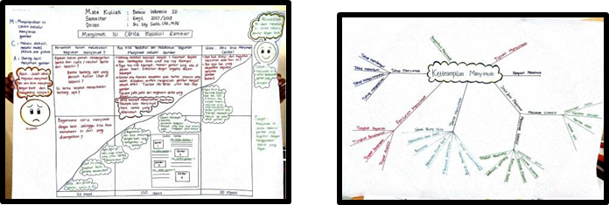
Figure 1. The Lesson Study (Consisting of Lesson Design and Chapter Design) of Indonesian Language for Primary School Course

The Cycle I activity was an Image Observation. The treatment in the first cycle started by assigning assignments to students, followed by learning discussions and continued by sharing between groups.
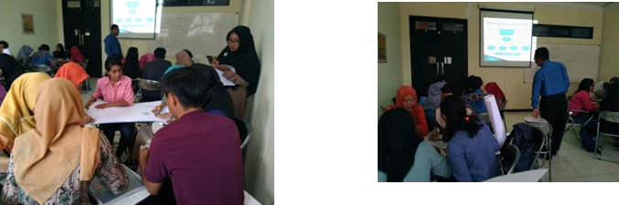
Figure 2. The Process of The Implementation Stage (Do) during Indonesian Language for Primary School Course
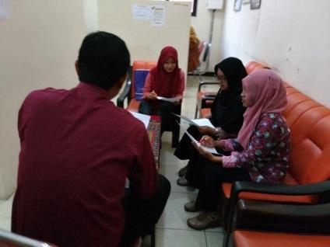
During the activity in Cycle I, it employed picture and picture learning model. When performing the stage of reflection (See), the lesson study teams discussed regarding the activity carried out in the stage of implementation. Based on the observation carried out by the appointed observers, it was observed that the group division made by teacher was too big and the discussion was ineffective.

Figure 3. The Implementation Stage (Do) during Indonesian Language for Primary School Course

The solution offered to improve learning activities in Cycle II was a consideration of proportional group member division by teacher to create an effective discussion process. Based on the observation on the model lecturer during the implementation stage, it was found that the learning activities carried out were enjoyable. During the learning process, students engaged in the activity of arranging pictures and composed it into a complete story. In addition, it was found that the preparedness of the model lecturer in planning the learning activity was good.
In Cycle II, the model lecturer employed Jigsaw learning model which comprised of two primary activities: group discussion and sharing between groups. In Cycle II, the learning material delivered was observing an article.
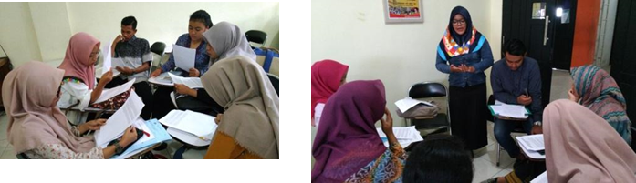
Figure 4. The Implementation Stage (Do) of Cycle II during Indonesian Language for Primary School Course
Based on the results of observation, it was found that the students were not completely paying attention to the article delivered. Most of the students focused more on the individual preparation before presenting an article. Therefore, the students paid less attention to the article presented.
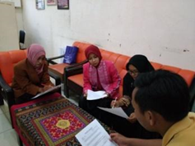

Figure 5. The Reflection Stage (See) of Cycle II during Indonesian Language for Primary School Course
During the observation to the model lecturer, it was found that the learning activity carried out, reviewing article, was able to train and advance students’ concentration and critical thinking. In addition, it was found that Jigsaw learning model used by the model lecturer during lesson study was effective. The group division was efficient and it allowed each student to take an equal part.
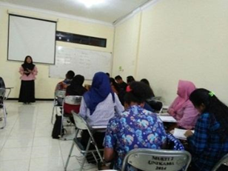
In Cycle III, the model lecturer employed demonstration learning model which consisted of three primary activities: demonstrating (delivering a speech), group discussion, and sharing between groups.

Figure 6. The Implementation Stage (Do) of Cycle III during Indonesian Language for Primary School Course
During the stage of reflection (See), it resulted an observation result based on the implementation stage of lesson study (Do). Based on the observation, it was found that students were not able to improve their speech since they were not accustomed to. In addition, when delivering their speech, most students were not focused since they spent too much time to memorize the content of their speech. Therefore, based on the discussion results concerning the implementation of Cycle III, it requires an improvement on the preparation of students’ performance in delivering a speech. It also needs to reinforce individual responsibility when paying attention to the individual assignment to make the upcoming Cycle IV can run well. Furthermore, based on the observation to the model lecturer, it was found that the model lecturer was able to provide an enrichment to the students and were able to provide a proper conclusion based on the group finding. The learning model employed was also able to train students’ speaking skill. Last but not least, the preparation of students related to speech text was good since they prepared the speech text in their home.
During the implementation of Cycle IV, the learning process was carried out by using STAD learning method with multimode approach which consisted of discussion, question and answer session, role playing, and providing individual assignment.
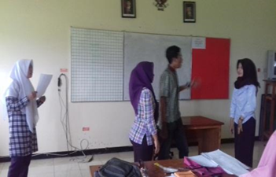
Figure 7. The Implementation Stage (Do) of Cycle IV during Indonesian Language for Primary School Course

Based on the results of the stage of reflection (See), it was found some drawbacks during the stage of implementation as follows: when performing a storytelling, students were not maximum in representing the role that they needed to demonstrate. It was also found that there were some students who took less role. Furthermore, some of the stories prepared by students were not in accordance with the scenario. Providentially, the model lecturer has been able to encourage students to actively involve in the learning activity through role playing game. In addition, some students have been able to improve during storytelling performance since students’ speaking ability has been trained during the implementation of Cycle IV.
In Cycle V, the model lecturer implemented the learning process by employing STAD learning model with multimode approach which consisted of discussion, question and answer session, demonstration, and individual’s assignment. Based on the results in the stage of reflection (See), it was found that the text used for storytelling, poem reading, and dialogue were similar with the text used by the lecturer. Thus, the contents were less varied. The students did not use the text provided in the student’s worksheet. During the presentation, the students focused more on the text presented in the slide, thus the students had poor interaction with the audience. Based on the discussion on the reflection stage, it requires an improvement for the Cycle VI to create more satisfactory learning process to achieve learning objectives.

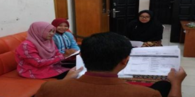
Figure 8. The Reflection Stage (See) of Cycle V during Indonesian Language for Primary School Course
During the implementation of Cycle V, students’ performance in reading the text was good since they were not demanded to memorize the content of the text. In addition, it was also found that the student’s collaboration in group work has been effective and the distribution of assignment has been efficient. Furthermore, when examining the prepartion of the model lecturer, the model lecturer has demonstrated good preparation before carrying out learning activity. At the end of the learning, the model lecturer also provided an enrichment and conclusion of the lesson.
In Cycle VI, the model lecturer implemented Think Pair Share learning model with multimode approach which consisted of brainstorming, discussion, individual’s assignment, question and answer session, and presentation.
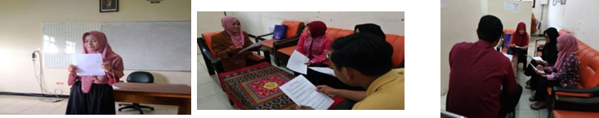
Figure 9. The Stage of Implementation (Do) and Reflection (See) in Cycle VI during Indonesian Language for Primary School Course.
Based on the observation carried out by the appointed observers, during the implementation stage (Do), the learning activity was properly applied and it was not found a crucial issued. The learning activity carried out was in accordance with student-centered approach and it was effective. During Cycle VI, the preparation by the lecturer was maximum and suitable. The model lecturer provided a systematical direction to students before continuing to the core lesson. Thus, it offers students a chance to improve the reading ability.
Furthermore, based on the summary of lesson study activity consisting of the stage of planning, the stage of implementation (do), and the stage of reflection (see) [12], [16]. Each learning activity implemented in the lesson study was started by the stage of planning. The stage of planning offers the model lecturer to make a plan and design learning instrument such as Lesson Plan, Chapter Design, Lesson Design, Student’s Worksheet, and Observation Sheet. The stage of planning implemented by the model lecturer has been in accordance with the requirements and taking into consideratiomn students’ characteristics and initial condition. The planning was created and taking into account some important aspects for students such as cooperation, confidence, language skills based on critical thinking ability, creative thinking, collaboration, and communicative [17].
The next activity was the stage of implementation (do). The stage of implementation was started by intial activity of lesson activity. During this stage, an appreciation was given to connect the lesson contents to be learned with students' experiences or previous learning acquired. This stage allowed the lecturer to deliver learning content and learning objectives. In addition, the lecturer divided that students into some groups and gave assignments to students that lead to language skills development. In this activity, students took an active engagement because the learning activities carried out allowed students think critically, creatively, collaboratively, and communicatively [3], [18]. This activity was carried out to prepare the students to acquire some important soft skills that are beneficial for them later in the community. .
The implementation learning activities are proven to increase learning activity in the classroom. In addition to implementing 4C, the lecturer also applied a cooperative learning model. Cooperative learning leads to the formation of small groups (4-6 students) that allow students to discuss, solve problems, and complete tasks in groups to achieve common goals. Cooperative learning includes a learning model in which students work in small groups (generally 4-6 students) [19]. In cooperative learning students have the opportunity to ask questions, answer, give suggestions, and critically reflect on ideas [17], [20].
The final activity after the learning process is reflection (see), where the observers and the model lecturer gather to discuss the results of the observations. The reflection activity reviewed the input to the model lecturer about the learning process and also student activities during the learning process. Therefore, the input will be beneficial for achieving better goals in the further learning [21].

Conclusion
The implementation of Lesson Study during Indonesian Language for Primary School course has generally run well based on the stages which consisted of the stage of planning, the stage of implementation, and the stage of reflection. In addition, it was found that the students’ activities and involvement in the learning process were increasing. The use of cooperative learning in each cycle by paying attention to the application of 4C was able to help students improve language skills (listening, speaking, reading and writing). Students were increasingly responsible for collaborating in Indonesian Language for Primary School course. The suggestions given were the need for continuous Lesson Study workshops (chapter design and lesson design), thus, the lecturer team could improve the quality of learning..

References

[1] A. Tanak, “Designing Tpack-Based Course For Preparing Student Teachers To Teach Science With Technological Pedagogical Content Knowledge,” Kasetsart J. Soc. Sci., Vol. 41, No. 1, Pp. 53–59, 2020.
[2] I. W. Redhana, “2239 Mengembangkan Keterampilan Abad Ke-21 Dalam.”
[3] E. Prihadi, P. Keterampilan, P. Mata, P. Pai, D. A. N. Budi, And E. Prihadi, “Pengembangan Keterampilan 4c … [,” No. 5, Pp. 464–479, 2016.
[4] A. Harjono Et Al., “Jurnal Ilmiah Profesi Pendidikan Identifikasi Kesiapan Lkpd Guru Terhadap Keterampilan Abad 21 Pada Pembelajaran Ipa Smp Jurnal Ilmiah Profesi Pendidikan,” Vol. 3, No. November, Pp. 124–128, 2018.
[5] I. Zulaeha, “Volume 12 , Nomor 1 , April 2013,” J. Penelit. Bahasa, Sastar, Dan Pengajaran, Vol. 12, No. April 2013, 2016.
[6] Y. Cleovoulou And P. Beach, “Teaching Critical Literacy In Inquiry-Based Classrooms : Teachers ’ Understanding Of Practice And Pedagogy In Elementary Schools,” Teach. Teach. Educ., Vol. 83, Pp. 188–198, 2019.
[7] C. P. Dwyer, M. J. Hogan, And I. Stewart, “An Integrated Critical Thinking Framework For The 21st Century,” Think. Ski. Creat., Vol. 12, Pp. 43–52, 2014.
[8] L. Mendelman, “Critical Thinking And Reading,” No. December 2007, Pp. 300–302, 2008.
[9] H. Alrayah, “The Effectiveness Of Cooperative Learning Activities In Enhancing Efl Learners’ Fluency,” English Lang. Teach., Vol. 11, No. 4, P. 21, 2018.
[10] C. Bosch, E. Mentz, And G. M. Reitsma, “Integrating Cooperative Learning Into The Combined Blended Learning Design Model: Implications For Students’ Intrinsic Motivation,” Int. J. Mob. Blended Learn., Vol. 11, No. 1, Pp. 58–73, 2019.
[11] N. Foldnes, “The Flipped Classroom And Cooperative Learning: Evidence From A Randomised Experiment,” Act. Learn. High. Educ., Vol. 17, No. 1, Pp. 39–49, 2016.
[12] M. Akiba, A. Murata, C. C. Howard, And B. Wilkinson, “Lesson Study Design Features For Supporting Collaborative Teacher Learning,” Teach. Teach. Educ., Vol. 77, Pp. 352–365, 2019.
[13] C. D. Bruce, T. C. Flynn, And S. Bennett, “A Focus On Exploratory Tasks In Lesson Study: The Canadian ‘Math For Young Children’ Project,” Zdm - Math. Educ., Vol. 48, No. 4, Pp. 541–554, 2016.
[14] N. K. D. Tristiantari And I. M. Sumantri, “Model Pembelajaran Cooperatif Integrated Reading Composition Berpola Lesson Study Meningkatkan Keterampilan Membaca Dan Menulis,” Jpi (Jurnal Pendidik. Indones., Vol. 5, No. 2, P. 203, 2016.
[15] Fauziah, I. Safiah, And S. Habibah, “Upaya Meningkatkan Motivasi Belajar Siswa Melalui Lesson Studydi Kelas V Sd Negeri Lampagen Aceh Besar,” Ilm. Pendidik. Guru Sekol. Dasar, Vol. 2, Pp. 30–38, 2009.
[16] D. N. Ariani, L. Study, P. Saintifik, And G. Sd, “Pendampingan Lesson Study Untuk Meningkatkan Kompetensi Guru Sekolah Dasar Di Kkg Gugus Sungai Miai Banjarmasin Dalam Menerapkan Pendekatan Saintifik Menggunakan Kurikulum 2013 Abstrak Kegiatan Pengabdian Ini Bertujuan Untuk Memberikan Pemahaman Yang Apli,” J. Publ. Pendidik., Vol. 8, No. 2, 2018.
[17] R. I. Segundo Marcos, V. López Ferández, M. T. Daza González, And J. Phillips-Silver, “Promoting Children’s Creative Thinking Through Reading And Writing In A Cooperative Learning Classroom,” Think. Ski. Creat., Vol. 36, No. May, P. 100663, 2020.
[18] L. Sugiyarti, A. Arif, And U. N. Jakarta, “Pembelajaran Abad 21 Di Sd,” Pp. 439–444, 2018.
[19] R. E. Slavin, Cooperative Learning Teori, Riset Dan Praktik. Bandung: Nusa Media., 2009.
[20] M. A. Veldman, S. Doolaard, R. J. Bosker, And T. A. B. Snijders, “Young Children Working Together. Cooperative Learning Effects On Group Work Of Children In Grade 1 Of Primary Education,” Learn. Instr., Vol. 67, No. February, P. 101308, 2020.
[21] A. Widiyatmoko And S. D. Pamelasari, “Pembelajaran Berbasis Proyek Untuk Mengembangkan Alat Peraga Ipa Dengan Memanfaatkan Bahan Bekas Pakai,” J. Pendidik. Ipa Indones., Vol. 1, No. 1, Pp. 51–56, 2012.

