Lesson Study Based on Flipped Classroom on Primary School

Arief Rahman Hakim/Universitas Kanjuruhan Malang

Faculty of Education

Primary School Department

Indonesia

[ariefrahman@unikama.ac.id](mailto:ariefrahman@unikama.ac.id)

Prihatin Sulistyowati/Universitas Kanjuruhan Malang

Faculty of Education

Primary School Department

Indonesia

[prihatinsulistyowati@unikama.ac.id](mailto:prihatinsulistyowati@unikama.ac.id)

Abstract—This paper aims at discovering and examining the implementation of Lesson Study on Social Studies for Primary School course based on flipped classroom. To answer the questions, this paper employed descriptive qualitative approach. The obtained data were then processed through data collection, reduction, presentation, and conclusion. The implementation of Lesson Study was performed to students of C2017 class and it involved 38 students. The results of Lesson Study indicated that the planning and implementation of learning activities which were carried out through three stages improved the quality of teaching and learning process. It was proven from the results of observation conducted during the implementation of learning activities as well as the reflection phase after the learning activities by the lecturer team. The drawbacks in stage 1 of learning activities were reflected and resolved before continuing to stage 2. The drawbacks in stage 2 of learning activities were reflected and resolved before continuing to stage 3. These reflections further improved the quality of learning activities. It also offered a new experience for the lecturer regarding team teaching learning activities. The improvement of learning through Lesson Study could be taken continuously.

Keywords— lesson study; flipped class; primary school

# Introduction

The comprehension of Social Sciences theories by primary school teacher is one of the fundamental competence that must be acquired. Effective and satisfactory learning process might support students, as a pre-service teacher, to improve their competences. The implementation of lesson study activities intends to improve the quality of teaching process of pre-service teacher. Social Sciences for primary school teacher course allows students, as a pre-service teacher, to obtain basic knowledge and comprehension about social science concepts in primary school. Each learning phase carried out in classroom influences the accomplishment of learning objectives. To be able to accomplish learning objectives in classroom, it is fundamental to generate substantial and meaningful learning process. Substantial and meaningful learning denotes a process that connects newly acquired knowledge on the relevant concepts stored in an individual’s cognitive structure [1].

College students are expected to be actively involved in every single learning process (referred as student-centered learning) to acquire substantial learning experience. We developed an activity achieving meaningful learning from the above noted principles [2]. Social Studies for Primary School courses allows pre-service teacher to acquire relevant understanding about conceptual comprehension for students. It is, therefore, pre-service teacher must understand the varied concept within Social Studies subject to avoid miscomprehension when delivering it to the students in classroom in the near future.

The results of learning activities review which was conducted with the affiliated lecturers indicated that the learning process undergo in classroom remains passive and monotonous, only a small number of students acquire the expected results. Students’ motivation in learning seemed to be lacking. These constraints are indeed having a major impact on students’ critical thinking. At the same time, critical thinking is essential for students when acquiring new concepts and theories as well as connecting it with their previously acquired knowledge. To stimulate and enhance students’ critical thinking, constructivist learning paradigm could be taken into account. Russian Psychologist, Lev Vygotsky, states that an individual is an active participant in generating their own knowledge through social constructivism [3]. It would be automatically constructed by means of social interaction with their peers, teachers, and parents, while teachers only play a role as a mere facilitator [4].

Teacher’s pedagogical competences ought to be developed comprehensively. Teacher’s pedagogical competences constitute a teacher’s capability and capacity to manage learning process which include understanding, learning design and learning evaluation, and personal development of students to actualize their potency [5]. Lesson study when informed by an explicit learning theory, such as variation theory, provides a strong basis for the development of a practitioner-based science of teaching [6]. Lesson study allows students to construct satisfactory pedagogical competence and curricular understanding. “Although interest in conducting lesson study in USA is still strong and greater numbers of teachers have become involved in this professional learning, there are significant obstacles to conducting high quality and effective lesson study that enhances teacher's content and pedagogical knowledge, as well as improving their instruction and student learning in classrooms” [7][8].

Lesson Study comprises a program that intends to improve learning process quality which is conducted by the affiliated lecturer(s) collaboratively. Lesson study activity is primarily conducted by designing lesson activities to achieve learning objectives, implementing lesson activities, observing lesson activities implementation, and performing comprehensive reflection towards lesson activities implementation to examine what have been implemented for further enhancement in the next session [9][10]. Lesson-study positively influenced the quality of the teachers’ discussion facilitation, their appreciation for lesson-study as a professional development model, and their adoption of broader cultural principles necessary for independent inquiry-oriented teaching practice [11][12]. Lesson Study innovation developed in this present research was Contextual Teaching Learning Lesson Study based on Flipped Classroom.

Contextual Teaching Learning constitutes a learning concept that enables teachers to connect lesson topics delivered within learning activities with the real-life context and setting around students. This contextual teaching, thus, allows students to be able to implement the acquired knowledge in their real life [13]. This present research took Social Studies for Primary School course. Contextual teaching activities allows students to be able to be an independent learner who are competent in constructing and developing their own knowledge understanding [14][15].

A flipped approach to the classroom is a teaching/learning technique and practice in which direct teacher instruction in the classroom and homework for out-of-class students are modified. [16].

This learning approach minimizes and reduces the direct role of teacher in learning process. In this learning approach, students are initially asked to read the lesson topics in their home independently. When coming to classroom, students, thus, only work on the given assignment by teacher and discuss the material that they do not understand or discuss the issues they face while reading at home. On that account, flipped classroom allows students to develop their knowledge and skills as well as enhancing their involvement and self-efficacy [17].

# Method

This research was a descriptive qualitative research by employing interactive model approach suggested by Miles and Hubberman (consisting of data collection, reduction, presentation, conclusion) [18] to analyze the obtained data. The activities in qualitative analysis were carried out interactively and were performed continuously until it satisfied its objectives and the data was saturated. These activities were carried out to observe the phenomena comprehensively on the subject. Then, the findings were described scientifically to be able to generate a scientific context by means of scientific process. The process of interactive model suggested by Miles and Hubberman is presented in the following Figure 1.

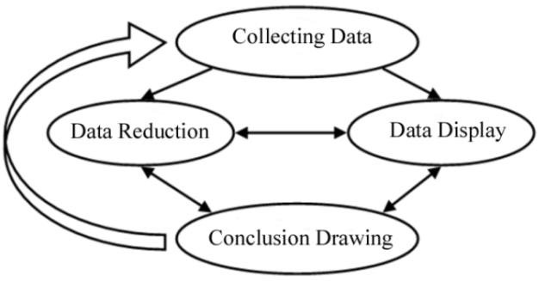.

**Figure 1. Interactive model of data analysis**

The Lesson Study activities in this research was carried out on C2017 class of Primary Teacher School major involving 38 students. It was carried out by implementing three stages of lesson study consisted of Plan, Do, and See [18]. To obtain the data, it employed observation sheets and documentation.

# Result

The implementation of Lesson Study activities on Social Studies for Primary School course from cycle 1 to cycle 3 has been carried out based on the pre-determined planning. According to the interactive model suggested by Miles and Hubberman, the first stage was data collection. The data collected in this research was data related to the implementation of lesson study activities from the beginning until the ending of the activities. The data collected consisted of all activities both from the lecturer and the students during the learning process and were collected by means of observation sheets and documentation.

The second stage was data reduction. All collected data during the observation in the first stage were analyzed and selected according to the needs of research. The primary purpose of this research was to describe the students’ activities during lesson study implementation based on flipped classroom. After selecting the data that met the objectives of the research, the data were then presented.

The third stage of this research was data presentation. This stage aimed at presenting the data based on the phase of lesson study activities consisting of plan, do, and see. The first lesson study phase was **Plan**. In the first phase of lesson study, it determined the model lecturer, developed lesson plan and lesson media, selected proper lesson model and method to be implemented, designed instructional materials, developed and designed assessment model, and prepared observation sheets.

The lesson study lecturers team carried out a discussion about lesson instrument that was delivered to the students. This activity was carried out to determine learning model, learning method, learning media, and instructional materials that were suitable to be used in the learning process. When planning on the instructional media used, it took into account the students’ needs and the lesson topic. The need assessment carried out is presented in Figure 2.

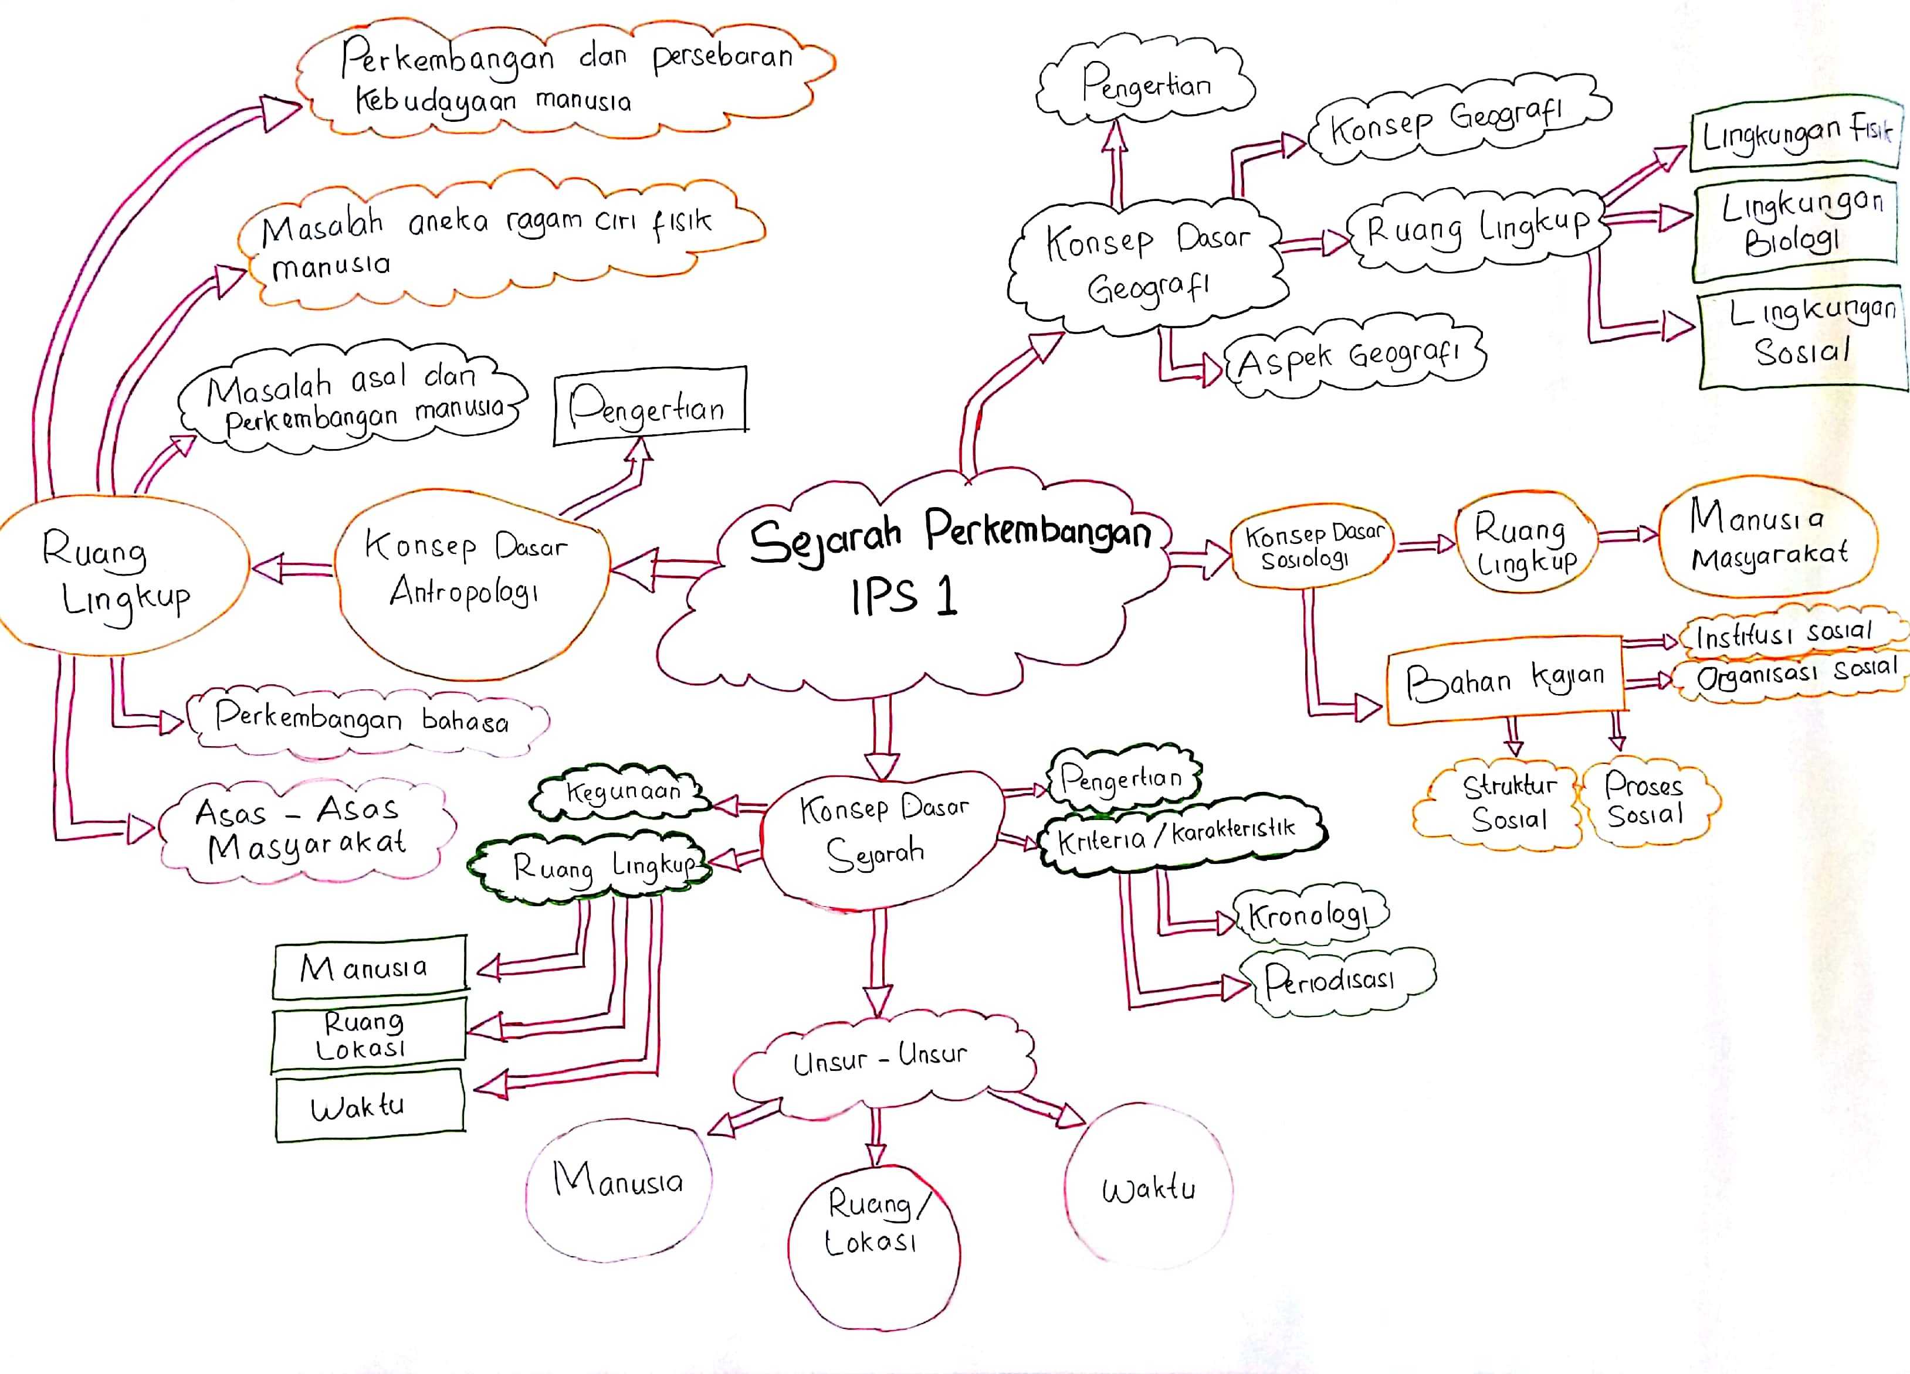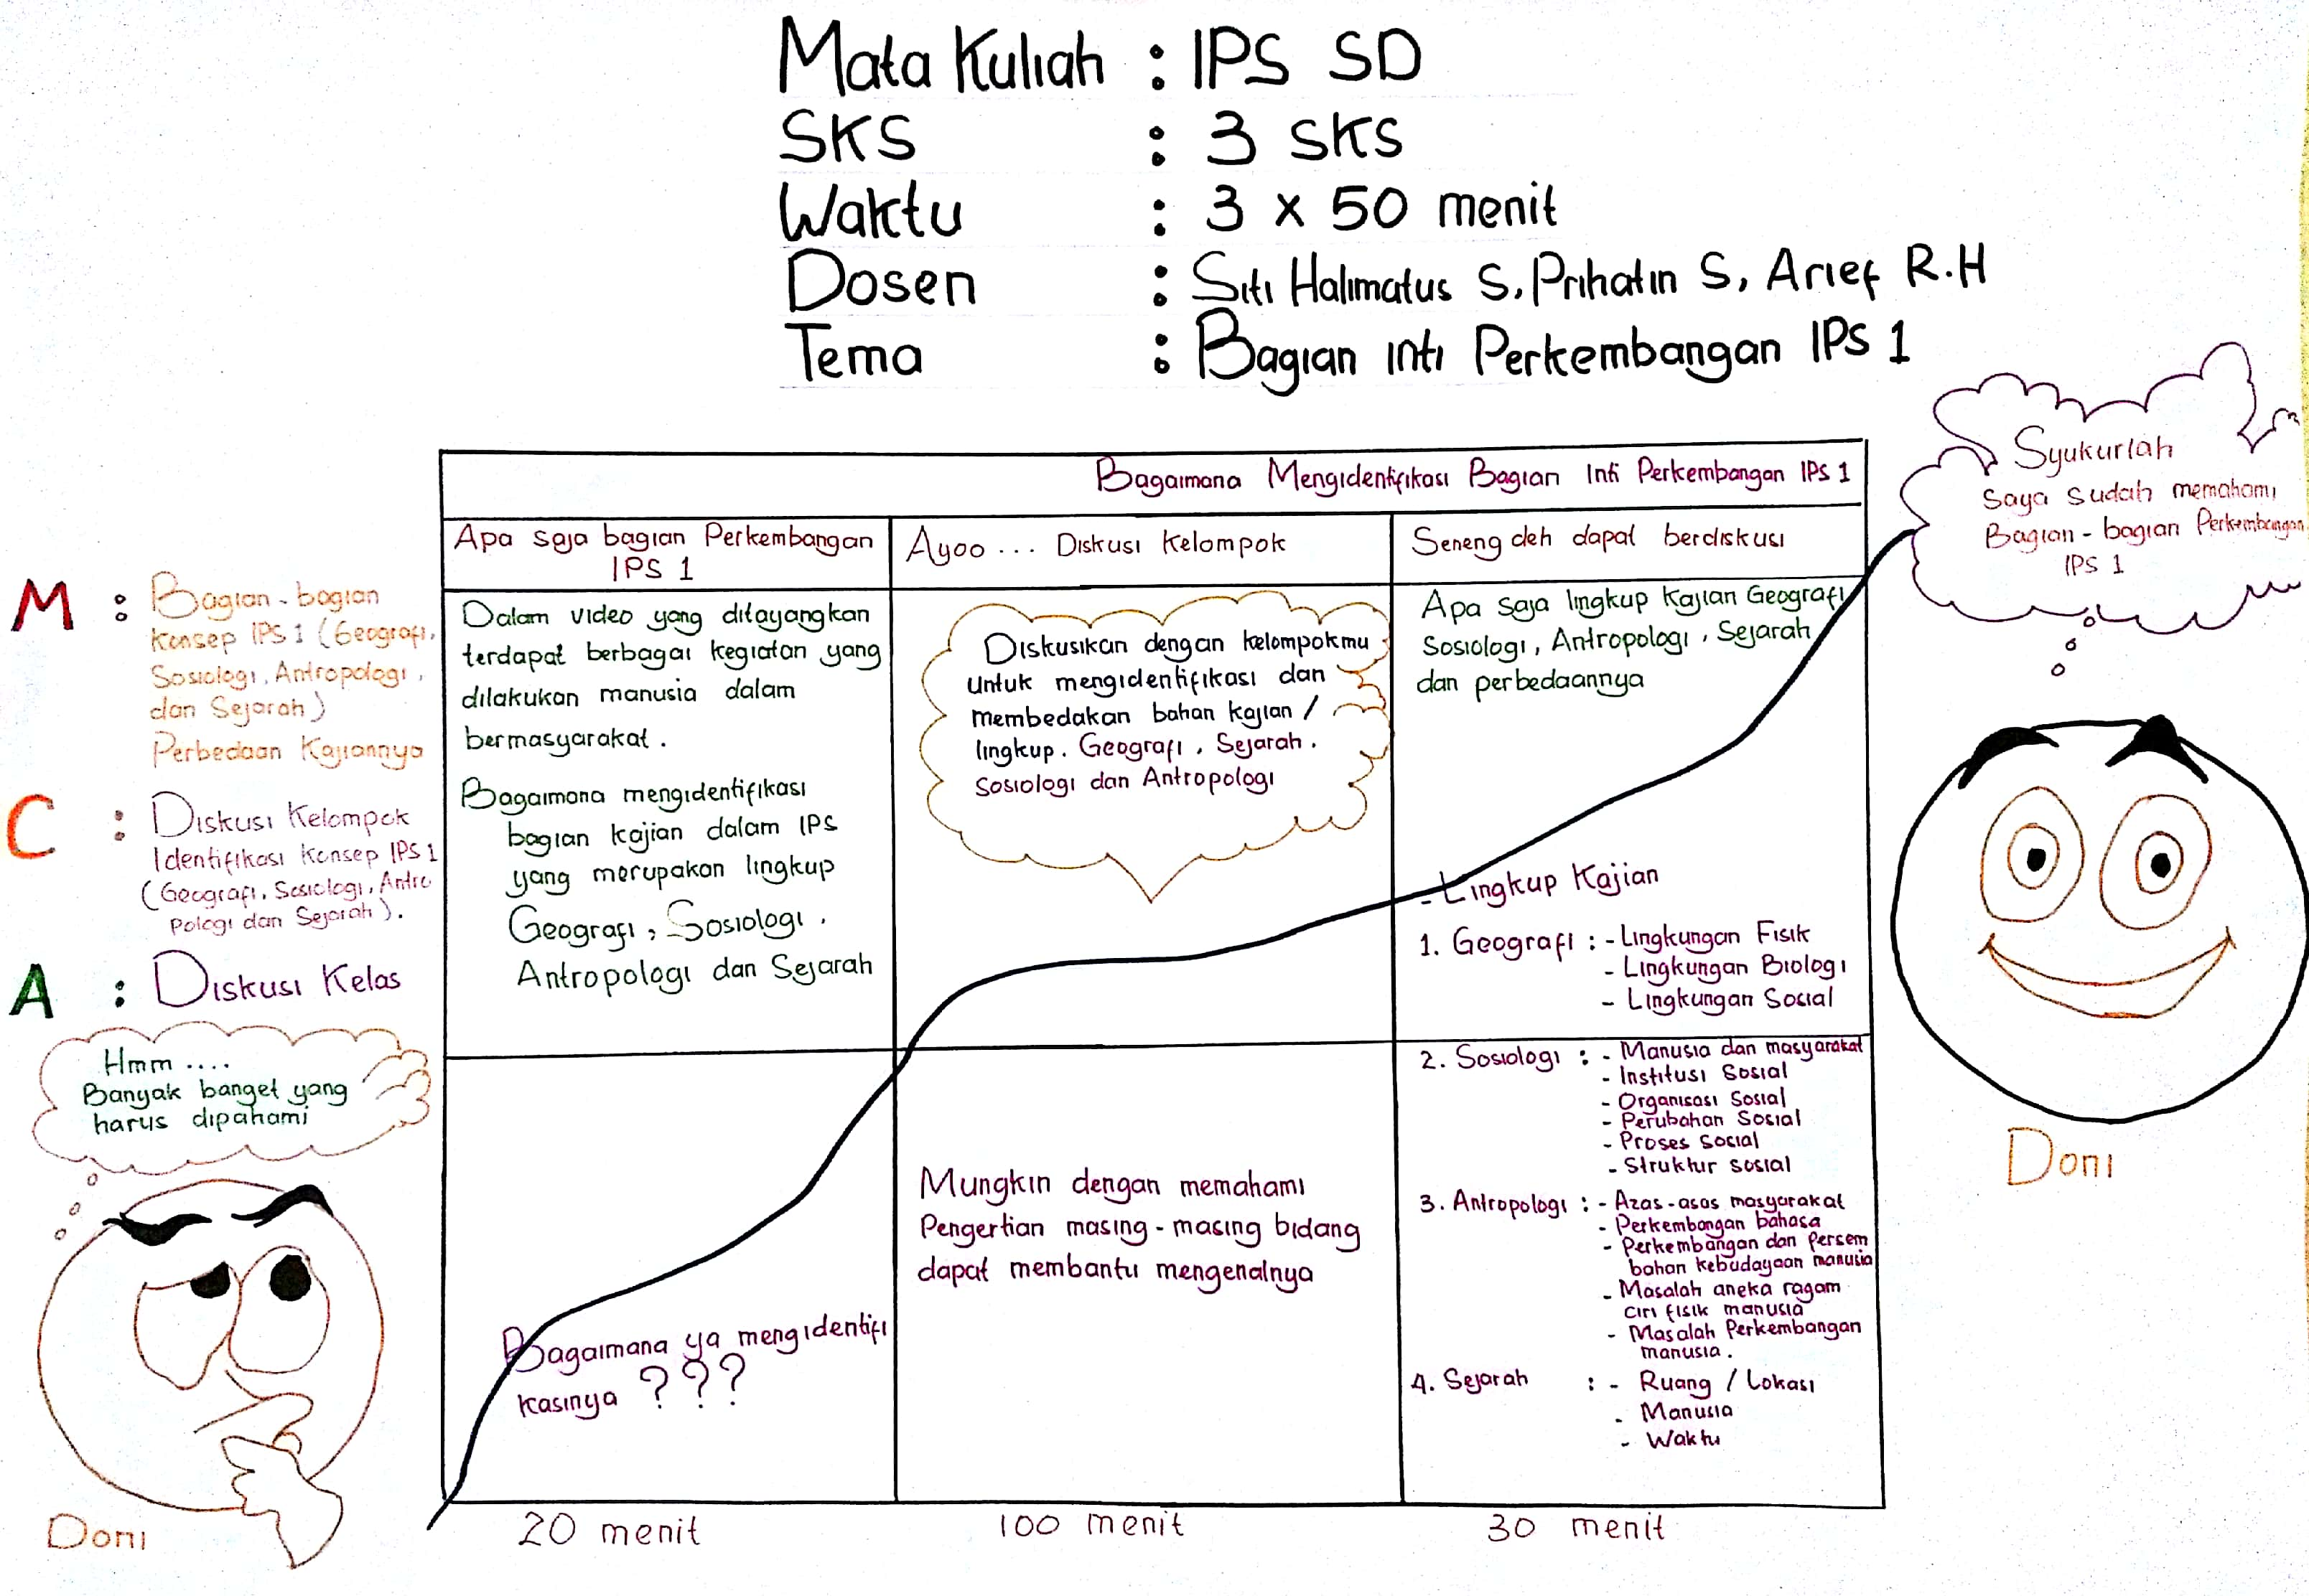

**Figure 2. The Implementation of Plan Phase Lesson Study**

The learning design was made by focusing on emphasizing the importance of cooperation and students' critical thinking skills. Instructional materials were developed according to the students' needs of geography and sociology lessons. Real life examples of students were also presented in the instructional materials developed. These contextually given examples supported students to develop problem-solving skills and scientific manner [19].

Learning design and student’s worksheet were developed based on TPACK components which consists of Technological, Pedagogy, and Content Knowledge. These components were presented in a lesson instrument which then supports effective and interesting learning activities based on students’ needs [20].

The second step carried out was **Do**. At this stage, the lecturer team carried out activities in accordance with the job desk that has been determined at the planning stage. The assignment was divided into observers and model lecturers. The implementation activity was initiated by giving initial problems to students. This initial problem was given to students for assignments at home before they attend the lectures in classroom. This was done to stimulate students to search for numerous sources or literature in solving the problems given. Furthermore, the students formed groups to discuss problems on the worksheet. This activity was carried out during the learning process in the classroom. The group discussion process run more actively because students have prepared the material beforehand. Flipped classroom approach is able to increase student involvement in discussions [16][17]. In discussion activities, students prepared the results of the discussion to be delivered and conveyed to other groups. After the discussion, each group appointed one member as its representative to present to other groups or to present it to the class.

The presentation activity was accompanied by a game of questions to other groups of students, it was intended to make other students pay attention to their friends who were presenting and to find out the understanding of each student. This type of cooperative learning is able to increase students’ activity and learning achievement [21]. Teams Game Tournament learning model is proven to be able to increase students’ active involvement in class. In addition, students would enjoy the atmosphere of the tournament, and because they compete with groups with equal abilities, it generates a fairer setting than competition in learning in general [22].

The Teams Games Tournament model is a learning process by combining study groups with team competitions, and can be used to improve learning various kinds of facts, concepts and skills [21]. This model would encourage student participation, since none of the students are not involved in giving their opinion in the Teams Games Tournament, students with lower and upper group abilities work together to complete the teacher's assignments. Teamwork is prioritized within this TGT learning model. In addition, there is an award for the team that is the most active or earns the highest ranking, since all team members are encouraged to be active in answering, answering and asking questions [23]. The activities performed at this stage can be seen in Figure 3.

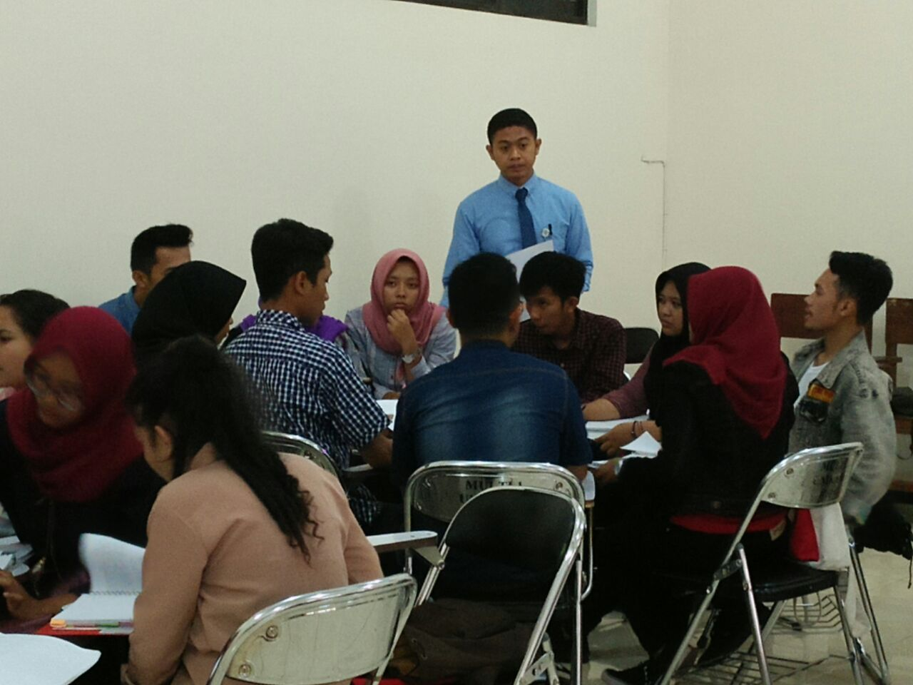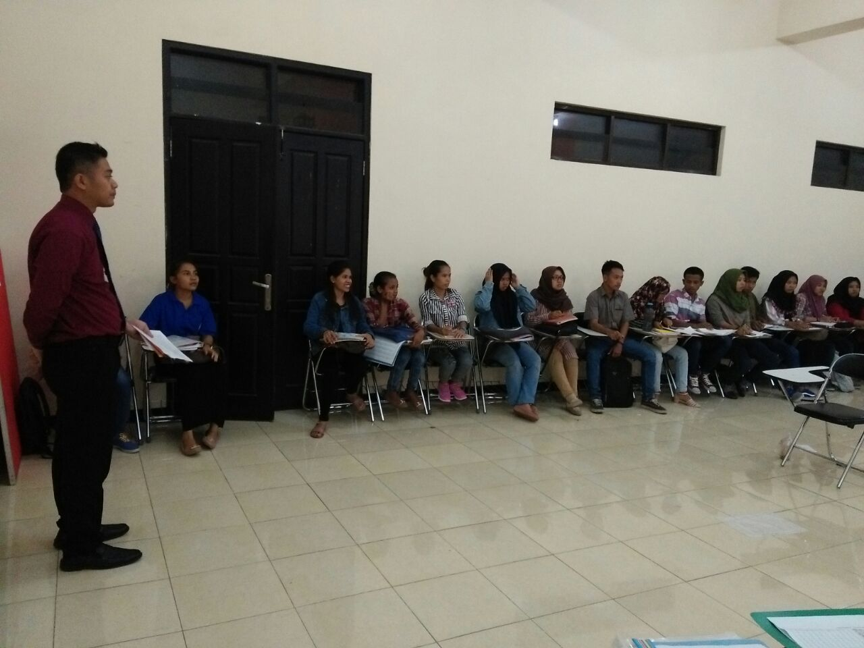

**Figure 3. The Implementation of Learning Activities (Do)**

The third step was see, which was to reflect on the learning process that has been carried out. The model lecturer began the discussion by delivering and conveying impressions in carrying out learning. Furthermore, the observer was asked to give comments from the lesson, specifically with regard to student activities. Indeed, for the sake of improving learning, criticism and suggestions are wisely delivered to lecturers. On the other hand, to maximize subsequent learning, model lecturers must be able to obtain feedback from observers. The results of this reflection were to find out the strengths and weaknesses, as well as student problems during the learning process and to discover solutions to improve learning activities in the next cycle. Reflection activities at this stage can be seen in Figure 4.

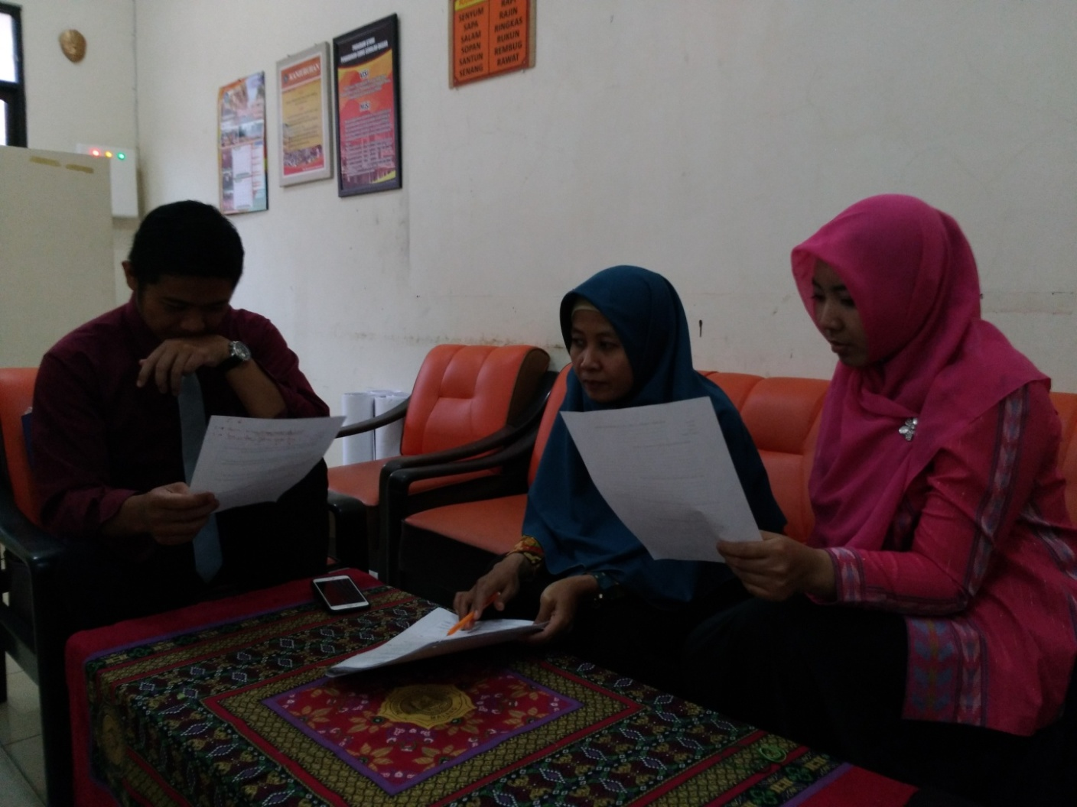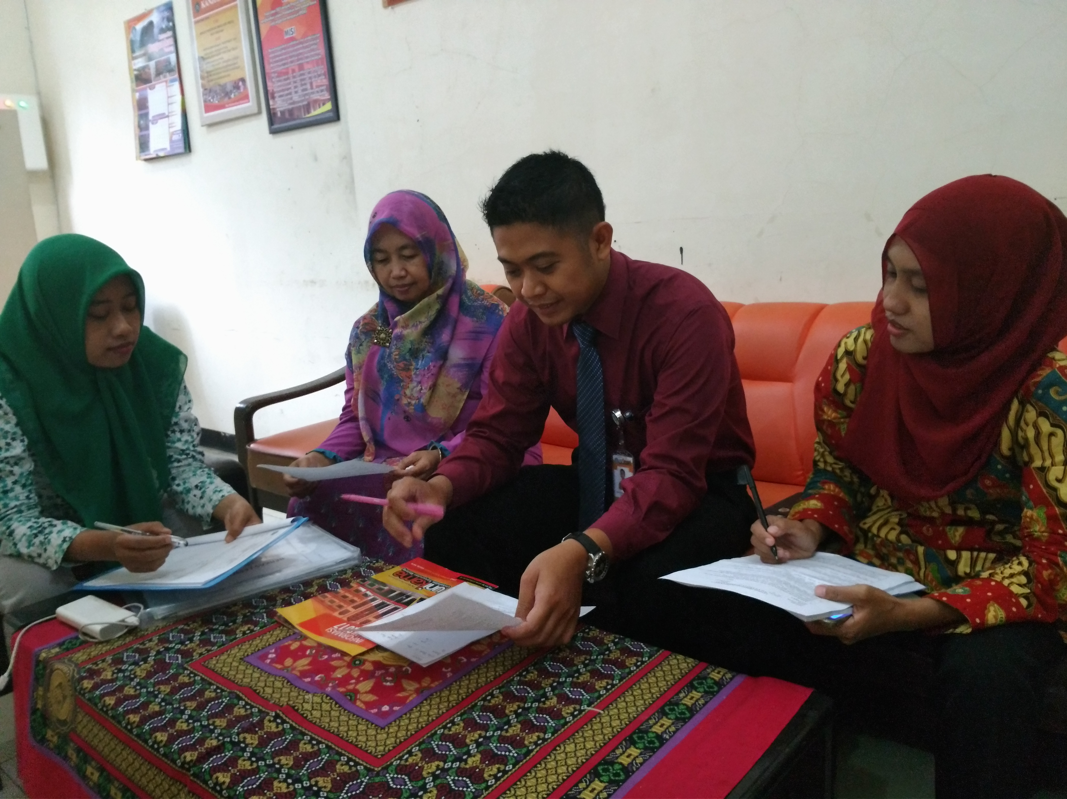

**Figure 4. The Implementation of Reflection (See)**

The fourth stage was the drawing of the conclusion. The results of presenting the data in the previous stage suggested that the activities of the lesson analysis were effectively implemented through the steps of Plan, Do, and See that were carried out by the teaching lecturers in teams. The introduction of the flipped classroom-based lesson study demonstrates that during the learning process, both answering and asking questions, students are able to play an active role. This is inseparable from the involvement of the team of lecturers in the preparation, execution and reflective practices of lessons.

# Conclusion

It can be inferred that the lesson study has been successfully implemented through the Plan, Do See steps that are carried out by elementary social studies teaching lecturers in a team on the basis of the execution of the learning that has been implemented. It further reflects an improvement in learning efficiency. Lesson study preparation activities started from the compilation of lesson instrument that were compiled based on the needs of the student and the TPACK materials and elements provided by the lecturers who teach the course. The results of findings and reflections on the implementation of the activities of the lesson study indicate that students' active engagement in flipped class-based lesson study has increased.

##### Acknowledgment

The authors would like to express their appreciation to study program Primary School Universitas Kanjuruhan Malang to opportunity mixed up with bequest lesson study in social science learning.

##### References

[1] R. Faslah, “Pemanfaatan Internet dalam Pengembangan Konsep IPS dan Implikasinya Terhadap Pembelajaran Bermakna,” *Econosains J. Online Ekon. dan Pendidik.*, vol. 9, no. 2 SE-Articles, Apr. 2017.

[2] A. Vallori, “Meaningful Learning in Practice,” *J. Educ. Hum. Dev.*, vol. 3, Jan. 2014.

[3] L. M. Schreiber and B. E. Valle, “Social Constructivist Teaching Strategies in the Small Group Classroom,” *Small Gr. Res.*, vol. 44, no. 4, pp. 395–411, May 2013.

[4] K. Powell and C. Kalina, “Cognitive and Social Constructivism: Developing Tools for an Effective Classroom,” *Education*, vol. 130, Jan. 2009.

[5] M. H. Rahman, “Professional competence pedagogical competence and the performance of junior high school of science teachers,” *J. Educ. Pract.*, vol. 5, no. 9, pp. 75–80, 2014.

[6] J. Elliott, “Developing a science of teaching through lesson study,” *Int. J. Lesson Learn. Stud.*, vol. 1, pp. 108–125, May 2012.

[7] M. Yoshida, “Mathematics Lesson Study in the United States: Current status and ideas for conducting high quality and effective Lesson Study,” *Int. J. Lesson Learn. Stud.*, vol. 1, pp. 140–152, May 2012.

[8] C. Lee Bae, K. N. Hayes, J. Seitz, D. O’Connor, and R. DiStefano, “A coding tool for examining the substance of teacher professional learning and change with example cases from middle school science lesson study,” *Teach. Teach. Educ.*, vol. 60, pp. 164–178, 2016.

[9] W. Cerbin and B. Kopp, “Lesson Study as a Model for Building Pedagogical Knowledge and Improving Teaching,” *Int. J. Teach. Learn. High. Educ.*, vol. 18, no. 3, pp. 250–257, 2006.

[10] J. M. Lewis, “Learning to lead, leading to learn: How facilitators learn to lead lesson study,” *ZDM*, vol. 48, no. 4, pp. 527–540, 2016.

[11] J. Kohlmeier and J. Saye, “Developing Discussion Leaders Through Scaffolded Lesson-Study,” *Soc. Stud.*, vol. 108, no. 1, pp. 22–37, Jan. 2017.

[12] A.-L. Halvorsen and A. Kesler Lund, “Lesson Study and History Education,” *Soc. Stud.*, vol. 104, no. 3, pp. 123–129, May 2013.

[13] E. Johnson, “Contextual Teaching and Learning: What It Is and Why It’s Here to Stay,” Jan. 2002.

[14] C. Bolick, “The Diffusion of Technology into the Social Studies,” 2017, pp. 499–517.

[15] S. G. Grant, “High-stakes testing: How are social studies teachers responding?,” *Soc. Educ.*, vol. 71, pp. 43–52, Jan. 2015.

[16] M.-N. Tsai, Y.-F. Liao, Y.-L. Chang, and H.-C. Chen, “A brainstorming flipped classroom approach for improving students’ learning performance, motivation, teacher-student interaction and creativity in a civics education class,” *Think. Ski. Creat.*, vol. 38, p. 100747, 2020.

[17] M. M. H. Ahmed and B. Indurkhya, “Investigating cognitive holding power and equity in the flipped classroom,” *Heliyon*, vol. 6, no. 8, p. e04672, 2020.

[18] M. B. Miles, A. M. Huberman, and J. Saldana, *Qualitative Data Analysis A Methods Sourcebook*. Arizona State University, USA: SAGE Publications, Inc, 2019.

[19] E. Suryawati, K. Osman, and T. S. M. Meerah, “The effectiveness of RANGKA contextual teaching and learning on students’ problem solving skills and scientific attitude,” *Procedia - Soc. Behav. Sci.*, vol. 9, pp. 1717–1721, 2010.

[20] M. Koehler *et al.*, “Deep-play: Developing TPACK for 21st century teachers,” *IJLT*, vol. 6, pp. 146–163, Jan. 2011.

[21] R. E. Slavin, “Cooperative Learning in Schools,” J. D. B. T.-I. E. of the S. & B. S. (Second E. Wright, Ed. Oxford: Elsevier, 2015, pp. 881–886.

[22] A. Veloo and S. Chairhany, “Fostering Students’ Attitudes and Achievement in Probability Using Teams-games-tournaments,” *Procedia - Soc. Behav. Sci.*, vol. 93, pp. 59–64, 2013.

[23] S. Kagan, *Kagan Cooperative Learning Structures*. Kagan Publishing, 2013.