The Promotion Digital Strategy in Tourism Sector Towards Sustainable Tourism

Erna Susanti*, Deni Amelia
Prodi Sistem Informasi
Universitas Putra indoensia YPTK\
Padang, Indonesia
ernasusan77@gmail.com*

Abstract---The development of technology and communication is rapidly increased, in line with the increasing number of internet users in the world. This gives opportunities for business people to market their business online, as well as the opportunity for the government to promote strategic sectors, one of them is the tourism sector. This study aims to determine the digital promotion strategy of the tourism sector in Padang City. This research is a descriptive qualitative research using triangulation method as the data collection, which includes the observation method, the survey method and the literature study method simultaneously. The results showed that the digital promotion strategy used by the Padang city government was using websites and social media in the form of Instagram and Facebook with well packaged and attractive.

Keyword : strategy, promotion, digital, tourism, sustainable development.

INTRODUCTION
The development of information and communication technology (ICT) is growing rapidly in line with the increasing number of internet users around the world, including in Indonesia. From the 2018 Indonesian Internet Penetration and Behavior Survey by the Indonesian Internet Service Providers Association (APJII) released in February 2018, the number of internet users in Indonesia reached 171,17 million people [1]. With this significant number, Indonesia is the 5th country that has the most internet users in the world. Data released by Internet World Stats as of December 31 in 2017, states that the 1st to 4th ranks are China, India, the United States and Brazil [2]. With the large number of information technology users in Indonesia, this is certainly a great opportunity for people who have business in marketing their business online. Not to be missed, the government also has opportunity to provide information and promote its strategic sectors, such as in tourism sector. Technological progress is inevitable, all sectors must face it with new spirit and enthusiasm in the digital world. Innovation must be developed continuously to answer the challenges and opportunities in this digital era.
Nowadays, tourists have taken advantage of online technology. For this reason, tourism can no longer be cultivated by relying solely on conventional methods and a transformation from conventional to digital is needed. There are several social media that can be used to share information such as the use of websites, blogs and social media like Facebook, Instagram, Twitter and similar applications. These accounts can be accessed easily through computers, smart phones and tablets which have become part of today's society.
Many social media accounts spread information about their travels. These social media users then become a reference for the public regarding interesting places through their writing and reportage on social media accounts. Social media readers or well-known as netizen are greatly helped and interactions often occur between account owners and readers in cyberspace.
The development of communication and information technology (ICT) cannot be separated from people's lives in this digital era. ICT plays an important role in various aspects of human life. In the past, information was easily accessible using printed and electronic mass media such as newspapers, magazines, television, radio and so on. Along with the times, ICT shifted to internet-based media. The internet makes it easy to share information widely through social media and can also be accessed anytime and anywhere. Furthermore, the use of internet-based social media brings information providers and recipients closer together.
Based on data obtained from the Padang City Central Bureau of Statistics, a positive trend can be seen in the increasing of foreign and domestic tourists visiting from year 2013 – 2016 [3], as illustrated in table 1 below:

TABEL I AMOUNT OF FOREIGN AND DOMESTIC TOURIST IN PADANG CITY 2013 - 2016
Tourist | Amount of Foreign and domestic tourism
 | 2013 | 2014 | 2015 | 2016
Foreign | 53,067 | 54,967 | 57,318 | 45,194
Domestic | 3,001,306 | 3,199,392 | 3,298,454 | 3,628,299
Total | 3,054,364 | 3,254,359 | 3,355,772 | 3,673,493
Soucer : BPS Kota Padang

The increase in the number of tourists, both foreign and domestic, has revived other economic sectors, including the increase in hotel accommodation facilities from various hotel classifications, as below:

TABEL II TOTAL HOTEL ACCOMODATION BY HOTEL lCLASSIFICATION IN PADANG CITY 2013-2016
Hotel Level | 2013 | 2014 | 2015 | 2016
Five Stars | 1 | 1 | 1 | 1
Four Stars | 2 | 3 | 3 | 5
Three Stars | 5 | 5 | 5 | 6
Two Stars | 5 | 5 | 5 | 9
One Stars 1 | 2 | 2 | 12 | 5
Inn/ Motel | 55 | 56 | 76 | 62
Sumber : BPS Kota Padang

Literatur Review

Types of Marketing Communication (Promotion) on Social Media.
There are 2 (two) types of marketing communication (promotion) on social media [4], as follows:
- Advertising through social media.
Advertising through social media is any form of paid non-personal communication about an organization, product, service or idea that uses social media as its medium

- Marketing through social media.
Beside as an additional in online advertising, marketers also use social communities which consist of various forms of interaction ranging from forums (Kaskus or Fashionesdaily), social networking sites (Facebook or Instagram), the virtual world (Second Life, There, or Kaneva), games, sharing sites (Flickr or YouTube), to micro-blogging (Twitter).

Social media is the media used by consumers to share text, images, sound, and video information both with other people and companies and vice versa. With these unique characteristics, social media can be used as an effective business promotion tool.
Blogs, Facebook, Twitter, Instagram and Youtube are business promotion tools that are considered effective enough for broader and more effective promotion than conventional media such as printed media, brochures, and billboards.
The activity of using social media is part of verbal communication via electronic or electronic word of mouth communication and it is one of the marketing strategies that influence consumer decisions in using products or services. The success of electronic word of mouth is natural and honest, so people give testimonials about the experiences they have had with a product or service without asked or voluntarily.
Social media represent a key touchpoint in the traveller customer journey. Specifically, in pre purchase phase, social media a source of inspiration for traveller; during the hotel stay, these platform are used by traveller to share their experience in the realtime with their community; finally, in the post purchase phase, traveller can write review in social media or keep in sharing their experience with other user, thus favouring e-WOM [5].
In social marketing, in practice, is to be complex to be managed and executed exclusively by a single individual or even department. Cross-functional collaboration along the four dimension of social media are necessary to successfully navigate in this dynamic arena [6]. Hospitality and tourism companies and organization should formulate their brand strategy in social media differently and according to the industry they belong to, as the existing range of platform seem to plays distinct role [7].
Social media marketing activities indirectly affect satisfaction through social identification and perceived value. At the same time, social identification and perceived value directly affect satisfaction that then influences continuance intention, participation intention and purchase intention [8]. The future of social media marketing is exciting, but also uncertain. If nothing else, it is vitally important that we better understand social media since it has become highly culturally relevant, a dominant form of communication and expression, a major media type used by companies for advertising and other forms of communication, and even has geopolitical ramifications [9].

E - Tourism
According to the Minister of Tourism, E-Tourism is a digital platform that connects all tourism stakeholders, simplifies the licensing process, integrates all tourism activities and makes it easy for all tourists to explore Indonesia's charm through an easy-to-use application, anytime and anywhere. E-Tourism is an effort to optimize tourist visits in order to increase the country's foreign exchange.
Optimizing tourism potential is not only in the direction of improving locations and tourist objects, but must be followed by the use of internet technology in promoting and direct bookings by tourists through the application of E-tourism. The government integrates all components of tourism services in one application. E-tourism can bridge tourists and actors in the tourism sector, such as transportation, lodging, tourist attractions managers, and so on.
E-Tourism is a good breakthrough. In the digital era, people prefer to pay attention to their cell phones. They demand things that are easy and fast. Digital means can fulfill that desire. This promotion will increase tourist visits both in quality and quantity". E-tourism can be used as the spearhead in capturing tourists as a whole, both foreign and domestic. Tourists will be able to easily arrange tourism financing, because of the certainty of costs incurred when traveling. People nowadays tend to prefer visiting tours after seeing some posts on social media that have become "hitz" and present. Many tourist spots were previously untouched, but after the post circulated the place became a hit. This can be used as a means of developing tourism potential in these places so that it can drive the economy of the local tourist area community.
The destination manager and other tourism business should optimize social media marketing effort to facilitate a co-creational process of destination communication by encouraging traveler to consume content and share their experience on social media before, during and after they visit. Providing a platform for tourist to have a meaningful interpretation of the social context of the destination could result in a memorable unique acculturating experience in the mind of the tourist [10].

METHODOLOGY
This research is a qualitative research with a descriptive research design. By using triangulation techniques, namely data collection with the method of observation, in-depth interviews and documentation carried out simultaneously to the actors / stakeholders of tourism in Padang City.
The subjects of this study were the tourism actors in Padang City, which consisted of the Tourism Office, PHRI, Community, and NGOs.

RESULT AND DISCUSSION

Result
Digital promotion strategy used by Padang City Government are using website and social media. Social media platform used are Instagram and facebook. These social media giving information about destination, shopping centre, attraction event, culinary and local culture.

Discussion
Social medial used by Padang Govement to promote Padang tourism and culture, as follow :
- Website
The website of Padang City can be visited at tourism.padang.go.id which provides complete information about the city of Padang. The information available on the website are city profiles, tourist destinations, events & culture, culinary & shopping, about Padang and publications.

Figure 1 Website of the Padang City
Culture and Tourism Office

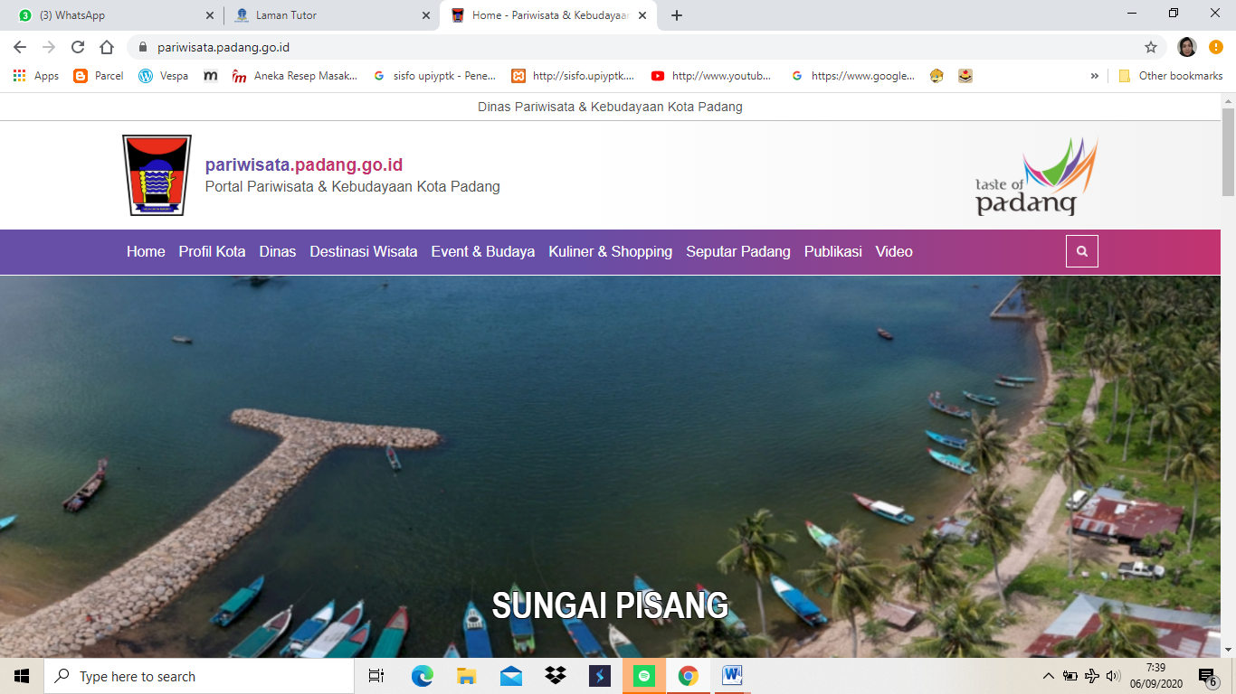

- Instagram
The social media instagram of the Padang City Tourism and Culture Office was created to promote tourism and culture of the City of Padang to local, national and international communities, with the creation of this Instagram it is hoped that all tourism activities and information can be known by all followers of this Instagram social media.

Figure 2 Instagram of Padang City
Culture and Tourism Office

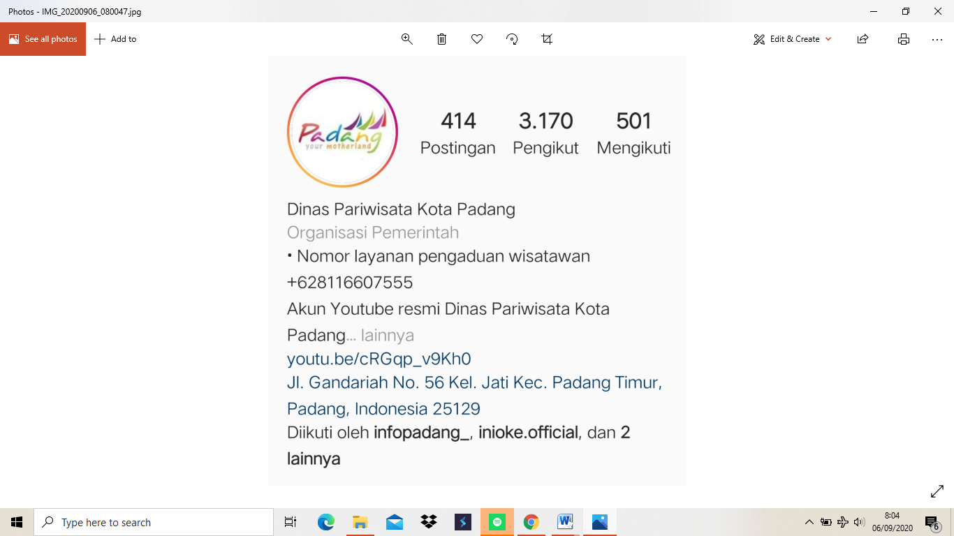

This social media Instagram provides information on tourism activities in Padang City, in the form of ongoing events, tourist objects, traditions and traditional arts and other tourism information.

- Facebook
In this social media, Facebook provides information about tourist destinations, reviews of the creative industry of Padang City, traditions and traditional arts, tourism events and tourism information on Padang City.

Figure 3 Social media facebook of the Padang
City Culture & Tourism Office

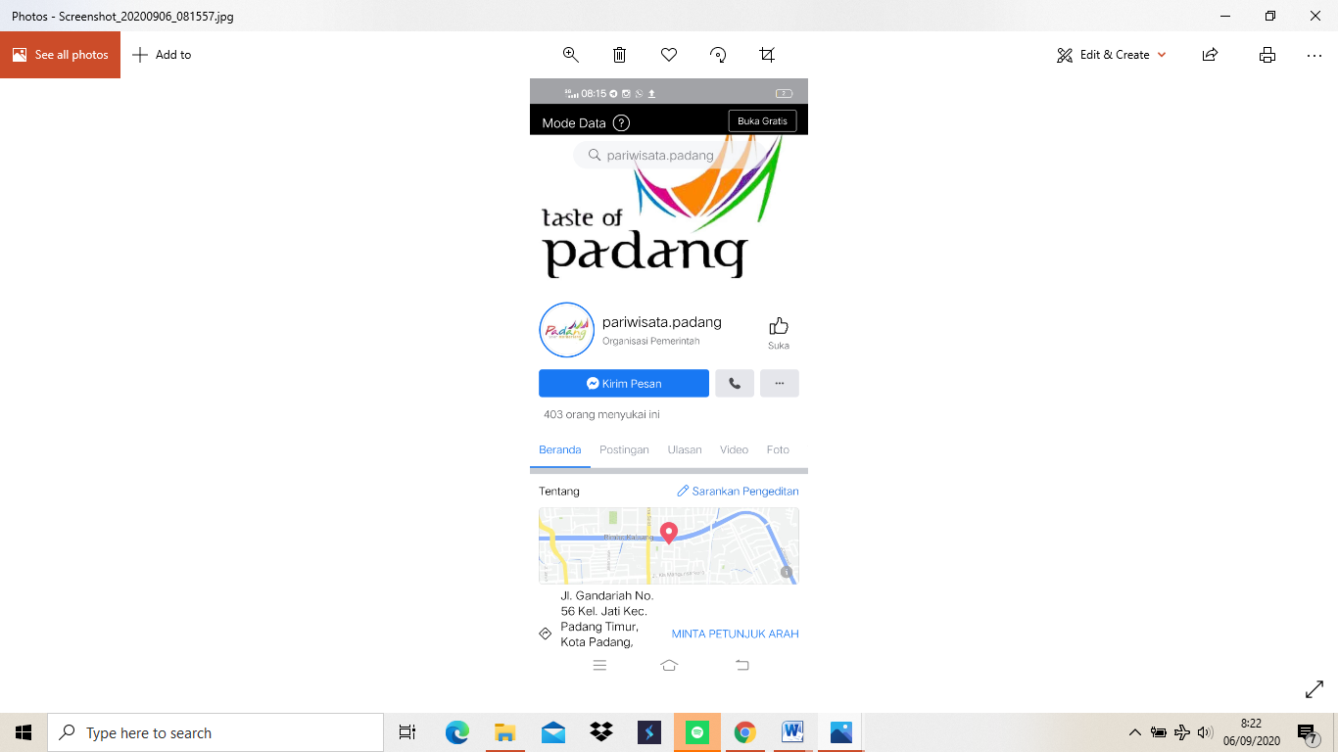

V. CONCLUSION
Based on the results of observations and surveys in the field and literature studies that have been carried out, the following conclusions are obtained: Padang City Government uses a digital promotion strategy to promote the tourism sector, the digital promotion strategy used is to build a website/ portal and use social media in the form of Instagram and Facebook, the website and social media used are designed to be attractively packaged and provide various information about tourism and culture of Padang City.

VI. Acknowledgment
This Study funded by Universitas Putra Indonensia YPTK Padang.

vii. References
[1] I. internet service Assosiation, “survey APJII,” Jakarta, 2018.
[2] Internet world stat, “internet world stat,” www.internetoworldstat, 2018. .
[3] www.bpspdg.go.id, “local bereau Stat,” 2017.
[4] Kottler and Keller, Marketing Management, 14th ed. NJ: Prentice Hall, 2011.
[5] L. Hu and M. Olivieri, “Social media management in the traveller’s customer journey: an analysis of the hospitality sector,” Curr. Issues Tour., vol. 0, no. 0, pp. 1–12, 2020, doi: 10.1080/13683500.2020.1819969.
[6] R. Felix, P. A. Rauschnabel, and C. Hinsch, “Elements of strategic social media marketing: A holistic framework,” J. Bus. Res., vol. 70, 2017, doi: 10.1016/j.jbusres.2016.05.001.
[7] S. Moro and P. Rita, “Brand strategies in social media in hospitality and tourism,” Int. J. Contemp. Hosp. Manag., vol. 30, no. 1, pp. 343–364, 2018, doi: 10.1108/IJCHM-07-2016-0340.
[8] S. C. Chen and C. P. Lin, “Understanding the effect of social media marketing activities: The mediation of social identification, perceived value, and satisfaction,” Technol. Forecast. Soc. Change, vol. 140, no. July 2018, pp. 22–32, 2019, doi: 10.1016/j.techfore.2018.11.025.
[9] G. Appel, L. Grewal, R. Hadi, and A. T. Stephen, “The future of social media in marketing,” J. Acad. Mark. Sci., vol. 48, no. 1, pp. 79–95, 2020, doi: 10.1007/s11747-019-00695-1.
[10] C. Li, S. Guo, C. L. Wang, and J. Zhang, “Veni, vidi, vici: The impact of social media on virtual acculturation in tourism context,” Technol. Forecast. Soc. Change, vol. 145, no. January, pp. 513–522, 2019, doi: 10.1016/j.techfore.2019.01.013.

