Business-Map Learning Media: Application-based Business Planning Media

Udik Yudiono

Economic Education Study Program

Universitas Kanjuruhan Malang

Malang, Indonesia

u_yudiono@unikama.ac.id

*Abstract*- The Entrepreneurship Program at SMK has fully received the attention of the Government. Teachers of Creative Products and Entrepreneurship (PKK) are required to be able to develop creative, adaptive and practice-based learning media so that students have sufficient learning experience to foster self-confidence and competence. The purpose of this research is to develop a business-map learning media using the iMindMap application. The product specifications from this study were business-map media tools including: 1) lesson plans and learning scenarios, 2) student worksheets in the form of a business-map. This development uses the Borg and Gall approach with the stages: 1) research and information collecting, 2) planning, 3) developing preliminary forms of product, 4) expert validation. Based on the validation of material experts on the presentation of material, lesson plans, and worksheets as well as validation of learning technology experts on business-map media, it is in the range of 80-100% assessment which is generally good and suitable for use without revision. The results showed the importance of maximizing student competence in entrepreneurship, especially in making a business plan using a business-map because through the business map that has been made, students will learn to design a complex and real business

Keywords— Learning media; Business-map; Entrepreneurship

# Introduction

The Open Unemployment Rate (TPT) for Vocational High Schools (SMK) is the highest compared to other education levels, amounting to 1.42 million people at around 8.92% [1]. This has consequences on the importance of improving the quality of human resources and providing productive employment for them. In addition, due to limited employment opportunities, which can be seen from the decline in employment, SMK graduates are also faced with competition from adult job seekers [2] who are considered to have readiness and experience [3]. This is what requires them to create their own jobs by doing entrepreneurship with the knowledge of entrepreneurship taught in schools.

In the SMK curriculum, craft and entrepreneurship education is taught to all students [4]. The provision of this material is intended to foster an entrepreneurial spirit from an early age. Entrepreneurship education that is given at SMK, will form the mindset and paradigm of students who initially are "graduating from school looking for work, being graduated from school creates jobs" [5]. With the presence of entrepreneurship education at SMK, it is hoped that graduates will be able to create jobs as a result of an attitude and mentality of independence which will later benefit themselves, others, and especially in improving national development in order to minimize the unemployment rate caused by the depletion of jobs [6][7].

In entrepreneurship learning, of course, teachers must have a powerful learning media strategy so that their students are able to absorb entrepreneurship subjects [8]. The success of entrepreneurship learning is determined by the learning media made by teachers in schools [9][10]. The knowledge and skills of students obtained through learning media while studying in school are the basic assets that can be used for entrepreneurship [11] Knowledge, skills, industrial work experience and work abilities possessed by students can encourage the growth of interest in entrepreneurship [12][7][6].

The application of ICT, especially in entrepreneurship subjects, is expected to be able to fully contribute to students in gaining insights and skills as well as a forum for student creativity [13][14]. The existence of information and communication technology as a medium in managing entrepreneurship learning will make students more creative, innovative, and keep up with the times [13][15]. Given that SMK is a vocational-oriented school, where schools prepare students to engage in the world of work both in industry and entrepreneurship.

However, from observations in the framework of a preliminary study at one of the SMK in Malang Regency which is an accredited flagship Vocational High School, it can be seen that entrepreneurship theory teachers in Creative Products and Entrepreneurship (PKK) subjects have been using classical learning models characterized by the lecture method so that the learning object that is achieved is only the cognitive aspect, while the affective and psychomotor aspects have not been achieved. Teachers are only fixated on delivering material in textbooks and students have not been introduced to technology-based entrepreneurship learning media and have not been directed to build their own knowledge about the potential that can be utilized and of sale value so that the essence of entrepreneurship is not achieved which results in low student interest in PKK learning. Even in planning the products to be produced, students' ideas are still dictated by the teacher, and write them down in notebooks so that the description of the product / business pattern to be carried out by students is still abstract and very simple. Based on these problems, the authors developed application-based business map learning media as an effort to maximize student competence in entrepreneurship, especially in making business plans using a business-map because through the business map that has been created, students will learn to design a complex and real business.

# method

The research design used in this study is Research and development (R&D). This study was adapted and modified from the Borg and Gall model [16] adapted to the characteristics of the learner, the characteristics of the objectives and the type of content in the field of study, and the learning background. The stages of research and development carried out are: (1) research and information collecting by conducting preliminary observations and interviews; (2) planning to formulate a product design then developing (3) developing a preliminary form of product, namely developing a product for media where there are two categories of product components developed at this stage, namely lesson plans and learning scenarios, and student worksheets in the form of business map; (4) expert validation, after product development is carried out, an expert test is carried out.

Processing of questionnaire data obtained from experts (both experts and teachers of economics subjects). The data is then calculated using the formula:

Percentage of product eligibility = x 100% $\frac{jumlah skor jawaban}{jumlah skor maksimal}$

After the calculation for all questionnaire data has been carried out, the percentages obtained are grouped on certain criteria so that the feasibility level of the product can be determined. The percentage of eligibility criteria can be grouped as follows:

**Table 1. Percentage of product eligibility**

|  |  |  |  |
| --- | --- | --- | --- |
| Test results | | | Follow-up |
| Score Category | Percentage | Qualification |
| 4 | 85% - 100% | Very good | No need for revision |
| 3 | 75% - 84% | Good | No need for revision |
| 2 | 55% - 74% | Enough | Revision |
| 1 | <55% | Less | Revision |

Source: Sugiyono, 2010

# RESULT AND DISCUSION

1. *Research and Information Collecting*

This research and information gathering constitutes a preliminary research stage which is carried out by means of a needs assessment. The research stage and information collection on Creative Products and Entrepreneurship (PKK) learning are a process of exploring information about the learning process, starting with tracking information and analyzing student characteristics and teacher and student needs. Based on the results of the interview, the PKK teacher stated that the teacher had difficulty creating a pleasant atmosphere for entrepreneurial learning, the exposure of material in the book was limited so that students easily got bored and considered the material presented easily, besides the production idea, so far it was still centered on the teacher's initiative, not students

This is confirmed by the opinion of students who state that they are more interested if entrepreneurial theories are presented with new methods such as games or interesting shows accompanied by concrete examples around them so that they are easier to understand. In addition, students consider entrepreneurship material delivered by the teacher monotonous. In fact, they said they prefer to be given concrete problems and find the answers themselves rather than explain too much by Teacher.

1. *Planning (Planning)*

After finding the problem, the researcher began to design a product that would be a solution to the problems that had been found in the first stage. Based on the needs analysis, the researcher feels the need to develop a basic entrepreneurial learning media, namely an application-based business plan. The use of technology or applications is expected to be able to provide new experiences for students in learning, where they will get used to operating technology. In addition, the features contained in the application are able to simplify and make the appearance of a business plan more attractive. The development of this media will be contained in learning tools in the form of lesson plans and learning scenarios.

1. *Initial product development (Develop preliminary form of product)*

The initial product development aims to produce a prototype / initial design of the development of business map learning media which includes lesson plans and learning scenarios, as well as student worksheets in the form of a business-map. Business-map is an adoption of a business plan or business design used by researchers as LKS (Student Worksheets). The business map includes important things that an entrepreneur must analyze to determine the readiness of goods / services to be produced and marketed. In learning Creative Products and Entrepreneurship using business map media, students are invited to think analytically about the strengths, weaknesses, opportunities and threats faced if they decide to produce a good / service.

Students will design a business idea based on a problem in the field, namely the lack of processing potential in their area. Then students will analyze the business idea in SWOT (Streght, Weakness, Opportunity, Threat) on the business-map sheet. The teacher's role is only to direct the business ideas created by students and evaluate whether the business idea will bring significant changes by increasing the selling value. If the business idea is appropriate, then the students will then prepare a production implementation plan using the POAC (Planning, Organizing, Actuating, Controlling) approach in the business-map sheet and apply it. In this POAC analysis, students plan important things in building a business, namely the availability of Human Resources (HR) and the division of work specifications consisting of implementing divisions so that each division has job responsibilities, availability of raw materials used, financial resources, and work steps for the manufacture of goods / services.

**Figure 1. SWOT analysis on an application-based business map**

1. *Expert Validation*

The initial product that has been developed is tested with a questionnaire through filling out a questionnaire by an expert. The expert in question is someone who is considered to have mastered the development of the learning model. The aspects that will be used in this research are material experts and learning technology experts. Material and learning tools in the form of lesson plans and student worksheets (LKS) were validated by material experts and educational technology experts. Researchers used an instrument in the form of a questionnaire to validate the learning protocol.

Through the results of validation and assessment by material experts on the developed business map learning media, the percentage value is 91.96%, which is generally good and suitable for use without revision. This shows that the business map learning media instruments and scenarios are considered feasible to be applied and can improve students' entrepreneurial competence.

In addition, through the results of validation and assessment by material experts on the lesson plans for the business map learning media developed, a percentage value of 94.1% was obtained, which is generally good and suitable for use without revision. This shows that each component in the lesson plan is considered appropriate for learning references and can stimulate students' entrepreneurial competence to increase.

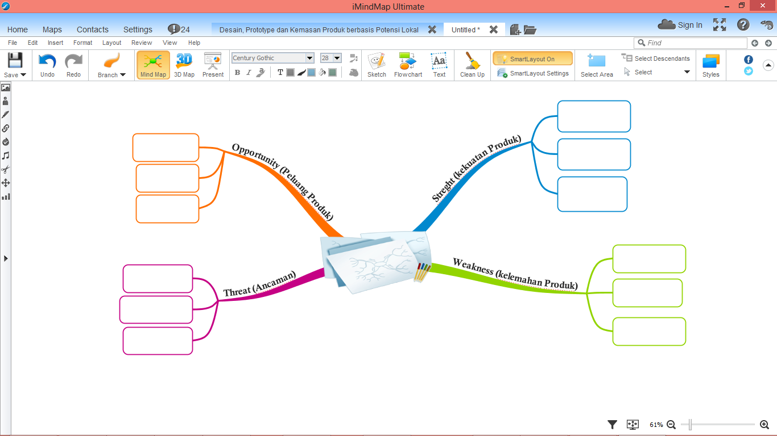The results of validation and assessment by educational technology experts on the developed business map learning media, obtained a percentage value of 81.25%, which is generally good and suitable for use without revision. This shows that learning media in the form of technology is considered appropriate when used in the mapping-project learning process so that it can improve students' knowledge, skills and attitudes.

And the results of validation and assessment by practitioners on the development of learning media media business map, obtained a percentage value of 98.6%, which is generally good and feasible to use without revision. Practitioners who in this context are PKK Subject Teachers state that the media is good and ready to be applied where the lesson plans are appropriate if applied to vocational students with PKK subjects but need to pay attention to class mastery when the media is applied.

# CONCLUSION

Business-map is an adoption of a business plan or business design used by researchers as LKS (Student Worksheets). The business map includes important things that an entrepreneur must analyze to determine the readiness of goods / services to be produced and marketed. In learning Creative Products and Entrepreneurship using business map media, students are invited to think analytically about the strengths, weaknesses, opportunities and threats faced if they decide to produce a good / service. Based on the material expert validation on the presentation of material, lesson plans, and student worksheets as well as the validation of learning technology experts on the business-map media, it is in the 80-100% assessment range which is generally good and suitable for use without revision.

##### Acknowledgment

Gratitude goes to the Rektor and Head of Economic Education Study Program, Universitas Kanjuruhan Malang for contributing publication funds and the ANCOSH Committee for providing the opportunity and a place to express research results in the form of proceedings.

##### References

[1] K. K. Indonesia, “STATISTIK,” no. 41, pp. 1–16, 2019.

[2] G. Solomon, “An examination of entrepreneurship education in the United States,” *J. Small Bus. Enterp. Dev.*, vol. 14, no. 2, pp. 168–182, 2007.

[3] B. Y. R. Hujer, S. L. Thomsen, and C. Zeiss, “T h e effects of vocational training p r o g r a m m e s on the duration of u n e m p l o y m e n t in Eastern Germany *,” vol. 321, no. 2001, pp. 299–321, 2006.

[4] T. Järvi, “Teaching entrepreneurship in vocational education viewed from the regional and field perspectives,” *J. Vocat. Educ. Train.*, vol. 64, no. 3, pp. 365–377, 2012.

[5] A. Winarno, “Entrepreneurship Education in Vocational Schools: Characteristics of Teachers, Schools and Risk Implementation of the Curriculum 2013 in Indonesia,” *J. Educ. Pract.*, vol. 7, no. 9, pp. 122–127, 2016.

[6] A. Fayolle and B. Gailly, “The impact of entrepreneurship education on entrepreneurial attitudes and intention: Hysteresis and persistence,” *J. Small Bus. Manag.*, vol. 53, no. 1, pp. 75–93, 2015.

[7] R. Bell, “Developing the next generation of entrepreneurs: Giving students the opportunity to gain experience and thrive,” *Int. J. Manag. Educ.*, vol. 13, no. 1, pp. 37–47, 2015.

[8] M. Bagheri, W. Zah, W. Ali, M. Chong, B. Abdullah, and S. M. Daud, “Effects of Project-based Learning Strategy on Self-directed Learning Skills of Educational Technology Students,” *Contemp. Educ. Technol.*, vol. 4, no. 1, pp. 15–29, 2013.

[9] E. Ruskovaara and T. Pihkala, “Entrepreneurship education in schools: Empirical evidence on the teacher’s role,” *J. Educ. Res.*, vol. 108, no. 3, pp. 236–249, 2015.

[10] M. Botha, “A project-based learning approach as a method of teaching entrepreneurship to a large group of undergraduate students in South Africa,” *Educ. as Chang.*, vol. 14, no. 2, pp. 213–232, 2010.

[11] R. Putri, H. Wahyono, and D. A. N. B. Pranowo, “PENGEMBANGAN MODEL PEMBELAJARAN EKONOMI THE MONEY ADVENTURE ( TMA ).”

[12] M. Henrekson, “Entrepreneurship and Institutions,” *Ssrn*, vol. 2, no. 1, pp. 74–89, 2007.

[13] M. Delmastro, “Technology-Based Entrepreneurs : Does Internet Make a Difference ?,” pp. 177–190, 2001.

[14] K. Kleine, “The Learning Process in Technology from an Engineering Degree *,” vol. 00, no. 00, pp. 1–17, 2019.

[15] Q. Aini, I. Dhaniarti, and A. Khoirunisa, “Effects of iLearning Media on Student Learning Motivation,” vol. 3, no. 1, pp. 1–12, 2019.

[16] Sugiyono, *Metode Penelitian Pendidikan: Pendekatan Kuantitatif, Kualitatif, dan R&D*. Bandung: Alfabeta, 2013.