Performance of Cosmos caudatus Chlorophyll Dye on TiO2 Nano Particles Coating in the Manufacture of Dye-Sensitized solar cells (DSSC)

Muh Iman Darmawan1,a), Alpi Zaidah2,b), Alpiana Hidayatulloh3,c), Ika Nurfajri Mentari4,d),

Evi Fatmi Utami5,e), Hardani6,f*)

1Universitas Hamzanwadi Selong, NTB, Indonesia

Jl. Cut Nyak Dien No.85, Pancor, Selong, Kabupaten Lombok Timur, NTB. 83611

2Institut Pendidikan Nusantara Global, NTB, Indonesia

Aik Mual, Praya, Kabupaten Lombok Tengah, Nusa Tenggara Barat. 83511

3Universitas Pendidikan Mandalika (UNDIKMA) Mataram, NTB, Indonesia

Jl. Pemuda No.59A, Dasan Agung Baru, Mataram, NTB. 83125

4,5,6Politeknik Medica Farma Husada Mataram, Mataram, NTB, 83116, Indonesia

Jl. Medica Farma No.1 Lingkungan Batu Ringgit Selatan, Sekarbela, Mataram, NTB. 83116

Email corresponding: f*danylastchild07@gmail.com

adarmawan240290@gmail.com, balpizaidah90@gmail.com, calpianahidayatulloh11@gmail.com, dikanurfajri26@gmail.com, eevifatmiutami@gmail.com

**Abstract.** Energy derived from fossils is diminishing and cannot be renewed. Therefore many experts are looking for other alternatives to create new renewable energy, and Dye-sensitized solar cells (DSSC) are one of them. This study aims to know the characterization of the electrical properties of dye cosmos caudatus material. The research was conducted at the UNS FMIPA Materials Laboratory. Absorbance test using PC UV Visible Spectrophotometer 1601 and Current and voltage test (I-V) using Keithley. These results show that some natural dyes from natural organic material extraction have an absorbance spectrum range of 300-800 nm, which has the potential as DSSC.

**Keywords**: Dye-Sensitized Solar Cells (DSSC). Dye Organic, TiO2, Nanoparticle.

1. **Introduction**

Currently, photovoltaic technology has very much progress in the field of solar energy as an alternative and renewable energy. To produce solar cells at a low cost, there have been many models with new structures and materials currently being developed [1]. Solar panels are often called photovoltaic cells. Photovoltaics can be interpreted as "electric light" [2].

Solar energy is one of the energies that is being developed [3]. One of the applications of solar energy is its utilization in the conversion of light energy into electricity i.e. solar cells. Thus, the term "solar power" means to convert sunlight directly into heat energy or electrical energy [4]. Many ways to harness the energy coming from the sun are abundant. As seen in plants convert sunlight into chemical energy in the process of photosynthesis [5].

Now the cost of solar panels makes it impractical for everyday use where electric power "cables" are available. Currently, photovoltaic technology has great progress in the field of solar energy as an alternative and renewable energy [6]. Solar cells of this type or commonly known as photovoltaic device work by converting photons from solar energy into electrical energy are based on the energy band gaps of semiconductors, dyes, and electrolytes [7].

Organic photovoltaics have many attractive features, among them, the potential to be flexible can be produced with simple and inexpensive techniques in terms of the cost of making them [8]. In the last two decades, M.Gratzel has invented the Dye-Sensitized Solar Cell (DSSC) as a photovoltaic device [9]. Dye-Sensitized Solar Cells have attracted attention as an energy converter compared to silicon solar cells. DSSC uses three active materials: organic dye as material that absorbs photons, nanocrystal layer of metal oxide as an electron transporting material, and liquid or metal oxide coating as a hole transporting material (HTM) [10].

One of the dyes often used as a photosensitizer material is chlorophyll [11] [12][13] chlorophyll is widely found in almost all kinds of green plants. This study used dye Cosmos caudatus. The DSSC operation scheme is generally presented in Figure 1.

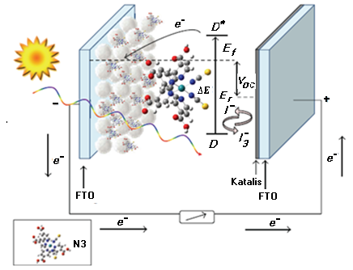

Figure 1 DSSC operation scheme [14]

Semiconductors TiO2 DSSC not only acts as a support for dye sensitizers but also serve as electron acceptance and electronic conductors [15]. The performance of Dye-Sensitized Solar Cells (DSSC) based solar cells can be seen based on the conversion efficiency of electrical energy. Efficiency can be known through the current-voltage curve (I-V) produced by the solar cell. Figure 2, showing the I-V curve of the solar cell.

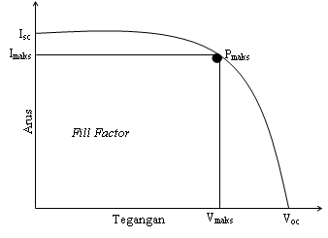

Figure 2. DSSC I-V Curve

In open-circuit conditions, the resulting current is zero, resulting in maximum voltage or open-circuit voltage (Voc). Pmaks is a point where the maximum power is generated by a solar cell. Fill Factor (FF) is a quantitative measure of the quality of a solar cell and is the outer size of the I-V curve square, the Fill Factor can be obtained using equations [16].

$FF=\frac{V_{max}I_{max}}{V_{oc}I_{sc}}$ (1)

$P_{max}=V_{oc}I_{sc} FF$ (2)

$η=\frac{P_{max}}{P_{cahaya}}$ (3)

This efficiency value is a global measure in determining the performance quality of a solar cell.

1. **Research methods**

TiO2 used in this study is Titanium dioxide (nanopowder) with a size of 21 nm. TiO2 as much as 0.5 grams dissolved in 1.5 ml of ethanol stirred for 30 minutes using vortex stirrer. TiO2 is coated on fluorine tin oxide (FTO) conductive glass with a deposition area of 2 cm x 2 cm using the spin coating method. The deposition TiO2 coating is heated at 5000C for 60 minutes on a hot plate.

This study used dye from Cosmos caudatus which is dissolved with ethanol. The DSSC construction used is a sandwich system. Working electrodes in the form of FTO conductive glass that has been coated TiO2 that has been soaked with dye Cosmos caudatus. The opposing electrodes are FTO conductive glass that has been coated in a thin layer pt (Hexachloroplatinic (IV) acid 10%). Electrolytes made of KI 0.8 gr added I2 0.127 gr dissolved with 10 ml PEG, which is dripped between the opponent's electrode and the working electrode is given a limiter using the keyboard protector so as not to occur short-circuit.

1. **Results and discussion**

Dye solutions are made from extracts that can absorb and pass on the visible spectrum of light. The dye solution is made from cosmos caudatus leaf extract that can absorb and pass on the spectrum of visible light. This color substance serves as Dye-Sensitized Solar Cells using the extraction of Cosmos caudatus leaves as a dye sensitizer has been done testing the extraction of Cosmos caudatus leaves using a UV Visible spectrophotometer 1601 PC to find out the absorbance of Cosmos caudatus leaf extract against visible wavelengths. Spectrum absorbance is measured in the range of 200-800 nm. The rubberization of spectrum absorbance figure 3 shows that the absorption spectrum of Cosmos caudatus leaf extract is 340-800 nm. This color substance serves as a DSSC using organic material extraction as dye sensitizer has done, organic material extraction testing using UV Visible spectrophotometer 1601 PC to know the absorbance of organic material extraction against visible wavelengths.

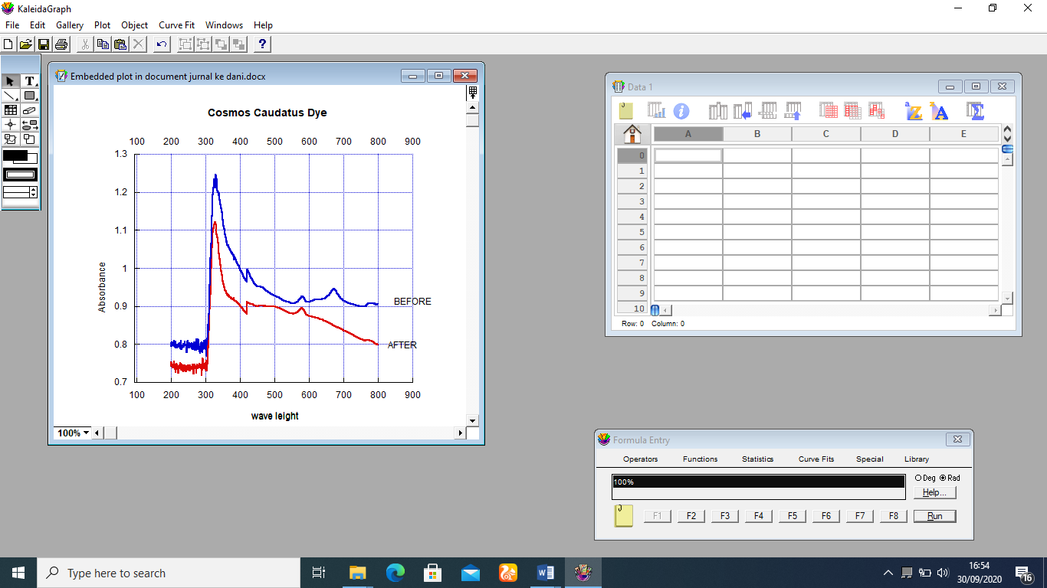

Figure 3. Cosmos caudatus Absorbance Graph

Current-voltage characterization (I-V) is a method of knowing the Performance of Dye-Sensitized Solar Cells which is how much ability DSSC can convert light into electrical energy I-V measurements are carried out in dark and light conditions that are under the exposure of halogen lamps with an intensity of 1000 W/m2. For conductivity values from DSSC can be seen in figure 4.

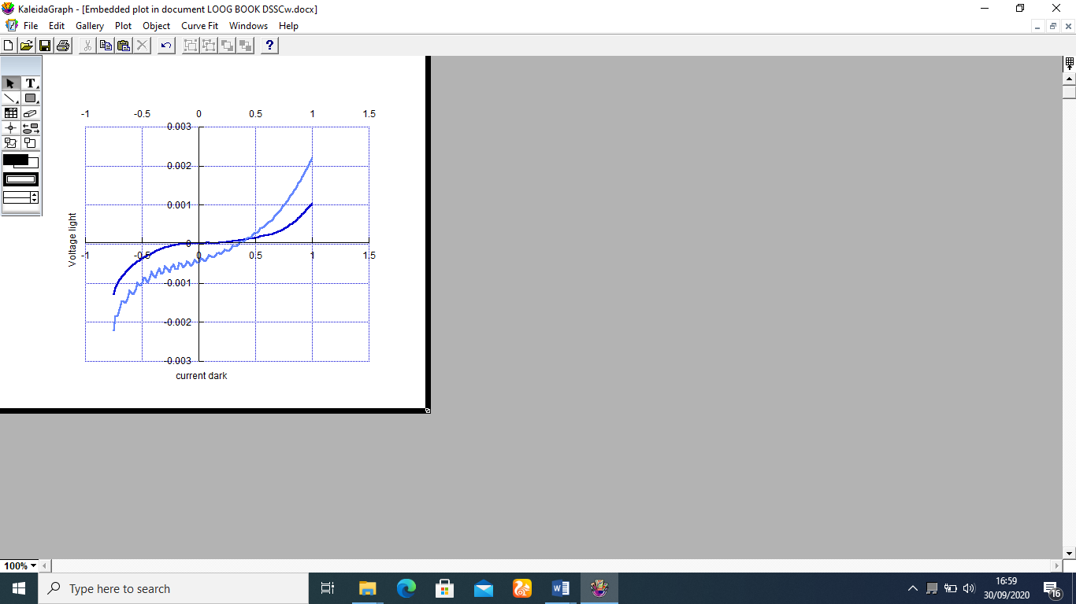

Figure 4. Organic material I-V curve

Figure 4 shows the I-V curve of the characterization value of organic matter at a light current greater than in dark currents. The efficiency produced by DSSC using organic extracts combined with Cosmos caudatus treatment differences in TiO2 is presented in table 1. This study using electrode counter Pt (Hexachloroplatinic (IV) acid 10%).

Table 1. DSSC generated efficiency

|  |  |  |  |  |
| --- | --- | --- | --- | --- |
| *Dye­* | Vmax (Volt) | Isc (Ampere) | pmax (Volt) | Ef (%) |
| *Cosmos caudatus* | 3.5 x10-6 | 2 x10-5 | 1 x 10-6 | 8.3x10-3 |

The efficiency produced in this study is still relatively low. This is because organic materials have low mobility properties and are easily combined as well as the use of liquid electrolytes, where the longer they are used because they evaporate and produce less maximum transfer catalysts. According to the function of the electrode/charge. If the electrolyte runs out or does not even exist then the electron transfer activity will be reduced/ none.

1. **Conclusion**

Dye-Sensitized Solar Cells (DSSC) using organic material extraction materials have been fabricated. With the current and voltage generated. The area of the curve indicates the DSSC of the organic material extract with the immersion method resulting in a good I-V curve. The opposing electrode is one of the most important components not usually released in the DSSC structure. Administration Pt (Hexachloroplatinic (IV) acid 10%) the opponent's electrodes provide better performance on the DSSC. Pt (Hexachloroplatinic (IV) acid 10%) catalyzes accelerating redox reactions with electrolytes. The efficiency is produced by each organic material. What needs to be suggested for further research is to improve the structure of DSSC to produce better synergy and efficiency. Using opposing electrodes from other materials that have better conductivity and catalyst properties.

**Acknowledgment**

The researcher thanked the laboratory manager of FMIPA UNS Surakarta and the team researcher who has funded this publication.

**References**

[1] A. S. Ho Soon Min, Hardani, Cari, “Thin Film-Based Solar Cell and Dye-Sensitized Solar Cells : Review,” vol. 29, no. 11, pp. 2413–2426, 2020.

[2] M. Ishida *et al.*, “β-(Ethynylbenzoic acid)-substituted push-pull porphyrins: DSSC dyes prepared by a direct palladium-catalyzed alkynylation reaction.,” *Chem. Commun.*, vol. 49, pp. 9164–9166, 2013.

[3] T. T. Win, Y. Maung Maung, and K. K. Kyaw Soe, “Characterization of Nano-sized ZnO Electrodes with Curcumin-derived Natural Dye Extract for DSSC Application,” *Am. J. Mater. Sci. Technol.*, pp. 28–33, 2012.

[4] C. Sunyong and L. S. Shin, “Current status and research trend of dye-sensitized solar cell (DSSC),” *Chaeryo Madang*, vol. 24, no. Copyright (C) 2011 American Chemical Society (ACS). All Rights Reserved., pp. 15–25, 2011.

[5] M. Bastianini *et al.*, “Effect of iodine intercalation in nanosized layered double hydroxides for the preparation of quasi-solid electrolyte in DSSC devices,” *Sol. Energy*, vol. 107, pp. 692–699, 2014.

[6] T. H. Meen *et al.*, “Applications of vertically oriented TiO2 micro-pillars array on the electrode of dye-sensitized solar cell,” *J. Phys. Chem. Solids*, vol. 72, no. 6, pp. 653–656, 2011.

[7] M. B. Qadir *et al.*, “Composite multi-functional over layer: A novel design to improve the photovoltaic performance of DSSC,” *Sol. Energy Mater. Sol. Cells*, vol. 140, pp. 141–149, 2015.

[8] A. H. Hardani, “The efficiency of Dye-Sensitized Solar Cell ( DSSC ) Improvement as a Light Party TiO 2 -Nano Particle With Extract Pigment Mangostana Peel ( Garcinia mangostana ) with various solvents,” 2018.

[9] and Q. K. M. Hassan Farooq1, 2*, I. Aslam3, Ahmad Shuaib2, H. Sadia Anam4, M. Rizwan5 and 1L, “Band Gap Engineering for Improved Photocatalytic,” *Catalysts*, vol. 33, no. 3, pp. 561–571, 2019.

[10] A. A. Bayod-Rújula, “Solar photovoltaics (PV),” *Sol. Hydrog. Prod. Process. Syst. Technol.*, vol. 1, no. 4, pp. 237–295, 2019.

[11] M. Hardani, Iman Darmawan and A. Supriyanto, “PENGGUNAAN EKSTRAK DAUN BINAHONG (BASSELA RUBRA LINN) SEBAGAI ZAT PEKA CAHAYA TiO2-NANO PARTIKEL DALAM DYE-SENSITIZED SOLAR CELL (DSSC),” 2014.

[12] M. Hardani, Iman Darmawan and A. Supriyanto, “Fabrication of dye natural as a photosensitizers in dye- sensitized solar cells (DSSC),” *J. Phys. J. Phys. Theor. Appl*, vol. 1, no. 1, pp. 2549–7316, 2017.

[13] A. Kitai, *Principles of Solar Cells , LEDs and Diodes e role of the PN junction*. Wiley, 2011.

[14] M. A. Othman, B. H. Ahmad, and N. F. Amat, “An overview of nanonet based dye-sensitized solar cell (DSSC) in solar cloth,” *J. Semicond. Technol. Sci.*, vol. 13, no. 6, pp. 635–646, 2013.

[15] I. A. Sahito, K. C. Sun, A. A. Arbab, M. B. Qadir, and S. H. Jeong, “Graphene coated cotton fabric as textile structured counter electrode for DSSC,” *Electrochim. Acta*, vol. 173, pp. 164–171, 2015.

[16] K. Sharma, V. Sharma, and S. S. Sharma, “Dye-Sensitized Solar Cells: Fundamentals and Current Status,” *Nanoscale Res. Lett.*, vol. 13, 2018.