THE EFFECT OF PREHEATING TEMPERATUR ON WELDING TRUCK FRAME REPAIR USING FCAW TECHNIQUE

**Tumiantoa*, Muhammad Al'hapis a, Azmi Hassanb, a ,Fauzan Rahmana**

a Manufacturing Section,Universiti Kuala Lumpur, Malaysian Spanish Institute Kulim Hi-Tech Park, 09000 Kulim, Kedah, Malaysia .

b Electrical, Electronics & Automation Section, Universiti Kuala Lumpur, Malaysian Spanish Institute Kulim Hi-Tech Park, 09000 Kulim, Kedah, Malaysia

* Tumianto-mail: tumianto@s.unikl.edu.my

Muhammad Al’hapis

e-mail: alhapis@unikl.edu.my

Azmi Hassan

e-mail: azmi.hassan@unikl.edu.my

Surya Atmadyaya

e-mail: atmadyaya.surya@s.unikl.edu.my

Iwan susanto

e-mail: iwan.susanto @s.unikl.edu.my

**Abstract:** This paper presents an effect FCAW technique to repair 100T Mining truck, in process repair frame. FCAW is a welding process that uses a heat source that comes from electrical energy that is converted into a heat source in an electric arc. Author illustrates this method using FMEA for simulated temperature effect time improvement successfully.

**Keywords –** FMEA, welding, Heat, FCAW, Mining, frame

**1 Introduction**

As competitive pressures intensify on organizations around the globe to be more efficient and effective a once peripheral management activity, maintenance, has now been given a central focus. This proposal would enable reducing not only a single company's material losses, but also the avoidance of a significant proportion of all material losses that occur in the transformation processes along a supply chain.

However, improvements made to the production equipment in the frame of mobile equipment is welding. The existence of residual stress from the welding process reduces the strength of the structure. This of course will reduce productivity which ultimately reduces profit.

**2 Literature**

FMEA is a systematic activity in the product design stage and process design stage to analyze the subsystems, parts and processes of the product one by one, and then find out all potential failure modes and analyze their possible consequences, so as to take necessary measures in advance to improve product quality and reliability.  
In this study, FMEA is used to analyze the causes and consequences of possible failure modes in the process of improving the quality of electro-fusion fittings.  
Manufacturing processes of electro-fusion fittings were analyzed by FMEA and relative solutions were given to failure models with high Risk Priority Number indices.  
By the integration of FMEA into QFD, the product qualification ratio of electro-fusion fittings has increased by 12% based on the improvement of the technical design and manufacturing processes

**3. Methodologies**

**3.1 Data Collection Method**

The data required as input data for calculation is a record of overall maintenance activities which must include official maintenance categories of SAP used by the company. This data will be used to compare the conditions before and after the implementation of the Maintenance management improvement program.

**3.2 Validation and Verification**

The aim is to create a model that represents conditions close to the characteristics of the actual system as a substitute for the actual system for the purpose of system testing, system behavior analysis, and system performance prediction.

**3.3 Implementation & Post Implementation Analysis**

Implementation and post implementation of FMEA analysis is designed to: a. Identify and fully understand potential failure modes and their causes, and the effects of failure on the system or end users, for a given product or process.  
b. Assess the risk associated with the identified failure modes, effects, and causes, and prioritize issues for corrective action.  
c. Identify and carry out corrective actions to address the most serious concerns. FMEA can be viewed as a proactive procedure for evaluating a process by identifying where and how it might fail and assessing the relative impact of different failures.  
Despite FMEA’s primary objective is improving the system design, it can be applied in any stage of a project to mitigate potential future risks produced by failure modes. FMEA is conducted by a cross-functional team of subject matter experts that analyzes the system to identify weaknesses and propose correcting actions that prevent a negative impact on the system’s performance. At this point, it is important to note that FMEA’s objective is not to predict failures. Its aim is to identify existing and potential failures through a subjective and systematic assessment to classify those failures according to a risk measure.  
• Frequency of Occurrence : that represents the number of times the failure mode occurs.  
  
• Detectability Assign an Occurrence Assign a Detectability Assign a Severity Reevaluate the RPN number after the actions are completed.

**4.1. Map description**

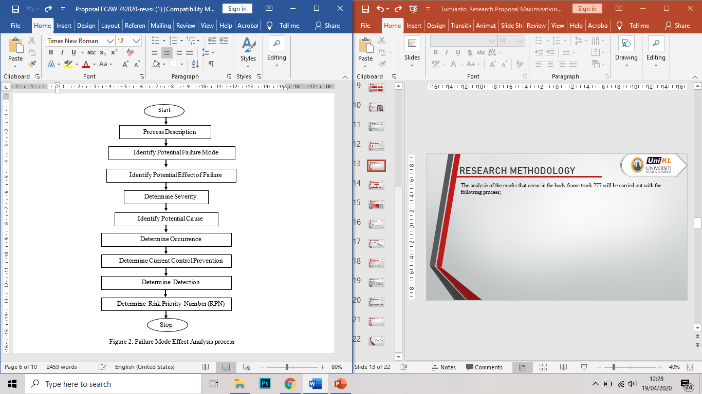

Figure 1. Research Routine using FMEA

**5. The Root Cause of Cracks That Occur on The 777D 100 Tons’ Truck**

Here all the load cases that have added to the failure and abusive driving condition cases like over-steering, over speeding, sudden braking and overloading have been studied. When the truck is overloaded its handling precision during emergency will reduce because braking distance for overloaded trucks is more causing the misjudgment of stopping distance.in addition to safety concern, the cost of operation of an overloaded truck is more. During sudden braking and over steering the truck cab structure experiences high rates of loading and the material experiences elevated strain-stress. The new material that we have proposed is JFE CA780A when has a yield point of 400Mpa, Tensile strength of 780Mpa and elongation of 24%.



Figure 2. Fishbone Diagram

**6. Inspection and Execution Perform Correctly**

The 777D is designed for quick and easy servicing. Each step of the inspection should be acknowledged as complete when the task is completed. The inspection documents should be signed by the inspector completing the inspection. Any repairs or adjustments that are completed during the inspection should be recorded on the inspection form and signed off as completed by the maintenance worker performing the work.

**7. Truck Systems Periodic Inspection and Maintenance**

The current state map shows the current situation of the company. The following Periodic inspection and maintenance tasks on truck systems should be performed on a regular schedule as determined by the RTS. The frequency of any task contained within this Recommended Practice shall comply with all applicable federal, state and local regulations.  
  
Table 1. provides baseline intervals that can be used for developing the truck system preventive maintenance component of an RTS’s vehicle inspection and maintenance program

**Table 1.**

**Baseline Truck Maintenance Intervals**

|  |  |  |  |
| --- | --- | --- | --- |
| **Inspections and Maintenance** | **Miles** | **Time** | **Interval** |
| Visual inspection | 3,000 to 5,000 | Monthly | NA |
| Wheel gauging, measuring, adjusting, checking and replenishing lubricants | 12,000 to 15,000 | Three to four months | NA |
| Predictive testing (*See Section 2.5.2.1*) | NA | As determined by RTS | After Overhaul |

NOTE:In the absence of experience, recommendations or history, initial inspection intervals should be no longer than 30 days or 3,000 to 5,000 miles.

**8. The Effect of Preheating Temperature on Welding Truck Frame Repair Using FCAW Technique**

Preheating can be defined as heating the base metal to a certain temperature before welding. Reclamation includes the disassembly and rewelding of defective items manufactured in the factory and in the field. It has been used for maintaining and repairing items too expensive to repair with oxyacetylene welding and other arc welding processes.  
Preheating enables the electrode to burn off at a faster rate and increases deposition. The preheating also decreases the heat available for melting the base metal, resulting in a shallower penetration than the gas shielded process.

Tabel 4.1 Preheats for various metals



**9. Conclusion**

1. The Root Cause of Cracks That Occur on The 777D 100 Tons’ Truck are as follows: Here all the load cases that have added to the failure and abusive driving condition cases like over-steering, over speeding, sudden braking and overloading have been studied.

2. The Own Inspection and Execution Perform Correctly According to Original Equipment Manufacturer (OEM). Periodic inspection and maintenance tasks on truck systems should be performed on a regular schedule as determined by the RTS

3. The Effect of Preheating Temperature on Welding Truck Frame Repair Using FCAW Technique. Inadequate preheating results in different types of cracking, insufficient fusion, and penetration. Carbon equivalent is used as a tool for approximating proper preheats. Besides CE, optimum preheating temperature also depends on section thickness, restraint, ambient temperature, filler metal hydrogen content, and previous cracking problems.

4. There are three most important set of Establish New Method of Welding Procedure on Maintenance/Repair 777D 100 Tons’ Truck: preparation for welding, repair welding, postweld operation.

**REFERENCES**

[1] L. A. S. Rodrigues, C. R. Loayza L, D. J. A. Borges, P. E. C. Baia, E. N. Freitas, and E. M. Braga, “Welding procedures influence analysis on the residual stress distribution and distortion of stiffened panels welded via robotized FCAW,” *Thin-Walled Struct.*, vol. 141, no. August 2018, pp. 175–183, 2019

[2] A. Aloraier, A. Al-Mazrouee, J. W. H. Price, and T. Shehata, “Weld repair practices without post weld heat treatment for ferritic alloys and their consequences on residual stresses: A review,” *Int. J. Press. Vessel. Pip.*, vol. 87, no. 4, pp. 127–133, 2010.

[3] E. A. Gyasi, P. Kah, and J. Martikainen, “Welding management as a tool for innovative, competitive and sustainable manufacturing,” *Int. J. Dev. Sustain. Int. J. Dev. Sustain. Int. J. Dev. Sustain.*, vol. 3, no. 8, pp. 1782–1793, 2014.

[8] V. Balasubramanian and B. Guha, “Analysing the influences of weld size on fatigue life prediction of FCAW cruciform joints by strain energy concept,” *Int. J. Press. Vessel. Pip.*, vol. 76, no. 11, pp. 759–768, 1999.

[9] S. Xing, P. Dong, and A. Threstha, “Analysis of fatigue failure mode transition in load-carrying fillet-welded connections,” *Mar. Struct.*, vol. 46, pp. 102–126, 2016.

[10] N. Recho, T. Lassen, and O. N. Mikkelsen, “Fatigue crack growth in welds based on a V-notch model for the short crack propagation at the toe,” *Procedia Eng.*, vol. 213, no. 2017, pp. 239–254, 2018.

[11] C. P. Surya Andiyanto, Agung Sutrisno, “PENERAPAN METODE FMEA (FAILURE MODE AND EFFECT ANALYSIS) UNTUK KUANTIFIKASI DAN PENCEGAHAN RESIKO AKIBAT TERJADINYA LEAN WASTE,” *J. Online Poros Tek. Mesin Vol. 6 Nomor 1*, vol. 6, pp. 45–57