Improvement Of Calorific Value In Sew Powder Biomass With Carbonization and Densification Methods

A Anam*, M Asroni and T Rahardjo

Mechanical Engineering, National Institute of Technology Malang, Malang, Indonesia

*asrofulan@gmail.com

**Abstract**. Energy is a source of life that is needed by all people in the world, including the industrial community in Indonesia, which currently still depends on fossil energy sources such as oil and coal. These energy sources will be exhausted and non-renewable, so the use of new renewable energy sources is absolutely necessary to fulfil and maintain the sustainability of industrial processes, such as biomass fuel. This paper presents experimental results of biomass fuel from teak sawdust (TS) waste which aims to increase the calorific value by carbonization and forming pellets with added cotton seed oil (CS) and starch (S). Composing the teak sawdust for 100 minutes; temperature 200 °C-50 °C; and Variation of the mixture ratio of the three ingredients in gram size (TS:CS:S) are M1 = 1000: 100: 500, M2 = 1000: 250: 500, M3 = 1000: 400: 500, M4 = 1000: 550: 500, and M5 = 1000: 700: 500. The results showed that the M5 mixture had the highest calorific value, 4539.49 call/gr with the density value of 2.60 gr / mm2, moisture content of 4.45%, and ash content of 5.17%.

Keywords: Energy, biomass, calorific value, teak

1. Introduction

Energy is a source of life that is indispensable for the entire world community, including for the industrial community in Indonesia (Rachmat, 2018). Energy needs in Indonesia currently depend heavily on fossil energy sources that cannot be repaired, such as coal fuel, natural gas, and fuel oil (BBM). The energy source is widely used by people in the industrial sector. The fuels used by the people in Indonesia today are oil and coal on a large scale, thus causing the supply in nature to be increasingly limited and scarce and the price is expensive (Anam & Majid, 2020) (Syamsiro et al., 2019). These energy sources will be depleted and cannot be renewed, so the utilization of renewable energy sources, like biomass, is absolutely required to fulfill and maintain the sustainability of industrial processes, both industries that produce energy themselves and those that produce other products (Motghare et al., 2016).

Biomass is a source of energies from many woods, activities wastes of forest processing industry, agriculture and plantations; animal wastes such as cow, buffalo, and horse (Aditya et al., 2019). The potential for biomass energy sources is very competitive to be used as fuel, such as teak powder waste of the furniture industry (Febijanto, 2007). This waste has the opportunity to be optimally utilized as an alternative energy that is beneficial to the needs of the community, industry and the wider community by converting teak sawdust into charcoal pellet fuel combined with a mixture of other raw materials (Rajput et al., 2020) (Zeng et al., 2018).

Teak sawdust is a biomass that has not been used optimally and has a relatively large calorific value with the main components of cellulose, hemicellulose, lignin and wood extracts (Mutmainnah et al., 2017). According to (Wulandari et al., 2011), wood sawdust is a porous material that can absorb water filling the pores which can reduce its quality if it is used as direct fuel. So it is necessary to do treatment in order to obtain quality teak sawdust biomass with high heating value. A few of the treatments to obtain quality teak sawdust biomass with a high calorific value are through the pyrolysis or charcoal process (Yank et al., 2016) (Sudding & Jamaluddin, 2015); mixture of any difference woods (Saeed et al., 2019) (Jamradloedluk & Lertsatitthanakorn, 2017); densification of biomass (Iftikhar et al., 2019). Experimental treatments and tests to obtain quality teak sawdust biomass with high heating value had been carried out to replace fossil fuel sources.

1. Research materials and method

The biomass materials of this study are teak sawdust waste (TS) (Figure 1), obtained from the rest of the furniture industry process; cotton seed oil (CS); and starch (S). TS is sieved to obtain a uniform powder size before the charring process (Figure 2). After coking, TS is re-filtered and put in a mixing container and added with CS and S. Composing the TS for 100 minutes; temperature 200 °C-50 °C; and Variation of the mixture ratio of the three ingredients in gram size (TS:CS:S) are M1 = 1000: 100: 500, M2 = 1000: 250: 500, M3 = 1000: 400: 500, M4 = 1000: 550: 500, and M5 = 1000: 700: 500.

After the ingredients are mixed, they are put into a pellet machine (Figure 3) using a hydraulic system as a driving force for a pressing machine with components, namely the solenoid valve, pressure gauge, pressure valve, and controller. The working principle of the pellet pressing device is that the pressure is controlled by the pressure valve, the solenoid is used to regulate the rise and fall of the press piston, the controller functions as a solenoid drive, the pressure gauge is used to determine the pressing pressure.

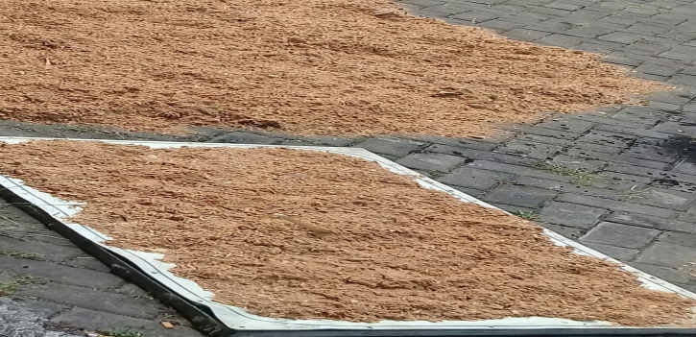

Figure 1. Teak Sawdust Waste (TS)

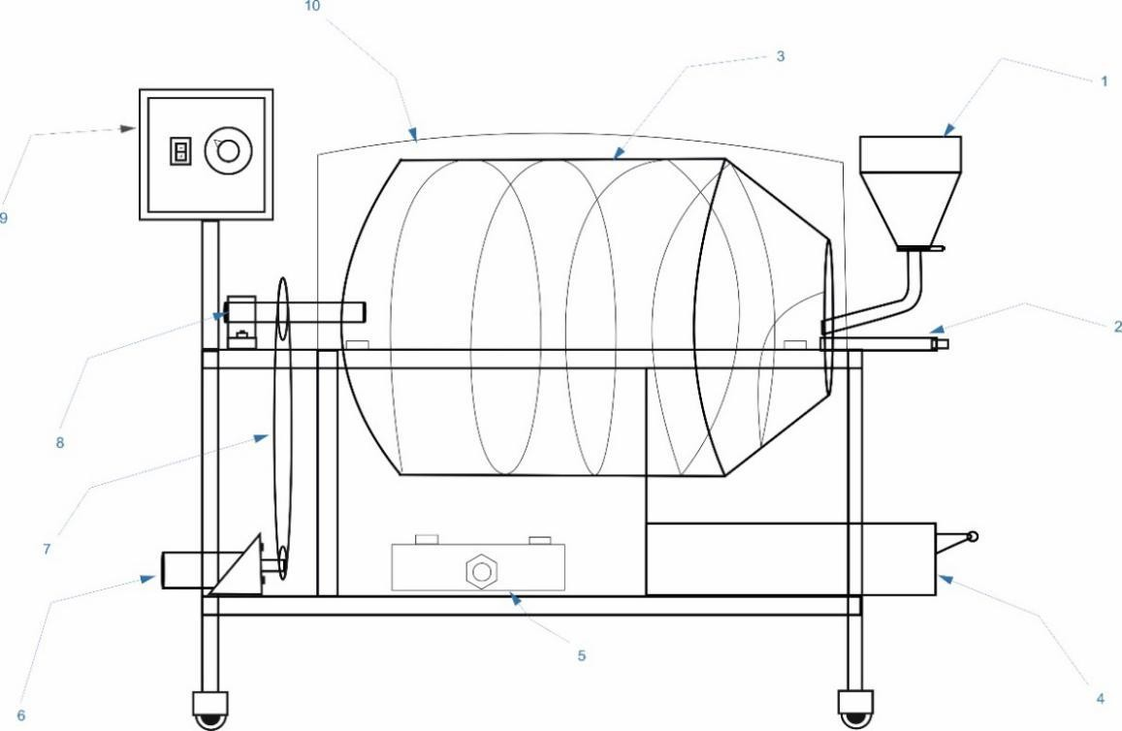

Figure 2. Charcoal Tool

Remark:

1. The funnel for entering raw materials.
2. Charcoal domes / tubes.
3. Check ventilation.
4. Carried containers.
5. Stove.
6. Dynamo.
7. Gear assembly.
8. Axle tube charring.
9. Controller.
10. Cover of the charcoal tube.

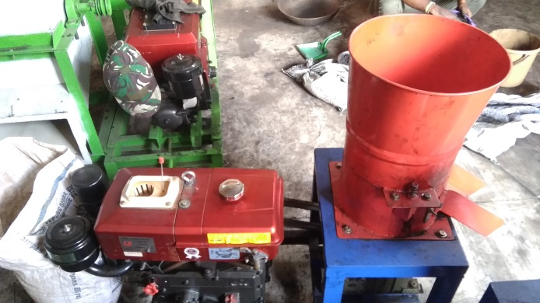

Figure 3. Densification Tool

Several addition tools are used:

1. Pellet burner.
2. Thermocouple.
3. Stopwatch.
4. Digial scale.
5. Moisture meter.
6. Pellet mold.
7. Results and discussion

## Calorific and ash values of biomass sawdust

The results of the charcoal pellet combustion experiment showed that the variation in the ratio of the mixture had an effect on the calorific and ash values of biomass sawdust. The calculation of the heating calorific value of combustion was carried out by means of averaging data analysis.

**Table 1.** Heating calorific value of combustion

|  |  |  |  |  |
| --- | --- | --- | --- | --- |
| Specimen | Teak Powder (gr) | Cotton seed oil (gr) | Starch (gr) | Calorific value (cal/gr) |
| M1 | 1000 | 100 | 500 | 4208.32 |
| M2 | 1000 | 250 | 500 | 4271.61 |
| M3 | 1000 | 400 | 500 | 4387.12 |
| M4 | 1000 | 550 | 500 | 4457.66 |
| M5 | 1000 | 700 | 500 | 4539.49 |

**Table 2.** Ash value of combustion

|  |  |  |  |  |
| --- | --- | --- | --- | --- |
| Specimen | Teak Powder (gr) | Cotton seed oil (gr) | Starch (gr) | Ash value (%) |
| M1 | 1000 | 100 | 500 | 27.50 |
| M2 | 1000 | 250 | 500 | 19.08 |
| M3 | 1000 | 400 | 500 | 18.95 |
| M4 | 1000 | 550 | 500 | 12.07 |
| M5 | 1000 | 700 | 500 | 5.17 |

## According to the first data (Table 1), it is shown that the highest calorific value is in the M5, namely 4539.49 cal / g, and the lowest is in M1, 4208.32 cal / g. This explains that the variation of the mixture between teak sawdust charcoal, cottonseed oil, and starch affects the calorific value of the biomass pellets, namely by increasing the concentration of cottonseed oil, the calorific value of each mixture will also increase. Meanwhile, increasing the heating value will reduce the ash content from the combustion, as shown in Table 2. The table shows that the lowest residual ash content is in mixture 5 and the highest is in mixture 1, namely 5.17% and 27.50% respectively.

## Density and moisture values of biomass sawdust charcoal pellets

## Based on the test of sawdust biomass charcoal pellet specimens, it is shown that the density and moisture values affect the calorific value of each charcoal pellet specimen. Density changes in each material were analyzed the mean data.

**Table 3.** Density of biomass sawdust charcoal pellets

|  |  |  |  |  |
| --- | --- | --- | --- | --- |
| Specimen | Teak Powder (gr) | Cotton seed oil (gr) | Starch (gr) | Density (gr/cm3) |
| M1 | 1000 | 100 | 500 | 2.00 |
| M2 | 1000 | 250 | 500 | 2.35 |
| M3 | 1000 | 400 | 500 | 2.40 |
| M4 | 1000 | 550 | 500 | 2.55 |
| M5 | 1000 | 700 | 500 | 2.60 |

Concert with the Table 3, it tells that the highest density value is in M5, 2.60% and the lowest is in M1, 2.00%. It describes that the density value affects the calorific value of each charcoal pellet specimen, the highest and the lowest calorific values are in the M5 and M1, namely 4539.49 cal/g with 2.60% and 4208.32 cal/g with 2.00% of density values respectively*.*

**Table 4.** Moisture of biomass sawdust charcoal pellets

|  |  |  |  |  |
| --- | --- | --- | --- | --- |
| Specimen | Teak Powder (gr) | Cotton seed oil (gr) | Starch (gr) | Moisture (%) |
| M1 | 1000 | 100 | 500 | 12.63 |
| M2 | 1000 | 250 | 500 | 10.32 |
| M3 | 1000 | 400 | 500 | 8.30 |
| M4 | 1000 | 550 | 500 | 6.54 |
| M5 | 1000 | 700 | 500 | 4.45 |

Based on the Table 4, it is shown that moisture value also affects the calorific value of each charcoal pellet specimen. The highest and the lowest moisture values are M1 and M5, 12.62% with 4539.49 cal/g and 4.45% with 4208.32 cal/g of the calorific values severally.

1. Conclusion

Based on the result and discussion of the study, any conclusions are:

1. Improving of calorific value in sew powder biomass is effected by mixture of teak sawdust charcoal (TS), cotton seed oil (CS), and starch (S).
2. By increasing the concentration of cottonseed oil, the calorific value of each mixture will also increase.
3. The highest calorific value is in the M5, 4539.49 cal/g, and the lowest is in M1, 4208.32 cal/g.

References

Aditya, F. U., Rahmadi, A., Kehutanan, J., Kehutanan, F., & Lambung, U. (2019). *KECAMATAN BANJARMASIN UTARA DAN BANJARMASIN BARAT KOTA BANJARMASIN PROVINSI KALIMANTAN SELATAN Study of Potential Waste of Sawn Timber Processing in Banjarmasin Utara District and Banjarmasin Barat District the City of Banjarmasin Province of Kalimantan S*. *02*(5), 854–864.

Anam, A., & Majid, M. A. (2020). Karakteristik Limbah Daun Tebu Sebagai Sumber Energi Baru Terbarukan Berbasis Densification Method. *Jurnal Rekayasa Mesin*, *15*(1), 59. https://doi.org/10.32497/jrm.v15i1.1832

Febijanto, I. (2007). Potensi Biomasa Indonesia Sebagai Bahan Bakar Pengganti Energi Fosil. *Ejurnal.Bppt.Go.Id*, *9*. http://ejurnal.bppt.go.id/ejurnal2011/index.php/jsti/article/view/669

Iftikhar, M., Asghar, A., Ramzan, N., Sajjadi, B., & Chen, W. yin. (2019). Biomass densification: Effect of cow dung on the physicochemical properties of wheat straw and rice husk based biomass pellets. *Biomass and Bioenergy*, *122*(April 2018), 1–16. https://doi.org/10.1016/j.biombioe.2019.01.005

Jamradloedluk, J., & Lertsatitthanakorn, C. (2017). Influences of Mixing Ratios and Binder Types on Properties of Biomass Pellets. *Energy Procedia*, *138*, 1147–1152. https://doi.org/10.1016/j.egypro.2017.10.223

Motghare, K. A., Rathod, A. P., Wasewar, K. L., & Labhsetwar, N. K. (2016). Comparative study of different waste biomass for energy application. *Waste Management*, *47*, 40–45. https://doi.org/10.1016/j.wasman.2015.07.032

Mutmainnah, I. K. E. R., Sains, F., & Teknologi, D. A. N. (2017). *PEMANFAATAN LIMBAH GERGAJI KAYU JATI (Tectona grandits L.f) SEBAGAI ENERGI ALTERNATIF DENGAN METODE PIROLISIS*.

Rachmat, A. N. (2018). Indonesia dalam Pusaran Politik Energi Global. *Indonesian Perspective*, *3*(1), 66. https://doi.org/10.14710/ip.v3i1.20179

Rajput, S. P., Jadhav, S. V., & Thorat, B. N. (2020). Methods to improve properties of fuel pellets obtained from different biomass sources: Effect of biomass blends and binders. *Fuel Processing Technology*, *199*(October 2019). https://doi.org/10.1016/j.fuproc.2019.106255

Saeed, M. A., Farooq, M., Andrews, G. E., Phylaktou, H. N., & Gibbs, B. M. (2019). Ignition sensitivity of different compositional wood pellets and particle size dependence. *Journal of Environmental Management*, *232*(November 2018), 789–795. https://doi.org/10.1016/j.jenvman.2018.11.122

Sudding, & Jamaluddin. (2015). Pengaruh Jumlah Perekat Kanji terhadap Lama Briket Terbakar menjadi Abu. *Jurnal Chemical*, *16*(1), 27–36.

Syamsiro, M., Management, W., Janabadra, U., & Yogyakarta, J. T. R. M. (2019). *Peningkatan Kualitas Bahan Bakar Padat Biomassa Dengan Proses Densifikasi Dan Torrefaksi*. *1*(April 2016), 7–13.

Wulandari, T. G., Paduan, P., Liat, T., & Karanganyar, D. I. K. (2011). *Pengaruh Penambahan Serbuk Gergaji Kayu Jati*.

Yank, A., Ngadi, M., & Kok, R. (2016). Physical properties of rice husk and bran briquettes under low pressure densification for rural applications. *Biomass and Bioenergy*, *84*, 22–30. https://doi.org/10.1016/j.biombioe.2015.09.015

Zeng, T., Pollex, A., Weller, N., Lenz, V., & Nelles, M. (2018). Blended biomass pellets as fuel for small scale combustion appliances: Effect of blending on slag formation in the bottom ash and pre-evaluation options. *Fuel*, *212*(August 2017), 108–116. https://doi.org/10.1016/j.fuel.2017.10.036