Game-Based Learning for the Mastery of HOTS in Prospective Physics Teachers in Digital Electronics Courses
D Dewantara, M Misbah, S Haryandi, S Mahtari
Physics Education Study Program, Universitas Lambung Mangkurat¹

*Corresponding author: dewantara_pfis@ulm.ac.id

Abstract. This study aims to describe the mastery of HOTS of prospective physics teachers in digital electronics courses after implementing game-based learning. The type of research is a quantitative descriptive study. The number of research subjects consisted of 50 students. Data were collected using a test of learning outcomes about digital circuits in the cognitive domains. The data were analyzed to categorize the students' high-level thinking skills. The data processed were displayed in the form of diagrams and graphs. The data were also equipped with a student response questionnaire. The results of the analysis showed that 46% of the HOTS in students were categorized in “good” category; 28% in “very good” category; a small proportion of others were categorised as “quite good” and “less good”. The HOTS of prospective physics teachers was already sufficient with an average of 70.25. Student responses were deemed in the “good” category. Therefore, it can be concluded that the mastery of HOTS in prospective physics teachers in digital electronics courses after implementing game-based learning is categorized as high. Thus, it is concluded that the mastery of HOTS in prospective physics teacher candidates in digital electronics courses can be further enhanced and trained by applying game-based learning.
- Introduction
The era of Industrial Revolution 4.0 which is currently occurring requires educators to develop innovative learning [1,2]. One of the innovative learning methods promoted is the integration of technology in the learning process [3,4]. An example of innovative teaching strategies today is Game-Based Learning. Several studies have outlined the positive effects of Game-Based Learning which is eventually further improved and developed for the purpose of integrating the skills of 21st century for students [5–9]. Game-Based Learning refers to a teaching strategy which integrates the contents of a game in learning activities in order to motivate students in gaining knowledge and skills [10]. Games in learning can provide various contexts which help students to practice various skills [6].
Illustrations of various logic circuits are indispensable for the fulfilment of the learning achievements within digital electronics courses that are studied by prospective physics teachers [11]. Sub-course learning outcomes of these courses include that prospective physics teachers must have the knowledge and skills to analyze and evaluate logical sequences, such as equations (Boolean algebra), sum of product, product of sum, and remake the series in standard form. This shows that students' higher order thinking skills are essential. Higher Order Thinking skill Skills is considered the taxonomy: analyze, evaluate, and create. This is in accordance with the demands of the 21st century which states that students must develop Higher Order Thinking Skills [12]
Therefore, a method which can improve students' Higher Order Thinking Skills is critically needed. Higher Order Thinking skil Skillsls can be thoroughly developed with the use of innovative learning [13]. Teacher skills play an important role in practicing Higher Order Thinking Skills to students [14]. One of these innovative teaching strategies is Game-Based Learning [15]. The game which is selected to be used in learning logic gates is "Make It True: Solve the Circuit.apk". This game provides several sequences in which each individual sequence gets more complicated at every level. The circuit uses various logic gates studied in digital electronics.
Previous research [11,16,17] have proven that Game-Based Learning affects, or improves student learning outcomes. Other studies have also supported on how Game-Based Learning impacts Higher Order Thinking Skills [15]. Specifically, at the prospective physics teacher cognitive level, according to the Bloom taxonomy of digital electronics, it has not been discussed, including in the realm of Higher Order Thinking Skills. Hence, this article will describe the mastery of Higher Order Thinking Skills of prospective physics teachers in digital electronics courses after the implementation of Game-Based Learning.
- Method
The type of this research is a quantitative descriptive study. The number of research subjects was 50 students. Data on Higher Order Thinking Skills were obtained from student learning outcomes tests. The learning outcomes test distributed to students consisted of C4 and C5 cognitive domains, namely in the realm of analyzing and evaluating. The learning outcomes test is based on games which the students have been playing on. In this case, students are asked to analyze the standard equation, sum of product and product of sum of a series located at a certain level in the game. Another problem illustrates how to evaluate several existing sequences at the game level which have similar standard form. Then, students are asked to create another series which also has similar standard form. The data is processed in the form of plots, diagrams or graphs. Data analysis to categorize students' Higher Order Thinking Skills vary from very good, good, quite good, poor, and very poor, which can be seen in Table 1 below.
Table 1. Criteria for Higher Order Thinking Skills score
Interval Score | Criteria
$$80 <X ≤100$$ | Very good
$$60 <X ≤80$$ | Good
$$40 <X ≤60$$ | Quite Good
$$20<X ≤40$$ | Poor
$$0 <X ≤20$$ | Very Poor

The data are also equipped with a student response questionnaire about the application of Game-Based Learning. The responses to be assessed consist of two criteria, namely responses and reactions. The response criteria contain two indicators, namely format and relevance, while the reaction criteria have three indicators, namely attention, satisfaction and self-confidence [18]. Student responses are categorized into several categories: very good, good, quite good, poor and very poor,as displayed in the following Table 2.
Table 2. Criteria for students responses
Interval Score | Criteria
$$4.2 <X ≤5$$ | Very good
$$3.4 <X ≤4.2$$ | Good
$$2.6 <X ≤3.4$$ | Quite good
$$1.8<X ≤2.6$$ | Poor
$$1 <X ≤1.8$$ | Very poor

- Result and Discussion
Digital electronics learning is carried out using a Game-Based Learning model. Game-Based Learning refers to a learning model which integrates the contents of a game within learning activities in order to assist students in gaining knowledge and skills [10]. The game used in this lesson is "Make It True: Solve the Circuit" which has an interface display shown in Figure 1 below. This game provides several sequences where each sequence gets more complicated in every level. The circuit uses various logic gates studied in digital electronics. In this game, the player is instructed to provide the right input so that the output of the circuit can light up.
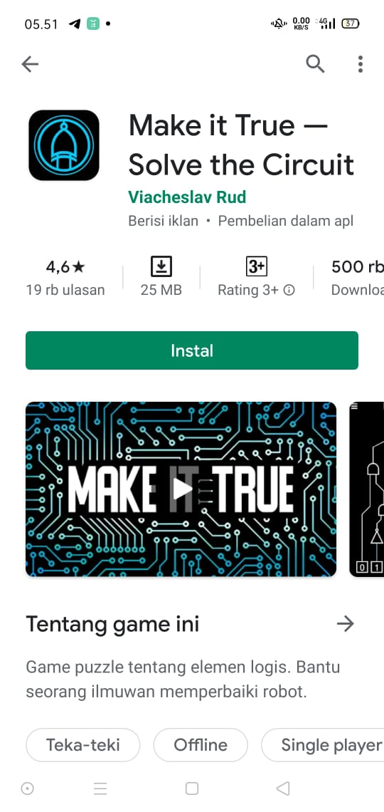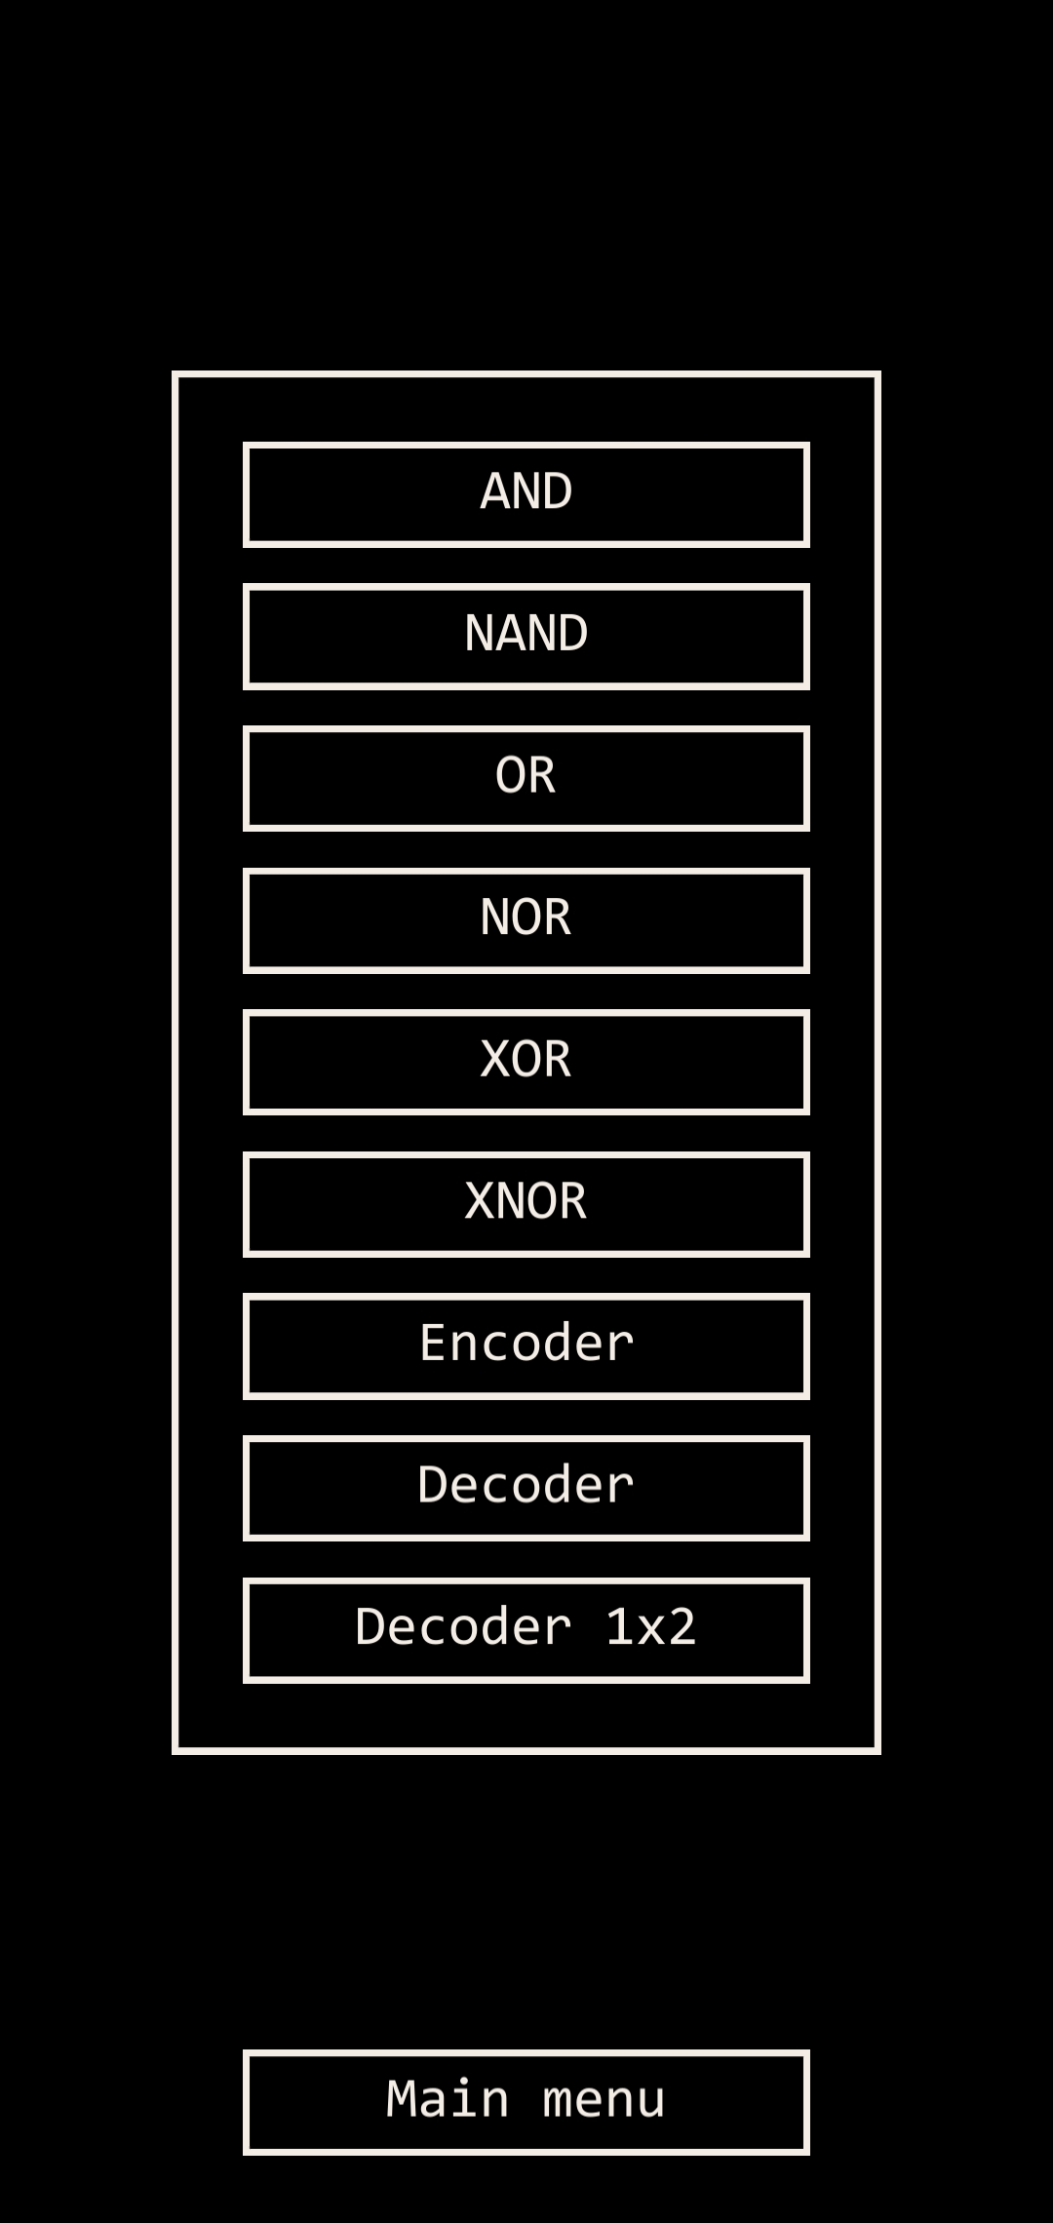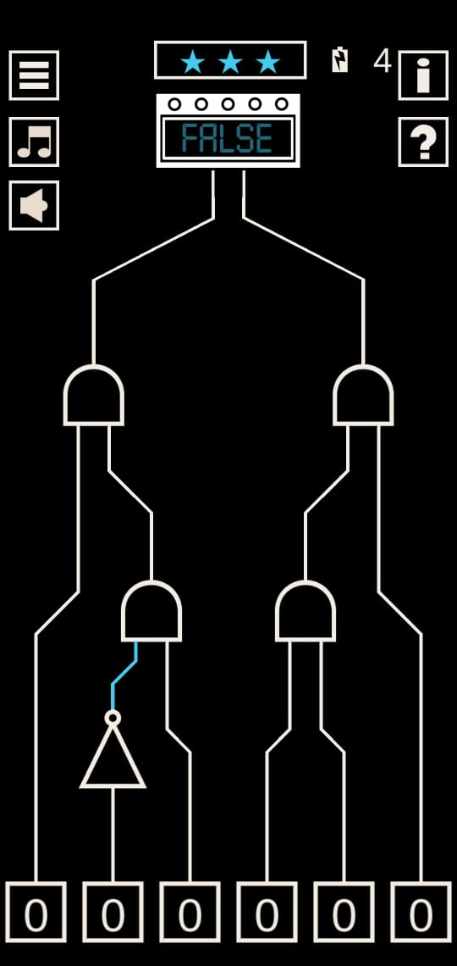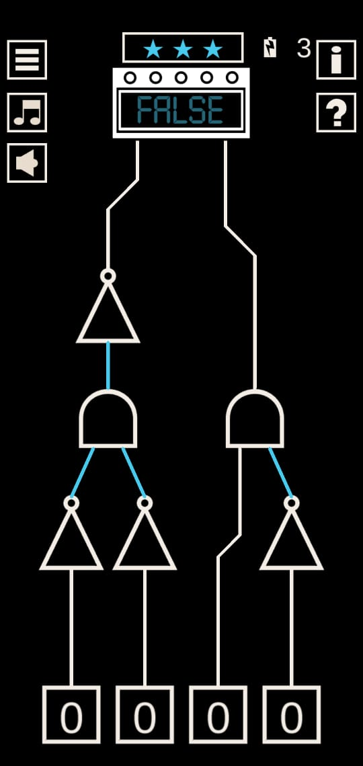
Figure 1 Display of the “Make It True: Solve The Circuit” Game
Through this game, prospective physics teachers can learn to analyze the logic gates utilized in the circuit. Prospective physics teacher can also determine the algebraic equation of the series, then proceed by analyzing the form of the equation to find the standard form of the equation. Additionally, prospective physics teachers can simplify the sequence if possible. The next stage is to analyze the product of sum (PoS) and sum of product (SoP) in the series. Then, in the steps of Higher Order Thinking Skills, the evaluation of several sequences that either have the same standard form, or similar simple form, is carried out. The highest level of Higher Order Thinking Skills in this game requires the player to make different sequences, but have either similar simple form with a series at a certain level, or have the same SoP and PoS.
In the end, students were given a test to measure their Higher Order Skills. However, this is only limited to the C4 and C5 cognitive domains. The instrument test used has been through the validation process by experts, and it has been categorized as valid. The test results are described descriptively in the following Table 3. The table displays the mean, mode, and median values of the student test results. As a result, the HOTS of prospective physics teacher is good with an average of 70.25.

Tabel 3. Statistics Descriptive of HOTS Score
N | Valid | 50
 | Missing | 0
Mean |  | 70,2460
Std. Error of Mean |  | 2,10133
Median |  | 75,1000
Mode |  | 59,00ª
Std. Deviation |  | 14,85862
Variance |  | 220,778
Minimum |  | 35,10
Maximum |  | 90,60

Afterwards, the data were analyzed again and adjusted to the data in Table 1. The results of the analysis indicated that 46% of students had “good” Higher Order Thinking Skills. Moreover, 28% of students were categorised in the “very good” category. Meanwhile, a small proportion of others were categorized as “quite good” and “poor”. The graph of the percentage of students' Higher Order Thinking Skills can be seen in the following Figure 2.
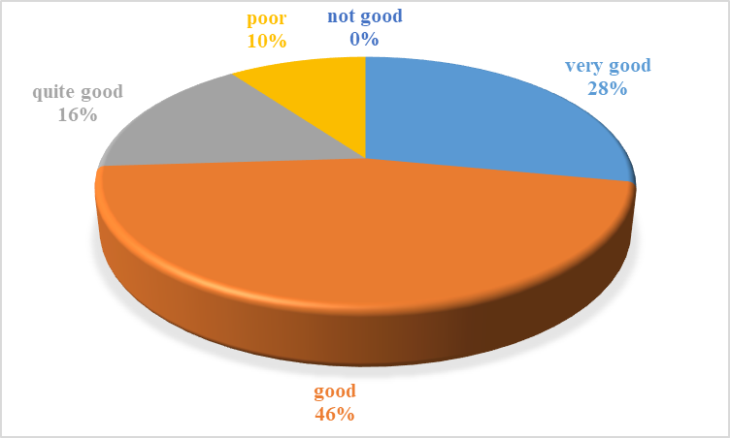
Figure 2. Percentage of high-order thinking skills

The results obtained indicate that game-based learning has an important role in practicing Higher Order Thinking Skills to students. One of these innovative teaching strategies is Game-Based Learning [15]. This is in accordance with previous research [11,16,17] have proven that Game-Based Learning affects, or improves student learning outcomes. Other studies have also supported on how Game-Based Learning impacts Higher Order Thinking Skills [15].
Apart from the data mentioned above, it is important to explore the students’ responses to Game-Based Learning. Exploring their responses can assist teachers to evaluate the learning model carried out to improve it better for the classroom experience. The responses to be assessed consist of two criteria, namely responses and reactions. The responses criteria have two indicators: format and relevance, while the reaction criteria have three indicators: attention, satisfaction and self-confidence [18]. Table 4 illustrates the average student response to each indicator as well as the overall student response. Student response is categorized in the “very good” category with an average of 4.52.
Table 4. Average of students responses
Criteria | Indicator | Average | Category
Responses | Format | 4.66 | Very Good
 | Relevance | 4.44 | Very Good
Reaction | Attention | 4.5 | Very Good
 | Satisfaction | 4.32 | Very Good
 | Self confidence | 4.68 | Very Good
Total |  | 4.52 | Very Good

The results of the Higher Order Thinking Skills test of the prospective physics teachers are categorized as “good”. This is also supported by the responses of the prospective physics teachers which are categorized as “very good”. Thus, this indicates that digital electronics learning using Game-Based Learning provides good quality in training the Higher Order Thinking Skills of prospective physics teachers. This is in accordance with previous research which also shows that Game-Based Learning is effective to be used in improving student learning outcomes [11].
- Conclusion
The mastery of Higher Order Thinking Skills of prospective physics teacher in digital electronics courses can be trained by implementing Game-Based Learning. This learning model can be utilized as an alternative for innovative learning model which can nurture Higher Order Thinking Skills for prospective physics teachers. Further research and development is critical to accommodate Game-Based learning and the variants of games used in special teaching materials, such as student worksheets. This is to enhance the process of training Higher Order Thinking Skills of prospective physics teachers, which will be more optimal.
- References
[1] Dewantara D, Wati M and Misbah M 2020 Blended Learning to Improve Learning Outcomes in Digital Electronics Courses 1st South Borneo International Conference on Sport Science and Education (SBICSSE 2019) (Atlantis Press)
[2] Dewantara D, Misbah M and Wati M 2019 The Implementation of Blended Learning in analog electronic learning J. Phys. Conf. Ser. 1422 1–5
[3] Hartini S, Misbah M, Dewantara D, Oktovian R A and Aisyah N 2017 Developing Learning Media Using Online Prezi into Materials about Optical Equipments J. Pendidik. IPA Indones. 6 313–7
[4] Zainuddin Z, Hasanah A R, Salam M A, Misbah M and Mahtari S 2019 Developing the interactive multimedia in physics learning. In J. Phys. Conf. Ser. 1171
[5] Qian M and Clark K R 2016 Game-based Learning and 21st century skills: A review of recent research Comput. Human Behav. 63 50–8
[6] Sousa M J and Rocha Á 2019 Leadership styles and skills developed through game-based learning J. Bus. Res. 360–6
[7] Huizenga J, Admiraal W, Ten Dam G and Voogt J 2019 Mobile game-based learning in secondary education: Students’ immersion, game activities, team performance and learning outcomes Comput. Human Behav. 99 137–43
[8] Admiraal W, Huizenga J, Akkerman S and Dam G Ten 2011 The concept of flow in collaborative game-based learning Comput. Human Behav. 27 1185–94
[9] Hamari J, Shernoff D J, Rowe E, Coller B, Asbell-Clarke J and Edwards T 2016 Challenging games help students learn: An empirical study on engagement, flow and immersion in game-based learning Comput. Human Behav. 54 170–9
[10] Emerson A, Cloude E B, Azevedo R and Lester J 2020 Multimodal learning analytics for game‐based learning Br. J. Educ. Technol. 51 1505–26
[11] Dewantara D, Wati M, Misbah M, Mahtari S and Haryandi S 2020 The Effectiveness of Game Based Learning on The Logic Gate Topics J. Phys. Conf. Ser. 1491
[12] Ichsan I Z, Sigit D V, Miarsyah M, Ali A, Arif W P and Prayitno T A 2019 HOTS-AEP: Higher Order Thinking Skills from Elementary to Master Students in Environmental Learning Eur. J. Educ. Res. 8 935–42
[13] Istiyono E, Dwandaru W S B, Setiawan R and Megawati I 2020 Developing of Computerized Adaptive Testing to Measure Physics Higher Order Thinking Skills of Senior High School Students and Its Feasibility of Use Eur. J. Educ. Res. 9 91–101
[14] Ghaemi H and Sadoughvanini S 2020 The Relationship between Translation Competence and Higher-order Thinking Skills of Novice Translators. Athens J. Philol. 7 1–15
[15] Mohamad F S, Morini L, Minoi J L and Arnab S 2019 Game-based learning to teach Higher Order thinking in Rural Schools: Case studies in Sarawak Borneo Interact. Des. Archit. J. 41 78–86
[16] Cheng C H and Su C H 2012 A Game-based learning system for improving student’s learning effectiveness in system analysis course Procedia - Soc. Behav. Sci. 31 669–75
[17] Park J, Kim S and Yi A Y 2019 Learning to be better at the game: Performance vs. completion contingent reward for game-based learning Comput. Educ. 139
[18] Savitri E, Panjaitan R G P and Marlina R 2015 Respon siswa terhadap media e-comic bilingual saluran dan kelenjar pencernaan J. Pendidik. dan Pembelajaran Khatulistiwa 5

