**Profile of Creative Thinking Process of Prospective Teachers with Reflector Learning Style in Proposing and Solving Problems in Geometry Material**

Rosita Dwi Ferdiani1, Manuharawati2, Siti Khabibah3

[rositadf@unikama.ac.id](mailto:rositadf@unikama.ac.id), [manuharawati@unesa.ac.id](mailto:manuharawati@unesa.ac.id), sitikhabibah@unesa.ac.id

Universitas Kanjuruhan Malang, Universitas Negeri Surabaya

**Abstract.** The purpose of this study was to describe the creative thinking process of students in reflector learning style in proposing and solving review problems from the Wallas stage. This research is a qualitative research. The subjects of this study were students of semester VII of the Mathematics Education Study Program of the University of Kanjuruhan Malang with the following criteria: a) age between 18-25 years, b) of the same gender, c) At least getting a B grade for the course of School Mathematics Development Studies. Researchers in this study acted as the main instrument and the supporting instruments used were Honey and Mumford's Learning Style Questionnaire (LSQ) questionnaire, test sheets, and interview guides. Questionnaires will be given to research subjects, and subjects with reflector learning styles will be selected. Based on the researchers' observations, it can be concluded that during the preparation stage, subject 1 was seen to be contemplating while observing around the room. Meanwhile, subject 2 tends to carry out activities to collect data by making pyramid shapes out of paper. In the incubation stage, subject 1 looked restless while reading the questions, then seemed to free his mind by playing a pen and scribbling paper. Meanwhile, subject 2, contemplated while observing the pyramid structure that was made. In the Illumination stage, subject 1 looks careful in writing down his answers. This can be seen by reading repeatedly what is written. Tend to be slow to decide which answer to write. Meanwhile, subject 2 began to find ideas in solving problems. This can be seen, writing answers with enthusiasm and occasionally appearing a reminiscent expression. In the verification stage, subject 1 seemed to be careful in checking his answers again, as if they were "afraid of being wrong" in doing them. Meanwhile, Subject 2 can write down the formula used in solving the problem. Based on the research results, it can be concluded that a person's learning style will influence a person's creative thinking process. A person with a reflector learning style will tend to prefer to observe, be careful in making decisions that will be seen at every stage of his creative thinking process.

1. Introduction

The development of science in the era of the industrial revolution 4.0 allows changes in all areas of life, one of which is in the field of education. As a result of these changes, 75% of human jobs will involve abilities; science, technology, engineering and mathematics, and the internet of things, (Zimmerman, 2018). In order to face the challenges in the era of the industrial revolution 4.0, students must be prepared to have cognitive abilities and 4C skills (Critical Thingking and Problem Solving, Communication, Collaboration, Creating and Innovation). One of the cognitive abilities and 4C skills that students need to develop is creative thinking. If students leave school without having the ability to think creatively in innovation, it will be difficult to face challenges in society and the world of work (NEA 2010). Individual success is greatly influenced by their creative abilities. (Sternberg, Wisdom; 2007). Sternberg (2012) states that individuals who have high creative thinking abilities can innovate and create jobs for others, solve available opportunities, excel in technology, adapt to change, or can change the world. So that to face challenges in the future, creative thinking skills are needed (Sriraman, 2005).

Increasing the ability to think creatively requires time and experiences that require creative thinking (Mann, 2006). Teachers must be creative thinkers in designing appropriate learning and assessment tools to improve students' creative thinking skills. But so far, traditional mathematics learning still emphasizes procedures, calculations and algorithms. Some mathematics learning that has been carried out tends not to provide opportunities for students to develop creative thinking skills.

One way to encourage students to think creatively in learning mathematics is to make students familiar with problem solving (Setiawani, et al; 2018). It is important for the teacher to know the creative thinking process of students in solving problems. Each student certainly has different characteristics at each stage of the creative thinking process. (Wessels, 2014). For that, teachers must be able to pose problems, and teachers are also required to solve these problems. The ability to propose and solve this problem must be continuously trained starting from students who will become prospective teachers.

Based on observations made in the even semester of 2017/2018, in the 6th semester students of the Mathematics Education Study Program of the University of Kanjuruhan Malang who took the School Mathematics Development Study course, it was found that students as prospective teachers found it difficult to propose and solve problems. So far, students are accustomed to making questions according to the example questions, by changing numbers or changing the sentences. So that when students are asked to make problem solving problems, they are confused.

The ability to pose and solve problems is influenced by learning styles (Aljebri, et al; 2015, Waskitoningtyas; 2017). Learning style is a unique way of learning, to absorb information from outside himself. Each individual naturally has a different learning style. Differences in learning styles can also lead to differences in the formation and understanding of information. Many experts classify learning styles, one of which is Peter Honey and Alan Mumford. Honey and Mumford classified learning styles into four types of activist, reflector, theorist, and pragmatic. In this study, researchers put more emphasis on the reflector learning style. Someone with a reflector learning style will prefer learning through books, discussions and arguing with each other and attending seminars (extracting information). Reflectors tend to learn by observing and thinking carefully about something that has happened and thinking about the consequences of what will happen when he is about to express an opinion (Honey and Mumford, 2006). A person with a reflector learning style will tend to learn from experience and observe situations from a different perspective. Reflectors tend to collect data, analyze, and think deeply before drawing conclusions. A reflector is someone who is very conscientious and wise, this is what causes them to be very careful and tend to be slow in making decisions (Maric, et al: 2015).

**Table 1 Indicators of Creative Thinking Process in Proposing and Solving Problems**

|  |  |  |  |
| --- | --- | --- | --- |
| No | Posing Problems | Wallas's stage | Solving Problem |
| 1. | Students collect information that will be used to pose problems | Preparation | Students collect information that will be used to solve problems. |
| 2. | Students free the mind from tiring things due to the process of solving problems by doing activities | Incubation | Students free the mind from tiring things due to the process of solving problems by doing activities  . |
| 3. | Starting to emerge inspiration or new ideas to pose a problem by starting to write down the problem posed. | Illumination | Starting to emerge inspiration or new ideas to solve problems. Activities carried out can be in the form of:   1. Start writing down ideas or solutions to problems 2. Trying to find other solutions or ideas to solve the problem |
| 4. | Students test and review the problems posed by: checking back and thinking about possible solutions to the problems posed | verification | Students will carry out their ideas to get answers in a way  recheck the answer and find another way to solve it |

1. Research methods

This research is a qualitative study which aims to describe the creative thinking process of students in reflector learning style in proposing and solving problems in the review of the Wallas stage. The subjects of this study were students of the Mathematics Education Study Program, Kanjuruhan University of Malang, class 2016/2017 (VII semester). Criteria based on a) the age of the research subject with a range of 18-25 years, b) the same gender, c) at least get a B grade for KPMS Subject .

Researchers in this qualitative study acted as the main instrument and the supporting instruments used in this study were Honey and Mumford's Learning Style Questionnaire (LSQ) questionnaire, test sheets, and interview guides. Questionnaires will be given to research subjects, and subjects with reflector learning styles will be selected. Before being given to the research subjects, the test sheets and interview guidelines will be validated by the validator, in order to obtain a valid instrument.

The data analysis in this study will be conducted qualitatively. Data analysis was carried out here during and after data collection. The data analysis steps were as follows: 1) data reduction, 2) data presentation, 3) coding, 4) checking the validity of the data, 5) analyzing research data and other findings, 6) research conclusions.

1. Results and Discussion

Based on the results of the distribution of Honey and Mumford's Learning Style Questionnaire (LSQ) questionnaires, it was found that 2 research subjects had a reflector learning style and met the following criteria: a) the age of the study subjects was 18-25 years old, b) the same gender, c) minimum get a B grade for KPMS Subject. After obtaining research subjects who have a reflector learning style, the next step is to give a test to determine the process of creative thinking in proposing and solving problems in the material for grade 8 junior high school about flat-sided space. The following are the results of the test of subject 1 in proposing and solving problems in the 8th grade junior high school material about flat-sided shapes:

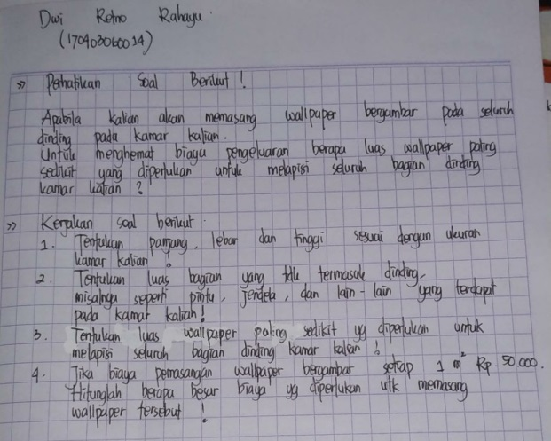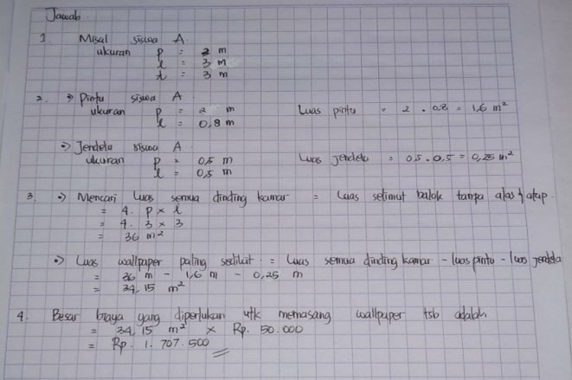

Picture 1

Test result of subject 1 in posing a problem and Solving Problems

Table 2 Thinking Process of Subject 1 in Proposing and Solving Problems based on Wallas Stages

|  |  |  |  |
| --- | --- | --- | --- |
| No | Posing Problems | Wallas's stage | Solving Problem |
| 1. | 1. Subject 1 understands the question command. 2. Subject 1 looks contemplating, thinking about answers by repeatedly reading the test questions. 3. The subject begins to look around the room. | Preparation | 1. Subject 1 began to read repeatedly the problem posed. 2. Subject 1 looks contemplating, and shows expressions of remembering - remembering something |
| 2. | 1. Subject 1 returned to contemplation, occasionally playing the ballpoint used. 2. Looks a little nervous. 3. Looks carefully in raising the problem, this can be seen with a lot of scribbles or wasted paper. 4. 10 minutes passed, subject 1 started scribbling on the answer paper while playing the pen. | Incubation | 1. Subject 1 scribbles - scribbles on paper while showing an expression to remember the formula to be used in solving the problem created. 2. Every now and then the gaze looks blank, while playing the ball, or biting the ballpoint pen. 3. Subject 1 looked at the surroundings, saw his friend who was working on it, then scribbled the paper again |
| 3. | Subject 1 started writing down the answers and copying them onto bar paper. Look carefully in writing answers. This can be seen by reading repeatedly what is written. Tend to be slow to decide which answer to write. | Ilumination | 1. Subject 1 began to find ideas in solving problems. This can be seen, writing answers with enthusiasm and occasionally appearing a reminiscent expression. 2. After working for 7 minutes, subject 1 looks doubtful about the written answer. 3. There are a lot of scribbles on the paper 4. But at the end of the work, subject 1 began to copy the answers on the new paper carefully. |
| 4. | Subject 1 was seen repeatedly reading the written answers. | Verification | 1. Subject 1 can write the formula used in solving the problem. 2. Subject 1 performs arithmetic operations by substituting the known data into the formula. 3. Subject 1 looks careful in checking his answer again, as if he is "afraid of being wrong" in doing it. |

The following are the results of the test subject 2 in proposing and solving problems in the material for grade 8 junior high school about the flat side room:

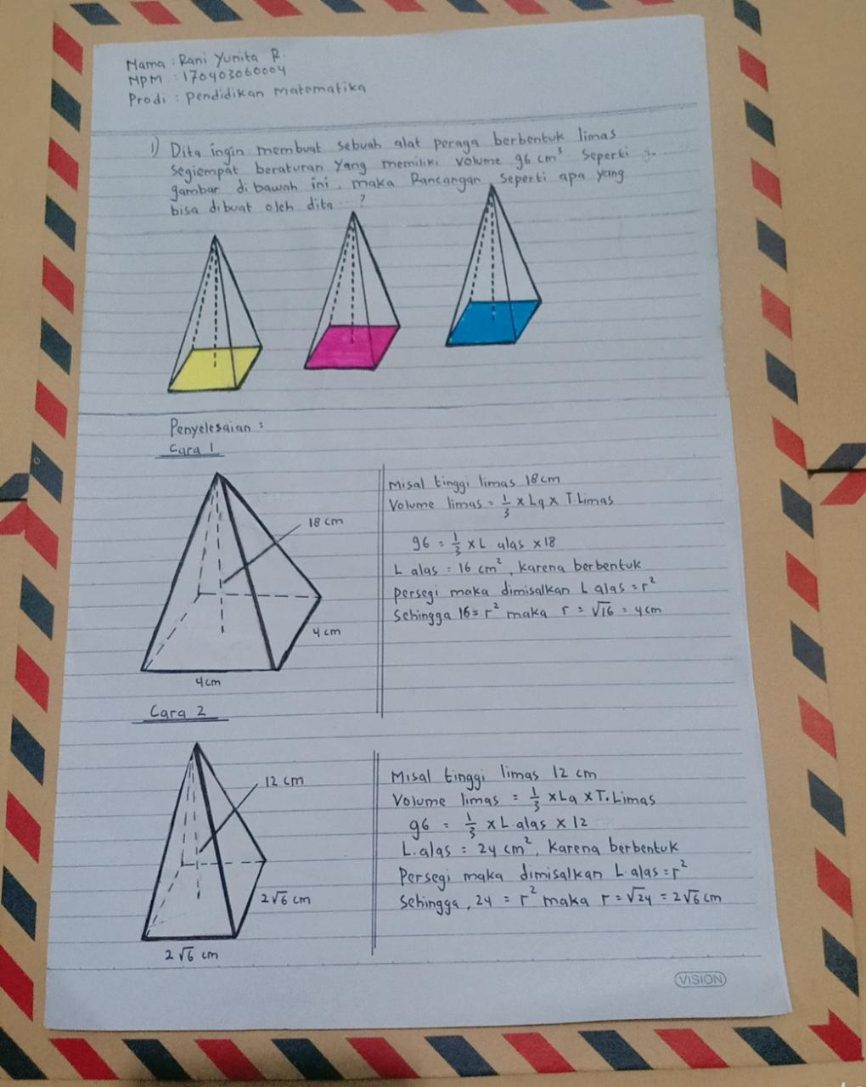

Figure 3

Test results of subject 2 in posing a problem and Solving Problem

Table 3 Thinking Process of Subject 2 in Proposing and Solving Problems based on Wallas Stages

|  |  |  |  |
| --- | --- | --- | --- |
| No | Posing Problems | Wallas's stage | Solving Problem |
| 1. | 1. Subject 2 reads the test questions. 2. Subject 2 looks silent for a moment, showing an expression of remembering something, but it doesn't last long, only about 2 minutes. 3. Subject 2 took blank paper, then shaped it to resemble a pyramid shape. 4. Subject 2 is seen observing the pyramid shape made | Preparation | 1. Subject 2 reads the problem raised. 2. Subject 2 seems to remember the formula that will be used by dismantling the pyramid that has been made to form a pyramid net. |
| 2. | 1. Subject 2 looks contemplating while observing the pyramid that is made. 2. After 5 minutes, observing the pyramid material, suddenly subject 2 took a pen and wrote | Incubation | 1. Subject 2 reads the problem repeatedly 2. Subject 2 looks dreamy |
| 3. | 1. Subject 2 begins to draw the pyramid made into new paper. 2. Subject 2 begins to write down the problem posed, while occasionally looking at and observing the pyramid structure that is made or drawn. | Ilumination | 1. Subject 1 began to find ideas in solving problems. This can be seen, writing answers with enthusiasm and occasionally appearing a reminiscent expression. 2. Subject 2 starts to find the pyramid formula, looks happy expression when finding the formula. |
| 4. | Subject 2 is seen repeatedly reading and replacing sentences that have been made. Then copy the answers onto new paper. | Verification | 1. Subject 2 can write down the formula used in solving the problem. 2. Subject 2 performs arithmetic operations by substituting the known data into the formula |

1. Conclusion

A person with a reflector learning style will tend to learn from experience and observe situations from a different perspective. Reflectors tend to collect data, analyze, and think deeply before drawing conclusions. A reflector is someone who is very conscientious and thoughtful. This is what causes them to be very careful and tend to be slow in making decisions. When it is related to the creative thinking process of students with reflector learning style in proposing and solving problems based on the Wallas stage, then in the preparation stage, subject 1 looks contemplating while making observations around the room. Meanwhile, subject 2 tended to carry out activities to collect data by making pyramid shapes out of paper. In the incubation stage, subject 1 looked restless while reading the questions, then seemed to free his mind by playing a pen and scribbling paper. Meanwhile, subject 2, contemplated while observing the pyramid structure that was made. In the Illumination stage, subject 1 looks careful in writing down his answers. This can be seen by reading repeatedly what is written. Tend to be slow to decide which answer to write. Meanwhile, subject 2 began to find ideas in solving problems. This can be seen, writing answers with enthusiasm and occasionally appearing a reminiscent expression. In the verification stage, subject 1 seemed to be careful in checking his answers again, as if they were "afraid of being wrong" in doing them. Meanwhile, Subject 2 can write down the formula used in solving the problem.

Based on the research results, it can be concluded that a person's learning style will influence a person's creative thinking process. A person with a reflector learning style will tend to prefer to observe, be careful in making decisions that will be seen at every stage of his creative thinking process.

**DAFTAR PUSTAKA**

Aljebri, Nahil M., & Eman Gheith. (2015). *University Students’ Level of Metacognitive Thinking and their Ability to Solve Problems*. American International Journal of Contemporary Research, 5(3), 121-134

Mann, E. 2006. *Creativity: the essence of mathematics.* Journal for the Education of the Gifted, 30 (2), 236-260.

Maric M, Penger S, Todorovic I, Djurica N, Pintar R. (2015). *Differences in Learning Styles: A comparison of Slovenian Universities*. Procedia - Social and Behavioral Sciences 197 ( 2015 ) 175 – 183

NEA (National Education Association). 2010. *Preparing 21st century students for a global society* ( an educators‟ guide for 4cs)

Honey. P & Mumford, A. 2006. *The Learning Styles Questionnaire, 80-item version (Revised edition, July 2006)*. Maidenhead Berks: Peter Honey Publications Limited. K. E. Lestari, dan M.R. Yudhanegara. 2015. Penelitian Pendidikan Matematika. Bandung: PT Refika Aditama

Setiawani.S, Fatahillah, A. dkk. 2018. *The students’ creative thinking process in solving mathematics problem based on wallas’ stages***.** ICEGE 2018.

Sio, U. N., & Ormerod, T. C. (2009). *Does incubation enhance problem solving? A meta-analytic review.* Psychological Bulletin, *135*(1), 94–120. http://doi.org/10.1037/a0014212

Sriraman, B. 2005. *Are giftedness and creativity synonyms in mathematics?* Journal of Secondary Gifted Education, 17(1), 20-36.

Sternberg, Robert J. Wisdom. 2007. *Intelligence, and Creativity Synthesized*. Cambridge: Cambridge UP.

Sternberg, R. J. 2012. The Assessment of Creativity: *An Investment-based Approach. Creativity Research Journal*, 24(1), pp.3–12.

Walton, A. P., & Kemmelmeier, M. 2012. *Creativity in its social context: The interplay of organizational norms, situational threat, and gender*. Creativity Research Journal, 24(2-3), 208–219. <http://doi.org/10.1080/10400419.2012.677345>.

Waskitoningtyas, R.S. *Pengaruh Gaya Belajar Terhadap Kemampuan Pemecahan Masalah Mahasiswa Calon Guru Matematika*. Magistra No. 100 Th. XXIX Juni 2017 ISSN 0215-9511.

Wessels H. 2014. *Levels of Mathematical Creativity in Model Eliciting Activities*. Journal of Mathematical Modelling and Application 1(9) p. 22-40.

Zimmerman, H. (2018) “*In the fourth industrial revolution, we need an education overhaul*” The Australian 14 March 2018 <https://www.theaustralian.com.au/higher-education/opinion/in-the-fourth-industrial-revolution-we-need-an-education> overhaul/news-story