Master Plan of Local E-government for village office information system refer to ministerial regulations on work procedures

M Susilowati1, Y Kurniawan1, C Lenny1, W Adistianaya2, M ahsan3

1 Program Studi Sistem Informasi, Fakultas Sains dan Teknologi, Universitas Ma Chung, Villa Puncak Tidar Blok N-1, Malang, Jawa Timur, Indonesia

2 Program Studi Sistem Informasi, STMIK Pradnya Paramita, Jl. Laksda Adi Sucipto No.249A, Pandanwangi, Kec. Blimbing, Kota Malang, Jawa Timur, Indonesia

3 Program Studi Teknik Informatika, Fakultas Sains dan Teknologi, Universitas Kanjuruan, Jl. S. Supriadi, No. 48 Malang, Jawa Timur, Indonesia

meme.susilowati@machung.ac.id

**Abstract**. This article contains a local e-government master plan with a case study in a village in Malang district. The master plan referred to the Ministerial regulation regarding the Organizational Structure and Work Procedure of Village Administration. This article will present the background, methods, results and conclusions of a research about requirement analysis and design of information systems in village offices. This research method will begin with data gathering (literature study, observation, interview), analysis of SRS (Software Requirement and Specification) documents for synchronization with division of work tasks, creating focus groups, making Master Plan. This article also will present a focus group diagram on the division of labour results based on the 2015 ministerial regulation. Then proceed with a master plan diagram based on the requirement of the actor system in the village office. Namely the village head, village secretary, 3 heads of affairs (administration, finance, planning) and a section head. This article will present 13 names and descriptions of applications needed to support the administrative system at the village office. This article also provides 58 tables needed for a Master Plan of Local E-government for village office information system refer to ministerial regulations on work procedures

1. Introduction

One of the instruments of planning is master plans [1]. Even the master plan especially on information and communication technology is a guide to construct ICT [2]. There are also those who explain how important this master plan. He said if The IT master plan is a long-term plan in an organization. This plan is created to support the organization's vision and mission [3]. This fact is presentation if the master plan is very important to start developing an information system. As well as the process of developing information system in the village is very important. The local e-government need the master plan to know how the planning and developing schedule for implementation information system.

So this research will concern to create master plan of local E-government for village office information system refers to ministerial regulations on work procedures. On many years ago The E-government has become a major topic of interest for academics and practitioners. Because the study of the success of e-government implementation is part of the success study of the IS application [4].

This article contains a local e-government master plan with a case study in a village in Malang district. The master plan referred to the Ministerial regulation regarding the Organizational Structure and Work Procedure of Village Administration. This research method will begin with data gathering (literature study, observation, interview), analysis of SRS (Software Requirement and Specification) documents for synchronization with division of work tasks, creating focus groups, making Master Plan. This article also will present a focus group diagram on the division of labor results based on the 2015 ministerial regulation. Then proceed with a master plan diagram based on the requirement of the actor system in the village office.

1. Object of Research

This research will concern to implementation ministerial regulation on procedures to be the object of research. The ministerial regulation is the main document that is the basic for requirement analysis to create a master plan. The main document is Peraturan Menteri No. 84 Tahun 2014 about Susunan Organisasi dan Tata Kerja Pemerintahan Desa [5] this document from Ministry of Home Affairs.

On chapter two from this document shared about organization structure, duty and functional of local e-government. I means is personnel of village office.

## Organization Structure

Chapter two section two describes the organizational structure of the village officials. There are Chief of village, Secretary of village, Regional Staff, technical Staff.

## Task and Functional

Chapter two section six describes the duty and functional of Chief of village, Secretary of village, Regional Staff, technical Staff.

* + 1. The village chief task.is organizing Village Administration, implementing development, community development, and community empowerment.
    2. The Secretary of village task.is in charge of assisting the Chief of Village in the field of government administration.
    3. The head of affairs serves as an element of the secretariat staff Secretary of village task. The head of affairs are Head of administration and general, head of finance, head of planning.
    4. The section head serves as the technical executing element. The section head help Chief of Village for operational technical. There are section head of government, head of social, head od services.
    5. The head of regional help Chief of Village to do the task on their regional.
    6. the technical executing element. The section head help Chief of Village for operational technical. There are section head of government, head of social, head od services.

1. Method

This research method will begin with data gathering (literature study, observation, interview), analysis of SRS (Software Requirement and Specification) documents for synchronization with division of work tasks, creating focus groups, making Master Plan. This article also will present a focus group diagram on the division of labour results based on the 2015 ministerial regulation. Then proceed with a master plan diagram based on the requirement of the actor system in the village office. Namely the village head, village secretary, 3 heads of affairs (administration, finance, planning) and a section head. This article will present 13 names and descriptions of applications needed to support the administrative system at the village office. This article also provides 58 tables needed for a Master Plan of Local E-government for village office information system

1. Result and Discussion

According to the method, we can share about the result. The master plans will presentation on three matrix tables. The first table describes about Information Requirement for Head of Affairs. And the second table describes about Information Requirement for Section Head Serves. And the last table describes about Information Requirement for Head of Regional, Secretary And Chief of Village.

The number of information system in table is not representation about priority number. It’s just sequence number.

Table 1 : Head of affairs master plan

|  |  |  |  |  |
| --- | --- | --- | --- | --- |
| **NO** | **Information System Requirement** | **Head of affairs** | | |
| **Administration** | **Finance** | **Planning** |
| 1 | Citizen Database | v |  |  |
| 2 | Family Card Record | v |  |  |
| 3 | Repository | v |  |  |
| 4 | Letters Administration | v |  |  |
| 5 | Human Resource Management | v |  |  |
| 6 | Aset Management | v | v | v |
| 7 | APBD Planning |  | v | v |
| 8 | Finance Report |  | v |  |
| 9 | Cash Flow |  | v |  |
| 10 | Planning Management |  |  | v |
| 11 | Internal archives |  |  |  |
| 12 | Governance |  |  |  |
| 13 | Social Community Management |  |  |  |
| 14 | Village website | v | v | v |
| 15 | Inventory Management | v | v | v |

There are three software that has not needed by head of affairs on first table. There are Internal archives, Governance, and Social Community Management. And then In second table, There are seven software that has needed by Section head Serves. There are Citizen Database, Repository, Aset Management, Internal archives, Governance, Social Community Management and Village Profile website. In three table, the entire table is needed by Head of Regional, Secretary And Chief of Village. Because Secretary must be verification all of document, data and information before Chief of Village give validation. Likewise, regional heads also require almost all applications.

Table 2 : Section Head Serves master plan

|  |  |  |  |  |
| --- | --- | --- | --- | --- |
| **NO** | **Information System Requirement** | **Section Head Serves** | | |
| **Government** | **Social** | **Services** |
| 1 | Citizen Database | v | v | v |
| 2 | Family Card Record | v |  |  |
| 3 | Repository | V |  |  |
| 4 | Letters Administration | V |  |  |
| 5 | Human Resource Management |  |  |  |
| 6 | Aset Management | V | v |  |
| 7 | APBD Planning |  |  |  |
| 8 | Finance Report |  |  |  |
| 9 | Cash Flow |  |  |  |
| 10 | Planning Management |  |  |  |
| 11 | Internal archives | v |  |  |
| 12 | Governance | v |  |  |
| 13 | Social Community Management | v | v | v |
| 14 | Village website | v |  |  |
| 15 | Inventory Management |  |  |  |

Table 3 : Head of Regional, Secretary And Chief of Village master plan

|  |  |  |  |  |
| --- | --- | --- | --- | --- |
| **NO** | **Information System Requirement** | **Head of Regional** | **Secretary** | **Chief of Village** |
|
| 1 | Citizen Database |  | v | v |
| 2 | Family Card Record | v | v | v |
| 3 | Repository |  | v | v |
| 4 | Letters Administration | v | v | v |
| 5 | Human Resource Management |  | v | v |
| 6 | Aset Management | v | v | v |
| 7 | APBD Planning | v | v | v |
| 8 | Finance Report | v | v | v |
| 9 | Cash Flow | v | v | v |
| 10 | Planning Management |  | v | v |
| 11 | Internal archives |  | v | v |
| 12 | Governance |  | v | v |
| 13 | Social Community Management | v | v | v |
| 14 | Village website | v | v | v |
| 15 | Inventory Management |  | v | v |

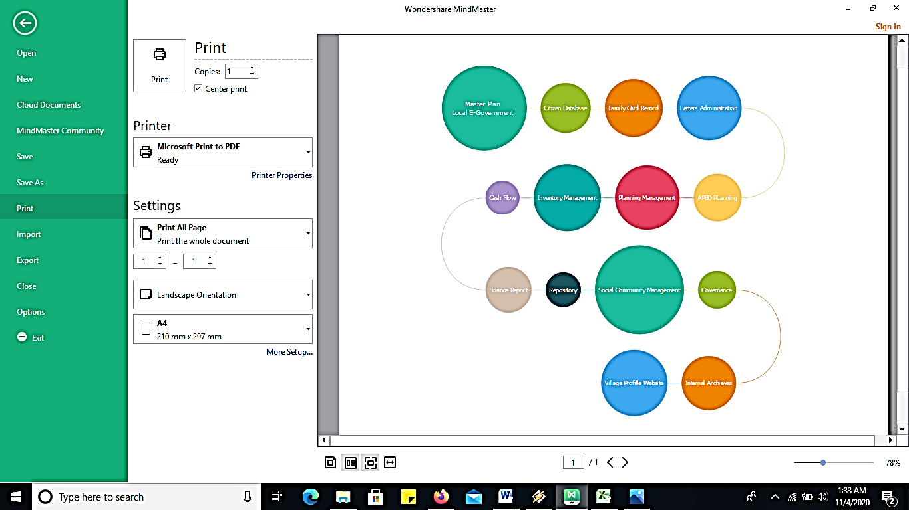

References

1. R Nallathiga, 2017 Assesing the Role of Master Plans in City Development: Reform Measures and Approaches (New Delhi: NAGARLOK) pp 1-4
2. Y Afrizal 2018 The Arrangement of the Information Technology and Communications Master Plan using PeGI Model (e-Governance Ranking Indonesia) to Improve District Government Services IOP Conf. Ser.: Mater Sci. Eng. 407 012141
3. Mochammad Kautsar Sophan et all 2020 Online Survey for supporting and developing IT Master Plan: The case of HVA Teolongredjo Hopsital J. Phys.: Conf. Ser. 1569 022063
4. Dody Herdiana et all 2018 Development of System Continuance Models for Assessing among Local E-Government in Indonesia Conference Paper researchgate.net/publication/328802870
5. Kementrian Dalam Negeri 2015. Peraturan Menteri No. 84 Tahun 2014 tentang Susunan Organisasi dan Tata Kerja Pemerintahan Desa.
6. L Van Velsen et al 2009 Requirements engineering for e-Government services: A citizen-centricapproach and case studyGovernment Information Quarterly 26 (Amsterdam: Elsevier) pp 477-486