Discrete Numerical Solution for Modelling of Phytoplankton Growth
R N I Dinnullah¹, T Fayeldi²
^{1,2}Mathematics Education Study Program, Faculty of Science and Technology, Universitas Kanjuruhan Malang, Jl. S. Supriyadi No. 48, Malang 65148, Indonesia

ky2_zahra@unikama.ac.id
Abstract. Phytoplankton growth model has been observed extensively to track the movement of elements through aquatic food webs and ecological processes. This study is purposed to find numerical solution of The modelling of phytoplankton growth and know the dynamic behavior. The method used to transform the phytoplankton growth model is Finite Difference Euler Method. We focused on the existence and stability of the fixed-points. We break into two cases. The result is that all of cases is dynamically consistent with its continous model only for relatively small-step size. We present some numerical simulation to illustrate those cases. We break into two cases. The result is that all cases is dynamically consistent with its continous model only for relatively small-step size. We present some numerical simulation to illustrate those cases.
- Introduction
Ecology can be describe as scientific study of how organism interact with other and their environment. Aquatic ecology, in other hand, includes the study of those relationship in all aquatic environments, including rivers, lakes, and oceans. One focus on studying aquatic ecology is phytoplankton growth, since they supply food to their environment [1]–[3]. They act as water indicator that show whether the water quality is good or poor [4]. They also have ability to respond to enviromental changes. It means that the quantity of phytoplankton in an aquatic environmet plays important thing.
Many research has been done recently to identify the dynamics of phytoplankton, especially on blooming algae phenomenon called HABs (Harmful Algae Blooms). HABs occur when colonies of algae grow out of control and produce toxic effects on nearby environment. Nutrient loadings, pollution, water flow modification and climate change play a role to the HABs phenomenon. Mathematical model can be an effective means to discover the dynamics of plankton using conceptual model [5]–[7].
Phytoplankton growth was introduced as the following system.
$\frac{dN}{dt}$= input – uptake – loss
$\frac{dP}{dt}$= uptake – (death + sinking) (1)
Previous research discuss about the generic mathematical model of phytoplankton blooms [8]–[10]. With a simple model analysis, it is known that bloom is influenced by nutrient concentration [11]–[15]. These studies are modeled by using ordinary differential equations (ODE). Dynamic behavior can be seen from each of the models.
Furthermore, our purpose is focused on using the euler method for discretize the continous model to find its numerical solution. In this method, the step-size h plays an important role [16], [17]. This method have been applied to various models, such as [18]–[20]. Furthermore, analyses and numerical simulations can obtain insights into the mechanism of phytoplankton growth, where modifications to the equations via simulations to illustrate our theoretical results. In the following section, we wil discuss whether this method will dynamically consistent with its continous model or not.
- Method

A simple phytoplankton growth
The phytoplankton growth model that we used in this paper is written as follow.
$\frac{dN}{dt}$ = I – NP – qN
$\frac{dP}{dt}$ = NP – P (2)
where N denote nutrient supply in such aquatic environment, P denote phytoplankton biomass, I and q are parameters. We assume that the concentration of the nutrient is given in mg/m³ of water per day. In this paper, we break the parameters into two cases. The first case is I = q = 0 which means that there is no nutrient supply and nutrient loss over (2), while the second case is I > 0 such that there is nutrient loss q ≥ 0.

Euler Method
Euler method state that if we have system of differential equation
$\frac{dx}{dt}$ = f(x, y)
$\frac{dy}{dt}$= g(x, y) (3)
then the numerical system of (3) can be written as
x_{n+1} = x_{n} + h f(x_{n}, y_{n})
y_{n+1} = y_{n} + h g(x_{n}, y_{n})
where h is the step-size.
Subtituting (2) to (3) for the first equation with step-size h, we have
$\frac{N_{n+1}-N_{n}}{h} = I-N_{n}P_{n}-qN_{n}$,
$N_{n+1}-N_{n}=\left(I-N_{n}P_{n}-qN_{n}\right)$
$N_{n+1}=N_{n}+\left(I-N_{n}P_{n}-qN_{n}\right)h$. (4)
Doing the same for the second equation, we have
$\frac{P_{n+1}-P_{n}}{h}=N_{n}P_{n}-P_{n}$, $P_{n+1}-P_{n}={(N}_{n}P_{n}-P_{n})h$,
$P_{n+1}={P_{n}+(N}_{n}P_{n}-P_{n})h$. (5)
Combining (4) and (5), the discrete model of (2) now can be written as
$N_{n+1}=N_{n}+\left(I-N_{n}P_{n}-qN_{n}\right)h$, $P_{n+1}={P_{n}+(N}_{n}P_{n}-P_{n})h$ (6)

- Result and discussion

First case (I = q = 0)
If we subtituting I = q = 0 to (6) then we have
$N_{n+1}=N_{n}-\left(N_{n}P_{n}\right)h$,
$P_{n+1}={P_{n}+(N}_{n}P_{n}-P_{n})h$ (7)
We know that
$N^{*}=N^{*}+\left(N^{*}P^{*}\right)h$,
$0={(N}^{*}P^{*})h$. (8)
and
$P^{*}=P^{*}+\left(N^{*}P^{*}-P^{*}\right)h$,
$0=\left(N^{*}P^{*}-P^{*}\right)h$, (9)
Since h > 0, then we have
(N*P*) = 0 (10)
or
(NP* − P*) = P* (N* − 1) = 0 (11)
With easy manipulation, one can find that N* − 1 = 0 or P* = 0. Subtituting P* = 0 to (10) then we have N* = k, where k constant derrived from initial condition. Equilibrium for the first case is E₁ = (k, 0).

Second case (I > 0, q ≥ 0)
For the second case, we have
$N^{*}=N^{*}+\left(I-N^{*}P^{*}-qN^{*}\right)h$
$0=\left(I-N^{*}P^{*}-qN^{*}\right)h$ since $h>0$,
$N^{*}P^{*}=I-{qN}^{*}$ (12)
and
$P^{*}=P^{*}+\left(N^{*}P^{*}-P^{*}\right)h$,
$P^{*}=P^{*}+\left(N^{*}P^{*}-P^{*}\right)h$,
$0=\left(N^{*}P^{*}-P^{*}\right)h$,
since $h>0$, we have
$N^{*}P^{*}-P^{*}=0$
${(N}^{*}-1)P^{*}=0$ (13)
From (13), we can conclude that
${ P}^{*}=0$ (14)
and
$N^{*}=1$.
Subtituting (15) to (12)
$N^{*}=\frac{I}{q}$. (15)
E₂ = ${(N_{1}}^{*},{P_{1}}^{*})=(\frac{I}{q},0)$. (16)
Subtituting (15) to (12)
$P^{*}=I-q$ (17)
E₃ = ${(N_{2}}^{*},{P_{2}}^{*})=(1,I-q)$. (18)
Equilibrium point for second case are E₂ and E₃.
Next we will discuss the stability of those equilibrium points we found before. Suppose that
F(N, P) = N – (NP)h
G(N, P) = P + (NP – P)h
The Jacobian matrix for the model is
J =
= (19)
Subtituting E₁ = (k, 0) to (19), we have
J =

Lemma 1
If h <$\frac{2}{1-k}$and k < 1 then Equilibrium point E₁ saddle, otherwise it is unstable.

Proof:
Notice that the first eigenvalue of J, that is |λ₁| = |1| = 1 ≥ 1. It is clear that 1 – k > 0. Suppose that h <$\frac{2}{1-k}$. Since h > 0, we can write as 0 < h <$\frac{2}{1-k}$ that leads to 0 < h (1 – k) < 2, similar to 0 < − h (k – 1) < 2 or −1 < −1 − h (k – 1) < 1. We then rewritten as −1 < 1 + h (k – 1) < 1, that is |λ₂| =|1 + h (k – 1)| < 1.
For the second case, we only consider in analyzing E₂.

Lemma 2
If h < min$\left\{\frac{2}{q},\frac{2}{1-\frac{I}{q}}\right\}$ then equilibrium point E₂ is stable.
Proof:
It can be shown that Jacobian matrix of this case is
J =$\left(\begin{matrix}1-hq & -\frac{I}{q}h \\ 0 & 1+\left(\frac{I}{q}-1\right)h\end{matrix}\right)$.
Suppose that h <$\frac{2}{q}$. Since h > 0, we can write 0 < h < $\frac{2}{q}$ or −2 < −hq < 0 which leads to −1 < 1 – hq < 1, that is |λ₁| < 1. On the other hand, suppose 0 < h <$\frac{2}{1-\frac{I}{q}}$ or 0 < h$\left(1-\frac{I}{q}\right)$ < 2. Subtracting 1 from the inequalities then we have −1 < −1 + $\left(1-\frac{I}{q}\right)$h < 1 or −1 < −(1 − $\left(1-\frac{I}{q}\right)$h) < 1. We see that −1 < 1 − $\left(1-\frac{I}{q}\right)$h < 1 or −1 < 1 + $\left(\frac{I}{q}-1\right)$h < 1, in other word |λ₂| = |1 + $\left(\frac{I}{q}-1\right)$h | < 1.

- Numerical solution
Having found the equilibrium points and analyze the stability in some points, now we can simulate them to show their behavior. We use step-size h = 0.05 for all cases. For the first case in (7), we use (2.9, 0.0001) as initial condition. Figure (2) and (3) shows the result.

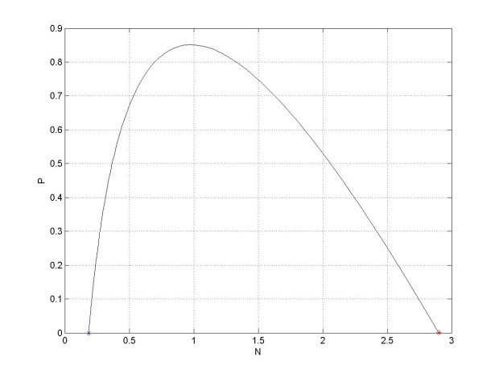 |  | 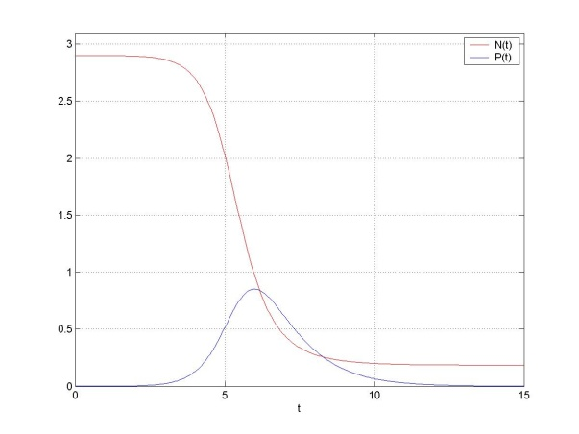
Figure 1. The Plot of N – P |  | Figure 2. The Plot of N(t) – t and P(t) – t

Figure 2 shows that the numerical result converge to its equilibrium, that is E₁ = (0.185, 0), note that 1 – k = 1 – 0.185 > 0. Figure 3 shows that the nutrient decreases as time increases and reach the value k. We present the simulation for the second case E₂.
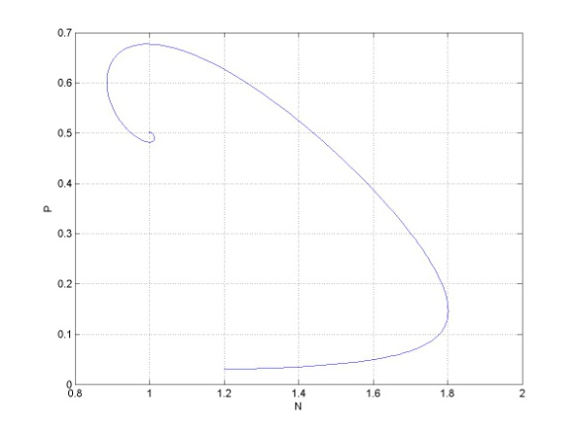 |  | 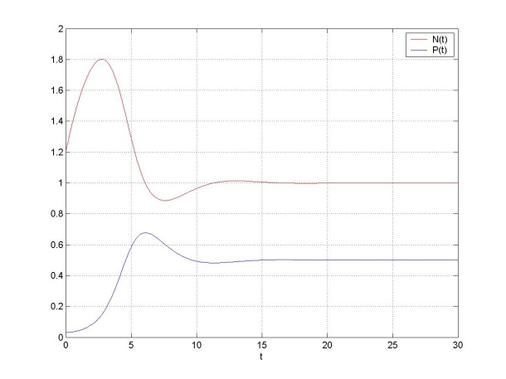
Figure 3. The Simulation for The Second Case E₂ |  | Figure 4. The Plot of N(t) – t and P(t) – t
- Conclusion
We have found the equilibrium points of the model, and then analyze them. We found that these equilibrium points need to met certain criteria to be a stable equlibrium. We also found that choosing step-size h is impotant to reach the correct solution.
References
- Enquist B, Economo E, & Huxman T 2003 Scaling Metabolism From Organisms To Ecosystems Nature 423 639–642
- Xu H, Paerl H, Qin B, Zhu G, & Gao G 2010 Nitrogen and phosphorus inputs control phytoplankton growth in eutrophic Lake Taihu, China Limnology and Oceanography 55 420–432
- Burson A, Stomp M, Greenwell E, Grosse J, Huisman J 2018 Competition for nutrients and light: Testing advances in resource competition with a natural phytoplankton community Ecology 99 1108–1118
- Zakariya A, Adelanwa M, Tanimu Y 2013 Physico-Chemical Characteristics And Phytoplankton Abundance Of The Lower Niger River, Kogi State, Nigeria IOSR Journal Of Environmental Science, Toxicology And Food Technology (IOSR-JESTFT) 2 31-37
- Huppert A, Blasiusa B, Olinkya R, Stone L 2002 A Model Of Phytoplankton Blooms The American Naturalist 159 156-171
- Huppert A, Blasiusa B, Olinkya R, Stone L 2005 A Model For Seasonal Phytoplankton Blooms Journal Of Theoretical Biology 236 276–290
- Allegretto W, Mocenni C, Vicino A 2005 Periodic Solutions In Modelling Lagoon Ecological Interactions Journal of Mathematical Biology 51 367–388
- Mei D, Zhao M, Yu H, Dai C, Wang, Y 2015 Nonlinear Dynamics of a Nutrient-Phytoplankton Model with Time Delay Discrete Dynamics in Nature and Society 2015 1-12
- Dai C, Yu H, Guo Q, Liu H 2019 Dynamics Induced by Delay in a Nutrient-Phytoplankton Model with Multiple Delays Hindawi 2019 1-16
- Fayeldi T 2015 Skema Numerik Persamaan Leslie Gower Dengan Pemanenan Cauchy 3 214-218
- Dinnullah R, Fayeldi T 2018 Discrete numerical scheme of modified leslie-gower with harvesting model Cauchy 5 42-47
- Elsadany A, EL-Metwally H, & Elabba E 2012 Chaos and bifurcation of a nonlinear discrete prey-predator system Computational Ecology and Software 2 169–180
- Hu Z, Teng Z, & Jiang H 2012 Stability analysis in a class of discrete SIR Sepidemic models Nonlinear Analysis: Real World Applications 13 2017–2033
- Ongun M & Turhan I 2013 A Numerical Comparison For A Discrete HIV Infection Of Cd4+ T-Cell Model Derived From Nonstandard Numerical Scheme Journal Of Applied Mathematics 2013 1-9
[15] Findlay H S, Yool A, Nodale M, & Pitchford J W 2006 Modelling Of Autumn Plankton Bloom Dynamics J Plankton Res 28 209–220
[16] Fayeldi T 2015 Skema Numerik Persamaan Leslie Gower Dengan Pemanenan CAUCHY –Jurnal Mat Murni dan Apl 3 34–38
[17] Dinnullah R N I & Fayeldi T 2018 A Discrete Numerical Scheme of Modified Leslie-Gower With Harvesting Model CAUCHY –Jurnal Mat Murni dan Apl 5 42–47
[18] Elsadany A A, EL-Metwally H A, Elabbasy M E, & Agiza H N 2012 Chaos And Bifurcation Of A Nonlinear Discrete Prey-Predator System Chaos And Bifurcation Of A Nonlinear Discrete Prey-Predator System Comput Ecol Softw 2 169–180
[19] Hu Z, Teng Z, & Jiang H 2012 Nonlinear Analysis: Real World Applications Stability Analysis In A Class Of Discrete SIRS Epidemic Models Nonlinear Anal Real World Appl 13 2017–2033
[20] Ongun M Y & Turhan I 2013 A Numerical Comparison For A Discrete HIV Infection Of Cd4+ T-Cell Model Derived From Nonstandard Numerical Scheme J Appl Math 2013 1–9

