Design of UPI's Incinerator Classic Rankine Cycle Boiler

M M Al Gifari, Sriyono, and I Mubarak

Department of Mechanical Engineering, Indonesia University of Education

maris_algifari@upi.edu

**Abstract**. UPI has made an incinerator with a 3.4 m3 capacity. Al Gifari (2020) calculated heat that can be produced by waste combustion, then the heat was used for a simple Rankine cycle with water as the working fluid. The boundary condition for the boiler system is based on Al Gifari’s work (2020). The water temperature enters the boiler with pressure 5 bar with the temperature set at 15 oC and outlet temperature boiler is 406 oC.  This paper is used to find geometries that can accomplish this mission. The boiler is divided into three parts, namely the economizer, evaporator, and superheater. The placement starts with the evaporator being stored near the combustion area, followed by the superheater and finally the economizer. The determination of the evaporator geometry is adjusted to the UPI incinerator geometry and operation. The geometry taken is steam-drum. Pressure drive calculation is the analytical tool at the beginning of the design of the evaporator. Then the economizer and superheater used shell and tube configuration and analysis using the NTU method. The superheater shows that the output temperature was less than the design in Standard Rankine Cycle. The economizer needs more heat supply to reach saturated liquid temperature.

Keywords : *Incinerator, Classical Rankine Cycle, Heat Potential, Output Power, Cycle Efficiency*

1. Introduction

UPI has built an incinerator with minimal smoke production. The next step of the product development is how to use the heat from burning waste into electrical energy. The heat from combustion can be applied to operate the Rankine Cycle [1]. The heat from this combustion is considerable according to Dian [2] that the heating value is 2049.11 kcal / kg. If the pressurized water coming out of the pump is put into the incinerator, it can be converted into superheated water.

Steam Generator according to El-Wakil [3] and Astolfi [4] is generally divided into three parts. First, the economizer which functions to increase the temperature of the water until the liquid is saturated. Second, the task of the evaporator is to change phase of water from saturated liquid to saturated vapor. Finally, the superheater is to increase the steam temperature from saturated to the superheater temperature. A diagram that represents the process that occurs in a boiler as a steam generator can be seen in Figure 1.

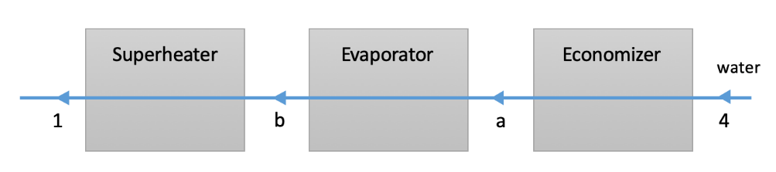

**Figure 1.** Diagram of Boiler as Steam Generator

The three stages require different heat. Table 1 contains the equations that will be used to assess the initial heat requirements required for each process.

**Table 1.** Equations for Initial Assessment of Heat Required

|  |  |  |  |
| --- | --- | --- | --- |
| no | Component | Equation | Assumption |
| 1 | Economizer | ${\dot{Q}}_{4-a}=\dot{m}c_{f}\left(T_{f,s}-T_{4}\right)$ [8,15] | Constant Specific heat, $c_{f}=$ 4300 J/kg. oC [5] |
| 2 | Evaporator | $${\dot{Q}}_{a-b}=\dot{m}\left(h_{g,s}-h_{f,s}\right)$$ | Steady |
| 3 | Superheater | ${\dot{Q}}_{b-1}=\dot{m}c_{g}\left(T_{1}-T_{g,s}\right)$ [8, 15] | Constant Specific heat, $c_{g}=$ 2068 J/kg. oC [5] |

The following table will be filled into equations 1, 2 and 3. Conditions 4 and 1 are derivatives of the Rankine cycle previous [6]. Here are the numbers that will be used for each equation. The value of each property is taken from Dincer [5].

**Table 2.** Property of Every States

|  |  |  |  |  |
| --- | --- | --- | --- | --- |
| State | Property | Symbol | Value | Unit |
| 4, a, b, 1 | Pressure | $$p_{4}$$ | 5.04 | bar |
| 4 | Economizer Inlet Temperature |  | 15 | oC |
| a | Economizer Outlet Temperature |  | 152.14 | oC |
| 1 | Superheater Outlet Temperature |  | 490.2 | oC |
| 4 | Saturated Liquid Water Specific Heat | $$c_{f}$$ | 4300 | J/kg. oC |
| b | Saturated Vapor Water Specific Heat | $$c_{g}$$ | 2068 | J/kg. oC |
| a | Saturated Liquid Water Specific Enthalpy | $$h_{f,s}$$ | 641.484 | kJ/kg |
| b | Saturated Vapor Water Specific Enthalpy | $$h_{g,s}$$ | 2748.46 | kJ/kg |
| 4-a-b-1 | Mass flow | $$\dot{m}$$ | 0.13 | kg/s |

Based on these conditions, the heat required for each process is obtained as shown in Figure 2.

**Figure 2.** Diagram of Heat Required for every Components

The required heat will be the starting point for placing the component correspond to heat source, in this case the incinerator. The component installation formation in the steam generator is depicted in Figure 3.

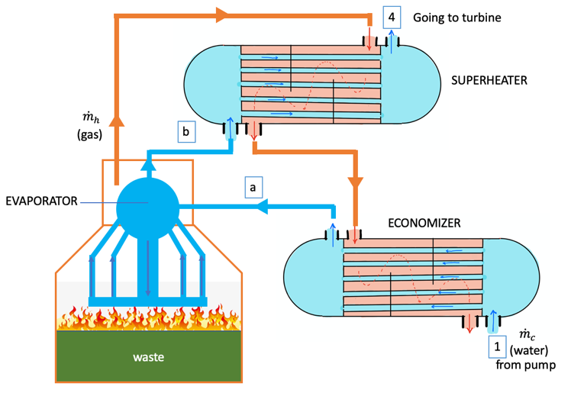

**Figure 3.** The Flow of Water and Gas in Each Component of the Boiler

Process analysis on each component was carried out at a pressure 5.04 bar. The hot gas from combustion will be used for the evaporator first because of its high heat requirements. Then the hot gas from combustion enters the superheater and finally in the economizer. This sequence is also carried out in the design process.

The phenomenon of heat exchange and water change from liquid phase to steam is a complex analysis so that in the design process to be accurate requires CFD simulation. The input of CFD is a geometry that has to be derived fundamentally so that the optimization process is carried out in a relatively shorter time because the geometric parameters have been determined based on existing basic equations. This research goal is to determine the main geometric parameters of evaporator, economizer and superheater.

1. Method

The design process is generally divided into two parts. First, the evaporator design takes the form of a steam drum as the basis because of its compatibility with the UPI’s incinerator geometry. The second is the economizer and superheater design using shell and tube as a basis. This shell and tube shape was taken because according to Incropera [7] the compact heat exchanger is suitable for small heat exchanger and incinerator category is big category. Shell and tube analysis for these two components used the NTU (Number of Transfer method [7]. The output obtained by using this NTU method is the shell diameter, the number of water pipes used and the length of the heat exchanger.

## Design of Evaporator

The evaporator design process uses a steam drum that is adjusted to the incinerator geometry. Then the shape is analyzed by paying attention to the pressure drive in order to ensure the water circulation is running. This pressure drive is depicted in equation (1) [3]. The parameters used in the equation for the evaporator design process are illustrated in Figure 4.

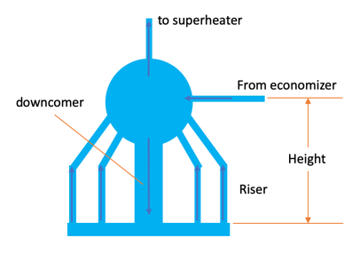

**Figure 4.** The name of the part on the steam drum

|  |  |  |
| --- | --- | --- |
|  | $${∆p}_{d}=\left(ρ_{dc}-{\overline{ρ}}_{r}\right)Hg$$ | (1) |

where

|  |  |  |
| --- | --- | --- |
| $${Δp}_{d}$$ | : | Pressure drive (Pa) |
| $$ρ_{dc}$$ | : | Density of water in the downcomer (kg/m3) |
|  | : | Average density of water-steam mixture in riser (kg/m3) |
|  | : | Height of water-drum above bottom downcomer (m) |
| $$g$$ | : | Gravitational acceleration (m/s2) |

The water that enters the drum is already in a saturated phase, while the approach to determine the average density of the vapor-liquid phase mixture is using equation (2).

|  |  |  |
| --- | --- | --- |
|  | $$ρ_{r}=ρ_{f}-\frac{ρ_{f}-ρ_{g}}{1-ψ}\left\{1-\left(\frac{1}{α_{e}\left(1-ψ\right)}-1\right)ln\frac{1}{1-α_{e}\left(1-ψ\right)}\right\}$$ | (2) |

Where

|  |  |  |
| --- | --- | --- |
| $$ρ_{f}$$ | : | density of water in saturated liquid phase (kg/m3) |
|  | : | density of water in saturated vapor phase (kg/m3) |
|  | : | riser exit void faction |

## Design of Superheater and Economizer

Superheater design is done by setting the shell and tube to be the initial design and then analyzing it to determine two main geometric parameters, namely the number of pipes and the length of the shell and tube required. This analysis was performed using the NTU (Number of Transfer Unit) method. The following is a more detailed process for using this NTU method.

The first step in superheater design is to determine the heat transfer coefficient based on the average conditions of the superheater. Then the second step is to find the length and number of pipes. The final step is to determine the temperature after the heat exchange process occurs.

The heat transfer coefficient that occurs from the combustion gas to water as a working fluid is described by equation (5).

|  |  |  |
| --- | --- | --- |
|  | $$U=\frac{1}{h_{h}}+\frac{1}{h_{c}}$$ | (5) |

U is the total heat transfer coefficient of the combustion gas and water as the working fluid. Then $h_{h}$ is the convection coefficient of heat transfer of combustion gases and $h_{h}$ is the heat transfer coefficient of water flowing in the pipe. The value of convection coefficient of combustion gases $h_{h}$ according to Wardhani [8] at locations from combustion location farther than 50 cm is 200,000 W / m2.K. The input to get the water convection coefficient is to determine the pipe diameter for the water vapor line and the Reynolds number of water flow in the pipe. After the pipe diameter and Reynolds number are known, the next step is to determine the mass flow in the pipe. Reynolds number is actually a number that describes the flow conditions [9,10]. Determination of the mass flow in hot combustion that occurs is done by determining the time of combustion that occurs in the waste which is then carried out according to Trilaksono [11], that students combustion is 20% to ash and the rest turns into gas. The volume of the incinerator, the density of waste is known and the portion that becomes gas has been known, so the mass flow rate of the combustion gas is known.

The NTU value is obtained by looking at the NTU v efficiency of heat transfer diagram with a value of ${C_{min}}/{C_{max}}=0$ as an initial approach. The diagram can be seen in figure 5, take from Holman [12].

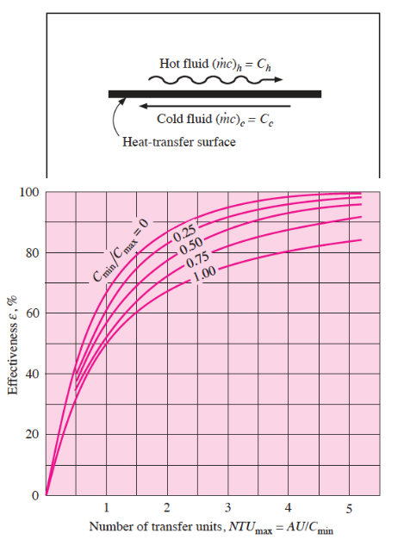

**Figure 5.** The NTU v efficiency of heat transfer diagram (Holman) [12]

After got the NTU value, it is then entered into equation (6) to get the length of the heat exchanger.

|  |  |  |
| --- | --- | --- |
|  | $$L=\frac{NTU.C_{min}}{U\left(N2πD\right)}$$ | (6) |

This method is also used to design the size of the economizer.

1. Result and Discussion

The evaporator design geometry is adjusted to the incinerator geometry. The steam-drum’s height is 0.48 m and this altitude allows it to have a pressure-drive of 4180 Pa. El-Wakil [3] said that for a boiler pressure 2500 psi (172 bar) has a pressure drive 1.52 psi (0.3 bar). This illustrates that 4180 Pa is enough to ensure water circulate in the steam drum system. The temperature of the gas that comes out of the evaporator was 490oC which will become heat source for superheater component.

The analysis result of superheater design said that the number of tube is 70 pipes with a length of 1.09 m and the pipe diameter is 2.54 cm. The analysis uses the Reynolds number 5000 with a velocity in the pipe 1.93 m/s. This can be a foundation to proceed to the next step because the simulation results carried out by Makoul for a 6 mm diameter and 200mm length of flow velocity range from 0.17 m / s - 0.448 m / s [13]. The direction of flow in the shell tube is opposite with the flow in the shell. The shell diameter is 36 cm in consideration of adjusting the required number of pipes. The analysis shows that the maximum temperature of the steam is 221.37 oC which is lower than the superheated temperature according to the designed Rankine cycle by Gifari [6].

The analysis results that the required length of economizer is 1.1 m with the number of pipes 25 and output temperature was 31oC. This figure shows that additional heat is still needed in order to turn the water into a saturated liquid state before entering the evaporator. However, this figure still has the opportunity to be higher because the actual temperature in the incineration of waste can reach a minimum of 800 oC according to Fu [14]. The mission in the economizer is no less important than the evaporator because it will help make the evaporator's work easier so that the system can be more efficient [15]. This result will then be the input geometry to enter the Computational Fluid Dynamics simulation. The input geometry will be used to see whether the process of changing from the liquid phase to the superheated vapor phase occurs. This process is important because the possibility of optimization will be narrow so that it will save time.

1. Conclusion

The geometric parameters for the steam generator have been prepared based on the heat transfer analysis using the NTU method. There is a note that the heat from combustion is only enough to increase the temperature until 221.37 oC. The final heat of the economizer requires additional heat in order to reach a saturated liquid state. This geometric parameter becomes the starting point for design optimization to proceed to Computational Fluid Dynamics (CFD) analysis. The steam generator geometric model that will be inputted by CFD based on this analysis produces the following criteria:

1. The evaporator has a height of 0.4 m

2. Superheater pipe diameter 2.54 cm with 70 pipes with a length 1.09 m

3. Economizer pipe diameter 2.54 cm pipe 25 pipes with a length 1.1m

References

1. Moran M, Shapiro H, Boettner D and Bailney M 2014 *Fundamental of Engineering Thermodynamics 8th ed*, ed Ratts L (New York: John Wiley & Sons)p 442
2. Novita D and Damanhuri E 2010. *Perhitungan Nilai Kalor Berdasarkan Komposisi dan Karakteristik Sampah Perkotaan di Indonesia dalam Konsep Waste To Energy (Jurnal Teknik Lingkungan* vol 16(2)) p 112
3. El-Wakil M 1988 *Powerplant Technology* (New York: McGraw Hill)pp 88-94
4. Astolfi M, Martelli E and Pierobon L 2017 Organic Rankine Cycle (ORC) Power Systems *Thermodynamic and technoeconomic optimization of Organic Rankine Cycle systems)* ed Macchi E and Astolfi M (Amsterdam: Elsevier) chapter 7 p 232
5. Dinçer İ and Zamfirescu C 2016 *Drying Phenomena: Theory and Applications* (New York: John Wiley & Sons) Appendix B
6. Al Gifari M M, Sriyono, and Wiyono A 2020 Design of UPI Incinerator Heat-Electricity Conversion System by Applying Classic Rankine Cycle*Preprint* gr-qc/0401010
7. Incropera F, Dewitt D, Bergman T and Lavine A 2007 *Fundamentals of Heat and Mass Transfer* (New York: John Wiley & Sons)pp 671-699
8. Wardhani V and Damanhuri E 2015 *Prediksi Karakteristik Termofluida Proses Perpindahan Panas di dalam Ruang Bakar Incinerator (Indonesian Journal of Nuclear Science and Technology* vol 16(1)) p 50
9. Munson B, Young D, Okiishi T and Huebsch W 2009 *Fundamental of Fluid Mechanics 6th ed*, (New York: John Wiley & Sons)p 311
10. White F 2002 *Fluid Mechanics 5th ed*, ed Holman J and Lloyd J (New York: McGraw Hill)pp 24-26
11. Bagus T 2002 *Pengelolaan dan Pemanfaatan Sampah Menggunakan Teknologi Insinerator (Jurnal Teknologi Lingkungan* vol 3(1)) p 50
12. Holman J 2010 *Heat Transfer 10th ed*, ed Lloyd J (New York: McGraw Hill)p 543
13. El Metoui M, Zaite A, Meziane M and Ben Abdellah A 2016. *Numerical comparison of shell-side performance for shell and tube heat exchangers with trefoil-hole, helical and segmental baffles. Applied Thermal Engineering* vol 109*,* pp175–185
14. Fu Z, Zhang S, Li X, Shao J, Wang K and Chen H 2015 *MSW oxy-enriched incineration technology applied in China: Combustion temperature, flue gas loss and economic considerations. Waste Management* vol 38*,* pp 149–156
15. Wang Y, Cao L, Li X, Wang J, Hu P, Li B and Li Y 2019 *A novel thermodynamic method and insight of heat transfer characteristics on economizer for supercritical thermal power plant. Energy, 116573*