### USING VALUE MAPPING STREAM TO IMPROVE COMPETITIVENESS IN AN OIL AND GAS SERVICES COMPANY

**Yusri Yamin a*, Muhammad Al'hapis a, Azmi Hassanb, Tumiantoa ,Fauzan Rahmana**

a Manufacturing Section,Universiti Kuala Lumpur, Malaysian Spanish Institute Kulim Hi-Tech Park, 09000 Kulim, Kedah, Malaysia .

b Electrical, Electronics & Automation Section, Universiti Kuala Lumpur, Malaysian Spanish Institute Kulim Hi-Tech Park, 09000 Kulim, Kedah, Malaysia

*Yusri Yamin-mail: [yamin.yusri@s.unikl.edu.my](mailto:yamin.yusri@s.unikl.edu.my)

Muhammad Al’hapis

e-mail: alhapis@unikl.edu.my

Azmi Hassan

e-mail: azmi.hassan@unikl.edu.my

Tumianto

e-mail: tumianto@s.unikl.edu.my

Fauzan Rahman

e-mail: fauzan.rahman@s.unikl.edu.my

**Abstract:** This paper presents a new approach to the Value Stream Mapping (VSM), a proven tool of Lean Manufacturing (LM) in a service company in the oil and gas sector. VMS is used to map the activities that occur, ideal activities so that it can analyze unnecessary / waste activities, which then generate new activity proposals / future state, the company can respond to more project opportunities ordered by users as expected. Author illustrates this approach using VSM for PO processing time improvement successfully. They found that organizations faced problems such as high administrative processing times for PO issuance and by using the VSM tool they achieves an increase in lead time reduction from 30,2 days to 14 days.

**Keywords –** Value Mapping Stream (VMS), Purchasing Order (PO), Process, Activity

### 1 Introduction

Small and Medium Enterprises (SME) are continuously aiming to compete when it comes to the pricing of the products and reducing lead time. Time is money and using fewer resources could be a good strategy for an enterprise. Masuti describe (1) that shorter lead times are the main requirement of a customer in the manufacturing industry. Hence, a methodology to reduce the lead time and eliminate waste which would result in reduced production cost and faster Return On Investment (ROI) would be beneficial. Lean philosophy which is derived from the Toyota Production System (TPS) is the key to increasing productivity by eliminating seven wastes from production (2, 3) . Material and Information Flow Mapping referred to as “Value Stream Mapping” (VSM) is a method used by Toyota Production System (TPS) to represent the current product flow and the future product flow (ideal). VSM helps in identifying waste by depicting value-added time, non-value added time, the flow of the material, information and of the people(4). In the new normal era due to the Covid19 pandemic, currently there are many service companies that have been severely affected financially, especially service companies that engaged in the oil and gas sector by cutting operational budgets, reducing the number of workers, selling company assets, or closing the company’s operations. To avoid those decission, service companies are required to optimize every possible lines they can, such as; operational cost efficiency, asset optimization, regulation and improve the worker effectiveness and productivity(5, 6). So that the core business of the company survived and increased. It can be said that surviving is the new normal for most service companies / contractors during a pandemic because oil and gas companies are also affected and doing the same thing. In the company where this study was conducted, VMS helped analyze and mark non value add activities as waste. significant effect on the duration of PO processing time are expected, so that the company could respond to more user-ordered project opportunities (7).

### 2. Method

Value Stream Mapping (VSM) is one of several methods in Lean manufacturing, like other tools in Lean Manufacturing works on identifying and eliminating wastages from each step in the manufacturing cycle of a product. The wastages in manufacturing cycle of a product may be energy, time, motion and resources. Many manufacturing organizations are effectively using lean tools and techniques to identify and eliminate wastages through continuous improvement. VSM also identify all types of wastes in the value stream and take steps to eliminate these. Many researchers have developed number of tools to optimize individual operations within a supply chain. But these tools are not able to check how the material and information flow through the entire production cycle. Thus VSM deals with broader view instead of individual process (8). Gopi, Suresh, & John Sathya;2020 describe VSM as a communication tool, a business tool, and a tool to manage the change process (9)

#### **2.1. The value stream map description**

Henry Ford said ‘‘Before everything else, getting ready is the secret of success”. The quote by the ford tells us to be ready for the upcoming situation. VSM tells to be prepared that is gather as must as information about the current state of the company that will help us to find problems and provide the relevant solution for

them. The value stream map can be plotted with following set of rules.

 The map should include all the value added as well as non-value activity of the product to be manufactured.

 Pencil and paper are used to draw a current state map usually. Next step is to analyze the map by finding problem and providing solution to them and to prepare action plan for implementing them with certain deadlines, responsibilities and targets.

 Value Stream Maps are drawn as pictures of the process and used to document both Current State Map (reality) and the Future State Map (the goal).

 Current state map is current situation of the company from which all improvements are measured.

 Future State Map is the vision of how the project team sees the value stream in future after improvements have been made.

### 3. Results and Discussion

This author has carried out various operations and studied the appropriate organization to find out the root causes of various wastes in administrative activities in the company. By finding different types of waste in routine activities, they discovered how far the company was from the lean manufacturing concept. To eliminate various wastes from the company an action plan is drawn up and minimizes the root causes (8). They found that organizations faced problems such as high administrative processing times for PO issuance. By using the VSM tool they found an increase in lead time reduction from 30,2 days to 14 days using the pull system. This author used the VSM lean tool at the company PT Gearindo Prakarsa, Balikpapan. They have collaborated cycle times with processing times with the help of a one minute exchange of dies (SMED) used in the PO issuance process.. The advice given to the company is to implement this system for all activities and continue to monitor compliance with its use. They apply IT-capable purchasing system in the case of manual purchasing system for better material flow in a certain time.

PT Gearindo Prakarsa. in the business of construction, electrical, mechanical, Performing and providing work-related equipment in accordance with the agreed work contract, currently has the average processing capability per PO unit on 30 working days. Increasing the processing time line is an urgent matter to increase the company's responsiveness to customers in the future. The challenge is to meet customer demands with a fast response without reducing quality(10-12). Some of the problems observed in the early stages of observing the PO issuance process line must be resolved to meet customer demands. Problems such as rework, manual distribution of documents, Long journey offline approval of authorities, are bureaucratic problems of a long workflow (Table 1.). Value flow mapping is needed to reduce the waiting time for processing PO documents as the result of Pareto (Figure 1.) .prioritization helps designers know what part of the product or process is most beneficial to focus on major or root problem (13)to increase company productivity. By implementing the lean tools at particular stations were problems were found and reducing the cycle time, lead time and excess rework because of more inventories. All these changes are shown on future state map with the help of kaizen burst (Figure 3.). Results of comparison between current state map and future state map are shown as follows:

Table 2. Improvement

|  |  |  |  |
| --- | --- | --- | --- |
| Metric | Current State | Projected Future State | % Improvement |
| Lead time | 30,2 days | 14,05 days | 48% |
| Process Time | 115 mins | 60 mins | 52% |
| %Activity | 0,79% | 0,89% | 13% |
| Rolled First Pass Yield | 3,20% | 7,10% | 222% |

Table 1. Tally Discrete Variable of Processing time

|  |  |  |  |  |  |
| --- | --- | --- | --- | --- | --- |
| Processing time | Percent | CumPct | Percent | CumCnt | CumPct |
| Material & Service Sourching | 6,67 | 6,67 | 13,33 | 2 | 13,33 |
| Make OE | 6,67 | 13,33 | 33,33 | 7 | 46,67 |
| Create a follow-up warrant | 6,67 | 20 | 26,67 | 11 | 73,33 |
| Make a follow-up procurement warrant | 6,67 | 26,67 | 6,67 | 12 | 80 |
| Receiving Orders (Communication - Email) | 6,67 | 33,33 | 6,67 | 13 | 86,67 |
| Send / Forward to Jakarta (Communication - Email) | 6,67 | 40 | 6,67 | 14 | 93,33 |
| Sending OE Balikpapan to Jakarta | 6,67 | 46,67 | 6,67 | 15 | 100 |
| Sending Final OE to User | 6,67 | 53,33 |  |  |  |
| Confirming Supplier's offer | 6,67 | 60 |  |  |  |
| Waiting for Reply from Jakarta | 6,67 | 66,67 |  |  |  |
| Waiting for final OE Reply on source comparison | 6,67 | 73,33 |  |  |  |
| Waiting for the Supplier's Answer | 13,33 | 86,67 |  |  |  |
| Waiting for User Answers (Price & Delivery) | 6,67 | 93,33 |  |  |  |
| PO Process | 6,67 | 100 |  |  |  |
| N= | 15 |  |  |  |  |
|  |  |  |  |  |  |



Figure 1. Pareto Chart

#### **3.1. Current state map**

The current state map shows the current situation of the company. The following principle guides to plot the Current State Map: Observe the total processing time of Purchase Order (PO). Collecting specific data such as administration review, verification until the approval performed, administrator, management, flow of work and necessary information

Specific graphical symbols are used to represent the results.

Value stream map drawing steps

* Draw customer, process control and supplier icons.
* Calculate monthly production demand. Show the communication symbols.
* Add process boxes in sequence from left to right.
* Add data boxes below.
* Add communication arrows
* Calculate process attributes and add to the data boxes.
* Add operator symbols and numbers.
* Add inventory levels in days of demand at bottom.
* Add working hours.
* Add Cycle time and lead times.
* Calculate total cycle time and lead time.

According to the rules of current state map all the current situation of the organizations were studied. Cycle time, available time, number of worker, uptime and changeover time of each and every station were studied and all data was collected. The total value added time required from current state map was 115 mins, total nonvalue added time was 31 days and processing lead time was 31,2 Days. As per forecasted demand from the customer to the organization it was required to decrease the per day processing time from 30 per day to 14 per day. To meet this requirement by reduce the bottleneck from the process, increase the value addition of work material and reduce non value added activities. The detailed current state map is given in Figure 2 and 3.

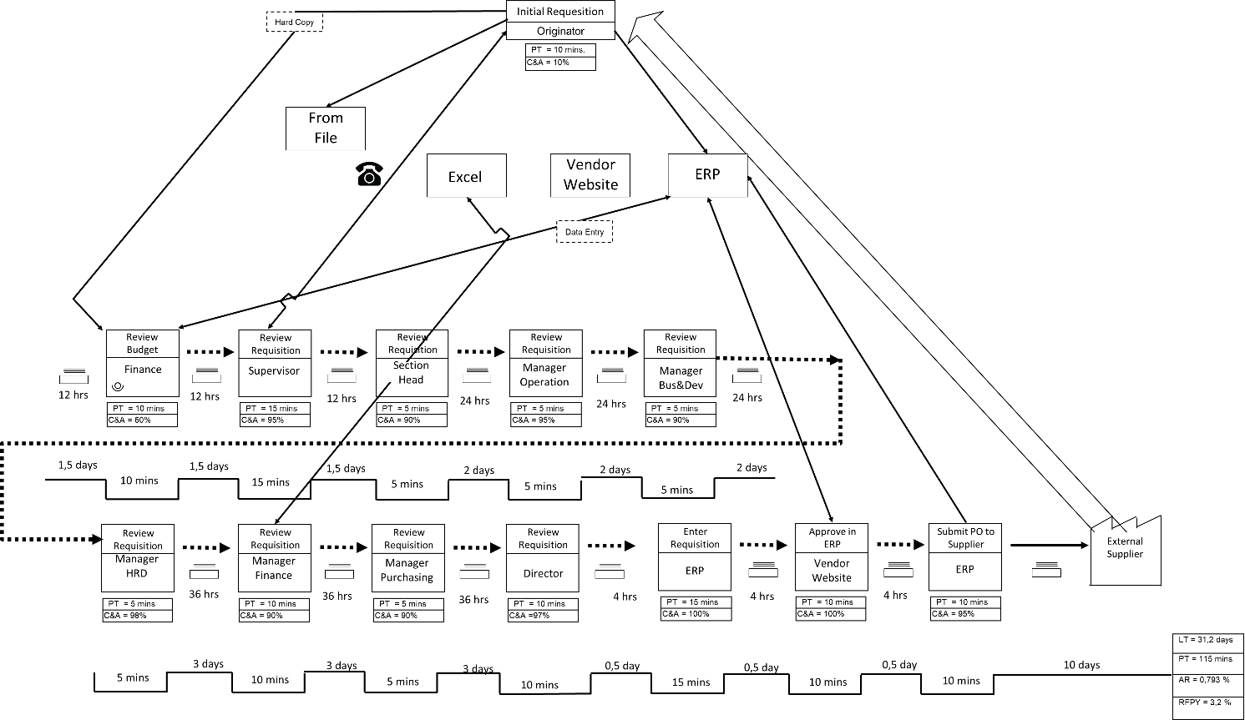**Figure 2. Current State Map**

#### **3.2. Future state map**

The future state map is the map which shows the future of the organization after implementing lean tools. It consist important tools which helps us for the continuous improvement of the organization. Lean practitioners can be dependable on this map as action plans are made by mapping the team(1, 14, 15). Future state map easily helps the user to find out where the changes are to be made and how to tackle them with the help of symbol that is kaizen brust. Future state map helps organization to forecast the demand and make changes accordingly (9), The detailed current state map

is given in Figure 3.

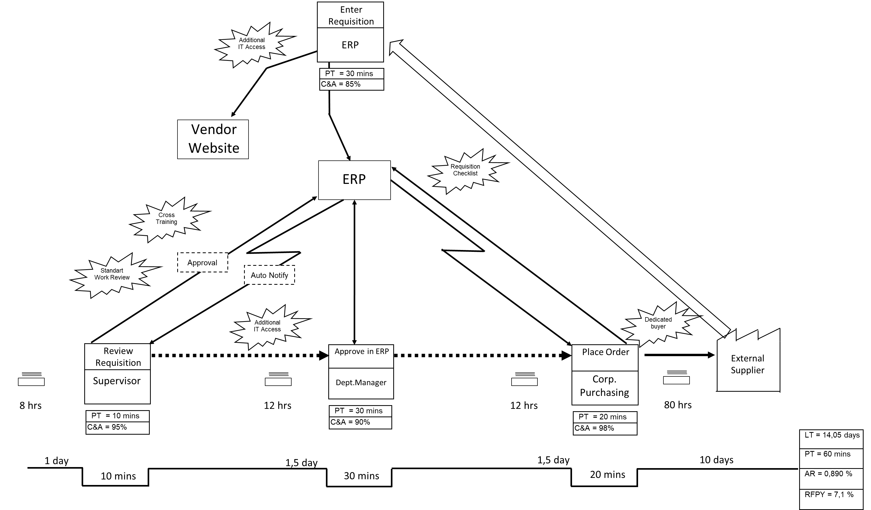

**Figure 3. Future State Map**

### 4. Conclusion

VSM is a great tool to be used to find out whole value stream that is from customer order and then through purchasing, manu- facturing and shipping the finished goods to the customer. VSM helps to focus on eliminating the waste for the process and to add value to the product for which the customer pays. To achieve the goal it links peoples, tools and process. In this project we have found out lots of improvement areas with the help of current state map. Implementation of lean tools contributes the overall reduction of 55 minutes to value added activities and 17 days to non-value added activities, together contribute reduction of 17,15 days in Production lead time.

### 5. References

1. Masuti PM, Dabade UA. Lean manufacturing implementation using value stream mapping at excavator manufacturing company. Materials Today: Proceedings. 2019;19:606-10.

2. Basu R. Chapter 9 - Quantitative techniques. Implementing Six Sigma and Lean2008. p. 153-94.

3. David Ginn MZaPKA. Enhancing agility in manufacturing - The role of QFD. 2001.

4. Wilson G. Chapter 5 - Quality function deployment. Six Sigma and the Product Development Cycle2005. p. 69-106.

5. Romero LF, Arce A. Applying Value Stream Mapping in Manufacturing: A Systematic Literature Review. IFAC-PapersOnLine. 2017;50(1):1075-86.

6. Ellingsen O. Commercialization within Advanced Manufacturing: Value Stream Mapping as a Tool for Efficient Learning. Procedia CIRP. 2017;60:374-9.

7. Antonelli D, Stadnicka D. Combining factory simulation with value stream mapping: a critical discussion. Procedia CIRP. 2018;67:30-5.

8. Narke MM, Jayadeva CT. Value Stream Mapping: Effective Lean Tool for SMEs. Materials Today: Proceedings. 2020;24:1263-72.

9. Gopi S, Suresh A, John Sathya A. Value stream mapping & Manufacturing process design for elements in an auto-ancillary unit – A case study. Materials Today: Proceedings. 2020;22:2839-48.

10. Zhang C-cCaH. A FMEA-Aided Equipment Life-Cycle-Cost Measurement System. 2013.

11. Danny Faturachman SM, Fanny Octaviany, Theresia D. Novita. FAILURE MODE AND EFFECTS ANALYSIS (FMEA) OF DIESEL ENGINE MARITIME TRANSPORTATION FOR SHIP NAVIGATION SYSTEM IMPROVEMENT. 2013.

12. Braaksma AJJ, Meesters AJ, Klingenberg W, Hicks C. A quantitative method for Failure Mode and Effects Analysis. International Journal of Production Research. 2012;50(23):6904-17.

13. Lamers TL, David M, Goodson K, Ishii K, Pruitt BL. Application of a Modified Quality Function Deployment Method for MEMS. 2007:159-68.

14. Deshkar A, Kamle S, Giri J, Korde V. Design and evaluation of a Lean Manufacturing framework using Value Stream Mapping (VSM) for a plastic bag manufacturing unit. Materials Today: Proceedings. 2018;5(2):7668-77.

15. Garza-Reyes JA, Torres Romero J, Govindan K, Cherrafi A, Ramanathan U. A PDCA-based approach to Environmental Value Stream Mapping (E-VSM). Journal of Cleaner Production. 2018;180:335-48.