Designing educational facilities that outrun railways to be inclusive, safe, resilient, and sustainable

S Hermawan1,2, V N Husada1, V R Husada1, W Alfred3

1 Civil Engineering Department, Faculty of Civil Engineering and Planning Petra Christian University, Surabaya, Indonesia

2 Department of Engineer Profession Program of Petra Christian University, Surabaya, Indonesia

3 Architecture Department, Faculty of Civil Engineering and Planning Petra Christian University, Surabaya, Indonesia

shermawan@petra.ac.id

**Abstract**. In recent years, Surabaya as one of the Metropolitan cities in Indonesia has become increasingly crowded. Through the increasing level of urbanization in Surabaya, people's purchasing power of land has decreased and the number of illegal buildings erected around public facilities is increasing, such as on the outrun of railways. Therefore, the background and object of this research is an elementary school which is located in the middle of the intersection of two Dupak Magersari railroad tracks, Surabaya, which is less than two meters. Besides, COVID-19 pandemic is still one of the concerns of all people. During the New Normal, the school may reopen soon. The research method begins with a survey and questionnaires to determine the behavior and perceptions of residents related to the existence of the elementary school. The results of the initial survey illustrated that some people think that every accident is fate without realizing that there is a solution to prevent it. Then the results of the analysis from observations and questionnaires are used as a reference in providing solutions for both problems in the short and long term in the form of safe and sustainable school design.

1. Introduction

According to *KBBI (Kamus Besar Bahasa Indonesia),* security is a condition of safety and peace. This condition seems trivial and is rarely being paid attention to, but it has a great impact on its victims. One of the locations that need a high level of security is around the railway area. Railway accidents frequently happened in several countries, mainly developing countries.

One of the news that caught the attention of the writer was an accident that occurred in Surabaya, to be precise at Dupak Magersari. That train was carrying 30 containers collapsed and caused considerable damage to seven buildings located adjacent to the railroad tracks. The seven buildings are the RW hall, five residents' houses, and the Uswatun Hasanah Elementary School [1]. This accident-only killed 1 person whose house is adjacent to this elementary school. The train accident did not destroy the school building, but only damaged the school fence. It is inconceivable how many casualties would have been incurred if the accident occurred during the day when the teaching and learning process was taking place or when many students were passing by in the school fence area.

Meanwhile, in December 2019, the first virus case was found in Wuhan, Hubei Province, China, namely Corona Virus Disease-19 (COVID-19). Since 11 March 2020, COVID-19 has been declared a pandemic by the World Health Organization [2]. In Indonesia, the government has designated COVID-19 as a *Kejadian Luar Biasa* (Extraordinary Incident) on March 31, 2020 [3]. The COVID-19 pandemic has caused changes in various sectors of people's lives, one of which is the teaching and learning process. With this pandemic, the teaching and learning process must be carried out through an online method.

At the time of writing, which was in mid-June 2020, COVID-19 has not been tamed in Indonesia. Hence, its effects on economic growth, jobs, and welfare remained uncertain. For that reason, the government in Indonesia implied a new policy, which will be known as the new normal, that must be followed by all people in Indonesia [4]. New Normal itself is a condition that requires humans to adapt to new lifestyles in preventing transmission of COVID-19 before a vaccine is invented [5]. This allows humans to continue to carry out their activities by following the health protocols established by the government. Schools that were initially carried out through an online method, began to be prepared to be conducted face-to-face. This is also due to the ineffectiveness of online learning due to a lack of understanding of boring learning materials or techniques [6].

Based on these two problems, through this scientific work, this research wants to analyze the factors that cause schools to violate the boundaries of the setback space of railroad tracks and design the buildings of Uswatun Hasanah Elementary School. It requires inclusive, resilient, safe, sustainable, and certainly does not change the location of the school. The school design also can be adjusted with New Normal conditions to prevent the increasing spread of the COVID-19.

1. Materials and methods

The research started by conducting a literature study on existing problems. After that, a location survey was carried out to measure the distance between the school and the railroad track. Then, recorded the number of train movements, the response of parents, students, and residents around Dupak Magersari when the train would pass through the area, including conducting interviews with students' parents and residents around the Uswatun Hasanah Elementary School Dupak Magersari Surabaya. To add insight into the views of the general public, a questionnaire was filled in, represented by 79 students from several universities in Surabaya. This can be a reference in making the design of the Uswatun Hasanah Elementary School building which is safe from train accidents and also following New Normal conditions.

The research was continued by estimating the area of ​​the existing SD Uswatun Surabaya building through Google Maps. Once the area is known, the building is analyzed using *Undang-Undang Nomor 23 Tahun 2007*. In the explanation of *Pasal 42,* it has been explained that the allowable land use limit is 6 (six) meters measured from the right and left of the outer side of the railroad construction [7]. With these limitations, it is known that the available building area is following existing regulations.

Furthermore, buildings are analyzed based on space requirements during COVID-19 which are adjusted to Peraturan Walikota Number 33 of 2020 [8]. From *Peraturan Walikota Nomor 33 Tahun 2020*, it is known that people have to apply a distance of 1 m between two people. With the assumption that if the width per person is 60 cm, then two people are 120 cm plus 100 cm so that the total distance for the building design is 220 cm. Besides, the space requirements during New Normal are double the normal space requirements as shown in Figure 1 [9]. After knowing the available building area and space requirements during COVID-19, a building design is suitable for the short, medium, and long term.

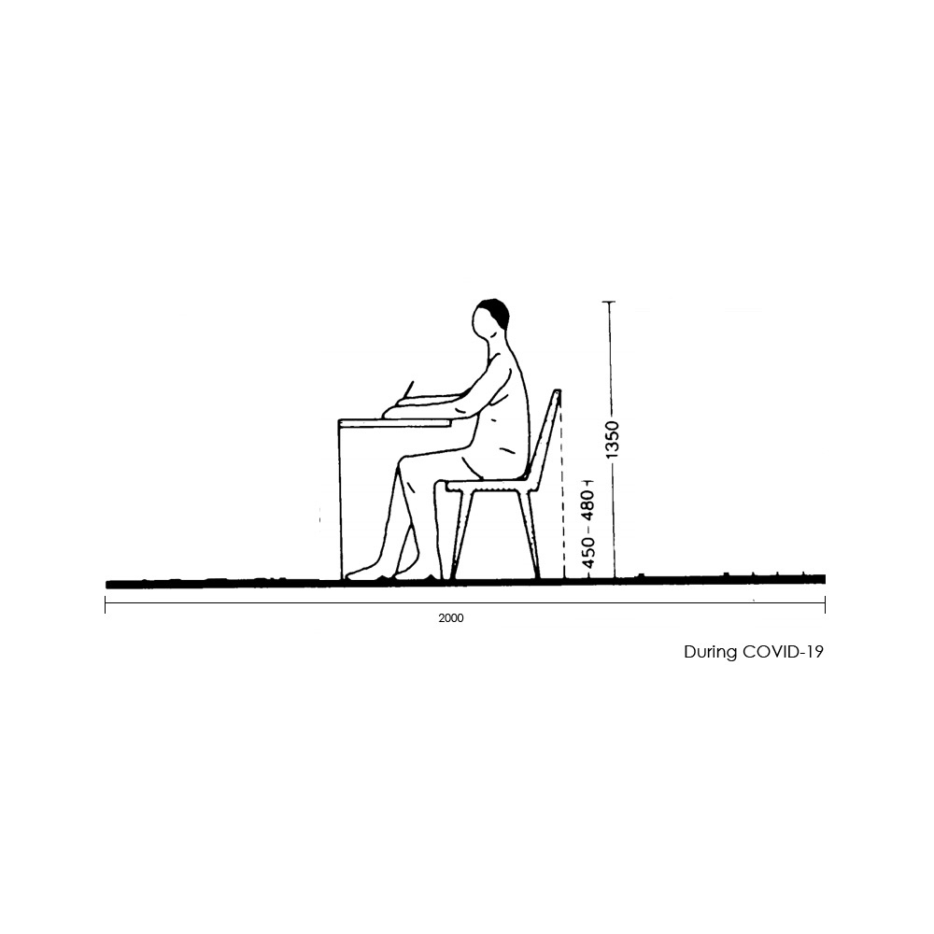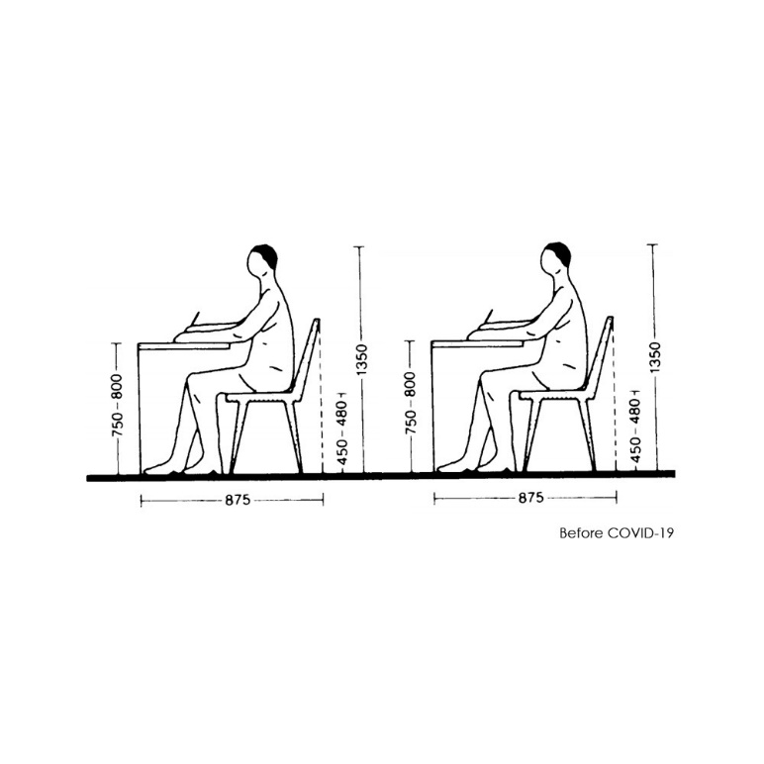**Figure 1.** Space requirement before COVID-19 and during COVID-19 [9]

1. Result and discussions

Based on a brief observation, the population in Uswatun Hasanah Elementary School is not too diverse, the majority of students who go to school there has a place to live not too far from the school. There are various options for students to come to this school, having the option between walking, riding a bicycle, or being taken to school by motorbike. The security level of students is really low due to the distance of the railroad tracks to the building is only 2 (two) meters away. The integration of the existing aspects in this facility is not yet adequate, such as the lack of natural aspects in the facility.

The research was then continued by conducting interviews with several residents who had children and relatives who were attending Uswatun Hasanah Elementary School. Based on the results of the interview, the people around did not seem too worried about the safety of school children because the answer was "Oh, it's okay, when there is a sound of an alarm for a train passing by, the children will step aside." According to this author, more action is needed because children are not sure to be alert at all times and need more supervision. Parents who take their children to school casually walk on the existing train tracks, even though there are other roads around them.

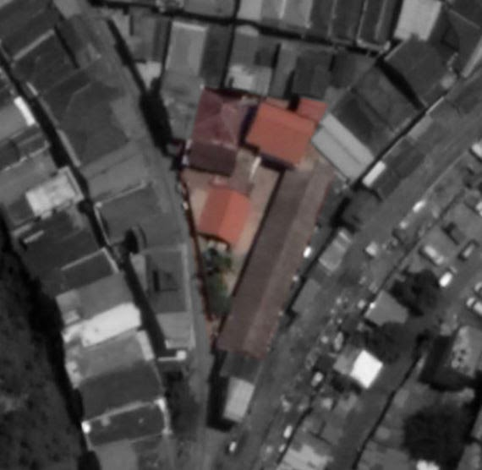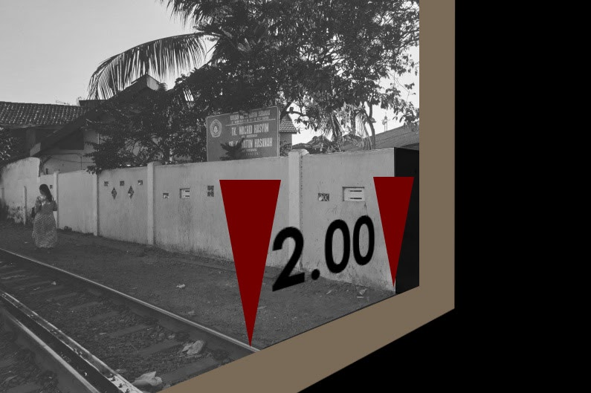

**Figure 2.** Location map of Uswatun Hasanah **Figure 3.** The distance between the train tracks and

Elementary School Surabaya [10] Uswatun Hasanah Elementary School Surabaya

Figure 2 is a photo from Google Earth, showing how much land the school owns. The school is 1.5 to 2 meters from the railroad track measured from the outer wall of the school (see Figure 3). This school has a land area of ​​about 500 square meters.

To enrich data and opinions from some students, a questionnaire was filled through Google Forms with a total of 79 respondents. Based on questionnaire data, most respondents (96.2%) agree that the ideal school environment is a comfortable one. Also, as many as (86.1%) chose a clean environment for school to be called an ideal one. The third highest is the safety of students going to and from school (74.7%). Another small proportion chose to be away from the crowd (26.6%), no discrimination between students (1.3%), clean, safe, and comfortable (1.3%), there are cheap foods around (1.3%).

Most of the respondents (55.7%) agree that being comfortable in a learning atmosphere is the most important thing in a school. While some of the other respondents chose a clean school environment (20.3%), safety when going to and from school (19%), having an open area (3.8%), there was no discrimination between students (1.3%) as the main thing in choosing a school. As many as 88.6% of respondents do not want to attend schools which are located approximately 1.5 m from the railroad track. Meanwhile, the rest (11.4%) thought this was not a problem. The response that chooses a school environment that is close to the rail is not a problem, choosing to pay more attention to a school from the quality of its teachers (44.4%), school facilities (33.3%), location close to home (11.1%), the togetherness of teachers and students (11.1 %).

The reasons for respondents who did not want to go to school close to the railroad tracks were that they felt they could not concentrate while studying (81.4%) and it would be noisy (75.7%). Besides, 68.5% felt prone to accidents and 64.3% of respondents felt uncomfortable. Unfortunately, only 38.6% of the respondents were concerned about reporting the school and the solution. Meanwhile, 72.9% of respondents only chose to avoid and did not go to school there.

The author offers a solution to existing problems and is also adapted to the New Normal conditions. The building design refers to *Undang-Undang Nomor 23 Tahun 2007* and *Peraturan Walikota Nomor 33 Tahun 2020*. The solution in this case will be divided into two, namely short-term and long-term solutions.

Based on survey data provided by Google Maps, the existing land area, and the designed land area were obtained. In Figure 5. it is shown that the existing land area is around 500 m2. Meanwhile, after being adjusted to *Undang-Undang Nomor 23 Tahun 2007* where the permissible land use limit is 6 (six) meters measured from the right and left of the outer side of the railroad construction, the resulting designed land area is around 300 m2. With a reduction in land area, the building area, and the function of the rooms in it will be reduced. To overcome this problem, the authors decided to propose a solution by increasing the number of the floor level. The second floor will be constructed with construction scaffolding as the main structural material.

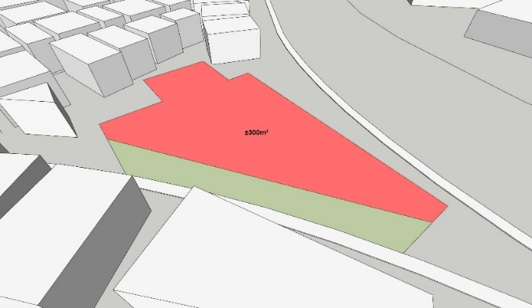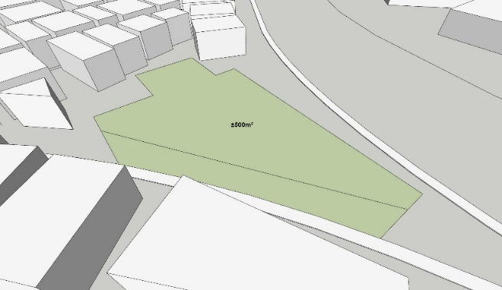

**Existing Land Area Designed Land Area**

**Figure 4**. Land area Uswatun Hasanah Elementary School

Scaffolding was selected as the main material is due to its fast and easy assembly process. The ease of assembly since the scaffolding itself is designed to help with structural work. Besides, there are connecting holes to facilitate the installation and dismantling process. This supports the current condition, because of the ongoing COVID-19 case, students must follow the physical distancing health protocol. After the conditions change where COVID-19 can be overcome, the school design can be changed quickly so that students can be with each other without any distance. Apart from the ease of the assembly process, the module can be used *comfortably* enough for space [11]. A construction experiment was carried out by Yu Sing, who is a principal architect in Akanoma studio, to find out how sets of scaffolding can be used as a building. He has succeeded in creating a micro-housing with that sets of scaffolding and several light materials. With the experiments conducted by Yu Sing, it shows that scaffolding can be used as a house structure with light-load construction, can be assembled, and can be grown or developed.

The design should be made as attractive as possible, even using scaffolding as its main material. Besides, the building must be designed to be able to adapt to the environment so that the building can become a comfortable place for students, teachers, and each school party. Layout arrangement, space program, air circulation, and lighting are also important factors that must be adjusted to the existing climate and weather.

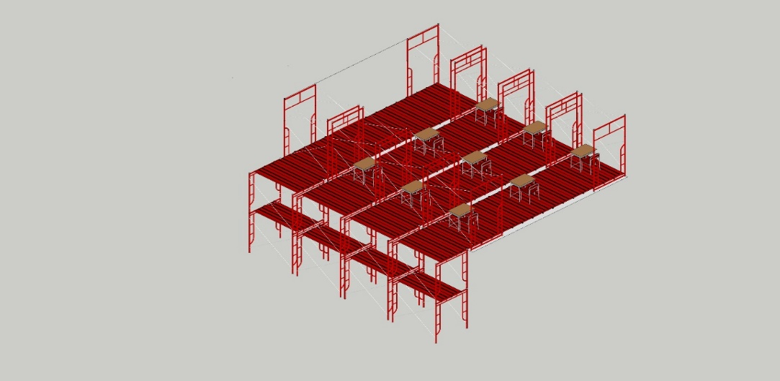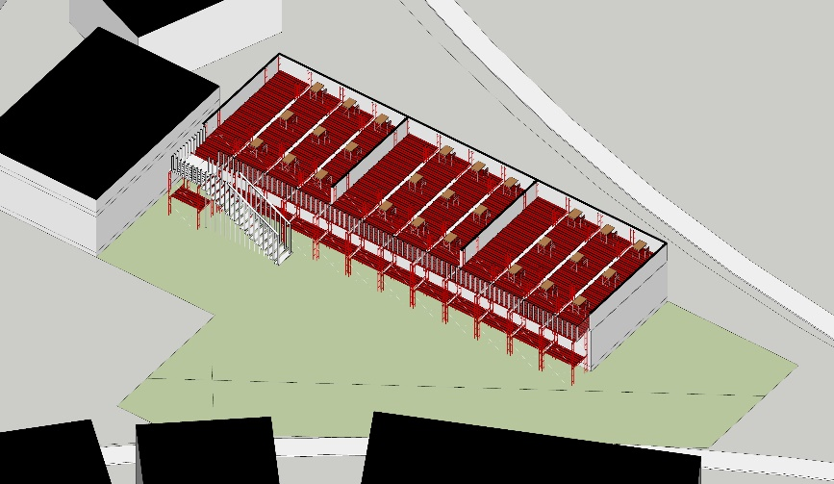In Figure 8, it can be seen that when the building area is 52 (fifty-two) m2, with student space capacity during COVID 19 is 9 (nine) people. For future solutions, if the estimated class population increases to 24 (twenty-four) students. This kind of design can be adjusted and adapted easily if there are space adjustments through addition or vice versa. For example, when more space is needed, Figure 9 can be one of the alternative plans. Then, Figure 10 shown the front view of the scaffolding building design for Uswatun Hasanah Elementary School.

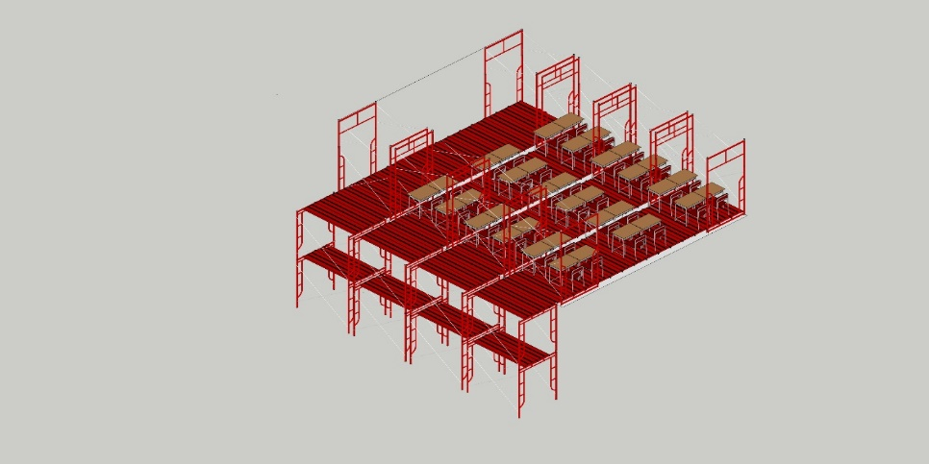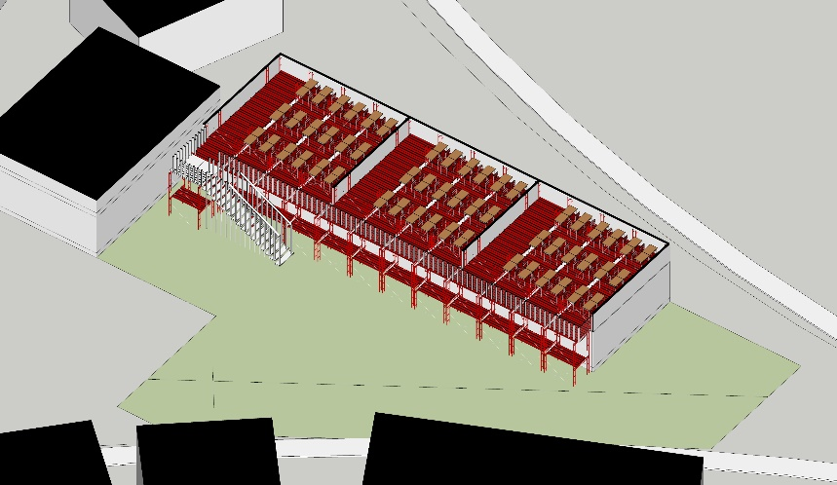During COVID-19 possibility

After COVID-2019 possibility

**Figure 6.** Scaffolding building design before and after COVID-19

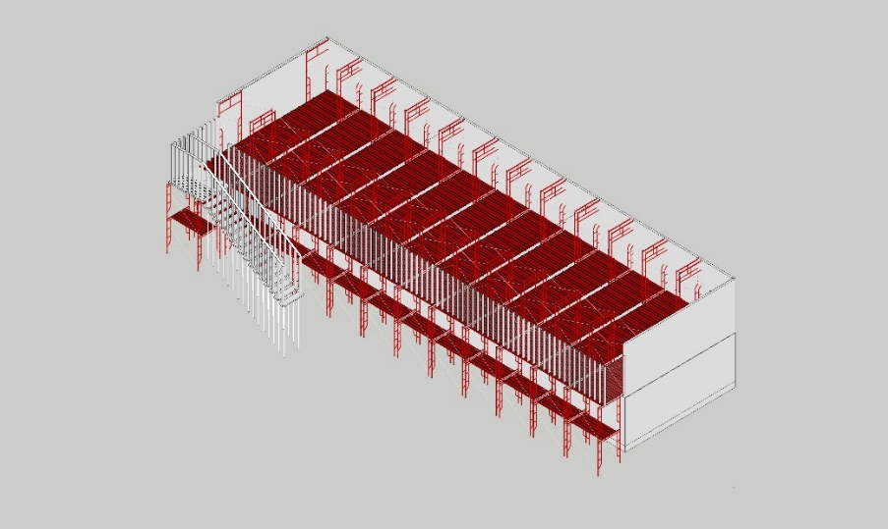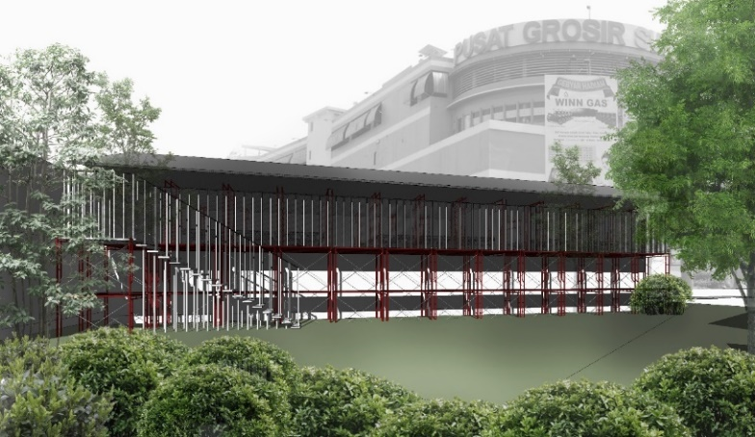**Figure 7.** Alternative plan **Figure 8.** Uswatun Hasanah Elementary School’s design

1. Conclusion

Based on the results of the discussion above, it can be concluded that the Uswatun Hasanah Elementary School building has violated *Undang-Undang Nomor 23 Tahun 2007* so that a renovation is required which allows the building area to be reduced by ± 300m2. To replace the reduced building area, a second floor is needed in the facility. Due to the COVID-19 pandemic has not ended yet and schools will be reopening soon, the author suggests that the construction method should be using scaffolding which is easier to install, lower cost, and adaptable form to existing conditions. However, this still requires further research on the strength of the building structure with scaffolding and building finishing methods so that it will become more comfortable for students to use.

References

1. Detik News 2015 *Ini Penampakan Rumah dan Bangunan Tertabrak Kereta Anjlok* [Online] Retrieved from: <https://news.detik.com/berita-jawa-timur/d-3034715/ini-penampakan-rumah-dan-bangunan-tertabrak-kereta-anjlok>. Accessed on 19 October 2020
2. [Driggin](https://pubmed.ncbi.nlm.nih.gov/?term=Driggin+E&cauthor_id=32201335) E, [Madhavan](https://pubmed.ncbi.nlm.nih.gov/?term=Madhavan+MV&cauthor_id=32201335) MV, [Bikdeli](https://pubmed.ncbi.nlm.nih.gov/?term=Bikdeli+B&cauthor_id=32201335) B, [Chuich](https://pubmed.ncbi.nlm.nih.gov/?term=Chuich+T&cauthor_id=32201335) T, [Laracy](https://pubmed.ncbi.nlm.nih.gov/?term=Laracy+J&cauthor_id=32201335) J, [Zoccai](https://pubmed.ncbi.nlm.nih.gov/?term=Biondi-Zoccai+G&cauthor_id=32201335) GB, [Brown](https://pubmed.ncbi.nlm.nih.gov/?term=Brown+TS&cauthor_id=32201335) TS, [Nigoghossian](https://pubmed.ncbi.nlm.nih.gov/?term=Der+Nigoghossian+C&cauthor_id=32201335) CD, [Zidar](https://pubmed.ncbi.nlm.nih.gov/?term=Zidar+DA&cauthor_id=32201335) DA, [Haythe](https://pubmed.ncbi.nlm.nih.gov/?term=Haythe+J&cauthor_id=32201335) J, [Brodie](https://pubmed.ncbi.nlm.nih.gov/?term=Brodie+D&cauthor_id=32201335) D, [Beckman](https://pubmed.ncbi.nlm.nih.gov/?term=Beckman+JA&cauthor_id=32201335) JA,  [Kirtane](https://pubmed.ncbi.nlm.nih.gov/?term=Kirtane+AJ&cauthor_id=32201335) AJ, [Stone](https://pubmed.ncbi.nlm.nih.gov/?term=Stone+GW&cauthor_id=32201335) GW, [Krumholz](https://pubmed.ncbi.nlm.nih.gov/?term=Krumholz+HM&cauthor_id=32201335) HM, [Parikh](https://pubmed.ncbi.nlm.nih.gov/?term=Parikh+SA&cauthor_id=32201335) SA 2020 Cardiovascular considerations for patients, health care workers, and health systems during the COVID-19 pandemic. *Journal of the American College of Cardiology* **75**(18): 2352-2371
3. Andriani H 2020 Effectiveness of Large-Scale Social Restrictions (PSBB) toward the New Normal Era during COVID-19 Outbreak: A Mini Policy Review. *Journal of Indonesian Health Policy and Administration***5**(2)
4. Olivia S, Gibson J, Nasrudin R A 2020 Indonesia in the Time of Covid-19. *Bulletin of Indonesian Economic Studies* **56**(2) 143-174
5. Chen R C, Tan T T, Chan LP 2020 Adapting to a new normal? 5 key operational principles for a radiology service facing the COVID-19 pandemic. *European Radiology* **1**
6. Alexander M W, Truell A D, J J Zhao 2012 Expected advantages and disadvantages of online learning: Perceptions from college students who have not taken online courses. *Issues in Information Systems* **13**(2) 193-200
7. Pemerintah Indonesia 2007 Undang-Undang Nomor 23 Tahun 2007 17
8. Walikota 2020 Peraturan Walikota Surabaya Nomor 33 Tahun 2020 8
9. Neufert, Ernst, and Neufert P 2012 *Arhitect’s Data* (Oxford : John Wiley & Sons)
10. Google Inc 2020 Google Maps: Peta Lokasi Dupak Magersari [Online] Retrieved from <https://goo.gl/maps/bQR13YHJhucMCfDA9>. Accessed on 22 October 2020
11. Suharyani S and Fathonah N N 2019 Identifikasi Material Scaffolding sebagai Alternatif Tempat Tinggal untuk Kalangan Masyarakat Berpenghasilan Rendah (MBR) Studi kasus di Akanoma Studio. *Sinektika : Jurnal Arsitektur* **15**(1) 23-33