Technology Readiness Base of Small and Medium Enterprises for Business Improvement

P W Ndari1, P Vitasari2

1Master Student, Postgraduate Program of Industrial Engineering, National Institute of Technology (ITN) Malang, Indonesia

2Industrial Engineering Departement, Postgraduate Program, National Institute of Technology (ITN) Malang, Indonesia

E-mail: priskawulandari21@gmail.com

**Abstract**. SMEs in Malang City must be able to survive and improve as well as with digital technology during new normal post the COVID19 Pandemic. This study aims to (1) determine the digital technology 4.0 of SMEs in Malang City; (2) analyze the readiness of SMEs in Malang City in using Technology for Business Improvement. This research is survey with Technology Readiness Index measurement model and SEM PLS analysis. This study was conducted using survey online method, to obtain primary data by using 50 respondents SMEs Owner . The data used primary data is obtained directly from interviews with SMEs owner that use digital technology. Secondary data is obtained from the website of the Malang City Office of Cooperatives and SMEs. Results showed (1) that most SMEs in New Normal Era using cloud computing technology with business length <5 years and have readiness because most of SMEs have TRI index > 3,51. (2) The readiness of SMEs to use digital technology in the variable of optimism and innovativeness has a significant effect on business improvement. But, the discomfort and insecurity is insignificant. Most of the SMEs are ready for business improvement in the new normal post the COVID19 Pandemic due to digital technology. This Business Improvement is marked by an increase in the number of sales of goods or services and the number of customers.

1. Introduction

The growth of Malang City in various SME sectors has increased quite rapidly as Industrial 4.0[1] [2]. This is a positive thing that can encourage the economy in Malang City with digital technology. Ultimately, deeper digitalization may save time, improve people’s quality of life, and revitalize businesses[3]. Currently, SMEs in Indonesia are facing various problems, one of which is technology and this situation encourages SMEs to be innovative in improving their business in order to survive in the global market [4].The process of implementing technology in SMEs must have strong costs before the digitization process because each company has a different background and infrastructure such as budget deficiencies of SMEs, impossibility of investment due to high investments and operational costs, unability to understand internet technologies, inconveniency of sector, data security, privacy concern, and technological developments.[5] [6]. On the other hand, the Covid 19 Pandemic also made SMEs have an awareness of the era of the Industrial Revolution 4.0.[7] [8]. The condition of SMEs which is full of uncertainty makes SME owners have to prioritize good business management. The use of technology keeps the process in line with the system.[9][10]

Therefore, several previous studies stated that readiness was needed in the application of technology for business improvement[11]. Generally, Business Improvement is the performance of SMEs. This Study research compile a technology readiness model with the Technoloy Readiness Index to support business improvement. The SMEs Digital Technology in question is based on Cloud Computing and the Internet of Thing.[3] Technology readiness is measured through an instrument, namely the Technology Readiness Index (TRI). It has four dimensions consisting of: optimism, innovativeness, discomfort and insecurity with a total of 36 indicators [11]. In this case, measure of business improvement experts suggest increasing sales turnover, workforce growth, and customer growth. The TRI model approach states that readiness level refers to a person's tendency to use new technology in achieving their goals both in everyday life and in the world of work. Based on this it can be said that the TRI method can be used to solve application problemsfor business improvement.

In the era of the Industrial Revolution 4.0 and in the New Normal Era after the Covid 19 Pandemic, SMEs must adopt digital technology in order to survive. This condition is required to provide online services that depend on network and system connectivity. Data and information exchange needs to be done quickly, human work systems are largely replaced by technology. Indicators of the success of business improvement still use the performance measurement method, to fill the gap in the problem of authentic assessment in the use of technology for business development. This paper will try to present the results of research on the technology readiness of Small and Medium Enterprises for business improvement. This study aims to determine the digital technology 4.0 of SMEs in Malang City and analyze the readiness of SMEs in Malang City in using Technology for Business Improvement.

1. Method

This type of research is survey research. Survey research is research conducted on large or small populations, but the data studied is data from a sample taken from that population, so that relative incidents, distributions, and relationships between sociological and psychological variables are found.

Research procedures include determining the study and research object, compiling the problem formulation, determining research objectives, making questionnaires, collecting questionnaire data, testing validity and reliability, analyzing data, conducting Model Testing, Results and Discussion and conclusions. The data collection technique uses the online Google form questionnaire method and telephone interviews due to the Covid-19 pandemic conditions which do not allow face-to-face contact. The population in this study were 92 Small and Medium Business Owners who already have digital technology 4.0 in Malang City as many as 92 SMEs with medium-sized businesses. The sample taken in this study is at least 25% of the population [12]. In this study the sample taken is 50 SMEs in Malang City with digital technology in the medium business cluster. The data processing technique was performed using excel and data analysis using SEM PLS 3 model [13] The measurement scale to determine the questionnaire with a linkert scale of 1-5 with the provisions Strongly Disagree = 1 Disagree = 2 Neutral = 3 Agree = 4 Strongly Agree = 5. [14]

The research model can be described as follows:

Figure 1 Model Path Diagram 1 determine that the Technology Readiness variables consisting of optimism (x1), innovativeness (x2), insecurity (x3) and discomfort (X4) [15] will affect business improvement in the form of sales turnover (Y1) and the number of customer (Y2) [16].

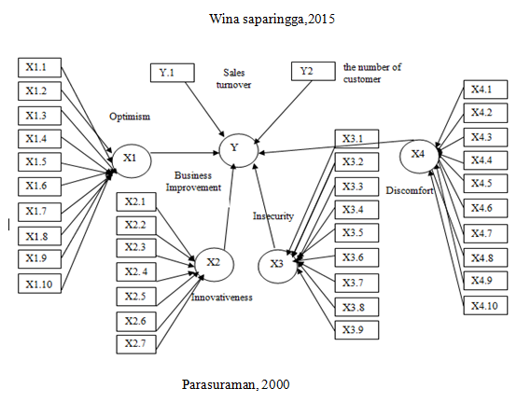

**Figure 1.** Model Path Diagram

1. Results and discussion

3.1 Demographic characteristic of responden

Table 1 explained that respondents were male on average and the technology used by SMEs consisted of with male gender 86 %, age 31 to 40 years 70 %, Length of Business <5 years 78,12%, technology used cloud computing 60,53% and last education are bachelor's degree 89,48%

**Table 1** Respondent Profile Distribution

|  |  |  |
| --- | --- | --- |
| Respondent Characteristics | | Presentase (%) |
| Gender | Male | 86 % |
| Female | 14 % |
| Age | 25-30 years | 10 % |
| 31-40 years | 70 % |
| 41-50 years | 20 % |
| Length of Business | < 5 years | 78,12 % |
| >5 years | 21,88 % |
| Technology used | Cloud Computing | 60,53 % |
| Internet of thing | 39,47 % |
| Last education | High School | 7,48 % |
| Bachelor's degree | 89,48 % |
| Master's degree | 30 % |

3.2 Based on the results of the convergent validity test, discriminating and composite reliability

The results of the convergent validity test show that all outer model values are > 0.7 with AVE values > 0.5, so it can be concluded that all indicators are convergent validity and the discriminating validity test results show that the latent constructs are optimism (x1), innovativeness (x2), discomfort (x3).), insecurity (x4), and business improvement(y) are good models, so that all the constructs in the estimated model have met the discriminating validity criteria.

Table 2 show that the composite reliability value of all variables is more than 0.9, it can be concluded that all observed variables are optimism (x1), innovativeness (x2), discomfort (x3), insecurity (x4), and business improvement (y).

Table 2 Composite Reliability

|  |  |
| --- | --- |
|  | Composite Reliability |
| X1 | 0,951 |
| X2 | 0,953 |
| X3 | 0,954 |
| X4 | 0,950 |
| Y | 0,942 |

3.3 Structural Analysis Model Results (inner model)

Figure 2 show that Model Structural Analysis Model Results (inner model), the resulting coefficient of determination (R-square) for the Business Improvementvariable (Y) is 0.842, which means business improvement (y) is influenced by optimism (x1), innovativeness (x2), discomfort (x3), and insecurity (x4), amount to 56.4%, while the other 43.6% are influenced by other factors.

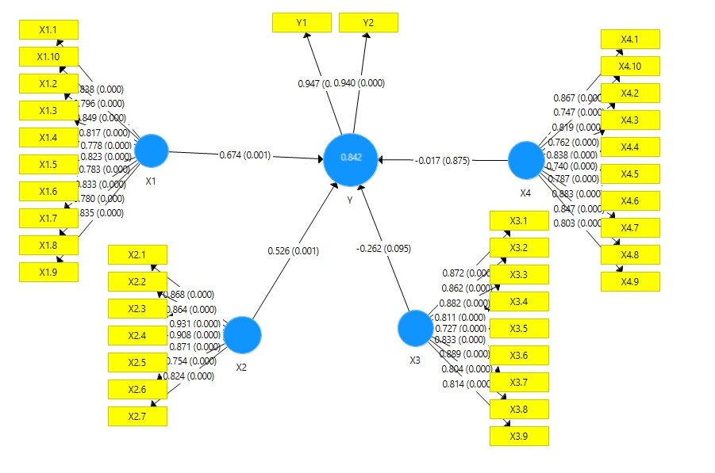

**Figure 2.** Model Structural Analysis Model Results (inner model)

3.4 The direct effect of exogenous variables on endogenous variables

Table 3 show that the estimation results of the inner model for the direct effect of optimism (x1) and innovativeness (x2) on business improvement(y) show a p-value smaller than alpha 0.05 (error rate α = 5%), which shows the direct effect of Optimism ( X1) and Innovativeness (X2) on Business Improvement (Y) are significant. Thus it can be concluded that the readiness factor of SMEs in the use of information technology or digital technology has a significant effect on business development. SMEs owners who are optimistic and innovative in using technology will quickly obtain information, be responsive in finding something new, responsive to customer service so that they have a competitive advantage.

Business improvement is carried out quickly according to conditions so as to be able to dominate the market which in turn can increase sales volume by 95% and the number of customers 94%

**Table 3** Direct effect

|  |  |  |  |  |  |
| --- | --- | --- | --- | --- | --- |
| Direct effect | Original Sample (O) | Sample Mean (M) | Standard Deviation (STDEV) | T Statistics (|O/STDEV|) | P Values |
| X1 -> Y | 0,674 | 0,709 | 0,203 | 3,327 | 0,001 |
| X2 -> Y | 0,526 | 0,468 | 0,158 | 3,327 | 0,001 |
| X3 -> Y | -0,262 | -0,255 | 0,157 | 1,671 | 0,095 |
| X4 -> Y | -0,017 | 0,005 | 0,108 | 0,157 | 0,875 |

Original Sample (O)= koefisien path

On the other hand, discomfort (x3) and insecurity (x4) on business improvement (y) show a p-value greater than alpha 0.05 (error rate α = 5%), which shows the direct effect of Insecurity (X4) on Business Improvement ( Y) is insignificant.

The following is a picture of the results of respondents' answers to the readiness of the Technology Readiness Index of SMEs. There are 3 categories in implementing the Technology Readiness Index, namely: 1. Low Technology Readiness: the TRI is low even if the TRI is equal to or less than 2.89 (TRI = <2.89). 2. Moderate Technology Readiness: TRI is at the media stage if the TRI is between 2.90 to 3.51 (2.90 = <TRI = <3.51). 3. High Technology Readiness: TRI can be said to be high if the TRI is above 3.51 (TRI> 3.51).[15].

Based on Figure 3 Technology Readiness Index SMEs Digital in Malang City Radar Diagram show that the TRI index of 50 digital SMEs in Malang City most of the above > 3,51. It can be said that the most of SMEs in Malang City with digital technology 4.0 have a high level technological readiness index such as 3,6 and 3,8 eventually they can improve business.

**Figure 3.** Technology Readiness Index SMEs Digital in Malang City Radar Diagram

1. Conclusion

The results showed that most SMEs use cloud computing technology with SME owners who are male, business length <5 years, and aged 31 to 40 years. The readiness of SMEs to use digital technology in the variable of optimism and innovativeness has a significant effect on business improvement. This Business Improvement is marked by an increase in the number of sales of goods or services and the number of customers. Customers can access goods and make payment transactions at any time without having to meet face to face. This shows that it is not only customers who will buy products or services online but new buyers because they know by of information technology as cloud computing and internet of thing.

**Acknowledgement**

Authors would like to thanks for National Institute of Technology (ITN) Malang on financial support and the completion of this research.

**References**

[1] Fonseca L M 2018 Industry 4.0 and the digital society: concepts, dimensions and envisioned benefits *Proc. Int. Conf. Bus. Excell.* **12** 386–97

[2] Schumacher A, Erol S and Sihn W 2016 A Maturity Model for Assessing Industry 4.0 Readiness and Maturity of Manufacturing Enterprises *Procedia CIRP* **52** 161–6

[3] Sestino A, Prete M I, Piper L and Guido G 2020 Internet of Things and Big Data as enablers for business digitalization strategies *Technovation* **98** 102173

[4] Handoko F, Vitasari P, Hidayat S and Tjahjadi M E 2019 Technology transfer program for SMEs in Indonesia *J. Phys. Conf. Ser.* **1375**

[5] Ulas D 2019 Digital Transformation Process and SMEs *Procedia Comput. Sci.* **158** 662–71

[6] Ranta V, Aarikka-Stenroos L and Väisänen J M 2021 Digital technologies catalyzing business model innovation for circular economy—Multiple case study *Resour. Conserv. Recycl.* **164** 105155

[7] Amankwah-Amoah J, Khan Z and Wood G 2020 COVID-19 and business failures: The paradoxes of experience, scale, and scope for theory and practice *Eur. Manag. J.*

[8] Papadopoulos T, Baltas K N and Balta M E 2020 The use of digital technologies by small and medium enterprises during COVID-19: Implications for theory and practice *Int. J. Inf. Manage.* **55** 102192

[9] Ghobakhloo M, Hong T S, Sabouri M S and Zulkifli N 2012 Strategies for successful information technology adoption in small and medium-sized enterprises *Inf.* **3** 36–67

[10] Xuan V N, Thu N T P and Anh N T 2020 Factors affecting support services in small and medium enterprises: Evidence from Vietnam small and medium information technology enterprises *Manag. Sci. Lett.* **10** 303–12

[11] Gusaptono R H, Effendi M I and Charibaldi N 2012 The Information Technology (IT) Adoption Process and E- Readiness to Use within Yogyakarta Indonesian Small Medium Enterprises (SME) *JICT-International J. Inf. Commun. Technol. Res.* **2** 29–37

[12] Arikunto S 2018 *Prosedur penelitian: suatu pendekatan praktik* (Jakarta: Rineka Cipta)

[13] Ghozali I 2008 *Structural equation modeling: Metode alternatif dengan Partial Least Square (PLS)* (Badan Penerbit Universitas Diponegoro)

[14] Sugiyono D R 2006 Statistika untuk penelitian *Bandung CV. Alf.*

[15] Parasuraman A 2000 Technology Readiness Index (Tri): A Multiple-Item Scale to Measure Readiness to Embrace New Technologies *J. Serv. Res.* **2** 307–20

[16] Kore E L R and Septarini D F 2018 Analisis Kinerja Usaha Mikro Kecil Dan Menengah (UMKM) (Studi Kasus Pada UMKM Sektor Industri Kecil Formal Di Kabupaten Merauke) *J. Ilmu Ekon. Sos.* **9** 22–37