Technology Readiness Base of Small and Medium Enterprises for Business Improvement
P W Ndari¹, P Vitasari²
¹Master Student, Postgraduate Program of Industrial Engineering, National Institute of Technology (ITN) Malang, Indonesia
²Industrial Engineering Departement, Postgraduate Program, National Institute of Technology (ITN) Malang, Indonesia

E-mail: priskawulandari21@gmail.com
Abstract. Small and Medium Enterprises (SME's) has an important role in increasing the regional income of Indonesia. One of the important factors that can define the competitiveness of SME’s is technology. This enterprise does not have appropriate willingness to use technology. In the last five years, the Ministry of Industry showed contribution of SME’s to gross domestic product (GDP) has increased by 60.34% from 57.84%. These preliminary data show respectable progress for SME's in Indonesia. However, this was not followed by the application of digital transformation. Whereas most of the SME’s do not have sufficient promptness. Even though there are many business opportunities that involve technology. SME's owner must have the focus such as short time to market, increase in flexibility, volatile markets, high productivity and boost inefficiency. This study aims to analyze the readiness of SME’s in Malang City in using Technology for Business Improvement. Sampling technique was selecting by purposive sampling. Responden selected are SME’s owner that use digital technology.Total forfifty respondents are taking participate in this study. Inquiry data are using Technology Readiness Index with SEM PLS analysis. Result show that the readiness factor has a significant influence on information technology for business improvement in SME's.
- Introduction
The growth of Malang City in various SME sectors has increased quite rapidly. This is a positive thing that can encourage the economy in Malang City. One of the strategies implemented by the Malang City Government in order to support the Malang 4.0 program and strengthen the economy of Malang City is through strengthening technology [1]. (Malang Merdeka, 2020) Currently, SMEs in Indonesia are facing various problems, one of which is technology and this situation encourages SMEs to be innovative in improving their business in order to survive in the global market [2]. (Handoko F, 2019) However, not all SMEs are able to use digital technology. The process of implementing technology in SMEs must have strong costs before the digitization process because each company has a different background and infrastructure [3]. (Kilimis P, 2019) On the other hand, the Covid 19 Pandemic also made SMEs have an awareness of the era of the Industrial Revolution 4.0. The condition of SMEs which is full of uncertainty makes UKM owners have to prioritize good business management. The use of technology keeps the process in line with the system.
Therefore, several previous studies stated that readiness was needed in the application of technology for the development of a business [1-6]. (Malang Merdeka, 2020) (Handoko F, 2019) (Kilimis P, 2019) (RH, 2012) (Mohammed G. Aboelmaged, 2014) (Schumacher A, 2016). Generally, Business Improvement is measured by the company KPI performance method. As an alternative, the authors compile a technology readiness model with the Technoloy Readiness Index to support business improvement. The SME Digital Technology in question is based on Cloud Computing and the Internet of Thing. Technology readiness is measured through an instrument, namely the Technology Readiness Index (TRI), developed by Parasuraman. TRI has four dimensions consisting of: optimism (optimism), Innovativeness (innovativeness), discomfort (discomfort), and insecurity with a total of 36 indicators [7]. (John., 2017) In this case, experts suggest increasing sales turnover, workforce growth, and customer growth as measures of Business Improvement [8]. (W, 2015). But in this study because of the use of digital technology, the labor growth variable was not taken. The TRI model approach states that Technology Readiness or readiness level refers to a person's tendency to use new technology in achieving their goals both in everyday life and in the world of work. Based on this it can be said that the TRI method can be used to solve application problems. technology in business development.
In the era of the Industrial Revolution 4.0 and in the New Normal Era after the Covid 19 Pandemic, SMEs must adopt digital technology in order to survive. This condition is required to provide online services that depend on network and system connectivity. Data and information exchange needs to be done quickly, human work systems are largely replaced by technology. Indicators of the success of business improvement still use the performance measurement method, to fill the gap in the problem of authentic assessment in the use of technology for business development. This paper will try to present the results of research on the technology readiness of Small and Medium Enterprises for business development. Malang City in using technology for business development.
.
- Method
This type of research is survey research. Survey research is research conducted on large or small populations, but the data studied is data from a sample taken from that population, so that relative incidents, distributions, and relationships between sociological and psychological variables are found [9]. (A, 2000) Research procedures include determining the study and research object, compiling the problem formulation, determining research objectives, making questionnaires, collecting questionnaire data, testing validity and reliability, analyzing data, conducting Model Testing, Results and Discussion and conclusions. The data collection technique uses the online Google form questionnaire method and telephone interviews due to the Covid-19 pandemic conditions which do not allow face-to-face contact. The population in this study were 92 Small and Medium Business Owners who already have digital technology 4.0 in Malang City as many as 92 SMEs with medium-sized businesses. The sample taken in this study is at least 25% of the population [10]. (Sugiyono, 2015) In this study the sample taken is 50 SMEs in Malang City with digital technology in the medium business cluster. The data processing technique was performed using excel and data analysis using SEM PLS 3 model [11]. (Ghozali, 2011) The measurement scale to determine the questionnaire with a linkert scale of 1-5 with the provisions Strongly Disagree = 1 Disagree = 2 Neutral = 3 Agree = 4 Strongly Agree = 5.
The research model can be described as follows:

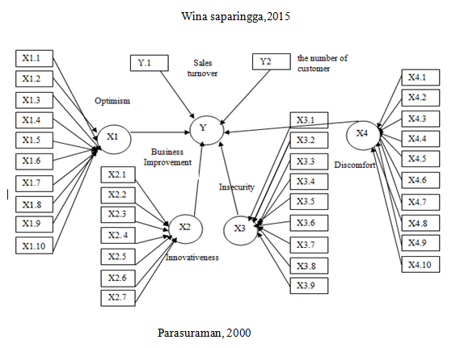

Figure 1. Figure Model Path Diagram
- Results and discussion
3.1 Demographic characteristic of responden
From the Table 2 above, it is explained that respondents were male on average and the technology used by SMEs consisted of with male gender 86 %, age 31 to 40 years 70 %, Length of Business <5 years78,12%, technology used cloud computing 60,53% and last education is bachelor's degree 89,48%

Table 1 Respondent Profile Distribution

Respondent Characteristics |  | Presentase (%)
Gender | Male | 86 %
Gender | Female | 14 %
Age | 25-30 years | 10 %
Age | 31-40 years | 70 %
Age | 41-50 years | 20 %
Length of Business | < 5 years | 78,12 %
Length of Business | >5 years | 21,88 %
Technology used | Cloud Computing | 60,53 %
Technology used | Internet of thing | 39,47 %
Last education | High School | 7,48 %
Last education | Bachelor's degree | 89,48 %
Last education | Master's degree | 30 %

- 3.2 Based on the results of the convergent validity test, discriminating and composite reliability
The results of the convergent validity test show that all outer model values are> 0.7 with AVE values> 0.5, so it can be concluded that all indicators are convergent validity and the discriminating validity test results show that the latent constructs are Optimism (X1), Innovativeness (X2), Discomfort (X3).), Insecurity (X4), and Business Improvement(Y) are good models, so that all the constructs in the estimated model have met the discriminating validity criteria. Table 2 shows the composite reliability value of all variables is more than 0.9, it can be concluded that all observed variables are Optimism (X1), Innovativeness (X2), Discomfort (X3), Insecurity (X4), and Business Improvement (Y). [12-13] (D, 2015) [

Tabel 2 Composite Reliability

 | Composite Reliability
X1 | 0,951
X2 | 0,953
X3 | 0,954
X4 | 0,950
Y | 0,942

3.3 Structural Analysis Model Results (inner model)

Based on data processing with PLS, the resulting coefficient of determination (R-square) for the Business Improvementvariable (Y) is 0.842, which means Business Improvement(Y) is influenced by Optimism (X1), Innovativeness (X2), Discomfort (X3), and Insecurity (X4), amounting to 56.4%, while the other 43.6% are influenced by other factors.
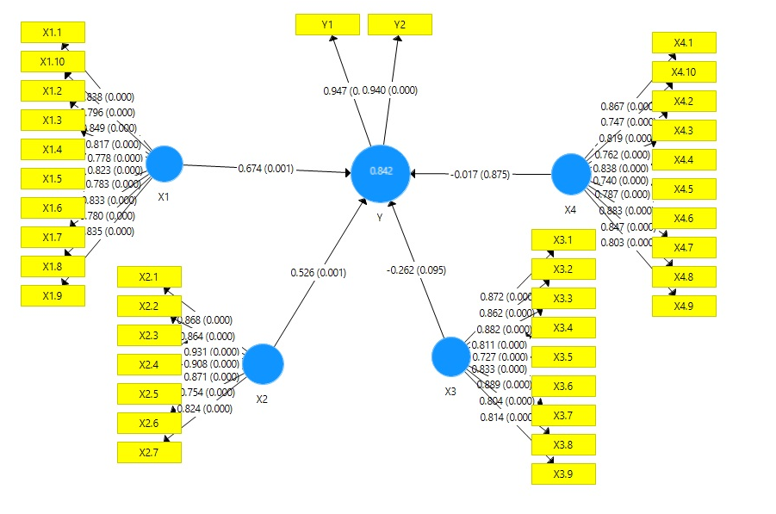

Figure 2. Model Path Diagram

3.4 The direct effect of exogenous variables on endogenous variables

Tabel 3 Direct effect
Pengaruhlangsung | Original Sample (O) | Sample Mean (M) | Standard Deviation (STDEV) | T Statistics (|O/STDEV|) | P Values
X1 -> Y | 0,674 | 0,709 | 0,203 | 3,327 | 0,001
X2 -> Y | 0,526 | 0,468 | 0,158 | 3,327 | 0,001
X3 -> Y | -0,262 | -0,255 | 0,157 | 1,671 | 0,095
X4 -> Y | -0,017 | 0,005 | 0,108 | 0,157 | 0,875

Original Sample (O)= koefisien path
The estimation results of the inner model for the direct effect of Optimism (X1) and Innovativeness (X2) on Business Improvement(Y) show a p-value smaller than alpha 0.05 (error rate α = 5%), which shows the direct effect of Optimism ( X1) and Innovativeness (X2) on Business Improvement(Y) are significant. Thus it can be concluded that the readiness factor of SMEs in the use of information technology or digital technology has a significant effect on business development. UKM owners who are optimistic and innovative in using technology will quickly obtain information, be responsive in finding something new, responsive to customer service so that they have a competitive advantage. Business management is carried out quickly according to conditions so as to be able to dominate the market which in turn can increase sales volume by 95% and the number of customers 94%.
On the other hand, Discomfort (X3) and Insecurity (X4) on Business Improvement(Y) show a p-value greater than alpha 0.05 (error rate α = 5%), which shows the direct effect of Insecurity (X4) on Business Improvement( Y) is insignificant.
From the calculation of the TRI index of 50 digital SMEs in Malang City above> 1.00, it can be said that they are at a high level and have technological readiness so that they can develop a business. The following is a picture of the results of respondents' answers to the readiness of the Technology Readiness Index of UKM.

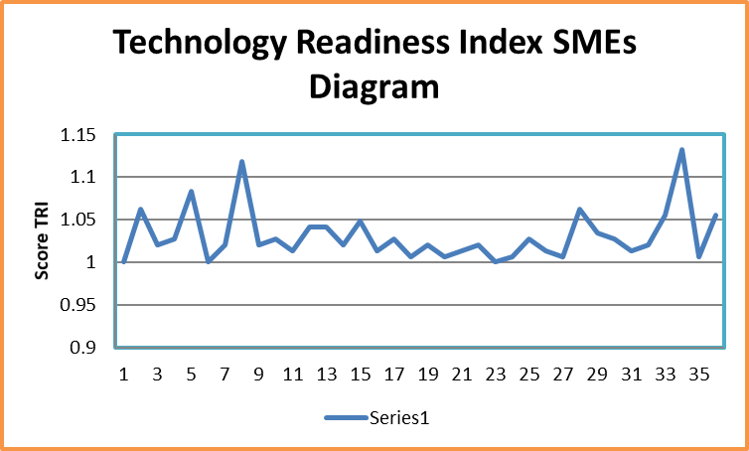

Figure 3. Technology Readiness Index SMEs Digital in Malang City Diagram
- Conclusion
The results showed that most SMEs use cloud computing technology with SME owners who are male, business length <5 years, and aged 31 to 40 years. The readiness of SMEs to use information technology or digital technology in the form of optimism and innovativeness has a significant effect on business development. This Business Improvementis marked by an increase in the number of sales of goods or services and an increase in the number of customers. Customers can access goods and make payment transactions at any time without having to meet face to face. Based on the research results, readiness to use technology will increase the number of sales compared to the number of customers. This shows that it is not only customers who will buy products or services online but buyers who are new to this information because of information technology.

Acknowledgement
Authors would like to thank for National Institute of Technology (ITN) Malang on financial support and the completion of this research.

References
- Malang City Small Micro and Medium Enterprises Continue to be Pushed into the Digital Economy Era. https://malang.merdeka.com/kabar-malang/SMEs -malang-city-terus- pushed-to-the-era-digital-economy-1909129.html
- Handoko F, Vitasari P, Hidayat S and Tjahjadi M E 2019 Technology Transfer Program for SMEs in Indonesia, 1st International Conference of Sciences and Technology (ANCOSET), Malang, 2019 1375
- Kilimis P, Zou W Lehmann M and Berger U 2019 A Survey on Digitalization for SMEs in Brandenburg, German 9th International Conference on System Sciences, Hawaii, 2019 2140-2145
- Muafi RH 2012 The information technology (IT) adoption process and e-readiness to use within Yogyakarta Indonesian small medium enterprises (SME) International Journal of Information and Communication Technology Research, 29-37
- Mohammed G. Aboelmaged, 2014 Predicting e-readiness at Firm Level: An Analysis of Technological, Organizational, and Environmental (TOE) Effects on e-maintenance Readiness in Manufacturing Firms, International Journal of Information Management 34, 639-651
- Schumacher A, Erol S and Sihn W, 2016 A maturity model for assessing Industry 4.0 readiness and maturity of manufacturing enterprises, Procedia CIRP, 52
- Basl John, 2017 Pilot Study of Readiness of Czech Companies to Implement the Principles of Industry 4.0 Management and Production Engineering Review, 8(2), 3-8.
- Saparingga W, 2015 Comparative Analysis of Development Levels of Micro, Small and Medium Enterprises Before and After Obtaining Micro Financing Facilities (Case Study at BRI Syariah KCP Kopo Bandung), (Bandung: UNISBA, 38)
- Parasuraman A 2000 Technology Readiness Index (Tri) A Multiple Item Scale to Measure Readiness to Embrace New Technologies Journal of Service
- Sugiyono, 2015 Statistik untuk Penelitian. (Bandung: Alfabetha)
- Ghozali, Imam 2014 Structural Equation Modeling, Alternative Methode with Partial Least Square (PLS) Edisi 4. (Semarang : Diponegoro University)
- Faller C and Feldmüller D 2015 Industry 4.0 Learning Factory for regional SMEs, Procedia CIRP, (32) 88-91
- T Anna and Liu Z, 2018 Small and Medium Technology enterprises in Zhongguancun and Silicon Valley, emerald, 35-57

