Design of Gearbox for Vertical Savonius Wind Turbine (TASV) Using Finite Element Analysis (FEA) Method

A J A Wasesa1*, M N A Mukhtar1, E J Pratama1

1Industrial Engineering Department, Universitas PGRI Adi Buana, Surabaya, Indonesia

*andarmadi@unipasby.ac.id

**Abstract**. The development of a wind turbine drive transmission gearbox is carried out to maximize the energy output of the vertical savonius wind turbine (TASV) using the Finite Element Analysis (FEA) method to analyze the structure of the materials used. The gearbox gear design is made with a ratio of 1:50 which is expected to increase the rotation output of the vertical savonius wind turbine (TASV). The simulation process is carried out using Solidwork Premium 2016 software to see the Von mises force and stress, Displacement / Deformation, Safety Factor, and torque in the gearbox gear design which are important parts so that the gearbox design process can be formed and simulated correctly. It is hoped that the design is easy to apply and can help increase the rotation output of the vertical savonius wind turbine (TSAV).

1. Introduction

The demand for electricity is greatly increased in coastal areas. So that a wind turbine is currently very much needed in power generation technology to be used in coastal areas, which is known to be very minimal electrical energy source. It is recorded that around 15.32 percent of administrative areas at the village / kelurahan level are located by the sea. This percentage is slowly increasing from year to year, which indicates that there is a significant expansion of villages / kelurahan in the coastal area[1].

It is known that the coastal area is very rich in wind energy which can be used for generating wind turbine type electricity[1]. However, wind potential in Indonesia generally has low wind speeds ranging from 3 m/s - 7 m/s, so this type of vertical wind turbine is considered very suitable for use in low wind speed conditions [2].

Many wind turbine designs are made to meet the needs of electrical energy with various models and advantages of each, ranging from vertical and horizontal axis wind turbines. However, from some designs, the savonius vertical wind turbine (TASV) is more dominant because it can rotate at low wind speeds. So it is necessary to develop a gearbox for the acceleration of wind turbine rotation, which is expected to produce a much greater output of electrical energy[3].

1. Method

A gearbox is a component of an engine consisting of a housing for transmission gears[4]. This component must have the right construction in order to place the gear shafts on the correct axis so that the gears can rotate properly with as little friction as possible [5].

The gearbox is a transmission system that functions as a power transfer to distribute power from one part of the engine to another. So that it can produce a rotational or shift movement of the connected parts[6]. In a gearbox there are several components that support a power transfer transmission consisting of several gears that are continuous with one another to transmit rotation according to the ratio used[7].

The process of analyzing the gearbox design structure in this study will use the FEA method, the Finite Element Analysis Method or the Finite Element Method, which was first introduced by Turner et al, which is a powerful computational technique for finding solutions to complex problems[8]. This method is one of the methods used to simulate the behavior of a material so that it can find out the characteristics of the material later and can reduce the number of experiments required .

Finite Element Analysis (FEA) or the Finite Element Method is a method used to determine stress, deformation, heat transfer, fluids and other physical effects. This element is used to solve problems that are difficult for other methods to solve. This analysis is used to show whether there is a problem with a product, for example broken, worn or the product is good or not [9]. The output of this analysis is the prediction results that will occur when the product is processed or used [10]. In the research, parameters that will be explained including Von mises, Displacement / Deformation, Safety Factor, force and torque that occur in gears.

## Gearbox design

4mm gear was used for adjusting gear dimensions gearbox with vertical savonius wind turbine (TASV) and the generator. So the gearbox design can be made by comparison which is needed according to the results of the calculations in the table the following:

|  |  |  |  |  |  |  |  |  |  |  |
| --- | --- | --- | --- | --- | --- | --- | --- | --- | --- | --- |
| Gears | Parts | | | | | | | | | |
| M | Z | D | Da | Df | ha | hf | H | T | b |
| 1 | 4 | 72 | 288 | 296 | 279 | 4 | 4,6 | 8,6 | 6,3 | 20 |
| 2 | 4 | 24 | 96 | 104 | 86,7 | 4 | 4,6 | 8,6 | 6,3 | 20 |
| 3 | 4 | 67 | 268 | 276 | 259 | 4 | 4,6 | 8,6 | 6,3 | 20 |
| 4 | 4 | 17 | 68 | 76 | 58,7 | 4 | 4,6 | 8,6 | 6,3 | 20 |
| 5 | 4 | 51 | 204 | 212 | 195 | 4 | 4,6 | 8,6 | 6,3 | 20 |
| 6 | 4 | 12 | 48 | 56 | 38,7 | 4 | 4,6 | 8,6 | 6,3 | 20 |

From the results of the calculation of table 1, the comparison number of gears with 4mm modules will be made, the details are as follows :

Z = Number of teeth

* 1. Gearbox Material Planning.

The gearbox design consists of several components with different material. The materials specifications used in the gearbox design available on the following image:

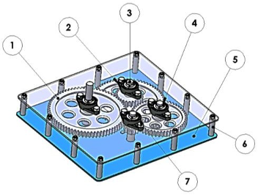

**Figure 1.** Gearbox Design

**Table 1.** Gearbox Parts

|  |  |  |  |  |
| --- | --- | --- | --- | --- |
| No | Material | Specification | Amount | Note |
| 1 | Gear 1 | Ø 296 mm x 25 mm | 1 Pcs | ST 70 |
| Gear 2 | Ø 104 mm x 25 mm | 1 Pcs |
| Gear 3 | Ø 276 mm x 25 mm | 1 Pcs |
| Gear 4 | Ø 76 mm x 25 mm | 1 Pcs |
| Gear 5 | Ø 212 mm x 25 mm | 1 Pcs |
| Gear 6 | Ø 56 mm x 25 mm | 1 Pcs |
| 2 | Pillow Block | UCFL 205 @25mm | 8 set | ASB |
| 3 | Steel shaft | Ø 40 mm x 600 mm | 1 Pcs | ST 70 |
| 4 | Snap ring | DIN 471S @25mm | 8 Pcs | Carbon steel |
| 5 | Steel Plate | 8 x 510 x 560 mm | 2 Sheet | BS 4360 |
| 6 | Steel shaft | Ø 20 mm x 1300 mm | 1 Pcs | ST 70 |
| 7 | Lug & bolt | M 10 x 15 mm | 40 Pcs | Hex bolt 8.8 |

1. Results and Discussion
   1. *Initial Gear Torque Calculation*

Before doing the torque calculation, The moment of inertia must be calculated due to Gearbox gear shaft shape is solid cylindrical. The formula used is:

$$I= \frac{1}{2}m.r^{2}=\frac{1}{2}7,08kg {. (0,144)}^{2}$$

I = 0,073405 kg/m2

The cross-sectional area of ​​the gear on the first body contact, with length (b) = 20 mm and width (h) = 8.6 mm. Then the cross-sectional area of ​​the gear = b x h = 20 x 8,6 = 0,712 m2

With an assumption of the initial gearbox rotation desired is 40 rpm and a gear diameter size was 288 mm, the rotational speed of the gear was calculated using this formula:

$$V= \frac{π.Dp A.n_{1}}{1000.60} =\frac{3,14 ×288 × 40}{6000}$$

V = 0,603 m/s

Then, the bending stress of the gears is calculated with the value from the tangential force equation:

$$Ft= \frac{102.Pa}{V}=\frac{102 × 0,006}{0,603}$$

Ft = 1,02 kg

Then, the bending stress of the gears is calculated with the value from the tangential force equation:

$$σ_{t}= \frac{b.Ft.h}{{bt}^{2}}=\frac{6.1,02.8,6}{{20 × (6,3)}^{2}}$$

= 0,0663 kg/mm2

Shear stress calculated

= 0,00593 kg/mm2

Before acceleration calculated, assumed that the Δt (time required by the gearbox when it stops until constant speed state) 1 second. And then counted with the formula:

$$ω= \frac{2 × 3,14}{60} × 100=10,467 rad/s$$

$$α= \frac{11,304rad/s-0rad/s}{1s}$$

= 10,467 rad/s

Initial gear force value

$$F_{D}= \frac{1}{2} . C_{D}. P . v^{2}= \frac{1}{2} . 2,05 . 19,32 . {0,603}^{2}. 0,172$$

$F_{D}$ = 1,24 Nm

Initial gearbox torque :

$$T=\left(I . α \right)+(F . r)$$

$$T=(0,073405 kg/m^{2} × 10,467rad/s^{2} ) +(1,24×144)$$

= 0,7683 Nm + 178,56 Nm

= 179,33 Nm

From the calculations above, it is found that the amount of torque is 179.33 N.m / 18.30 kg.

*4.2 Simulation Process*

After the initial torque of the gearbox is observed, the next step is to simulate the gearbox teeth design using solidwork 2016 software. The design simulated using DIN steel st70 -2/E360 material, to find out the force and stress that occurs at the starting torque. The process is done by meshing and simulation running by giving a load of 10 N.m – 250 N.m. From these simulations, following results were obtained:

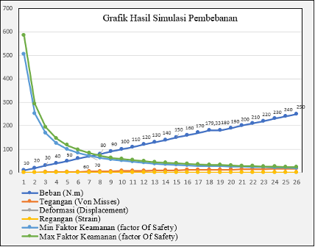

**Figure 2.** Simulation Result

From the graph, it can be seen that giving load from 10 N.m – 250 N.m produce stresses, deformations, and strains that linear according to the load given. If the load given is greater, the value of stress, deformation and strain will be even greater. However, the maximum and minimum safety factors indicate that the greater the load, the smaller the safety factor on the material. From these data, the torque load is taken according to the calculations that have been carried out with the results of the simulation process imposed on the first body contact with the following results

*4.2.1 Meshing Process*

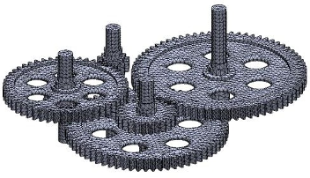

**Figure 3.** Meshing Process

*4.2.2 Von Misses Stress*

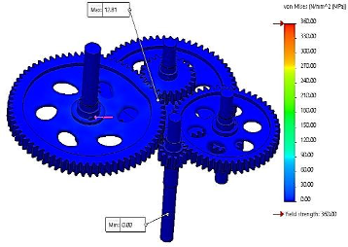

**Figure 4.** Von Misses Stress

From the simulation results of the gearbox gear with a load of 179.33N.m, the resulting stress can be seen in the image above with a maximum stress value of 12.81 MPa where the value is still far below the material yield strength value of 360 MPa so that there has not been excessive plastic deformation and can still be said to be safe.

*4.2.3 Displacement*

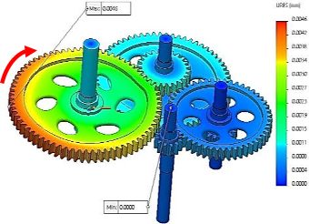

**Figure 5.** Displacement

Giving a load of 179.33N.m in the gearbox simulation produces the deformation plotted in the image above with a maximum deformation value of 0.0046 mm where the value is still small from the direction of the rotating load force given.

*4.2.4 Strain*

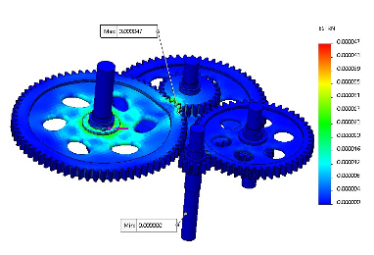

**Figure 6.** Strain

The strain resulting from the simulation process with a load of 179.33N.m, can be plotted in the image above with a maximum strain strain value of 0.000047 mm where the value is still low from the elastic modulus (E) structure of the DIN Steel St70-2 / E360 material of 210,000 MPa.

*4.2.5 Safety Factor*

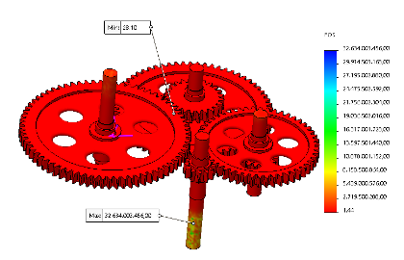

**Figure 7.** Safety Factor

To find out the safety of the simulated part, it can be displayed with a Factor Of Safety (FOS) graph. The simulation results show that the minimum safety factor is 28.10 while the average safety factor due to the load received is 0.34, which is still far from a plastic condition below the yield strength / elastic value.

*4.2.6 Stress Calculation*

The results of manual calculations of stress (σ) according to theory:

$$Stress \left(σ\right)= \frac{Force}{Cross sectional area}= \frac{179,33 N.m}{0,172{mm}^{2}}=1.043 N.m$$

The results of manual calculations of strain (ℇ) according to theory:

$$Strain \left(ℇ\right)= \frac{Strain (ℇ)}{Modulus of Elasticity (E)}= \frac{1,043 MPa}{210000 MPa}=0,00496 MPa$$

The results of manual calculations of deformation (δ) according to theory:

$$Deformation \left(δ\right)= Strain \left(ℇ\right)× T=0,00496 × 6,3=0,031 mm$$

The results of manual calculations of Factor of Safety (FOS) according to theory:

$$Factor of Safety (FOS)= \frac{Material Strength Yield}{Stress \left(\right)}= \frac{360 MPa}{1043 MPa}=0,34 MPa$$

Manual torque calculations and simulation tests are performed on the gearbox gear design. The results of the manual calculation of torque, it is known that the moment of inertia of the initial gear is I = 0.073405 kg/m2 with the circumference of the gear speed of V = 0.603 m/s so that the tangential force of the gear is Ft = 1.02 kg, the bending stress is σt = 0.0663 kg/mm2 and the shear stress is 0.00593 kg/mm2 From the initial force of the gearbox gear of Fd = 1.24 Nm, the initial torque of the gearbox is 179.33 Nm or 18.30 kg.

After knowing the results of the initial torque of the gearbox, a simulation test was carried out to determine the strength of the material used in the gearbox gear design using the Finite Element Analysis (FEA) method, with several parameters, namely Von Mises, Deformation / Displacement, Strain (Strain). and Safety Factor and the following results from simulation comparisons and manual calculations:

**Table 2.** Simulation Results

|  |  |  |  |  |
| --- | --- | --- | --- | --- |
| Results | Von Misses | Deformation | Strain | Factor of Safety |
| Simulation | 12,81 Mpa | 0,0046 mm | 0,000047 mm | 30 |
| Manual | 1.043 Mpa | 0.031 mm | 0.00496 mm | 0,34 |

From the simulation and calculation results above, the resulting value is far below the material strength standard of DIN Steel St70-2 / E360. So that the gearbox gear design structure can be said to be safe. For this reason, the gearbox gearbox is made according to the design that has been made to produce a gearbox with a ratio of 1:50

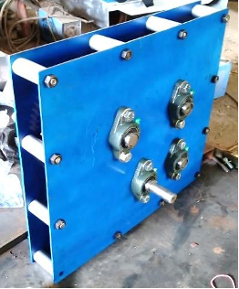

**Figure 8.** Gearbox Prototype

4. Conclusion

From the simulation results carried out using the Finite Element Analysis (FEA) method and the results of the gearbox calculation that have been made, we can find out the stress and force that occurs in the gearbox gear design and several things. From the calculation of the gearbox, we get a gear with a 4 mm module with a spur gear type so that the dimensions of gear 1 = Ø 296 mm x 20 mm, gear 2 = Ø 104 mm x 20 mm, gear 3 = Ø 276 mm x 20 mm, gear 4 = Ø 76 mm x 20 mm, gear 5 = Ø 212 mm x 20 mm, gear 6 = Ø 56 mm x 20 mm, so the gearbox output has a ratio of 1:50. The application of loads from 10 N.m - 250 N.m results in stress, deformation, and strain running linearly according to the load given. If the load given is greater, the value of stress, deformation and strain will be even greater. However, the minimum and maximum safety factors indicate that the greater the load, the smaller the safety factor on the material. The gearbox gear requires an initial torque of 179.33 N.m / 18.30 kg which is charged to the gear body contact during the initial rotation.

**References**

[1] Badan Pusat Statistik 2018 *Statistik Sumber Daya Laut dan Pesisir*

[2] Alit I B, Nurchayati N and Pamuji S H 2016 Turbin angin poros vertikal tipe Savonius bertingkat dengan variasi posisi sudut *Din. Tek. Mesin* **6**

[3] Putranto A, Prasetyo A and Zatmiko A 2011 Rancang Bangun Turbin Angin Vertikal Untuk Penerangan Rumah Tangga *J. Tek. Mesin UNDIP* 1–55

[4] Abdul Qodir Al-Jailany, Silas Prayoga Putra W P W 2016 Definisi Turbin Angin. Makalah Meisiin Konversi Energi

[5] Ikhsan K, Mawardi M, Jannifar A and Zaimahwati Z 2018 Rancang Bangun Alat Simulator Gearbox Untuk Pengujian Kinerja Minyak Pelumas *J. Mesin Sains Terap.* **1** 81–8

[6] Yamin D-I M and Purwoko W 2014 Perencanaan Gear Box Dan Analisis Statik Rangka Conveyor Menggunakan Sofware Catia V5 *Perenc. Gear Box Dan Anal. Statik Rangka Conveyor Menggunakan Sofware Catia V5* 3

[7] Mohamed M H, Janiga G, Pap E and Thévenin D 2011 Optimal blade shape of a modified Savonius turbine using an obstacle shielding the returning blade *Energy Convers. Manag.* **52** 236–42

[8] Oyague F 2009 Gearbox Modeling and Load Simulation of a Baseline 750-kW Wind Turbine Using State-of-the- Art Simulation Codes *Nrel* 81

[9] Anon 2014 Analisa Kekuatan Konstruksi Internal Ramp Sistem Steel Wire Rope Pada Km. Dharma Kencana Viii Dengan Metode Elemen Hingga *Kapal* **11** 85-92–92

[10] Oliver J 2013 insole shoe orthotic datar yang ditujukan bagi penderita metatarsalgia dengan menggunakan desain insole shoe orthotic berbahan EVA *J. Chem. Inf. Model.* **53** 1689–99