“States of Matter” Electronic Worksheet Assisted by Powtoon Based on Sigil

A R Hakim1*, N K T Yulia2

1Elementary School Education, Universitas Kanjuruhan Malang, Indonesia.

2Early Childhood School Education, Institut Agama Islam Al-Qolam Malang, Indonesia.

*[ariefrahman@unikama.ac.id](mailto:ariefrahman@unikama.ac.id)

**Abstract**. The purpose of this research was to describe the development of worksheets based on sigil and powtoon. This research and development used ADDIE Model. The research subjects were III grade elementary school students. The data collection instruments used a validation sheet and a questionnaire. Data analysis techniques used qualitative and quantitative data. The results of the evaluation of material experts and media experts obtained valid criteria with an average score of 86.36% for material experts and 87.5% for media experts. The responses given by students on this worksheet were 92.91% in the "very interesting" category. Based on these findings, it can be concluded that sigil and powtoon-based worksheets are suitable for use as instructional materials.

1. Introduction

The learning process continues to move forward dynamically, along with the development of information technology systems, specifically to design instructional instrument that are attractive, engaging and comprehensive [1]. As a source of knowledge, the learning process between adults and children needs fascinating instructional materials to be implemented. One is through the development of electronic worksheets. The development of worksheet intends to provide students a summary of lesson contents, learning activities, and exercises that must be completed based on the intended competences and learning objectives. In addition, the development of worksheet aims at training students’ skills, improving students’ knowledge as well as their attitude in learning process [2]. Therefore, when developing electronic worksheet, it is important to take into account students’ needs and characteristics as well as their capability.

This present research aims at developing electronic worksheet for state of matter (solids, liquids, and gases) lesson content [3]. The development of this electronic worksheet is expected to be able to support students’ learning process through the interactive presentation of the lesson content which is contextualized with the real-life context of the students to promote students’ interest in learning [4].

This digital instructional media could be utilized as an exercise media in developing the cognitive aspects of students through the development of learning in the form of experiments [5]. Electronic worksheets are used as a means of teaching and learning in schools that aim to improve the quality of education [6] which is designed in the form of media developed through Powtoon. Powtoon is an IT-based application that is useful for creating and designing cartoon animation videos [7]. This digital media is able to make it easier for students to understand the lesson contents because it is presented in a more attractive interface [8][9]. The developed electronic worksheet using Powtoon media in this research was then converted by using Sigil application. The development of this electronic media, thus, aims at promoting students’ curiosity and interest in the learning process as well as enhancing students’ motivation and interaction, both physical and emotional [10].

Sigil is an editor application for epub. Epub (Electronic publication) is one of the digital standardization formats introduced by the International Digital Publishing Forum (IDPF) in 2011 which can be accessed through files of type html, xhtml, xml, css which are made into one file with the extension epub [11]. Through Sigil application, the developed electronic worksheet can be added with pictures, animations, audio, and videos to support lesson content delivery that can be used by students [12].

1. Method

The development of electronic worksheet based on Sigil application employed ADDIE research and development model which consisted of five stages, specifically, Analyze, Design, Development, Implementation, and Evaluation [13]. The stages of this development are presented in the following Figure 1.

**Figure 1. The Stages of Development**

To collect the data, this research and development employed validation expert sheets that were distributed to media, language, and content experts; observation sheets; questionnaire sheets; and documentation. The process of validation and trial aimed at identifying whether the developed electronic worksheet has meet the standard and feasible to be applied in the learning process.

1. Result and Discussion

The results of this research and development was an electronic worksheet with Powtoon based on Sigil application for states of matter lesson content. This research and development was conducted by employing an ADDIE research and development model. The first stage was Analyze. Based on the first stage, it was obtained an initial observation which reported that students mostly encountered a difficulty in understanding and discovering the correlation of states of matter. In addition, it was also found that students were interested to an attractive and contextualized instructional media rather than conventional one.

The results of the initial observation mentioned above played a role as a background of the development of this product. The determination of electronic worksheets based on empirical studies from previous researchers who stated that the use of electronic teaching materials can increase children's attention, motivation, understanding in understanding the material [14][15].

The second stage was data design. The data collected was in the form of secondary data in the form of journals related to worksheets, Powton applications, Sigil applications and any literatures of states of matter topic [3]. The data was then selected based on its suitability for the students’ needs. The development of an electronic spreadsheet would be more interesting if it was added with an animated video. Giving animated videos could help students to think creatively [9], solve problems [16] and could improve students’ conceptual understanding [7].

The third stage was development. The development of electronic worksheet took states of matter lesson topic. When developing the electronic worksheet, the authors included some attractive animated videos designed by using Powtoon. At the end, the electronic worksheet was converted by using Sigil application. At first, drafting was carried out by using Microsoft Word. The draft was then converted into html file before proceeding to Sigil application. The procedure of the development is presented in Figure 2.

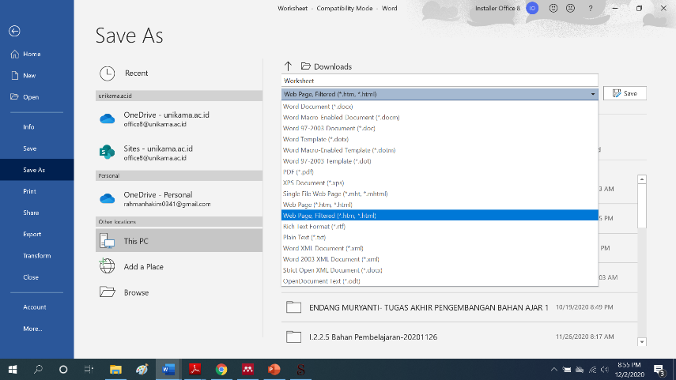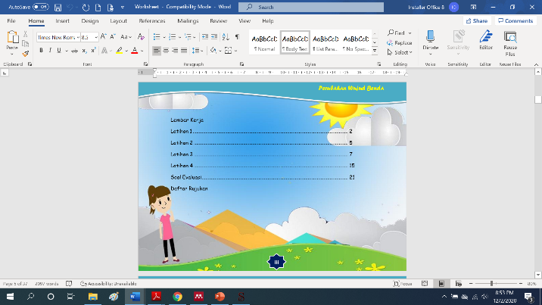

**Figure 2. Electronic Worksheet Drafting in Microsoft Word**

After developing the content for electronic worksheet, the next stage was creating some animated videos by using Powtoon application. The animated videos created were adjusted with the contents, a lesson about states of matter, developed in the draft of the electronic worksheet. The videos created were contextualized with the surrounding environment of the students to allow them to connect what they learn with their experience, and thus, it enhances their active involvement in learning [17]. In addition, contextualized animated videos could improve students’ understanding about states of matter by observing common phenomena around their environment. In fact, however, conventional textbooks are not sufficient to make students understand the phenomena of states of matter comprehensively and contextually [18]. The procedure of creating animated videos is presented in the following Figure 3.

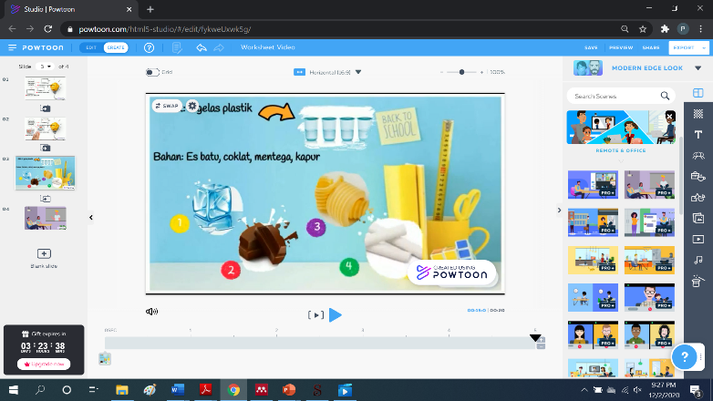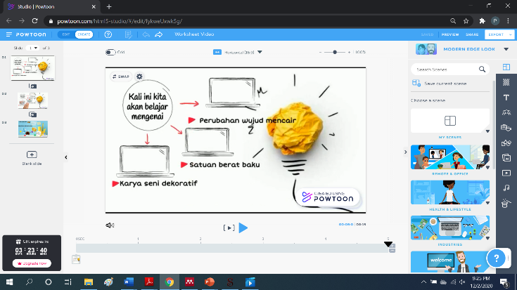

**Figure 3. Creating Animated Videos Using Powtoon**

After developing the contents and animated videos for the electronic worksheet, the next stage was compiling all the drafts to the Sigil application. The developed electronic worksheet was added with attractive audios, images, and animated videos to make the delivery of the lesson content becomes more interactive to students. The procedure of compiling all drafts in Sigil application is presented in Figure 4.

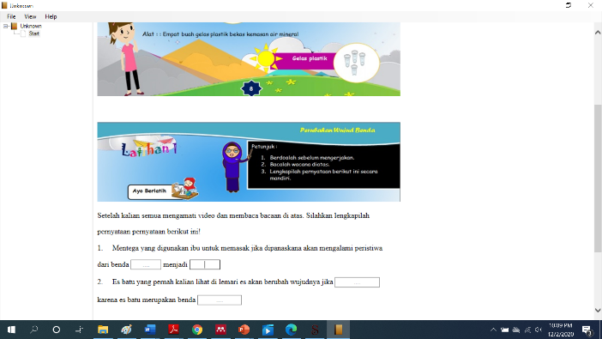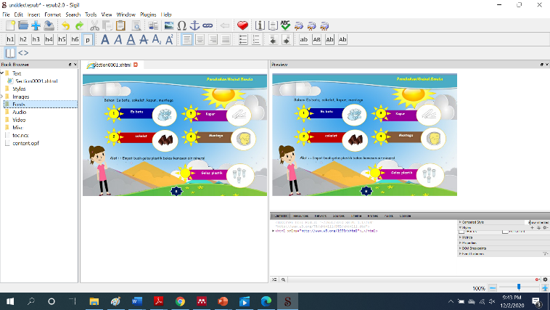

**Figure 4. The Development of Electronic Worksheet Using Sigil**

After all elements of the electronic worksheet were compiled in Sigil application, then the project was saved in the form of “epub”. To access an epub file, it is important to install epub file reader. For android users, this file could be accessed by epub file reader application such as “Reasily”.

The result of the development of electronic worksheet was then validated by the experts. In this development, it involved three experts, they were content expert, media expert, and language expert. The validation process aimed at obtaining suggestions and critics for further improvement. The results of validation are presented in the following Table 1.

**Table 3. The Results of Validation on Electronic Worksheet**

|  |  |  |
| --- | --- | --- |
| **Validators** | **Average value** | **Remark** |
| Content | 83,36% | Very feasible |
| Language | 91,7% | Very feasible |
| Media | 87,5% | Very feasible |

Based on the results of the three appointed validators, it was obtained that the developed electronic worksheet assisted with Powtoon based on Sigil application was classified very feasible to be used. The average results obtained indicated that the product development was valid.

The fourth stage was implementation. During the implementation, the product developed was trialed to 20 students of third grade. In this stage, the students and teacher of the third grade evaluated the electronic worksheet practicality and effectiveness through the questionnaire. The learning process by using student’s worksheet is, to a greater extent, effective than by using conventional textbooks [19]. The implementation of worksheet allows students to be involved in a meaningful learning process and enables them to connect the lesson content with the real-life experience [20]. The results of practicality assessment are presented in Table 2.

**Table 4. The Results of Practicality of Product**

|  |  |  |
| --- | --- | --- |
| **Indicator** | **Average Score** | **Remark** |
| Teacher’s response | 97,5% | Very practical |
| Student’s response | 92,91% | Very practical |

The final stage was evaluation. The researchers carried out a revision and improvement on the developed electronic worksheet assisted by Powtoon based on Sigil application according to the suggestions, comments, and critics from teacher, students, and experts. Based on the comments given, the researchers were required to revise the front cover of the worksheet since it was not suitable with content of the lesson, the fonts must be adjusted with the design, and the background must be adjusted in order to make the text more readable. After all stages were carried out, it was concluded that the developed electronic worksheet assisted by Powtoon based on Sigil application is feasible to be applied. The developed electronic worksheet offers students an interesting way of learning since it is equipped with attractive animated videos and presented in a digital form by using Sigil. Therefore, the developed electronic worksheet is able to improve students’ motivation in learning as well as their interaction [4][7][21].

1. Conclusion

Based on the results obtained during the research and development, it obtained that the developed electronic worksheet assisted by Powtoon based on Sigil application through ADDIE development model (Analysis, Design, Development, Implementation, and Evaluation) was declared feasible to be used. The feasibility was based on the assessment and evaluation given by the appointed experts (media, content, and language). In addition, teacher, and students of the third grade provided a positive response regarding the developed electronic worksheet.

1. References

[1] Wardani N F K, Sunardi and Suharno 2020 Thematic Learning in Elementary School: Problems and Possibilities **397** 791–800

[2] Servitri M and Trisnawaty W 2018 The Development of Inquiry Science Worksheet to Facilitate the Process Skills *J. Educ. Learn.* **12** 575

[3] Brainard J and Ph D 2013 *States of Matter* (CK-12 Foundation)

[4] Fadila A, Dasari R, Setiyaningsih S, Septiana R, Sari R M and Rosyid A 2019 The Development of Electronic Flash Worksheet Based on Adobe Flash Cs6 on Fraction Numbers in the Seventh Grade of Junior High School *J. Phys. Conf. Ser.* **1155**

[5] Rahayu D and Budiyono 2018 Masalah Materi Bangun Datar *Pengemb. LKPD Berbas. Pemecahan Masal. Pengemb.* **06** 249–59

[6] Octaviani S 2017 Pengembangan Bahan Ajar Tematik Dalam Implementasi Kurikulum 2013 Kelas 1 Sekolah Dasar *EduHumaniora | J. Pendidik. Dasar Kampus Cibiru* **9** 93

[7] Kafah A, Nulhakim L and Pamungkas A 2020 Development of video learning media based on powtoon application on the concept of the properties of light for elementary school students *Gravity J. Ilm. Penelit. dan Pembelajaran Fis.* **6**

[8] Syafitri A, Asib A and Sumardi S 2018 An Application of Powtoon as a Digital Medium: Enhancing Students’ Pronunciation in Speaking *Int. J. Multicult. Multireligious Underst.* **5** 295

[9] Buchori A and Cintang N 2018 The Influence of Powtoon-Assisted Group to Group Exchange and Powtoon-Assisted Talking Chips Learning Models in Primary Schools *Int. J. Eval. Res. Educ.* **7** 221

[10] Haqsari R 2014 Pengembangan dan Analisis E-LKPD (Elektronik - Lembar Kerja Peserta Didik) Berbasis Multimedia pada Materi Mengoperasikan Software Spreadsheet *Univ. Negeri Yogyakarta* **53** 1689–99

[11] Park J H, Kim H-Y and Lim S-B 2019 Development of an electronic book accessibility standard for physically challenged individuals and deduction of a production guideline *Comput. Stand. Interfaces* **64** 78–84

[12] Putry R 2018 Gender Equality: Internasional Journal of Child and Gender Studies ISSN: 2461-1468/E-ISSN: 2548-1959 *J. Child Gend. Stud. ISSN* **4** 39–54

[13] Ngussa B 2014 Application of ADDIE Model of Instruction in Teaching-Learning Transaction among Teachers of Mara Conference Adventist Secondary Schools, Tanzania *J. Educ. Pract.* **5** 1–10

[14] Payudi P, Ertikanto C, Fadiawati N and Suyatna A 2017 The development of student worksheet assisted by interactive multimedia of photoelectric effect to build science process skills *Int. J. Sci. Appl. Sci. Conf. Ser.* **2** 273

[15] Primanda A, Wayan Distrik I and Abdurrahman 2018 The impact of 7e learning cycle-based worksheets toward students conceptual understanding and problem solving ability on newton’s law of motion *J. Sci. Educ.* **19** 95–106

[16] Primanda A, Distrik I W and Abdurrahman A 2019 The Impact of 7E Learning Cycle-Based Worksheets Toward Students Conceptual Understanding and Problem Solving Ability on Newton’s Law of Motion *J. Sci. Educ.* **19**

[17] Johar R, Agussalim, Ikhsan M and Zaura B 2018 The development of learning materials using contextual teaching learning (CTL) approach oriented on the character education *J. Phys. Conf. Ser.* **1088** 12039

[18] Dhar D 2009 States of matter *Resonance* **15**

[19] Celikler D 2010 The effect of worksheets developed for the subject of chemical compounds on student achievement and permanent learning *Int. J. Reseacrh Teach. Educ.* **1** 42–51

[20] Celikler D and Aksan Z 2012 The Effect of the Use of Worksheets About Aqueous Solution Reactions on Pre-service Elementary Science Teachers’ Academic Success *Procedia - Soc. Behav. Sci.* **46** 4611–4

[21] Marian F and Suparman 2019 Design of Student Worksheet Based on Discovery Learning to Improve the Ability of Mathematics Reasoning Students of Class VII Junior High School *J. Phys. Conf. Ser.* **1306**