**Rapid Identification of Urban Green Space Using Planetscope Satellite Image and Artificial Intelligence**

**M A S Adhiwibawa**1 **and T H P Brotosudarmo**1

1Ma Chung Research Center For Photosynthetic Pigments, Universitas Ma Chung, Kabupaten Malang, 65151, Indonesia.

**Abstract.** Urban green open space is areas in a city or town filled with vegetation to support socio-ecological functions. These areas have increasingly threatened as a result of being converted to urban infrastructures. As an important feature of city infrastructure, urban green space should be monitored according to the spatial plan of the city area. However, the space that has been assigned to the urban green space is not match for its current use. One of the problems that caused urban green space usage mismatch is difficulties in identifying the urban green space changes. Planetscope satellite imagery is a high resolution satellite image that can be used to identify open green spaces in urban areas. In this research we used artificial intelligence method to develop a pixel classification process for accurate and efficient identification of the green open space. The results showed that Planetscope satellite imagery and artificial intelligence methods had 99% accuracy in monitoring green open spaces. The use of this technology can assist in early detection of green open space changes effectively and efficiently.

1. Introduction

Green open space is an area with vegetation and is located in a city or town that has a socio-ecological function. Green open space functions such as the lungs of the city, as water catchment areas, air pollution reducer, recreation areas and reserving habitat for various animals. Green open space is one of the important elements that can increase the quality of the urban environment [1][2][3][4]. Provisions for the proportion of the availability of urban open space in UU number 26 of 2007 are at least 30% of the total area of the city. Measuring the availability of green open space is very important for the sustainability of a city [5][6]. Methods that used to identify the availability of green open space is by utilizing photogrammetric technology, remote sensing and artificial intelligence. The conventional method commonly used is manual observation by digitizing on-screen corrected satellite images. Green open space identification technique by digitizing on screen requires high accuracy so it takes a long time. In addition, the application of methods that use interpretation by analysts has limited subjectivity which differs between analysts[7][8]. Currently, along with the development of computer technology, the method of identifying the availability of green open space can be done by utilizing artificial intelligence technology, one of the artificial intelligence technologies that has high accuracy is the random forest. The random forest method is a supervised pixel classification method. This method groups all pixels or objects in an image into a number of classes according to the training data provided. Supervised pixel classification can be applied to big data over large areas[9][10].

To support the application of artificial intelligence in identifying green open spaces, the use of satellite imagery with high spatial resolution is very important to distinguish vegetation cover in areas with heterogeneous land cover so as to avoid misinterpretation. Therefore, this study uses Planetscope satellite imagery with a spatial resolution of 3 m which is classified as a high spatial resolution satellite. In addition, the Planetscope satellite has a shorter revisit time than other satellites, thus ensuring the availability of temporal data. To provide an alternative method of identifying green open space, this study discusses the application of the random forest method and high resolution Planetscope satellite imagery for the rapid identification of green open spaces in Malang city. The result to be achieved in this study is an evaluation of the performance of the random forest method in classifying high-resolution Planetscope satellite images to identify green open spaces rapidly[11].

1. Method

This research is located in Malang City, which is geographically located at coordinates 112.06 ° - 112.07 °E and 7.06 ° - 8.02 °S with an area of 110.06 km2[12]. Malang City is bordered by Malang Regency. This research covers all areas in Malang city. This study uses 2020 Planetscope satellite imagery. The Planetscope image is one of the remote sensing satellite images that can be used for extraction of land use information, especially in urban areas. This satellite image is the latest generation that was launched in April 2013 by an American company, Planet Labs. The Planetscope image has a spectral resolution of 4 bands (R, G, B, NIR) and a high spatial resolution of 3 meters. The Planetscope image has a multispectral image consisting of 4 bands so it is very adequate for the purposes of spatial analysis of natural resources and the environment, especially in urban areas[13]. The 2020 Planetscope image of Malang city can be seen in Figure 1. The Planetscope image is used because the image has high resolution and is the best spatial data that can be accessed using an academic research scheme. The data has been radiometrically corrected to Bottom of Atmosphere (BoA) reflectance so the image has a uniform radiometric scale factor. The Planetscope image also contains data with guaranteed geometric quality. The 4-band Planetscope image will improve the ability to distinguish between surface objects so that more accurate analysis can be performed[13].

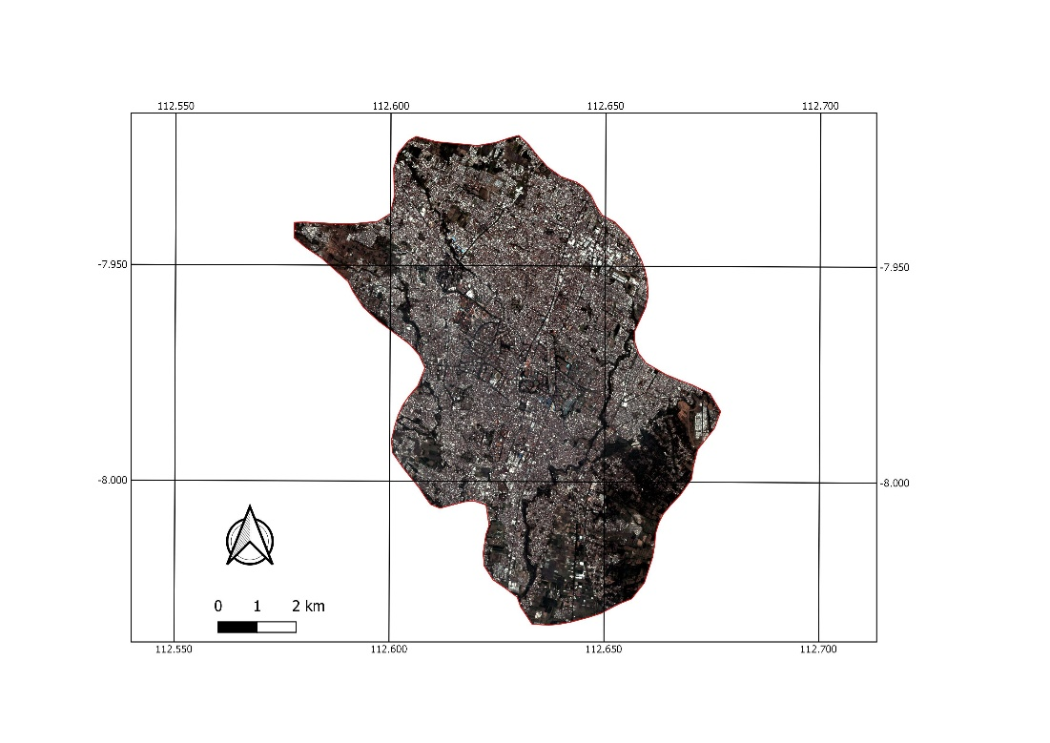

Figure 1. Planetscope image of Malang city in 2020

The data analysis in this study used the random forest method, which is a combination of many predictive decision trees where each tree depends on the value of the random sample vectors which are independent of each other and have the same distribution on all trees in random forests[14]. Random forest has stages similar to bagging in resampling and voting, but what is different is the formation of classifiers. Random forest conducts a training process on the sample data. Sampling was done by means of sampling with replacement. As much as one third of the sample will be used to determine Out of Bag (OOB) data. Determination of out of bag data is carried out to estimate errors and determine variable importance. The variables that will be used to determine the best separation are determined randomly. After all trees are formed, the classification process is carried out. Class determination is done by means of voting from each tree, the class with the highest number of votes will be the winner[14]. To perform random forest classification method, R software was used.

To determine the performance of the random forest method, this study uses several metrics, such as accuracy, sensitivity, specificity and the ROC curve. Accuracy describes how accurately a model can classify correctly. Hence, accuracy is the ratio of true predictions (positive and negative) to the overall data. In other words, accuracy is the level of closeness of the predicted value to the actual value (equation 1). Sensitivity or recall is the proportion of true positive cases that predicted correctly positive (equation 2). Specificity is the degree of model reliability to detect data labeled negative correctly (equation 3). The ROC curve is a measure of how well a classification method can separate positive and negative samples and to identify the best threshold for separating these samples[15].

$Accuracy=\frac{True Positive+True Negative}{True Positive+False Positive+False Negative+True Negative}$ (1)

$Specificity=\frac{True Negative}{True Negative+False Positive}$ (2)

$Sensitivity= \frac{True Positive}{True Positive+False Negative}$ (3)

1. Results

The results of identification of green open spaces using the random forest method provide sufficient results to represent the distribution of the green open spaces availability in Malang city. Based on the results of the random forest classification, Malang City has green open space covering an area of 15.99 km2 and areas other than green open space covering an area of 94.07 km2. Malang City has a total area of 110.06 km2. The data on the area of green open space is presented in table 1. The distribution of vegetation density identified rapidly by the random forest method is presented spatially in the form of a map in Figure 2.

**Table 1.** Area of ​​green open space in Malang city

|  |  |  |
| --- | --- | --- |
| Land use | Area (km2) | Percentage |
| Urban green space | 15.99 | 14.53 |
| Other | 94.07 | 85.47 |
| Total | 110.06 | 100.00 |

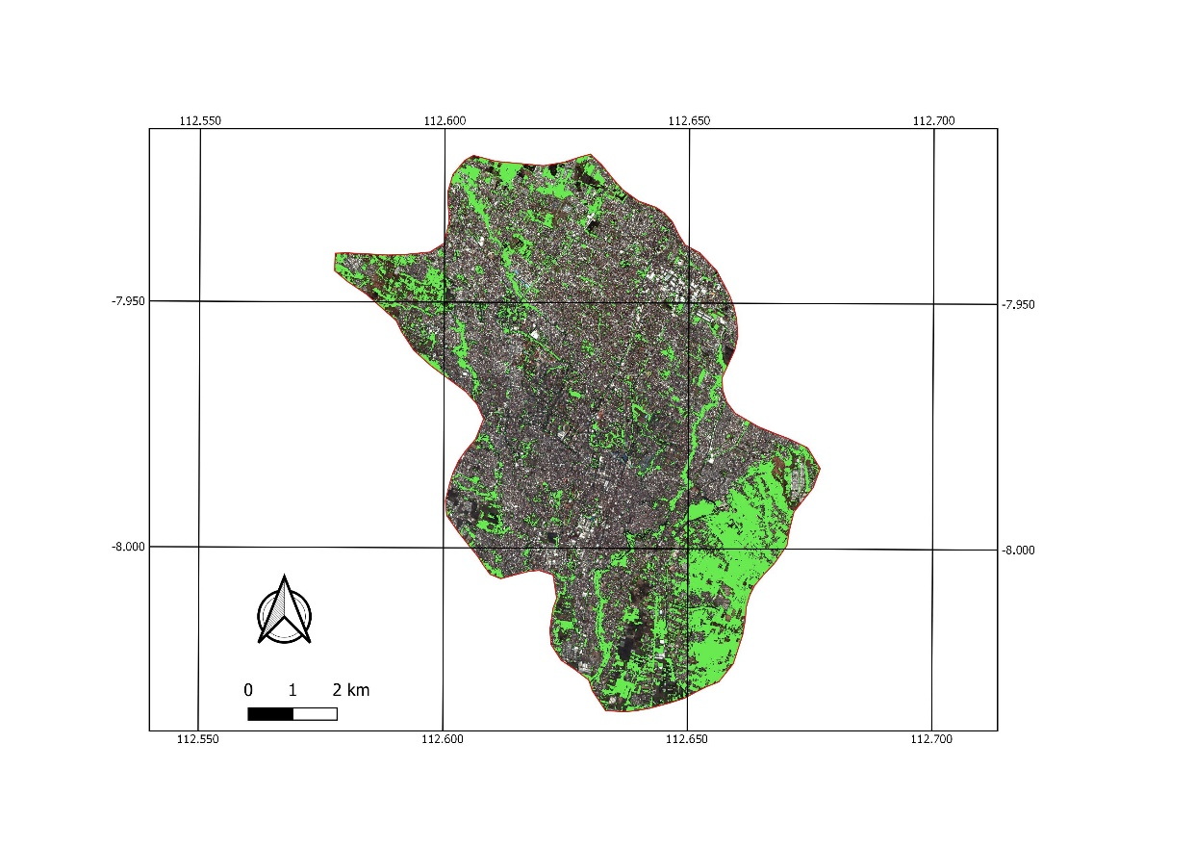

**Figure 2.** Image of urban green space in Malang city identified by random forest

The classification performance of the random forest method to identify green open spaces is good with an accuracy level of 0.995, a specificity level of 0.9964 and a sensitivity level of 0.9932. The random forest method performance metrics is presented in table 2. The ROC curve also confirms the good performance of the random forest method with an AUC value of 0.9948 where the value is close to 1. The ROC curve is presented in Figure 3. From the results obtained, it can be concluded that the random forest method can be used to rapidly identify green open spaces.

**Table 2.** The performance of random forest classification

|  |  |
| --- | --- |
| Metric | Value |
| Accuracy | 0.995 |
| Specifity | 0.9964 |
| Sensitivity | 0.9932 |
| AUC | 0.9948 |

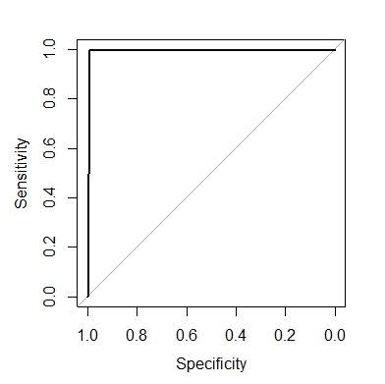

**Figure 3.** The ROC curve

1. Discussion

The results of identifying green open spaces in the Malang city area based on 2020 Planetscope image data using the random forest method gave quite good results. This can be seen from the results of delineation of vegetation and non-vegetation areas that are appropriate and in accordance with actual conditions. Vegetation can also be thoroughly identified, both in open areas and around urban settlements. In addition to the details, the time needed to get the spatial distribution of vegetation is also very short so that the results of this delineation can be used as an approach to the availability of green open space in urban areas. The map of the availability of green open space in Malang city illustrates that the distribution of green open space in Malang is evenly distributed throughout the city. However, the coverage of dense vegetation is only in a few area, including in the east, the Kedung Kandang sub district area (Figure 2) and in the north, the area leading to Batu city. Image analysis from random forest classification results also illustrates that the downtown area has a large green open space, namely the main square in the middle of Malang. The results of the calculations in table 1 show that the area of green open space in Malang City still does not meet the broad requirements in accordance with UU 26 of 2007 concerning the provision of green open spaces in urban areas. According to the regulation, regency/cities must have at least 30% green open space of the total area, while Malang City only has 14% green open space of the total area. The green open space consists of RT parks, RW parks, urban village parks, district parks, cemeteries, city parks, city forests, and green open spaces for certain functions.

1. Conclusion

The use of Planetscope high resolution imagery and the random forest method in this study, is able to provide complete, rapid and relatively accurate detection of vegetation areas. The distribution of green open spaces in the city of Malang is evenly distributed throughout the city, but only certain areas have green open spaces with dense vegetation coverage. The area with the largest green open space is in the Kedung Kandang sub district and the smallest green open space is in the Klojen sub district. The availability of green open spaces in the city of Malang has not met the provisions in accordance with UU No. 26 of 2007 concerning the provision of green open spaces in urban areas as much as 30% of the total area. Malang city government is expected to continue to improve the quantity and quality as well as the distribution of green open spaces from the current conditions. Utilization of analysis of the availability of green open space with the random forest method can be used to rapidly identify vegetation objects in urban areas. The results of this identification can then be used to detect the relationship between the availability of green open space and sustainable city variables.

1. Acknowledgement

Authors wishing to acknowledge Planet Labs for providing access to the Planetscope satellite imagery data through an academic program scheme. In addition, acknowledgement also given to Navama, GmbH which has partially funded this research.

1. Reference

[1] Xue F, Gou Z and Lau S 2017 The green open space development model and associated use behaviors in dense urban settings: Lessons from Hong Kong and Singapore Urban Design International 22(4) p 287-302

[2] Sutanto E and Junadi P 2019 The Role of Environmental Quality in Kalijodo Green Open Space for Society in Jakarta City, Indonesia IOP Conference Series: Earth and Environmental Science 264(1) p 012008

[3] Iswoyo H, Dariati T and Junardi D 2020 An assessment on land typology and achievement of government target for green space area development according to spatial plan 2005-2015 of Makassar city IOP Conference Series: Earth and Environmental Science 575(1) p 012152

[4] Malek N A, Mohammad S Z and Nashar A 2018 Determinant factor for quality green open space assessment in Malaysia Journal of Design and Built Environment 18(2) p 26-36

[5] Wikantiyoso R and Suhartono T 2018 The role of CSR in the revitalization of urban open space for better sustainable urban development International Review for Spatial Planning and Sustainable Development 6(4) p 5-20

[6] Marsawal D A 2020 Mangrove ability to support green open space in Mamuju Regency IOP Conference Series: Earth and Environmental Science 575(1) p 012092

[7] Marangoza A M and Alkışb Z 2012 Detection of urban features and map updating from satellite images using object-based image classification methods and integration to GIS Proceeding of the 4th GEOBIA

[8] Colak T I, Senel G and Goksel C 2019 Coastline zone extraction using Landsat-8 OLI imagery International Archives of the Photogrammetry, Remote Sensing and Spatial Information Sciences 42(4/W12).

[9] Shade C and Kremer P 2019 Predicting land use changes in Philadelphia following green infrastructure policies Land 8(2) p 28

[10] Zhao L, Ren H, Cui C and Huang Y 2020 A Partition-Based Detection of Urban Villages Using High-Resolution Remote Sensing Imagery in Guangzhou, China Remote Sensing 12(14) p 2334

[11] Kaku K, Aso N and Takiguchi F 2015 Space-based response to the 2011 Great East Japan Earthquake: Lessons learnt from JAXA's support using earth observation satellites International Journal of Disaster Risk Reduction 12 p 134-153

[12] BPS 2020 Luas Kecamatan Kota Malang Available at: https://malangkota.bps.go.id/dynamictable/2020/04/30/197/luas-kecamatan-dan-persentase-luas-kecamatan-di-kota-malang-2018-2019.html Accessed 25 October 2020

[13] Planet labs 2016 Planet imagery product specification: planetscope & rapideye Available at: https://www.planet.com/products/satellite-imagery/files/1610.06_Spec%20Sheet_Combined_Imagery_Product_Letter_ENGv1.pdf Accessed 25 October 2020

[14] Breiman L 2001 Random forests Machine Learning 45(1) p 5–32

[15] Zhu W, Zeng N and Wang N 2010 Sensitivity, specificity, accuracy, associated confidence interval and ROC analysis with practical SAS implementations NESUG proceedings: health care and life sciences p 67