Helping Early Childhood Education Teacher Teach English with an E-book Guide

Bambang Harmanto
English Department
, Muhammadiyah University of Ponorogo
Ponorogo, Indonesia
bambange,unmuhpo@gmail.com
Heri Wijayanto, Ida Yeni Rahmawati,
Early Childhood Education Department
, Muhammadiyah University of Ponorogo
Ponorogo, Indonesia
ok_coi@yahoo.com. Idayenir@gmail.com

Abstract—This paper aims to identify the responses of early childhood education teacher (ECET) toward E-book guide for English teaching practices which was developed by the writer. By identifying their responses properly, it is assumed that they can be helped to be competent English practitioners with the e-book independently. The survey technique was conducted with 19 respondents from the ECET from Ponorogo, Indonesian through a questionnaire. The analysis data was done by calculating the percentage of responses and descriptively explored. The result showed that only 12% of the respondents were fairly interested. Meanwhile as many as 88% of them was very interested in the e-book designed. The model was very effective to motivate the especially when it was used in the pandemic covid-19 situation. Therefore, e-book guide as an alternative that can be offered for their want.
Keywords—ECET; English Teaching; E-Book Guide

Introduction
In the context of Indonesian, even though English is not obligatory subject in early childhoods education (ECE), parents still want them to equip their children with English. They want it earlier because they know that learning English will be easier when they are children. The awareness of these parents has made some early childhood education especially in Ponorogo Indonesia already attempted to introduce English earlier to their students in their part of learning activities. As the condition, they tried to meet their want by teaching it as they know and master. They cannot serve them optimally due to their insufficient pedagogical and linguistic readiness. The skillful and trained English teacher is not well distributed. Normatively, there must be a great demand for specialized language teachers, since teaching to young learners requires special skill, competence and motivation. (Camlibel-Acar, 2016). Therefore, professional teachers are needed to support students’ attitudes who were mostly positive toward learning English. They will fully engage the class when their favourite activities like singing songs and playing games are available there for building their intrinsic motivation to learn English. (Asmali, 2017)
The preliminary research dealing with the ECE teachers’ eduaction qualification in introducing English in Ponorogo done by Harmanto (2019), it was found that as many as 58% respondents were s1 degree holder and 42% were Senior High school graduates. Looking at the data it meant that ECE teachers formally were not prepared to teach English. Knowing who they were it can be imagned how they teach and what they teach. It can also create serious problems if it is done by somebody without regard to his/her teaching background. The fact was also discovered by Pransiska ( 2016) and Copland et.al. (2013). Many challenges challenges are more localised found in the process such as constructing appropriate curriculum, developing teachers’ English competence, choosing and using proper media and method in the classroom. They argue that teacher education should focus less on introducing teachers to general approaches to English language teaching and more on supporting teachers to meet the challenges that they have identified. Beyond the locus of classroom practice, the age-appropriate pedagogy, from the use of English in a creative way to real-life practice, helps to raise TEYL teachers’ awareness of the challenges and rewards of their work. (Ngunyen, 2018).
Researcher viewed the fact opens the gap between parents wants and ECE teacher’s English proficiency. It is not possible to facilitate them by joining formal education to get the English qualification as needed. There were no significant differences on teachers’ beliefs due to academic level (Qbeita, 2011). Therefore, to fill the gap it should be provided a shortcut for helping them introduce English for their students practically. Looking at the context of pandemic covid-19, the assistance can be given to them is, of course, should be done through virtually or e-media guide. In this paper, therefore, will show a model of training in the forms of e-book guide to help the ECETs improve their teaching capacity. This guide is designed to help them understand what important information about the development, abilities, and everyday experiences of the students through videos. Researchers hoped this breakthrough enable them to practice some English instructions in the e-book free and independently. It is completed with QR Code that possible be scanned by them anytime and where they want to play. They can also repeat it when they need it. This idea in theoretical concepts will equip pre- and in-service ECE teacher with competence and knowledge about innovation, and they are expected to be capable of implementing such innovative ideas into classroom practice (Wang & Cheng, 2005 in Chien 2019). This guide should be a starting point for ECE teacher to expand on what they already know about the needs and the belief of their preschool English learners. Careful consideration of the beliefs will help preschool teachers focus on each child’s experiences and circumstances as that child begins the journey toward the acquisition of academic English. Familiarity with these beliefs will also help teachers implement the information, principles, and practices presented in this guide (California Department of Education, 2009). The material developed in this e-book guide is matched to the children language development. It is very important that materials for young learners persuade them to want to learn the language (Tomlinson, 2017). The universal criteria would be:
- To what extent are the reading texts likely to promote connections with the learners’ lives?
- To what extent are the tasks likely to give learners opportunities to use the language for communication?
- To what extent are the topics likely to engage the learners affectively?

METHODOLOGY

Research Design
The design used in this study is a survey technique using questionnaire to evaluate the developing of e-book guide to facilitate ECET in improving their way of indroducing English early. The questionnaire only asked about the respondent’s response on the design which were the result of analyzing preliminary research about the needs of teaching young learners. The design was proceeded by collecting the references and learning resources in the form of videos and journals. Arranging the material based on the order of teaching practices. Give QR Code in every video used. Try out and revise. Publish

B. Data Sources and Analysis
Data was obtained from ECET spread in Ponorogo, Indonesia which involving 19 respondents as primary data. The data was obtained from this research are information data from the data source in the form of responses. The survey technique with questionnaire and interview were used to collect the data. The results of this study were analyzed using a qualitative descriptive approach. To get the expected data, the e-book guide was arranged in accordance with the finding of the previous research. It covered three areas of training for ECET i.e building motivation, teaching strategies, and material and media development in English teaching. It was expected to be an assistance for the ECET in self-training to practice English teaching strategies during the pandemic.

result and discussion

A. The ECETs’ Responses

Based on the data collected has resulted the data that as many as 12% of the respondents gave response positive. Meanwhile as many as 88% of them was very appreciated on the idea of E-book guide. Because all material trainings were written completely in e-book guide, they were very happy. They can practice independently in their home or schools together with their students. They felt it very practical to be implemented in the classroom. The data was clearly described in picture 1 below.
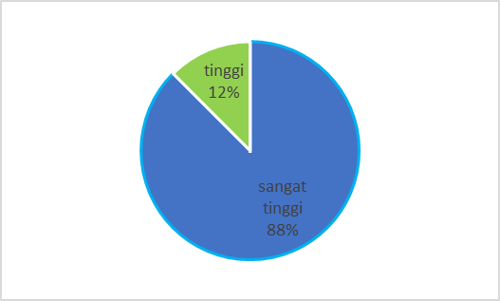
Picture 1. The ECETs’ Interest on E-Book Training

B. E-Book Guide Design
Responding the ECETs’ expectation of the previous research, the writer has tried to develop the material for trainings. Since the training cannot be done in big number of participants, it was made up into e-book guide. Although it was simply designed, it will be helpful the ECET to practice teaching alone as it was accompanied with video that can be play by scanning the QR Code. To operate the link, ECET can follow the procedure below.
- Download Qr Code Scanner application in playstore through link: https://cutt.ly/8gjK4Cs
- Scan qr code in every picture for video playing.
- Qr code will lead you to the link provided.

The material developed in the e-book consisted of:
- Building Motivation
This section was constructed by showing some testimonies from some experts and experienced parents about the importance of learning English early-age period. They told their experiences during the togetherness with their children in acquiring English language. Although they expressed in different version.

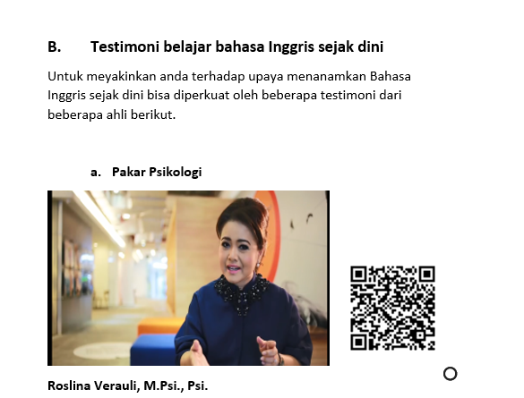

Picture 2. Motivation Testimony

- Game based learning. (GBL)
This part was completed with some examples of games that can be followed by ECET. They can access easily to the links provided. They presented simple and practical playing game.

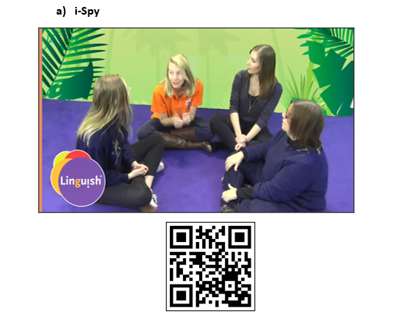

Picture 3. Model of GBL

- Song based learning (SBL)
The ECET can open the links to practice how to sing some songs relevant for the young learner. The songs are simple and easy to memorize. The songs are selected carefully to meet the children wants and needs. The vocabularies were so simple that teachers can follow easily and understandable.

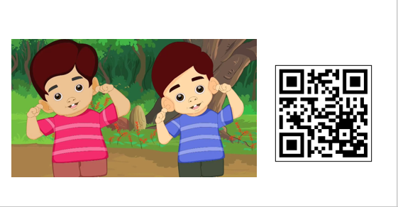
Picture 4. Model of SBL

- Story based learning. (STBL)
The techniques of story telling was collected to give an opportunity for the ECET to select the appropriate one for their students. The stories are arranged in a such way that teacher can manipulate them in the different setting of situation.

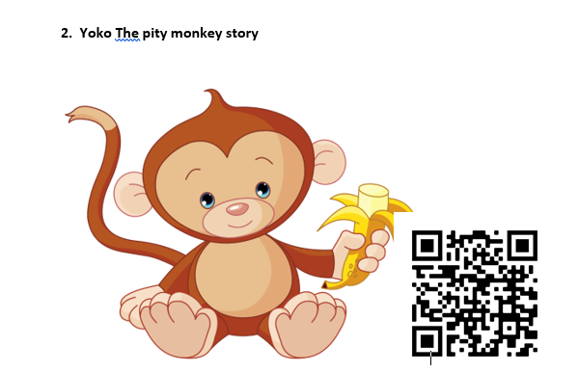

Picture 5. Model of STBL

- Gesture based learning. (GTBL)
This type of learning will train the ECET how to introduce English by following the gestures practiced. The example of activities to show the way of teaching gesture is associated with clear vocabularies.

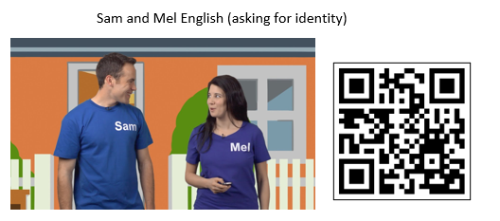

Picture 6. Model of GTBL

- Materials and Media Development.
The last chapter will lead the ECET how to make simple teaching madia and material development. It is completed with procedure to use or teach it. Therefore, the ECET can develop it based on the context of leaner living.

Picture 7. Ways of Material and Media Development

IV. Conclussion
The responses of ECET was very positive toward the idea of e-book guide. It was able to help them to improve their capacity of teaching English. This can be also strategic for the ECET to build self confidence in introducing English early. This guide is very helpful for them to be a well-prepared English practitioner by drilling the techniques played in QR code for videos. This guide also leads them to learn the implementation of the teaching techniques into realm. The material presented e-book guide has been matched to the source of students’ interest such as game, song, movement, and story. To get a maximum result of practices, the use of the e-book guide properly is recommended.

Acknowledgment
This article is research product to help the early childhood education teachers prepare the English lesson for their students through self-training using e-book guide. The author would like to thank everybody for their help with compiling the learning resources. He also would extend the gratitude to the government especially for the education and culture ministry by directorate of research and technology which has given him a grant of my research on “Developing a system for building ECET capacity in introducing English early for an internationalization of Reyog Ponorogo 2020.

References

- B. Harmanto, “Preserving The Uniqueness of English Teaching at Early Childhood Education”, 2019, ELLIC 2019. DOI.10.4108/eai.27-4-2019.2285319.
- Acar, Z.C, “Teaching English to Young Learners: Some Challeges Faced by Pre-Service Teachers,” The Eurasia Proceeding of Educational and Social Sciences (EPESS) 2016, vol. 5, pp. 323-327.
- M. Asmali, Young Learners’ Attitutudes and Motivation to Learn English, Novitas-ROYAL ,2017,11 (1) pp.53-68.
- R. Pransiska, “Requirement of Teaching English for Young Learers: An Overvoew in Padang, West Sumatra, Proceeeding of the forth 2016, pp. 271-350.. 2016. The Forth International Seminar on English Language and teaching.
- F.Copland, S. Garton, A.Burns, “Challenges in Teaching English to Young Learners: Global Perspectives and Local Realities, 2013. Tesol Quarterly. Vol.0, No.0. pp 1-25
- C.W. Chien, “Pre-Service Teachers’ Innovation on English Activity Designs and Materials for Young Learners,” 2019, The Educator.Vol.54 No.1 pp 4-21.
- C.D. Ngunyen,”The Contruction of Age-appropriate pedagogies for Young Learners in Primary Schools,” 2018. The Language Learning Journal, pp1-13. http;//doi.org/10.1080/09571736.2018.1451912
- B.Tomlinson,” Developing Principled Material for Young Learners of English as a Foreign Language,’2017, book chapter pp 281-291.
- A. Qbeita,”Kindergaten Teachers’ Belief abaout Teaching English in Jordan”, 2011. An-Najah Univ.J.Res. (Humanities) Vol. 25(5), pp 1435-1462.
- California Edaprtment of Education “Preschool English Learners: Principles and Practices to Promote Language, Literacy, and Learning-A Resorce Guide( 2nd Edition.),” 2009. The CDE Press Sales Office.

