Character-Building’s Analysis on Civic Education Course Through Lesson Study Activities

Yulianti
Elementary Teacher Education Program Universitas Kanjuruhan Malang,
Malang, Indonesia
yulianti@unikama.ac.id¹
Nury Yuniarsih
Elementary Teacher Education Program
Universitas Kanjuruhan Malang
Malang, Indonesia
Nuryyuniarsih@unikama.ac.id

Abstract— This qualitative-descriptive research aims to explain character building in the Civics Education Course using Lesson Study Strategy as our research method. There were three stages of Lesson Study: Rencana (Plan), Implementasi (Do), Refleksi (See). The subjective of the research are fifth-semester students of the elementary-teacher education program. The results state that students' independent character has an improvement in Civics Education Course through lesson study. we can see it on the I-II cycles. The initially lazy attitude of students during lectures was indicated by only a few students actively asking questions and giving responses during discussions. In other words, most of the students just listened. After the lecturer implements good classroom management with the flipped class model, students who are less active in answering questions have the opportunity to answer during discussion presentations. Students also feel enthusiastic because they have studied the previous material so that they can be more focused during the lecture. The implementation of the Lesson Study strategy is proven to be able to build better independent student character. They can focus more on attending lectures, be more confident in expressing their opinions during discussions to respond to friends' views, and respect friends who are talking and studying the material or material given by the lecturer with full responsibility. Students can prepare for lectures well, and lecturers can improve the quality of citizenship learning optimally. Hopefully, many lecturers will implement into other courses in improving the quality of education.
Keywords: Character education; Civics Learning; and Lesson Study.

Introduction
Character Building is all actions that educate and influence the formation of human behavior and habits. It has become an everyday awareness that the world of education is a way human beings have used throughout their lives to become a means of transmitting and transforming both values and knowledge [1]. A character has a significant role in determining one's future life. A Greek philosopher, Heraclitus,[2] said that "Character is destiny". The characters will shape one's destiny. He also describes that [3], “Be careful of your thoughts; your thoughts become your words. Be careful with your words; your words become your deeds. Be careful what you do; what you do becomes your habit. Be careful with your habits; your habits become your characters. Be careful with your character; your character becomes your destiny. The role of the educational environment has a significant influence on character building [4][5][6]. The number of violent phenomena in the educational environment shows that Character-Building Course needs to be supported by an excellent academic environment [6].
We realize that one or two activities alone cannot immediately create an individual character. Of course, this requires a continuous and integrated character building in lectures [7][8]. There are five central character values ​​derived from Pancasila, which are the development of the Gerakan PPK; religious, nationalist, integrity, independence, and cooperation. Students of the Elementary-Teacher Education Program are prospective educators for the next generation. They need sufficient provision to build competence as a competent teacher with character [9]. Independent character values ​​are attitudes and behaviors independent of others and use all energy, thoughts, and time to realize hopes, dreams, and ideals. Independent students are those who have a good work ethic, are tough, have a fighting spirit, are professional, creative, have courage, and are lifelong learners [10][11][12]. Citizenship education is a course that strengthens the internalization of moral values ​​and norms of students as agents of change in their community. As contained in Paragraph (1) Article 37 No. 20 of the 2003 Indonesia Law (Pasal 37 Ayat (1) pasal 37 ayat (1) Undang-Undang No 20 Tahun 2003) about National Education System (Sistem Pendidikan Nasional); “Citizenship education aims to shape students into human beings with noble characters who have a sense and honor of nationality”[13][2][14]. Civics Education Course should have a positive influence on student character [15]. It has not been quite successful in carrying out this role. The process that occurs in Civics Education Course is only oriented towards cognitive achievement because it tends to ignore fine or attitude attainments. Overcome this, and it is necessary to make modifications in Civics Education Curse, one of which uses the lesson study strategy. Lesson Study can help analyze the students’ character of elementary-teacher education program. Lesson study uses the integration of the concept of Character-Building Course in its learning activities to play a more role in the development of student character.
Lesson Study is a means of increasing the competence of educators. Besides that, it is a means of active, practical learning centering, and also the collaboration of teacher activities in learning[16][17][18]. In meeting the various needs of diverse students, not all teachers can have the skills to meet high expectations in teaching according to this diversity. So the teacher needs a lesson study strategy as one of the learning approaches to create teacher activities that can have a personality that educates and trains students' character in learning [19][20].

II. RESEARCH METHOD
We researched students of the Elementary Teacher Education Program, Faculty of Education, Universitas Kanjuruhan Malang. This study uses a lesson study strategy [21], consisting of 6 cycles of Civics Education course. Each process consists of the stages of Plan, Do, and See. In the Plan, model lecturers and observer lecturers discuss preparing Semester Lesson Plan (Chapter Design, Lesson Plan and Design, Teaching Media, Student Worksheets, Evaluations, and Learning Observation Sheets). At the Do, the lecturers' team of Civics Education Course carries out teaching activities based on the job descriptions at the Plan's stage. We divided the lecturer team into two; observer and model lecturers, while opening the lesson activities. At the See, we reflect on the observer and model lecturer. We discuss the results of observations to determine the weaknesses and mistakes that occur during learning activities, including the students who have problems during the learning process. After that, we look for and find the solutions, so that the next cycle will be even better.
III. RESULTS AND DISCUSSION
The implementation of character building in the Civics education course through Lesson-Study activity was well planned. Lesson Study activities begin with Perencanaan (Plan), Pelaksanaan (Do), and Refleksi (See) [18]. The Civics education course aims to educate citizens to be excellent and wise. We can say that it is how to inform students as intellectual candidates for the nation to become good citizens who can understand the country's philosophical values, and have a stable personality, have a strong viewpoint. Broad and capable of being democratic and civilized [22]. Cycle I activities begin with Perencanaan (Plan); Lecturers’ Team construct Semester Lesson Plan (Chapter Design, Lesson Plan and Design, Teaching Media, Student Worksheets, Evaluations, and Learning Observation Sheets) using an software, Prezy.

Picture 1. Chapter Design PKn

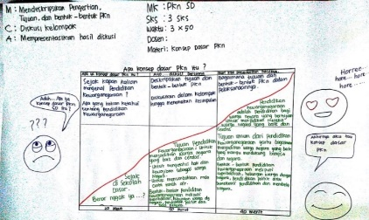

Gambar 2. Lesson Design Siklus I PKn

On cycle I material, Civics' basic concept, the researcher presents character behavior through apperception; ask questions that match their experience of their behaviour and attitudes. The model lecturer begins by asking the question, "when was Civics first taught to us?". Students are quite confused to see that their answers are not quite right.
At the do stage, the model lecturer gives an assignment so that students learn various behaviours about character values with their peers directly or indirectly. In this activity, students make discussion groups in working on student worksheets (LKM) related to Civics' essence and objectives.
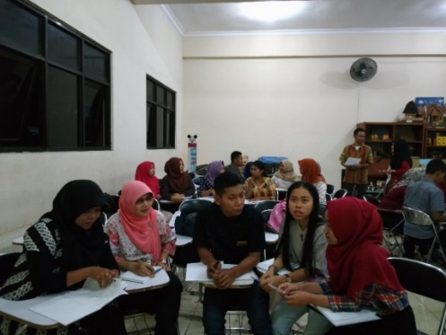
Picture 3. Do’s stage on Cycle 1 of Civics Education Course
Even though some students were still wondering about the answers to the apperception questions, the group discussion process worked well. Upon completion, the lecture asks each group to present while the other groups responded to one another. In this activity, students create and learn good characters in themselves, marked by conveying their responses correctly. Yet, it is the same student who dominates in asking questions and responding to presentations. Most of the students just listened.
At the see stage, the implementing team from the lesson study discussed activities carried out at the do stage. The result from the observations made by the observer is that the strategy implementation process still has shortcomings. Students are lazy in discussion activities because they have difficulty understanding their friends' opinions so that learning is less effective and seems monotonous.
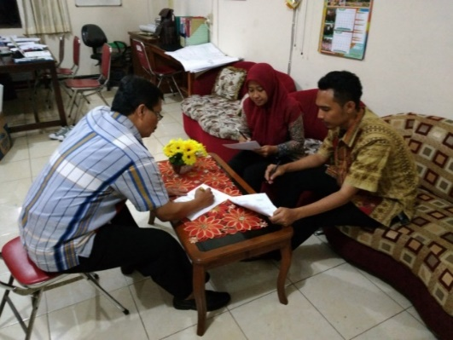
Picture 4. See’s stage on Cycle 1 of Civics Education Course

Improvements for the second cycle the lecturer team tried to use the Flipped Class and provided initial supplies to students before starting the class. That is also to build the character of students who are responsible for attending lectures. The material in cycle II is related to Civics Education for Elementary School.
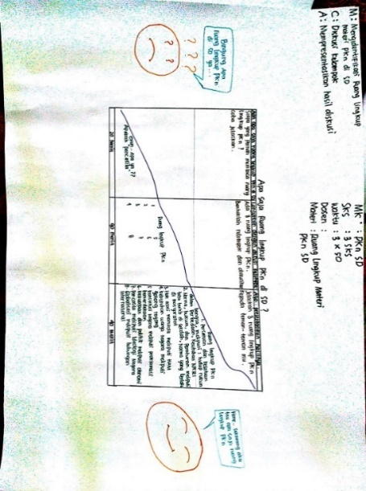
Picture 5. Lesson Design Cycle II Civics Education Course

At the Plan, model lecturers discuss chapter design, lesson plans and design, Students Worksheets, and observation sheets. In the Do section, the lecturer team started with an apperception in the form of the question "What do you know about national unity and integrity?". It aims to provoke an enthusiastic response from students. That is related to the character behavior of students that he can do either directly or indirectly. The lecturer asks students to form groups by giving the group name 1 to 6. Each group discusses material related to Civics Education for Elementary School. Each group has finished studying the previous material. Provide material to be learned during the implementation of learning and assign students to share previous learning results. With the flipped class model, the discussion process is more focused [18]. After that, the lecturer asked each group to present their discussion results, which aims to create a character of responsibility for students. After the group presented their work results, the lecturer asked questions to students who were less active with the assumption that each student had studied the material and discussed it in groups.
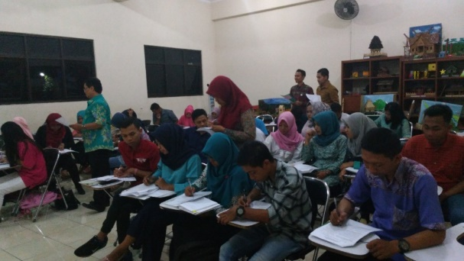
Picture 6. Tahap Do Siklus II Matakuliah PKn

Based on the results of the reflection, the team observed that students participated in the discussion well. They also discuss the material they have studied before. Students who have difficulty understanding their friends' opinions begin to get used to this class's discussion patterns. Lecturers motivate good attitudes during discussions and examples of good attitudes to make students active by asking them questions. However, there were still lazy members, so the lecturer team prepared good class management by appointing them to answer questions so that every student got the opportunity in class.
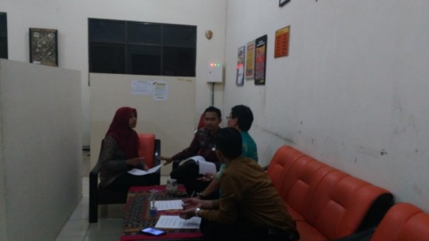
Picture 7. Tahap See Siklus II Civics Education Course
The learning process using the flipped class helps students in the learning process [20]. That is because students are ready with the material to be studied. Each student gets the opportunity to answer questions, each student focuses, and each student is very enthusiastic about learning. So, we conclude that in cycle II learning, every student gets the opportunity to answer questions so that each student focuses and is excited about participating in the learning activities.

IV. CONCLUSION
The implementation of Character-Building Course in Civics Education is ón the Finding. Through Persiapan (Plan), Pelaksanaan (Do), and Refleksi (See), student responsibility is still lacking; student participation in lectures is low, even laziness, chatting with friends, and lack of self-confidence by not expressing opinions in the discussion. It happens because of difficulty understanding their group friends' opinions and poverty of character among students. One class comes from different personalities and cultures. In cycle II learning, students' feelings of responsibility have begun to emerge with student readiness feelings answering, enthusiastically reading, or studying material given by the model lecturer before lectures. Even so, there are still students who do not focus on learning, especially in the discussion. So, lecturers must provide motivation and enthusiasm to them. Students also respect peers and respect other people's opinions during meetings. Lecturers also give questions that they understand to prepare students to become excellent and capable of character, noble character, smart, participatory, and responsible. Supporting factors that build success in the implementation of Character-Building Course are the students' enthusiasm and the lecturer team's role (model lecturers and observers) during lectures by utilizing flipped classes that help students in the learning process.

REFERENCES
[1] A. Sudrajat, Mengapa Pendidikan Karakter?, vol. 1, no. 1. 2011.
[2] P. Dianti, “Integrasi Pendidikan Karakter Dalam Pembelajaran Pendidikan Kewarganegaraan Untuk Mengembangkan Karakter Siswa,” J. Pendidik. ILMU Sos., 2016, doi: 10.17509/jpis.v23i1.2062.
[3] Burhanuddin Habibi Nasution, Abdul Rahman, and Syahnan Daulay, “Character Based Text for Development on V Grade Students of Elementary School,” AKSIS J. Pendidik. Bhs. dan Sastra Indones., 2019, doi: 10.21009/aksis.0302012.
[4] Muhammad Ali Ramdhani, “Lingkungan Pendidikan dalam Implementasi Pendidikan Karakter,” J. Pendidik. Univ. UNIGA, vol. 8, no. 1, pp. 28–36, 2014.
[5] F. Ilmu, K. Sunan, and K. Yogyakarta, “Pembentukan Karakter Mandiri Melalui Pendidikan Agriculture Di Pondok Pesantren Islamic Studies Center Aswaja Lintang Songo Piyungan Bantul YOGYAKARTA,” Pembentukan Karakter Mandiri Melalui Pendidik. Agric. Di Pondok Pesantren Islam. Stud. Cent. Aswaja Lintang Songo Piyungan Bantul Yogyakarta, no. 2, pp. 108–122, 2014, doi: 10.21831/jpk.v0i2.2784.
[6] D. A. Wulandari, S. Saefuddin, and J. A. Muzakki, “Implementasi Pendekatan Metode Montessori Dalam Membentuk Karakter Mandiri Pada Anak Usia Dini,” AWLADY J. Pendidik. Anak, vol. 4, no. 2, p. 1, 2018, doi: 10.24235/awlady.v4i2.3216.
[7] Wanda Chrisiana, “Upaya penerapan pendidikan karakter bagi mahasiswa,” J. Tek. Ind., vol. 7, no. Nomor 1, pp. 83–90, 2005.
[8] M. Khusniati, “PENDIDIKAN KARAKTER MELALUI PEMBELAJARAN IPA,” J. Pendidik. IPA Indones., vol. 1, pp. 204–210, 2012.
[9] A. T. Lidyasari, “Developing PGSD Students Character through Experience Learning Theory,” Procedia - Soc. Behav. Sci., vol. 123, pp. 189–195, 2014, doi: 10.1016/j.sbspro.2014.01.1414.
[10] Y. Efendi1 and Sudarwanto2, “Penguatan Karakter Mandiri, Disiplin, Kerjasama dan Kreatif Melalui Lesson Study Pada Pembelajaran Teknologi Sepedah Motor,” J. Pendidik. Vocasi Otomotif, vol. 1, pp. 89–99.
[11] F. Rokhman, M. Hum, A. Syaifudin, and Yuliati, “Character-Building Course for Golden Generation 2045 (National Character Building for Indonesian Golden Years),” Procedia - Soc. Behav. Sci., vol. 141, pp. 1161–1165, 2014, doi: 10.1016/j.sbspro.2014.05.197.
[12] T. Schipper, S. L. Goei, S. de Vries, and K. van Veen, “Developing teachers’ self-efficacy and adaptive teaching behaviour through lesson study,” Int. J. Educ. Res., vol. 88, no. November 2017, pp. 109–120, 2018, doi: 10.1016/j.ijer.2018.01.011.
[13] D. S. Permana, “IMPLEMENTASI PROSES PEMBELAJARAN PENDIDIKAN KEWARGANEGARAAN BAGI PENGEMBANGAN SEMANGAT BELA NEGARA MAHASISWA,” Pro Patria J. Pendidikan, Kewarganegaraan, Hukum, Sos. dan Polit., 2018, doi: 10.47080/propatria.v1i1.144.
[14] A. Wongwung, K. Tangdhanakanond, and S. Wongwanich, “Change Model of Attributes of Students in Terms of Discipline, Sufficiency Living and Public Mind FromCharacter-Building Course Activities,” Procedia - Soc. Behav. Sci., vol. 116, pp. 3996–3999, 2014, doi: 10.1016/j.sbspro.2014.01.879.
[15] T. Susiatik, “Pengaruh Pembelajaran PKn Terhadap Pembentukan Karakter Siswa,” Maj. Ilm. Pawiyatan, 2013.
[16] C. Fernandez, “Learning from Japanese approaches to professional development: The case of lesson study,” J. Teach. Educ., 2002, doi: 10.1177/002248702237394.
[17] Herawati Susilo, “LESSON STUDY SEBAGAI SARANA MENINGKATKAN KOMPETENSI PENDIDIK,” 2013, pp. 1–32.
[18] T. C. Rock and C. Wilson, “Improving Teaching through Lesson Study,” Source Teach. Educ. Q., 2005.
[19] T. Schipper, S. L. Goei, S. de Vries, and K. van Veen, “Developing teachers’ self-efficacy and adaptive teaching behaviour through lesson study,” Int. J. Educ. Res., 2018, doi: 10.1016/j.ijer.2018.01.011.
[20] C. K. Skott and H. Møller, “Adaptation of lesson study in a Danish context: Displacements of teachers’ work and power relations,” Teach. Teach. Educ., vol. 87, p. 102945, 2020, doi: 10.1016/j.tate.2019.102945.
[21] L. H. J. Lee and S. C. Tan, “Teacher learning in Lesson Study: Affordances, disturbances, contradictions, and implications,” Teach. Teach. Educ., vol. 89, p. 102986, 2020, doi: 10.1016/j.tate.2019.102986.
[22] P. Cahyo Aji, “Peran PKN Dalam Membentuk Karakter Kewarganegaraan Melalui Pendekatan Berbasis Nilai Di Perguruan Tinggi,” pp. 1–9, 2019.
[23] M. N. Tsai, Y. F. Liao, Y. L. Chang, and H. C. Chen, “A brainstorming flipped classroom approach for improving students’ learning performance, motivation, teacher-student interaction and creativity in a civics education class,” Think. Ski. Creat., vol. 38, no. September, p. 100747, 2020, doi: 10.1016/j.tsc.2020.100747.

