LOCAL WISDOM OF SAWAH LODOK (LODOK RICE FIELD) IN MELER VILLAGE, MANGGARAI REGENCY, AS GEOGRAPHY LEARNING RESOURCE

Ottovianus Diliano Nery¹
Student of Geography Education Dapartment, Universitas Pendidikan Indonesia¹
ottovianusdilianonery@upi.edu

Darsiharjo², Epon Ningrum³.
Lecturer of Universitas Pendidikan Indonesia.
Bandung city, Indonesia

Abstract
Sawah Lodok is a spider web rice field located in Meler Village, Manggarai Regency which is commonly known to the public, namely spider fields. The research was conducted to find out local wisdom of sawah lodok (lodok rice field) and utilization for geography lessons. Descriptive method with a qualitative approach is used in this research. Observations, in-depth interviews and literature study were carried out to collect data. Data analysis techniques used were by performing data reduction, data presentation and drawing conclusions. Sawah Lodok is the result of community interaction with the environment by applying local values and beliefs of the community to interact with their natural environment. The way of life of the local community is related to settlement patterns and agricultural patterns. Research on local wisdom of Sawah Lodok gives that description of Sawah Lodok contains local wisdom values that can be used as a resource of learning geography for Senior High Schools (SMA) in Manggarai Regency. The outdoor study method is chosen and recommended in utilizing local wisdom Sawah Lodok as learning resources for geography lessons at Senior High School (SMA) Manggarai Regency.

Keywords: Local Wisdom, Sawah Lodok, Learning Resources

- INTRODUCTION
Local wisdom is interpreted as a system in the order of social, political, cultural, economic and environmental life in local communities [1]. A strong distinctive character in local wisdom is dynamic, continuous, and tied to the community. Local wisdom contains a view or rules in the form of activities carried out by the community so that people have a more foothold in determining an action or meeting their needs in life. Likewise with people who interact with their natural environment in the form of activities based on customary values that are believed by local communities.
The appearance of cultural tourism is the identity of a region. [2] Cultural identity is something that is artificial, something that is formed by a representation and it is not something that is formed naturally. Physical appearance sawah lodok not just formed, but shaped by the local wisdom of the community in responding to their environment and the results of these actions are characteristic of a place or area.
Sawah Lodok (lodok rice field) which is located in Meler village, Ruteng sub-district, Manggarai district, East Nusa Tenggara province. The Manggarai community in general cannot be separated from farming and gardening activities. Sawah Lodok better known by people outside the Manggarai area as the spider rice field (Spider Fields), because the shape resembles a spider web. It needs to know that sawah lodok is different from rice fields in general, so the existence of sawah lodok needs to be known and try to be preserved to remember Sawah Lodok not just formed, but formed because it contains the values of local wisdom in it
One of the efforts to maintain and preserve local culture is through education in schools. [3] Schools can help to develop local wisdom. According to Sofan Amri [4], decentralization of education allows district and city governments to make policy innovations in education development. Law of the Republic of Indonesia number 20 of 2003 concerning the national education system in article 50 number 5 which states that district or city governments are obliged to manage education units based on local excellence [5]. [6] The objectives of learning will be maximally achieved with the presence of cultural, customary and local wisdom approaches that grow and develop in the community. Learning that raises local wisdom, as part of an effort to maintain and preserve local culture, through providing knowledge or insight to students in learning, makes students able to understand and able to act in their environment. Education integrates local wisdom through learning, and students or learners is the main goal to be able to understand and preserve local culture.
Geography is a science that is more focused on the interaction between humans and the environment in which they live [7]. In geography, there is cultural geography, which believes that place is not something that is independent or separate from humans, instead a place created as a product of certain social conditions that create that place [8]. Studying culture in geography emphasizes humans and their environment, which means how space and place are formed by beliefs and values held by people who inhabit a certain place.
Geography learning is currently dealing with the development of the 21st century. Good geography learning is able to adapt to the abilities of the 21st century. One of the 21st century capabilities published in the Word Economic Forum is strengthening knowledge about culture. Efforts that can be made are by utilizing the values contained in local wisdom. The values contained are used as a source of knowledge in geography lessons.
Geography has many learning resources, because geography studies human life with its natural environment. Local culture sawah lodok part of the resource type learning environment. [9] Environmental learning resources are divided into 3 parts, namely the social environment, physical environment, and cultural environment. The purpose of learning resources is to facilitate students' understanding of the material being taught. Deep local wisdom values sawah lodok can be used for the needs of learning geography.
The purpose of this research is to find out local wisdom of sawah lodok and to recommend learning methods in utilizing local wisdom of sawah lodok as a source of learning geography at Senior High School (SMA) in Manggarai Regency.

- RESEARCH METHOD
This research design is descriptive quantitative. This research describes local wisdom of sawah lodok which can be used as a learning resource in Geography subjects in Senior High Schools in Manggarai Regency. This research was conducted in Meler Village, Ruteng District, Manggarai Regency. Observation, interviews and heritage studies were used in this study to collect data.

- RESULTS AND DISCUSSION
Meler is the name of a sub-village located in Meler Village, Ruteng District, Manggarai Regency, East Nusa Tenggara Province. The Meler community applies the lodok system to the Lingko (agricultural land). Lingko sawah Lodok in Meler village is classified as very unique since the existence of sawah lodok can only be found in Manggarai, one of which is Meler village with an area of 165 ha [10]. Geomorphologically, the Meler village, Ruteng district, has a relatively flat landscape, with a slope from the north of the village. In terms of the size of the sub-district, the soil types for the Ruteng district consist of mediterranean and latosol soil types. Astronomically, Manggarai Regency is located between 8º N-8º.30 'S and 119.30º-12.30º East. Meler Village is bordered by Rahong Utara village (North), Beo Rahong village (east), Pang Leko village (south), Bangka Turi village (West).
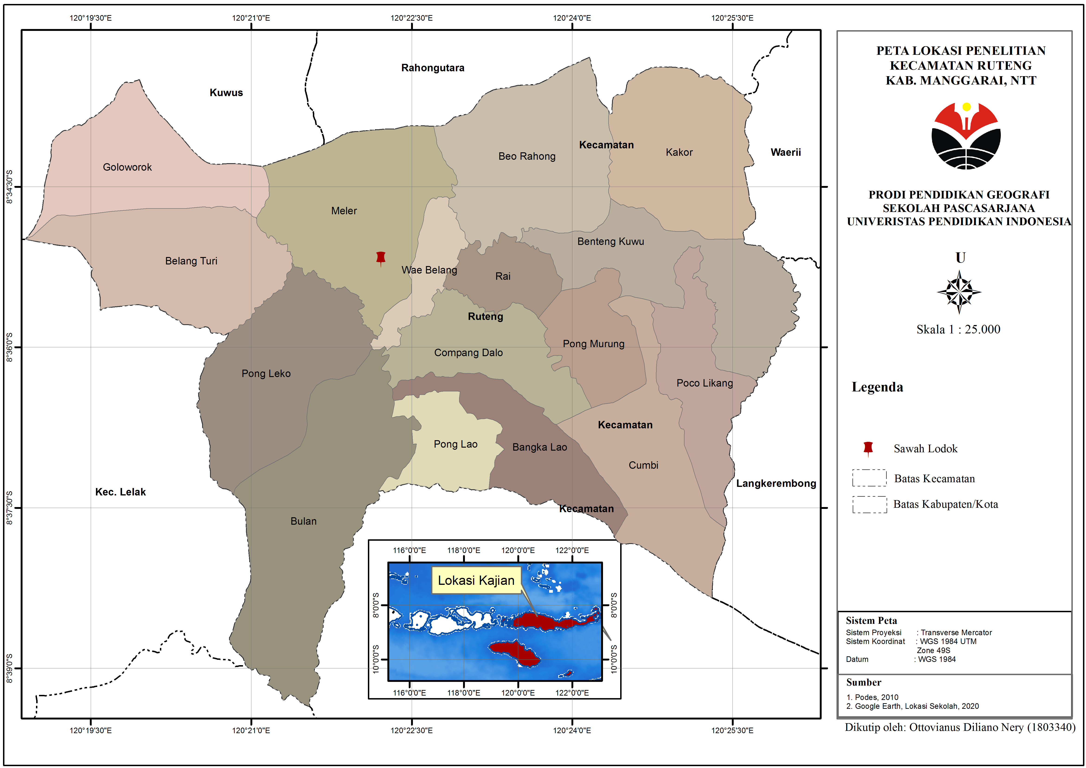
Figure 1. Location Map of Sawah Lodok, Meler Village, Ruteng District, Manggarai Regency.

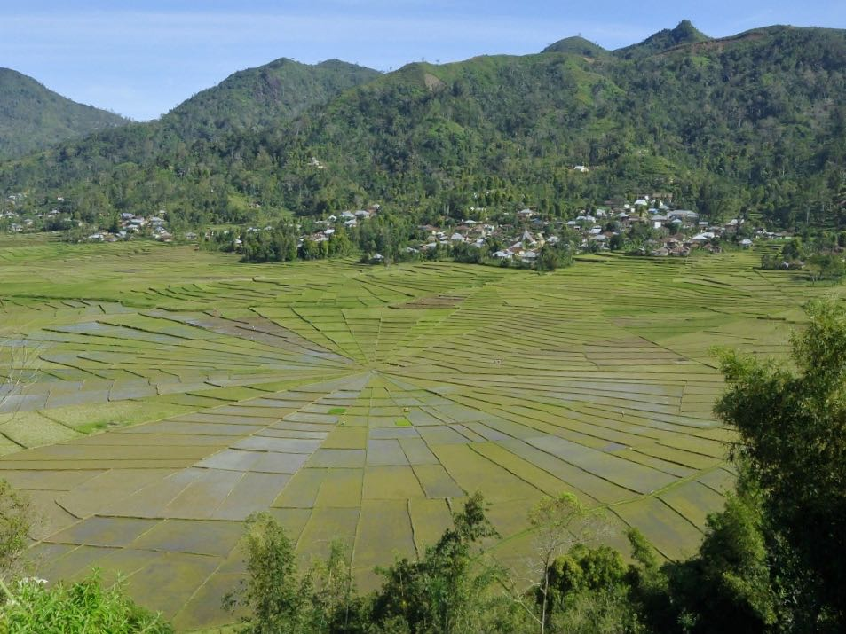
Figure 2. The Appearance of Sawah Lodok in Meler Village, Ruteng District, Manggarai Regency

- Local Wisdom of Sawah Lodok (Lodok Rice Field) in Meler Village
Formation and Division of Agricultural Land Sawah Lodok.
The Manggarai community in general cannot be separated from farming and gardening activities. Therefore, Manggarai people are familiar with expressions "Gendang One Lingko Peang". The phrase literally means “the drum inside and the garden outside". Drum is a gendang (musical instrument) but it can also mean a drum house, namely a traditional house, a communal house for the Manggarai people. Lingko is a communal garden. Custom home (mbaru drum) cannot be separated from garden (Lingko) which means where there are settlements or villages that are centered in traditional houses (mbaru drums) certainly have cultivated land for the so-called villagers Lingko. Meler Village has 8 lands sawah lodok (Lingko) which are worked on by local communities. Sawah Lodok part of the term expression above which is the result of the ability of a community or society to manage the environment for support the necessities of life. Lodok is a local language term Manggarai which means a system of dividing agricultural land. The parts in the circle of sawah lodok are called "moso ", the midpoint or the central point is called lodok and the circular outer part is called cicing.
Langang
Cicing
Lodok
Moso
Figure 3. Sawah lodok sketch

The shape of sawah lodok (lodok rice field) have in common with the form of a traditional house. The traditional house becomes the center of life for the Manggarai people since it is not only being the center of society in agriculture, as a place for interpersonal socialization, but also a place of mediation between the Manggarai community and Mori Kraѐng (the highest form in Manggarai society). Traditional house form (mbaru niang) and sawah lodok (Lingko or communal gardens) which is round or circular based on the Manggarai culture namely lonto leok which means sitting in a circle. Sit in a circle (lonto leok) what the community does inside the house is a tradition in Manggarai culture. Likewise, in sawah lodok when holding joint traditional events such as clearing agricultural land, thanksgiving for harvest and planting seeds, all residents sit in a circle around the teno tree at the tegah point sawah lodok (garden center). Lonto leok contains a bond of unity with the expression "Muku ca pu'u neka woleng curup and teu ca ambo neka woleng lako" Which means togetherness, kinship in one community.

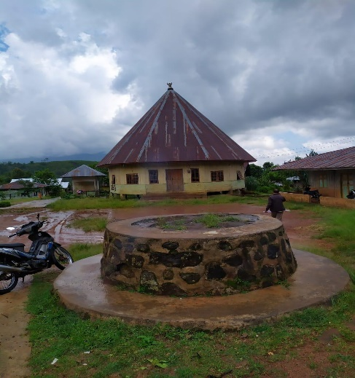
Figure 4. Outside View of Meler Village Traditional House
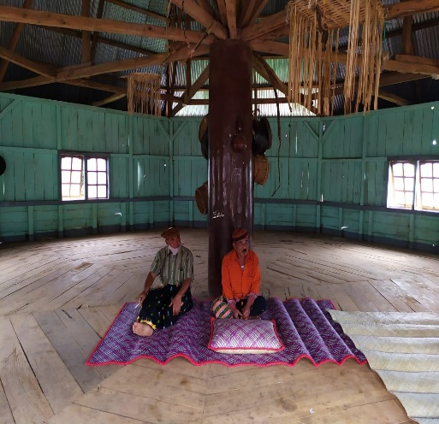
Figure 5. Inside the Traditional House of Meler Village
The existence of sawah lodok currently, it is not just formed, but through many stages carried out by local communities. The beginning of choosing a place for agricultural land sawah lodok it is based on the topography of the land in Meler village, depending on the availability of forest land (puar bate mose) and water sources (wae bate teku). Establishment sawah lodok adapted to the existence of forests that provide water availability, which functions as a source of life for the community and agricultural plants. Water springs (wae bate teku) and forest (puar bate mose) as a local community belief, namely a source of life, both as a source of life for plants, animals, and humans. The community believes that the existence of forests as a source of water can provide a longer life (long which means descent).
Lingko sawah lodok made by the ancestors aimed at dividing the land fairly and owned by all people. In clearing land for wetland farming, it is carried out on ulayat or customary land, based on an agreement or deliberation by the customary chief (old golo) with the village community. The activity begins by installing tree logs at the center point of the land. The activity is named tente teno. Teno is a type of straight wood or tree that is used by the local community and based on community belief, straight wood symbolizes an honest attitude and can be trusted by others. In addition, indigenous people also carry out traditional rituals by using chickens and eggs to ask permission from the spirits who inhabit the land or land with the aim that the land used for agriculture can bring blessings to community life. The division of rice fields for the community is carried out by tu'a teno. Tu'a teno is the leader in the distribution of agricultural land to the community. Division of agricultural land sawah lodok using the system sarmoso (fingers) and each family in a village gets its share. Moso contained in the land sawah lodok is arable land from the results of the division. Meanwhile, for people who do not get a share or feel less after the distribution, they are given additional land which is called in the local language Lingko cue.

Settlement Pattern
The pattern of judgment the village community cannot be separated from the history of the formation of the village. The choice of a place to live by the Meler village community depends on soil fertility, availability of water sources, availability of forest land and topography which were the targets of local communities at that time. The settlement pattern of meler village communities was initially concentrated, depending on the existence of a water source to easily meet daily needs. As time goes by, currently the settlement pattern of the Meler village community depends on the village lane or road.
The geomorphology of the Meler village area has a relatively flat landscape with a sloping direction to the north as well as being the center of the forest in Meler village, the name of the forest is a Kuwus meler forest, this forest extends from Meler village to Kuwus sub-district, West Manggarai Regency. The flat plains are used by the community for farming, sawah lodok and settlements, while the sloping land to the north of the village of Meler has forests as the main source of water for agriculture. In general, soil types for the Ruteng sub-district consist of Mediterranean and Latosol soil types. The morphological and soil conditions in the village of Meler, Ruteng sub-district, lead the community to plant types such as coffee, cassava, vegetables and rice as the main sources for the needs of the village community.

Sawah Lodok (Lodok Rice Field) Agricultural Management
The people of Meler village are mostly farmers in the type of agriculture, namely rice and coffee, which have been practiced from generation to generation. The management of rice plants, which until now is thick with the traditions of the Meler people, is added to its unique shape. Sawah Lodok in Meler village it was not formed just like that but went through a long process and the management still contained local management. Processing process sawah lodok starting from planting seeds in the local language, namely weri wini. Before planting the seeds, perform a ritual weri wiri which is done together with the community. The purpose of this activity is so that the added seeds are avoided from plant pests and hope that they can provide abundant yields. In the management of lowland land, the community is currently using tractor-type technology and no longer uses local animal technology such as buffalo.
Use of rice seeds The people of Meler village before 1990 still used local seeds, namely woja longko, woja siwa, woja nencel, and woja bengawan. Age of production of local seeds that is 6 months and the local seedlings were planted in the mountains or forests before planting. Local seeds planted by the community without using additional fertilizers, because they are supported by the conditions of fertile soil nutrients, make rice grow without additional fertilizers. In 1990 onwards, agricultural management began to change since receiving seed and fertilizer assistance from the government, whose production age was 3-4 months earlier. Since the use of chemical fertilizers for paddy farming, soil nutrient conditions have decreased and depend on fertilizers to support rice plants. People choose these seeds because the production process is faster.
In production activities or harvesting, the community performs mutual cooperation. Team work or activities of mutual assistance does not occur in rice fields alone, but in all types of agriculture, including the socio-economic activities of the community. The mutual cooperation activities carried out by the community are known as local terms, namely dodo. The word "dodo" this arises and lives in every community's heart to be able to live side by side with every community. At the end of every year the community holds a celebration for the results that nature gives. The activity in local language is called penti ceremonies.

Preservation and Utilization of Lodok Rice Fields (Sawah Lodok)
Agricultural management carried out by the village community is part of the efforts to conserve Lodok rice fields. The people in Meler village do not only pay attention to their agricultural land, they also care about the forest as a source of water to meet the needs of the community. The convincing knowledge of the local community that without the forest there is no water, without water there is no life. So that people interpret water, namely "Wae bate teku" and forest ie "Puar bate mose". The community implements local wisdom to protect forests and springs. The chief of the tribe made a prohibition for the community not to carry out building activities in the spring, it was prohibited to catch eels because the people believed that these animals were considered to be ancestors who guarded, protected the wiko plants that could only live in the springs which became the belief of the people that the wiko plant was a sign in the function of the water container, and each spring must be maintained. Apart from the prohibition, the tribal and community leaders performed ritual activities in the springs and these activities were called Barong wae. This activity is carried out at the spring where the community needs it. Likewise, with forests, it prohibits logging indiscriminately, but if forest trees are used for housing needs, the people who need it, please notify the tribal or customary leaders. The ritual activities carried out by the village community are ceremonial activities penti. The penti ritual is carried out as a thanksgiving to God (mori Jari dedek) and the arwa of the ancestors for the blessings received by the community.
Customary leader (golo old), chair in land management (old teno), and society together (dodo) strives to maintain and preserve existence sawah lodok as a form of identity of the Manggarai community. The agricultural land given by the community from the results of the distribution is communal land, therefore the tribal leaders or traditional leaders prohibit sawah lodok from being sold and converted into development. However, the prohibition issued by the tribal leader is not in the form of punishment if it violates. Chieftain (old drum) and head of land administration (old teno) ensure that the community will not sell or change functions sawah lodok. In the land inheritance system sawah lodok in one family is done based on the decisions of the family itself, the most important is the land of sawah lodok is kept in existence.
Sawah lodok (Lodok rice field) is used by the community not only to meet food needs, but also for tourism activities. Currently, The community and local government have made Lodok rice fields as cultural tourism objects in Manggarai Regency besides Wae Rebo Village. Sawah Lodok is used as a tourist attraction for the community to increase their income to fulfill their daily needs.
In 2019-2020, the people of Meler village experienced a decrease in the quality of the water discharge for rice fields. The decreasing intensity of rainfall makes people lack water during the dry season. The water source produced from the forest in Meler Village is not sufficient to meet the needs of rice fields, especially during the dry season. Hearing this problem, the Manggarai district government tried to solve the problem. Currently, the local government is still planning and has not been able to explain to the public about the planning that will be carried out by the local government.

- Utilization of Local Wisdom from Sawah Lodok (Lodok Rice Field) as a Geography Learning Source

Local culture of Sawah Lodok in geography learning is used as a learning resource for the environment, in the discussion of the material "environmental use and preservation", given local wisdom of Sawah Lodok is the result of the use of the environment by the community based on the values of belief and the community has local wisdom in maintaining, managing and preserving sawah lodok. Local culture sawah lodok be evidence of community action against the environment. The local people of Meler village have local knowledge about how to open new land for agricultural land and how to manage it. Selection or determination of location sawah lodok by the Meler village community based on the topography and availability of water sources. The water source in Meler village comes from the forest (Meler Kuwus forest) located north of Meler village. The indigenous people of Meler village strive to maintain natural forest and water resources to provide and fulfill the needs of the community and their agriculture. Tribal chief (old custom), head or head of land administration (old teno), and the community together to maintain the existence of the sawah lodok as the identity of the Meler village community, Ruteng sub-district, Manggarai Regency.
Geography lessons utilize Sawah Lodok, because in geography there is human geography, in human geography there is cultural geography which believes that a place is not something that stands alone or apart from humans, instead a place created as a product of certain social conditions that create that place [8]. [11] Geography discusses how humans live in a place. Every place we look at is influenced by and created by society, and every place reflects the culture of the people in that place. [12] Geography studies human phenomena such as language, religion and local identities, as well as physical phenomena such as landscapes, climate and environmental changes. [13] Geography is no longer looking for the meaning of the human world solely in terms of artifacts (such as houses, barns, and rice field layouts), as well as in terms of abstract concepts such as space and culture, but also seeking and interpreting the meaning of behavior, feelings, ideas, hopes, honesty, decisions, and the various things involved in it.
Sawah Lodok is a cultural landscape that is formed in the physical landscape by human activities. Decisions about locations, patterns and landscapes are influenced by cultural attitudes and practices Culture is an all-encompassing term that identifies not only the entire lifestyle of people, but also their values and prevailing beliefs. [12] Culture is an all-encompassing term, which identifies not only all the real lifestyles of people, but also their values and prevailing beliefs. To preserve local culture, people must maintain their customs. Customs change slowly over time, but they are maintained despite the onslaught of popular culture.
One of the efforts to maintain, preserve and learn local culture is through education in schools. Local culture of Sawah Lodok (lodok rice field) in geography learning is used as a learning resource for the environment. [9] Environmental learning resources are divided into 3 parts, namely the social environment, physical environment, and cultural environment. Environmental learning resources that are used for classroom learning are not always effective and certainly require learning resources such as tools or technology and additional media to support the implementation of the use of environmental learning resources. Learning outside of school allows learning to be more effective, because it interacts directly with the environment. Utilizing the environment in geography learning to study how humans interact with the environment or between the environment itself. [14] Direct observation gives the most complete and meaningful impression of information and ideas.
Learning activities outside the classroom make it possible for the school to be located close to the environment or objects that are used as learning resources. Geography learning at Budi Dharma High School is still teacher centered. Lack of learning resources such as books, tools / media and the internet, makes teacher learning still dominate with the lecture, question and answer method and tends to be in the form of knowledge transformation from teacher to student. Lack of learning resources for students also makes student note-taking activities very high in the learning process, because the only source for students to learn other than teachers is what they have recorded in class or school. SMA Budi Dharma Cancar, Ruteng sub-district, Manggarai district is very possible to take advantage of local wisdom sawah lodok with learning outside the classroom because it has close distance, without the need to spend a lot of money and time.
Learning activities by taking students out of the classroom to interact directly with the environment by using outdoor study learning, which is one of the field learning methods. [15] In outdoor study learning using environmental media. environment plays a very important role in the growth and development of children, because children will learn to understand something from the environment. [16] [17] There are six advantages to outdoor study, namely: 1) Increasing the learning capacity of students; 2) Revealing facts and obtaining data in the field; 3) Encourage student learning motivation, 4) Develop social-physical abilities, 5) Make student learning meaningful, and 6) Suitable methods are applied to Geography subjects. Apart from the advantages, there are also disadvantages to the use of outdor studies. One of the shortcomings of outdoor study learning is that the teacher will have difficulty arranging or managing learning when in the field and it requires time and travel costs if it is far from the object location [18] [19].
SMA Budi Dharma Cancar, Ruteng sub-district, is a school close to the location sawah lodok, which makes it possible to implement outdoor study learning and the proximity of the school location to the object reduces one of the obstacles of outdoor study learning. This does not indicate that schools that are further away from the object are not possible to use outdoor studies. It all depends on the teacher how to make use of the sawah lodok with outdoor study, without time and cost problems. To achieve the implementation of outdoor study learning, teachers or educators are expected to carry out careful planning related to the use and implementation of outdoor studies. There are several stages in using an outdoor study, namely preparation, implementation, and follow-up [15]. The concept of environmental learning resources is to change learning activities in the classroom (indoor) to outside the classroom (outdoor) by utilizing objects in the environment then students make direct observations. Outdoor learning activities lead students to be oriented towards problems around real life, and there is a process of student activity and creativity in understanding the problems around them.
Careful planning of outdoor learning can give good results, such as being able to overcome learning boredom, overcoming learning boredom, and providing motivation, understanding, and experience. [20] Learning outdoor study makes students more familiar with the environment.

- CONCLUSION
Sawah Lodok in Meler village, Ruteng sub-district, Manggarai district, is a rice field formed by local people in utilizing its natural environment. Sawah Lodok established on ulayat land or customary land based on the agreement between the customary chief and the community by gathering together for deliberation (lonto leok). Division sawah lodok done to meet the needs of society fairly. The Meler people try to defend themselves paddy fields lodok, because its shape reflects the life of the Meler community and the people of Manggarai Regency in general. The Meler community strives to maintain the balance of natural water and forest resources to keep their people and agriculture alive. Education through geography lessons has a major role in preserving local wisdom by making it a source of geography learning. Values in local wisdom of sawah lodok used to complement the needs of geography material in Senior High Schools (SMA). Selection of outdoor study in geography learning to utilize local wisdom of sawah lodok as a learning resource, so that students can interact directly with the object and as a solution to overcome the lack of learning resources such as books, media or tools and the internet

REFERENCES

[1] Wagiran, Pengembangan Karakter Berbasis Kearifan Lokal Hamemayu Hayuning Bawana (Identifikasi Nilai-Nilai Karakter Berbasis Budaya), Jurnal Pendidikan Karakter, 2012. DOI: https://doi.org/10.21831/jpk.v0i3.1249
[2] Barker, Chris, Cultural Studies, Yogyakarta: Kreasi Wacana, 2000.
[3] M. Ferrari, & G. Potworowski, Teaching for Wisdom: Cross-Cultural Perspectives on Fostering Wisdom, Netherland: Springer. (p. 37–57). ISBN: 978-1-4020-6531-6. doi:10.1007/978-1-4020-6532-3, 2008
[4] F. Guntara., Fatchan, & N. Ruja, Kajian Makna Sosial-Budaya Rambu Solo Dalam Pembentukan Karakater Peserta Didik, Jurnal: Pendidikan Progresif. Vol. VI No. 1 April 2016 hal. 48 – 54. 2016.
[5] Undang-Undang Republik Indonesia Nomor 20 Tahun 2003 Tentang Sistem Pendidikan Nasional, Cet.1; Jakarta: Bp Panca Usaha, 2003, Hal.6.
[6] Kemendikbud, Kerangka Dasar Kurikulum 2013, Kementerian Pendidikan dan Kebudayaan, Direktorat Jenderal Pendidikan Dasar. Jakarta, 2013.
[7] J. J. Hobbs, World Regional Geography, USA: Brooks/Cole, 2009
[8] J. Giles, and Tim Middleton, Studying Culture; A Practical Introduction. Oxford: Blackwell Publishers, 1999.
[9] E. Ningrum, A. Yani, A Design of Environmental-Based Learning to Instill Land Ethics in the Learners, American Journal of Applied Sciences. 2016, 13 (12): 1461.1469. DOI: 10.3844/ajassp.2016.1461.1469, 2016.
[10] F. Sumardi, & P. Sukardja, Makna Dan Fungsi Sawah Lodok Di Kampung Meler Desa Meler Kecamatan Ruteng Kabupaten Manggarai Nusa Tenggara Timur, Jurnal Humanis, ISSN: 2302-920X, Vol 18, No. 1, (2017). Hal. 10-15, 2017.
[11] E. C. Relph, Place and Placelessness, London: Pion, 1976.
[12] E. H. Fouberg, A. B. Murphy, H. J. de Blij, Human Geography: People, Place, and Culture, John Wiley & Sons, Inc, ISBN 978-1-118-01869-9. United States of America.
[13] J. Pickles, Geografi dan Humanisme, Penerjemah: S. R. Hardoyo, Yogyakarta: Ombak, 2014.
[14] A. Arsyad, Media Pembelajaran. Jakarta: PT Raja Grafindo Persada, 1997.
[15] Husanah, Pembelajaran Luar Kelas Outdoor Learning, Jakarta: Prestasi Pustaka Karya, 2019.
[16] N. Sudjana & Rivai, Media Pengajaran, Bandung: Sinar Baru Algesindo, 2010.
[17] A. E. Sejati, Sumarmi & N. Ruja, Pengaruh Metode Pembelajaran Outdoor Study Terhadap Kemampuan Menulis Karya Ilmiah Geografi SMA, Jurnal Pendidikan: Teori, Penelitian, dan Pengembangan. Vol. 1, No. 2, (2016), Hal. 80-86, 2016
[18] Harini, Pengaruh Pembelajaran Tugas Kelompok Berdasarkan Survei Lapangan (Outdoor Study) terhadap Kemampuan Menulis Karya Ilmiah dan Hasil Belajar Siswa, Jurnal Penelitian Pendidikan Lemlit-UM 22 (1): 12—21, 2012.
[19] A. E. Sejati, L. O. Amaluddin, D. Hidayati, S. K. Sejati, Sumarmi & N. Ruja, The Effect of Outdoor Study on the Geography Scientific Paper Writing Ability to Construct Student Character in Senior High Schoo,. Advances in Social Science, Education and Humanities Research. ISSN 2352-5398. https://doi.org/10.2991/seadric-17.2017.22. 2017.
[20] K. Paisley, N. Furman, J. Sibthorp dan J. Gookin, Student learning in outdoor education: a case study from the national outdoor leadership school,” Journal of Experimental Education, vol. 30, pp. 201-222, 2008.

