**How Store Image Affect Satisfaction and Loyalty:**

**A Structural Model for Traditional Market**

**Moh Farid Najib**

Business Administration Department,

Bandung State Polytechnic,

Indonesia

mohfaridnajib@polban.ac.id

*Abstract*—Store image is an important factor for customers in creating loyalty or direct repurchase intention. This paper aims to measure the effect of store image on customer satisfaction and loyalty in the context of traditional markets. This research has been conducted on 400 customers in 16 traditional markets in West Java, Indonesia. A procedure of structural equation modeling has been applied to evaluate the proposed research model. The methodology used consists of two stages. The first step was to see the construct validity through Convergent Validity (CV), Average Variance Extracted (AVE), Construct Reliability (CR), and Discriminant Validity (DC). Secondly, structural equation modeling. The results reveal that store image has positively influenced customer satisfaction, however, they show a non-significant effect on customer loyalty. Furthermore, satisfaction also positively influences on loyalty

Keywords— store-image, customer satisfaction, customer loyalty

# Introduction

Competition in the retail business is very competitive, where revenue and profit are largely determined by the “share of wallet” of customers [1], [2], [3]. Meanwhile, the key factors for the success of retail performance are determined by how to make loyalty, retention, and the intention to make repeat purchases [4], [5]. In the context of traditional markets, it is necessary to apply appropriate marketing strategies on how to identify the concept of loyalty models. Meanwhile, the quality of traditional market services is less competitive when compared to modern markets [6], the condition occurs because traditional retail is perceived as a slum, chaotic, muddy, dirty, and lack of facilities such as limited parking area, smelly and dirty trash cans, hallways, narrow and so on [7].

Several studies in the retail sector state that one of the main drivers of loyalty as well as repurchase intention directly is store image [4], [8], and indirectly through customer satisfaction [9]. Store image consists of various procedures that must be followed by customers in the physical environment of the store, the situation when in direct contact with employees/sellers, and retailer offerings [10]. Store image has been described as a function of the main attributes that are evaluated and considered from one store to another [9]. Store image and satisfaction together influence loyalty [11], [12]. High service quality will result in high customer satisfaction and increase customer loyalty [13]. Customer satisfaction is a significant predictor of customer loyalty [14].

Academic circles have widely discussed the importance of customer satisfaction and loyalty for organizational sustainability. In general, satisfaction is believed to have a positive influence on loyalty, although this influence is highly dependent on the differences of the factors and impacts, such as, the types and industries being analyzed [15]. Over the last few decades, several authors have dedicated their study to the topic of loyalty [16], [17]. Loyalty is seen as a customer's willingness to make personal sacrifices to strengthen the relationship between them [16].

The integration of the overall store image with satisfaction has been analysed empirically as a driver of customer loyalty in a more general structural models [18]. Therefore, this paper aims to evaluate the role of store image and satisfaction as direct impact on customer loyalty in a traditional market context. The novelty of the article is to put a structural model. Store image can be said conceptually as a variable that can affect loyalty either directly or indirectly through customer satisfaction. By using estimation techniques in the structural model, this model at the same time provides an satisfaction and loyalty indexes in an interrelated method, by sounding at the possible drivers, namely the image of the traditional market itself, without paying attention to other drivers.

# Theoretical background

There are many dimensions and aspects to a store image. The first dimension that is often found in some literature is the physical environment of the store. This means that the store layout must make it easier for customers to find products when they are going to buy and make it easy to move around in the store [19]. The second dimension is the personnel inside the store. This dimension is the most important aspect in shaping the store's image, because it is related to how they delight customers who come to the store, therefore, their right attitude determines the behavior of customers in the future, whether they will visit the same store or choose another store [20], [21]. The final dimensions of store image is merchandise or products available in the stores with the quality acceptable to consumers [9].

Customer involvement in each retail is strongly influenced by information about merchandise in the store [22], and these factors as a whole shape the store image. The retail company image which is the corporate image that it plays an important role in creating customer satisfaction [23]. Therefore, the store image becomes attached to the minds of customers when comparing the level of satisfaction they get related to the shopping experience and the suitability of their expectations between the current store and other stores [24]. When customers visit a retail store, their expectations from the store before shopping are not only based on their recent experience but also word of mouth marketing through other customers [19]. Likewise, shop personnel who engage customers will be a strong factor that has a significant influence on store image [25].

The retail image which is the corporate image plays an important role in the level of customer satisfaction [23]. Store image has a positive effect on customer loyalty through customer satisfaction [26]. Customer satisfaction is highly dependent on store image, and store image also has a very significant effect on customer loyalty, while the store image affects customer loyalty through customer satisfaction [9], [15], [27]. Meanwhile, a high level of customer satisfaction will effect in a high level of customer loyalty as well [28], [29]. However, consumer perceptions of store image are related to the customer satisfaction but have no direct effect on customer loyalty [30].

Customer loyalty is a manifestation of various ways including customer commitment to make repeat purchases or as a preference for the product or service chosen [31], [32], [24]. So that customer loyalty is a behavior or attitude of the customer [33]. The behavioral approach can be said to be customer loyalty shown by making repeat purchases and using these goods or services [34], [35], [36].

H1: Store image of the traditional market impacts on customer satisfaction significantly

H2: Store image of the traditional market impacts on customer loyalty significantly

H3: Customer satisfaction of the traditional market significantly impacts on customer loyalty

# Methodology

For data collection purposes, the survey was distributed on 400 respondents from 16 traditional markets around West Java, Indonesia. Respondents were asked to respond to a questionnaire that had 22 items. All these variable constructs are measured on a five-point Likert scale, which ranges from strongly disagree to strongly agree. Following this process, the instrument (in Indonesian) was tested on 20 traditional market customers to evaluate the suitability of the questionnaire instructions and questions.

Respondent responses were filtered and processed using SPSS-23 after collection, and data were filtered for univariate and multivariate outliers, to obtain accurate results. After initial screening of the data with the help of SPSS-23, the data were then statistically analyzed on a structural equation model (SEM) using AMOS-23 software.

# Result

## Reliability Analysis and Measurement Model

### Testing research instruments needs to be done so that the questionnaire can describe the level of stability, consistency, and homogeneity, besides that the questionnaire must be clear, easy to understand, comprehensive, consistent, firm, and non-causal, and should not lead to unclear answers. Reliability test using SPSS 23 (see Table 1). The results of the reliability analysis show that both the dimensions and the sub-dimensions show that the Cronbach's Alpha coefficient is more than 0.7 which means it is very reliable [37], [38]. Besides, confirmatory factor analysis was used to test the structure of the construct factor, and to estimate model parameters. This analysis also examines the multidimensionality of theoretical constructs. In addition, loading factor is an indicator of reliability, as well as testing for convergent validity by calculating the level of AVE (average variance extracted), CR (Construct reliability), and Cranbach's α coefficients as well as discriminant validity as shown in Table 1, all of which are reflective evaluations of the measurement mode [39].

1. Reliability and Measurement Model

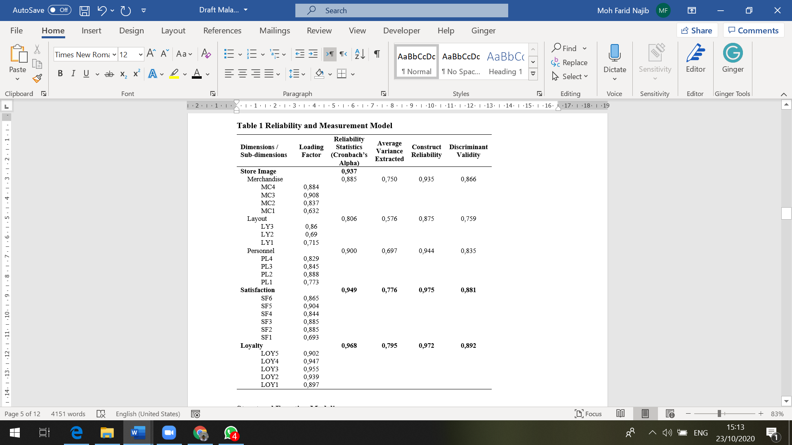

### The loading factor shows a significant level, with a score between 0.690 to 0.908, and an AVE value with a value greater than 0.5, so that convergent validity can be supported [40]. In addition, as the Cronbach's α coefficients for all constructs show very good reliability with the values greater than 0.70 [41], and also for Construct reliability (CR) with a criterion value greater than 0.60 [42], Then the Fornell-Larcker criteria approach is used, for discriminant validity [43]. This approach will assess the square root of each construct’s AVE (average variance extracted), which shows a higher value than the highest correlation value of other constructs [29], [39]. As shown in Table 1, the correlation between constructs is from 0.576 to 0.795, this result ensures a measure of discriminant validity.

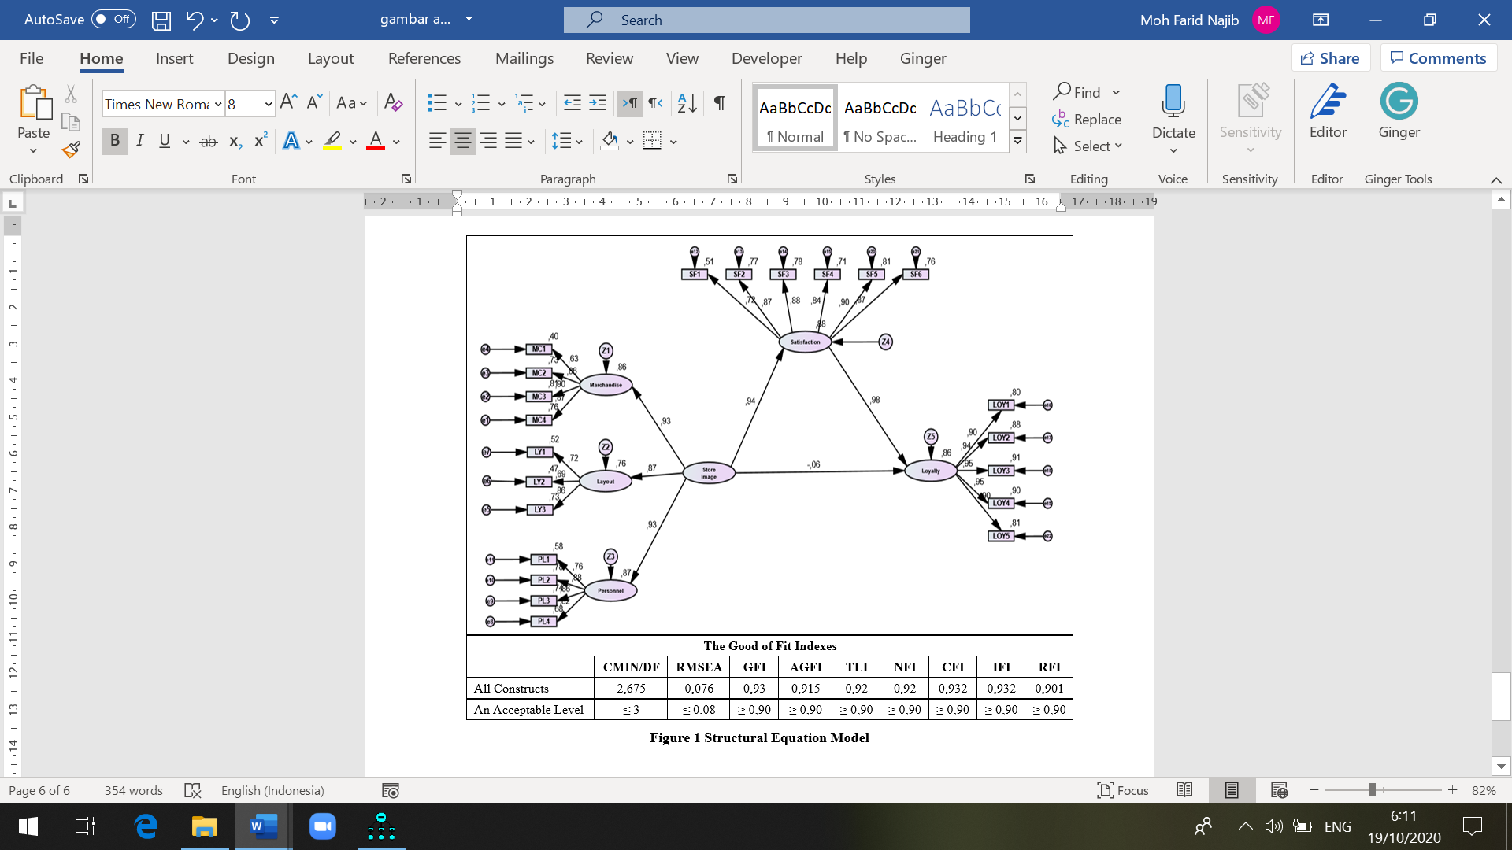

## Structural Equation Modeling

The Structural Equation Model is used for testing measurement models using the AMOS-23 software. Evaluation of the relevance of predictions and hypothesis testing is carried out to determine the relationship between variables empirically. Figure 1 shows the results of the path model, where the proposed operational model shows that CMIN / DF (2,675), RMSEA (0.076), GFI (0.93), AGFI (0.915), TLI (0.92), CFI (0.932), NFI (0.92), IFI (0.932), and RFI score (0.901), these results indicate that there is compatibility between the hypothesized models and the research data.

## Discussion

The purpose of this research is to analyze the effect of store image, customer satisfaction, and loyalty in the context of the Indonesian traditional market. Based on the results shown in Figure 1 and Table 2, the effect of these variables is clear: store image, customer satisfaction, and customer loyalty.

**Table 1. Hypothesis Testing Result**

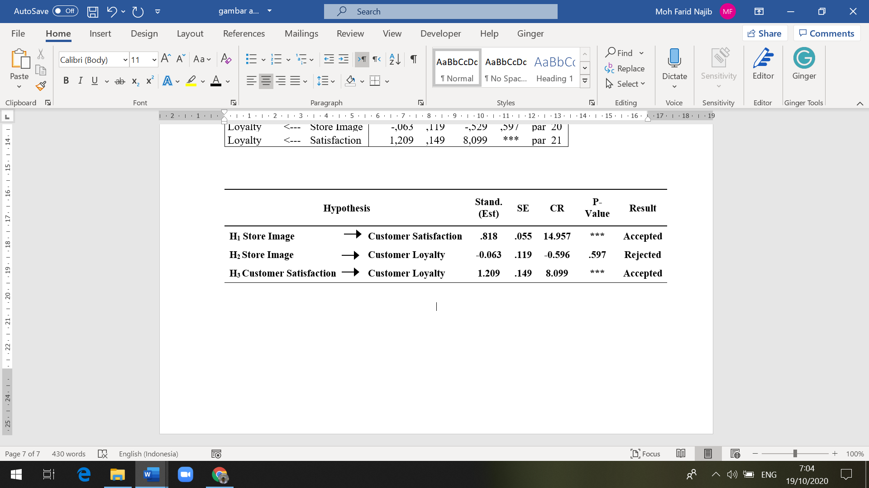

To test the research hypothesis, we used hierarchical linear regression analysis. Based on standard parameter estimates, the results provide support for H1 (store image → customer satisfaction) and H3 (customer satisfaction → customer loyalty) (stand. Est = 0.818, SE = 0.055, CR = 14,957, P-Value ***; stand. Est = 1.209, SE = 0.149, CR = 8.099, P-Value ***, respectively). Meanwhile, H2 (store image → customer loyalty), there is no relationship between this relationship from respondents (stand. Est = -0.063, SE = 0.119, CR = -0.596, P-Value = 0.597).

H1 (Store image of the traditional market impacts on customer satisfaction significantly) displays a Critical Ratio (CR) of 14,957 for the effect of store image on customer satisfaction, the P-value (probability) is significant with *** which means that by default it is significant. This means that the regression value for customer satisfaction is projected from the store image. Customer satisfaction differs from zero at the 0.05 (two-sided) level, therefore Ho is rejected, and Ha is accepted. The results of the study concluded that store image influences customer satisfaction of traditional market customers in West Java, Indonesia. Store image directly contributes 94% to customer satisfaction. This means that traditional market customers are satisfied with the image of the traditional market. The effect of store image on customer satisfaction supports the previous opinion [23], [19]. Furthermore, a good store image will make consumers more comfortable and satisfying [40], although, in reality, it shows that the image of a traditional market is perceived as a slum, chaotic, muddy, dirty, and lack of facilities such as limited parking space, smelly and dirty trash cans, aisles. narrow and so on [7]. This happens because traditional markets can provide fresh products, open from early morning, with a busy atmosphere.

H2 (Store image of the traditional market impacts on customer loyalty significantly) provides a critical value (CR) of -0.063 on the effect of store image on customer loyalty, on a significant P-value (probability) of 0.597 which is not significant. This shows that the customer loyalty regression value is not projected by the store image so that Ho is accepted, and Ha is rejected. Therefore, it can be concluded that the store image does not have a direct and positive effect on consumer loyalty of traditional market shoppers in West Java, Indonesia. The results showed that store image had no direct effect on loyalty. The results of this study are different from previous studies, which state that store image is one of the main drivers of loyalty or direct repurchase intention [4], [8]. Store image and satisfaction together influence loyalty [45], [46].; Moorthy, et al., 2018). This condition occurs because, in traditional markets, the market layout is narrow, muddy, and smelly [7]. Besides that, the arrangement of merchandise makes it difficult for buyers, as well as the number of people who offer the same product at the traditional market which makes customers choose another store.

H3 (Customer satisfaction of the traditional market significantly impacts on customer loyalty) reveals the critical value (CR) of 8,099 on the effect of customer satisfaction on customer loyalty, on the significance of P-value (probability) with *** showing significant by default. This means the regression weights for projected customer loyalty. Customer satisfaction differs from zero at the 0.05 level (two sides), as a result, Ho is rejected, and Ha is accepted. Thus, it can be concluded that traditional market consumer satisfaction in West Java Indonesia directly gives 98% of consumer loyalty. This means that traditional market buyers have loyalty. The results of this study prove that customer satisfaction has a direct and positive effect on customer loyalty. This finding is in line with the previous study completed by Bouzaabia et al. [19], and Najib and Sosianika [7]. This condition occurs because the completeness of products in traditional markets is the cause of customer loyalty, in addition to fresh products, and is open from early in the morning.

# Conclusion

This research was conducted by using the estimation technique in the structural model to measure the level of satisfaction and loyalty of traditional market customers in an interrelated way and to see the potential driver, namely the image of the traditional market itself, without paying attention to other drivers. The results of this research can be concluded that the image of the traditional market is a factor that needs to be considered to encourage customer loyalty in the traditional market. The condition of traditional markets is perceived as a slum, chaotic, muddy, dirty, and lack of facilities such as limited parking spaces, smelly and dirty trash cans, narrow alleys, and so on have made the image of traditional markets a major problem, even though customers are satisfied.

# Managerial Implication

This research provides various insights for traditional market managers as well as decision-makers. First, this study shows that the image of traditional markets is related to the market layout factors that encourage satisfaction and loyalty of traditional market customers. The second, traditional market managers need to increase their concern for the image of traditional markets, related to cleanliness, market layout. Narrow corridors need to be structured so that traditional markets can make modern traditional markets.

# Future research recommendations

The traditional market is one of the main intermediaries in the supply chain that ensures the availability of products in the market. Customers in these traditional markets are directly affected by this last point of contact before purchasing the product. Further researchers can also bring diversification by adding more variables such as product availability in stores (in-store logistics), store locations, various sizes, and composition. A comparative study between traditional and modern markets may also be important to understand the different perceptions of consumer behavior. Apart from that, the mediation effect can also be tested to get a better understanding of customer satisfaction and loyalty.

##### References

1. Dixon, J., K. Bridson, J. Evans, and M. Morrison. An alternative perspective on relationships, loyalty, and future store choice. *The International Review of Retail, Distribution, and Consumer Research*. Vol. 15, no. 4. Pp. 351–71. 2005.<https://doi.org/10.1080/09593960500197461>.
2. [Hernant, M.](https://www.emerald.com/insight/search?q=Mikael%20Hernant), [Andersson, T.](https://www.emerald.com/insight/search?q=Thomas%20Andersson) and [Hilmola, O.](https://www.emerald.com/insight/search?q=Olli%E2%80%90Pekka%20Hilmola) Managing retail chain profitability based on local competitive conditions: preliminary analysis. [*International Journal of Retail & Distribution Management*](https://www.emerald.com/insight/publication/issn/0959-0552), Vol. 35 No. 11, pp. 912-935. 2007. <https://doi.org/10.1108/09590550710828236>
3. Bustos-Reyes, C.A., and O´, Gonza´ lez-Benito. Store and store format loyalty measures based on budget allocation. *Journal of Business Research.* Vol. 61, pp. 1015–25. 2008. <https://doi.org/10.1016/j.jbusres.2007.03.008>
4. Pan, Y., and Zinkhan, G.M. Determinants of retail patronage: A meta-analytical perspective. *Journal of Retailing*. Vol. 82, no. 3: 229–43. 2006. <https://doi.org/10.1016/j.jretai.2005.11.008>
5. Martos-Partal, M., and O. Gonza´ lez-Benito. The effects of store brand loyalty: Evidence from the Spanish market. *The International Review of Retail, Distribution, and Consumer Research*. Vol. 19, No. 3, pp. 273–88. 2009. <https://doi.org/10.1080/09593960903234200>
6. Najib, M.F. and Sosianika, A.Retail service quality, satisfaction, and trust: the key to shopper loyalty in the context of the Indonesian traditional market. *Int. J. Electronic Marketing and Retailing*, Vol. 10, No. 4, pp. 425–440. 2019. <https://doi.org/10.1504/IJEMR.2019.104216>.
7. Najib, M.F. and Sosianika, A. Retail service quality scale in the context of Indonesian traditional market. *Int. J. Business and Globalisation*, Vol. 21, No. 1, pp.19–31. 2018. <https://doi.org/10.1504/IJBG.2018.094093>.
8. Chen, J.C., Ching, R.K.H. and Tsou, H.T. Multi-channel store image and the effects on purchase intention. *The Service Industries Journal*, Vol. 29 No.9, pp. 1215-1230. 2009. <https://doi.org/10.1080/02642060>701847786
9. Bloemer J, De Ruyter K, and Peeters P. Investigating drivers of bank loyalty, the complex relationship between image, service quality and satisfaction. [*International Journal of Bank Marketing*](https://www.emerald.com/insight/publication/issn/0265-2323)*,* Vol. 16 No. 7, pp. 276-286. 1998. <https://doi.org/10.1108/02652329810245984>
10. Morschett, D., Swoboda, B., & Foscht, T. Perception of store attributes and overall attitude towards grocery retailers: The role of shopping motives. *International Review of Retail Distribution and Consumer Research*, vol. 15 no. 4, pp. 423–447. 2005. <https://doi.org/10.1080/09593960500197552>
11. Enne, S., and Özkaya, B. A Study on Corporate Image, Customer Satisfaction and Brand Loyalty in the Context of Retail Stores. *Asian Social Science*, Vol. 10No. 14, pp. 52-66. 2014. <https://doi.org/10.5539/ass.v10n14p52>
12. [Moorthy, K.](https://www.emerald.com/insight/search?q=Krishna%20Moorthy), [Chun T’ing, L.](https://www.emerald.com/insight/search?q=Loh%20Chun%20T%E2%80%99ing), [Ai Na, S.](https://www.emerald.com/insight/search?q=Seow%20Ai%20Na), [Tze Ching, C.](https://www.emerald.com/insight/search?q=Chew%20%20Tze%20Ching), [Yuin Loong, L.](https://www.emerald.com/insight/search?q=Lee%20Yuin%20Loong), [Sze Xian, L.](https://www.emerald.com/insight/search?q=Lim%20Sze%20Xian) and [Wei Ling, T.](https://www.emerald.com/insight/search?q=Teoh%20Wei%20Ling) Corporate image no longer leads to customer satisfaction and loyalty: a Malaysian perspective. [*International Journal of Law and Management*](https://www.emerald.com/insight/publication/issn/1754-243X), Vol. 60 No. 4, pp. 934-952. 2018. <https://doi.org/10.1108/IJLMA-04-2017-0082>
13. [Kumar, M.](https://www.emerald.com/insight/search?q=Mukesh%20Kumar), [Tat Kee, F.](https://www.emerald.com/insight/search?q=Fong%20Tat%20Kee) and [Taap Manshor, A.](https://www.emerald.com/insight/search?q=Amat%20Taap%20Manshor) Determining the relative importance of critical factors in delivering service quality of banks: An application of dominance analysis in SERVQUAL model. [*Managing Service Quality: An International Journal*](https://www.emerald.com/insight/publication/issn/0960-4529), Vol. 19 No. 2, pp. 211-228. 2009. <https://doi.org/10.1108/09604520910943198>
14. Cheng, C.C., Chiu, S.I., Hu, H.Y. & Chang, Y.Y. A study on Exploring the Relationship Between Customer and Loyalty in the Fast-Food Industry: With Relationship Inertia as a Mediator. *African Journal of Business Management*, Vol. 5 No.13, pp. 5118-5126. 2011. <https://doi.org/10.5897/AJBM10.870>
15. [Biscaia, A.R.](https://www.emerald.com/insight/search?q=Ana%20Rita%20Biscaia), [Rosa, M.J.](https://www.emerald.com/insight/search?q=Maria%20J.%20Rosa), [Moura e Sá, P.](https://www.emerald.com/insight/search?q=Patr%C3%ADcia%20Moura%20e%20S%C3%A1) and [Sarrico, C.S.](https://www.emerald.com/insight/search?q=Cl%C3%A1udia%20S.%20Sarrico) Assessing customer satisfaction and loyalty in the retail sector. [*International Journal of Quality & Reliability Management*](https://www.emerald.com/insight/publication/issn/0265-671X), Vol. 34 No. 9, pp. 1508-1529. 2017. <https://doi.org/10.1108/IJQRM-03-2015-0039>
16. Reichheld, F. F. The one number you need to grow. *Harvard Business Review*, Vol. 81 No. 12, pp. 46-54. 2003.
17. Oliver, R.L. (1980), “A cognitive model of the antecedents and consequences of satisfaction decisions”, Journal of Marketing Research, Vol. 17 No. 4, pp. 460-469. <https://doi.org/10.2307/3150499>
18. Nesset, E., Nervik, B., and Helgesen, Ø. Satisfaction and image as mediators of store loyalty drivers in grocery retailing. *The International Review of Retail, Distribution and Consumer Research.* Vol. 21, No. 3, pp. 267–292. 2011. <https://doi.org/10.1080/09593969.2011.588716>
19. Bouzaabia, O., van Riel, A.C. and Semeijn, J. Managing in-store logistics: a fresh perspective on retail service. *Journal of Service Management*, Vol. 24 No. 2, pp. 112-129. 2013. <https://doi.org/10.1108/09564231311323926>
20. [20] Semeijn, J., van Riel, A.C.R. and Ambrosini, A.B. Consumer evaluations of store brands: effects of store image and product attributes. *Journal of Retailing and Consumer Services*, Vol. 11 No. 4, pp. 247-258. 2004. <https://doi.org/10.1016/S0969-6989(03)00051-1>
21. Baker, J., Grewal, D., and Parasuraman, A. The influence of store environment on quality inferences and store image. *Journal of the Academy of Marketing Science*. Vol. 22 No. 4, pp. 328-339. 1994. <https://doi.org/10.1177/0092070394224002>
22. [Mohd-Ramly, S.](https://www.emerald.com/insight/search?q=Suhaily%20Mohd-Ramly) and [Omar, N.A.](https://www.emerald.com/insight/search?q=Nor%20Asiah%20Omar) Exploring the influence of store attributes on customer experience and customer engagement. [*International Journal of Retail & Distribution Management*](https://www.emerald.com/insight/publication/issn/0959-0552), Vol. 45 No. 11, pp. 1138-1158. 2017. <https://doi.org/10.1108/IJRDM-04-2016-0049>
23. Wallin Andreassen, T. and Lindestad, B. Customer loyalty and complex services: the impact of corporate image on quality, customer satisfaction and loyalty for customers with varying degrees of service expertise. *International Journal of Service Industry Management,* Vol. 9 No. 1, pp. 7-23. 1998. <https://doi.org/10.1108/09564239810199923>
24. Oliver RL. *Behavioral perspective on the consumer.* McGraw-Hill, New York. 1997
25. [25] Brodie, R.J., Hollebeek, L.D., Jurić, B. and Ilić, A. (2011), “Customer engagement: conceptual domain, fundamental propositions, and implications for research”, *Journal of Service Research*, Vol. 14 No. 3, pp. 252-271. <https://doi.org/10.1177%2F1094670511411703>
26. Thomas, S. Linking customer loyalty to customer satisfaction and store image: a structural model for retail stores. *Decision*, Vol 40, pp 15–25. 2013. <https://doi.org/10.1007/s40622-013-0007-z>
27. Irfan, W., Siddiqui, D. A., and Ahmed, W. Creating and retaining customers: perspective from Pakistani small and medium retail stores*. International Journal of Retail & Distribution Management.* Vol. 47 No. 4, pp. 350-367. 2019. <https://doi.org/10.1108/IJRDM-03-2018-0045>
28. Anderson E.W, Fornell C, and Lehmann D.R. Customer satisfaction, market share, and profitability: findings from Sweden. *Journal of Marketing*, Vol. 58 No.3, pp. 53–66. 1994. <https://doi.org/10.2307/1252310>.
29. Fornell C, Johnson MD, Anderson EW, Cha J, and Bryant BE. The American customer satisfaction index: nature, purpose, and findings. *Journal of Marketing*, Vol. 60 No. 4, pp.7–18. 1996. <https://doi.org/10.2307/1251898>
30. Sivadas V, and Baker-Prewitt JL. An examination of the relationship between service quality, store satisfaction, and store loyalty. *International Journal of Retail & Distribution Management*. Vol. 28 No. 2, pp. 73-82. 2000. <https://doi.org/10.1108/09590550010315223>.
31. Reichheld F.F, and Sasser W.E Jr. Zero defections: quality comes to services. *Harvard Business Review*, No 4, pp.105–111. 1990.
32. Dick AS, and Basu K. Customer loyalty: toward an integrated conceptual framework. *Journal of the Academy of Marketing Science*. Vol. 22 No. 2, pp. 99–113. 1994. <https://psycnet.apa.org/doi/10.1177/0092070394222001>
33. Zeithaml VA. Service quality, profitability, and the economic worth of customers: what we know and what we don’t know. *Journal of the Academy of Marketing Science*, Vil. 28 No. 1, pp. 67–85. 2000. <http://dx.doi.org/10.1177/0092070300281007>
34. Woodside AG, Frey LL, and Daly RT. Linking service quality, patient satisfaction, and behavioural intention. *Journal of Health Care Marketing*, Vol. 9 No. 4, pp 5-17. 1989.
35. Zeithaml VA, Berry LL, and Parasuraman A. The behavioural consequences of service quality. *Journal of Marketing*, Vol. 60 No. 2, pp. 31–46. 1996. <http://dx.doi.org/10.2307/1251929>
36. Parasuraman A, Zeithaml V, and Berry L. SERVQUAL: a multiple-item scale for measuring customer perceptions of service quality. *Journal of Retailing,* Vol. 64 No. 1, pp.12–40. 1988.
37. Malhotra, N.K., Baalbaki, I.B, and Bechmati, N.N. *Marketing Research.* Pearson-Prentice Hall, UK. 2003.
38. Nunnally, J. *Psychometric Theory.* McGraw-Hill, New York, NY. 1978.
39. Hair, J., Hollingsworth, C.L., Randolph, A.B., and Chong, A.Y.L. An updated and expanded assessment of PLS-SEM in information systems research. Industrial Management&Data Systems, Vol. 117 No. 3, pp. 442-458. 2017. <https://doi.org/10.1108/IMDS-04-2016-0130>
40. Fornell, C.G. and Larcker, D.F. Evaluating structural equation models with unobservable variables and measurement error. *Journal of Marketing Research*, Vol. 18 No. 1, pp. 39-50. 1981. <https://doi.org/10.1177%2F002224378101800104>
41. Nunnally, J.C. and Bernstein, I.H. *Psychometric Theory*, 3rd ed., McGraw-Hill, New York, NY. 1994.
42. Bagozzi, R.P., Yi, Y. On the evaluation of structural equation models. *JAMS,* Vol.16, pp. 74–94. 1988. <https://doi.org/10.1007/BF02723327>
43. Henseler, J., Ringle, C.M. and Sarstedt, M. Examining the measurement invariance of composite models using variance-based structural equation modelling. *International Marketing Review*, Vol. 33 No. 3. 2016.
44. Sandstro¨m, S., Edvardsson, B., Kristensson, P. and Magnusson, P. (2008), “Value in use through service experience”, *Managing Service Quality*, Vol. 18 No. 2, pp. 112-126
45. Ene, S., & Özkaya, B. (2014). A Study on Corporate Image, Customer Satisfaction and Brand Loyalty in the Context of Retail Stores. *Asian Social Science*, Vol. 10 No.14, pp. 52-66. <https://doi.org/10.5539/ass.v10n14p52>
46. [Moorthy, K.](https://www.emerald.com/insight/search?q=Krishna%20Moorthy" \o "Krishna Moorthy), [Chun T’ing, L.](https://www.emerald.com/insight/search?q=Loh%20Chun%20T%E2%80%99ing), [Ai Na, S.](https://www.emerald.com/insight/search?q=Seow%20Ai%20Na), [Tze Ching, C.](https://www.emerald.com/insight/search?q=Chew%20%20Tze%20Ching), [Yuin Loong, L.](https://www.emerald.com/insight/search?q=Lee%20Yuin%20Loong), [Sze Xian, L.](https://www.emerald.com/insight/search?q=Lim%20Sze%20Xian) and [Wei Ling, T.](https://www.emerald.com/insight/search?q=Teoh%20Wei%20Ling) (2018), "Corporate image no longer leads to customer satisfaction and loyalty: a Malaysian perspective", [*International Journal of Law and Management*](https://www.emerald.com/insight/publication/issn/1754-243X), Vol. 60 No. 4, pp. 934-952. <https://doi.org/10.1108/IJLMA-04-2017-0082>