MDLC Model for Developing Multimedia E-Learning on Energy Concept for Primary School Students

F N Kumala1, A Ghufron2, P P Astuti2, M Crismonika3, M N Hudha1, C I R Nita1

1Universitas Kanjuruhan Malang, Jl. S. Supriadi no. 48, Malang 65148, Indonesia

2 Universitas Negeri Yogyakarta, Jl. Colombo Yogyakarta No.1, Sleman 55281, Indonesia

3Jatiguwi 02 Elementary School, Malang Indonesia

[cirn@unikama.ac.id](mailto:cirn@unikama.ac.id)

**Abstract**. This study aims at developing multimedia instructional material at the elementary school level by using the MDLC (Multimedia Development Life Cycle) model. This research developed multimedia platform which consisted of learning modules and videos. MDLC constitutes methods consisting of concept, design, collection of materials, assembly, testing, and distribution. In developing multimedia by using MDLC, it was based on a flowchart system and a learning video story board. The results indicated that the multimedia developed was in accordance with the MDLC steps. Based on the results of alpha and beta tests, it indicated that the e-learning multimedia developed is feasible and practical to be used by elementary school students. Multimedia that was developed employs a variety of learning sources that are able to enrich student’s knowledge in a more interactive presentation.

1. Introduction

The emergence of the Covid-19 virus, which has spread worldwide, has an effect on almost all aspects of human beings, including economics and education [1],[2],[3]. This virus currently affects 1.5 billion children and young people as a result of school closures [4],[5], [6]. This has resulted in a significant decrease in the education aspect especially the interest of students in learning [7]. Before the pandemic, students learn in the classroom conventionally by means of face-to-face learning. When it is extremely changing to virtual-based learning, most students are not ready yet. Based on the aforementioned issues, the latest technology is required to support the changing of learning process [8],[9],[10] which is attractive and in accordance with the conditions of students [11],[12]. According to [13] E-Learning requires students to study at a computer and be connected to the internet; utilize various digital technologies in learning activities [14]; using media that take advantage of the internet [15]. In addition, E-Learning allows both teachers and students to stay connected in online learning spaces [16].

On that account, it is necessary to develop E-Learning multimedia that is able to develop student interest in learning. Recently, multimedia is widely used in the educational setting, for instance a visualization of learning, simulation of learning, and interactive learning [17][18] Multimedia offers several benefits, specifically increasing student learning activities [19]; student learning performance [20]; learning process [21]; promotes exciting learning experience [22].

This study developed an instructional multimedia by using the MDLC frameworks. MDLC is frequently used to develop multimedia [23], [24], [25]. The MDLC model offers uncomplicated stages to develop multimedia such as alphabet and number introductory applications [26], interactive learning media [27]; and Educational games [28][29]. Previous development reported that there is no multimedia development for elementary school students, particularly an instructional media (videos and e-modules) by using the MDLC model. The purpose of this research is to develop multimedia (interactive e-modules and videos) on energy concepts for elementary school student. The development of multimedia on the concept of energy was based on students' difficulties in understanding the abstract concepts.

1. Method

This study employed the MDLC (Multimedia Development Life Cycle) method which consists of conceptualizing, designing, material collecting, assembly, testing, and distribution. The research stages are shown in the following Figure 1.

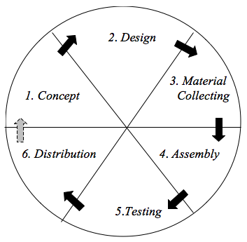

**Figure 1**. Step of MDLC

1. Concept

During the stage of conceptualizing, the objectives, subjects, and product concept were determined and drafted. The intended subjects of this development were elementary school students. The purpose of multimedia development is to facilitate elementary school to access lesson content, work on exercises and quizzes, watch and observe interesting videos related to lesson content. The entire elements were then compiled in a moodle-based LMS.

2. Design

During the stage of designing, the authors created a design of the product based on the pre-determined product development concept in the previous stage. This stage allowed the authors to design the interface of the multimedia and developed it into a storyboard and flow chart.

3. Material Collecting

The next stage was material collecting. This stage allowed the authors to collect some of the required materials for developing the multimedia. In this stage, the authors collected relevant images, illustrations, videos, animations, and audio files to be included in the media.

4. Assembly

After the material required were collected, then it proceeded by assembling and compiling based on the prepared story boards and flow charts. The development of the multimedia in this research utilized Adobe Primary Pro 2019. While to develop e-modules, this research utilized Kvisoft Flipbook Maker and Adobe Flash.

5. Testing

The next phase was testing. The phase of testing aimed at identifying the feasibility of the developed multimedia. It also aimed at testing the media to the intended subject to identify how accessible the media is. In this stage, the developed media underwent two stages of testing, alpha testing and beta testing. Alpha testing aimed at examining the multimedia features such as displays, illustrations, and any technical matter in the multimedia. While beta testing aimed at examining the users’ perceptions, for instance the user’s interest and interaction with the application. Beta testing was conducted by means of questionnaire. To test the product validity, it was examined by the appointed experts (material, media, and language) and also involved the users (teachers and students).

6. Distribution

After the media was declared valid and feasible, the developed product was stored on a moodle-based LMS.

1. Results

Based on the objectives developed and the characteristics of the research subject, then the design was carried out by developing an e-module flowchart and a learning video story board. Flowchart and story board are shown in Figure 2.

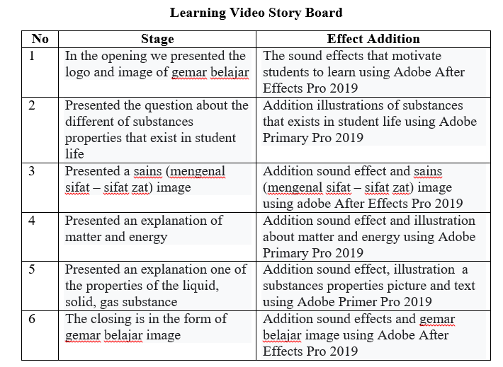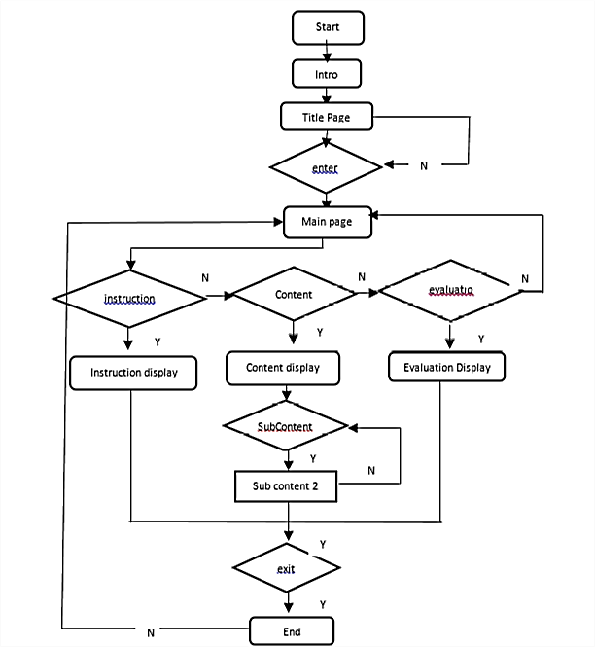

**Figure 2**. The Flowchart of e-module development and video storyboard

An assembly was then carried out to create e-modules and videos by combining the materials that were obtained. Images, energy animation and several buttons were added to the e-Module to direct the learning links to other learning opportunities including children's posts. Animation as representations of substances/objects in the video combined with music. Figure 3 demonstrates the production process.

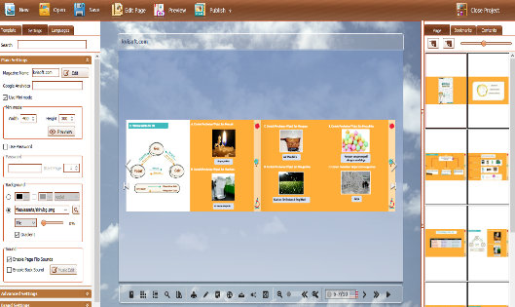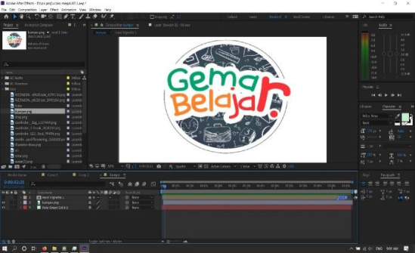

**Figure 3**. Development of learning video using Adobe Prime Pro 2019 and e module use Kvisoft flipbook Maker

The results of the development would be checked by running the multimedia that has been developed. Testing phase of the product was carried out after the product was developed. Testing phase was conducted by running the application. There were two phases at this level, specifically alpha testing and beta testing. The results of the alpha test indicated that all the features in the e-module could be operated correctly and could be easily accessed. Beta testing was done by testing the attractiveness, practicality and accuracy of the media developed. The results of the test are shown in Table 2.

**Table 2.** The result of Beta testing

|  |  |  |  |
| --- | --- | --- | --- |
| No | Aspect | Percentage | Criteria |
| 1 | Material expert | 90% | Very Good |
| 2 | Media expert | 93,8% | Good |
| 3  4  5  6 | Linguist expert  Teacher  Student  Effectiveness | 80,53%  93,96%  92,7%  94% | Very Good  Very Good  Very Good  Very Good |

Based on Table 2, it can be seen that the media developed has been declared valid by users and experts. Then, it proceeded with the distribution stage. This stage was conducted to store multimedia that has been developed. In this study, multimedia that has been developed was included into the Moodle-based LMS (see Figure 4).

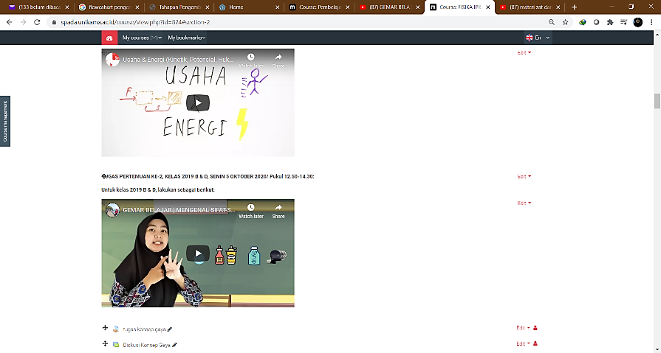

**Figure 4**. The Developed Multimedia in a Moodle-based LMS

1. Discussion

The multimedia e-learning developed was based on setting goals according to the MDLC steps. Multimedia developed in this study were videos and interactive e-modules that could be used by students in online learning / e-learning. The materials contained in the multimedia e-module are videos, images, photos and links to the related material being studied. The results of multimedia development according to experts, teachers and students were declared valid and attractive. This is because multimedia displays images, illustrations and videos that are attractive to students in learning. Interesting learning media could motivate [30] and offers students meaningful learning [31][32]. In addition, the images provided assists students to understand an abstract concept [33]

Also, the link provided allows students to develop their understanding deeper from various learning resources. When students are provided various resources, they are able to enrich their understanding [34]. Therefore, based on the overall discussion, it is concluded that multimedia could improve learning outcomes [35]; improve student learning process [36]; stimulate student learning activities [37]; student learning performance [38].

1. Conclusion

Multimedia development using the MDLC model consists of concept, design, material collecting, assembly, testing, and distribution. Based on the test results, the developed multimedia is declared feasible. Multimedia that has been developed is used in e-learning system by using the Moodle platform which is expected to increase student interest. Students' interest in learning can be increased through interactive and contextual media.

**Acknowledgement**

A deep grateful is addressed to Universitas Kanjuruhan Malang for their full supports in accomplishing this study.

References

[1] E. Dewa, M. Ursula, J. Mukin, and O. Pandango, “Pengaruh Pembelajaran Daring Berbantuan Laboratorium Virtual Terhadap Minat dan Hasil Belajar Kognitif Fisika,” vol. 3, no. 2, pp. 6–7, 2020.

[2] J. Anderson, *Should School Close when Coronavirus Cases are Still Rare? Quartz*. 2020.

[3] T. Azzi-Huck & Shims, *Maning the Impact of COVID-19 on Education System around the World*. 2020.

[4] UNESCO, “Education: Form Distruption to recovery, Scool Clusures Caused by Coronavirus (Covid-19),” 2020. .

[5] M. W. J. Couzin-Frangkel, G. Vogel, *Not open and shut. School openings across the globe suggest ways to keep the coronavirus at bay, despite outbreaks*. 2020.

[6] A. & S. Arora, “Impact of Pandemic COVID-19 on the Teaching-Learning Process: A study of Hhigher Education Teachers. Prabadhan: Indian Journal of Management 13(4),” 2020.

[7] I. Jamil, S.H., & Apriliasanda, “Pengaruh Pmebelajran Daring Terhadap Minat Belajar Mahasiswa Paa Masa Pandemi Covid-19,” *Behav. Account. J. 3(1).*, 2020.

[8] S. Aulia, “Pembelajaran Daring pada Masa Pandemi.,” 2020. https://www.suara.com/yoursay/2020/11/0175556/pembelajaran-daring-pada-masa-pandemi.

[9] R. Aderholt, *CoronaVirus Outbreak Shiningan Even Brighter Light on nternet disparities in Rural America. The Hill.* 2020.

[10] Karp & McGowan, “‘Clear as mud’ Schools ask for online learning help as coronavirus polivy confusion persists Australia news,” *The Guardian*, 2020.

[11] N. Collie, R., Shapka, J., & Perry, *Prediting Teacher Commitment: The Impact of SchoolClimate and Social-Emonational Learning. Psychologycal in the School, 48(10)*. 2011.

[12] M. Najeemah, “School Climate and Teachers’ Commitment: A case study of Malaysia.,” *Int. J. Econ. Bus. Manag. 1(2)*, pp. 65–75, 2012.

[13] &Wardono Dewi, K., “Peningkatan Literasi Matematika mahasiswa Melalui Pembelajaran Inovasi Realistik E-Learning Edmodo Bermuatan Krakter Cerdas Kreativ Mandiri,” *. J. Mat. Kreat. 6(1)*, pp. 93–100, 2015.

[14] D. Lase, “Education in the Fourth Industrial Revolustion Age,” *Jctes*, vol. 1, no. 1, pp. 28–43, 2019.

[15] S. Wardono, Waluya., Mariani, S., & Candra, “Mathematics Literacy on Problem Based Learning with Indonesian Realistic Matematics Edukation Approach Assited E-Learning Edmodo,” *Jounal Phys. Conf. Ser.*, p. 639, 2016.

[16] D. Fitriana, “Peran Media E-Learning dalam Pembelajaran Untuk Mengoptimalkan Kemampuan Literasi Matematika dan Norma Sosiomatematik.,” *Pros. Semin. Nas.*, pp. 58–62, 2020.

[17] M. S. S. B. G. Dan, B. Curless, D. Salesin, “Schematic Storyboarding for Video Visualization and Editing.,” *J. ACM Trans. Graph.*, vol. 25, no. 3, pp. 862–871, 2006.

[18] J. M. S. A. F. Barbara, “A Model for Developing Multimedia Learning Projects (MERLOT),” *J. Online Learn. Teach.*, vol. 6, no. 2, pp. 491–507, 2010.

[19] C. Wang, T. Fang, and Y. Gu, “Learning performance and behavioral patterns of online collaborative learning: Impact of cognitive load and affordances of different multimedia,” *Comput. Educ.*, vol. 143, no. 5, p. 103683, 2020, doi: 10.1016/j.compedu.2019.103683.

[20] D. A. Patterson, “Impact of a multimedia laboratory manual: Investigating the influence of student learning styles on laboratory preparation and performance over one semester,” *Educ. Chem. Eng.*, vol. 6, no. 1, pp. e10–e30, 2011, doi: 10.1016/j.ece.2010.10.001.

[21] S. D. Holubar, J. P. Hassinger, E. J. Dozois, B. G. Wolff, M. Kehoe, and R. R. Cima, “Impact of a Multimedia e-Learning Module on Colon Cancer Literacy: A Community-Based Pilot Study,” *J. Surg. Res.*, vol. 156, no. 2, pp. 305–311, 2009, doi: 10.1016/j.jss.2009.03.099.

[22] C. Adamczyk, M. Holzer, and R. Putz, “Student learning preferences and the impact of a multimedia learning tool in the dissection course at the University of Munich,” *Ann. Anat.*, vol. 191, no. 4, pp. 339–348, 2009, doi: 10.1016/j.aanat.2009.03.003.

[23] S. Aleem, L. F. Capretz, and F. Ahmed, “Game development software engineering process life cycle: a systematic review,” *J. Softw. Eng. Res. Dev.*, vol. 4, no. 1, 2016, doi: 10.1186/s40411-016-0032-7.

[24] R. Ramadan and Y. Widyani, “Game development life cycle guidelines,” *2013 Int. Conf. Adv. Comput. Sci. Inf. Syst. ICACSIS 2013*, pp. 95–100, 2013, doi: 10.1109/ICACSIS.2013.6761558.

[25] M. O. Al-Jabari, T. K. Tamimi, and A.-A. N. Ramadan, “Multimedia Software Engineering Methodology: A Systematic Discipline for Developing Integrated Multimedia and Software Products,” *Softw. Eng.*, vol. 8, no. 1, pp. 1–10, 2019, doi: 10.5923/j.se.20190801.01.

[26] H. Sugiarto, “Penerapan Multimedia Development Life Cycle Pada Aplikasi Pengenalan Abjad Dan Angka,” *IJCIT (Indonesian J. Comput. Inf. Technol.*, vol. Vol.3 No.1, no. 1, pp. 26–31, 2018.

[27] M. Mustika, E. P. A. Sugara, and M. Pratiwi, “Pengembangan Media Pembelajaran Interaktif dengan Menggunakan Metode Multimedia Development Life Cycle,” *J. Online Inform.*, vol. 2, no. 2, p. 121, 2018, doi: 10.15575/join.v2i2.139.

[28] R. I. Borman and Y. Purwanto, “Impelementasi Multimedia Development Life Cycle pada Pengembangan Game Edukasi Pengenalan Bahaya Sampah pada Anak,” *J. Edukasi dan Penelit. Inform.*, vol. 5, no. 2, p. 119, 2019, doi: 10.26418/jp.v5i2.25997.

[29] S. L. Rahayu, Fujiati, and R. Dewi, “Educational Games as A learning media of Character Education by Using Multimedia Development Life Cycle (MDLC),” *2018 6th Int. Conf. Cyber IT Serv. Manag. CITSM 2018*, no. Citsm, pp. 7–10, 2019, doi: 10.1109/CITSM.2018.8674288.

[30] Sudrajat A, *Media Pembelajaran.* surakarta: pustaka belajar, 2008.

[31] F. N. Setiawan, D. A. Shaleha, and P. Ridlatus, “Contextual-Based Animal Encyclopedia : HOTS on Elementary School ’ s Student s,” vol. 417, no. Icesre 2019, pp. 132–137, 2020.

[32] F. Kumala and D. Setiawan, “Local wisdom-based e-encyclopedia as a science learning medium in elementary school,” in *4th Annual Applied Science and Engineering Conference*, 2019, pp. 1 – 7, doi: 10.1088/1742-6596/1402/6/066061.

[33] C. Sundaygara, H. Y. Pratiwi, and M. N. Hudha, “Pengembangan bahan ajar media pembelajaran fisika dengan pendekatan multi representasi untuk meningkatkan kemampuan pembuatan alat-alat praktikum calon guru fisika,” *Momentum Phys. Educ. J.*, vol. 2, no. 2, pp. 86–93, 2019, doi: 10.21067/mpej.v2i2.2709.

[34] J. A. Pereira, E. Pleguezuelos, A. Merí, A. Molina-Ros, M. C. Molina-Tomás, and C. Masdeu, “Effectiveness of using blended learning strategies for teaching and learning human anatomy,” *Med. Educ.*, vol. 41, no. 2, pp. 189–195, 2007, doi: 10.1111/j.1365-2929.2006.02672.x.

[35] S. Aloraini, “The impact of using multimedia on students ’ academic achievement in the College of Education at King Saud University,” *J. King Saud Univ. - Lang. Transl.*, vol. 24, no. 2, pp. 75–82, 2012, doi: 10.1016/j.jksult.2012.05.002.

[36] N. Barzegar, S. Farjad, and N. Hosseini, “The Effect of Teaching Model Based on Multimedia and Network on the Student Learning (Case Study:Guidance Schools in Iran),” *Procedia - Soc. Behav. Sci.*, vol. 47, pp. 1263–1267, 2012, doi: 10.1016/j.sbspro.2012.06.809.

[37] F. Zhang, “Significances of Multimedia Technologies Training,” *Phys. Procedia*, vol. 33, pp. 2005–2010, 2012, doi: 10.1016/j.phpro.2012.05.315.

[38] H. Kassim, H. Nicholas, and W. Ng, “Using a multimedia learning tool to improve creative performance,” *Think. Ski. Creat.*, vol. 13, pp. 9–19, 2014, doi: 10.1016/j.tsc.2014.02.004.