Design and Installation of SME and Households Scale Solar Power Plants (Solar Home System)

Nurhadi Nurhadi1, Muhamad Rifa’i2, Chandra Wiharya3

1 Department of Mechanical Engineering, State Polytechnic of Malang, Jl. Soekarno Hatta 9, Malang 65141, Indonesia

2,3 Department of Electronic Engineering, State Polytechnic of Malang, Jl. Soekarno Hatta 9, Malang 65141, Indonesia

1 nurhadi@polinema.ac.id

**Abstract**. Designing and installing SHS for Small and Medium Enterprises (SME) and the general public is difficult, due to a lack of knowledge, skills, and relatively high costs. This paper describes the procedure for designing and installing SHS and provides a brief and practical reference in determining the appropriate and economical SHS specification. This research uses the method of calculating the SHS specifications based on the electrical load and the method of installing SHS directly at SME CITARA, Malang East Java. The result of this research is the installation of SHS in SME CITARA with 400 WP solar panel capacity, 850 VA controller capacity, 200 AH battery capacity, and 160 AH maximum battery output capacity. The SHS can generate electrical energy per day in bright sunlight conditions on is average of 960 watts for 2 hours of use, or 480 watts for 4 hours, or 160 watts for 12 hours, or 80 watts for 24 hours. Designing an economical SHS installation can be done by shortening the spare time under the theoretically recommended spare time, by looking at the real conditions at the SHS installation site.

**Keywords:** design, installation, SHS, solar power plants, SME CITARA

1. Introduction

An estimated 1.2 billion people around the world don't have access to electricity. Domestic energy poverty is most severe in the rural areas of South Asia, South East Asia, and Sub-Saharan Africa [1], moreover, during the COVID 19 pandemic, many SMEs and communities were affected [2], where SMEs did not produce so there was no income, and the burden of people's lives is getting heavier. One way to overcome this problem is by installing a solar home system as an alternative source of electrical energy. The problem is to design and install SHS for Small and Medium Enterprises (SME) and the poor society is a difficult one, due to a lack of knowledge, skills, and relatively high costs. The design and installation of SHS for SMEs and households is important to provide a brief and practical reference in determining appropriate and economical SHS specifications,

Photovoltaics could play a major role in overcoming domestic energy poverty, especially as most of the affected regions are within the Earth's Sunbelt [1], like Indonesia. The heat of the sun in Indonesia, which has a tropical climate, is very abundant throughout the year, so it is very potential to be developed into a source of electrical energy or a solar power plant (PLTS). Small PLTS for a household is called Solar Home System (SHS) [3]. SHS generally uses 50-100 Wp (Watt peak) solar modules and generates daily electricity of 150-300 W h [3]. Solar panels are power plants capable of converting solar radiation that is converted into electricity [4]. Because the scale is small, it uses a DC (Direct Current) system, so as not to be exposed to losses and self-consumption due to the use of an inverter. With this small system, it is installed in a decentralized manner (one house, one generator) so that it does not need a distribution network. The utilization of a solar PV system will avoid the production of approximately 27 million kg/year of pollutants and will reduce the cost of energy to USD$ 0.08746/kWh at Sudan [5] and about 9728892.115 and 13148128.5 kg/year of pollutants, reduce the cost of energy to USD$ 0.085/kWh at Oman [6]. The design of a stand-alone solar photovoltaic system, including solar panel, charge controller, battery, inverter, and electric load [7], however batteries in SHS can cause problems and costs for the users and/or operators [8]. Solar PV has been widely used as an alternative source of electricity. One of the most prominent applications of solar plants used for pumping systems in rural areas [9]. The solar power system is also used to supply heterogeneous cellular networks with their required energy sources and can satisfactorily meet the energy needs of the base stations (BSs) [10]. Solar PV has been widely used as a building heater known as solar water heating (SWH), like in China and Mexico [11] and [12], while in Soviet, solar energy used to renovate type apartment buildings [13].

The purpose of this study is to provide a brief and practical reference in designing and installing an appropriate and economical SHS installation to drive the biophonic (bio flock and hydro phonic) catfish pond water pump. The existing study of SHS generally provides information in installing SHS by ideal method, for the general public, whereas this article, described how to determine a more precise and economical SHS specification for SMEs and poor society so that it fits their needs and is more affordable because they were affected by the Covid-19 pandemic. The design and installation of SHS that uses sunlight as a source of electrical energy is one solution to the problem of high electricity costs for SMEs and the community during a pandemic.

1. Method

The SHS design method is based on electrical loads. This design method is carried out to determine the size of the solar panels, the battery capacity, and the area required for the installation of solar panels for a solar energy system with a specified maximum capacity. The SHS design steps refer to [14] are as follows:

## Determine the Total Load Current in Ampere-Hours (Ah)

The ampere-hour of the equipment is calculated in DC ampere-hour/day. The load current can be determined by dividing the wattage rating of the various devices under load by the nominal PV system operating voltage.

I total load DC = x hours of use per day (1)

I total load AC = x hours of use per day) / 0.85 (2)

I total load = I total load DC + I total load AC  (3)

Where: I total load = Total load current on Ampere hours (Ah)

## Determine the Losses and System Safety Factors

For PLTS systems with a power of 1000 Watt and below, a factor of 20% must be added to the loading as a replacement for system losses and the safety factor. Therefore the ampere-hour of load specified in step 3.1 is multiplied by 1.20 so that:

Total load + Losses & Safety Factor = I total load x 1,20 (4)

## Determine the worst of Equivalent Sun Hours (ESH)

The sundial equivalent of a place is determined based on the insolation map of the world sun issued by Solarex [15]. Based on the insolation map of the world's sun, it is obtained ESH for the East Java Region = 4.5

## Determine Total Current Requirements for Solar Panels

The total current required for the solar panels is determined by dividing the Total load + losses and safety factor by the ESH.

I total panels = (5)

## Determine the Battery Capacity for Recommended Spare Time

Generally, photovoltaic solar electric systems are equipped with storage batteries to provide energy to the load when operating at night or when the area where solar panels are installed is shown in Table 1.

**Table 1.** The relationship between the installation location and the spare time of PV module [15]

|  |  |
| --- | --- |
| Latitude of installation location | Spare Time (T rec) |
| 0o – 30o (North or South) | 5 – 6 day |
| 30o – 50o (North or South) | 10 – 12 day |
| 50o – 60o (North or South) | 15 day |

Table 1 shown that ideally, based on the insolation map of the world, the location of Indonesia's territory is located at 10o South Latitude - 10o North Latitude. This means that the reserved time for all regions of Indonesia, including East Java, is the same, namely 5 - 6 days.

Capacity Ampere-hour (Ah) minimum of the battery calculated by the equation:

Battery cap. = (I total load x 1,2) x T rec (6)

Where: Battery cap. = Battery capacity (Ah)

T rec = Recommended spare time, varies based on latitude. T rec can be shortened for efficiency and economy by looking at real conditions.

## Determine the Optimum Module Arrangements for Solar Panels

The optimum arrangement is a method that will determine the total current requirement of the panels with the minimum number of modules possible. Determination of the minimum module configuration by calculating the minimum number of modules that provide the required panel current values as follows:

Module parallel = $\frac{I total panel}{ I ops module}$ (7)

where: I total panel is Total current of panels

I op. the module is the current operation of the module

The number of modules arranged in series is determined by:

Module series = $\frac{V system}{/V module}$ (8)

where: V system is the nominal voltage of the system

V module  is the nominal voltage of the module

The total modules required = number of module series x number of module parallel (9)

1. Result and Discussion

## The calculation result

* + 1. *Total Load Current in Ampere-Hours (Ah)*

The load current is determined in DC ampere-hour/day by dividing the wattage rating of the various tools [16] used in SME CITARA, as shown in Table 2.

**Table 2.** The load current used by SME CITARA

|  |  |  |  |  |  |  |
| --- | --- | --- | --- | --- | --- | --- |
| No | Names of Load | Power  (watt) | Number (unit) | Lifetime  (hour) | Watt-hours (W h) | Remarks |
| 1 | Catfish pond water pump | 25 | 1 | 24 | 600 | DC |
| 2 | Lighting | 14 | 2 | 12 | 336 | AC |
|  | Total | | | | 936 |  |

Table 2 shows that the total current load used by SME CITARA is 936 watt-hours, including AC load 600 W h and DC load 336 W h. Refer to equation 3 [14] that I total load = I total load DC + I total load AC, so the I total load = 600 W h + 336 W h = 936 = 936/12 volt = 78 Ah.

* + 1. *The Losses and System Safety Factors*

Total load + Losses & Safety Factor refer to = I total load x 1,20 = 78 Ah x 1,2 = 93,6 Ah

* + 1. *The worst of Equivalent Sun Hours (ESH)*

The ESH for the East Java Region is 4.5 refer to [17].

* + 1. *Total current Panels Photovoltaic (PV)*

I total panels = = = 20,8 A [17].

* + 1. *Total number of modules required*

First, the type of module that will be used must be selected based on the specifications given by the manufacturer/distributor. Polytype module made by Solana, with data of 5.5 amperes operating current and 12 Volt nominal voltage, so that [14]:

The number of modules arranged in parallel = 20,8 Ampere / 5,5 Ampere = 3,78 = 4 unit

The number of modules arranged in series = 12 Volt / 12 Volt = 1 unit

The module = modules parallel x modules series = 4 x 1 = 4 unit

* + 1. *The Minimum Battery Capacity*

By selecting a spare time (autonomy day) for 2 days, obtained: Battery cap = (I total load x 1,2) x T rec = 93,6 Ah/day x 2 day = 187,2 Ah . Then the selected battery capacity is 200 Ah [14].

* + 1. *The area for installing solar panels*

After the number of panels and battery requirements are known, the area required for the installation of the SHS is determined. For a solar panel with a capacity of 100Wp, it has dimensions of 1030 x 700 x 55 mm. If 4 units of panels are required, the area required is: 1030 mm x 2 = 2.060 mm = 2,060 m and 700 mm x 2 = 1.400 mm = 1,4 m

So the area required is approximately 2 x 1.5 square meters, with a panel arrangement pattern as Figure 1.

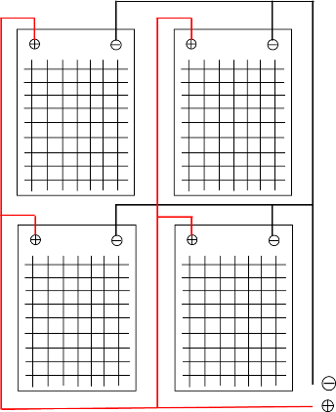

**Figure 1.** Design arrangement of solar panel

Figure 1 shows that 4 unit solar panels are arranged parallelly. With the arrangement, it can be calculated that the area required to install the solar panel is approximately 2 times of length and width of each solar panel.

## Design installation

The design of the SHS installation that is installed is drawn simply using computer software to make it easier to understand the installation as a whole. SHS installation design [17] is shown in Figure 2.

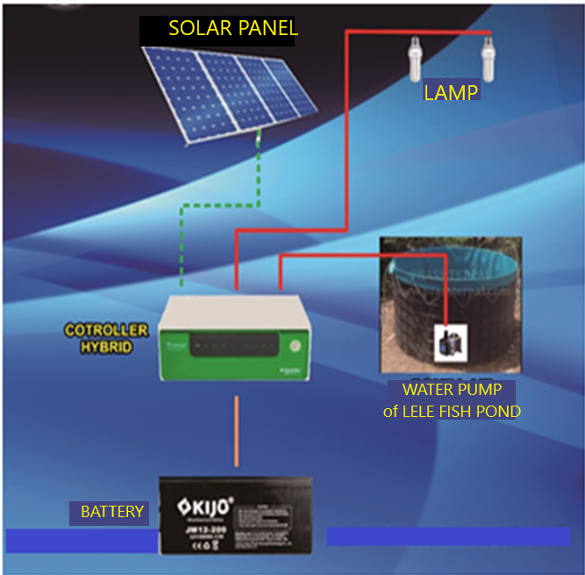

**Figure 2**. Design installation of SHS

Figure 2 shows that the design installation of SHS consists of a solar panel, controller hybrid, battery, and load (water pump and lighting).

## SHS Installation

Commonly, the practice installation of solar PV tends to prefer the Equator-facing orientation due to its maximized energy aggregate [18]. The solar panel of this SHS system is installed in a place that gets the most sunlight throughout the day, namely on the tile, while the battery and controller are installed in a place that is protected from heat and rain so that it is durable, namely inside the house. The installation process of SHS is shown in Figure 3.

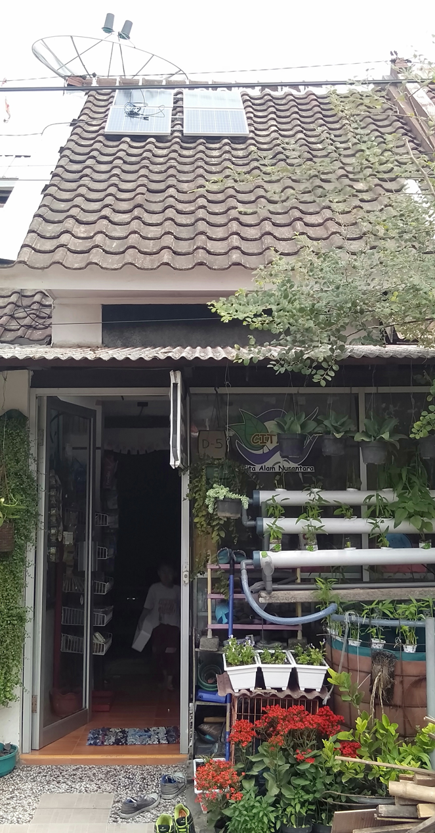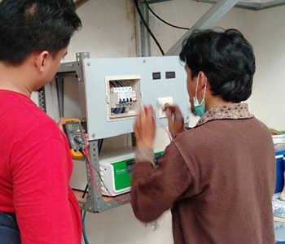

**Figure 3.** The installation process of SHS

Figure 3 shows that the solar panels are installed parallelly at the rooftop that gets the most sunlight during the day, while the battery and controller are installed at the protected place from heat and rain, namely in the house.

1. Conclusion

Designing an SHS required several steps including determine the total load current (Ah), determine the losses and system safety factors, determine the ESH, determine the total current requirements for solar panels, determine the battery capacity, and determine the optimum module arrangements. The SHS system was then installed at UKM CITARA consists of 4 units of solar panels @ 100 WP (400 WP), 1 unit of 850 VA hybrid controller, 1 unit of VRLA 200 AH battery, 2 units of lamps @ 14 watts, MCB switch, voltmeter, and ammeter with. SHS can be used to turn on a biophonic catfish pond water pump for 24 hours/day and turn on 2 lights for 12 hours/day.

Acknowledgment

This study was carried out within the statutory fund of the UPT P2M State Polytechnic of Malang.

References

[1] G. Zubi, F. Spertino, M. Carvalho, R. S. Adhikari, and T. Khatib, "Development and assessment of a solar home system to cover cooking and lighting needs in developing regions as a better alternative for existing practices," *Solar Energy,* vol. 155, pp. 7-17, 2017.

[2] M. I. PRATIWI, "DAMPAK COVID-19 TERHADAP PERLAMBATAN EKONOMI SEKTOR UMKM," *Jurnal Ners,* vol. 4, pp. 30-39, 2020.

[3] D. Dzulfikar and W. Broto, "Optimalisasi pemanfaatan energi listrik tenaga surya skala rumah tangga," in *Prosiding Seminar Nasional Fisika (E-Journal)*, 2016, pp. SNF2016-ERE-73-76.

[4] Z. Iqtimal, I. D. Sara, and S. Syahrizal, "Aplikasi Sistem Tenaga Surya Sebagai Sumber Tenaga Listrik Pompa Air," *Jurnal Karya Ilmiah Teknik Elektro,* vol. 3, 2018.

[5] S. O. Fadlallah and D. E. B. Serradj, "Determination of the optimal solar photovoltaic (PV) system for Sudan," *Solar Energy,* vol. 208, pp. 800-813, 2020.

[6] S. Abdul-Wahab, Y. Charabi, A. M. Al-Mahruqi, I. Osman, and S. Osman, "Selection of the best solar photovoltaic (PV) for Oman," *Solar Energy,* vol. 188, pp. 1156-1168, 2019.

[7] A. Trindade and L. Cordeiro, "Automated formal verification of stand-alone solar photovoltaic systems," *Solar Energy,* vol. 193, pp. 684-691, 2019.

[8] M. Gustavsson and D. Mtonga, "Lead-acid battery capacity in solar home systems—field tests and experiences in Lundazi, Zambia," *Solar energy,* vol. 79, pp. 551-558, 2005.

[9] Y. Kabalci, E. Kabalci, R. Canbaz, and A. Calpbinici, "Design and implementation of a solar plant and irrigation system with remote monitoring and remote control infrastructures," *Solar Energy,* vol. 139, pp. 506-517, 2016.

[10] M. H. Alsharif, "Optimization design and economic analysis of energy management strategy based on photovoltaic/energy storage for heterogeneous cellular networks using the HOMER model," *Solar Energy,* vol. 147, pp. 133-150, 2017.

[11] J. Huang, J. Fan, S. Furbo, and Q. Li, "A policy study on the mandatory installation of solar water heating systems–Lessons from the experience in China," *Solar Energy,* vol. 206, pp. 614-627, 2020.

[12] L. Salgado-Conrado and A. Lopez-Montelongo, "Barriers and solutions of solar water heaters in Mexican household," *Solar Energy,* vol. 188, pp. 831-838, 2019.

[13] K. Valančius and R. Mikučionienė, "Solar energy as a tool of renovating soviet-type multi apartment buildings," *Solar Energy,* vol. 198, pp. 93-100, 2020.

[14] M. Bachtiar, "Prosedur perancangan sistem pembangkit listrik tenaga surya untuk perumahan (solar home system)," *SMARTek,* vol. 4, 2006.

[15] Anonimous, *Discover The Newest World Power, Frederick Court,Maryland USA. Solarex. 1996.*

[16] S. Putra and C. Rangkuti, "Perencanaan Pembangkit Listrik Tenaga Surya Secara Mandiri Untuk Rumah Tinggal," in *PROSIDING SEMINAR NASIONAL CENDEKIAWAN*, 2016, pp. 23-1-23.7.

[17] S. Aryza, H. Hermansyah, A. P. U. Siahaan, S. Suherman, and Z. Lubis, "Implementasi Energi Surya Sebagai Sumber Suplai Alat Pengering Pupuk Petani Portabel," *IT Journal Research and Development,* vol. 2, pp. 12-18, 2017.

[18] H. Awad and M. Gül, "Load-match-driven design of solar PV systems at high latitudes in the Northern hemisphere and its impact on the grid," *Solar Energy,* vol. 173, pp. 377-397, 2018.