**Passively Q-Switched Erbium-Doped Fiber Laser with Graphene Oxide Film**

**as Saturable Absorber**

C Huda [1]*, M Yasin2, A H Zaidan2, SW Harun3, A A A Jafry4, and A H A Rosol3

**Abstract**

Passively Q-switched erbium-doped fiber laser (EDFL) have been demonstrated using graphene oxide (GO) film as saturable absorber (SA). Stable Q-switched operation can be achieved at 1558.8 nm. By increasing the pump power from 26.32mW to 71.65mW, the repetition rate also increased from 30.58 kHz to 51.81k Hz. The pulse width of the laser were 11.2 – 4.73 µs. The maximum output power and maximum peak power obtained are 128 µW and 521.98 µW respectively at a pump power of 71.65 mW. The pulse energy reaches 2.47nJ.

Keywords: Q-switching, graphene oxide saturable absorber, EDFL.

# Introduction

Various SAs were investigated for the generation of Q-switched laser [1,2]. SWCNTs, CNTs, and graphene are among the SAs which were widely used due to their ability to initiate pulsed laser. CNTs and graphene are the ideal SA with the low saturable intensity, low cost, and broad operational bandwidth [3]. Graphene is able to absorb photon in the visible to infrared region [4]. On the other hand, graphene also owns an outstanding optical and electronics properties [5,6] such as ultrahigh charge-carrier mobilities [7], high broadband nonlinearity [8,9], and high specific surface area [10]. Graphene absorber is compatible with broad electromagnetic spectrum due to its nonselective absorption properties.

In recent years, Graphene SA shows interesting characteristics which generates Q-switched laser operations [11–13]. This shows its vital role in optical device applications.

Pulsed laser can be achieved via Q-switched and mode-locked operation. Q-switched initiates the pulses with pulse duration in microsecond to nanosecond. The operation of Q-switched laser is cheaper, less complicated, and efficient in comparison to mode-locked. Passively Q-switched with saturable absorber is more reliable and compact [14], smaller in size, ease of integration, simple fabrication method, and less complicated Q-factor modulation without electro-optic modulator [15]. With a small dimension of graphene film, this work produced a stable and efficient Q-switched from erbium-doped fiber laser cavity.

Pulsed laser is important for biomedical application, sensor, corrective eye surgery, etc [16]. Ultrafast laser is a reliable technique for advance material processing, laser ablation, and steel cutting technology [17].

**Laser Configuration**

Figure 1 shows an erbium-doped fiber laser (EDFL) cavity for the generation of passive Q-switched with graphene oxide as SA. The arrangement of laser cavity is simple with the combination of various optical components which induces pulsed laser [18].

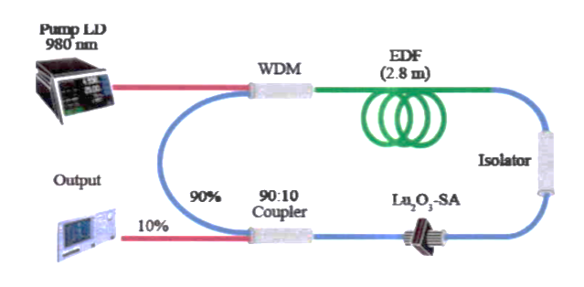

**SA**

**Figure 1**. Experimental setup of Q-switched EDFL

with graphene oxide as saturable absorber.

Erbium-doped fiber (EDF) possess a numerical aperture (NA) of 0.23, absorption coefficient from 23 to 17 dBm, wavelength of 980 nm, core diameter of 5.8 µm, and fiber diameter of 125 µm. The laser diode was pumped through a 980 nm port of 980/1550 nm wavelength-division multiplexer (WDM).

An optical coupler was used to block the laser light from travelling in bidirectional direction hence protecting the laser diode from broken. Later, the signal pass through the SA for the Q-factor modulation which controls the loss inside the cavity. Next, the signal was directed to a 3 dB optical coupler with 10:90 division ratio. 10% of the signal was sent off to the measuring instruments for measurement purposes while the rest of the signal travels back to the 1550 nm port of WDM.

The noise and value of the frequency was measured by radio frequency signal analyzer (RFSA) while the temporal characteristics was observed via a digital oscilloscope with a photodetector (PD). Optical spectrum of the Q-switched laser was captured with an Optical Spectrum Analyzer (OSA). The measurement of output power was recorded with an Optical Power Meter (OPM).

# Result ad Discussion

The experiment shows no Q-switching generation at the pump power below 26.32 mW. By adjusting the laser intensity to 26.32 mW, a stable Q-switched laser was observed. The rise of pump power from the threshold value to 71.65 mW produced a pulse laser with an increase in repetition rate. This shows typical Q-switched laser behavior.

**Figure 2:** Output spectrum of Q-switched EDFL at threshold pump power of 26.321 mW

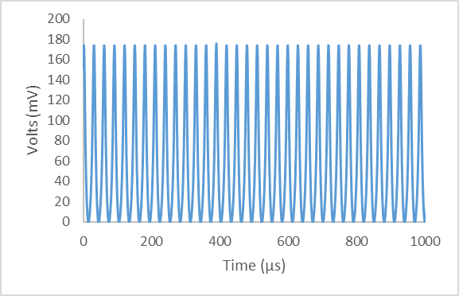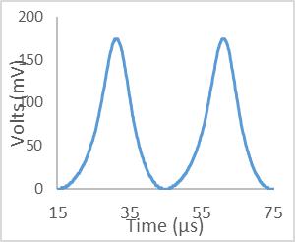

30.1 µs

11.2 µs

**Figure 3:** Oscilloscope pulse train at pump power of 26.321 mW

**Figurer 3** depicts a Q-switched laser at the pump power of 26.321 mW, which shows a typical Q-switched waveform. The Q-switched pulse owns pulses interval of 30.1 μs, repetition rate of 30.58 kHz, and a pulse width of 11.2 μs. The oscilloscope trace shows a stable Q-switched pulse without amplitude modulation. Upon removing thin film graphene from the laser cavity, no pulses were observed within a wide range of pump power (0 to 100 mW). It proved the generation of Q-switched was solely due to the implementation of graphene as SA inside the laser cavity.

**Figure 4:** Repetition rate and pulse width of Q-switched EDFL within 26.321 – 71.652 mW.

**Figure 4** depicts the relationship between pump power and repetition rate at the pump power variation of 26.321 mW to 71.652 mW. The repetition rate increases from 30.58 to 51.81 kHz. The increase in repetition rate relates to the saturation of SA as the pump intensity increased. On the other hand, the pulse width decreases as the pump intensity increased. This is due to the increase in the photon number inside the laser cavity which causes the saturation of SA [4]. The minimum pulse duration is 4.733 µs.

**Figure 5:** Output power and pulse energy of Q-switched EDFL within 26.321 – 71.652 mW

**Figure 5** illustrates the relationship between average output power and pulse energy with pump power. As observed in the graph, average output power and pulse energy increases with the rise of pump power.The output power increases linearly from 0.021 to 0.128 mW at the pump power of 26.321 – 71.652 mW. The maximum pulse energy was 2.47056 nJ at the maximum pump power of 71.652 mW. The increase in pump power makes the average output power and pulse energy to increase while the pulse width decreases.

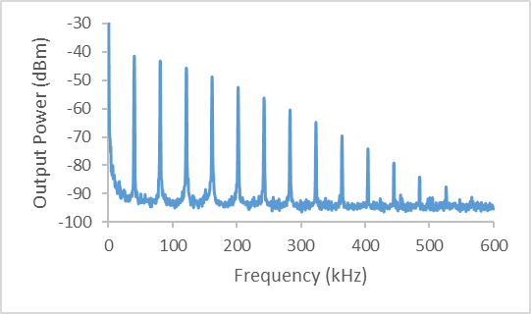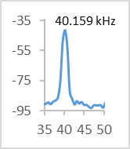

52 dB

|  |  |  |  |  |  |  |  |  |  |
| --- | --- | --- | --- | --- | --- | --- | --- | --- | --- |
|  |  |  |  |  |  |  |  |  |  |
|  |  |  |  |  |  |  |  |  |  |
|  |  |  |  |  |  |  |  |  |  |
|  |  |  |  |  |  |  |  |  |  |
|  |  |  |  |  |  |  |  |  |  |
|  |  |  |  |  |  |  |  |  |  |

**Figure 6:** RF spectrum at pump power of 42.805 mW

**Figure 6** shows a RF spectrum with a signal to noise ratio (SNR) of 52 dB and the fundamental frequency of 40.159 kHz. A high SNR shows a stable Q-switched laser generation, which was comparable to other Q-switched laser such as CNT dan graphene-based fiber laser [19,20].

# Conclusion

The implementation of Graphene oxide as SA has successfully produced a stable pulsed laser. The SA device incorporated into EDFL generates a Q-switched at the pump power of 26.32 mW to 71.65 mW. Passive Q-switched EDFL operates at a wavelength of 1558.8 nm. By adjusting the pump power, the repetition rate increases from 30.58 kHz to 51.81 kHz and the pulse width decreases from 11.2 to 4.733 µs. The maximum pulse energy captured was 2.47 nJ at the pump power of 71.65 mW. This works shows the ability of graphene oxide to generate a pulse laser in EDFL cavity.

# References

[1] Alim S, Vejayan J, Yusoff M M and Kafi A K M 2018 Recent uses of carbon nanotubes & gold nanoparticles in electrochemistry with application in biosensing: a review *Biosens. Bioelectron.* **121** 125–36

[2] Sakakibara Y, Rozhin A G, Kataura H, Achiba Y and Tokumoto M 2005 Carbon nanotube-poly (vinylalcohol) nanocomposite film devices: Applications for femtosecond fiber laser mode lockers and optical amplifier noise suppressors *Jpn. J. Appl. Phys.* **44** 1621

[3] Bao Q, Zhang H, Wang Y, Ni Z, Yan Y, Shen Z X, Loh K P and Tang D Y 2009 Atomic‐layer graphene as a saturable absorber for ultrafast pulsed lasers *Adv. Funct. Mater.* **19** 3077–83

[4] Mat F C, Yasin M, Latiff A A and Harun S W 2017 Graphene oxide film as a passive q-switcher in an erbium-doped fiber laser cavity *Photonics Lett. Pol.* **9** 100–2

[5] de Abajo F J G 2013 Graphene nanophotonics *Science (80-. ).* **339** 917–8

[6] Grigorenko A N, Polini M and Novoselov K S 2012 Graphene plasmonics *Nat. Photonics* **6** 749–58

[7] Bolotin K I, Sikes K J, Jiang Z, Klima M, Fudenberg G, Hone J ea, Kim P and Stormer H L 2008 Ultrahigh electron mobility in suspended graphene *Solid State Commun.* **146** 351–5

[8] Hendry E, Hale P J, Moger J, Savchenko A K and Mikhailov S A 2010 Coherent nonlinear optical response of graphene *Phys. Rev. Lett.* **105** 97401

[9] Lim G-K, Chen Z-L, Clark J, Goh R G S, Ng W-H, Tan H-W, Friend R H, Ho P K H and Chua L-L 2011 Giant broadband nonlinear optical absorption response in dispersed graphene single sheets *Nat. Photonics* **5** 554–60

[10] Schedin F, Geim A K, Morozov S V, Hill E W, Blake P, Katsnelson M I and Novoselov K S 2007 Detection of individual gas molecules adsorbed on graphene *Nat. Mater.* **6** 652–5

[11] Sun Z, Hasan T, Torrisi F, Popa D, Privitera G, Wang F, Bonaccorso F, Basko D M and Ferrari A C 2010 Graphene mode-locked ultrafast laser *ACS Nano* vol 4 pp 803–10

[12] Yao B C, Rao Y J, Huang S W, Wu Y, Feng Z Y, Choi C, Liu H, Qi H F, Duan X F, Peng G D and Wong C W 2017 Graphene Q-switched distributed feedback fiber lasers with narrow linewidth approaching the transform limit *Opt. Express* **25** 8202

[13] Aziz N A, Jusoh Z, Loman M Q, Yasin M, Hanafi E and Harun S W 2017 Q-switched erbium-doped fiber laser with graphene oxide embedded in PMMA film *Dig. J. Nanomater. Biostructures* **12** 325–30

[14] Rusdi M F M, Mahyuddin M B H, Latiff A A, Ahmad H and Harun S W 2018 Q-switched erbium-doped fiber laser using cadmium selenide coated onto side-polished d-shape fiber as saturable absorber *Chinese Phys. Lett.* **35** 104201

[15] Rahman M F A, Latiff A A, Rusdi M F M, Dimyati K and Harun S W 2019 Passively Q-switched fibre laser utilizing erbium-doped fibre saturable absorber for operation in C-band region *J. Mod. Opt.* **66** 235–9

[16] Nishizawa N 2014 Ultrashort pulse fiber lasers and their applications *Jpn. J. Appl. Phys.* **53** 090101

[17] Sugioka K and Cheng Y 2014 Ultrafast lasers-reliable tools for advanced materials processing *Light Sci. Appl.* **3**

[18] Panasenko D, Polynkin P, Polynkin A, Moloney J V, Mansuripur M and Peyghambarian N 2006 Er-Yb femtosecond ring fiber oscillator with 1.1-W average power and GHz repetition rates *IEEE Photonics Technol. Lett.* **18** 853–5

[19] Boguslawski J, Sotor J, Sobon G, Kozinski R, Librant K, Aksienionek M, Lipinska L and Abramski K M 2015 Graphene oxide paper as a saturable absorber for Er-and Tm-doped fiber lasers *Photonics Res.* **3** 119–24

[20] Ahmad H, Muhammad F D, Zulkifli M Z and Harun S W 2013 Q-switched pulse generation from an all-f iber distributed Bragg reflector laser using graphene as saturable absorber *Chinese Opt. Lett.* **11** 71401

1. *Department of Physics, Faculty of Science and Technology, Airlangga University, Surabaya (60115) Indonesia; Department of Physics Education, Faculty of Science and Technology, Universitas PGRI Kanjuruhan Malang, Malang, Indonesia*

   *2Department of Physics, Faculty of Science and Technology, Airlangga University, Surabaya (60115) Indonesia*

   *3Photonics Engineering Laboratory, Department of Electrical Engineering, University of Malaya, 50603 Kuala Lumpur, Malaysia*

   *4Department of Physics, Faculty of Science, Universiti Teknologi Malaysia, 81310 Skudai, Johor, Malaysia, Malaysia*