**Low carbon learning: Logical framework in learning process at elementary schools**

Muhammad Nur Hudha1)2), Ida Hamidah1), Iwan Kustiawan1), Anna Permanasari1), Putri Setiani3), and Ade Gafar Abdullah1)

1) Universitas Pendidikan Indonesia, Jl. Dr. Setiabudi 229, Bandung 40154, Indonesia

2) Universitas Kanjuruhan Malang, Jl. S. Supriadi no 48, Malang 65148, Indonesia

3) Environmental Engineering, Faculty of Agricultural Technology, Brawijaya University, Indonesia

**Abstract**. This study aims to identify learning content of low carbon at elementary school level in Indonesia. The method employed in this study was a combination between systematic literature review and content analysis. The results showed that low carbon content at elementary schools was mapped and presented in a simple structure so that the substantial aspects of the learning was easier to understand by the elementary school students. It has also been proven that low carbon learning content was beneficial to develop in learning within elementary school context as it trained the students to get used to living in low carbon since early ages.

**Introduction**

Education plays an important role in climate change [1]. Some of the most recent global issues in environment are global warming and climate change due to greenhouse effect [2]. Based on the data from the Ministry of Environment, Republic of Indonesia, there four types of greenhouse gases categorized to have a significant impact to the earth average temperature, namely carbon dioxide (CO2), methane (CH4), nitrogen oxide (N2O), and perfluorocarbon (PFC). However, the most predominantly affecting gasses are carbon dioxide (CO2) and methane (CH4) [3].

Such a condition causes the need to focus environmental education on low carbon learning as it is crucial to implement in education [4]. This is also due to the fact that greenhouse effect keeps increasing [5]. Nowadays, low carbon learning strategies are an effective way to deal with the improvement of carbon emission. Within the context of education, introducing low carbon concepts are a strategy in preventing low carbon in early childhood. Studies have shown that students’ knowledge regarding climate change is low and that there are some of them share the same opinion that ozone depletion is equal to climate change [6] [7].

Low carbon concepts have been studied by researchers in such fields as energy [8], technology [9], electricity [10], transportation [11], food and nutrition [12], and so on. There has also been a study of low carbon in education [13], even one conducted in Indonesia [2]. To this relation, content mapping of the low carbon was related to the substantial matters of the low carbon constructed into learning material [14]. However, there is very limited number of studies implementing the content mapping of low carbon in elementary education. This study aims to map low carbon learning content in elementary schools in Indonesia. Such mapping is important to carry out in order to have appropriate learning outcome. In Malaysia, for instance, low carbon concepts are taught on power and water saving subject matter [15].

**Method**

This study combined systematic literature review and content analysis [16]. The literature reviewed in this study included books (learning material observation), literature, and scientific articles on low carbon content [14] [17]. Meanwhile, research data were low carbon content from a variety of studies and book reviews (26 elementary education science textbooks from 10 different publishers taught in Indonesia and published from 2017 to 2020). The data were then analyzed and synthesized into a structured framework of scientific information.

**Results and Discussion**

Awareness of the importance of climate change can actually be enhanced by inserting the topic into school curriculum in order to filter misleading information [18]. However, there are a lot of teachers with lack of readiness to integrated knowledge, action, and content, which are the signature of climate change education, particularly in science in which the knowledge tends to be factual [19]. Therefore, we mapped out the content framework related to climate change content in low carbon learning in elementary schools based on the existing curriculum in Indonesia. The logical framework is presented in Figure 1.

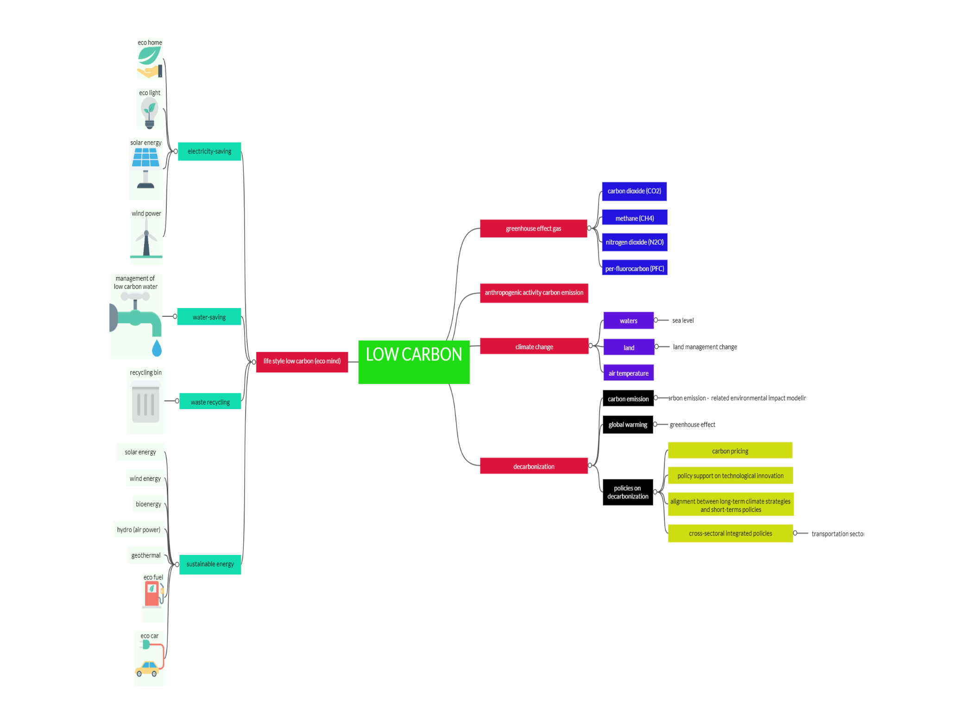

**Figure 1. Low carbon learning framework in elementary schools**

In Indonesia, the curriculum of elementary education required science to be taught thematically as it has to be integrated with other subjects. Figure 1 shows that some of the sub-topics have actually been taught in elementary education, some of which are energy, power saving, water cycle, and waste. However, the topics are scattered from grade 4 to grade 6. The low carbon learning is intended to be implemented in grade 6 as the students in this grade are considered having better knowledge in comparison with those from other grades [20].

The focus of this low carbon learning is mainly on definition and introduction of low carbon to the elementary school students. The introduction will have examples they easily find in their daily life. For instance, they are told to save the energy (AC, TV, refrigerator, etc.), the use of vehicles, and to have adequate knowledge on carbon in the household. The designed learning is also intended to explain the impacts of carbon emission in climate change. They are going to be informed that the emission leads to environmental issues and that the carbon emission is measurable through a mathematical model. The model is presented in equation 1 [3][21].

$I=P ×A ×T$………………………………………………………………………………………………………….(1)

In which

I = impact

P = population

A = affluence

T = technology

In addition, determining carbon emission from each of the vehicles is also discussed in the learning. The emission of each vehicle can be calculated in the following equation 2.

$Vehicle Emission=Fuel Consumption x Emission Factor$……………………………………………………………(2)

Based on the guidelines from the Office of National Development Planning (BAPPENAS), in 2014 [22], the emission factor of CO2 of the fuel (premium, pertalite, pertamax) in Indonesia was as much as 2.6 Kg CO2 /liter, and that of the solar was 2.2 Kg CO2 /liter. The guideline enables us to determine the fuel consumption of CO2 for a certain distance.

In addition to mathematical understanding, the low carbon learning also tries to instill conceptual and procedural understanding of each sub-chapter through discussion. It is believed that learning through collaborative discussion is able to enhance students’ conceptual understanding [23]. It is expected that students have find it easier to either understand or apply the low carbon concepts in their daily life. It is also expected that both the teachers and the students have more enthusiasm as well as knowledge in relation to climate change in elementary education through low carbon learning as schools are a place giving students knowledge, skills, behaviors, and actions particularly related to issues of environment such as global warming and greenhouse effect [24].

**Conclusion**

Environment education needs to put more focus on low carbon learning at school, starting from elementary education. Low carbon learning is expected to be able to create younger generation with better understanding on environmental issues as the impacts of both global warming and climate change are getting worse overtime. Low carbon learning content in elementary schools in Indonesia have actually been implied in the curriculum. However, this paper explained how the low carbon learning content could be implemented in elementary education based on logical framework from literature study.

**References**

[1] Molthan-Hill P, Worsfold N, Nagy G J, Leal Filho W and Mifsud M 2019 Climate change education for universities: A conceptual framework from an international study *J. Clean. Prod.* **226** 1092–101

[2] Amin M S, Permanasari A and Hamidah I 2020 Integrasi low carbon education dalam kurikulum pendidikan calon guru IPA di Indonesia sebagai upaya tantangan ekologis di masa depan *JIPI (Jurnal IPA dan Pembelajaran IPA)* **4** 231–43

[3] Setiani P 2020 *Sains Perubahan Iklim* ed L I Darojah (Jakarta: Bumi Aksara)

[4] Hudha M H, Hamidah I, Permanasari A, Abdullah A G, Rachman I and Matsumoto T 2020 Low Carbon Education: A Review and Bibliometric Analysis *Eur. J. Educ. Res.* **9** 319–29

[5] Jiang Y, Asante D, Zhang J and Cao M 2020 The effects of environmental factors on low-carbon innovation strategy: A study of the executive environmental leadership in China *J. Clean. Prod.* **266** 121998

[6] Andersson B and Wallin A 2000 Students’ understanding of the greenhouse effect, the societal consequences of reducing CO2 emissions and the problem of ozone layer depletion *J. Res. Sci. Teach.* **37** 1096–111

[7] Svihla V and Linn M C 2012 A Design-based Approach to Fostering Understanding of Global Climate Change *Int. J. Sci. Educ.* **34** 651–76

[8] Li H qiang, Wang L mao, Shen L and Chen F nan 2012 Study of the potential of low carbon energy development and its contribution to realize the reduction target of carbon intensity in China *Energy Policy* **41** 393–401

[9] Anbumozhi V, Kalirajan K, Impact T and Agreement P 2017 *Globalization of Low-Carbon Technologies* (Springer)

[10] Wang L, Wei Y M and Brown M A 2017 Global transition to low-carbon electricity: A bibliometric analysis *Appl. Energy* **205** 57–68

[11] Harto C, Meyers R and Williams E 2010 Life cycle water use of low-carbon transport fuels *Energy Policy* **38** 4933–44

[12] Batlle-Bayer L, Bala A, Aldaco R, Vidal-Monés B, Colomé R and Fullana-i-Palmer P 2021 An explorative assessment of environmental and nutritional benefits of introducing low-carbon meals to Barcelona schools *Sci. Total Environ.* **756** 143879

[13] Phang F A, Wong W Y, Ho C S, Musa A N, Fujino J and Suda M 2016 Iskandar Malaysia Ecolife Challenge: low-carbon education for teachers and students *Clean Technol. Environ. Policy* **18** 2525–32

[14] Amin M S, Permanasari A and Setiabudi A 2019 Strengthen the student environmental literacy through education with low carbon education teaching materials *J. Phys. Conf. Ser.* **1280**

[15] Phang F 2016 Iskandar Malaysia Ecolife Challenge: low-carbon education for teachers and students *Clean Technol. Environ. Policy* **18** 2525–32

[16] Khirfan L, Mohtat N and Peck M 2020 A systematic literature review and content analysis combination to “shed some light” on stream daylighting (Deculverting) *Water Secur.* **10** 100067

[17] Mazaya M S 2019 Logical framework for smart discussion in learning process *J. Phys. Conf. Ser.* **1157**

[18] Hess D J and Collins B M 2018 Climate change and higher education: Assessing factors that affect curriculum requirements *J. Clean. Prod.* **170** 1451–8

[19] Oversby J 2015 Teachers’ Learning about Climate Change Education *Procedia - Soc. Behav. Sci.* **167** 23–7

[20] Amin M S, Permanasari A, Setiabudi A and Hamidah I 2020 Menakar Level Literasi Low Carbon Siswa Sekolah Dasar dalam Aktivitas Kehidupan Sehari-Hari *Titian Ilmu J. Ilm. Multi Sci.* **12** 49–57

[21] Ehelich P R and Holdeen J P 1971 Impact of population growth *Obstet. Gynecol. Surv.* **26** 769

[22] Zacky A, Supriyadi A, R A, Kusumawanto A, Wicaksono A, Maeztri D, Wijaya E, Saptyani G, Manik K, Ambarsari L, Suhud M, W R T, Sirait S D, Thamrin S and Nugroho W A 2014 *Pedoman Teknis Perhitungan Baseline Emisi Gas Rumah Kaca Sektor Berbasis Energi* (Jakarta: Badan Perencanaan Pembangunan Nasional (BAPPENAS))

[23] Farrokhnia M, Pijeira-Díaz H J, Noroozi O and Hatami J 2019 Computer-supported collaborative concept mapping: The effects of different instructional designs on conceptual understanding and knowledge co-construction *Comput. Educ.* **142**

[24] Handayani R D and Putra P DA 2019 Student Cognition in the Context of a Climate System: Global Warming and Greenhouse Effect *Momentum Phys. Educ. J.* **3** 69–77