Prediction on the Multiplet Energy Diagram of α-Al2O3: Mn4+ under Pressure

Mega Novita1, Dian Marlina2, Haryo Kusumo3, Muchamad Taufiq Anwar4, Kazuyoshi Ogasawara5

1Faculty of Engineering and Informatics, Universitas PGRI Semarang, Jl. Sidodadi-Timur No.24 Semarang, Central Java 50232, Indonesia

2Faculty of Pharmacy, Universitas Setia Budi, Jl. Letjen Sutoyo, Mojosongo, Kec. Jebres, Kota Surakarta, Central Java 57127, Indonesia

3Department of Informatics Management, Universitas Stekom, Jl. Majapahit 605, Kec. Pedurungan, Semarang, Central Java 50192 Indonesia

4Faculty of Information Technology, Universitas Stikubank, Jl. Trilomba Juang No 1 Semarang, Central Java 50241, Indonesia

5School of Science and Technology, Kwansei Gakuin University, 2-1 Gakuen Sanda, Hyogo 669-1337, Japan

[novita@upgris.ac.id](mailto:novita@upgris.ac.id)

**Abstract**. To review the recommendations for the production of novel red phosphor materials, in this work we established the multiplet energy diagram of Mn4+ in α-Al2O3 under pressure. By the discrete variational multi-electron (DVME), the calculations were conducted based on many-electron approaches. Since the experimental data of Mn4+ in α-Al2O3 atzero pressure was theonly data reported so far, the results in this work are our predictions. The effect of increasing pressure is naturally similar with the effect of decreasing bond length. This work indicates that the multiplet energies responsible for the absorption process increase as the pressure increase. Whereas, those responsible for the emission process decrease. These tendencies are the same as our previous calculations on α-Al2O3: Cr3+.

1. Introduction

Previously we have calculated the optical properties of transition metal (TM) 3d3 ions doped in materials. They are V2+, Cr3+ and Mn4+ doped oxides such as MgO, MgTiO4, α-Al2O3. The investigations were about the ionic dependence on the lattice relaxation, energy correction, cluster size on the bond length, optical properties and the multiplet energies. In all cases, we found out that the absorption bands, *i.e*., the transition energies from ground state 4A2 to 4T2 to 4T1a, namely U and Y bands, rise in the order of V2+, Cr3+ and Mn4+ [1–3]. It indicates that Mn4+ exhibits highest absorption energy among these ions. Many studies reported that Mn4+ doped compounds deep red emission under visible-light excitation. The emitted light originates from the transition energy from 2E state to the ground state 4A2 (R-line). In the host crystal dependency analysis such as Mn4+-doped hexafluoro family (A2BF6) crystals reveals that the energies of the absorption bands increased when the Mn-F bond length decreased, while the energy of the emission line decreased [4,5].

Mn4+ has a high potential to be commercially used in lighting industry replacing the rare earth -doped phosphors. For example, europium (Eu) activated in nitrides and oxynitrides [6,7], because their excellent riches, they are the most commercialized. The non-rare earth Mn4+ ion activated red phosphor is an alternative with desirable properties and not as expensive as those including rare earth ion. Especially, Mn4+ activated in fluorides and oxides have gained great interest. Based on the observed spectra, the red emission of Mn4+ activated in phosphors is peaking at ~630 nm [8–15]. Regretfully, as far as high temperatures and high humidity are concerned, they are unstable. A more stable host material such as oxide is required, as described above. However, their emission wavelength shorter than those in fluoride host, the shortest emission wavelength is about 650 nm [16]. Thus, it is important to establish guidelines to control the emission wavelength by the multiple energy levels. Basically, there are unlimited number of combination of substituting ion and the host crystal, the trial and error experiments are rather ineffective. Therefore, here we try to establish guidelines based on Mn4+ doped compounds. Here, the applied pressures were naturally similar with the decreasing bond length. A practical energy diagram was constructed. Rather recently, we have published a non-empirical analysis focused on first-principles calculations on ruby, Cr3+ doped in α-Al2O3. The pressure dependency on its molecular orbital and multiplet energies was investigated [17–21]. Here, similar investigation was performed in α-Al2O3: Mn4+. Since the observed data reported so far was only for zero pressure, the results reported here are our prediction.

1. Methods

Two types of clusters were generated, *i.e*., no relax and CASTEP clusters, consisting of 15 aluminiums and 48 oxygens (Al15O4851-). Based on crystal structure data of α-Al2O3 with different pressures from 0-113 GPa, no-relax cluster was generated. The Mn4+ was substituted in the centre of the clusters. On the other hand, the CASTEP clusters were generated by performing first-principles band-structure calculations on α-Al2O3 at 0 pressure. First, we performed a structural optimization on the initial unit cell obtained from with ICSD #75560. Second, the pressure was applied from 0-120 GPa. Third, one Mn4+ ion was substituted into one Al3+ site. The detailed procedures to obtained the CASTEP clusters were similar with those used in Refs. [22,23]. After the MnAl14O4852- clusters were developed, the first-principle calculations were performed using the discrete variational multi electron (DVME) method. There are two steps *i.e.,* (1) the one-electron approach-based molecular orbital (MO) calculations using the discrete variational Xα (DV-Xα) method and (2) the many-electron approach-based multiplet energy calculations using the configuration interaction (CI) method. In order to increase the accuracy, the energy correction called configuration dependence correction and correlation correction (CDC-CC) was also used here. Originally, the detail procedure of these methods were explained in Refs. [24] and Refs. [25], for DV-Xα and DVME methods respectively.

1. Results and discussion

The pressure dependency on the MO of α-Al2O3: Mn4+ is shown in Figure 1. It was calculated based on clusters which (a) neglecting the effect of lattice relaxation and (b) taking into account the effect of lattice relaxation based on CASTEP code. The conduction bands (CB) are distinguished by dashed black lines which composed predominantly of aluminum orbitals 3*s*, 3*p*, and 3*d*. Whereas the solid black lines mark the valence bands (VB) that consisting predominantly of oxygen orbitals 2*p*. In this case, the highest value of VB is set up at zero. The solid blue lines represent the *t*2*g* orbitals, while the *eg* orbitals are represented by dashed red lines. Here, the *t*2*g*, *eg*, and CB lines are fitted by polynomial function. In the case of no-relax clusters, the *t*2*g* and *eg* orbitals increase from 1.565 to 2.323 eV and from 3.838 to 5.499 eV, respectively. The 10*Dq* increase from 2.272 to 3.176 eV, where the conduction band increase from 10.626 to 14.291 eV. On the other hand, the *t*2*g* and *eg* orbitals rise from 0.560 to1.593 eV and from 2.548 to 4.240 eV, respectively, in the case of CASTEP clusters. The crystal field splitting 10*Dq* increase from 1.988 to 2.775 eV, while the conduction band increase from 7.272 to 12.946 eV. Here, we can also see that the bandgap between the highest *eg* orbital and lowest CB becomes smaller in the calculations based on CASTEP clusters. The bandgaps for no-relax and CASTEP clusters increase from 6.784 to 8.787 eV and from 4.702 to 8.367 eV. However, here the lattice-relaxation effect was dominant in the clusters with lower pressure.

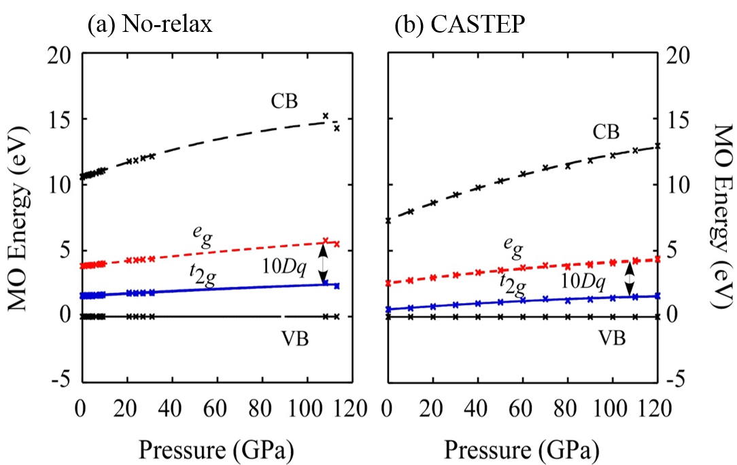

**Figure 1.** Molecular orbital energy of α-Al2O3: Mn4+ under pressure obtained from calculations based on (a) no-relax cluster and (b) CASTEP cluster.

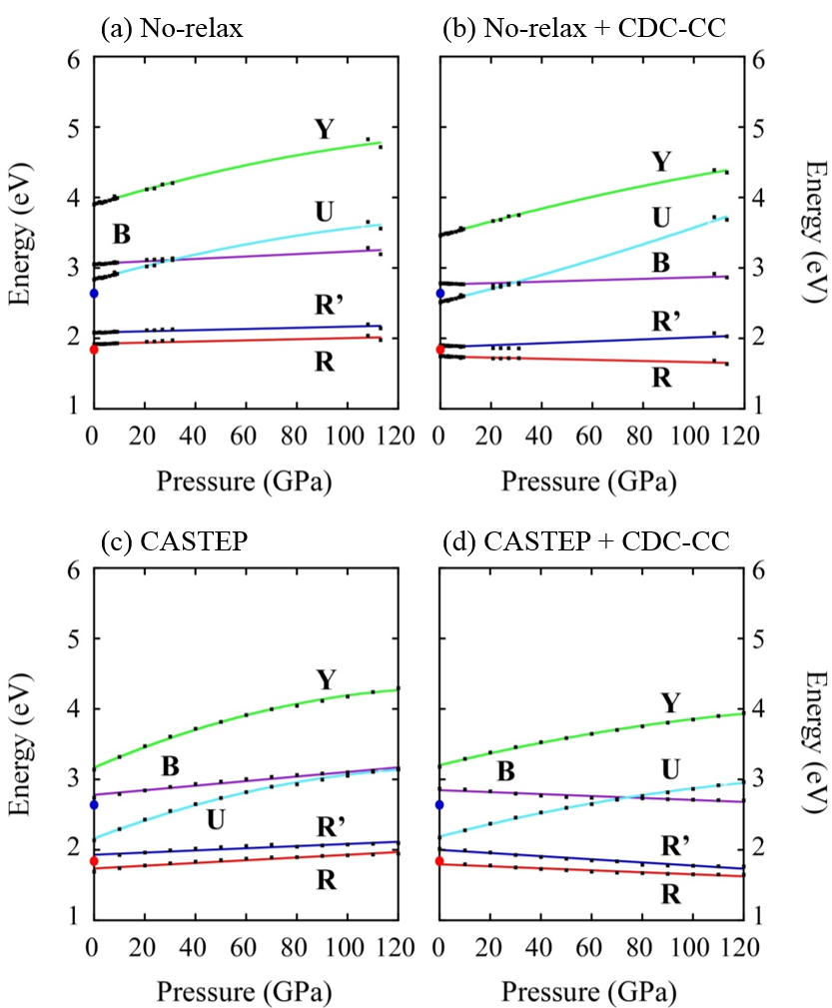

**Figure 2.** Schematic diagram of α-Al2O3: Mn4+ multiplet energy under pressure calculate from (a) no-relax cluster, (b) no-relax cluster with CDC-CC correction, (c) CASTEP cluster and (d) CASTEP cluster with CDC-CC correction.

The calculated multiplet energies of Mn4+ in α-Al2O3 under pressure as shown in Figure 2. They are emission R, R’, and B lines which correspond to the transition energies from 2E, 2T1,and 2T1 states to the ground state 4A2, respectively. The U and Y absorption bands refer to transition energies from the ground state 4A2 to 4T2 and 4T1a states, respectively. The experimental data for 0 GPa was obtained from Ref. [26]. The R-line was observed at ca. 1.84 eV, while the U-band was observed at ca. 2.64 eV. In our calculations based on no-relax clusters neglecting the CDC-CC correction, all of the emission R-, R-, B-lines and the absorption U-, Y-bands increase from 1.92 to 1.98 eV, from 2.08 to 2.14 eV, from 3.05 to 3.19 eV, from2.84 to 3.56 eV and from 3.90 to 4.72 eV for pressure from 0-113 GPa. On the other hand, based on no-relax clusters with taking into consideration the CDC-CC correction for the same pressure, the emission R- and R’- lines decrease from 1.75 to 1.55 eV and from 1.90 to 1.72 eV, respectively. But increase from 2.78 to 3.36 eV for B-line. The absorption U- and Y-bands rise from 2.52 to 2.65 eV and from 3.46 to 4.33 eV, respectively. In the calculations based on CASTEP clusters neglecting the CDC-CC correction for pressure from 0-120 GPa, all of the multiplet energies increase from 1.69 to 1.95 eV, from 1.88 to 2.10 eV, from 2.74 to 3.14 eV, from2.14 to 3.16 eV and from 3.14 to 4.29 eV for R-, R-, B-, U-, and Y-bands respectively. When the CDC-CC correction was taken into account, the emission R-, R’-, and B-lines decrease from 1.81 to 1.65 eV, from 2.012 to 1.76 eV, from2.87 to 2.70 eV. The absorption bands rise from 2.17 to 2.96 eV and from 3.18 to 3.94 eV for U- and Y-bands, respectively, for the same pressure.



**Figure 3.** Optical properties of α-Al2O3: Mn4+ (a) bond-length, (b) *J*AO, (c) *J*MO, (d) *c* factor, (e) orbital deformation parameter λ and (f) *J*eff.

When we consider lattice relaxation using CASTEP code, however, the zero pressure theoretical energies of R-line and U-band were underestimated. The increasing pattern in absorption energies was mainly due to the increasing crystal field splitting, which was strongly related to the local structure. The two types of bond lengths in α-Al2O3 at zero pressure were 1.871 and 1.993 Å for *d*1 and *d*2, respectively. As shown in Figure 3(a), they decrease continuously up to 1.695 and 1.806 Å at 113 GPa. After the Mn4+ substitution, the Mn-O bond length *d*1 decrease from 1.919 to 1.764 Å, the *d*2 decrease from 1.987 to 1.848 Å. Next, in the case of emission energies, they decrease mainly due to the decreasing of effective Coulomb integral(Jeff). the Coulomb integrals for atomic orbital (*J*AO), the molecular orbital (*J*MO), and the effective Coulomb integral (*J*eff) are all seen in Figure 3. The *J*AO was obtained from the weighted Racah parameters, while the *J*MO was obtained for each impurity orbital *t*2*g* and *eg* states. The *J*eff was acquired from the multiplication of *J*AO, c factor, and the orbital deformation parameter λ [27,28]. Our calculations show that the *J*AO increase from 24.22 to 24.65 eV, *J*MO for *t*2*g* and *eg* increase from 17.67 to 19.56 eV, and from 17.47 to 18.37 eV, respectively. Therefore, as the ratio of *J*AO and *J*MO, λ of *t*2*g* and *eg* slightly increase from 0.73 to 0.79 eV and from λ 0.72 to 0.75 eV, respectively. The *c* factors, which are coefficient determined as the consistency between one-electron and many-electron approach, decrease for no-relax and CASTEP clusters from 0.9171 to 0.8043 and from 1.06347 to 0.84586 eV, respectively. Thus we obtained *J*eff of *t*2*g* and *eg* decrease from 18.79 to 16.54 eV and from 18.58 to 15.54 eV, respectively.

1. Conclusion

In this work, we established a practical energy diagram of α-Al2O3: Mn4+ under pressure. However, since there are limited number of observed data, the results in this work are just our predictions. During the calculations, we consider two types of clusters i.e., no-relax and CASTEP clusters. They consist of one Mn4+ ion, 14 Al3+ ions and 48 O2- ions. We also investigated the effect of energy correction, CDC-CC. This work shows that (1) the absorption energies rise as the increasing pressure in all computational conditions, and (2) only the calculations combining both the effect of lattice relaxation and CDC-CC correction give the multiplet energy patterns comparable to ruby. We reproduced the R-line energy excellently. However, it could be possible to further increase the underestimation of the calculated U-band energy by different method of lattice-relation effect estimation.

References

[1] Novita M, Yoshida H and Ogasawara K 2012 Investigation of ion dependence of electronic structure for 3d3 ions in Mg2TiO4based on first-principles calculations *ECS Trans.* **50** 9–17

[2] Novita M and Ogasawara K 2014 Study on multiplet energies of V2+, Cr3+, and Mn4+ in MgO host crystal based on first-principles calculations with consideration of lattice relaxation *J. Phys. Soc. Japan* **83** 124707

[3] Novita M and Ogasawara K 2012 Comparative study of absorption spectra of V 2+, Cr 3+, and Mn 4+ in α-Al 2O 3 based on first-principles configuration-interaction calculations *J. Phys. Soc. Japan* **81**

[4] Novita M and Ogasawara K 2012 Comparative Study of Multiplet Structures of Mn4+ in K2SiF6, K2GeF6, and K2TiF6 Based on First-Principles Configuration–Interaction Calculations *Jpn. J. Appl. Phys.* **51** 022604

[5] Novita M, Honma T, Hong B, Ohishi A and Ogasawara K 2016 Study of multiplet structures of Mn4+ activated in fluoride crystals *J. Lumin.* **169** 594–600

[6] Li Y Q, van Steen J E J, van Krevel J W H, Botty G, Delsing A C A, DiSalvo F J, de With G and Hintzen H T 2006 Luminescence properties of red-emitting M2Si5N8:Eu2+ (M = Ca, Sr, Ba) LED conversion phosphors *J. Alloys Compd.*

[7] Kim Y-S, Choi S-W, Park J-H, Bok E, Kim B-K and Hong S-H 2013 Red-Emitting (Sr,Ca)AlSiN 3 :Eu 2+ Phosphors Synthesized by Spark Plasma Sintering *ECS J. Solid State Sci. Technol.*

[8] Takahashi T, Adachi S, Soc J E and E-e P 2008 Mn 4 ? + ? -Activated Red Photoluminescence in K 2 SiF 6 Phosphor service Mn 4 + -Activated Red Photoluminescence in K 2 SiF 6 Phosphor *J. Electrochem. Soc.* **155** E183

[9] Xu Y K and Adachi S 2009 Properties of Na 2 SiF 6 : Mn 4 + and Na 2 GeF 6 : Mn 4 + red phosphors synthesized by wet chemical etching *J. Appl. Phys.* **105** 013525

[10] Sekiguchi D, Nara J, Adachi S, Sekiguchi D, Nara J and Adachi S 2013 Photoluminescence and Raman scattering spectroscopies of BaSiF6 : Mn4 + red phosphor red phosphor *J. Appl. Phys.* **113** 183516

[11] Adachi S and Takahashi T 2009 Photoluminescent properties of K2GeF6 : Mn4 + red phosphor synthesized from aqueous HF / KMnO4 solution Photoluminescent properties of K 2 GeF 6 : Mn 4 + red phosphor synthesized *J. Appl. Phys.* **106** 013516

[12] Kasa R, Arai Y, Takahashi T, Adachi S, Kasa R, Arai Y, Takahashi T and Adachi S 2010 Photoluminescent properties of cubic K2MnF6 particles synthesized in metal immersed HF / KMnO4 solutions Photoluminescent properties of cubic K 2 MnF 6 particles synthesized in metal immersed HF / KMnO 4 solutions *J. Appl. Phys.* **108** 113503

[13] Kasa R and Adachi S 2012 Red and Deep Red Emissions from Cubic K 2 SiF 6 : Mn 4 + and Hexagonal K 2 MnF 6 Synthesized in HF / KMnO 4 / KHF 2 / Si **159** 89–95

[14] Arai Y and Adachi S 2011 Optical properties of Mn 4 þ -activated Na 2 SnF 6 and Cs 2 SnF 6 red phosphors *J. Lumin.* **131** 2652–60

[15] Barandiara´n Z and Seijo L 2014 Alternative configuration interaction expansions for transition metal ions with intermediate oxidation states in crystals : The structure and absorption spectrum of Cs2GeF6 : Mn4 + Alternative configuration interaction expansions for transition metal ions *J. Chem. Phys.* **115** 7061–5

[16] Du M H 2014 Chemical trends of Mn4+ emission in solids *J. Mater. Chem. C* **2** 2475–81

[17] Novita M, Cholifah N and Ogasawara K 2020 Lattice Relaxation Effects on the Multiplet Energies of Ruby Under Pressure using One-Electron Calculations Lattice Relaxation Effects on the Multiplet Energies of Ruby Under Pressure using One-Electron Calculations *IOP Conf. Ser. Mater. Sci. Eng.* **835** 012010

[18] Novita M, Marlina D, Cholifah N and Ogasawara K 2020 Study on the molecular orbital energies of ruby under pressure *Opt. Mater. (Amst).* **109** 110375

[19] Novita M, Marlina D, Cholifah N and Ogasawara K 2020 Enhance electron-correlation effect on the ruby multiplet energy dependence on pressure *Opt. Mater. (Amst).* **110** 110520

[20] Novita M, Wibowo S, Nada N Q and Ogasawara K 2019 Comparative Study on R-line and U-band Energies of Ruby Estimated from One-Electron and Many-Electron First-Principles Approaches *Journal of Physics: Conference Series*

[21] Novita M, Cholifah N and Ogasawara K 2019 Non-empirical study on pressure dependence of ruby bond length *J. Phys. Conf. Ser.* **1402** 066005

[22] Segall M D, Lindan P J D, Probert M J, Pickard C J, Hasnip P J, Clark S J and Payne M C 2002 First-principles simulation: ideas, illustrations and the CASTEP code *J. Phys. Condens. Matter* **14** 2717–44

[23] Clark S J, Segall M D, Pickard C J, Hasnip P J, Probert M I J and Refson K 2005 First principles methods using CASTEP *Z. Krist.* **220** 567–70

[24] Adachi H, Tsukada M and Satoko C 1978 Discrete Variational Xa cluster calculations I. Application to Metal Clusters *J. Phys. Soc. Japan* **45** 875–83

[25] Ogasawara K, Ishii T, Tanaka I and Adachi H 2000 Calculation of multiplet structures of Cr3+ and V3+ in α-Al2O3 based on a hybrid method of density-functional theory and the configuration interaction *Phys. Rev. B* **61** 143–61

[26] Geschwind S, Kisliuk P, Klein M P, Remeika J P and Wood D L 1962 Sharp-line fluorescence, electron paramagnetic resonance, and thermoluminescence of Mn4+ in -Al2O3 *Phys. Rev.*

[27] Fazzio A, Caldas M J and Zunger A 1984 Many-electron multiplet effects in the spectra of 3d impurities in heteropolar semiconductors *Phys. Rev. B*

[28] Fazzio A, Caldas M and Zunger A 1984 Separation of one- and many-electron effects in the excitation spectra of 3d impurities in semiconductors *Phys. Rev. B*