“Say no to coding”: Designing of mobile-app-based learning media using glide apps

**A I N Rahmawati1, I Ariffudin1, L Latifah1, L T Soejanto1**

1 Guidance and Counseling Study Program, Universitas Kanjuruhan Malang, Indonesia

Email: imamariffudin@unikama.ac.id

**Abstract.** Designing mobile-app-based learning media is challenging for educators with minimal programming skills. This paper aims to introduce a conceptual model as a framework for designing learning media. In this paper, we discuss steps by step a mobile-app-based learning media designer by using glide apps. Descriptive qualitative with literature review design was used in this article. Based on the literature review, it can be known that glide app can design a mobile app which easy to use, build without code, applicable for the m-learning era, and used for free. However, the creation of a mobile app in education should be careful, because it needs to be adjusted to the age level and psychological characteristics of students. Therefore, educators can use the glide app as an alternative to m-learning media designers.

**Keywords:** Mobile-app learning media, glide apps.

1. **Introduction**

Nowadays, learning models around the world continue to develop rapidly as technological development. Conventional (face-to-face) learning, switching significantly to online-based learning. This change has not been balanced yet with the readiness of educators as educational facilitators, especially in the competency aspect of managing online learning tools (1). This unpreparedness has an impact on the creation of online learning devices that are rough and tend to be monotone (1)(2). Educators as facilitators are ideally able to adapt to these changes, so stay up to date with technological developments without worrying about the declining quality of learning (3).

Online learning provided by educators in general still uses a wired virtual learning environment that utilizes a laptop/computer as the main media in online learning (4). The collaboration of these media is better known as the e-learning model. But along with the development of technology, education needs to follow the existing development trends, namely using the wireless learning environment or using a mobile phone or smartphone as an online learning media (4). The learning model that uses these media is better known as m-learning.

M-learning is the development of e-learning that utilizes mobile media such as smartphones to support the learning process of students to be more mobile and flexible. By using m-learning, students can learn whenever and wherever they want, without being challenged by relatively heavy devices such as laptops or computers (4)(5). To make it easier for students, the learning media used in m-learning needs to be portable on all students' smartphone devices. The learning media mentioned above is mobile-app-based. Some of the advantages offered from mobile app-based learning are unlimited space and time, faster learning process, all learning materials presented digitally, and in fact, the interest in learning students today leads to technology-based learning that is up to date (6)(7).

Designing a learning media based on a mobile app is not easy. Educators need skills in programming to design their own mobile app, while when asking an expert to design a mobile app, the cost is not small. This article aims to introduce a website that can be used by educators to design a mobile application that is elegant, modern, user friendly, and equipped with various features, without having to use any code (8). This website is called glide apps, a web that facilitates the creation of mobile apps in many fields, including Education. Mobile apps designed through this website can contain interesting features, such as images, videos, chat, and others. The main advantage of the website compared to other software is that it does not require a coding formula, where not all experts in the field. So that without education background programming, users can make their mobile apps with the style they want. It is relevant when used in the world of Education. Where it does not require educators to learn in-depth about coding languages, and the time it takes to understand glide apps mechanisms is relatively short. So that with this website, educators can be more creative and innovative in providing online learning to students. This article aims to introduce and describe step by step in designing a mobile-app-based learning media using glide apps.

1. **Method**

This study used descriptive qualitative with library research design. Data collected by using online investigated through online texts or articles. The data gathered mainly focus on designing mobile-app learning media, mobile distance learning, also current and future challenges by using glade apps. Every data systematically analyzed and presented descriptively.

1. **Result and Discussion** 
   1. *Designing Mobile Apps Learning Media*

Glide apps is a website (glideapps.com) that allows its users to create their apps without having to learn programming in-depth and beyond their capabilities (9). This website claims that users can create apps without code and only provide Google spreadsheets as worksheets and google drives as a repository (8). Based on figured 1, to create an app using this website, it needs some basics components and steps to learn:

* + 1. *Creating google drive account.* The first step and component that needs to be prepared in creating an app through the glide app are to set up a google drive account as a place to store all the material files.
    2. *Creating and adding data to google spreadsheet.* From your google drive, you can create a google spreadsheet by right click on your mouse and click the empty spreadsheet. The sheet is open. You can create as many sheets as you need and rename the column according to the needs of the desired learning material. Don't forget to add some learning material that you have prepared in google drive before. You can add some image or video by right click on the image or video, copy the address, and paste in the photo or video column*.*

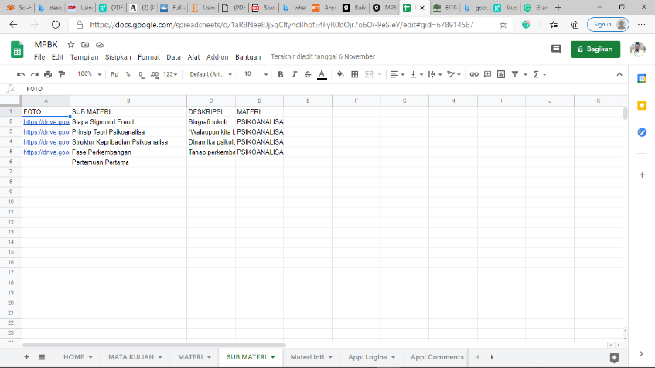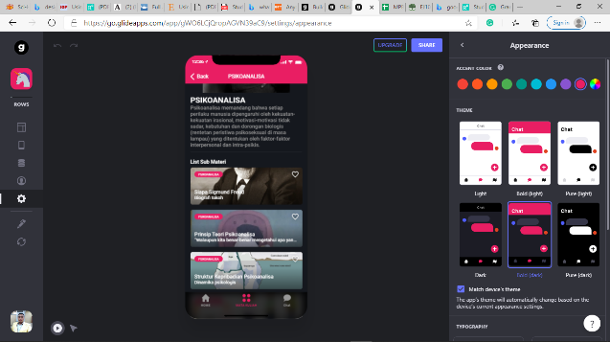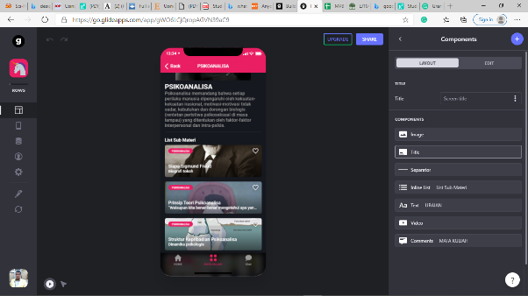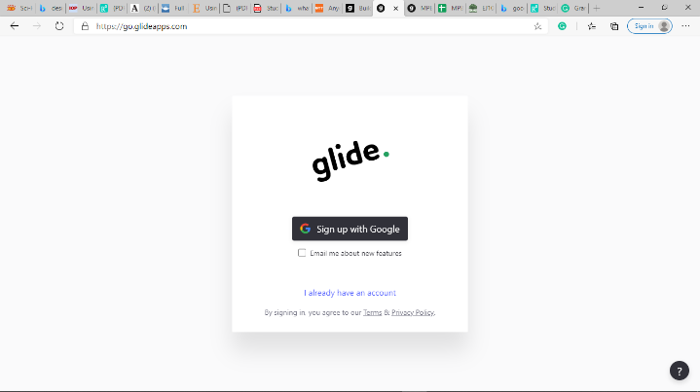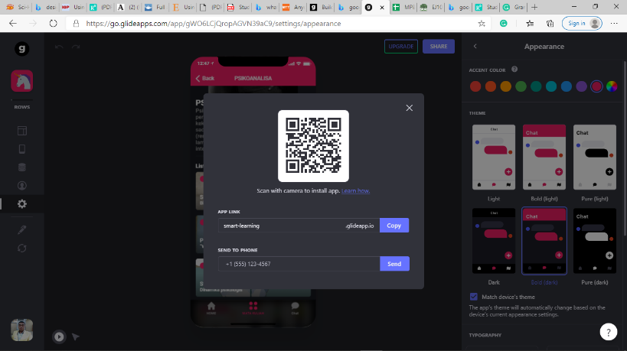

*(2)*

*Creating and adding data to google spreadsheet*

*(4)*

*Sharing the app*

*(3)*

*Creating and setting your app in glide apps*

*(1)*

*Creating google drive account*

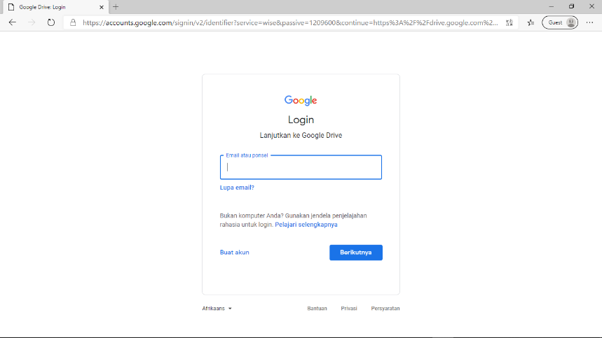

**Figure 1.** The designing process of mobile-app learning media

* + 1. *Creating and setting your app in glide apps.* After setting the materials in a spreadsheet, the next step is creating the app by using the glide app. Switch to glideapps.com and click the create an app button. A window will open, and you can choose the spreadsheet that you created in the google drive before. You can make your app is more beautiful by setting your app in the setting menu.
    2. *Sharing the app.* That’s it! After setting all of the parts of your app, and sure you create the best app you can do. The last step is to share your app with your students by clicking the share button in the center-up of your glide apps worksheet.
  1. *Education and Mobile distance learning*

Mobile Apps created through the glide app website are one form of mobile learning model (m-learning). This learning model fully utilizes smartphones and internet networks as educational and training media platforms (4). M-Learning emphasizes portability, flexibility, and context that facilitates student learning, collaboration (students to teachers/students to students) and encourages independent and cooperative learning (5). All these aspects have been facilitated in mobile apps designed using glide apps. Based on figure 2, students can do learning independently through video tutorials and conduct discussions through forums that have been provided by educators. Students and educators can also learn synchronously through these mobile apps by inserting a synchronous link.

By many features contain in glide apps, we can assume that the mobile apps that have been designed can facilitate the teaching and learning process to be easier and more flexible. Glide apps can be a breakthrough in the world of Education to be able to adapt to the rapid development of technology and information. Besides, although glide apps claim that the creation of mobile apps is a simple thing (without having to learn in-depth about coding). However, the process of creating a mobile app that utilizes this website is not entirely easy. Educators need to understand in detail the micro and macro mechanisms of the glide app so that the learning information desired by educators, can be fully conveyed to students. Thus, for educators who lack technology and programming skills, it is necessary to provide special training to create interactive mobile apps independently.

The utilization of mobile apps in the learning process brings its advantages and disadvantages for educators and students. On the one hand, learning becomes easy, and not limited by time, because students can open learning materials anytime and anywhere according to what they want (4)(5). For educators, designing a mobile app can improve professionalism in several fields, such as communication, self-assessment, and innovation (10). But on the other hand, educators need to consider carefully when wanting to utilize mobile-based learning media. This is important for educators. Why? Because m-learning requires smooth connectivity, the cost for internet packages is also not cheap, the relatively small size of smartphones is sometimes an obstacle for several users, memory limitations, copyright issues, and risk of sudden obsolescence (5)(11).

**Figure 2.** Prototype of mobile-app learning media

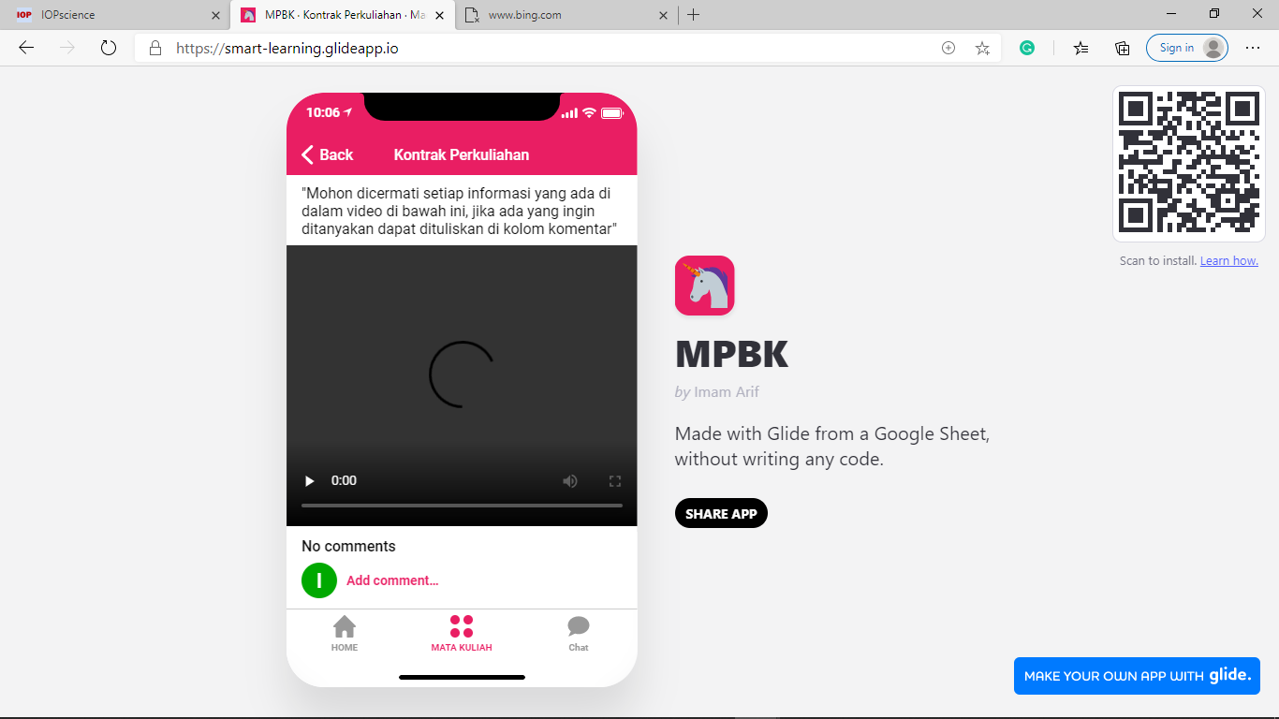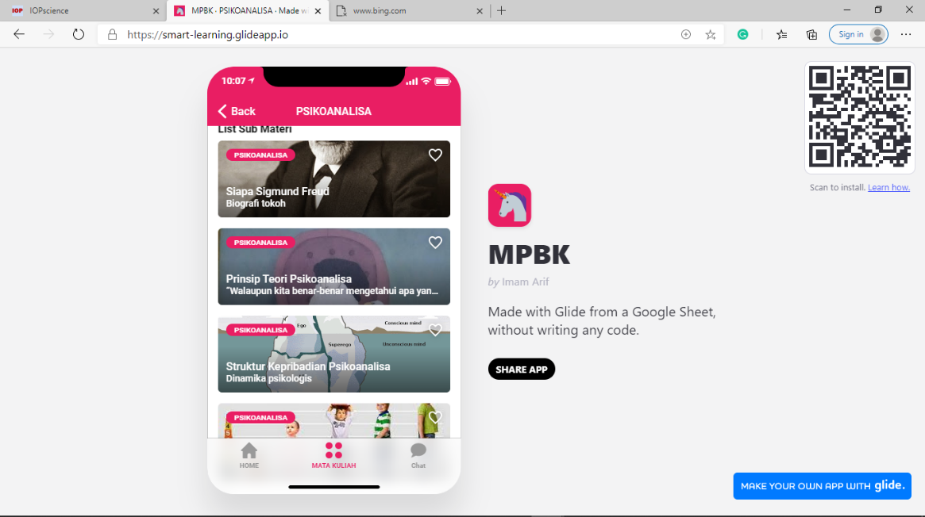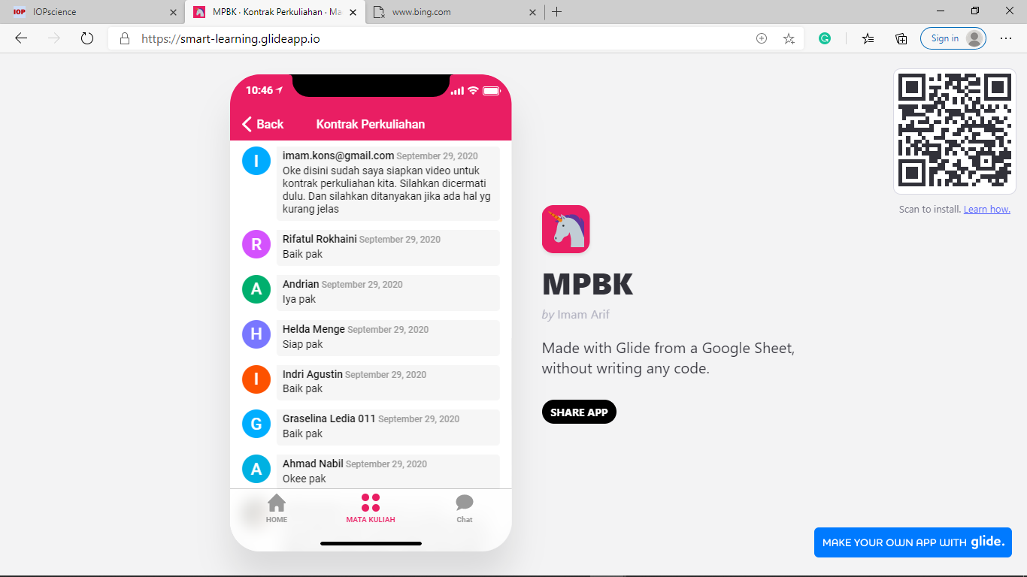

In general, this article has some limitations. This article focuses only on the introduction of glide apps as a mobile app maker website. This article has not been able to explain how effective and significant mobile-based learning media is with glide apps to the learning process and students' learning interests. The results of the study showed that the success of m-learning in the teaching and learning process influenced by several factors, such as personality, psychological characteristics of the user, age level, and adaptability of students with m-learning features used (12). Referring to these factors, educators can make it as a reference in designing more complex m-learning-based learning media, both in terms of learning management processes, methods of learning formation, as well as evaluation and supervision (12). Therefore, more research needs to be done.

1. **Conclusion**

Based on the results of the explanation above, it can be concluded that m-learning becomes a learning model that is more needed and in demand by students at this time. So educators need to adjust to the development of trends in the world of education. The m-learning provided to students needs to be adjusted to the age level, and psychological factors of the students to be more effective. Considering this study, glide apps can be used as an alternative in making beautiful, modern, elegant, and user-friendly m-learning media.

**References**

**[**1. Zheng B, Lin C, Bae J. Computers & Education The impact of learner- , instructor- , and course-level factors on online learning. Comput Educ [Internet]. 2020;150(January):103851. Available from: https://doi.org/10.1016/j.compedu.2020.103851

2. Vanslambrouck S, Zhu C, Lombaerts K. Students’ motivation and subjective task value of participating in online and blended learning environments [Internet]. The Internet and Higher Education. Elsevier Inc; 2017. Available from: http://dx.doi.org/10.1016/j.iheduc.2017.09.002

3. Ghavifekr S, Athirah W, Rosdy W, Teaching WAW. Teaching and Learning with Technology : Effectiveness of ICT Integration in Schools. Int J Res Educ Sci. 2015;1(2):175–91.

4. Mehdipour Y. Mobile Learning for Education : Benefits and Challenges. Int J Comput Eng Res. 2013;3(6):93–101.

5. Vázquez-cano E. Mobile Distance Learning with Smartphones and Apps in Higher Education. Educ Sci Theory Pract. 2014;14(4):1505–20.

6. Tugrul A, Alkan A. Differences between m-learning ( mobile learning ) and e-learning , basic terminology and usage of m-learning in education. Procedia - Soc Behav Sci [Internet]. 2011;15:1925–30. Available from: http://dx.doi.org/10.1016/j.sbspro.2011.04.029

7. Slavkovic N, Savic A. The Usage of m Learning for Adult Education in Serbia. Procedia - Soc Behav Sci [Internet]. 2015;174:2806–12. Available from: http://dx.doi.org/10.1016/j.sbspro.2015.01.971

8. Typeguard I. Glide apps [Internet]. 2020. Available from: https://www.glideapps.com/

9. McDowell G. Anyone Can Build an App with Glide Apps [Internet]. Online Tech Tips. 2019. Available from: https://www.online-tech-tips.com/smartphones/anyone-can-build-an-app-with-glide-apps/

10. Douch R, Savill-Smith C, Parker G, Attewell J. Work-based and vocational mobile learning: Making IT work. [Internet]. London: LSN; 2010. Available from: http://issuu.com/steveb123/docs/100186

11. Orr G. A Review of Literature in Mobile Learning : Affordances and Constraints. In: The 6th IEEE International Conference on Wireless, Mobile, and Ubiquitous Technologies in Education. 2010.

12. Ivanov I, Cárdenas J, Kosonogova M. ScienceDirect Implementation of developmental education in the digital learning environment. Procedia Comput Sci [Internet]. 2020;172(2019):517–22. Available from: https://doi.org/10.1016/j.procs.2020.05.062