Online Education on Social Media about Diabetes Mellitus

M Aditya1, D Notario2, A Kamilah1 and S E Buntoro1

1Department of Pharmacy Faculty of Sains and Technology, Universitas Ma Chung Malang, East Java, Indonesia

2Department of Pharmacy School of Medicine and Health Sciences, Atma Jaya Catholic University of Indonesia, Jakarta, Indonesia

martanty.aditya@machung.ac.id

**Abstract**. Education, as a preventive measure and essential factor in the effort to implement a healthy lifestyle to lowers the incidence rate of Diabetes Mellitus (DM). Instagram is currently one of the most popular social media. This study aims to assess the impact of social media on knowledge about DM. The study compared two educational methods, lectures and social media on Instagram. The research design uses a quasi-experimental trial and prospective. The respondents were 92 active students of Ma Chung University Malang. They were willing to participate in research with purposive sampling techniques and then divided into two groups as much as random allocation. The data collection technique uses DM knowledge questionnaires. The data is analyzed with multivariate regression using R open-source software. Results found improved knowledge of diabetes mellitus ( = 17.55, 95% CI: 9,399-24,059) with education using social media compared to the lecture group. The conclusion is that education by Instagram increases DM knowledge. Social media can be used as one of the media to educate young people about DM and its prevention

1. Introduction

In Indonesia, there is an addition of DM prevalence at ≥15 years of age by 8.5%, mostly caused by type 2 DM (DM2T). The increasing prevalence of DM happens due to the lack of public awareness of the importance of implementing a healthy lifestyle [1]. Education is an essential factor in the effort to implement a healthy lifestyle [2]. Instagram is currently one of the most popular social media. Instagram is ranked third in the Most Active Social Media Platforms category, with 38% [3]. This condition shows social media opportunities to promote health education in this millennial era, for example, through campaigns related to health behaviors [4]. On the other hand, some findings show that social media use negatively influenced a person's behavior [5]. The existence of these different results encourages research to see the influence of knowledge on education using social media. Besides, in Indonesia itself, there has been no research related to the influence of education by using social media to date. This study's result is compared with the result of conventional education methods using lecture and pocket notes as a comparison. This comparison method is a standard method to explain or verbal message to a target group to get health information. This study aims to assess the impact of social media on knowledge about DM.

1. Material and Methods

The quasi-experimental design layout is used by comparing different education methods in the form of a combination of lecture and pocket notes and social media Instagram. This study hypothesizes that social media, especially Instagram, can increase public knowledge and help prevent DM2T. This study was conducted from January until June 2019 at Universitas Ma Chung. Diabetes education by combining lectures from health experts and pocket notes was given to the respondents—learning materials such as etiology, pathophysiology, and manifestation. Respondents were asked to follow an Instagram account created by the researcher. This account contains summaries of information about diabetes redesigned with animated pictures to make them more understandable and interesting to look that. This Instagram account regularly posts animated educational content with similar content as the ones explained through direct lecture. This study's population is the active students of Universitas Ma Chung, with a total of 1215. The sampling process through a purposive sampling technique with the minimum sample and calculation using the Slovin's formula (margin of error 0.1) is 93 respondents and met the inclusion criteria. The inclusion criteria for this study are: [1] the active students of Universitas Ma Chung Malang; [2] respondents must have an attendance percentage of at least 60%; [3] respondents must not be under the treatment of steroid-class medications or weight loss program for the last three months. The exclusion criteria for this study are [1] hospitalized; [2] pregnancy; [3] resignation from the study. All respondents included in this study must sign informed consent to agree with the terms for this study. This study's instrument is the DM knowledge questionnaire that consists of 14 questions with the Alpha Cronbach value of 0.66. Acquired data in this study includes the characteristics of respondents as covariates. Respondent's characteristics data includes gender, age, body mass index (BMI), housemate(s), participation in students' activity unit (UKM), a family member with a history of DM, smoking habit, and the sleep duration within a day.

* 1. *Statistical Analyses*

To observe the impact of the difference on the outcome, a difference-in-difference (DiD). DiD coefficient $β_{1}$ in this study is the knowledge obtained from both Instagram and the lecture methods, $χ_{2}{;χ}_{3};…{;χ}_{n}$ is a specific covariate on each individual [6]. The data is analysed with multivariate regression and statistical measurements are calculated using the open-source software R [7]

1. Results and Discussion

DiD represents the outcome before and after the intervention, which also continued with multiple linear regression analysis. The increasing knowledge about DM in the Instagram group is better than the lecture method groupcould be seen in table 1 and DiD, represented in figure 1.

.

**Tabel 1. Relationship between outcome variable within covariates**

|  |  |  |  |  |  |
| --- | --- | --- | --- | --- | --- |
| Outcome variable | Factor | Coefficient | Lower 95% CI | Upper 95% CI | p |
| Knowledge | Overweight | -16.278 | -30.030 | -2.523 | 0.034 |
| Education *via* Instagram | 16.729 | 9.399 | 24.059 | <0.001 |

The results showed that education using Instagram could increase knowledge (16.729, 95% CI: 9.399-24.059). In this study, it was also found that overweight people have less knowledge (-16.278, 95% CI: -30.030-(-2.523).

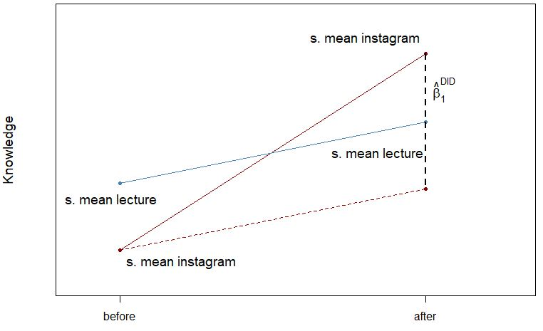

Figure 1 Differences-in-Differences Estimator Analysis of Knowledge

The knowledge measures the impact of Instagram as the chosen intervention media on health behavior. The intervention with Instagram increases knowledge about diabetes mellitus better than lecture and pocket note methods, as shown in Table 1 and Figure 1. The superiority of the Instagram method is the proof of public interest in a new communication media due to advancement and development on the implemented public communication means, known as the "age of communication" [8]. The increasing trend of social media usage is due to its advantages in providing reliable communication services that enable all users to stay connected more intensively [9–12], even before deciding to participate in the scope of health [13]. Some other advantages of using Social Networking Sites (SNSs) are more cost-effective in finding information and facilitating health behavior changes, although there is no further study for a longer-term [11]. SNSs changes the way people interact and socialize in the learning process [5]. Because the education targets in this study are the youths, social media is a better alternative by emphasizing the dietary arrangements to prevent insulin resistance in the future [14]. Social media can also bridge the gap between the number of health services as a primary resource in educating and observing the public, following the increasing demands of nutrition education to prevent DM [15]. Body mass index becomes a significant covariate, especially for overweight people. Table 1 shows that overweight people have less knowledge about DM than non-overweight people, which also affects attitudes and behavior [16]. The lack of knowledge about food types that may increase blood sugar makes it hard for most people to control body weight [16,17].

This study's limitation is short-term intervention and no follow-up to learn the long-term impacts of a healthy lifestyle. The Instagram intervention is also unable to measure engagement in health intervention in depth.

1. Conclusion

Using Instagram to educate individuals about the threat of diabetes mellitus is proven better than using the conventional method.

**Acknowledgements**

We thank the study participants and the Universitas Ma Chung

**Funding**

This studies was funded by the Ma Chung Research Grant (MRG) grant no: 068O/MACHUNG/STP/III/2019

**Competing interests**

None declared

References

[1] Kementerian Kesehatan RI. Riset Kesehatan Dasar (Riskerdas) Tahun 2013. vol. 3. 2013. https://doi.org/10.22201/fq.18708404e.2004.3.66178.

[2] Vahedian M, Sadeghi R, Farhadlu R, Nazeri A, Dehghan A, Barati H. Effect of Educational Booklet and Lecture on Nutritional Behavior Knowledge and Attitude on Third-Grade Male Guidance School Students. J Community Heal Res 2014;3:1–12.

[3] We Are Social. Trends shaping social in 2019. We Are Soc 2019.

[4] Wakefield MA, Loken B, Hornik RC. Use of mass media campaigns to change health behaviour. Lancet 2010;376:1261–71. https://doi.org/10.1016/S0140-6736(10)60809-4.

[5] Abbas J, Aman J, Nurunnabi M, Bano S. The impact of social media on learning behavior for sustainable education: Evidence of students from selected universities in Pakistan. Sustain 2019;11:1–23. https://doi.org/10.3390/su11061683.

[6] Fredriksson A, Oliveira GM de. Impact evaluation using Difference-in-Differences. RAUSP Manag J 2019;54:519–32. https://doi.org/10.1108/RAUSP-05-2019-0112.

[7] R Core Team. R: A Language and Environment for Statistical Computing. Vienna, Austria R Found Stat Comput 2012:R Foundation for Statistical Computing, Vienna, Au.

[8] Zarei E, Jabbarzadeh A. Knowledge management and social media: A scientometrics survey. Int J Data Netw Sci 2019;3:359–78. https://doi.org/10.5267/j.ijdns.2019.2.008.

[9] Dibb B. Social media use and perceptions of physical health. Heliyon 2019;5:e00989. https://doi.org/10.1016/j.heliyon.2018.e00989.

[10] Gurcan HI. Contribution of Social Media to the Students’ Academic Development. Int J Inf Educ Technol 2015;5:965–8. https://doi.org/10.7763/ijiet.2015.v5.647.

[11] Laranjo L, Arguel A, Neves AL, Gallagher AM, Kaplan R, Mortimer N, et al. The influence of social networking sites on health behavior change: A systematic review and meta-analysis. J Am Med Informatics Assoc 2014;22:243–56. https://doi.org/10.1136/amiajnl-2014-002841.

[12] Sales AE, Estabrooks CA, Valente TW. The impact of social networks on knowledge transfer in long-term care facilities: Protocol for a study. Implement Sci 2010;5:1–10. https://doi.org/10.1186/1748-5908-5-49.

[13] Hong M, Shin H, De Gagne JC. Social networks, health-promoting behaviors, and health-related quality of life in older adults with and without arthritis. PLoS One 2019;14:e0220180. https://doi.org/10.1371/journal.pone.0220180.

[14] Lee Ventola C. Social media and health care professionals: Benefits, risks, and best practices. P T 2014;39:491–500.

[15] Nutrition D, Resource E. Diabetes Nutrition Education Resource 2019:1–11.

[16] Okonta HI, Ikombele JB, Ogunbanjo GA. Knowledge, attitude and practice regarding lifestyle modification in type 2 diabetic patients. African J Prim Heal Care Fam Med 2014;6. https://doi.org/10.4102/phcfm.v6i1.655.

[17] Saleh F, Mumu SJ, Ara F, Ali L, Hossain S, Ahmed KR. Knowledge, attitude and practice of type 2 diabetic patients regarding obesity: Study in a tertiary care hospital in Bangladesh. J Public Health Africa 2012;3:29–32. https://doi.org/10.4081/jphia.2012.e8.