**Technology of Holobox Augmented Reality *Grebeg* *Pancasila* Rite for Mathematics Learning in Elementary School**

**S Septinaningrum 1,5* , K A Hakam2, W Setiawan3, M Agustin4, W Sopandi1,**

**A S Surur3**

1Study Program of Elementary Education, Postgraduate Program at the Indonesia University of

Education, Bandung, Indonesia

2Departement of Character and General Education, Faculty of Social Science Edcuation,

Indonesia University of Education, Bandung, Indonesia

3Departement of Computer Science Education, Indonesia University of Education, Bandung,

Indonesia

4Departement of Early Childhood Education, Indonesia University of Education, Bandung,

Indonesia

5Department of Islamic Elementary Teacher Education,State Institute of Tulungagung for

Islamic Studies, Tulungagung, Indonesia

[*ningrumseptina@gmail.com](mailto:*ningrumseptina@gmail.com)

**Abstract.** The use of technology in learning needs to be encouraged starting from the elementary school level. Another thing that needs to be encouraged is local wisdom-based media to support character learning. This study aims to develop holobox augmented reality technology media of local wisdom of the *Grebeg Pancasila* rite for mathematics learning in elementary schools. This research produces multimedia based on technology Holobox Augmented Reality(AR) with the content of material *Grebeg* *Pancasila* for learning mathematics and building spaces in elementary schools. The method in media development using the Development Life Cycle developed by Luther consists of six stages, namely: concept, design, material collection, assembly, testing, and distribution. The media produced meets the standard of feasibility and can provide information and knowledge about understanding the concept of flat and space structures through the flag and *gunungan* symbols in the Rite *Grebeg Pancasila*. The implication of this study is that cultural diversity in local wisdom of the *Rite Grebeg Pancasila* can be used as a medium for learning mathematics in elementary schools (MI / SD) through Technology Holobox. Augmented Reality.

1. **Introduction**

The use of technology in learning is growing rapidly, but there are still many lessons in elementary schools, especially mathematics, have not fully used technology-based media. Media is one of the main keys for a teacher to achieve learning goals and create interesting and quality learning. The use of smartphones as learning facilities is very effective because it is attractive to children. However, their utilization is still minimal in the learning process and understanding mathematical concepts.

Mathematics concepts learn by children consist of three stages, such as enactive, iconic, and symbolic [1] . The enactive stage is where the students learn while manipulating objects, iconic stage is where the students present knowledge through visual figures, symbolic is where the students present knowledge into symbols or emblem. The Grebeg Pancasila Rites is enriched with symbols, meaning, value internalization, character, multiliteracy learning and multicultural learning [2][3][4][5]. This study was intended to present Mathematics concept learning in form of symbolic Indonesia’s flag and *Gunungan Lima* (five cones) in local wisdom of *Grebeg Pancasila* rite.

Mathematics learning must be constructively active and dynamic to build knowledge from self experience and from interaction with others. Based on the level of thinking, elementary students level is in concrete operational meaning that their understanding of concept through real objects or activities are acceptable for their thoughts. Therefore, Mathematics learning at elementary schools need concrete modeling and real-life experiences.

One of the real and concrete modeling is by using Holobox Augmented Reality technology that is largely used in delivering information. Holobox, derived from Hologram Box, is a simple technology design created to integrate monitor/tablet screen put and projected on glass box to display objects’ shadow which is similar to hologram [6]. Objects will be displayed by holobox in this design in form of pyramids. The size of the pyramids are customized to the size of the screen displayed. AR is a technology used to convert virtual objects to be real objects and can be implemented in smart phone as a learning media innovation [7][8][9][10] The main objective of this study was to develop Holobox Augmented Reality(AR) technology-based multimedia with the materials of symbols in *Grebeg Pancasila* rite for Mathematics learning at elementary schools.

1. **Research Method**

Research method used in developing Holobox Augmented Reality technology-based media is Research and Development (R&D). Designing stages of this multimedia apply Development Life Cycle multimedia development according to Luther consisting of six stages, such as; concept, design, material collection, assembly, testing, and distribution [11].

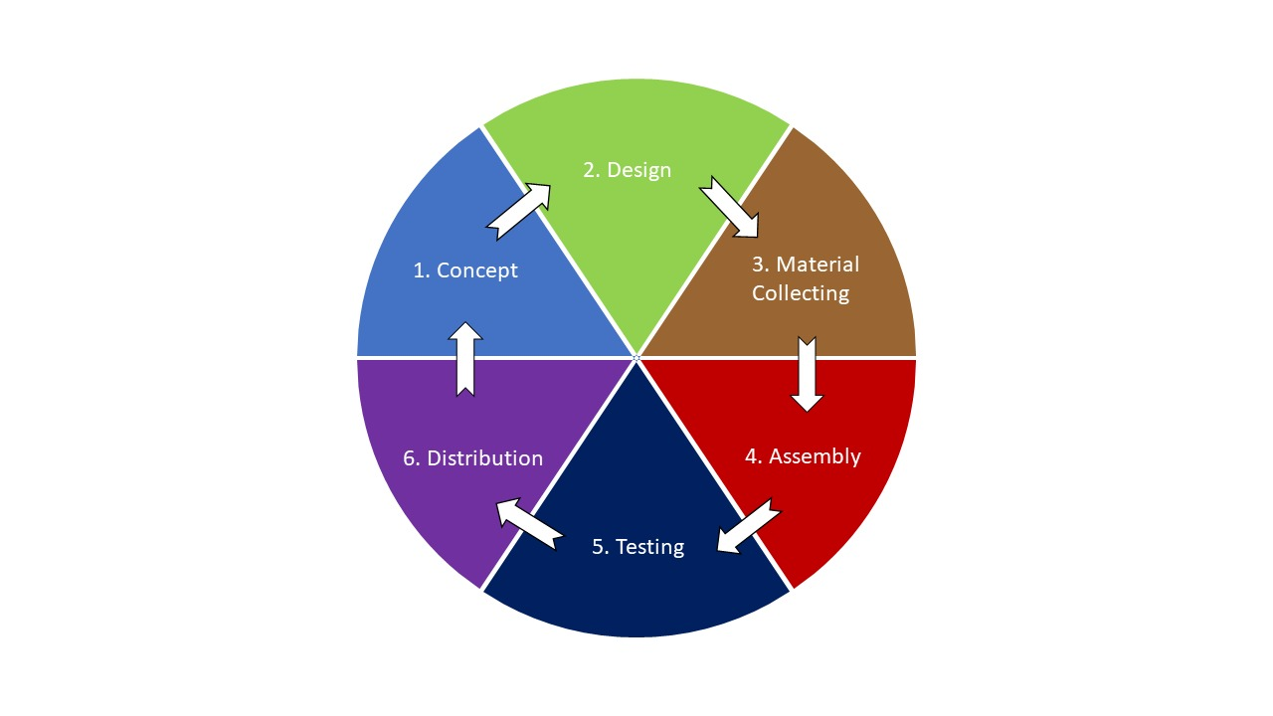**Figure 1.** Multimedia Development Model of Luther

* 1. *Concept*

In this stage, objective analysis is made by developing Holobox AR technology-based design of *Grebeg Pancasila* rite for Mathematics learning at elementary schools. Then, the researcher identified the user or the audience which are the third year students of elementary school and Islamic elementary school in the city of Blitar. After that, the researcher determine the content materials consisting of symbols in Gerebeg Pancasila rite that can be interpreted into two-dimensional figure and geometry. After analysis study, she determine the symbols of Indonesia’s flag and five cones which can be modified into two-dimensional figure of rectangle and geometry such as cone.

* 1. *Design*

In this stage, media designed by using story board to describe every scene. Every scene is interconnected in flowchart to describe the detail designing process of media. The specification is detail so that the next process, such as material collection assembly, is not necessary. However, practically, there will be addition and reduction as well as change on the application. Assets are needed to create AR in the unity. After being design, assets are created by using blender application. Blender is a software to create 3D which is capable to do modeling, texturing, ringing, animating, lighting, operating camera, and rendering [12][13]. When using blender to create asset such as rectangle and cone which are the forms of symbols Indonesia’s flag and five cones.

* 1. *Material Collection*

Material collection is based on the animation criteria and necessity that will be developed in the media. This stage consists of several processes such as; collecting files, texts, pictures, clip art, photos, animation, video, audio which are related to the 3D Hologram creation. Videos installed to the application are the videos of Grebeg Pancasila rite procession in the city of Blitar in 2019; video of two-dimensional figure, video of human digestion system, and tutorial video of hologram projector creation.

* 1. *Assembly*

Assembly stage is the stage of creating animation where all objects or multimedia materials are created based on storyboard made in designing stage. Animation of waving Indonesia’s flag and five cones are created by using Adobe Animate CC 2019.

* 1. *Testing*

In this stage the researcher validate that the result of the multimedia animation creation is valid as it planned. Animation should be created well and suitable with the user environment.

* 1. D*istribution*

In this stage, after completing the projects, the researcher did the application packaging. In the application of Grebeg Pancasila, the files are packaged into executable file (.apk), then those files are packaged become one file, self extractor.apk so the size of the file is smaller than the original one. This process eases the research to distribute them online through internet or offline through CD.

1. **Result and Discussion**

Based on the research steps of research method, the following is the result of media designing: hardware needed are laptop, mouse, and data cable. Software needed are Windows operating system, Ecclipps for android to create coding and system on the android application, blender as the application of creating 3D objects, Camtasia Studio 8 is to split the videos into four sides [11][13].

The final result of this research is the Android application package (apk.) file. The apk. file is an installer file that create for devices that run on Android devices [12] . The apk. file Holobox AR *Grebeg Pancasila* needed to be installed first on the Android smartphone.

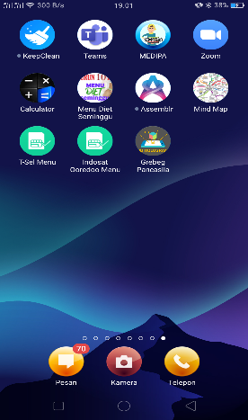

**Figure 2.** Display Application on a Android smartphone

After installed, open the application you will see a menu display, namely Grebeg Pancasila, Gallery, Video, Hologram, Project and Quiz can be seen in the figure 3a.

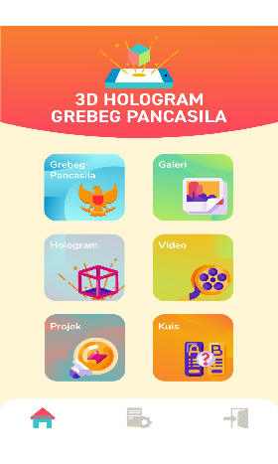 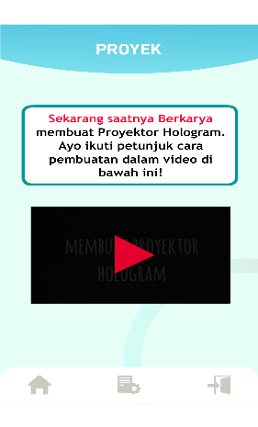 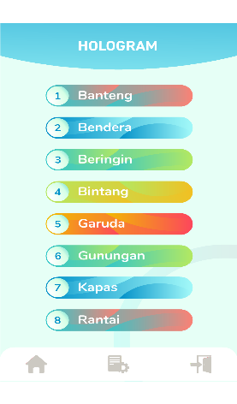

1. (b) (c)

**Figure 3.** Application Menu Display

Learning mathematics with Holobox technology can be done by opening the Hologram menu. The Holobox can be viewed through a hologram projector whose manufacturing steps are in the project menu at figure 3b. The projector is made of transparent mica by utilizing the mathematical concept of a trapezoidal shape. After four trapezoidal sizes are assembled and glued together on both sides of the alignment there is a hologram projector. Open the hologram menu then select one of the 3D hologram flags or mountains videos at figure 3c.

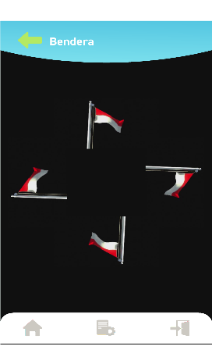 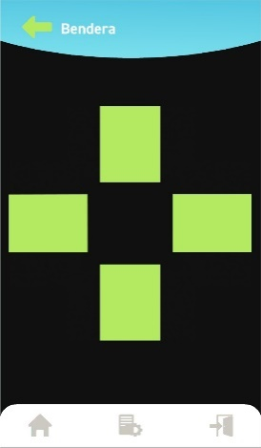 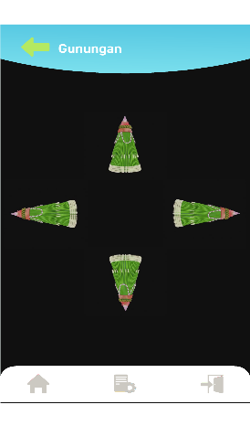 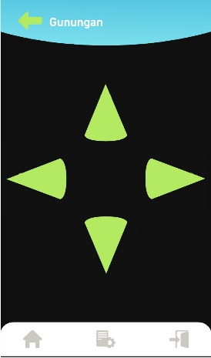

1. (b) (c) (d)

**Figure 4.** 3D Video of Hologram

After the figure 4 3D hologram video appears. The Holobox is ready to be used for learning mathematics, the concept of rectangular flat shapes with flag at the figure 4a and 4b. Learning conical spaces through the symbols of *gunungan* at the figure 4c and 4d in the Grebeg Pancasila rite.

.

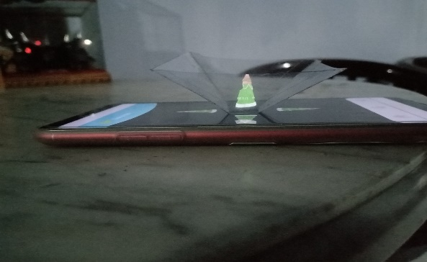 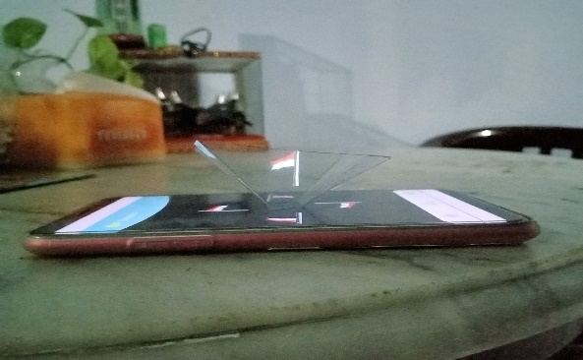

(a) (b)

**Figure 5.** The Display of 3D video of Holobox on the Smartphone

Image object in holobox AR only can be seen clearly in dark condition. Take the projector put it on the smartphone like the figure 5a and 5b. Put it in the middle of the 3D video hologram. You can learning mathematics with Holobox AR.

1. **Conclusion**

Based on the research and development conducted, it can be concluded that the use of Holobox AR technology can contribute to new learning experience for elementary school students. The application created can increase the students’ enthusiasm on learning Mathematics and the local wisdom of *Grebeg Pancasila* rite. The use of 3D hologram technology by utilizing the holographic reflection of the application connecting 3D objects to real life environment. The interaction by using button provided in the application ease the users to run the application.

The media produced meets the standard of feasibility and can provide information and knowledge about understanding the concept of flat and space structures through the flag and *gunungan* symbols in the Rite *Grebeg Pancasila*. The implication of this study is that cultural diversity in local wisdom of the *Rite Grebeg Pancasila* can be used as a medium for learning mathematics in elementary schools (MI / SD) through Technology Holobox. Augmented Reality.

**Acknowledgments**

We would like to thank for Postgraduate School of the Indonesia University of Education which facilitated and supported this research. All parties for sharing information with us during this research, and we thank reviewers foe they called their insights.

**References**

[1] A. P. A. Rahmawati, R Wijayanti, “*Pengembangan eksplorasi MAR ( Matematika Augmented Reality ) dengan penguatan karakter pada materi bangun ruang sekolah dasar,*” Delta-Pi J. Mat. dan Pendidik. Mat., vol. 9, no. 2, pp. 92–105, 2020.

[2] S. Septinaningrum *et al.*, “*Multiliteracy in The Rite of Grebeg Pancasila as aMedium for Character Education in Digital Era*,” Proc. 2nd Int. Conf. Local Wisdom, no. January, pp. 389–396, 2019.

[3] D. . W. Putriana, “*Grebeg Pancasila sebagai Sarana Penanaman Nilai-Nilai Pancasila (Studi Kasus di Kota Blitar),*” Kaji. Moral dan Kewarganegaraan, vol. 07, no. 2, pp. 1237–1252, 2019.

[4] Septinaningrum, “*An Analysis of Multikultural Values Actualization In Grebeg Pancasila Rite , Blitar , East Java,*” Proceeding 4 Int. Semin. Soc. Stud. Hist. Educ. 2019, 2019.

[5] Luh Suryatni, “*Komunikasi Media Sosial dan NIlai-Nilai Budaya Pancasila Sosial Media Communications and Cultural Values of Pancasila*,” J. Sist. Inf. Univ. Suryadarma, vol. 5, no. 1, pp. 117–133, 2018.

[6] A. H. Rustaman, “*Perancangan Fosil Digital Dinosaurus Dengan Pemanfaatan Teknologi Holobox Di Museum Geologi Bandung*,” Desain Komun. Vis. Manaj. Desain dan Periklanan, p. 57, 2018.

[7] A.-M. Depape, M. Barnes, and J. Petryschuk, “*Students’ Experiences with VR and AR Innovative Practice in Higher Education 22*,” Barnes, Petryschuk, vol. 3, no. 3, pp. 22–57, 2019.

[8] K. T. Sun and M. H. Chen, “*Utilizing free augmented reality app for learning geometry at elementary school in Taiwan: Take volumetric measurement of compound body for example,*” Int. J. Distance Educ. Technol., vol. 17, no. 4, pp. 36–53, 2019.

[9] Aquami,dkk “*Pengembangan Media Pembelajaran Berbasis Ict Menggunakan Macromedia Flash Pada Mata Pelajaran Ipa Mi/Sd,*” J. AL-MUDARRIS, vol. 2, no. 1, p. 53, 2019.

[10] Fatimah et al., “*Development of Smart Content Model-based Augmented Reality to Support Smart Learning,*” J. Sci. Learn., vol. 2, no. 2, p. 65, 2019.

[11] R. Fibriyanti and T. Listyorini, “*3D Hologram Media Interaktif Pengenalan Proses Pembuatan Jenang Sebagai Upaya Pelestarian Kuliner Khas Kudus*,” Simetris J. Tek. Mesin, Elektro dan Ilmu Komput., vol. 10, no. 1, pp. 333–340, 2019.

[12] M. Sarosa, A. Chalim, S. Suhari, Z. Sari, and H. B. Hakim, “*Developing augmented reality based application for character education using unity with Vuforia SDK*,”

J. Phys. Conf. Ser., vol. 1375, no. 1, 2019.

[13] W. Amelia and Rustaman, “*Pengembangan Media Pembelajaran Tata Surya Berbasis Teknologi Holobox Pada Mata Pelajaran Ipa Di Sekolah Dasa*r,” J. Elem. Edukasia, vol. 3, no. 1, pp. 117–125, 2020.