Geographic Information System (GIS): Potential Mapping of Agribusiness in Southern Part of West Java

T Maskun1,*, M Masluh2, E N Resmiawati2, Komarudin Tasdik3, Didin Muhafidin4, Gunawan Undang5 and Ova Nurisma Putra3

1Prodi Studi Teknologi Industri Pertanian, Universitas Al-Ghifari, Jl. Cisaranten Kulon No.140, Kota Bandung, Indonesia.

2Prodi Manajemen, Universitas Al-Ghifari, Jl. Cisaranten Kulon No.140, Kota Bandung, Indonesia.

3Program Studi Sistem Informasi, Sekolah Tinggi Manajemen dan Informatika (STMIK) Jabar, Kota Bandung, Indonesia.

4Program Studi Ilmu Adminsitrasi, Universitas Padjadjaran, Kota Bandung, Indonesia.

5Prodi Ilmu Administrasi, Program Pascasarjana, Universitas Pembinaan Masyarakat Indonesia, Jl. Teladan No.15, Kota Medan, Indonesia.

*tommaskun9@gmail.com

**Abstract**. In this study, a mapping of the potential for agribusiness in the southern part of West Java was carried out, which serves as a policy material and business development in developing local potential in the agribusiness sector to improve local communities' welfare. West Java Provincial Regulation Number 12 of 2014 divides the Southern part of West Java into three Growth Center (PP) zones, namely PP Palabuhanratu, PP Rancabuaya, and PP Pangandaran. The agribusiness potential of South West Java is dynamic and varied. However, it has not been developed optimally to improve local communities' welfare, which is generally scattered in underdeveloped villages. The government and developers (entrepreneurs) have difficulty obtaining digital data updates. The purpose of this research is to map the regional potential in the field of agribusiness in the form of digital data to facilitate the development of agribusiness potential in coastal areas located on the shores of the Indian Ocean (Indonesian Ocean). The research method uses Geographical Information Systems. The results showed that the potential and variants of agribusiness in PP Palabuhanratu are spread across 5 districts. In PP Rancabuaya spread into 5 districts. Meanwhile, PP Pangandaran is spread over 5 districts. This research can be used as policy materials and business development in developing local potential in the agribusiness sector to improve the welfare of the people of West Java.

1. Introduction

Indonesia is known to have great agricultural and maritime potential in the world [1]. If the southern part of West Java's agribusiness potential is managed optimally, it will solve DKI Jakarta's problems, such as floods, traffic jams, and social disparities. The Jakarta problem is one of the contributors to Indonesia's bad image in the world's eyes. Good governance of agribusiness in the southern part of West Java can be one of the pillars of potential bilateral relations between the business sector and Australia. Optimizing cooperation between the two countries in southern West Java can reach maritime products because there is a Rancabuaya beach. It can be continued in agribusiness after maritime affairs because agricultural products are spread not too far from Rancabuaya, Garut Regency, West Java. Indonesian people who work as farmers reach 34.36%. This percentage is above trade, manufacturing, and other occupations [2]. It was found that the highest share of Gross Domestic Product (GDP) in Indonesia is in the industrial sector, not agriculture. The industrial sector contributed to economic growth up to 19.66 percent [3]. The movement of public attention to agriculture in Cisewu sub-district, Garut district, an area that is part of South West Java, is beginning to appear among low-income communities and middle-income communities. However, after harvesting, some of them experienced marketing problems, so they suffered significant losses. This shows that agribusiness optimization is needed so that farmers can benefit. Investors can easily find the potential for agribusiness in each region to stabilize prices for agricultural products. Farmers need price stability to calculate the potential profit that will be obtained at harvest.

The southern region has lagged somewhat behind due to different sources of growth. This region is the source of growth in the agricultural, agro-tourism, and tourism sectors so that economic development is not carried out sporadically or unevenly. There needs to be a mapping according to the potential of the existing area [4]. Based on the analysis of diversity and institutions, rice agribusiness in West Java shows that farming communities have been cultivating relatively well from the aspect of cultivation techniques. Important policy implications that need to be taken to improve rice agribusiness include reviving the market for the middle and upper economic segments with the spirit of regional autonomy and nationalism through product quality assurance. Institutional alternatives that are considered to improve the performance of rice agribusiness development in West Java in the future include the small-medium scale agribusiness model [5]. Based on the Williamson index analysis, regional inequality in West Java is a high level of inequality.

The analysis and mapping of regional potential based on GIS can provide information to investors to encourage investment in the region concerned [6]. In the same source, we need a GIS-based system that can support and monitor the implementation of local potential development to support e-government. Data and information displayed in the application are always linked to geographic position. The geographic coordinates (latitude and longitude) are known and accessed via the internet by the user [7]. GIS-based programs can provide information to anyone who wants to know about the development of agricultural potential quickly and accurately, thereby saving time, effort, and cost [8]. GIS-based applications can also be used for mapping agricultural land and commodity crops [9]. In these three studies, it appears that quite a several researchers are interested in the application of GIS in agriculture. These studies tend to provide information for agricultural land use, not for marketing agricultural products. Meanwhile, this research was conducted to help all stakeholders discover the potential of agribusiness digitally so that farmers' profits can be optimal and agricultural product business people have no trouble finding potential areas related to products needed by the market.

West Java Provincial Regulation Number 12 of 2014 concerning Management of Metropolitan Development and Development and Growth Centers in West Java, regulates that the South West Java region is divided into 3 (three) Growth Center (PP) zones, namely PP Palabuhanratu, PP Rancabuaya, and PP Pangandaran [10]. According to Regional Regulation No. 28/2010 concerning the Development of the Southern Region of West Java in 2010-2029, the policy for the Southern part of West Java's development direction includes agribusiness, agro-industry, marine industry, and integrated tourism. The purpose of this research is to map the regional potential in the agribusiness sector using GIS so that digital data can be obtained to facilitate the development of the potential for agribusiness in the coastal areas located on the shores of the Indian Ocean (Indonesian Ocean). The potential of agribusiness in the southern part of West Java is vibrant and varied. Still, it has not been optimally developed to improve local communities' welfare, which is generally scattered in underdeveloped villages. The government and developers (entrepreneurs) have difficulty obtaining digital data updates.

1. Method

In this study, a mapping of the potential for agribusiness in the southern part of West Java (South West Java) was carried out, which functions as a policy material and business development in developing local potential in the agribusiness sector to improve the welfare of local communities. The research method uses GIS [11]. This research was conducted in all sub-districts in South West Java, Indonesia. The research scheme can be seen in Figure 1. The steps taken in this study are shown in Figure 2, which includes an inventory of the addresses of growth centers, carrying out an address survey using the Global Positioning System (GPS), entering and tabulating data from the coordinate location using Microsoft Excel, determining the growth center on Google Map to see the location on a wider scale, importing coordinate data from Excel using Google Map, and symbolizing and placing the agribusiness potential of each PP in the Southern part of West Java.This research was conducted in all sub-districts in South West Java, Indonesia, using the GIS method.

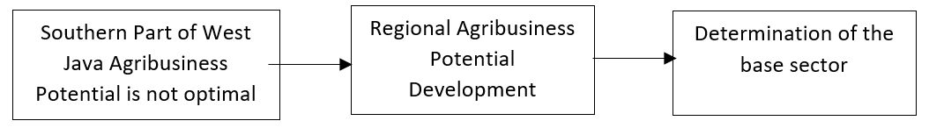

**Figure 1**. Agribusiness potential analysis scheme.

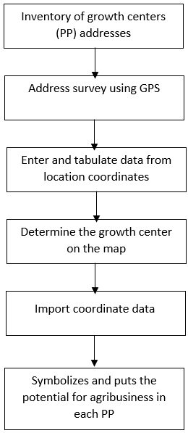

**Figure 2**. Research stages.

1. Result and discussion

## Overview of agribusiness potentials of southern part of West Java

Cisewu District is one of the areas in Garut district, Southern West Java. This sub-district has good agribusiness potential because it has several villages used to produce plantation products, such as cloves, pepper, rice, brown sugar, and others. Villages that produce peppers and cloves include Karangsewu village. Meanwhile, the Cisewu sub-district is an area that has road access to tourist attractions, Rancabuaya beach, which along the way can be optimized into agro-tourism and agribusiness areas. The main road, known as the South Ring Road, which runs along the coast of South Garut, Cianjur, and Sukabumi, is the infrastructure to support South West Java's economic progress. Even Cisewu also has a Tiwu Genteng tea garden (Panggalih village), which can be optimized for agribusiness and agro-tourism.

The opportunity for South West Java's success can be seen from at least 3 aspects, namely geopolitics, urban planning management, and agricultural industry technology. Geopolitically, several South West Java areas experienced expansion, such as Pangandaran district, which has separated from Ciamis and South Garut districts and is separating from Garut regency. Both examples of these areas have great potential in the agribusiness sector. Urban planning management is also a concern, especially in South Garut. Urban infrastructure development is underway. This area is usually the center of attention for governor candidates during the Pilkada in West Java because it has potential voters. In addition to these two aspects, agricultural, industrial technology must also receive great attention so that agricultural products have a more profitable selling value.

One of the problems with Indonesia's capital city, Jakarta, is the population factor. The floods sent from Bogor were exacerbated by the river in Jakarta, which had many garbage and many residential areas on the riverbank [11]. The population boom in Jakarta is due to urban areas, among others, from South West Java. Likewise, congestion in Jakarta, apart from the lack of discipline in the community when using the roads, too many vehicles also trigger it, many vehicles are caused by many urban residents as well [12]. The densely populated Jakarta makes the government overwhelmed in dealing with social inequalities. Many rich people in Jakarta, many poor people. Many people live in luxurious buildings in Jakarta, and many people live in rickety huts [13]. Related to this problem, if the agribusiness management of South West Java is optimal, it will suppress the urban flow from South West Java to Jakarta so that the population of Jakarta is not too dense. Thus, the Jakarta population's management will be easier to do, both in overcoming floods, traffic jams, and social disparities.

The presence of good agro-business management in Southern West Java affects the alleviation of national problems and can also increase the benefits of bilateral relations between Indonesia and Australia. The Rancabuaya Sea can penetrate Australia so that the potential for marine product business relationships is more open. Because the Rancabuaya area is not too far from the agricultural centers of the population, the agribusiness relations between the two countries are also wider, as shown in Figure 3.

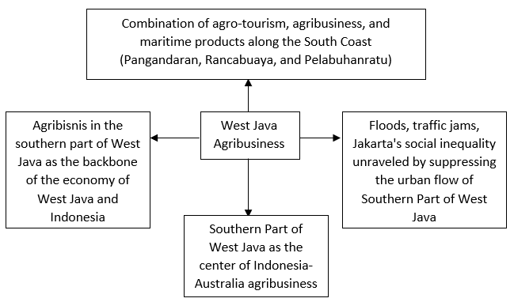

**Figure 3**. Southern Part of West Java Agribusiness and Indonesia's welfare.

The potential and variants of agribusiness in the Palabuhanratu Growth Center (PP) are scattered in Cisolok District, Cikakak District, Palabuhanratu District, Simpenan District, and Ciemas District. Meanwhile, PP Rancabuaya is scattered in Caringin District, Cisewu District, Bungbulang District, and Mekarmukti District (in Garut Regency) as well as in Cidaun District (Canjur Regency). Meanwhile, PP Pangandaran is spread in Kalipucang District, Pangandaran District, Sidamulih District, Parigi District, and Cijulang District.

## Application of Agribusiness Potentials of South West Java based on GIS

This application can be applied in government agencies, companies, institutions, or interested individuals. The end-users of this GIS application can consist of business actors, government, and the general public. Technically, South West Java's agribusiness map contains the features of the name of the district, the name of the potential product, the number of production, and the route. In this application, users can also see a map of agribusiness's potential in the southern part of West Java (Figure 4). There is also a menu View in Google Maps, routes, and distances from certain addresses to agribusiness locations. Figure 5 shows a page that can be used by the admin to change the names of the sub-districts and complete the potential details and other settings that are deemed necessary to change.

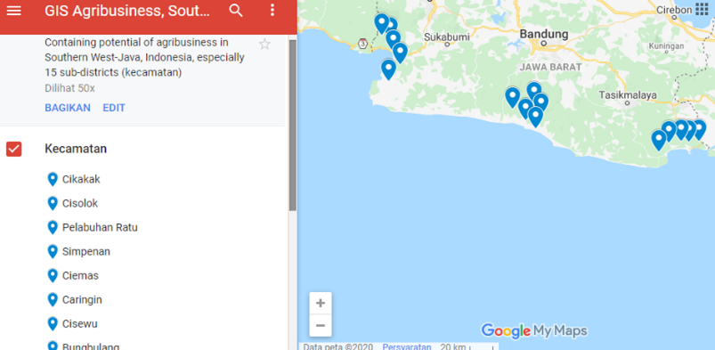

**Figure 4**. Map of agribusiness potential.

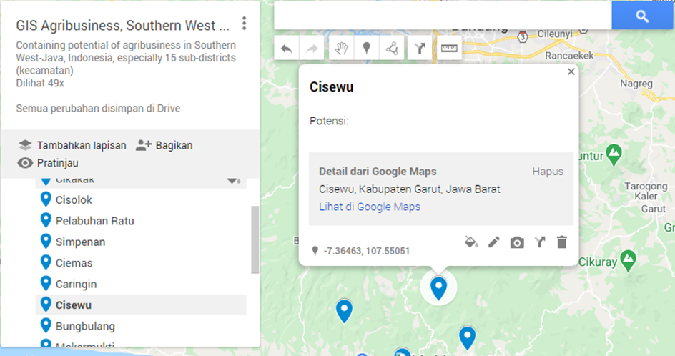

**Figure 5**. Admin page.

1. Conclusion

The results showed that agribusiness's potential and variants in PP Palabuhanratu are scattered in Cisolok District, Cikakak District, Palabuhanratu District, Simpenan District, and Ciemas District. PP Rancabuaya is spread in Caringin District, Cisewu District, Bungbulang District, and Mekarmukti District (in Garut Regency) as well as in Cidaun District (Canjur Regency). Meanwhile, PP Pangandaran is spread in Kalipucang District, Pangandaran District, Sidamulih District, Parigi District, and Cijulang District. Mapping the potential of agribusiness using a geographic information system (GIS) in the southern part of West Java is needed to optimize the marketing of agricultural products so that farmers and stakeholders get maximum benefits. The government needs this application to support policymaking, both local and central government. The combination of agribusiness, agro-tourism, and maritime products along the South Coast (Pangandaran, Rancabuaya, and Pelabuhanratu) can contribute to Indonesia's problems Jakarta, which routinely experiences flooding, traffic jams, and social disparities. The mapping of GIS-based agribusiness in the Southern part of West Java is one contributor to realizing this combination of Indonesia's welfare.

References

1. Rompas J, Engka D and Tolosang K 2015 Potensi sektor pertanian dan pengaruhnya terhadap penyerapan tenaga kerja di Kabupaten Minahasa Selatan *Efisiensi* **15**
2. Kusumaningrum S I 2019 Pemanfaatan Sektor Pertanian Sebagai Penunjang Pertumbuhan Perekonomian Indonesia *Transaksi* **11** 80–9
3. Susanto D 2018 Masihkah Indonesia Negara Agraris? *news.detik.com*
4. Praditya I I 2017 Penyebab Ekonomi Jawa Barat bagian Selatan Tertinggal *Liputan6.com*
5. Saptana S, Suwarto and Nur M 2003 Kinerja Kelembagaan Agribisnis Beras di Jawa Barat *Penyusunan Profil Investasi dan Pengembangan Agribisnis Beras di Jawa Barat*
6. Stępniak C and Turek T 2020 Possibilities of Using GIS Technology for Dynamic Planning of Investment Processes in Cities *Procedia Comput. Sci.* **176** 3225–34
7. Mukherjee F 2020 GIS and E-Governance for Urban Local Bodies in India: A Qualitative Approach *Citizen-Responsive Urban E-Planning: Recent Developments and Critical Perspectives* (IGI Global) pp 168–93
8. Contreras D A, Hiriart E, Bondeau A, Kirman A, Guiot J, Bernard L, Suarez R and Van Der Leeuw S 2018 Regional paleoclimates and local consequences: Integrating GIS analysis of diachronic settlement patterns and process-based agroecosystem modeling of potential agricultural productivity in Provence (France) *PLoS One* **13** e0207622
9. Nurda N, Noguchi R and Ahamed T 2020 Change Detection and Land Suitability Analysis for Extension of Potential Forest Areas in Indonesia Using Satellite Remote Sensing and GIS *Forests* **11** 398
10. Mayantia R and Sumiyati Y 2019 Pembangunan Meikarta Sebagai Industrial Research Center (IRC) Dan Dampaknya Terhadap Lingkungan Hidup Ditinjau Dari Undang-Undang Nomor 32 Tahun 2009 Tentang Perlindungan Dan Pengelolaan Lingkungan Hidup Jo. Peraturan Daerah Provinsi Jawa Barat Nomor 12 Tahun 2014 Tentang Pengelolaan Pembangunan Dan Pengembangan Metropolitan Dan Pusat Pertumbuhan Di Jawa Barat Rompas J, Engka D and Tolosang K 2015 Potensi sektor pertanian dan pengaruhnya terhadap penyerapan tenaga kerja di Kabupaten Minahasa Selatan *Efisiensi* 15
11. Höhn J, Lehtonen E, Rasi S and Rintala J 2014 A Geographical Information System (GIS) based methodology for determination of potential biomasses and sites for biogas plants in southern Finland *Appl. Energy* **113** 1–10
12. Pambudi A S 2020 System Dynamics Modelling of Deforestation Rate and Forest Rehabilitation in the Upstream of Ciliwung Watershed, Bogor Regency *J. Perenc. Pembang. Indones. J. Dev. Plan.* **4** 327–46
13. Sitanggang R and Saribanon E 2017 Transportation policies for Jakarta’s congestion *global research on sustainable transport (GROST 2017)* (Atlantis Press)
14. Somantri G R 2020 The Growing Megapolis Jakarta: Urbanization, Cities-Integration, and Future Issues *Metrop. Circles Dev. Futur. Urban.* 279