Distance and displacement concept: Comprehension shifting of students on learning process

A Jufriadi1, H D Ayu1\*, Sholikhan1, A Muttaqin2, A Budiyono3, C Sundaygara1, M N Hudha1

1Physics Education Study Program, Universitas Kanjuruhan Malang, Jl. S. Supriadi No 48, Malang 65148, Indonesia

2MTs Al Fathoni Poncokusumo, Jl. Raya Poncokusumo No 01, Malang 65157, Indonesia

3Physics Education Study Program, Universitas Islam Madura, Jl. Pondok Pesantren Miftahul Ulum Bettet, Pamekasan 69351, Indonesia

\*henadian@unikama.ac.id

**Abstract**. This study aims to investigate comprehension shifting students of distance and displacement concept on learning process. A mixed methods approach using embedded experiments has been used to analyze the comprehension shifting of students. Quantitative and qualitative data obtained from responses to multiple-choice conceptual questions and the reasons put forward during the discussion in the learning process. The results of the analysis have shown that initially all students were not able to distinguish distances and displacements correctly. After the initial verbal discussion, about 10% of students were able to correctly distinguish distance and displacement. The discussion was continued with lecturer intervention by asking students to visualize the problem through pictures or graphics, so that all students (100%) were able to distinguish distances and displacements correctly. Furthermore, the results of the analysis of changes in student understanding can be used as a basis for educators to design learning strategies for the topics of distance and displacement in particular and kinematics in general.

*Keyword: distance, displacement, kinematics, Comprehension shifting*

1. Introuction

Research on students 'general understanding of physics concepts is an important one (1), because students' initial understanding of a physics concept will build other physics concepts. This is due to the strong relationship between concepts in physics. Knowing students' initial understanding of a physics concept and changing understanding from initial understanding to final understanding, will help educators to determine effective strategies that will be applied in learning (2). So that problems that arise during learning can be minimized (3). One of the important physics concepts is kinematics, including distance, displacement, velocity, velocity, acceleration and other essential kinematics concepts. This concept is a basic concept and is very important for learning physics concepts (4–8).

Research in physics continues to be developed, such as research on earth physics (9–11), nuclear physics (12), as well as in the field of education. Educational research continues, such as research to explore critical thinking (13), student creativity (14), student conceptual understanding (15), and others. Likewise, research to examine students' understanding of kinematics, whether specific understanding of students is limited or general understanding of students is widely used. From this research, it can be seen that many of the students' initial understanding is still not in accordance with expert understanding, such as understanding displacement, speed, velocity, acceleration, graphic interpretation of kinematics, vector operations in kinematics (5,16–20). However, research that discusses changes in students 'understanding of the kinematic concept, especially students' understanding of the difference between distance and displacement, is very little done. This study aims to analyze the students 'initial understanding, the shift in understanding after the intervention of the educator, and the students' final understanding of the concepts of distance and displacement.

1. Methods

This research has used a mixed-methods approach and was carried out in October 2020 in the Physics Education Study Program of Kanjuruhan University Malang for the 2020-2021 Academic Year. The research subjects were first semester students taking basic physics 1 courses. The research instrument that has been used is a simple question to distinguish between distance traveled and displacement, which is shown in Figure 1.

**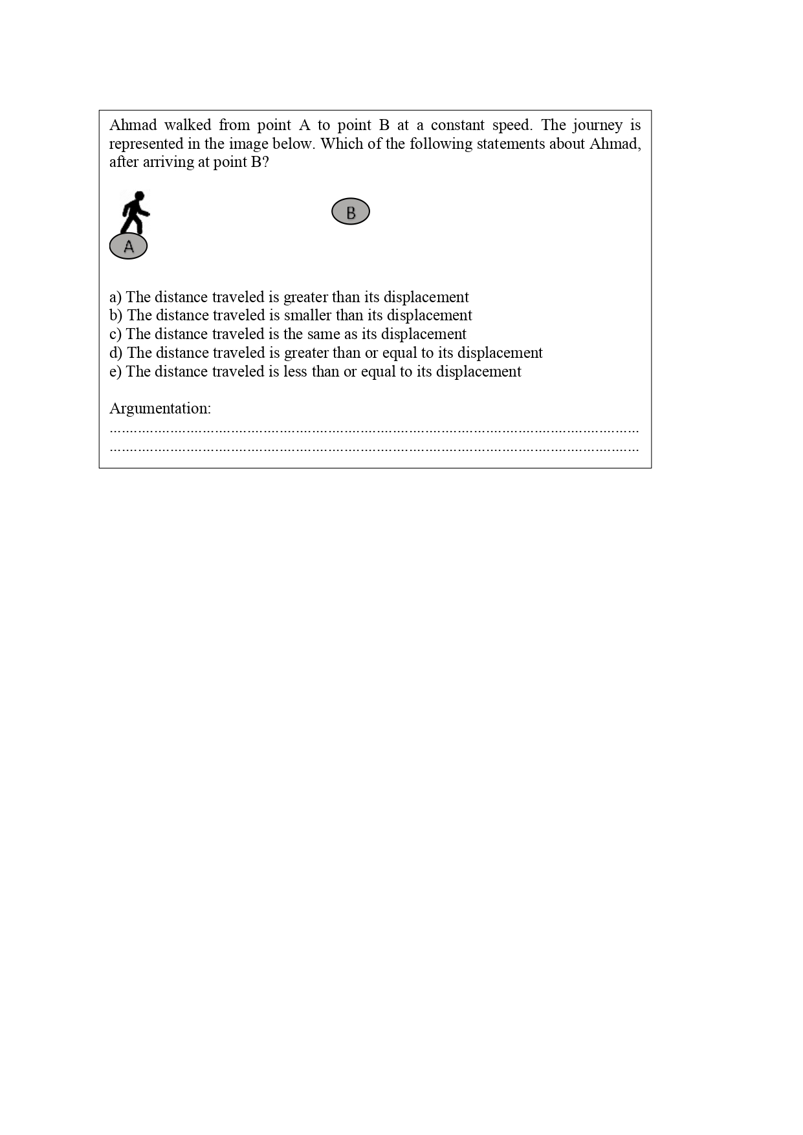**

**Figure 1**. Simple test about distance and displacement

Students 'initial and final understanding of the concepts of distance and displacement has been analyzed from students' responses and arguments to the tests given at the beginning and end of the lesson. Meanwhile, the shift in student understanding has been analyzed from interviews and student responses when there is a discussion process during learning.

1. Result and Discussion

Students 'initial understanding was analyzed through students' responses and arguments to the simple test. The distribution of student responses is shown in Figure 2 (a), with choice **A** about 20% and choice **C** being 80%, while options **B**, **D** and **E** are 0%. From the picture, it is known that all students do not understand with a correct and strong understanding of the difference between distance traveled and displacement.

|  |  |  |
| --- | --- | --- |
| E:\5) Journal & Confrence\Ancoset\Grafik pemahaman siswa_page-0001.jpg |  |  |
| (a) Initial respons | (b) Response after initial discussion | (c) Final respons |

**Figure 2**. Respons of students by test about distance and displacement (***D correct answer***)

In general (80% of students) it is known about students' initial understanding of the concept of distance and displacement, namely "the distance traveled from an object is the same as the distance it is displaced". In addition, some other students (20% of students) understand that "the distance traveled from an object is greater than the distance it is moving". Based on the initial arguments that have been put forward, students are very confident in their choices, especially those who choose the answer "**C**", which is shown in Figure 3.

|  |  |
| --- | --- |
| E:\5) Journal & Confrence\Ancoset\jawab c.jpg | E:\5) Journal & Confrence\Ancoset\jawab a.jpg |
| (a) Students who have chosen the answer **C** | (b) Students who have chosen the answer **A** |

**Figure 3.** Examples of initial arguments of students

From the two arguments that have been put forward, it can be seen that students have begun to distinguish between distance and displacement. This is indicated by different definitions of the lines they have created themselves, one that indicates distance and another that represents displacement. However, the group of students "**C** answer" and "A answer" were different in determining the path taken by Ahmad. the “C answer” group determined the path by directly drawing the closest straight line, while the “**A** answer” group chose the path towards the X axis (right) first then turned towards point B along the Y axis (up).

This has also been strengthened by the arguments that were put forward by the two groups during the initial discussion. Excerpts of a brief discussion between the two groups are as follows:

Instructor: Please, a representative from the student group "**C** answer" to explain their arguments and then the group "**A** answer" can respond to them.

Student **C**: when Ahmad moves, he will take a straight path from point A to point B. So it is clear that the distance traveled with the displacement will be the same.

Instructor: How about the other? I mean the “**A** answer” group?

Student **A**: In my opinion, Ahmad cannot walk in a straight line. There must be a turn even slightly. So that the distance traveled will be greater than the distance traveled.

From the preliminary discussions that have been carried out at the beginning of the learning process, it can be stated that in general students have argued with their daily knowledge and experiences. This is reflected in the statement "it is impossible for Ahmad to walk in a straight line".

After the learning process which started with the initial discussion with verbal, it can be seen that there has been a shift in students' general understanding. This has been shown by different student responses to the same problem, as shown in Figure 2 (b). After the initial verbal discussion, the composition of the student responses changed to 50% choosing A, 0% choosing B and E, 30% choosing C, and 20% of students choosing D (correct answer). From the distribution of these choices, it can be seen that there has been a shift in the understanding of a group of students from "The distance traveled is the same as its displacement" to "The distance traveled is greater than its displacement". One of the compelling reasons for this change was the argument that "it was impossible for Ahmad to walk a straight line".

After the initial discussion has been carried out, the next discussion process begins with an explanation of the instructor about the difference in distance and displacement by using simple pictures as a learning medium. Then a parallel discussion was then carried out. After the discussion which was assisted by pictures as a learning medium, all students were able to correctly distinguish and master the difference in the concept of distance and displacement. This is shown in Figure 2 (c), where all students responded to the simple test that was tested correctly. The use of pictures, graphics and other representations in learning has been able to encourage students to understand the concepts that have been discussed in the learning process. This is also in line with previous research, that multiple representations can help students master and understand the concepts of physics (21,22). One of the student arguments in the final test is shown in Figure 4.

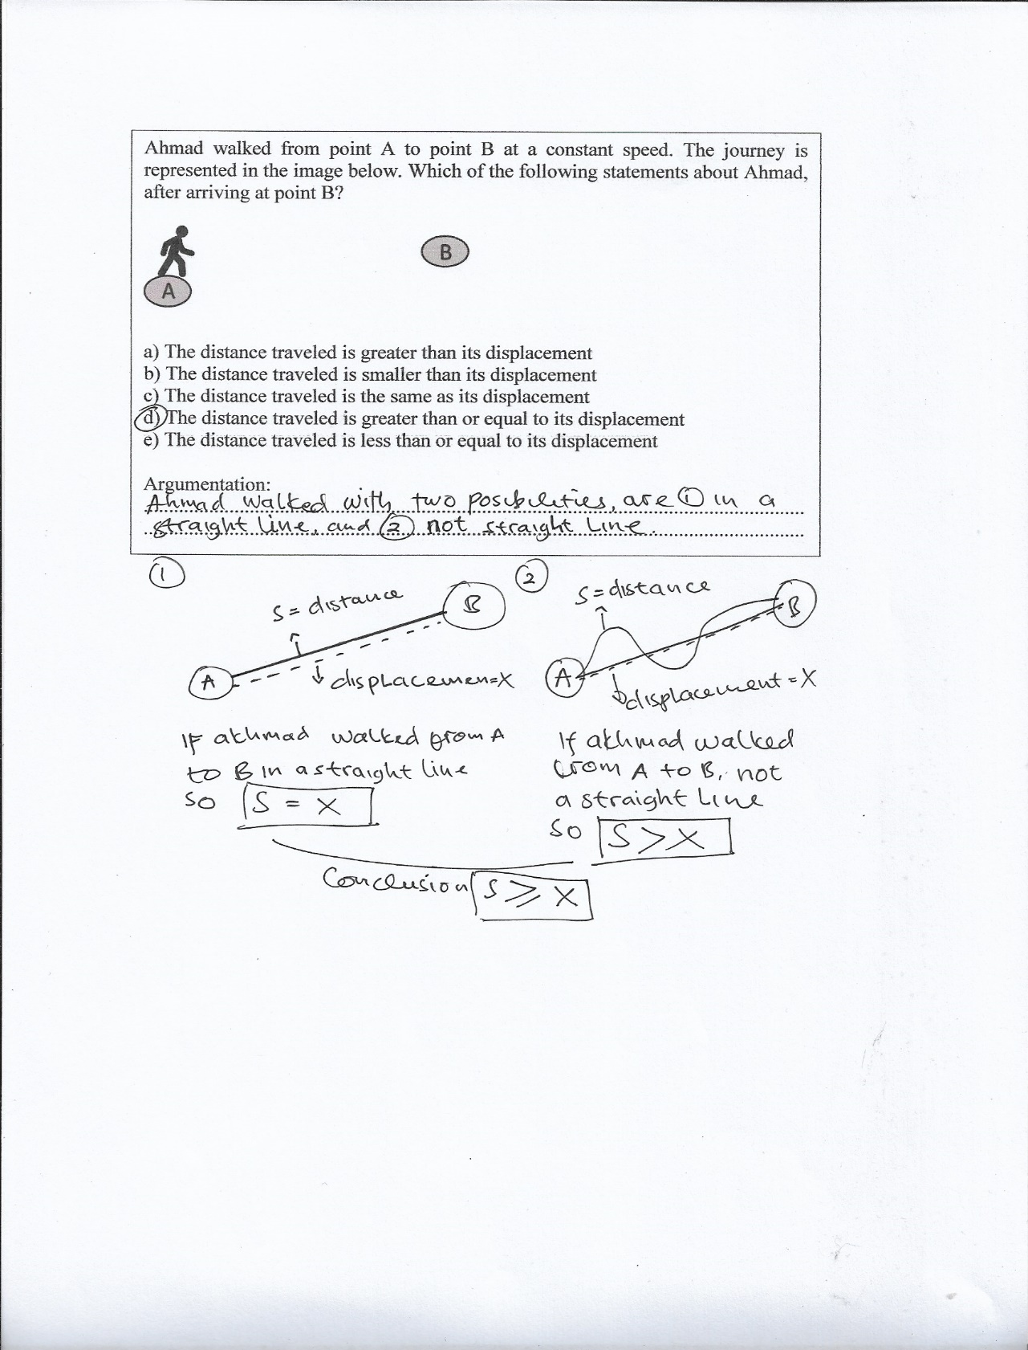

**Figure 4.** Examples of final arguments of students

1. Conclusion

Students' initial understanding is built on their daily knowledge and experiences. So that in responding to a problem, students tend to combine the concepts obtained in formal education with their daily experiences. However, the student's initial understanding can shift to a correct and stronger understanding. One of the things that an instructor can do to shift student understanding to a correct and strong understanding is by conducting visual-based discussions.

References

1. Wells J, Henderson R, Traxler A, Miller P, Stewart J. Exploring the structure of misconceptions in the Force and Motion Conceptual Evaluation with modified module analysis. Phys Rev Phys Educ Res [Internet]. 2020;16(1):1–16. Available from: https://doi.org/10.1103/PhysRevPhysEducRes.16.010121

2. Hammer D. Student resources for learning introductory physics. Am J Phys. 2000;68(7):52–9.

3. Rimoldini LG, Singh C. Student understanding of rotational and rolling motion concepts. Phys Educ Res. 2005;1(1):1–9.

4. Hestenes BD, Wells M. A Mechanics Baseline Test. Phys Teach. 1992;30(3):159–66.

5. Trowbridge DE, Mcdermott LC. Investigation of student understanding of the concept of velocity in one dimension. Am J Phys. 1980;48(12):1020–8.

6. Saifullah AM, Sutopo S, Wisodo H. SHS Students’ Difficulty in Solving Impulsee and Momenyum Problem. J Pendidik IPA Indones [Internet]. 2017 Apr 30;6(1):1–10. Available from: https://journal.unnes.ac.id/nju/index.php/jpii/article/view/9593

7. Suarez A, Kahan S, Zavala G, Marti AC. Students ’ conceptual difficulties in hydrodynamics. Phys Rev Phys Educ Res. 2017;13(2):1–12.

8. Sutopo, Liliasari, Waldrib B, Rusdiana D. Impact Of Representational Approach On The Improvement Of Students’ Understanding Of Acceleration. J Pendidik Fis Indones. 2012;8(2):161–73.

9. Wiyono, Lailatin N, Jufriadi A. Interpretation Patterns for the Distribution of the Turbidity of Soil Water Around TPA Supit Urang (Final Removal of Garbage) Using Geoelectric Resistivity Methods. In: IOP Conference Series: Materials Science and Engineering. 2019.

10. Jufriadi A, Ayu HD. Investigation of resistivity for delineation aquifer layers and subsurface structures Investigation of resistivity for delineation aquifer layers and subsurface structures. J Phys Conf Ser. 2019;1381:1–6.

11. Ayu HD, Sarwanto S. Analysis of seismic signal in order to determine subsurface characteristics Analysis of seismic signal in order to determine subsurface characteristics. In: Journal of Physics: Conference Series. 2019. p. 1–6.

12. Wahyuningsih D, Jufriadi A, Ayu HD, Muslih MI. Design of Moderator Neutron for Boron Neutron Capture Therapy in Kartini Nuclear Reactor Using Monte Carlo N Particle 5 Simulation. In: The 2nd Annual Applied Science and Engineering Conference (AASEC 2017). IOP Publishing; 2018. p. 1–12.

13. Miterianifa M, Trisnayanti Y, Khoiri A, Ayu HD. Meta-analysis : The effect of problem-based learning on students ’ critical thinking skills. In: The 2nd International Conference on Science, Mathematics, Environment, and Education [Internet]. AIP Publishing; 2019. p. 020064–1–020064–7. Available from: https://doi.org/10.1063/1.5139796

14. Trisnayanti Y, Khoiri A, Miterianifa M, Ayu HD. Development of Torrance test creativity thinking ( TTCT ) instrument in science learning. In: The 2nd International Conference on Science, Mathematics, Environment, and Education [Internet]. AIP Publishing; 2019. p. 020129–1–020129–5. Available from: https://doi.org/10.1063/1.5139861

15. Jufriadi A, Andinisari R. JITT with assessment for learning : Investigation and improvement of students understanding of kinematics concept. Momentum Phys Educ J. 2020;4(2):94–101.

16. Trowbridge DE, McDermott LC. Investigation of student understanding of the concept of acceleration in one dimension. Am J Phys. 1981;49(3):242–53.

17. Reif F, Allen S. Cognition for Interpreting Scientific Concepts : A Study of Acceleration. Cogn Instr. 1992;9(1):1–44.

18. Beichner RJ. Testing student interpretation of kinematics graphs. Am J Phys. 1994;62(8):750–62.

19. Flores S, Kanim SE. Student use of vectors in introductory mechanics. Am J Phys. 2004;72(4):460–8.

20. Shaffer PS, Mcdermott LC. A research-based approach to improving student understanding of the vector nature of kinematical concepts. Am J Phys. 2005;73(10):921–31.

21. Campos E, Zavala G, Zuza K, Guisasola J. Students’ understanding of the concept of the electric field through conversions of multiple representations. Phys Rev Phys Educ Res [Internet]. 2020;16(1):10135. Available from: https://doi.org/10.1103/PhysRevPhysEducRes.16.010135

22. Sundaygara C, Gaharin D. Pengaruh Multiple Representation pada Pembelajaran Berbasis Masalah Terhadap Penguasaan Konsep Fisika Dasar II Mahasiswa Fisika. Momentum Phys Educ J. 2017;1(2):111–21.