Design of Information Systems of Reporting The Peformance of Honorary Employees at The Web Based Office of Communicatoin and Informatics in Blitar Regency

Wiji Setiyaningsih1, Hari Lugis Purwanto2, Gaguk Susanto3, Moh Ahsan4, Amak Yunus Eko5, Yesika Trestiarso6, Daryanto7

Faculty of Science and Technology, Kanjuruhan University of Malang1, 2, 3, 4, 5, 6, Muhammadiyah University of Jember 7

[wiji@unikama.ac.id](mailto:wiji@unikama.ac.id), [hari_lugis@unikama.ac.id](mailto:hari_lugis@unikama.ac.id), [gaguk.susanto@unikama.ac.id](mailto:gaguk.susanto@unikama.ac.id), [ahsan@unikama.ac.id](mailto:ahsan@unikama.ac.id), [amakyunus@unikama.ac.id](mailto:amakyunus@unikama.ac.id), [yesikatrestianto@gmail.com](mailto:yesikatrestianto@gmail.com), [daryanto@unmuhjember.ac.id](mailto:daryanto@unmuhjember.ac.id)

**Abstract**. The Office of Communication and Informatics of Blitar Regency carries out its main tasks supported by temporary personnel with their respective work targets. To find out the number of performance targets that have been carried out and performance appraisals per year, the temporary staff must make daily and monthly performance reports to the leadership. So far, technical reporting uses Microsoft Excel which must be printed one by one before being reported. If there are errors on the report must edit one by one. Each sheet stores daily reports so that many sheets are used to store reports in one month. Reports submitted to the leadership are still in copy which is prone to loss. This has a negative impact on the deadlines for collecting reporting and monitoring by the leadership. Based on these problems, a Web-Based Performance Reporting Information System was built to optimize performance reporting. The system is built with 3 access rights: admin, leadership, and non-permanent personnel, employee mastering and performance targets with targets, as well as daily and monthly reporting transactions. From the test results, the system with UAT 89.8% has been able to optimize performance reporting with the output of performance values per month and per year completed with graphs of performance targets.

1. Introduction

To help carry out their duties and functions, the Blitar Regency Communication and Information Office is supported by the presence of honorary employees. So far, the technical daily and monthly performance reporting of honorary employees at the Office of Communication and Information Technology of Blitar Regency is still manual using Microsoft Excel. Performance reports must be printed one by one before being reported, if there are errors in the daily report, you must edit one by one. Each sheet stores daily reports so that there are multiple sheets used to store reports in a month. Next, the printed report must be signed by the Division Head.

There are obstacles to reporting performance that is not timely and performance reporting is often not conveyed to the Central Personnel if the Head of the Division is often on duty outside the office, while the performance reporting deadline must be conveyed to the central staff as material for assessing the sustainability of work contracts and routine monitoring. This allows for the invalidity of performance reporting that is not in accordance with the reality of the performance targets that have been achieved by honorary employees according to the performance targets set by the Division Head, which has an impact on decreasing the sense of responsibility and discipline of honorary employees and high levels of complaints, high social jealousy among honorary employees, as well as the continuation of the next work contract.

Management of performance reporting data storage in the form of softfile is still stored on the computer of the honorary employee respectively. Meanwhile, hardcopy of performance reporting data is stored at the Head of Division and Central Personnel, which of course is prone to loss and from a less economic side. If the data is needed at any time, with the number of files stored, of course, the data search process takes a long time and requires high accuracy.

Based on the description of the problem, a web-based performance reporting information system was built at the Blitar Regency Information and Communication Office. The objectives of this study are 1). To design a web-based performance reporting information system; 2). To optimize daily and monthly performance reporting data management by honrary employees, as well as to optimize section heads in monitoring work targets and the number of performance targets for honrary workers to be more effective and timely.

Informaion system is a system that provides information for management in making decisions and also for running company operations, where the system is a combination of people, information technology and organized procedures. An information system is a system within an organization that meets the daily transaction management needs, supports operations, is managerial, and strategic activities of an organization and provides certain external parties with the required reports [1].

A performance report is a report that lists the results of both individual and team performance in one period. This report is used to communicate progress to employees and forecast future progress to stakeholders. The data displayed must be clear and unambiguous. The work results of the performance process are presented in table or graphical format and are visual based to make it easier to understand. That way, the report is easy to understand. Feedback reports are needed to measure the activities carried out in order to improve performance and accountability in implementing a plan or when implementing a budget, so that management can know the results of implementing the plan or achieving the set budget targets [2].

There is research by Mukhammad I and Endang K regarding the performance reporting information system of employees of the environmental service, resulting in research that can help employees and supervisors of the Mojokerto City environmental service in reporting daily performance and submitting employee equipment [3]. Erid's research on analysis and design of employee performance reporting system using the work system framework with UML modeling resulted in research to overcome delays in submitting daily employee reports per month [4]. Meanwhile, Imam, Hanim, Radityo's research on Designing and Making Online-Based Performance Reporting Systems for Computer Institutions resulted in research with a reporting system application that could store list data and KPI realization and carry out hardware inventory [5]. Yulanda's research on the design of a web-based PDAM Pekanbaru employee performance reporting system with PHP and MYSQL resulted in research. With this system, employees were more efficient and effective in presenting reports and evaluating performance results [6]. Thus it can be concluded that the existence of an employee performance reporting information system can optimize the performance reporting process, and increase the effectiveness of monitoring and evaluating the achievement of employee performance targets by the leadership.

1. Method

The research method in the implementation of this research is to use a development method that applies the waterfall development model, which includes the stages: definition and analysis of system requirements, system and software design, implementation and unit testing, system integration and testing, and operation and maintenance [7] [8].

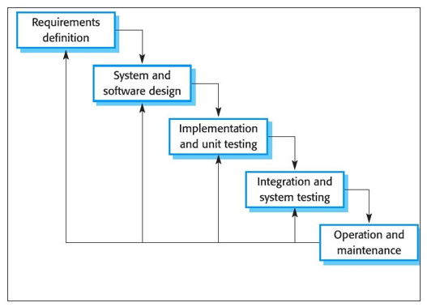

**Figure 1.** Waterfall Method Stages

## Definition And Analysis of System Requirements

The activity at this stage aims to identify the running system based on data at the Blitar Regency Communication and Information Office and collect the data needed to meet the needs for software development by conducting interviews and observations with related parties, namely the Head of the Application Development and E-Governance Section. Gov and two irregular forces. Interviews were conducted in November 2019. The following are the results of interviews with temporary staff related to user needs:

a. The initial need for users is to build a performance reporting information system for temporary personnel that can help optimize the management of daily and monthly performance reporting data by non-permanent workers, as well as optimize section heads in each field in monitoring work targets and the number of performance targets for non-permanent workers to be more effective. and on time.

b. In building a performance report information system for non-permanent personnel, the following information is needed: District Information and Communication Office employee data Blitar, data on work targets and the number of performance targets for non-permanent workers, performance report format is not fixed.

## System and Software Design

Activities in this stage compile a series of system work by determining the actors of the system and the tasks that must be done. In addition, making models to understand system requirements as well as system design. The models used in this study are:

1. Use case diagrams, sub-use case diagrams, activity diagrams, sequence diagrams, and class diagrams to describe the interactions that are carried out by each actor [9].
2. Interface design for making information system display design.

## Implementation and Unit Testing

At this stage, a performance report information system is built by coding. The system is built according to the model that was created in the previous stage. In the development of this system using the programming language PHP, HTML, Javascript, CSS and MySQL. And supported by XAMPP software and the CodeIgniter framework. After the coding is complete, then system testing is carried out using black box testing to find out errors that may occur in the system which will then be corrected [10] [11] [12].

## System Integration and Testing

The operational test of the performance report information system for non-permanent personnel at the Office of Communication and Information Technology in Blitar Regency was carried out by several actors, namely administrators, unit leaders, and non-civil servant employees. System operational testing can use User Acceptance Testing (UAT) [13] [14] [15] [16] through the following steps:

a. Planning

Designing a questionnaire list that will be filled in by 20 respondents consisting of the head of the e-gov application development and governance section, the head of the section for managing information and public opinion, the information system admin, 10 non-permanent staff and 7 other employees. Making research instruments consisting of several core points of the questionnaire, namely: information system interface, ease of access to information systems, suitability of functions that run on information systems.

b. Implementation

Provide a questionnaire sheet to a predetermined sample, testing, analyzing and establishing research instruments, evaluating, analyzing and processing the data that has been collected, prepare reports from research results.

## Operation and Maintenance

The finished information system is submitted to the user, then evaluates the operation of the system that has been run by the user. With this stage, it is hoped that the creation of an information system for temporary staff performance reports that is in accordance with the needs of the Blitar Regency Communication and Information Office.

1. Result and Discussion

## Analysis of System Requirements

1. Employee data is used as the basis for system user data, main performance data and additional productivity as well as daily and monthly reporting that can be managed by the admin.
2. Job targets consist of the types of performance targets with the number of targets in each section and field.
3. The main performance data is in the form of submissions from input honorary employees who can be verified by the admin or leader as the verifier.
4. Additional productivity data is in the form of submissions from honorary employees input that can be verified by the admin or leader as the verifier.
5. Verifiable key performance and additional productivity proposals can be calculated by name of the precarious worker.
6. Daily verified key performance and additional productivity data reports can be displayed as reports by name and date.
7. Monthly key performance and productivity data reports additions that have been verified can be displayed in the form of monthly reports based on name, month, and year.
8. This graph of the number of work targets shows the number of work targets that have been completed by precarious workers

## System and Software Design

Figure 2 is the implementation of programming and testing for daily performance reporting forms by non-permanent employees including adding data, editing data, and deleting data.

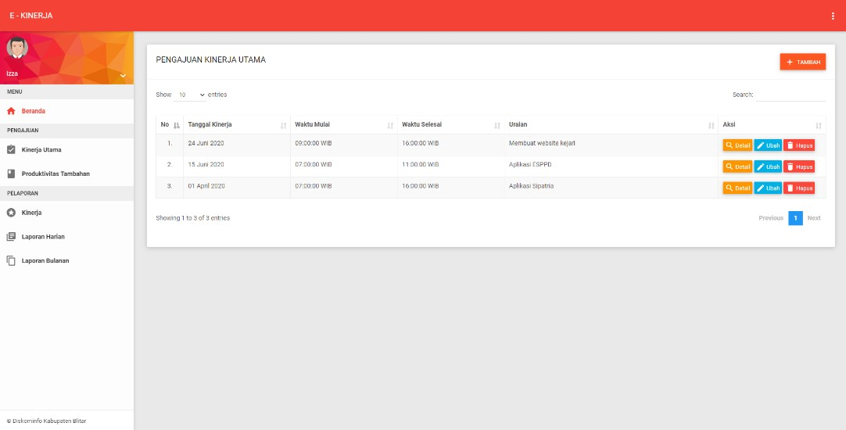

**Figure** 2. Performance Reporting Interface by Employees

Figure 3 shows a detailed interface of the main performance and additional performance of each employee.

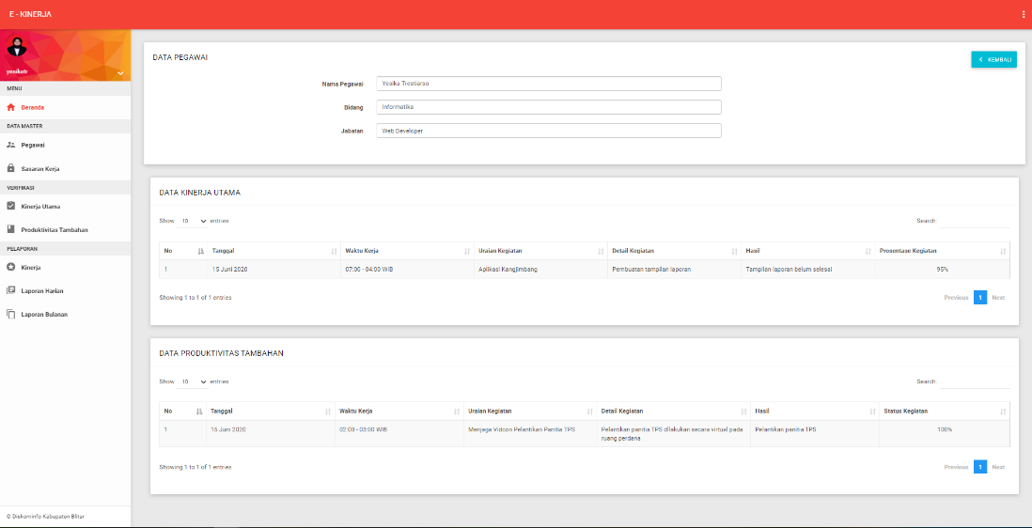

**Figure 3.** Interface of Main Performance Details and Additional Performance

In Figure 4 below, it displays a work target graphic.

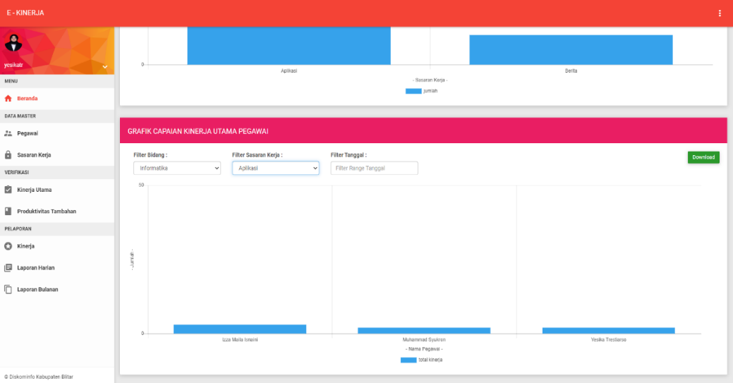

**Figure 4.** Graphical Interface Job Target

1. Conclusion

Based on testing with black box testing, it was concluded that the system was running in accordance with the system design, and the average UAT test result was 89.8%. This means that the performance reporting information system can be used by the Office of Communication and Information of Blitar Regency which is able to increase the effectiveness of daily and monthly performance reporting, as well as optimize routine performance monitoring by division heads and personnel.

1. Anknowledgment

Thank you to the entire research team and all parties from the Blitar Regency Communication and Information Office for supporting the implementation of this research.

1. References
2. Jeperson H 2015 *The Concept of Information Systems* (Yogyakarta: Deepublish)
3. LinovHR Admin 2020 The Main Benefit Of Performance Reports In The Company LinovHR
4. Mukhammad I P and Endang K 2020 Employee Performance Reporting Information System Environmental Services *EXPLORE* **10** 31
5. Erid A P 2018 Analysis And Design Of Employee Performance Assessment System Using Work System Framework With Uml Modeling *Intecoms: Journal of Information Technology and Computer Science* **1** 151
6. Imam T I, Hanim M A, Radityo P W 2020 Design and Development of Online Performance Reporting System for Computer Technician *JUITA: Jurnal Informatika* **8** 91
7. Yulanda 20019 Designing Web-Based PDAM Pekanbaru Employee Performance Reporting System with PHP and MYSQL *Scientific Journals CORE IT: Community Research Information Technology* **7** 1
8. Ian S 2011 *Software Engineering* (Jakarta: Erlangga)
9. Abdul K 2014 *Introduction to Revised Edition Information Systems* (Yogyakarta: ANDI) ISBN 9792921583
10. Rosa A S, and Muhammad S 2015 *Structured and Object Oriented Software Engineering* (Bandung: Informatics)
11. Linmin Y, Zhe D, Thomas R F 2011 *Information Gain of Black-Box Testing* (Switzerland: Springer International Publishing)
12. Jiangyuan Y, Zhiliang W, Xia Y, Xingang S, Jianping W 2014 Formal Modeling and Semantyc Black-Box Testing of SDN Data Plane *IEEE 22nd International Conference on Network Protocols*
13. Srinivas N, Jagruthi D 2012 Black Box and White Box Testing Techniques-A Literature Review *International Journal of Embedded Systems and Applications (IJESA)* **2** 29
14. Brian H, Pauline V G 2013 *User Acceptance Testing: a Step by Step Guide* (Swindon : BCS Learning & Development)
15. Pallavi P, Swati T 2015 AgileUAT: A Framework for User Acceptance Testing based on User Stories and Acceptance Criteria *International Journal of Computer Applications* **120** 16
16. Fatihah M, Wan F F Y, Masita A J, Suryani I, Noor M M N, Mohamad N H 2019 User Acceptance Testing (UAT) For The Development And Evaluation Of An Automated Learning Style Detection System *AIP Conference Proceedings* **2138**, 040019
17. Ganesh, Sanjay M, Anbuudayasnkar, Sivakumar 2014 *Enterprise Resource Planning User Acceptance Test* (Switzerland: Springer International Publishing)