IMDAS : Android System for Supporting Indonesian Maritime Diplomacy in Indian Ocean, Southern West Java

D Dina1,*, T Finaldin, H Primawanti, T Alamsyah, M D Yusuf, K Kosidin2,

I Sumardi, A Dadang3, I Hikmawati, G Undang4

1International Relations Departement, Faculty of Social and Political Sciences, Al-Ghifari University, Bandung

2Bandung Informatics Engineering Study Program, College of Management and Informatics (STMIK) West Java, Bandung

3Public Administration Study Program, College of Social and Political Sciences of the Southern Indonesian Ocean (STISIP SAINS), Garut

4Administration Science Study Program, Indonesian Community Development University,

Medan

dina.shusein@gmail.comType the corresponding author’s e-mail address here

**Abstract**. Indonesia has geographic, geostrategic and geo-economic potential which is an important factor for the dynamics of international relations in the two oceans, the Indian Ocean which interconnects with the South China Sea and the Java Sea through the Malacca Strait. This is what makes the potential vulnerable to marine terrorism. This study aim to improve maritime diplomacy against the threat of illegal immigrants in the Indian Ocean (Indonesian Ocean), especially Southern West Java. Data show that during 2011-2012 there were 11 smuggling of illegal immigrants through Southern West Java coastal entrances. This incident show the weaknesess of Indonesia's maritime diplomacy, especially with Australia. This research offers a solution to increase security in southern West Java with an information system technology approach. More specifically, this study designs an android-based application that can be used by the public to report security disturbances to illegal immigrants to the apparatus as a form of the Universal People's Defense and Security System *(Sishankamrata*) easily and quickly. The research method uses a Geographic Information System (GIS) approach. The results of this study produce an android based application design.

Keywords: android system, maritime diplomacy, Indian Ocean

1. Introduction

Indonesia is an archipelago island, almost 70% of the territorial is water or ocean. Indonesia's position is a strategic area, which is between two continents (Asia and Australia) and two oceans (Pacific and Indian). The Indian Ocean, which is interconnected with the South China Sea and the Java Sea through the Malacca Strait, is prone to maritime terrorism. The International Maritime Organization (IMO) has showed a trend of piracy in the Malacca Strait with a significant presence from 2000-2004 [1]. In 2005, the Strait of Malacca was categorized as a high-risk zone by Lloyd's Joint War Risk Committee. In the 2000s, in the aftermath of the September 11 terrorist attacks, the international community raised concern over the safety of the Straits of Malacca because of the idea that piracy could pose a risk to marine terrorism. This is evidenced by the existence of the Indonesian archipelago sea lanes, which are the routes traversed by foreign ships and aircraft to reach their destination easier. So that parts of Indonesia are made into international sea traffic flows. Data show that the number of vessels passing through the Malacca Strait from 1999-2008 has increased by 74 percent and data from the Ministry of Defense predicts that 114,000 ships will use the Malacca Strait in 2020[2] . Indonesian territory is prone to threats. Most of these threats come from outside. Many threats that come from outside include: illegal fishing, buying and selling of drugs, human and gun trafficking, terrorism, illegal migrations.

The problem in this research is based on the data that illegal immigrants have smuggled 11 times through the Southern West Java coastal entrance in 2011--2012. Data show that during 2011-2012 there were 11 illegal immigrants smuggling through the the Southern West Java coastal entrance, including (1) March 6, 2012 Garut Police arrested 67 illegal immigrants from Palestine and Aghanistan in Cibalong District, South Garut with the aim of crossing to Chrismast Island, Australia; (2) 8 March 2012 as many as 55 illegal immigrants from Aghanistan who were about to cross to Chrismast Island were caught in Muara Gatah Beach, Cimerak District, Ciamis Regency (now Pangandaran Regency), (3) 11 March 2012 as many as 53 (more than 68 people) illegal immigrants from Iran and Afghanistan, who were about to cross to Christmas Island, were arrested at the dock in Kampung Cibuntu, Loji Village, Simpenan District, South Sukabumi. This incident show the weaknesess of Indonesia's maritime diplomacy, especially with Australia. President Joko Widodo needs to reorient Indonesia's foreign policyWith the vision and mission of the Indonesian Police, which has a special characteristic of Indonesia as the world's maritime axis, it will revive the nation's identity as a maritime power between the Indian Ocean and the Pacific Ocean[3]. Through this idea, the Indonesian people will optimally maximalize the geographical, geostrategic and geo-economic potential which are important factors for the dynamics of international relations in the two oceans.

Integration of analytical hierarchy processes (AHP) and geographic information system (GIS) technology (GIS) in dealing with problems in Indonesian waters has been carried out especially in the case of illegal fishing so that a spatial model is produced that is in accordance with the multi-criteria decision making framework[4]. With the information related to illegal immigrants in the Indian Ocean, especially southern West Java, it becomes a reference for the Indonesian government to make policies and make decisions related to maritime diplomacy in order to maintain Indonesia's maritime security and achieve the ideals of the maritime axis. Therefore, this study aims to design an android application system that supports maritime diplomacy in financing illegal immigrants in the Indian Ocean, especially southern West Java. This research will analyze the potential for illegal immigrants in Indonesia through GIS. This research is useful for the authorities in Indonesia as a reference in making decisions related to safeguarding Indonesian waters in order to achieve the ideals of the maritime axis. Therefore, the research aims to create an android application to support maritime diplomacy in handling illegal immigrants in the Indian Ocean, especially south west Java. This research will look at cooperation and coordination between government organizations, like Indonesian national army,police, the navy that carries out marine patrols, local governments and the community, in this case is fishermen.

**Method**

This research method uses Geographical Information System (GIS) and waterfall model. GIS is used to store and analyze geographic information. The waterfall method intends to develop a system which is the process of developing or changing a software system using methods or models that can be used by others in developing software systems, in this case the creation of an android application to support maritime diplomacy on handling.illegal migrants in the Indian Ocean especially southern west Java. The Waterfall model is a sequential software process, seen as continuously flowing downward (like a waterfall) through the phases of planning, modeling, implementation, testing, deployment and maintenance. This will be explained through Figure 1 where the stages in IMDAS using the waterfall model are as follows:

1. Requirements Gathering and analysis, namely gathering the needs of stakeholders, both government and non-government organizations in an effort to report the existence of illegal immigrants.

2. Design, at this stage the developer will produce the system as a whole and determine the flow of the software to a detailed algorithm.

3. Implementation is the stage where the entire design is converted into program code. The resulting program code is still in the form of modules that will be integrated into a complete system.

4. Integration & Testing

At this stage the modules that have been made are combined and this test is carried out to find out whether the software that has been made is in accordance with the design and function of the software there is an error or not.

5. Verification or deployment is the user testing whether the system is in accordance with what has been approved.

6. Operation & Maintenance, namely the process of installing and repairing the system according to approval.

Figure 1. Waterfall Model in IMDAS

**MAINTENANCE**

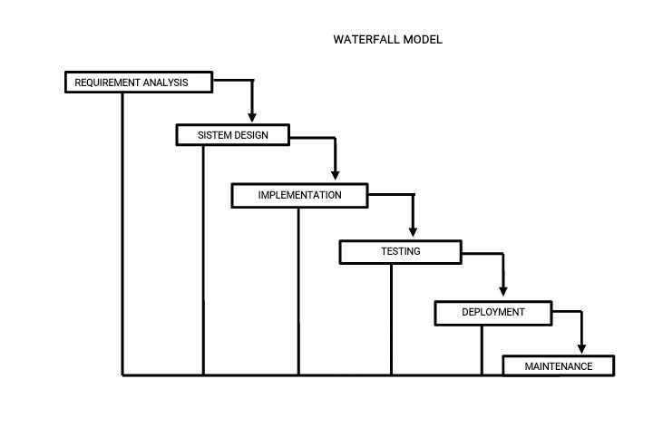

**Result and Disscussion**

**Geographic Information System (GIS) Based on Andriod Application**

**Geographic Information System** (GIS) is a computer based technology and methodology for collecting, managing, analyzing, modelling, and presenting geospatial data for a wide range of applications[5].Geographic Information Systems (GIS) on android application is a development of maritime diplomacy tools in reporting the existence of illegal immigrants entering the sea or Indonesian waters. This GIS based on android application help find out geographical position of illegal immigrants in the sea or Indonesian waters, so that the potential for illegal immigrants seen in Indonesian waters and its surroundings can be immediately detected and reported by the government and non-government to be immediately handled by the authorities.The use of GIS on android systems has been carried out in various studies both in the field of mapping and school data collection [6]; mapping of small and medium enterprises [7], future electricity network information systems and how to manage more efficiently[8], survey and urban mapping [9],[10]. Actually there is already a Coastal and Marine Geographical Information Systems (CMGISs) permit to collect, manage and anlyze a great amount of heterogonous data concerning coastal, sea and ocean environments[11]. Geographic Information Systems (GIS) based on android application is a tool to report is a new thing, specially to report on illegal immigrants, so the finding of this study IMDAS is an android system for supporting Indonesian maritime diplomacy specially in Indian Ocean, Southern West Java. This will be describe ini figure 2. The use of GIS based on an Android application, is able to detect the presence of ships carrying out illegal immigrants in real-time and report this to the authorities. This report can be done by the navy who is conducting patrols, the community in this case fishermen. This reporting is carried out using the Andriod application which is easy and fast to use so that the related apparatus can immediately take action.

***Maritime Diplomacy***

Maritime diplomacy is a diplomatic relationship between one country and another in the economic, social, political, security and cultural fields in the territorial waters. Maritime diplomacy can be defined as the art of negotiating between representatives of countries [12]. Maritime diplomacy can also be interpreted as various kinds of activities in maritime or marine areas, the main task is with the Navy of a sovereign country. This is done to influence other countries to behave in the context of interactions and transactions that occur in water areas [2]. So it can be said that maritime diplomacy is a negotiation produced by two or more countries related to maritime boundaries, cooperation and defense of a country. Deterrence is generally defined as the threat of military retaliation directed at preventing other countries from carrying out activities that could harm the country implementing the deterrence policy and is generally limited to the use of nuclear weapons (Cold War perspective). In the Jokowi era, Indonesia carried out a maritime axis policy by prioritizing maritime diplomacy which was shown to the international world. Therefore, Indonesia needs infrastructure and preparation of various instruments involved in the implementation of maritime diplomacy. One of the tools that need to be developed is maritim diplomacy based on the Geographic Information System using an android application. This application can help improve maritime diplomacy, accelerate handling of the TNI, Police, and local government apparatus and facilitate and accelerate the reporting of public participation against the threat of illegal immigrants as a form of *Sishankamrata* in the Indian Ocean region, southern West Java.To become a world maritime axis is not only concerned with maritime safety and security issues but must underline maritime and infrastructure relations [13]. Indonesian maritime diplomacy in maintaining security in its territorial waters must collaborate with various stakeholders, both government and non-government. We can study India in maritime diplomacy in the Indian Ocean, which did not materialize optimally because the Indian government ignored the navy as resistance to the army and air forces. Indian thinkers have always thought that the most vital threat from land, especially from the east and the west [14]. That way, the balance of power is something that really needs to be applied to maritime diplomacy because it not only sees formal alliances but also the direct military challenges in the future but is more pursuit through diplomacy, economic efforts and coordination and technology transfer [15].

***Indonesian Maritime Diplomacy Android System (IMDAS)***

Indonesian Maritime Diplomacy Android System (IMDAS) is an application designed to develop application system based on geographic information system (GIS) using the waterfall method which will produce an android application system for maritime diplomacy. This android application is a way to support Indonesia's defense in dealing with illegal immigrants in Indonesian waters, especially the Indian Ocean, Southern West Java. IMDAS is a preventive tool for all stakeholders who have the authority to deal with illegal immigrants. This tool can also be used by the community or fishermen related to the reporting of illegal immigrants.

This can be described as follows:

Figure 2.

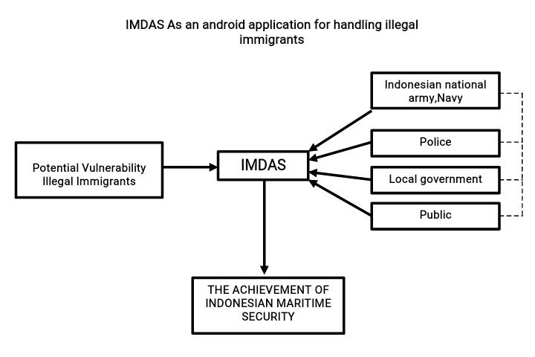

Source : Research Result, 2020

**Conclution**

The design of making android applications to support maritime diplomacy in handling illegal immigrants is a must for the government. This cooperation is carried out by government organizations such as Indonesian National Army, Navy, marine patrols, regional government and non-government organizations, in this case the community, namely fishermen. An android application that uses GIS find the position of the ship carrying illegal immigrants to Indonesia, then can immediately report it, so that all stakeholders can immediately know the coordinates of the illegal immigrants and can take security and action. The phenomenon of making andrroid applications is the development of maritime technology and diplomacy in the case of illegal immigrants.

References

[1] Arifin B and Damanik N A 2009 The implementation of indonesia’s counter piracy strategies through multilateral cooperation in the malacca strait (2004-2009) 5–20

[2] Nugraha M H R and Sudirman A 2016 Maritime Diplomacy Sebagai Strategi Pembangunan Keamanan Maritim Indonesia *J. Wacana Polit.* **1**

[3] Witarti D I, Konsep A, Menurut K, Tahrir H, Annissa J, Ranggakusumah R M A, Demokrasi P, Polimpung H Y S, Serikat A, Nasionalisasi T and Minyak P 2011 Jurnal Ilmu Hubungan Internasional Fakultas Ilmu Sosial dan Ilmu Politik Universitas Budi Luhur Jurnal Ilmu Hubungan Internasional **9** 2014–9

[4] Dede M, Widiawaty M A, Setiawan I and Huda N 2019 INTEGRASI AHP DAN SISTEM INFORMASI GEOGRAFIS UNTUK ANALISIS POTENSI KERAWANAN ILLEGAL FISHING DI INDONESIA (Integration AHP and Geographic Information System to Analyse Vulnerability of Illegal Fishing in Indonesia) *J. Sains Inf. Geogr.* **2** 8

[5] Choi Y 2020 Recent advances in geographic information system for earth sciences *Appl. Sci.* **10** 10–3

[6] Bahtiar H and Kerta Wijaya L 2020 Mobile Based Geographic Information System for mapping and data collection Towards 4.0 Industry *J. Phys. Conf. Ser.* **1539** 1–6

[7] Irawati A R, Kurniawan D, Yusman M and Ibrahim M R F 2019 Implementation of Geographic Information System for Micro, Small, and Medium Enterprises (MSMEs) in Lampung Province using Android Platform *J. Phys. Conf. Ser.* **1338**

[8] Zhang Q, Liu R, Qi X and Xi P 2020 Application of Mobile Geographic Information System Platform in High Voltage Grid Planning *J. Phys. Conf. Ser.* **1549** 1–6

[9] Wang Y 2020 On Application of Geographic Information System in Urban Surveying and Mapping *J. Phys. Conf. Ser.* **1533** 1–5

[10] Rey-p J 2020 Multidisciplinarity , Citizen Participation and Geographic Information System , Cross-Cutting Strategies for Sustainable Development in Rural Heritage . The Case Study of Valverde de Burguillos ( Spain )

[11] Alcaras E, Parente C and Vallario A 2020 The importance of the coordinate transformation process in using heterogeneous data in coastal and marine geographic information system *J. Mar. Sci. Eng.* **8**

[12] Susilowati E, Sulistiyono S T and Rochwulaningsih Y 2018 Coastal civilization and maritime diplomacy in premodern Southeast Asia *Int. J. Marit. Hist.* **30** 649–62

[13] Indrayani I, Pratita C K B and Halim P 2019 Indonesian maritime diplomacy, through the Indian Ocean Rim Association, in realising the goal to become the world maritime axis *Int. J. Innov. Creat. Chang.* **9** 116–34

[14] Das C 2019 India’s maritime diplomacy in South West Indian Ocean: Evaluating strategic partnerships *J. Strateg. Secur.* **12** 42–59

[15] South I N 2018 the Implementation of Japan-Philippines Maritime Diplomacy As Proactive Approach To Respond To the **1**