The Building's Shape as part of Green Building's Passive Strategy

Sahid1, Y Sumiyati2, and R Purisari1

1,1Department of Architecture, Pembangunan Jaya University

2Faculty of Law, Bandung Islamic University

sahid@upj.ac.id

**Abstract**. One of the efforts to meet the green building criteria can be met by implementing a passive strategy. Passive strategies are used to make optimal use of the surrounding environmental conditions, including sunlight and wind flow, to get comfort and energy savings without using electrical or mechanical equipment. Passive strategies include form, orientation, shrouding, interior, interior, greening strategies. This study aims to determine the effectiveness of several shape options, as a passive strategy, in tall buildings associated with one of the criteria for green buildings, namely overall thermal transfer value ( OTTV). This study uses simulation software as a basis for analyzing OTTV performance. This study produces recommendations on building forms that can minimize the achievement of OTTV in tall buildings so that they meet the criteria for local green building regulation

Keywords: Green Building, Criteria, Regulation, Indonesia

1. Introduction

In principle, green buildings can apply two strategies, namely, passive and active systems. The passive strategy are efforts to exploit the potential of the environment [1, 2]. as well as reduce the obstacles that have an impact on the building, one of which is how to utilize the potential of the sun as a source of lighting and at the same time reduce the heat effects it causes. Passive strategies rely on architects' ability to design the building's form, envelope, orientation, interior, and greenery in their designs [3, 4]. Conversely, an active strategy is a planner's effort to utilize electrical and mechanical equipment [1, 2] to achieve the expected environmental conditions. The active approach relies on engineers' ability to design effective and efficient electrical and mechanical systems, including expertise in selecting electrical and mechanical equipment.

The selection of a passive strategy begins with an understanding of local climatic conditions [5]. The fundamental passive approach used in humid tropical areas such as Indonesia is to minimize the building's heating due to solar radiation while still utilizing sunlight for natural lighting needs. Sunlight, which consists of light and heat, is only used by its light components and warding off the heat. The implementation of this strategy can be realized by choosing the right building shape so that the entry of solar heat into the building can be avoided as little as possible. This strategy certainly does not stand alone. They are usually supported by an orientation strategy and the selection of the right building envelope material. The accuracy of this strategy will have a direct impact on reducing energy for air conditioning.

Energy requirements in a building are influenced by various factors that are very diverse and complex [6], namely: 1) size and shape of the building, 2) building orientation, 3) roof system, 4) space planning and organization, 5) thermophysical properties (thermal resistance & thermal capacity), 6) window systems, 7) construction details. These seven factors can be classified as passive-design factors. Furthermore, Aun [6] explained non-design factors that affect a building’s energy consumption, including user behavior and habits, indoor Environment Quality, climate, and site design.

These various factors can be used as a consideration in developing criteria for green building. The development of green building criteria can be done in multiple ways, including experiment [7, 8, 9], simulation [7, 10, 11, 12], consensus [13, 14, 15]. This study tries to use simulation as a basis for proposing consideration of building shape as a passive criterion in designing green buildings.

1. Methodology

To understand the role of building's form as part of a passive strategy, a simulation was carried out using the Ecotect software. Following the research scope, testing was only carried out on building form options as passive strategy options. The test was carried out by comparing the OTTV results from several shape options placed in two positions of orientation to the sun's movement. The shapes chosen are rectangle, square, triangle, hexagon. The per-floor area of ​​the building is determined to be approximately 1000m² and a height of 20 floors.

Table 1. Simulation Scheme

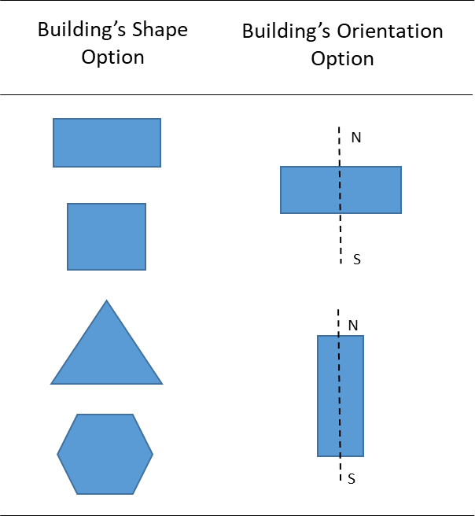

Simulation using Ecotect software in this study uses the following limitations:

* Using Jakarta's weather data, simulation time is 10 hours from 08.00 - 18.00 WIB throughout the year, with a floor area of ​​approximately 1000m².
* The calculation results from the simulation using Ecotect have units of Wh / m2. To get the results, the W/m2 unit is divided by the simulation time, which is 10 hours multiplied by 365 days.
* OTTV is calculated without taking into account the condition of the building envelope (materials) or, in other words assuming a 100% window to wall ratio and a solar heat gain coefficient of 1
* Calculate the OTTV on the entire outer wall using the following equation:

$$OTTV =\frac{\left(Ao1 x OTTV1\right)+ \left(Ao2x OTTV2\right)+ ……… +(Aoi x OTTVi)}{Ao1+Ao2 + ………+Aoi }$$

with:

Aoi = wall area on the outer wall i (m²).

This total area includes all opaque wall surfaces and window surface areas contained in that part of the wall;

OTTVi = the overall thermal displacement value over the wall section 1 (Watt / m²) as a result

calculations using equations.

1. Results and Discussion

For a rectangular shape with the widest sides facing north and south (Figure 1), the result is that the building envelope's total radiation is 148 W / m². The total radiation on the roof of the building is 392 W / m². For a rectangular shape with the widest sides facing west and east (Figure 2), the result is that the building envelope's total radiation is 139 W / m². The total radiation on the roof of the building is 394 W / m². For a square shape with the sides of the building facing west and east or north and south (Figure 3), the result is that the total radiation received by the building envelope is 143 W / m². The total radiation on the roof of the building is 395 W / m².

 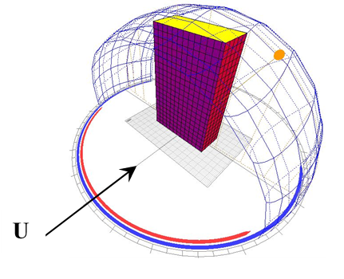

Figure 1. Illustration of Model 1 Figure 2. Illustration of Model 2



Figure 3. Illustration of Model 3

For a triangular shape with the building's width facing north and south (Figure 4), the result is that the building envelope's total radiation is 144 W / m². The total radiation on the roof of the building is 391 W / m². For a triangle with the acute side of the building facing north and south (Figure 5), the result is that the building envelope's total radiation is 192 W / m². The total radiation on the roof of the building is 391 W / m².

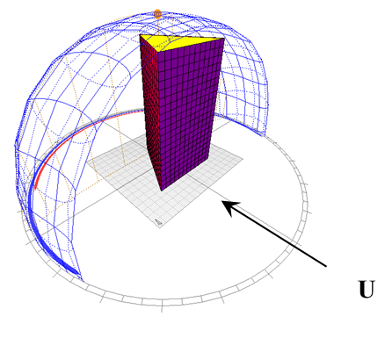 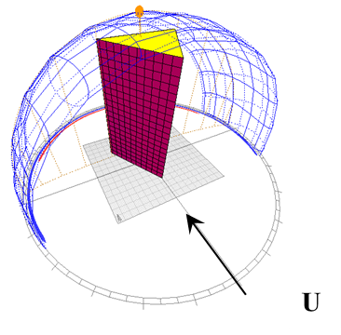

Figure 4. Illustration of Model 4 Figure 5. Illustration of Model 5

For the hexagon shape with the building's width facing north and south (Figure 6), the result is that the building envelope's total radiation is 142 W / m². The total radiation on the roof of the building is 395 W / m². For the hexagon shape with the building's width facing north and south (Figure 7), the result is that the total radiation received by the building envelope is 143 W / m². The total radiation on the roof of the building is 391 W / m².

 

Figure 6. Illustration of Model 6 Figure 7. Illustration of Model 7

Figure 8 below compares the OTTV performance values ​​from the seven shape and orientation options that have been simulated using the Ecotect software. From this comparison, it can be seen that model 2 (Figure2), which is a rectangular shape with the widest openings in the north and south positions, is the ideal shape to get the lowest OTTV value. Meanwhile, model 5 (Figure5) with a triangular prism with one side facing north is a building shape that is not recommended to choose because it can produce the highest OTTV.



Figure 8. Comparison of Building's Shape Performance

1. Conclusion

The shape of the building has a direct effect on its OTTV performance. Apart from the building’s form, building orientation also plays a significant role in achieving the expected OTTV performance. Based on this simulation, architects should be wise in determining the shape of the building being designed and determining its orientation direction. Optimizing the shape and orientation of the building is the basis for obtaining optimal green building performance. Furthermore, the architects are expected to maximize green building performance through other passive strategies, namely the building envelope strategy, the interior arrangement strategy, and the building greening strategy. If all passive strategy options have been combined optimally, the architect can use the next strategy, namely the active strategy.

References

1. Yeang, Ken (2005) Green design in the hot humid tropical zone
2. Hegger, Fuchs dan Zeimmer, Stark. (2008): Energy Manual, Sustainable Architecture, Birkhauser, Basel
3. King, Steve (1991); Building for Conservation: Appropriate Design for Environmental Controls in the Tropics, Proceedings of Symposium Cultural Heritage in Asia dan the Pasific: Conservation dan Policy, Hawaii
4. Sarte, S Bry. (2010): Sustainable Infrastructure: The Guide to Green Engineering Design, John Wiley & Sons Inc, Hoboken, New Jersey
5. Sharma, Anupama., Tiwari, K K Dhote R. (2002): Climatic Responsive Energy Efficient, Passive Techniques in Building, Eighteenth National Convention of Architectural Engineers, Jaipur
6. Aun, Ar Chan Seong (2009) Applying MS1525:2007 Code of Practice on Energy Efficiency dan Use of Renewable Energy for Non-Residential Buildings, CPD Seminar 14th February 2009
7. Adrubali, Francesco et al (2013): Evaluation of Green Buildings’ Overall Performance through in Situ Monitoring and Simulations. Energies, Vol 6, Issue 12.
8. Venkatraman, S and Ramasamy, V (2018). Study on performance of green buildings constructed with special materials. International Journal of Pure and Applied Mathematics, Vol 119, Issue 12. Sustainability, Vol 12, Issue 7.
9. Pham, Anh-Duc et al (2020). The Development of a Decision Support Model for Eco-Friendly Material Selection in Vietnam.
10. Loekita, S and Priatman, J (2015). OTTV (SNI 03-6389-2011) and ETTV (BCA 2008) Calculation for Various Building's Shapes, Orientations, Envelope Building Materials: Comparison and Analysis. Civil Engineering Dimension, Vol. 17, No. 2.
11. T.H. Nguyen1,T. Shehab dan Z. Gao (2010) : Evaluating Sustainability of Architectural Designs Using Building Information Modeling, The Open Construction dan Building Technology Journal, Vol 4, Pages 1-8
12. Sadineni, Suresh B; Madala, Srikanth; Boehm, Robert F (2011): Passive Building Energy Saving, A Review of Building Envelope Components, Renewable dan Sustainable Energy Reviews, Vol 15 Issue 8, Pages 3617-3631
13. Rajendran, Sathyanarayanan (2006): Sustainable Construction Safety dan Health Rating System, a dissertation at Oregon State University
14. Ali, Hikmat H dan Al Nsairat, Saba F (2009) : Developing a green building assessment tool for developing countries, Building dan Environment 44, Pages 1053–1064
15. Hsueh, Sung-Lin Hsueh, Yan, Min-Ren (2011): Enhancing Sustainable Community Developments: A Multi-criteria Evaluation Model for Energy Efficient Project Selection, Energy Procedia vol 5 Pages 135-144

Acknowledgment

We convey our gratitude and appreciation to the Directorate of Research and Community Service, Directorate General of Research Strengthening and Development, Ministry of Research, Technology and Higher Education of the Republic of Indonesia for the research grant given to us through the 2020 National Competitive Grant scheme with contract numbers: 8/E1/KPT/2020; 226/SP2H/AMD/LT/DRPM/2019; 009/SP2H/AMD/LT-AMAND/LL4/2020; 007/PER-P2M/UPJ-DIKTI/04.20