Physics module based on STEM problem based learning on newton’s motion law material for senior high school
Apit Fathurohman¹, Esti Susiloningsih², Anissa Arianti³
¹⁾ Physics Education, Faculty of Teacher Training and Education, Sriwijaya University
²⁾ Primary School Teacher Education, Faculty of Teacher Training and Education,
Sriwijaya University
³⁾ Post Graduate Student of Physics Education, Faculty of Teacher Training and
Education, Sriwijaya University

Email: apit_fathurohman@unsri.ac.id, esti.susiloningsih.unsri@gmail.com,
anissaarianti@gmail.com

Abstract. This research aims to produce senior high school physics module based on STEM Problem Based Learning on Newton’s Motion Law Material that is valid and practical. This is a development research using a design model of ADDIE that modified with Tessmer’s formative evaluation method. Tessmer's formative evaluation stages in this study include self evaluation, expert review, one-to-one and small groups. Data were collected through interviews, expert testing and questionnaires at the expert review stage. The one-to-one and small group stages and field tests were conducted at SHS Number 1 Banyuasin, South Sumatra. The results of the expert review stage obtained the final score of material validation 1 (very feasible or very valid), design validation 0.91 (very feasible or very valid) and language validation 0.95 (very feasible or very valid). Based on the results showed this research produced senior high school module based on STEM Problem Based Learning on Newton’s Motion Law Material. It is recommended that this module can be used as an alternative teaching for Newton’s motion law material.

- Introduction
At present, the world is rapidly developing the revolution with the 4.0 technology platform (Thai, Thi, & Anh, 2017). The fourth industrial revolution is different from the previous three. This is because machines and artificial intelligence play a significant role in enhancing productivity and wealth creation, which directly changes and challenges the role of human beings. The fourth industrial revolution will also intensify globalisation. Therefore, technology will become much more significant, because regions and societies that cope positively with the technological impact of the fourth industrial revolution will have a better economic and social future (Schäfer, 2018). Job profiles at many workplaces are set to change because of technological impact. This means that major conversion and adaptation measures will also be necessary in the fields of education and employee development (Weber, 2015).

Education is required that can form a creative, innovative, and competitive generation. One of them can be achieved by optimizing the use of technology as an educational aid that is expected to produce output that can adapt and change the era for the better. Without exception, Indonesia also needs to improve the quality of graduates according to the world of work and the charges of digital technology (Lase, 2019). Indonesia as a large country with a wealth of natural resources and abundant human resources should be a nation that plays a great role in the development of science and technology. STEM education can be used in other scientific fields by utilizing the principles of STEM as a basis for learning and developing potential students (Nugroho, Permanasari, & Firman, 2019) .

Integrated STEM education is an effort to combine science, technology, engineering, and mathematics into one class that is based on connections between the subjects and real world problems (Stohlmann, Moore, & Roehrig, 2012). There are some benefits using STEM education, such as: Improving professional development, meeting workplace demands, STEM education for sustainable work, innovative models of secondary education, domestic development, having skills to identify questions and problems in life (Ismail, 2018) (Bybee, 2013). Technology Education teachers may use educational technology to deliver lessons and for assessment. However, the confusion between the two disciplines is clearly a problem for most educators. The Leaders in Technology and Engineering Education recently made a name change from “Technology Education” to “Technology and Engineering Education” in an attempt to alleviate the confusion and have a solid identity within the educational community (White, 2012).

Based on the results of interviews with physics teachers, the teaching materials used in the learning process are textbooks, student worksheets and sometimes the teacher explains using power points. Only some students are actively involved in the learning process. In addition, there is no use of modules in the learning process. Meanwhile, based on a questionnaire that was distributed to class X students of SHS No.1 Banyuasin, the learning resource used by textbooks was 62.5%. However, it can be seen from the percentage obtained that 62.5% of students still do not understand the physics books they have. Students need learning resources in the form of modules and also students are more interested if physics learning is presented with problems related to daily life with a percentage of 75%. So it can be concluded that students still do not understand the learning resources they use so that they are less motivated to learn independently and reflect back on the lessons taught by the teacher. Therefore, one effort to make learning more interesting and easier to understand is by using modules that are given problems in daily life using the STEM approach.

II. Research Method
This research aims to produce senior high school physics module based on STEM Problem Based Learning on Newton’s Motion Law Material that is valid and practical. This is a development research using a design model of ADDIE that modified with Tessmer’s formative evaluation method. The subjects of this study were second grade high school students, the one-to-one trial stage will be carried out on 3 class, the small group trial stage will be carried out on 9 second grade students, and the test stage effectiveness is one class of second grade high school students which is carried out at the field test stage. The research model used in this research is the ADDIE model modified with Tessmer's formative evaluation (Aldoobie, 2015). Data collection techniques in this study include interviews, expert validation, and questionnaires. The data analysis technique used is validation by 2 material experts, 2 design experts and 2 language experts, and practical data analysis. Validation conducted by experts aims to determine the validity of the module. The results of the validation are then processed using the Cohen Kappa’s coefficient.

III. Results and Discussions
3.1 Analysis
The initial stage of development research is needs analysis. The needs analysis consists of curriculum analysis, lesson plan analysis, material analysis and analysis of the characteristics of high school students (Almuharomah, Mayasari, & Kurniadi, 2019).
In the analysis of curriculum was adjusted to the 2013 high school physics curriculum of the Ministry of Education and Culture. Based on the framework of the 2013 Curriculum, the goal of learning physics is to master concepts and principles and have the skills to develop knowledge and a confident attitude as provisions for continuing education at a higher level and developing science and technology (Kemdikbud, 2017). At the stage of analyzing the Learning Implementation Plan which is based on Core Competencies, Competency Standards, Basic Competencies, learning indicators and learning objectives from the Newton’s Motion Law. The core competencies of KI-3 are understanding, applying, analyzing factual, conceptual, procedural knowledge based on their curiosity about science, technology, arts, culture and humanities with insights into humanity, nationality, statehood and civilization regarding the causes of phenomena and events, and applying procedural knowledge in a specific field of study according to their talents and interests to solve problems.
Basic competence in this material is to analyze the interaction of forces and the relationship between force, mass and motion of objects in straight motion. Conducting the experiment and the presentation of the results related to the interaction of forces and the relationship of force, mass, and acceleration in straight motion and their physical meaning. As for learning indicators for Newton's law of motion, namely: 1) Applying Newton's First, Second, and III Laws; 2) Analyze the forces on the object (weight, normal force, rope tension, friction); 3) Presenting and communicating the results of discussions and observations.
The next phase is material analysis, Newton's law of motion material was chosen because Newton's law of motion material is one of the difficult materials and misconceptions often occur in physics subjects (Rahmawati, Jumadi, Kuswanto, & Oktaba, 2020). From the results of previous research, it shows that students' mastery of concepts and understanding of this material is still low (Hermanto, Muslim, Samsudin, & Maknun, 2019). Based on the basic competencies of the newton motion law material, it is analyzing the interaction of forces and the relationship between force, mass, and movement of objects in straight motion. From the basic competencies and expected indicators, STEM Problem Based Learning is an alternative solution. Based on previous research, the PBL Model can be used as an alternative learning model by lecturers to improve their abilities (Mushlihuddin, Nurafifah, & Irvan, 2018) (Simamora, Sidabutar, & Surya, 2017).
The analysis phase of student characteristics, based on the results of interviews with teachers of physics subjects, is still teacher-centered. Only some students are active in the learning process. Based on the questionnaire that the percentage obtained was 65.6% (21 students out of 32 students) students still did not understand the physics books they had. Students are more interested if physics learning is presented with problems related to daily life with a percentage of 68.7% (22 of 32 students) and students need learning resources in the form of modules with a percentage of 78.1% (25 of 32 students).

Design
At the design stage, there is a self-evaluation stage carried out by self-evaluating the products that have been developed which are supported by comments and suggestions from peers, as well as comments and suggestions from the physics teacher as a reference in evaluating the product. Colleagues provide suggestion that module that has been created has not brought up the STEM PBL yet, the problem used is not related to daily life, not related to the material of Newton's motion law yet and suggest to the existence of typing or writing errors, then colleagues suggest much more literature from relevant journals or books. PBL model is very suitable applied in learning physics remembering that physics material is in the form of concepts, laws, principles, and theories which are closely related to the scope of problems in daily life. Therefore, it is necessary to prepare appropriate teaching materials to support the PBL learning model (Hasanah, Huda, & Kurniawati, 2017)
After repairs and revisions were made, a specific prototype was obtained. The making of teaching materials in the form of modules is adjusted to module components consisting of an introduction, student activity sheets, worksheets, worksheet answer keys, and test sheets, glossary, and module design bibliography can be seen in table 1.

Table 1. Product Design
Cover  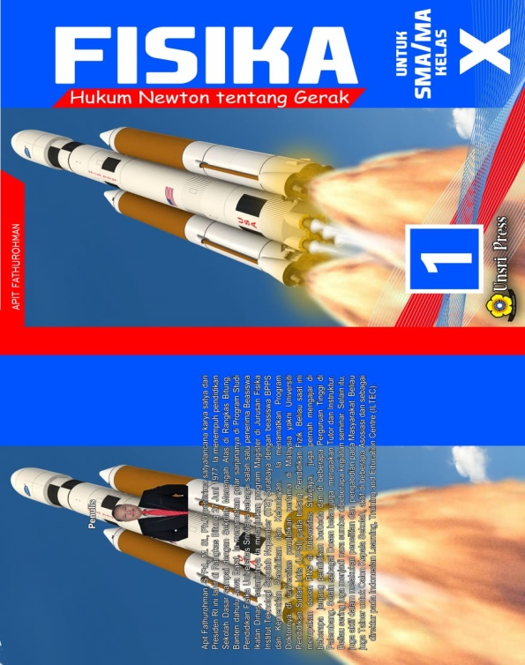  Content  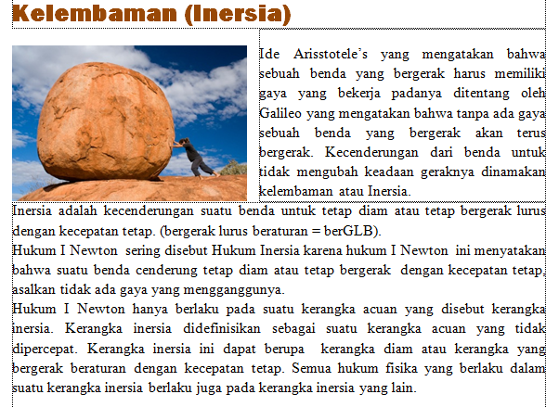 | Introduction  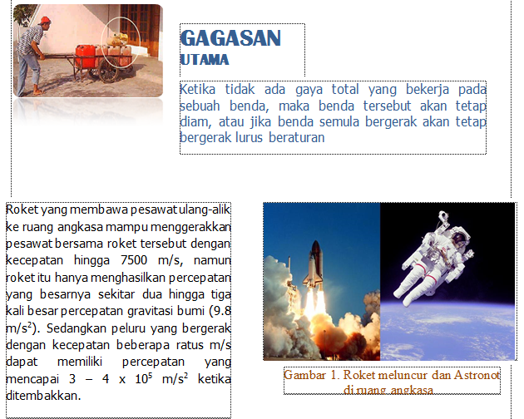  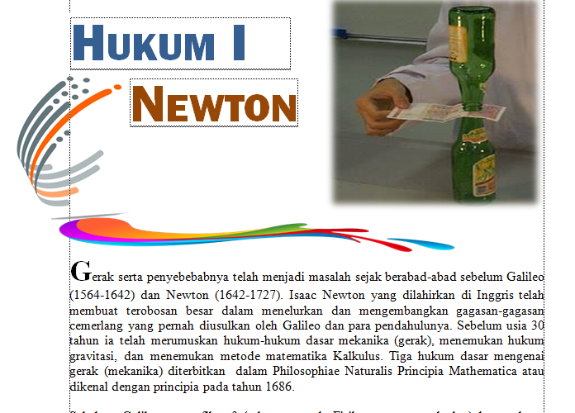  Get to know Beta Physics  “So Close and Real”  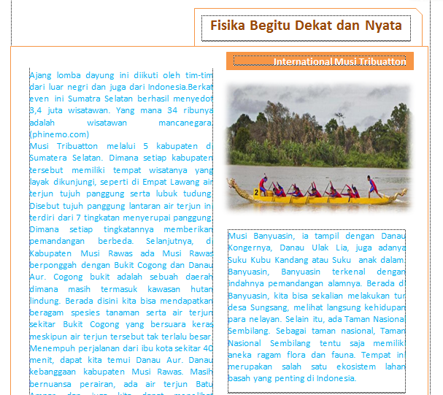

As seen in the Get to Know Beta Physics "So Close and Real" section, there is a rowing sport image. This is local wisdom found in South Sumatra, Indonesia. There are laws of physics in these sports. In rowing boats, the thrust is applied intermittently, as the oars alternate, once in the water and once in the air. While pedaling an athlete moves back and forth on a slide that creates positive and negative force. The positive force causes the boat to move forward and negative force causes the boat to move backward.

Development
In this development phase, products began to be developed that were in accordance with the learning approach and model used, namely the STEM Problem Based Learning and also developing validation instruments used to measure and assess the products being developed. The product developed has been repaired with peers and has gone through the self-evaluation stage which resulted in a specific prototype. At this phase it is modified by using Tessmer's formative evaluation consisting of expert reviews, which aims to validate the modules that have been developed .

3.4 Expert Review
The product of this research is in the form of a physics module based on STEM problem based learning on Newton's Law Material, which has been carried out in the self-evaluation and repair phase with peers which produces a specific prototype. Based on the results of discussions with experts, it turns out that some improvements or revisions still have to be made to some parts of the module, including content, writing format, layout, images and color combinations in the module so that it can be seen that the module developed meets the valid criteria. After fulfill the valid criteria, the module can then be tested at a later phase as well as the writing format and layout so that it can be tested later. The expert review score on the module can be seen in table 2 below.
Table 2. Results of the Interpretation of the Validation Test

Expert | Expert 1 | Expert 2 | Mean | Category
Material | 1 | 1 | 1 | very decent
Design | 0,93 | 0,89 | 0,91 | very decent
Linguist | 0,91 | 1 | 0,95 | very decent

3.5 One to One
One to one stage was carried out on 3 students of senior high school. The physics module that has been revised is based on comments and suggestions from peers along with the expert review stage, namely in the form of a specific prototype, the physics module is tested on students. Students are selected, based on the category of high, medium and low ability levels as measured by student test scores and determined by the Standard Deviation formula.

3.6 Small Group
The revised physics module based on comments and suggestions from the expert review stage and the one to one stage, namely in the form of prototype I. Prototype I was tried out at the small group stage involving 9 students consisting of 3 high category students, 3 medium category students and 3 students low category. Students selected are also based on high, medium and low categories as seen from the student's ipk. In the small group stage, just like the one to one stage, students are given a physics module in the form of prototype I, and then asked to fill out a practical assessment questionnaire and provide comments and suggestions. Comments and suggestions at the small group stage are used as material for product revisions.

IV. Conclusion
This research produced senior high school physics module based on STEM Problem Based Learning on Newton’s Motion Law Material and has been proven valid. Based on the results of the research that has been done, at the expert review stage, the material expert score was 1 in the very valid category, the design expert's score was 0.91 in the very valid category and the linguist's score was 0.95 with the very valid category. It is recommended that this module can be used as an alternative teaching for Newton’s motion law material in senior high school.

REFERENCES
Aldoobie, N. (2015). ADDIE Model. American International Journal of Contemporary Research, 107(3), 361–373.
Almuharomah, F. A., Mayasari, T., & Kurniadi, E. (2019). Pengembangan Modul Fisika STEM Terintegrasi Kearifan Lokal “Beduk” untuk Meningkatkan Kemampuan Berpikir Kreatif Siswa SMP. Berkala Ilmiah Pendidikan Fisika, 7(1), 1. https://doi.org/10.20527/bipf.v7i1.5630
Bybee, R. W. (2013). Challenges and Opportunities The Case for Education. Retrieved from www.nsta.org/permissions.
Hasanah, T. A. N., Huda, C., & Kurniawati, M. (2017). Pengembangan Modul Pembelajaran Fisika Berbasis Problem Based Learning (PBL) pada Materi Gelombang Bunyi untuk Siswa SMA Kelas XII. Momentum: Physics Education Journal, 1(1), 56. https://doi.org/10.21067/mpej.v1i1.1631
Hermanto, I. M., Muslim, M., Samsudin, A., & Maknun, J. (2019). K-10 students’ conceptual understanding on Newton’s laws: Current and future directions. Journal of Physics: Conference Series, 1280(5). https://doi.org/10.1088/1742-6596/1280/5/052059
Ismail, Z. (2018). Benefits of STEM Education. (September). Retrieved from https://assets.publishing.service.gov.uk/media/5c6c0ec740f0b647abb525a7/418_Benefits_of_STEM_Education.pdf
Kemdikbud. (2017). Pendidikan Kesetaraan Paket C Setara Sma / Ma.
Lase, D. (2019). EDUCATION AND INDUSTRIAL REVOLUTION 4.0 Delipiter. Jurnal Handayani, 10(1), 48–62. https://doi.org/10.24114/jh.v10i1
Mushlihuddin, R., Nurafifah, N., & Irvan, I. (2018). The effectiveness of problem-based learning on students’ problem solving ability in vector analysis course. Journal of Physics: Conference Series, 948(1). https://doi.org/10.1088/1742-6596/948/1/012028
Nugroho, O. F., Permanasari, A., & Firman, H. (2019). The movement of stem education in Indonesia: Science teachers’ perspectives. Jurnal Pendidikan IPA Indonesia, 8(3), 417–425. https://doi.org/10.15294/jpii.v8i3.19252
Rahmawati, D. U., Jumadi, Kuswanto, H., & Oktaba, I. A. (2020). Identification of students’ misconception with isomorphic multiple choices test on the force and newton’s law material. Journal of Physics: Conference Series, 1440(1). https://doi.org/10.1088/1742-6596/1440/1/012052
Schäfer, M. (2018). the Fourth Industrial Revolution: How the Eu Can Lead It. Tạp Chí Nghiên Cứu Dân Tộc, (23). https://doi.org/10.25073/0866-773x/94
Simamora, R. E., Sidabutar, D. R., & Surya, E. (2017). Improving Learning Activity and Students’ Problem Solving Skill through Problem Based Learning ( PBL ) in Junior High School. International Journal of Sciences: Basic and Applied Research, 33(2), 321–331. Retrieved from https://www.researchgate.net/profile/Rustam_E_Simamora2/project/Improving-Learning-Activity-and-Students-Problem-Solving-Skill-through-Problem-Based-Learning-PBL-in-Junior-High-School/attachment/593927d01042bfac8918d9a5/AS:502924565336065@1496917968551/do
Stohlmann, M., Moore, T., & Roehrig, G. (2012). Considerations for Teaching Integrated STEM Education. Journal of Pre-College Engineering Education Research, 2(1), 28–34. https://doi.org/10.5703/1288284314653
Thai, H. Van, Thi, L., & Anh, K. (2017). the 4.0 Industrial Revolution Affecting Higher Education Organizations’ Operation in Vietnam. International Journal of Management Technology, 4(2), 1–12.
Weber, E. (2015). Industrie 4.0 – Wirkungen auf Wirtschaft und Arbeitsmarkt. Wirtschaftsdienst, 95(11), 722–723. https://doi.org/10.1007/s10273-015-1894-8
White, D. W. (2012). What Is STEM Education and Why Is It Important? Congressional Research Service, (August), 1–15. Retrieved from https://www.ccc.edu/departments/Documents/STEM_labor.pdf

