Covid-19 sir model with nonlinear incidence rate

T Fayeldi1, R N I Dinnullah2

1,2Mathematics Education Study Program, Universitas Kanjuruhan Malang, Jl. S. Supriadi No. 48, Malang, 65148, Indonesia

trija_fayeldi@unikama.ac.id

**Abstract**. Covid-19 is part of worldwide pandemic since early 2020. Various mathematical models have been proposed to understand the behaviour of the disease, but most of them were failed to predict the biological phenomenon of this infectious diseases since they use incorrect assumptions due to early stage symptoms. The aim of this paper is to develop a covid-19 mathematical model with nonlinear incidence rate. We use some logical assumption to develop the model. We discretize the model by using Euler method. We use literature review in our research methodology. Then, we simulate the model by using computer software. We found that this model has two equilibrium points, namely disease free equilibrium point and endemic equilibrium point. The stability of the model is changed by increament or decreament of the step-size. If the step-size of the model is large enough, then it lead numerical solution to blown up. Finally, we also found that this model is fair enough to simulate the pandemic in our case. Also, we found some interesting phenomenon from our simulation that is the effect of government policies or social distancing. Further work is needed to analyze the stability of the model and the effect of delay.

1. Introduction

Since its first case several months ago, Covid-19 is still a main problem in the world. Many researcher proposed their mathematical model to describe the behavior of the virus such as [1], [2], [3], [4] and [5] . They use some assumption to simplify their mathematical models. For example, in [6] they use Richard’s Curve in their model which gave a good result in SARS endemic in Hongkong. Since Coronavirus can be transmitted by bats, some researcher proposed vector-host model as in [7]. These models predict that end of endemic would happened around mid 2020. However, this prediction is far from reality. This incorrect prediction is caused by lack of data and incorrect assumption.

In this paper, we proposed a SIR model with nonlinear incidence rate. We develop this model since no researcher has done modeling Covid model using nonlinear nor nonmonotone incidence rate. We assume that the population has a factor called inhibitory effect. In daily life, it can be represent as social distancing, government policy, or using mask for travelling. Unlike the other model which represent these effect as linear factor, we represent them as nonlinear factor, that is $\frac{1}{1+γI^{2}}$. It means that graphically, this model will increase to its maximum value, but then it decrease faster than the linear one. We assume that these disease will decrase faster because the population has been vaccinated by that time.

This paper is organize as follow: the first section is introduction. In the next section, we introduce the model. Since solution of the model is difficult to find directly, we discretize it and find its numerical solution. We use Euler method to discretize the model. Then, we apply some parameters and simulate the model. We discuss the behavior of the model based on result of our simulation. In the last section, we conclude the results that we found and suggest further works on this paper.

1. Method

In this paper, we use model as follow.

$\left\{\begin{aligned}\dot{S}=α-μS-\frac{β}{1+γI^{2}}SI \\ \dot{I}=\frac{β}{1+γI^{2}}SI-\left(μ+ϑ\right)I \\ \dot{R}=ϑI-μR\end{aligned}\right.$ (1)

In our model as in (1), *S*, *I*, and *R* represents susceptible, infected, and recovered population respectively. Parameter α represent birth rate, β represent transmission rate of Coronavirus, γ represent inhibitory effect - that is some action that prevent the spread of disease such as government policy or social distancing, µ represent death rate, and υ represent recovery rate. The next step is discretize the model. We use Euler method to discretize this model due to its effectiveness in computation time [8], [9], and [10]. Aside from its effectiveness, Euler method sensitive to step-size [11], [12]. It means that small shift in step-size can effect the whole numerical solution. So, step-size play an important role in Euler method [13], [14]. By using forward-difference [15], we have the following scheme.

$\left\{\begin{aligned}\frac{S_{n+1}-S_{n}}{h}=α-μS_{n}-\frac{β}{1+γI_{n}^{2}}S_{n}I_{n} \\ \frac{I_{n+1}-I_{n}}{h}=\frac{β}{1+γI_{n}^{2}}S_{n}I_{n}-\left(μ+ϑ\right)I_{n} \\ \frac{R_{n+1}-R_{n}}{h}=ϑI_{n}-μR_{n}\end{aligned}\right.$ (2)

By using some easy manipulation, we can rewrite (2) as follow.

$\left\{\begin{aligned}S_{n+1}=S_{n}+αh-μhS_{n}-\frac{β}{1+γI_{n}^{2}}hS_{n}I_{n} \\ I_{n+1}=I_{n}+\frac{β}{1+γI_{n}^{2}}hS_{n}I_{n}-\left(μ+ϑ\right)hI_{n} \\ R_{n+1}=R_{n}+ϑhI_{n}-μhR_{n}\end{aligned}\right.$ (3)

Notice that from this model, we can find that the basic reproduction number (the secondary infections of the disease) is $R_{0}$ = $\frac{αβ}{μ\left(μ+ϑ\right)}$. In the following section, we discuss about the two equilibrium point of model (3) and do some simulation to analyze its behavior.

1. Result and Discussion

Suppose that $\left(S^{*},I^{*},R^{*}\right)$ represent equilibrium point of model (3), then we have

$\left\{\begin{aligned}S^{*}=S^{*}+αh-μhS^{*}-\frac{β}{1+γI^{*^{2}}}hS^{*}I^{*} \\ I^{*}=I^{*}+\frac{β}{1+γI^{*^{2}}}hS^{*}I^{*}-\left(μ+ϑ\right)hI^{*} \\ R^{*}=R^{*}+ϑhI^{*}-μhR^{*}\end{aligned}\right.$ (4)

Simplify(4) into the following equation.

$\left\{\begin{aligned}0=αh-μhS^{*}-\frac{β}{1+γI^{*^{2}}}hS^{*}I^{*} \\ 0=\frac{β}{1+γI^{*^{2}}}hS^{*}I^{*}-\left(μ+ϑ\right)hI^{*} \\ 0=ϑhI^{*}-μhR^{*}\end{aligned}\right.$ (5)

Notice that from $0=\frac{β}{1+γI^{*^{2}}}hS^{*}I^{*}-\left(μ+ϑ\right)hI^{*}={hI}^{*}\left(\frac{β}{1+γI^{*^{2}}}S^{*}-\left(μ+ϑ\right)\right)$ with *h* > 0, we can conclude that *I*\* = 0 or $S^{*}=\left(μ+ϑ\right)\frac{\left(1+γI^{*^{2}}\right)}{β}$. If we substitute each cases into the remain equation, then we have two equilibrium points, namely $E_{0}=\left(\frac{α}{μ},0,0\right)$ and $E_{1}=\left(\frac{α-\left(μ+ϑ\right)I_{e}}{μ},I_{e},\frac{ϑ}{μ}I_{e}\right)$, where $I_{e}=\frac{-β+\sqrt{β^{2}-4μ^{2}γ\left(1-R_{0}\right)}}{2μγ}$. It can be shown that if *R*0 > 1 then *I*e > 0. Since the first two equations in (1) is independent from *R*, we define the following equation.

$\left\{\begin{matrix}F\left(S,I\right)=α-μS-\frac{β}{1+γI^{2}}SI \\ G\left(S,I\right)=\frac{β}{1+γI^{2}}SI-\left(μ+ϑ\right)I\end{matrix}\right.$ (6)

Jacobian matrix of (6) is $J\left(S,I\right)=\left(\begin{matrix}\frac{∂F}{∂S} & \frac{∂F}{∂I} \\ \frac{∂G}{∂S} & \frac{∂G}{∂I}\end{matrix}\right)$ where $\frac{∂F}{∂S}=1-h\left(μ+φ\left(I\right)\right)$, $\frac{∂F}{∂S}=-hS\frac{∂φ}{∂I}$, $\frac{∂G}{∂S}=hφ\left(I\right)$, and $\frac{∂G}{∂I}=1+h\left(S\frac{∂φ\left(I\right)}{∂I}-\left(μ+ϑ\right)\right)$ where $φ\left(I\right)=\frac{β}{1+γI^{2}}$. It is easy to show that $J\left(E_{0}\right)=J\left(\frac{α}{μ},0\right)=\left(\begin{matrix}1-μh & -\frac{αβ}{μ}h \\ 0 & 1-h\left(μ+ϑ\right)\left(1-R_{0}\right)\end{matrix}\right)$. It can be shown that $E_{0}$ is sink if $h<\min_{}\left(h_{1},h_{2}\right)$ where $h_{1}=\frac{2}{μ}$ and $h_{2}=\frac{2}{\left(μ+ϑ\right)\left(1-R_{0}\right)}$. However, since this disease has already happened then we only focus on endemic cases, that is *R*0 > 1.

In the following, we simulate model (3) to observe the big picture of its numerical solution. We use parameter as follow: α = 0.1, µ = 0.1, β = 0.5, γ = 0.5, υ = 0.15, and step size *h* = 0.1. It is easy to observe that the basic reproduction number under this condition is *R*0 = 2. The graphic of this numerical solution can be seen in figure 1.

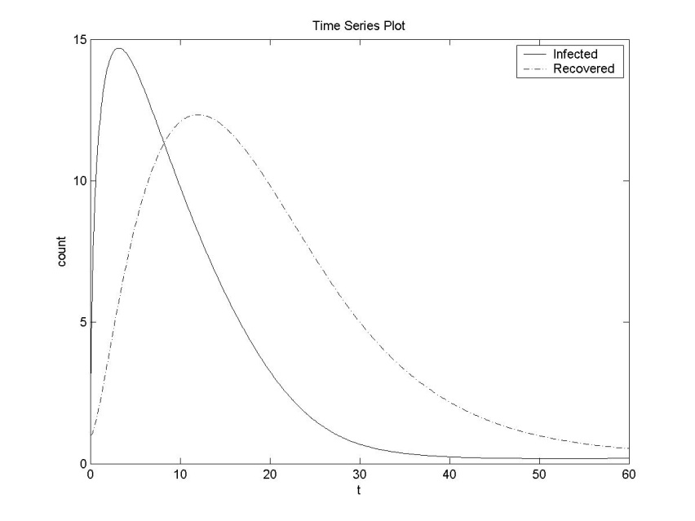

Figure 1. Time Series Plot

From figure 1, it can be seen that this model is more reasonable to represent the spread of Covid-19 recently. Infected population increase rapidly at the first stage since it was no government policy nor social distancing, but it decreased as soon as it reach the peak of the model. This phenomenon happened because of government or people intervention such as policy or social distancing. If we focus on inhibitory effect γ, we found this interesting phenomenon as in figure 2.

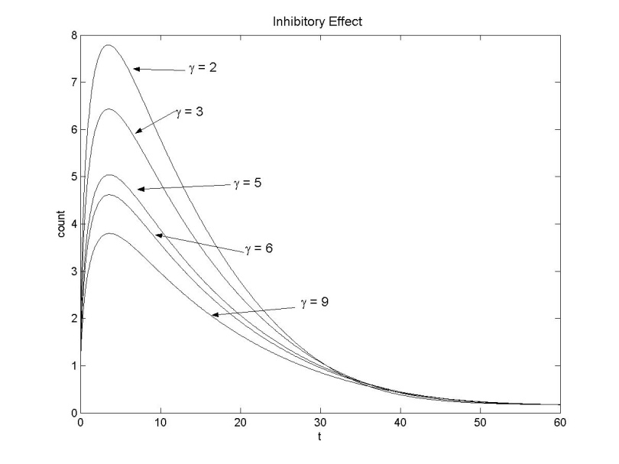

Figure 2. Inhibitory Effect for Various Values

From figure 2, we found that inhibitory effect play an important role for the model. We found that this parameter can affect the peak i.e the most death cases in Covid-19. It means that government policy or social distancing can cause less mortality of this disease.

1. Conclusion

This paper proposed a new model to describe the behavior of Covid-19. We found two equilibrium points, but in this paper we only focus on endemic one. We found that the intervention from government such as policies or social distancing can make this disease decrease faster.

Further works still need to be done in order to analyze the stability of the model, chaos or delay effect, and the consistency of this model to the real data.

References

[1] Soewono E 2020 On the analysis of Covid-19 transmission in Wuhan, Diamond Princess and Jakarta-cluster *Commun. Biomath. Sci.* **3** 9–18

[2] Pham H 2020 On Estimating the Number of Deaths Related to Covid-19 *Mathematics* **8** 655

[3] Corey L, Mascola J R, Fauci A S and Collins F S 2020 A strategic approach to COVID-19 vaccine R&D *Science* **368** 948–50

[4] Fauci A S, Lane H C and Redfield R R 2020 Covid-19 — Navigating the Uncharted *N. Engl. J. Med.* **382** 1268–9

[5] Du S Q and Yuan W Mathematical modeling of interaction between innate and adaptive immune responses in COVID-19 and implications for viral pathogenesis *J. Med. Virol.* **n/a**

[6] Nuraini N, Khairudin K and Apri M 2020 Modeling Simulation of COVID-19 in Indonesia based on Early Endemic Data *Commun. Biomath. Sci.* **3** 1–8

[7] Chen T-M, Rui J, Wang Q-P, Zhao Z-Y, Cui J-A and Yin L 2020 A mathematical model for simulating the phase-based transmissibility of a novel coronavirus *Infect. Dis. Poverty* **9** 24

[8] Kucharski A J, Russell T W, Diamond C, Liu Y, Edmunds J, Funk S, Eggo R M, Sun F, Jit M, Munday J D, Davies N, Gimma A, Zandvoort K van, Gibbs H, Hellewell J, Jarvis C I, Clifford S, Quilty B J, Bosse N I, Abbott S, Klepac P and Flasche S 2020 Early dynamics of transmission and control of COVID-19: a mathematical modelling study *Lancet Infect. Dis.* **20** 553–8

[9] Bichara D, Kang Y, Castillo-Chavez C, Horan R and Perrings C 2015 SIS and SIR epidemic models under virtual dispersal *Bull. Math. Biol.* **77** 2004–34

[10] Huang C, Cao J, Wen F and Yang X 2016 Stability Analysis of SIR Model with Distributed Delay on Complex Networks *PLOS ONE* **11** e0158813

[11] Cao Z, Liu X, Wen X, Liu L and Zu L 2019 A regime-switching SIR epidemic model with a ratio-dependent incidence rate and degenerate diffusion *Sci. Rep.* **9** 1–7

[12] Miller J C 2017 Mathematical models of SIR disease spread with combined non-sexual and sexual transmission routes *Infect. Dis. Model.* **2** 35–55

[13] Yang C and Wang J 2020 A mathematical model for the novel coronavirus epidemic in Wuhan, China *Math. Biosci. Eng.* **17** 2708

[14] Wang P and Jia J 2019 Stationary distribution of a stochastic SIRD epidemic model of Ebola with double saturated incidence rates and vaccination *Adv. Differ. Equ.* **2019** 433

[15] Fayeldi T 2019 A Discrete Numerical Solution of The SIR Model with Horizontal and Vertical Transmission **6** 1–9