Autonomous Car Using CNN Deep Learning Algorithm

I Sonata1,a), Y Heryadi1,b), Lukas2,c), A Wibowo1,d)

1)Computer Science Department, BINUS Graduate Program – Doctor of Computer Science, Bina Nusantara University Jakarta, Jl. Kyai H. Syahdan No.9, Jakarta, Indonesia 11480

2)Cognitive Engineering Research Group (CERG), Faculty of Engineering, Universitas Katolik Indonesia Atma Jaya, Jl Jend. Sudirman No.51, Jakarta, Indonesia 12930

a)ilvico@binus.ac.id, b)yayaheryadi@binus.edu, c)lukas@atmajaya.ac.id, d)anwibowo@binus.edu

**Abstract**. Autonomous cars have become an interesting discussion in recent years. Several major automotive industries such as Tesla, GM and Nissan are trying to become pioneers in autonomous car technology. Giant technology companies such as Google Waymo, Baidu and Aptiv also developing autonomous car technology. Several technological approaches are carried out in implementing autonomous cars for recognizing surrounding situations, such as radar, lidar, sonar, GPS, and odometry. An automatic control system is used to control navigation based on the data obtained from these sensors. This paper will discuss the use of CNN deep learning algorithm for recognizing the surrounding environment in creating the automatic navigation required by autonomous cars. The system designed will create and learn the data set that will be taken in advance and the learning outcomes will be implemented in an open simulation system. This simulation shows high accuracy in learning to navigate the autonomous car by observing the surrounding environment.

1. Introduction

Applications of artificial intelligence and machine learning are increasingly widespread and penetrate all fields including in the field of autonomous cars. The development of autonomous cars which are currently being developed by many technology companies such as Waymo and Uber is starting to lead to the use of artificial intelligence and machine learning to replace the conventional systems which require very expensive equipment such as LRF, lidar, GPS for detecting the surrounding [4].

Many researches of autonomous cars are currently being progress to ensure the safety of autonomous cars before they are launched to the public. A car with a driver provides a sense of safety and comfort for passengers where the driver can control the car well and meet safety standards. The challenge of autonomous cars today is how to produce a model of driving behaviour that is the same as humans so that it still provides a sense of safety and comfort for passengers [1].

Artificial intelligence and machine learning approaches have proven successful in areas of image classification such as facial and image recognition systems [2][5]. This classification system approach will be used for the recognition of the surrounding environment in determining the direction and movement of autonomous cars. Machine learning with images as inputs is achieved by Convolutional Neural Networks (CNN), which has become dominant in various computer vision tasks including autonomous car. CNNs are one of the best deep learning algorithms for recognizing image content and have demonstrated good performance in image segmentation, classification, detection, and retrieval related tasks as reported by Giusti, Cireşan, Masci, Gambardella and Schmidhuber [2]

In previous models, many autonomous cars were developed using some sensors such as LRF, GPS and LIDAR as described by Lattarulo, Pérez, and Dendaluce [11] and Du, Ang and Rus [8]. In this paper, the model uses only one camera as a sensor for autonomous mode to reduce hardware usage and thus lower costs. The collected data image will be processed by CNN deep neural network and finally the steering model is generated to control an autonomous car.

1. Method

CNN is a technique that is inspired by the biological visual perception. CNN always contains three basic operations, namely convolution, pooling and fully connected [2].

Convolution layer is a fundamental component of the CNN architecture that performs feature extraction using multiple filters. The convolutional layer consists of filters with height and width [18] [5]. Convolution process is done by transform the parts of certain size of image become small array of number called kernel, the system gets new representative information from the multiple parts of kernel and process it become feature map [5].

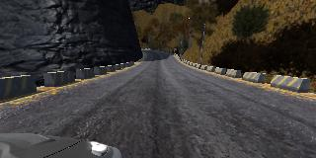

**Figure 1.** The original image from the image data becomes smaller images with the same convolution.

CNN has the ability to recognize objects in an image. CNN's ability to recognize an object is given by the feature extraction. The feature map is produced from each thumbnail of the convolution results as shown in Figure 1. All parts of each thumbnail are processed using the same filter. Every difference of each image will be marked as special characteristic object. The whole thumbnail collection is arranged into a kernel [5] [18].

Figure 2 shows the CNN architecture. The pooling layer performs a sub-sampling process to reduce input spatially (reduce the number of parameters) with a down-sampling operation. This is used to reduce the dimensionality of feature maps from the convolution operation. The important information from the section is still taken even if the number of parameters is reduced. The feature map will be fed into deep neural networks by using a small array. The small array will be converted into a 1-dimensional array by the flatten process. The final neural network output is the probability of each image classification task performed by the fully connected layers [5].

To reduce the loss from the previous process, backpropagation is used as an error correction. Backpropagation basically is supervised learning algorithms with multi-layered perceptrons. Backpropagation uses an output error to update the weight values. The error is obtained from forward propagation process output (predicted value) compared with actual value. The weights will be updated by the calculation base on the error value. The process will be repeated until the error rate decrease [17].

Improvement of the model performance can be done by selected the number of pooling layers. This is the main thing in CNN modelling, as reported by Lee, Gallagher and Tu [15].

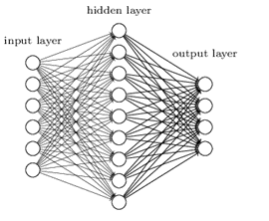

Flatten

Input Image

Actual Value

C

o

n

v

o

l

u

t

i

o

n

P

o

l

l

i

n

g

Compare

Error/

Adjustment

Fully Connected

Feature extraction

Feed Forward

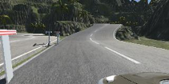

Back Propagation

Error/

Adjustment

**Figure 2.** CNN Architecture.

Figure 3 shows a simplified block diagram of the autonomous car system for training data collection that adopted from NVIDIA model [12]. Images from the three cameras and steering angle are fed into a CNN. CNN then computes a prediction model of steering command. The actual model of steering command is compared to the prediction model and the weights of the CNN are adjusted to bring the CNN output closer to the desired output. The back propagation is used to accomplish the weight adjustment.

After training process finish, the system generates steering model and this model will be used for driving command base on single centre camera as shown in figure 4.

Centre Camera

Correction value

Prediction

value

Actual value

CNN

Left Camera

Right Camera

Steering angle

Error/

Adjustment

Back propagation Weight

**Figure 3.** Autonomous car training model.

Centre Camera

Trained CNN

(Driving model)

Steering command

**Figure 4.** Autonomous car driving model.

1. Result and Discussion

The simulation environment was using udacity self-driving car simulator and the network is based on NVIDIA model [12]. Figure 5 shows the learning environment created in the simulation study and figure 6 shows sample images taken by left camera, centre camera and right camera in training mode.

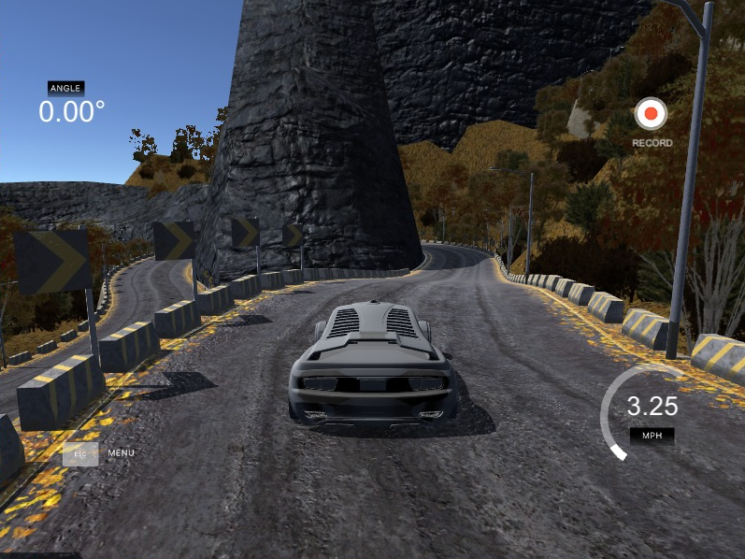

**Figure 5.** Learning environmental.

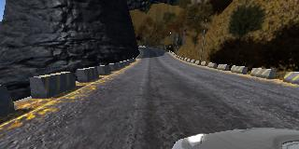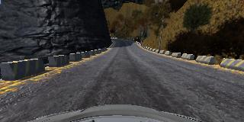

**Figure 6.** sample image taken by left camera, centre camera and right camera.

The data collected is about 16,000 images and labelled with the type of road and driver activity such as on lane or turning. The simulation sampling rate is 10 FPS and image resolution 320x160 pixels. Before the learning process, the image taken will be normalize by removing the sky and other unnecessary parts of picture for simplifying the learning process. Some pre-processing of collected data images also include rotation, horizontal flip, vertical flip, and RGB to YUV transform to improve the quality of the classification results.

The training process using 5x5 kernel for the first three convolution layer and 3x3 kernel for the last three convolution layer and maximum epochs 20 with 2.000 sample for each epoch.

After the training finish about two or three laps, the simulator then switches to the autonomous mode and then base the model created by the CNN, the car will run autonomously and can predict for every road condition.

The simulation is implemented on a Laptop with i5-4200U CPU, NVIDIA Geforce 740M GPU and 12G memory. The learning process takes about 4 hours.

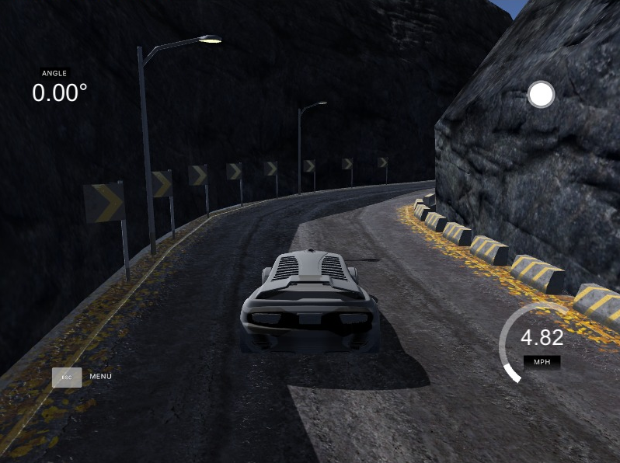

**Figure 7.** Autonomous mode in simulator.

1. Conclusion

The proposed method of autonomous car using CNN deep learning can run smoothly without error and very stable without oscillation in environmental simulation using udacity self-driving car simulator as shown in figure 7.

CNN can learn road condition from three cameras (left, centre and right) and also make a model for driving in autonomous mode controlled by one centre camera.

To get the better performance, next experiment will include the obstacle in the simulation environment and rain simulation with additional noise and distortion at data image set.

References

1. Zhu M, Wang X and Wang Y 2018 Human-like autonomous car-following model with deep reinforcement learning *Transp. Res. Part C Emerg. Technol.* **97** 348–68
2. Giusti A, Cireşan D C, Masci J, Gambardella L M and Schmidhuber J 2013 Fast image scanning with deep max-pooling convolutional neural networks *2013 IEEE Int. Conf. Image Process. ICIP 2013 - Proc.* 4034–8
3. Yang Y, Wu Z, Xu Q and Yan F 2018 Deep Learning Technique-Based Steering of Autonomous Car *Int. J. Comput. Intell. Appl.* **17** 1–18
4. Okuyama T, Gonsalves T and Upadhay J 2018 Autonomous Driving System based on Deep Q Learnig *2018 Int. Conf. Intell. Auton. Syst. ICoIAS 2018* 201–5
5. Yamashita R, Nishio M, Do R K G and Togashi K 2018 Convolutional neural networks: an overview and application in radiology *Insights Imaging* **9** 611–29
6. Masci J, Meier U, Cireşan D and Schmidhuber J 2011 Stacked convolutional auto-encoders for hierarchical feature extraction *Lect. Notes Comput. Sci. (including Subser. Lect. Notes Artif. Intell. Lect. Notes Bioinformatics)* **6791 LNCS** 52–9
7. Sallab A El, Abdou M, Perot E and Yogamani S 2017 Deep reinforcement learning framework for autonomous driving *arXiv* 70–6
8. Du X, Ang M H and Rus D 2017 Car detection for autonomous vehicle: LIDAR and vision fusion approach through deep learning framework *IEEE Int. Conf. Intell. Robot. Syst.* **2017**-**Septe** 749–54
9. Bechtel M G, McEllhiney E, Kim M and Yun H 2019 DeepPicar: A low-cost deep neural network-based autonomous car *Proc. - 2018 IEEE 24th Int. Conf. Embed. Real-Time Comput. Syst. Appl. RTCSA 2018* 11–21
10. Al-qizwini M, Barjasteh I, Al-qassab H, Fellow H R, Lqirupdwlrq H, Surfhvvhg L V and Wkh L 2017 DL for autonomous driving using GoogleNet *IEEE Intell. Veh. Symp. (IV), June 11-14, 2017, Redon. Beach, CA, USA* 89–96
11. Lattarulo R, Pérez J and Dendaluce M 2017 A complete framework for developing and testing automated driving controllers *IFAC-PapersOnLine* **50** 258–63.
12. Bojarski M, Del Testa D, Dworakowski D, Firner B, Flepp B, Goyal P, Jackel L D, Monfort M, Muller U, Zhang J, Zhang X, Zhao J and Zieba K 2016 End to End Learning for Self-Driving Cars 1–9
13. Haq F U, Shin D, Nejati S and Briand L C 2020 Comparing Offline and Online Testing of Deep Neural Networks: An Autonomous Car Case Study *Proc. - 2020 IEEE 13th Int. Conf. Softw. Testing, Verif. Validation, ICST 2020* 85–95
14. Ahmad I and Pothuganti K 2020 Design implementation of real time autonomous car by using image processing IoT *Proc. 3rd Int. Conf. Smart Syst. Inven. Technol. ICSSIT 2020* 107–13
15. Lee C Y, Gallagher P W and Tu Z 2016 Generalizing pooling functions in convolutional neural networks: Mixed, gated, and tree *Proc. 19th Int. Conf. Artif. Intell. Stat. AISTATS 2016* 464–72
16. Liu B, Yu X, Zhang P, Yu A, Fu Q and Wei X 2018 Supervised deep feature extraction for hyperspectral image classification *IEEE Trans. Geosci. Remote Sens.* **56** 1909–21
17. Hecht-nielsen R 1992 *Theory of t h e Backpropagation Neural Network \** (Academic Press, Inc.)
18. Ke Q, Liu J, Bennamoun M, An S, Sohel F and Boussaid F 2018 Computer Vision for Human – Machine Interaction (Elsevier Ltd)