BD-Print: An Android Based for Bilingual Digital Promotion of Integrated Tourism in Garut Selatan

R Y D Cahyani1,*, Hartono, R M N Sakinah, O N Putra2, I E Setyawati3 and G Undang4

1English Literature Study Program, Faculty of Letters, Al-Ghifari University (UNFARI), Bandung

2Information System Study Program, Management and Informatics College (STMIK) Jabar, Bandung

3State Administration Study Program, Faculty of Social and Political Sciences, Al-Ghifari University (UNFARI), Bandung

4Administration Science Study Program, Indonesian Community Development University (UPMI), Medan

Email: [yenicahyani69@yahoo.com](mailto:yenicahyani69@yahoo.com)

**Abstract**. South Garut has tourism potential areas in Indonesia. However, the lack of government attention and information of the tourist area in South Garut resulted a lack of tourists coming. South Garut tourism will be more accessible by developing an information system that implements the Android system as a promotional medium to introduce tourist objects. This study is undertaken to design an Android-based BD-Print application to assist the development of the regional potential tourism sector in the Southern Garut. The BD-Print system development will use the System Development life Cycle approach with the Waterfall method. This application has gone through several process such as planning, system analyzing, crafting, implementation, testing and development. Result of the experiment are: 1) The application programs created by using Android run well. 2) The features existed in the application program runs well as the main menu displays other menu options, login menu, tourism menu that displays some options of available tourist destinations, and mapping that displays the route from the current location to the location of the object destination tours. 3) This BD-Print application suits well as a reference for tourists that are going on a vacation without being accompany by tour guide.

1. Introduction

Tourism development is one of the development sectors that attracts the attention of the government in Indonesia. Tourism is an inseparable part of human life, especially regarding social and economic activities [1]. As such, tourism is a product of modern social arrangements. Tourism planning must be based on conditions and carrying capacity with the aim of creating long-term mutually beneficial interactions between the achievement of tourism development goals, increasing the welfare of local communities, and sustainable environmental carrying capacity in the future [2].

Indonesia as a developing country is in its development stage, trying to build a tourism industry as a way to achieve a balanced foreign trade balance. The current tourism development is not only to increase foreign exchange and local government revenue. However, it is also expected to expand business opportunities in addition to providing new jobs to reduce unemployment [3]. Tourism can increase the life standard of people living in these tourist destination areas through economic benefits. By developing facilities that support and provide recreational facilities, tourists and local residents benefit from each other. The development of a tourist area should reflect the cultural, historical and economic levels of the tourist destination [4]. The reason is because tourism can spur economic growth of the community, as well as improve the welfare of the people in the tourist area. South Garut Region (Garsel) has a wealth of tourism potential that varies, based on Regional Regulation No. 28 of 2010 on The Development of South West Java Region year 2010-2029, Garsel will be developed by the Government of West Java Province into an integrated tourism area, including coastal tourism, river tourism, technology tourism, indigenous village tourism, agricultural (*agro*) tourism, and special interest tourism. Garsel's special interest tourism includes paragliding (*gantole*), climbing, diving, adventure, rafting tour, and so on. Tourism potential of South Garut has a very opportunity to attract tourists both Indonesian and foreign. Therefore, it needs to be developed by optimizing the existed various potentials. The design of BD-Print application can support tourism promotion efforts in South Garut region, so that tourism potential in this area can be well known by tourists in foreign countries because the application is made in two languages: English and Indonesian. Based on this phenomenon, hopefully the developing strategies to promote the tourism potential of South Garut as a leading tourism destination in West Java province can be well prepared.

Research conducted by Ardy (2018), Rusmania (2015), and Sianipar (2019): Applications with mobile E-tourism based on the Android operating system can be run via smartphones by tourists, E-tourism with the function of selecting tourist attractions, scheduling activities tourism, giving users a good rating and comments for a tourist spot and the estimated time and route to be taken to get to tourist attractions around the area [5][6]. Applications that have developed today are more focused on e-commerce, online hotel reservations and accommodation. This application does not directly touch the components of local communities who need more effective ways to introduce villages and their natural potential through the digital world and are able to improve the economy through the tourism sector [7][8].

By rules, Garsel's tourism potential is reflected in the 2015-2025 West Java Tourism Development Master Plan, but empirically the potential has not been developed optimally, access to information and promotion is still very minimal, so tourists and prospective developers (entrepreneurs) have difficulty obtaining easily accessible information. The development of tourism in South Garut is not without challenges. Tourism in South Garut is still constrained by the effective use of mobile technology. The use of mobile technology, which is usually an application, still requires more portions to help the development of tourism in South Garut. The tourism potential will be more easily accessible by developing a digital information system as a promotional medium to introduce its attractions [9]. BD-Print is a concept of utilizing information and communication technology to increase usability of information technology in the field of tourism created in two languages. This application provides various tourism services to tourists that make tourism marketing more accessible both locally and internationally. Based on that understanding, the internet in tourism basically reflects a digital system in terms of tourism distribution that leads to the transformation of tourism industry development towards the internet which is usually in the form of websites or applications[10]. BD-Print is a digital platform that connects all tourism stakeholders, facilitates the licensing process, integrates all tourism activities and provides convenience for all tourists exploring the charms of the Southern Garut tourism through an easy-to-use app, anytime and anywhere.

These phenomenon leads the background of this research, with the hope it can develop a strategy to promote South Garut as a leading tourism destination in West Java. BD-Print application design can be used as a promotional medium that can reach local and foreign tourists. Through the creation of this application is expected to provide convenience for tourists to get information about tourist attractions located in the Southern Garut region.

1. Method

This study applies the waterfall method in application design which includes the stages of system design, analysis, design, coding and testing, implementation, and improvement [11]. The characteristics of the waterfall are activities that flow from one phase (stages) to the other phases sequentially, and each phase is passed first to completion to get to the next phase. As shown in figure 1, at the requirements stage, the research carried out the process of collecting tourist location data and feature requirements of the system to be created through a user needs questionnaire. On stages of analysis and design, research processing the results of tourist location data and needs questionnaires users, and translate them into system designs and face-to-face (display) devices soft. Then enter the coding and testing stage (code and testing), the results of the stages the design is implemented using a programming language that is understood by the computer for produce workable software. This stage is the implementation of the stages designs that will technically be done by the programmer. The coding stage will be carried out simultaneously with trials to test program deficiencies and functions of the system. After all software functions are tested to minimize errors and maximize compliance with predefined requirements, the next stage is the implementation of a new system to run. The last stage is system maintenance, including development. When the system is running, there is the possibility of minor errors that were not found before, or the addition of new functions. Development is required when changes occur such as operating system changes.

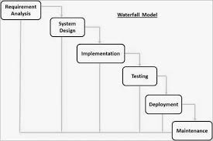

Figure 1. Waterfall Model

1. Result and Discussion
   1. *Use case diagram system design*

Use Case Diagrams describe the functionality expected of a system that emphasizes what the system makes and presents an interaction between actors and the system[12][13]. Use Case Diagram (Fig 2) is used to describe the stages that the actor goes through in carrying out any activities related to the application system[14]. In the following Use Case Diagram there are two actors, namely User and Admin. The user functions as a user who can search and display tourist locations, get routes, and perform ratings. The admin manages the tourist location. The admin inputs username and password in login menu, selects the tourist attraction data processing link on the menu. Admin can change, add, or clear the travel data.

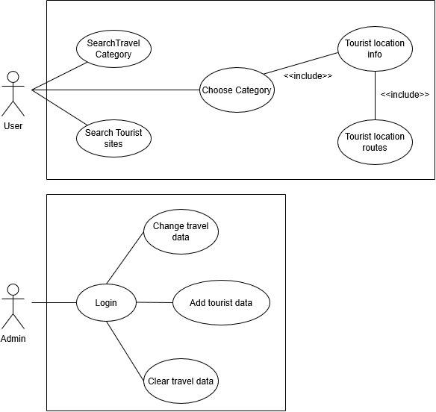

Figure 2. Use Case Diagram

Usage scenario Admin is as follows: before making an application regarding a tourist attraction, the Admin first conducts a research. This study aims to find and collect a list of tourist objects that are available and can be entered into the application to be made. This tourist attraction collection system by visiting the tourist objects directly, collecting information from books and the internet and also by coming directly to the relevant Tourism and Culture Office directly. The activity diagram looking for the tourism category above (figure 2) explains the activities that occur on the tourism website carried out by the user. Once the results are displayed, the user clicks and the system will display tourist attraction information based on search results.

* 1. *Software Development and Implementation*

The application is developed on hardware specifications, namely 1 GB, 2 GB, and 3 GB memory, 8 GB, 16 GB, and 64GB of storage, and has a GPS feature. In the testing phase, the application was tested on the following 3 devices and it worked well.

Table 1. Device Specifications for Application Testing

|  |  |  |  |
| --- | --- | --- | --- |
| Hardware | Vivo 1904 | Huawei Y3 2017 | OPPO A37f |
| Memory | 3 GB | 1 GB | 2 GB |
| Storage | 64,00 GB | 8,00 GB | 16,00 GB |
| GPS | Yes | Yes | Yes |
| Operating System | Funtouch OS_9, 2,0 GHz Octa-core | Android OS 6.0 Version, 1,1 GHz Quad-core | Android OS 5.1.1 Version, Qualcomm MSM 8916 Quad-core |
| Internet | 4G, HSPA | 4G, HSPA | 4G, LTE |

* 1. *BD-Print Design*

The BD-Print application is designed in two languages which aims to promote Southern Garut tourism objects in an integrated manner and can be recognized by foreign tourists. In addition to informing data about tourist objects and their routes, this application is also equipped with a database of restaurants, hotels, places of worship, playgrounds, malls, gas stations, and even ATM locations. As shown in figure 3, when the application on the cell-phone is clicked for the first time, the user will be presented with a login page. To be able to access all the menus on the main page, the user can click the allow menu. Then the user can choose the language whether it is in Indonesian or in English language. After logging in, we will enter the main menu and there are several other menus such as Home, Travel, About and Settings. Through the home menu we can see the tourist attraction to be visited

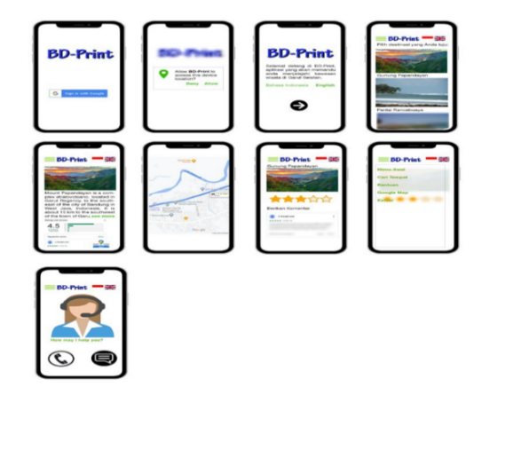

Figure 3. BD-Print Design

For example: figure 4 is a display of the results of entering the Mount Papandayan menu. If we click on a tourist attraction, a description of the tourist attraction will appear, and there are also several related categories such as tourist objects, locations and provinces. When the user clicks on a tourist attraction, besides there are related categories there are also several other sub-menus such as a sub-menu to display the map. The map can display the distance and route that can be traveled between the current location and the location of the tourist attraction that has been selected.

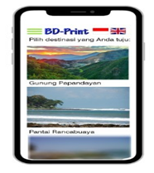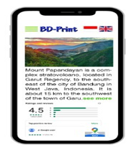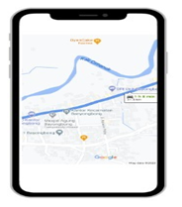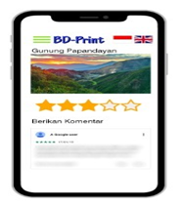

Figure 4. Search results for Mount Papandayan icon, along with information and routes

The design of BD-Print application aims to be a bilingual digital promotional medium so that the tourist destination of Southern Garut is more familiar and can be visited by local tourists as well as foreign tourists. But in the design of this application requires a thorough collection of information such as the potential of existing resources and the supporting capacity of the region for ecotourism development ranging from available facilities, visitor satisfaction, as well as people's attitude towards tourist activities[16]. This application is also useful to increase the use in the field of tourism, provide various tourism services to the community, and make the implementation of tourism marketing more accessible.

1. Conclusion

Based on the explanation above, it can be concluded that with the creation of the BD-Print application, the tourism potential in Southern Garut will be better known by both local and international tourists. They will more easily get information about Southern Garut Tourism. This promotional information system is built more easily and efficiently. With this information system is expected to help Southern Garut Tourism in order to compete better because all information about the tourism object is easier to obtain by visitors. The BD-Print application is certainly very helpful for those of you who want to visit Southern Garut without being accompanied by a guide. You can also file a complaint or comment through this application so that it can help the City Government respond to tourism developments. Hopefully, the development of the BD-Print application can promote tourism potentials and raise the economy of the surrounding area and make the dissemination of tourism information easier and more efficient.

References

[1] Wearing S and Mc Donald M 2002 The development of community-based tourism: Re-thinking the relationship between tour operators and development agents as intermediaries in rural and isolated area communities *J. Sustain. Tour.*

[2] Tavallaee S, Asadi A, Abya H and Ebrahimi M 2014 Tourism planning: an integrated and sustainable development approach *Manag. Sci. Lett.*

[3] Csapo J 2012 The Role and Importance of Cultural Tourism in Modern Tourism Industry *Strategies for Tourism Industry - Micro and Macro Perspectives*

[4] Zaei M E and Zaei M E 2013 the Impacts of Tourism Industry on Host Community *Eur. J. Tour. Hosp. Res.*

[5] Ardy U, Desiana J and Rachmadi M 2018 Pengembangan aplikasi perencana wisata “plesir” berbasis android dan ios *Ijccs*

[6] Sianipar C I and Liyushiana 2019 Pemasaran Pariwisata Digital oleh Pemerintah Kota Sabang *J. Darma Agung*

[7] Gunawan K and Eka B 2015 Implementation of Location Base Service on Tourism Places in West Nusa Tenggara by using Smartphone *Int. J. Adv. Comput. Sci. Appl.*

[8] Rusmania N 2015 *Android Based Mobile Application*

[9] Karpova G A, Kuchumov A V., Testina Y S and Voloshinova M V. 2019 Digitalization of a Tourist Destination *ACM International Conference Proceeding Series*

[10] Prats-Planagumà L and Camprubí R 2009 E-tourism image: The relevance of networking for web sites destination marketing *Information Communication Technologies and City Marketing: Digital Opportunities for Cities Around the World*

[11] Bulman M 2017 SDLC - Waterfall Model *Indep.*

[12] Visual Paradigm 2019 What is Use Case Diagram? *Vis. Paradig.*

[13] Seidl M, Scholz M, Huemer C and Kappel G 2015 The Use Case Diagram

[14] Powell-Morse A 2016 Waterfall Model: What Is It and When Should You Use It? *Airbrake*

[15] Supattranuwong S, Sinthupinyo S and Juwattanasamran P 2013 Applying Data Mining to Analyze Travel Pattern in Searching Travel Destination Choices *Int. J. Eng. Sci.*

[16] Encalada L, Boavida-Portugal I, Ferreira C C and Rocha J 2017 Identifying tourist places of interest based on digital imprints: Towards a sustainable smart City *Sustain.*