A Measurement of Various Length of the Stack on a Standing Wave Thermoacoustic Refrigerator

Wahyu Nur Achmadin, Indah Kharismawati, and Mochammad Maulana Trianggono

IKIP PGRI Jember, Jember 68121, Indonesia

Email: nurachmadin@ikipjember.ac.id

**Abstract**. A thermoacoustic refrigerator is a capable device to produce temperature differences with acoustic work (sound waves) as the source. The advantage of these machines is that the working gas medium used is air, so it doesn't produce much pollution and of course, it is environmentally friendly. This paper describes the measurement of stack length variations ranging from 4 cm to 7 cm on the performance of the standing wave thermoacoustic refrigerator. This study aimed to find the optimum stack length in a thermoacoustic machine with a resonator pipe length of 80 cm. Operation time is carried out for 30 minutes. The main components of a thermoacoustic device consist of a regenerator, resonator pipe, and a loudspeaker. The regenerator has a big role, namely as a place for energy conversion to occur. The results obtained are a temperature decrease, a temperature increase, and a temperature difference. The results showed that the temperature decrease and the temperature difference on the stack length of 7 cm were the decrease in temperature and the maximum temperature difference with the results of 4.6°C and 9.3°C, respectively. Therefore a standing wave thermoacoustic refrigerator with various lengths of the stack has been experimentally studied.

1. Introduction

A thermoacoustic refrigerator is a machine that applies the thermoacoustic phenomenon. The energy source of this phenomenon is to utilize acoustic waves to produce a temperature difference that can be used as heating or cooling or temperature differences that can occur to produce acoustic waves (sound). Generally, thermoacoustic devices are grouped into two types, namely those that produce sound waves due to temperature differences called thermoacoustic heat engines. Meanwhile, a device that produces a temperature difference due to sound waves is called a thermoacoustic refrigerator [1]. The advantage of this machine is that the medium we use is harmless, natural, and environmentally friendly, the medium is air [2]. Another advantage of this machine is that if there is a leak in the resonator pipe, there is nothing to worry about. This is due to the pollution (exhaust gas) produced in the air so it is not dangerous and can be easily recovered. The structure of these thermoacoustic components is fairly simple and can be assembled at a low cost [3].

The schematic diagram of this research is shown in Figure 1. It consists of a closed Polyvinyl Chloride (PVC) resonator pipe, an Audio Function Generator (AFG), an amplifier, a regenerator, and a loudspeaker. Three components are interconnected with the connector cables, namely AFG, Amplifier, and Loudspeaker. The regenerator contains a series of wire mesh sheets which are compressed to the desired thickness. When the acoustic waves across the regenerator, the stack will produce a temperature difference on the right and left side. The oscillating particles carried by acoustic waves are compressed and expanded on the other side [4]. The simple thermoacoustic refrigerator design using a stack of wire mesh was observed by Haris *et al*. The parameter which changed are the input voltage [5], heat flow [6], 3D-printed stack [7], particle swarm optimization method [8] and the organic stack [9]. Other researchers have observed parallel plate stack parameters [10–12], dynamic pressure in thermoacoustic refrigerators [13], and working gas on thermoacoustic [14].

In this paper, we describe our measurements regarding the effect of various lengths of a stack on the performance of refrigerator thermoacoustic. As has been described in the abstract section, the results of this research will refer that the 7 cm stack length has an optimal decreasing temperature and temperature difference in the machine being made. This study aims to determine the optimal performance of the thermoacoustic refrigerator (ie temperature reduction) when the stack thickness variation treatment is carried out. So that we know the best performance on thermoacoustic refrigerator with the specifications of the equipment as will be explained in the next section.

1. Experimental Method

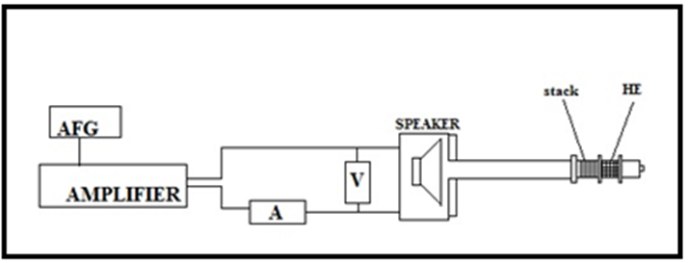

Figure 1. The schematic diagram of standing wave thermoacoustic refrigerator

This stage contains the steps that will be carried out in the research after knowing the problems and suggestions in previous research. In this study, a random pore stack of wire mesh size 18 was carried out. This wire mesh was formed into a circle with a diameter corresponding to the diameter of the resonator pipe. This wire mesh form is also to maintain the pores at a certain mesh size. The schematic diagram of the standing wave thermoacoustic refrigerator used in this measurement is illustrated in Figure 1.

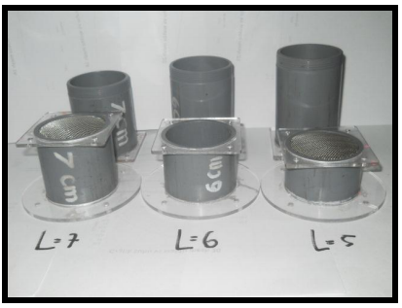

**Figure 2.** Various stack length

The operation of the Audio Function Generator is required to adjust the frequency of the acoustic waves. While the input voltage from the power source to the loudspeaker is regulated by the audio amplifier. we need to monitor the audio amplifier with a voltmeter and an ammeter, this is very necessary. The temperature in the regenerator field is recorded by a data logger and a computer that is connected to the LM35 temperature sensor. The signals with a certain frequency are generated by the Audio Function Generator (AFG) and then connected to the Audio Amplifier which functions as a frequency amplifier that comes out of the AFG. The signal that comes out of the AFG and the amplifier is then adjusted by amplifying the amplitude. This setting is conditional to the AFG panel and amplifier. The signal from the AFG which is then amplified by the amplifier becomes the input signal for the loudspeaker. The length and diameter of the resonator pipe are Lres = 80 cm and Dres = 5.25 cm. In this study, the desired stack length is arranged 4 cm to 7 cm in Figure 2.

1. Results and Discussion

3.1. Temperature Decrease

Figure 3 describes the time relationship to temperature changes that occurred for 30 minutes. The temperature decreasing occurs in each variation of the length stack has a difference. (see Figure 3). When the sound source (acoustic wave) starts to activate, the gas packet isolation process will occur. This process makes the refrigerator thermoacoustic unique in this study. The temperature on the sides of the regenerator will experience a temperature difference, which is close to the sound source, hot temperatures will be collected, while on the opposite side of the regenerator (away from the sound source) cold temperatures will collect. Figure 3 is the yield data on the cold side opposite the regenerator.

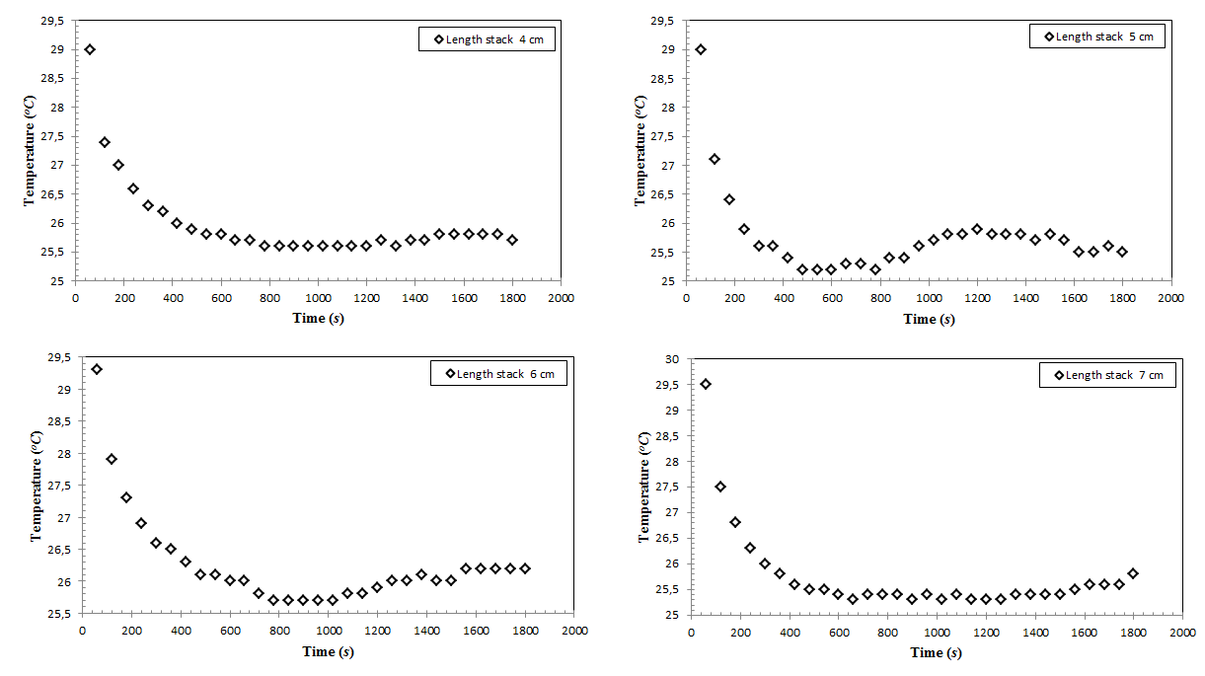

**Figure** **3.** Temperature decrease at a various length of the stack

It can be seen that the temperature sensor attached to the cold side of the thermoacoustic regenerator catches a decrease in temperature at each length of the stack. Therefore, if you pay closer attention, we will see the properties of the thermoacoustic itself, which will immediately experience an increase in temperature again. This temperature increase can occur due to the oscillation of the gas package in the regenerator which changes the speed and pressure [10]. A backflow the heat causes the cold reservoir temperature to rise again because the compressed area has a small volume but the pressure on the gas package continues to increase. As a result of this incident, the collisions that occur between molecules are getting bigger and resulting in a backflow of heat from the hot reservoir to the cold reservoir [6]. This change indicates that the heat on the hot side of the regenerator will be carried over to the cold side of the regenerator.

On a 4 cm stack attached to a thermoacoustic machine and activated, temperature decrease continuously was seen (See Fig. 3). In the 800th to 1200th seconds the temperature starts to become constant. The temperature stability indicates that the engine can no longer lower the temperature. Therefore, seen that at 1400th seconds, the temperature sensor on the cold side of the generator records an increased temperature. Based on this result, the temperature that has decrease will return to increase again if operating the engine for even longer.

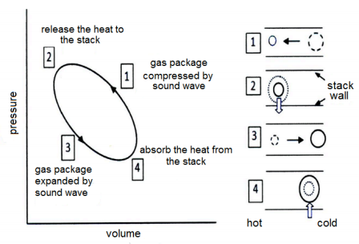

**Figure 4.** illustration of the gas package oscillation stages in the regenerator [15]

The explanation of the stages on the stack is shown in Figure 4. When the gas package moves from the right side (cold side of the regenerator) to the left (towards the hot side of the regenerator), the volume of the gas package will be compressed because of the pressure on the hot side is greater than the cold side (1). This compression process coincides with the process of releasing heat to the stack walls (2). After that, the gas pack returns from the left (hot side) to the right (cold side). In the process of returning the gas package, the volume of the gas package is stretched (expansion), this condition which makes the volume of the gas package is greater than before (3). The expansion process coincides with the absorption of heat in the cold stack walls (4). This is what keeps the right side cool. This cycle is repeated and provides a heat transfer effect [15].

3.2. Temperature Increase

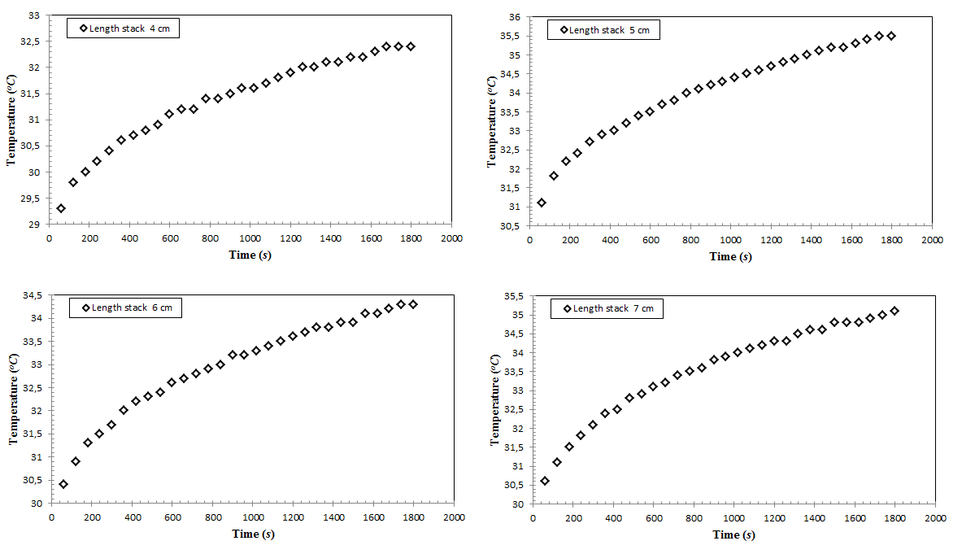

**Figure 5.** Temperature increase at a various length of the stack

The following is a comparison of each length of the stack on the performance of the thermoacoustic refrigerator. This temperature increase is measured on the LM35 sensor which is located on the hot side of the regenerator. It can be seen that the temperature increases steadily with the operating time (see Figure 5). This increase can occur because the hot side gets additional heat from the cold side of the regenerator. therefore, the temperature continues to increase simultaneously. If the operation of the engine is continued for a long time, it is possible that the temperature increase on the cold side of the regenerator can occur as previously mentioned. this incident can reduce the level of performance on the thermoacoustic refrigerator.

We can see in Figure 5 that at 1800th second, a stack length of 5 cm can increase the temperature up to 35.5 °C. The length of the 4 cm stack can increase the temperature up to 32.4 °C which shows the results of the lowest temperature increase in this study.

3.3. Determination of Optimum Length of Stack

Analytical calculations to obtain the optimum stack length conditions in thermoacoustic performance can be calculated by determining the values ​​of Temperature Hot (Th), Temperature Cold (Tc), and temperature differences (ΔT) as shown in Figure 6.

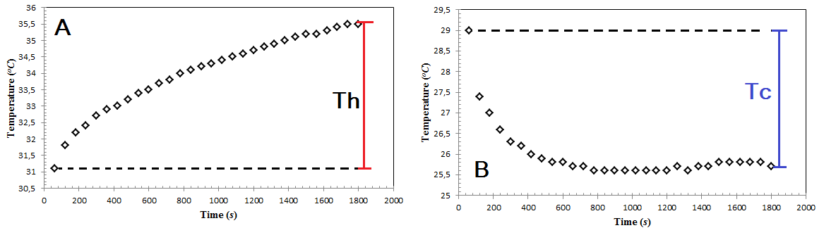

**Figure 6.** Determination value of Th and Tc. (A) when temperature increase (B) when temperature decrease

Meanwhile, the temperature difference is the sum of the values ​​of Temperature Hot (Th) and Temperature Cold (Tc) in one time period. The stack length of 7 cm can decrease the temperature of 4.6 oC from the initial temperature. This value represents the highest temperature decrease in this study. The influence on the stack length of 7 cm is also able to increase the temperature by 4.7 oC of which is the highest temperature increase. From these results, it can be seen that the highest temperature difference is in the 7 cm stack length with a value of 9.3 °C as shown in Table 1.

|  |  |  |  |
| --- | --- | --- | --- |
| **Table 1.** Influence Length of Stack at Thermoacoustic Refrigerator | | | |
|  |  |  |  | |
| Length of Stack (*cm*) | Temperature Decrease [Tc] (*°C*) | Temperature Increase [Th] (*°C*) | Temperature difference [ΔT] (*°C*) | |
| 4 | 4 | 3.3 | 7.3 | |
| 5 | 4.4 | 4.7 | 9.1 | |
| 6 | 4 | 4 | 8 | |
| 7 | 4.6 | 4.7 | 9.3 | |

1. Conclusions

A standing wave thermoacoustic refrigerator with various lengths of the stack has been experimentally studied. The higher temperature reduction of 4.6 °C is obtained by using a 7 cm charged length of the stack. At this stack length, the temperature difference is 9.3 °C, which is optimum to have the performance on this machine. From these results, this thermoacoustic refrigerator can be used as a cooler.

1. Acknowledgments

The research is supported by IKIP PGRI Jember and Laboratory of Atomic and Nuclear Physics, Department of Physics, Faculty of Mathematics and Natural Sciences, Universitas Gadjah Mada.

1. References

[1] Swift G 2002 *Thermoacoustics: a Unifying perspective for some engines and refrigerators* vol 113

[2] Setiawan I, Achmadin W N, Murti P and Nohtomi M 2016 Experimental Study on a Standing Wave Thermoacoustic Prime Mover with Air Working Gas at Various Pressures *J. Phys. Conf. Ser.* **710** 012031

[3] Wakeland R S and Keolian R M 2002 Thermoacoustics with idealized heat exchangers and no stack *J. Acoust. Soc. Am.* **111** 2654–64

[4] Tijani M E H, Zeegers J C H and de Waele A T A M 2002 The optimal stack spacing for thermoacoustic refrigeration *J. Acoust. Soc. Am.* **112** 128–33

[5] Dyatmika H S, Achmadin W N, Murti P, Setiawan I and Utomo A B S 2015 Development of The Thermoacoustic Refrigerator System Using a Stack Made of Some Stainless Steel Mesh and a Hot Heat Exchanger *Indones. J. Phys.* **26** 5–8

[6] Sakamoto S, Ise Y and Orino Y 2019 Measurement of heat flow caused by a standing-wave component generated by a thermoacoustic phenomenon *AIP Adv.* **9** 115006

[7] Zolpakar N A, Mohd-Ghazali N, Ahmad R and Maré T 2017 Performance of a 3D-printed Stack in a Standing Wave Thermoacoustic Refrigerator *Energy Procedia* **105** 1382–7

[8] Rahman A A and Zhang X 2019 Single-objective optimization for stack unit of standing wave thermoacoustic refrigerator through particle swarm optimization method *Energy Procedia* **158** 5445–52

[9] Hidayah Q, Achmadin W N, Candraresita A F and Utomo A B S 2016 The Effect of Organic Stack and Heat Exchanger on the Temperature Change of The Thermoacoustics Cooling System *AIP Conf. Proc.* **1746** 020026

[10] Mohd Saat F A Z and Jaworski A J 2017 Numerical predictions of early stage turbulence in oscillatory flow across parallel-plate heat exchangers of a thermoacoustic system *Appl. Sci.* **7**

[11] Amirin A, Triyono T and Yulianto M 2019 Experimental Study of Thermoacoustic Cooling with Parallel-Plate Stack in Different Distances *IOP Conf. Ser. Mater. Sci. Eng.* **539** 012037

[12] Liu L, Yang P and Liu Y 2019 Comprehensive performance improvement of standing wave thermoacoustic engine with converging stack: Thermodynamic analysis and optimization *Appl. Therm. Eng.* **160** 114096

[13] Arya B, Ramesh Nayak B and Shivakumara N V. 2018 Effect of Dynamic Pressure on the Performance of Thermoacoustic Refrigerator with Aluminium (Al) Resonator *IOP Conf. Ser. Mater. Sci. Eng.* **346** 012034

[14] Shivakumara N V. and Arya B 2020 Effect of Parallel Plate Stack Spacing on The Performance of Thermoacoustic Refrigerator in Terms of Temperature Difference Using Air as a Working Fluid *J. Phys. Conf. Ser.* **1473** 012051

[15] Russel D A and Weibull P 2002 Tabletop Thermoacoustic Refrigerator for demonstration *Am. J. Phys.* **70** 1231–3